Supplementary Materials

Previous Concepts of Nesophontid Relationships
Although exceptions exist, most Quaternary insular mammalian faunas represent pared-down versions of the diversity on immediately adjacent mainlands, from which (in most instances) it is plausible to think they were directly derived (Van de Geer et al. 2010). Although island species often exhibit interesting examples of morphological adaptation within strongly selective regimes (MacPhee 1994, Lomolino 2005), their general systematic placement tends to be uncontroversial, and for this reason it is usually tacitly assumed that they cannot shed much light on basal divergences within the larger clades of which they are members. This certainly applies to the systematic history of Nesophontes, a taxon that has played no more than an incidental role in lipotyphlan systematics since its original discovery 100 years ago (Anthony 1916).

The general lack of interest in nesophontids during the last century may be ascribed to several causes, but a paramount one is that, in the past, Nesophontes could be easily dismissed as just another one of the large number of persistently primitive placentals then grouped in and around Soricidae, which lacked clear affinities to anything else (Saban 1954, Van Valen 1967). This conclusion was in turn a reflection of the traditional dominance of dental characters in lipotyphlan systematics. Zalambdodonty is much rarer than dilambdodonty (Asher and Sánchez-Villagra 2005), and its presence within the Solenodontidae prompted much early interest in their possible relationships with other taxa expressing this morphology, particularly Afromalagasy tenrecoids and North American Paleogene “insectivores” such as Apternodus and Palaeoryctes (Winge 1941, Simpson 1945). By contrast, the dentition of Nesophontes was defined at the outset as descriptively dilambdodont (Anthony 1916, Winge 1941), although with some unexpected features which Anthony (1916) regarded as sufficient to warrant providing the genus with its own family. Apomorphies aside, to most specialists the dental features of Nesophontes indicated only that it must have had an origin quite different from that of solenodons (Saban 1954). Although there has never been a real consensus, by the mid-20th century it appeared that the relationships of Nesophontidae were sufficiently settled for Simpson (1945) to place them within Soricoidea without comment—and thus quite distant from Solenodontidae, which he placed in Tenrecoidea.

Nevertheless, over the decades a few authors had raised the alternative possibility that, despite their apparent dental differences, Nesophontes and solenodons might be fairly closely related to each other (Allen 1918, Gregory, 1920), and less so or not at all to “Old World zalambdodonts” (Wislocki 1940). However, it was McDowell (1958) who made a substantial breakthrough by showing that solenodontid molar morphology could be harmonized with that of Nesophontes by assuming that the dominant “zalambdocone” in the former was the homolog of the protocone in the latter, and that cusp arrangements were fully compatible if it were assumed that solenodons had completely lost the metacone. McDowell further buttressed his claim with an extensive (albeit plesiomorphic) list of cranial features which tended to show that the Caribbean “insectivores” were more closely related to each other than either was to supposed Paleocene relatives such as Apternodus and Palaeoryctes. Although his determination of cusp homologies in solenodons and Nesophontes was not widely accepted, and although he placed both groups within Soricoidea on the basis of jaw-joint morphology, the results of the present study show that he was correct in substance in asserting their sister-group relationship and the strong possibility that “the evolution of the group took place in the West Indies” (McDowell 1958).

Given precladistic views that Lipotyphla or Insectivora comprised a “wastebasket taxon” (MacPhee and Novacek 1993, Whidden and Asher 2001), that is, a repository for certain pervasively primitive placentals that could not then be reliably placed elsewhere, it is unsurprising that the basal nature of Solenodonota was not apparent before the advent of molecular analyses (Roca et al. 2004). Paleontologically, it is still the case that few studies using modern methods have explicitly considered the phylogenetic position of Nesophontes in relation to its wide range of possible extinct relatives. An exception (Asher et al. 2002) found that, in an ordered, strict consensus approach to tree-building using parsimony, Solenodon—but not Nesophontes—constituted the sister-group of a “soricid-fossil zalambodont” clade that consisted of crown soricids and certain fossil taxa (parapterodontids and oligoryctids) on the one hand and apternodontids on the other. Nesophontes was positioned close to but outside of this grouping, as were various other taxa that have been regarded as its possible relatives at one time or another (palaeoryctids, Centetodon; Lillegraven et al. 1981, Asher 1999). However, it is noteworthy that the unordered version of the analysis resulted in a similar array of taxa, but with tenrecids intercalated paraphyletically into the “soricid-fossil zalambodont” clade.

References
Allen GM. 1918. Fossil mammals from Cuba. Bull Mus Comp Zool 61: 1-12.
Anthony HE. 1916. Preliminary diagnosis of an apparently new family of insectivores. Bull Am Mus Nat Hist 35: 725-728.
Asher RJ. 1999. A morphological basis for assessing the phylogeny of the “Tenrecoidea” (Mammalia, Lipotyphla). Cladistics 15: 231-252.
Asher RJ, McKenna MC, Emry RJ, Tabrum AR, Kron DG. 2002. Morphology and relationships of Apternodus and other extinct, zalambdodont, placental mammals. Bull Am Mus Nat Hist 273:1–117.
Asher RJ, Sánchez-Villagra MR. 2005. Locking yourself out: diversity among dentally zalambdodont therian mammals. J Mamm Evol 12: 265-282.
Benton MJ, Donoghue PCJ, Asher RJ. 2009. Calibrating and constraining molecular clocks. In: Hedges SB, Kumar S, editors. The Timetree of Life. Oxford: Oxford University Press. p. 35–86.
dos Reis M, Inoue J, Hasegawa M, Asher RJ, Donoghue PC, Yang Z. 2012. Phylogenomic datasets provide both precision and accuracy in estimating the timescale of placental mammal phylogeny. Proc Roy Soc B 279:3491–3500.
Gregory WK. 1920. Studies in comparative myology and osteology: No. IV. A review of the evolution of the lacrymal bone of vertebrates with special reference to that of mammals. Bull Am Mus Nat Hist 42: 95-263.
Lillegraven JA, McKenna MC, Krishtalka L. 1981. Evolutionary relationships of middle Eocene and younger species of Centetodon (Mammalia, Insectivora, Geolabididiae) with a description of the dentition of Ankylodon (Adapisoricidae). Univ Wyoming Pub 45: 1-115.
Lomolino M. 2005. Body size evolution in insular vertebrates: generality of the island rule. J Biogeogr 32: 1683-1699.
MacPhee RDE. 1994. Morphology, adaptations, and relationships of Plesiorycteropus, and a diagnosis of a new order of eutherian mammals. Bull Am Mus Nat Hist 220: 1-213.
MacPhee RDE, Novacek MJ. 1993. Definition and relationships of Lipotyphla. In: Szalay FS, Novacek MJ, McKenna MC, editors. Mammal Phylogeny. New York: Springer. p.13-31.
McDowell SB. 1958. The Greater Antillean insectivores. Bull Am Mus Nat Hist 115: 113-214.
Roca AL, Bar-Gal GK, Eizirik E, Helgen KM, Maria R, Springer MS, O’Brien SJ, Murphy WJ. 2004. Mesozoic origin for West Indian insectivores. Nature 429:649–651.
Saban R. (1954) Phylogenie des insectivores. Bull Mus Nat Hist Nat 26: 419-432.
Simpson GG. 1945. The principles of classification and a classification of mammals. Bull Am Mus Nat His 85: 1-350.
Van Der Geer A, Lyras G, de Vos J, Dermitzakis, M. 2010. Evolution of Island Mammals: Adaptation and Extinction of Placental Mammals on Islands. Chichester: Wiley-Blackwell.
Van Valen L. 1967. New Paleocene insectivores and insectivore classification. Bull Am Mus Nat Hist 135: 217-284.
Winge H. 1941. The Interrelationships of the Mammalian Genera. Reitzel, Copenhagen.
Wislocki GB. 1940. The placentation of Solenodon paradoxus. Am J Anat 66: 497-531.
Whidden HP, Asher RJ. 2001. The Origin of the Greater Antillean Insectivorians. In Woods CA, Sergile FE, editors. Biogeography of the West Indies: Patterns and Perspectives. Boca Raton: CRC Press. p.237-252.

Supplementary Figure 1. Histogram showing the frequency distribution of merged Nesophontes read lengths in base pairs.
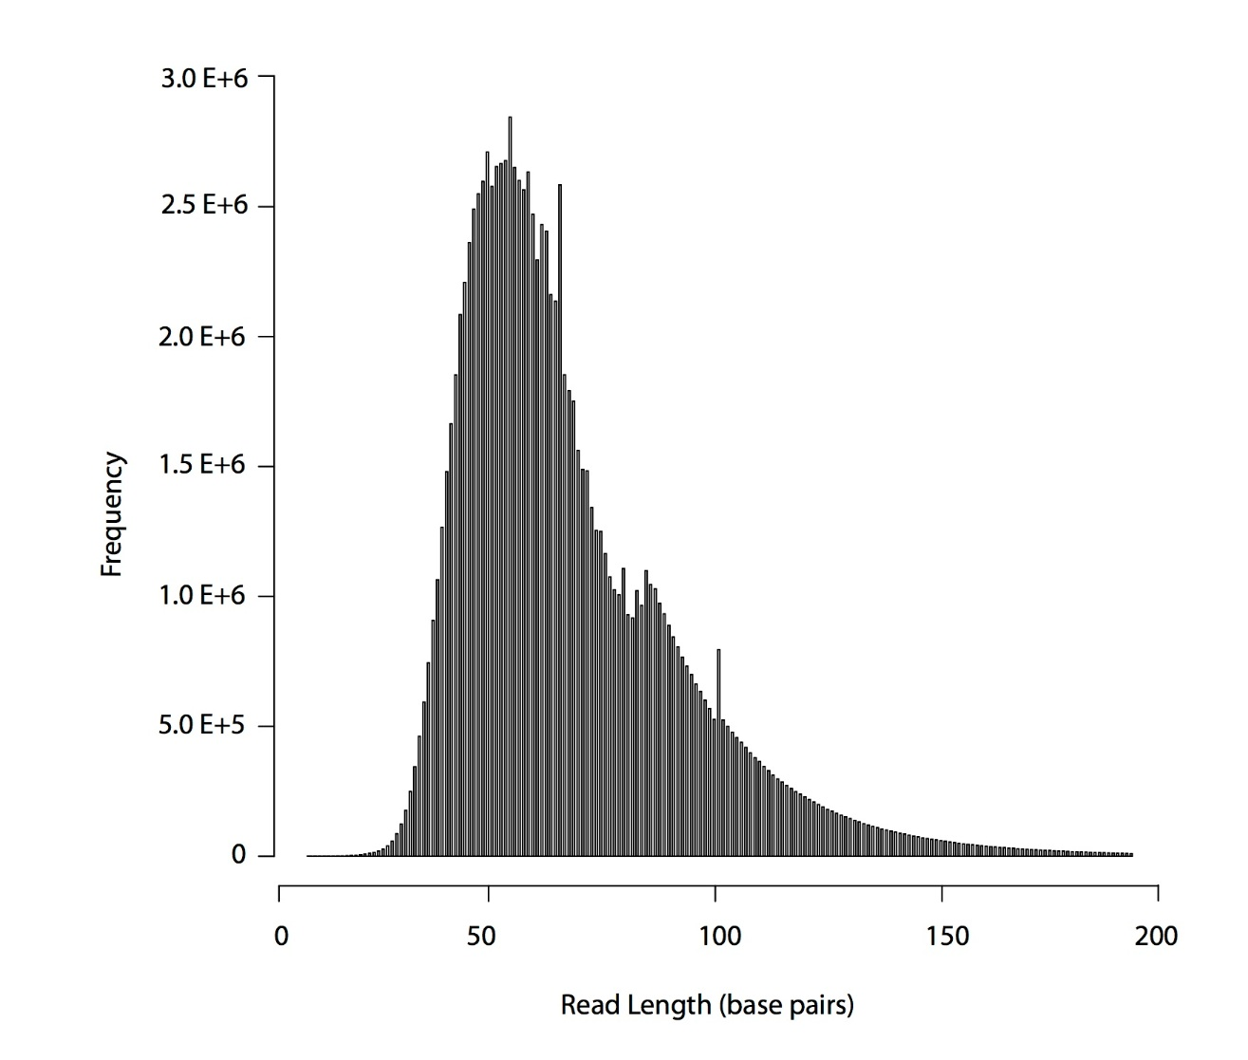

Supplementary Figure 2. DNA mis-incorporation patterns observed in the Nesophontes mitochondrial genome for (A) merged paired-end and (B) single-end reads. The frequencies of all possible mismatches and indels observed between the consensus Nesophontes genome and the reads are reported in grey as a function of distance for 5′- to 3′-ends (first 25 nucleotides sequenced) and 3′- to 5′- (last 25 nucleotides), except for C→T and G→A, which are reported in red and blue, respectively.

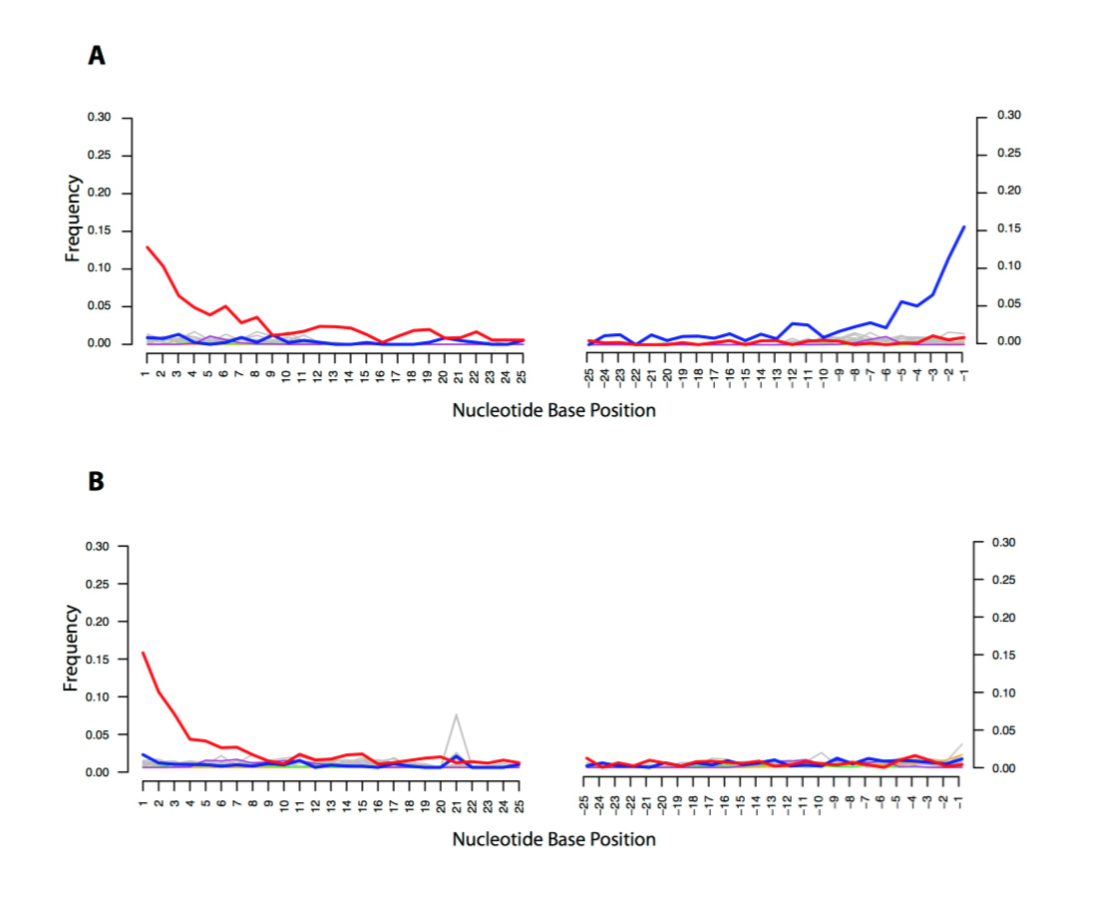

Supplementary Figure 3. Maximum Likelihood tree from Figure 1, additionally depicting outgroup taxa.

Supplementary Figure 4. Maximum Likelihood tree estimated as for Figure 1, using only the mitochondrial DNA dataset.

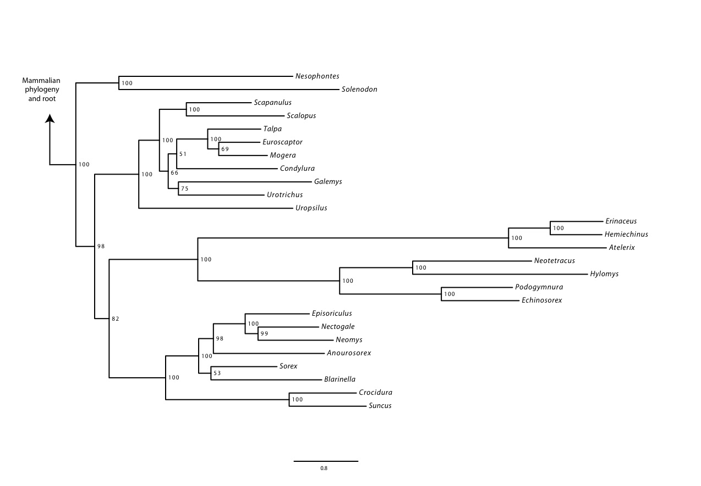

Supplementary Figure 5. Molecular timescales estimated in BEAST for the lipotyphlan and outgroup taxa dataset using molecular-clock derived node time estimates from Meredith et al. (2011). Posterior probability values are shown adjacent and to the left of nodes. Estimates of the median divergence data are shown adjacent and to the right of nodes, with the 95% highest probability density values indicated in square brackets.

Supplementary Table 1. Genbank accession numbers for the genes used in this study. Taxonomic information (from Genbank) with the accession numbers for each nuclear gene of interest are shown. X indicates gene assembled from genomic data in this study, * indicates chimeric taxon made up of two species.
Family | Subfamily | Genus | Species | Mitogenome | APP | BMI1 | CREM | PLCB4 | ADORA3 | APOB | ADRA2B | ADRB2
Nesophontidae |  | Nesophontes | sp |  | X |  | X |  |  | X | X | X
Solenodontidae |  | Solenodon | paradoxus | X | AY530068 | AY530071 | AY451973, AY530072 | AY530074 | AY530066 | JN414026 | AY530081 | AY530067
Erinaceidae | Erinaceinae | Erinaceus | europaeus | NC.002080 | XM.007519783 AY011319 | XM.007526364 | XM.007523995 | XM.007539576 | XM.007526934 | JN414024 | XM.007529903 | XM.007516378
 |  | Hemiechinus | auritus | NC.005033
 |  | Atelerix | albiventris | X |  |  |  |  | X | X | X | X
 | Galericinae | Echinosorex | gymnura | NC.002808 |  | AY986735 | AY451978 | AY451986
 |  | Hylomys | suillus | NC.010298 |  |  |  | AY451987 |  | DQ630204 | AJ505819
 |  | Neotetracus | sinensis | NC.019626
 |  | Podogymnura | truei | AF434823, AF434829, AF298578-9 | JN633548 | AY986742 | AY451980 | JN633106 | JN633426 | JN414025 | JN413881 | JN633682
Soricidae | Crocidurinae | Crocidura | russula/*fuliginosa  /**gueldenstaedtii | NC.006893 |  | AY986736** | AY451977** | AY451985** |  | GU981117* | AY121766
 |  | Suncus | murinus/*remyi | AB175074 AB032842 EF507245 AB032845 AB033720 F444469  FJ814528 J813943  FJ813963 AB011390 |  | AY986741 | AY451981 | AY451992 |  | DQ630181
 | Soricinae | Episoriculus | fumidus | NC.003040 |  |  |  |  |  | DQ630193
 |  | Sorex | araneus/*unguiculatus | NC.005435* | XM.004621155 | AY011509 | AY011631 | AY011754 | AY011200 | JN414027 | XM.004609236 | XM.004620597
 |  | Nectogale | elegans | NC.023351 |  |  |  |  |  | GU981129
 |  | Blarinella | sp | NC.023950 |  |  |  |  |  | DQ630187
 |  | Anourosorex | squamipes | NC.024563
 |  | Neomys | fodiens | NC.025559 |  |  |  |  |  | DQ630177
Talpidae | Talpinae | Mogera | wogura | NC.005035 | HG738058 | HG738000 | HG738020 | HG738041 | HG737959 |  | AB638542
 |  | Talpa | europaea /*altaica | NC.002391 | HG738065* | HG738009 | AY011629* | AY011752* | HG737968 | JN414028* | JN413891* | AY011259*
 |  | Euroscaptor | mizura/*parvidens | AB106233 DQ630336, AB076828 DQ630413 | HG738051 | HG737991 | HG738012 | HG738032 | HG737949 | DQ630168
 |  | Scalopus | aquaticus | AF069539 AY170059 AB076809 |  |  |  |  |  |  | AF496636
 |  | Scapanulus | oweni | NC.025777
 | (Scalopinae?) | Condylura | cristata | X | XM.004675316 | AY011508 | AY011630 | AY011753 | AY011199 | XM.004686059 | XM.004686125 | XM.004686868
 |  | Galemys | pyrenaicus | NC.008156 | AY833412 |  | AY833411 | AY833416 | AY833418 |  | AY121767 | AY833413
 |  | Urotrichus | talpoides | AB099483
 | Uropsilinae | Uropsilus | gracilis | NC.018598 |  | KF778096 | KF778144 | KF778255 | KF777913 | DQ630199 | AY121768
OUTGROUPS
Manidae |  | Manis | pentadactyla | NC.016008 | AY011374 | EF104992 | AY011684 | AY011807 | AY011251 | JN413999 | JN413856 | AY011311
Felidae |  | Felis | catus | NC.001700 | AY011369 | AY011553 | AY011679 | AY011802 | AY011246 | XM.003984468 | XM.006930331 | AY011306
Canidae |  | Canis | lupus | KF857179 | GU167668 | NM.001287063 | GU167419 | AY011805 | NM.001003178 | XM.005630596 | XM.005642442 | NM.001003234
Delphinidae |  | Tursiops | truncatus | NC.012059 | AY011360 | JQ002729 | AY011670 | AY011793 | AY011237 | JN413972 | XM.004311473 | AY011297
Bovidae |  | Bos | taurus | GU947019 | NM.001076796 |  | XM.005214245 | NM.001166510 | NM.001104611 | XM.002691511 | NM.001206628 | NM.174231
Suidae |  | Sus | scrofa | NC.012095 | AY011364 | NM.001285971 | AY011674 | AY011797 | AY011241 | XM.001501679 | NM.001037148 | AY011301
Equidae |  | Equus | caballus | NC.001640 | AY011366 | XM.005606891 | AY011676 | AY011799 | AY011243 | JN414029 | NM.001164012 | AY011303
Vespertilionidae |  | Myotis | davidii | KF111724 | XM.006758757 | XM.006759928 | XM.006774616 | XM.006758082 |  | XM.006767541 | XM.006761143 | XM.006766218
Pteropodidae |  | Pteropus | alecto/*giganteus | NC.023122 | XM.006908243 | XM.006907001 | XM.006911376 | XM.006921597 | XM.006919638 | XM.006910423 | XM.006909438 | XM.006906373
Elephantidae |  | Loxodonta | africana | NC.000934 | AY011326 | AY011513 | AY011635 | AY011758 | AY011204 | JN413956 | JN413853 | AY011264

Genus | ATP7A | BCHE | BDNF | BMP4 | BRCA1 | EDG1 | GHR | RAG1 | RAG2 | RHO | TTN | TYR | VWF
Nesophontes | X | X | X | XX | X | X |  | X | X | X | X | X | X
Solenodon | AY530069 | JN633032 | AY530070 | X | AY530080 X | AY530073 | JN414741 X | JN414936, X | AY451972 X | X | JN632931 | X | AY530079 X
Erinaceus | XM.007534345 | JN633031 | XM.007536962 | XM.007527364 | XM.007536840 DQ630279 | XM.007528597 | XM.007517617 | XM.007521831 | XM.007521832 | XM.007517079 |  | XM.007534507 | XM.007527833
Hemiechinus
Atelerix | X | X | X | X | X | X | X |  |  | AB455160 |  |  | X
Echinosorex |  |  | AY986746 |  |  |  | AF392887
Hylomys |  |  | AY986747 |  | AY121754 |  |  |  |  |  |  |  | AY121760
Neotetracus
Podogymnura | JN633737 |  | AY986745 |  | JN414177 | JN633256 | JN414740 | JN414935 | JN633319 |  | JN632930 | JN633851 | JN415064
Crocidura |  |  | AY986744** |  | AY121755 |  | AF392884 | JF914974* | GU981450* |  |  |  | AY057834
Suncus |  |  | AY986754 | AB081499 | DQ630286 |  | AF392888 | GQ290339 |  |  |  | AB430856 | KF110785*
Episoriculus |  |  |  |  | DQ630277 |  |  |  | GU981454
Sorex | AY011386 | JN633033 | XM.004607860 | XM.004601749 | AY057828 | AY011694 | XM.004605579 | XM.004607911 | XM.004607912 | XM.004613232 | JN632932 | XM.004619043 | XM.004610613
Nectogale |  |  |  |  | GU981204 |  |  |  | GU981462
Blarinella |  |  |  |  | GU981183 |  |  |  | GU981441 |  |  |  | AY121761
Anourosorex |  |  |  |  |  |  |  |  | GU981440
Neomys |  |  |  |  | GU981205 |  |  |  | GU981463
Mogera | HG738078 | HG738095 | HG737979 | AB638602 | HG737904 |  |  | AB106244 | HG737938 | AB455187 | HG738119 |  | AB638587
Talpa | HG738087 | HG738107 | HG737988 |  | AY121756 | JN633257* | JN414742* | AF447515 | AF447532 |  | JN632933* | AY011988* | AY121762
Euroscaptor | HG738069 | HG738089 | HG737971* | AB638591 | DQ630251* HG737898* KC481355* |  |  | AB176543 | HG737930 |  | HG738110
Scalopus |  |  |  |  | AF284007 |  |  |  |  | AB455200 |  |  | AF076479
Scapanulus
Condylura | AY011385 | XM.004674932 | XM.004682964 | XM.004681862 | XM.004684123 | AY011693 | XM.004678346 | XM.004682904 | XM.004682903 | AB455170 | XM.004674854 | XM.004683713 | XM.004692556
Galemys | AY833417 |  |  |  | AY121757 | AY833410 |  | AY833415 | AY833414 |  |  |  | AY121763
Urotrichus |  |  |  | AB638588 |  |  |  | AB106245 |  | AB455206
Uropsilus | KF777972 |  | KF778041 |  | AY121758 |  |  | AB106240 | KF778372 |  |  |  | AY121764
OUTGROUPS
Manis | AY011438 | JN633018 | AY011501 |  | JN414168 | AY011742 | EU448992 | AY249867 | AF447538 |  | JN632924 | JN633849 | JN415053
Felis | AY011433 | NM.001009364 | NM.001009828 | XM.003987645 | XM.006940385 | AY011738 | EU448991 | XM.003993168 | XM.004001424 | NM.001009242 | XM.003408633 | XM.003992642 | NM.001246279
Canis | AY011436 | XM.545267 | NM.001002975 | NM.001287170 | XM.005624317 | XM.005621856 | NM.001003123 | XM.540538 | XM.005631105 | XM.005632035 | XM.535982 | AY336053 | NM.001002932
Tursiops | AY011424 | XM.004324549 | JQ002728 | XM.004324609 | XM.004312200 | AY011730 | JN414697 | XM.004329819 | XM.004329820 | NM.001280659 | JN415003 | XM.004328885 | XM.004324678
Bos | NM.001192852 | XM.005895334 | NM.001046607 | NM.001045877 | XM.005220676 | BT021184 | NM.176608 | XM.002693521 | XM.005216393 | NM.001014890 | XM.002685260 | NM.181001 | NM.001205308
Sus | AY011428 | XM.003358664 | NM.214259 | NM.001101031 | XM.005656957 | AY011733 | NM.214254 | NM.001123184 | NM.001128481 | NM.214221 | M97767 | AB207239 | NM.001246221
Equus | AY011430 | NM.001081850 | NM.001081787 | NM.001163970 | XM.005597362 | AY011735 | AF392878 | NM.001256901 | XM.001487973 | XM.001490301 | XM.005601612 | XM.001492560 | NM.001242566
Myotis | XM.006755060 | XM.006761346 | XM.006753948 | XM.006767704 | XM.006773905 | XM.006762939 | XM.006774555 | XM.006756100 | XM.006756099 | XM.006758300 | XM.006760691 | XM.006759763 | XM.006757606
Pteropus | XM.006910199 | XM.006908174 | XM.006907988 | XM.006920174 | XM.006924563 | XM.006919571 | XM.006919521 | XM.006908040 | XM.006908043 | XM.006917646 | XM.005601612 | XM.006926703 | XM.006914709
Loxodonta | AY011390 | NW.003573451 | AY011453 | XM.003408633 | AF284021 | AY011698 | AF332012 | XM.003412274 | XM.003412273 | NM.001280858 | NW.003573451 | XM.003418555 | BK008003

Supplementary Table 2. Primer pairs designed to allow gap-closure of the Nesophontes mitochondrial genome.

Primer Name | Primer Sequence 5’ to 3’
Nes_1641_F | AGCTGGTTGTCCAGAAAAAGAAT
Nes_1641_R | GGCCAACTGTGAATTTAATTATGAATA
Nes_12231_F | CTCACCCTTCTATCACTAGCAATCCTTA
Nes_12231_LR | TTGATCATGTAACGAATAGTGCTACAGG
Nes_4200_F | TTCCCATACTAATAAATCCGATCATCTT
Nes_4200_R | AAGTTTTTATTAGGATTGGAATAATGGC
Nes_7615_F | GAACTATTCTCCCCGCAATTA
Nes_7615_R | AGTCAAAGTTTAGATCTTCGTAGTCTG
Nes_8350_F | CCCTGAGAAACAAAATGAACGAAA
Nes_8350_R | CGGTTATTAATTAGTCGATTAGGCGTG
Nes_9815_F | CCTTTATGTATCAATCTACTGATGAGG
Nes_9815_R | AAATGGAAGCTAAAGCTATGTTAGTAAA
Nes_10580_F | GGTGTTGACTACGTACAAAACCTTA
Nes_10580_R | GAATTGGTTAAGATACGTAAGAGTGATT
Nes_11900_F | CCTTCACACGAGAAAACAGTCT
Nes_11900_R | CGCCTCTATCTTTAGATTCACAA
Nes_14130_F | CCCAAAAATATCTCTCAACTGCAA
Nes_14130_R | TCGTGGAAACTAGTAATATCAAGCTGA

Supplementary Table 3. Partitions and models selected by PartitionFinder for mitochondrial and nuclear genes and applied in phylogenetic analyses. The genes included in the partition are indicated, as well as the model and the genome.

Partition | Model | Genome
tRNAs | GTR+G | Mito.
12s16s | GTR+G | Mito.
COIII_1, COII_1, ND1_1 | SYM+G | Mito.
COIII_2, COII_2, CytB_2, ND1_2 | K81uf+G | Mito.
ND1_3, ND2_3, ND5_3, CytB_3 | TVM+G | Mito.
ND2_1, ND5_1 | GTR+G | Mito.
ATP6_1, ND2_2, ND3_2, ND4L_2, ND4_2, ND5_2 | TVM+G | Mito.
COI_1 | SYM+G | Mito.
COI_2 | F81+I | Mito.
ATP6_2, COII_3, COI_3, ND4L_3 | K81uf+G | Mito.
ATP8_1, ND6_1, ATP8_2 | TIM+G | Mito.
ATP8_3 | TrN+G | Mito.
CytB_1, ND3_1, ND4L_1, ND4_1, ATP6_3 | GTR+G | Mito.
COIII_3, ND3_3, ND4_3, ND6_3 | K81uf+G | Mito.
ND6_2 | HKY+G | Mito.
APP_UTR, CREM_UTR | K81+G | Nucl.
BMI1_UTR, ADORA3_2 | TrN+G | Nucl.
PCLB4_UTR, BRCA1_2 | TVM+G | Nucl.
BMP4_UTR, BDNF_1, BMP4_1, RAG1_1, TTN_1 | GTR+G | Nucl.
RHO_1, ADRB2_2, BDNF_2, BMP4_2, EDG1_2, RAG1_2, RAG2_2, RHO_2, TTN_2 | GTR+I | Nucl.
BDNF_3, BMP4_3 | K81uf+G | Nucl.
ADORA3_1, APOB_2, ATP7A_2, GHR_2, VWF_2 | GTR+G | Nucl.
ADORA3_3, RAG1_3, TYR_3 | TVM+G | Nucl.
ADRA2B_1, BCHE_1, GHR_1, TYR_1, ADRA2B_2 | TVM+G | Nucl.
ADRA2B_3, ADRB2_3, EDG1_3, RHO_3 | GTR+G | Nucl.
ADRB2_1, ATP7A_1, EDG1_1, RAG2_1, BCHE_2, TYR_2 | K81uf+G | Nucl.
APOB_1, BRCA1_1 | TIM+G | Nucl.
APOB_3, BCHE_3, GHR_3, RAG2_3 | TIM+G | Nucl.
ATP7A_3, BRCA1_3, TTN_3 | K81uf+G | Nucl.
VWF_1 | HKY+G | Nucl.
VWF_3 | TVM+G | Nucl.

Supplementary Table 4. Fossils and prior distributions used in the BEAST molecular dating analysis. The nodes are numbered in the phylogeny and the associated fossil and deposit locality is indicated, together with the age of the fossil (in millions of years) and the prior distribution used in the BEAST analysis. All fossil calibration dates were taken from Benton et al. (2009) except for node 7 (dos Reis et al. 2012).

Root | Node | Fossil and Deposit Locality | Age (mya) | Prior distribution
 | Placentalia | Minimum: Earliest carnivoramorphan: Protictis from the Fort Union/Polecat Bench Formation  Soft maximum: Liaoning fossils of Eomaia and Sinodelphys (Theria) | Basal Torrejonian (To1) - Barremian  62.5 – 131.5 | logNormalPrior mean="22.55" stdev="1.0" offset="62.5"
1 | Laurasiatheria | As above | As above | logNormalPrior mean="16.02” stdev="1.0" offset="62.5"
2 | Laurasiatheria minus Lipotyphla | As above | As above | As above
3 | Ferungulata | As above | As above | As above
4 | Lipotyphla | Minimum: Oldest erinaceomorph: Adunator, from Torrejonian.  Soft maximum: As above | Early Danian – Barremian  61.5 – 131.5 | logNormalPrior mean="16.25" stdev="1.0" offset="61.5"
5 | Carnivora | Minimum: Hesperocyon, from earliest Duchesnean  Soft maximum: Oldest stem carnivorans in Torrejonian | Earliest Duchesnean – early Palaeocene, 39.68 – 65.8 | logNormalPrior mean="6.067" stdev="1.0" offset="39.68"
6 | Cetartiodactyla | Minimum: Himalayacetus from the base of the Subathu Formation in Pakistan.  Soft maximum: absence of crown Cetartiodactyla in Palaeocene | Early Eocene – early Palaeocene, 52.4 – 65.8 | logNormalPrior mean="3.111" stdev="1.0" offset="52.4"
7 | Chiroptera | Minimum: Icaronycteris,  Soft maximum: as for other members of Laurasiatheria | 48.6 – 65.8 | logNormalPrior mean="3.995" stdev="1.0" offset="48.6"

