Spatiotemporal Urban Mobility Forecasting Using Graph Neural Networks
Project Progress Review | NYC TLC Yellow Taxi Data | October 2026
Study period: January–December 2025

1. Project overview and current status
This project investigates short-term taxi pickup-demand forecasting across New York City geographic taxi zones. The research question is whether explicitly modeling spatial connections between zones, alongside historical hourly demand, can improve forecasts relative to non-graph time-series and machine-learning baselines.
Area | Progress
Data collection and preparation | Completed for all 12 months of 2025
Hourly pickup-demand matrix | Completed and structurally validated: 8,760 hours × 263 zones
Daylight saving time (DST) | Transitions investigated; experimental adjustment created and saved
Exploratory data analysis | Completed initial daily, hourly, weekly and monthly demand analysis
Graph construction and model comparisons | Planned; no comparative accuracy result established in this review

2. Problem statement and motivation
Taxi pickup demand varies by time and place. An isolated forecast for each zone may overlook relationships with surrounding areas. More accurate short-term demand forecasts could support fleet positioning and transportation planning. This project uses the geographic organization of TLC taxi zones to test whether a graph-based representation provides useful predictive information.

3. Research questions
ID | Research question | Evaluation approach
RQ1 | How accurately can future hourly pickup demand be predicted for each zone? | Evaluate 1- and 3-hour-ahead forecasts, with 6 hours as a possible extension.
RQ2 | Do graph-based spatiotemporal models outperform non-graph baselines? | Compare models using identical chronological data splits and metrics.
RQ3 | Where and when do prediction errors occur? | Analyze errors by zone, hour, weekday and demand level.

4. Data sources and study design
The primary source is NYC Taxi and Limousine Commission (TLC) Yellow Taxi trip records for January–December 2025. The TLC taxi-zone lookup identifies geographic pickup zones. The raw trip files contain approximately 20 attributes; the forecasting target is calculated from pickup timestamps and pickup-zone IDs, while other fields were inspected during data-quality work.
Dataset characteristic | Value
Study period | 2025-01-01 00:00 to 2025-12-31 23:00
Selected geographic zones | 263 (including the EWR lookup zone; nongeographic codes excluded)
Hourly labels | 8,760
Recorded pickups in restored matrix | 48,619,345
Matrix size | 8,760 × 263
Target | Recorded pickups per taxi zone per hour

5. Data preparation and cleaning methodology
The monthly Parquet files were processed month by month. Pickup timestamps were restricted to their corresponding 2025 calendar month, pickup-zone IDs were checked against the selected geographic lookup, and data-quality checks examined missing values, duplicate records and nonpositive trip durations. Pickup timestamps were rounded down to the hour, and records were counted for each hour–zone combination. Monthly matrices were aligned to a common 263-zone structure and combined into a full-year hourly matrix.
The initial strict-cleaning rule excluded records with nonpositive trip duration. A subsequent investigation showed that many such records still had valid pickup time and zone information. Because the target is recorded pickup counts rather than trip duration, eligible records were restored. These records may still include cancellations or logging artifacts; restoration does not certify completed passenger trips.
Cleaning milestone | Pickup records
Initial strict-cleaning matrix | 48,073,756
Eligible duration-invalid records restored | 545,589
Updated recorded-pickup matrix | 48,619,345
Increase relative to strict total | Approximately 1.13%

6. Dataset validation and persistence
The updated matrix passed checks for 8,760 rows, 263 columns, no missing matrix cells, no negative counts and no duplicate hourly labels. Its first and last timestamps correspond to the beginning and end of 2025. These checks demonstrate structural consistency, not the absence of every possible source-data error. The matrix was saved in Parquet format to Google Drive for reuse after Colab restarts.

7. Daylight saving time investigation
The New York local clock skipped 02:00 on March 9, 2025 and repeated 01:00 on November 2, 2025. The timezone-naive matrix represented the spring missing hour as a zero and the fall repeated hour under a single label. These are not ordinary hourly demand observations and require special consideration in temporal modeling.
DST hour | Original citywide count | Experimental adjusted count
March 9, 2025, 02:00 (nonexistent) | 0 | 7,017 (estimated from adjacent zone-level hours)
November 2, 2025, 01:00 (repeated) | 11,663 | 5,818 (approximately halved zone by zone)

An experimental adjusted matrix was created with 48,620,517 pickup-count units, compared with 48,619,345 recorded pickups in the original restored matrix (net +1,172). The spring values are synthetic estimates; the fall adjustment assumes an approximately equal split of the merged hour. Original and adjusted versions and a two-hour DST flag were saved. This adjustment should be treated as a sensitivity experiment, not as a reconstruction of actual pickup events. Forecasting evaluation must prevent future-information leakage from interpolation.

8. Exploratory data analysis: temporal demand patterns
Daily citywide totals, a two-week hourly time series (March 3–16), and a day-of-week by hour-of-day heatmap were examined using the experimental DST-adjusted matrix. The figures reveal recurring daily and weekly patterns, higher activity during many evening periods, and seasonal variation. These associations motivate temporal features but do not establish causal explanations or prove that GNNs will outperform baselines.
EDA finding | Observed result
Average pickups per hour | 5,550
Average pickups per day | 133,207
Highest average hour | 18:00 (6 PM), about 9,498 pickups
Lowest average hour | 04:00 (4 AM), about 986 pickups
Busiest weekday on average | Saturday, 144,625 pickups/day
Quietest weekday on average | Monday, 114,170 pickups/day
Busiest individual day | November 1, 2025 — 182,674 pickups
Quietest individual day | December 25, 2025 — 67,953 pickups
Highest monthly total | May — 4,582,134 pickups
Lowest monthly total | January — 3,465,683 pickups

The daily line plot shows substantial fluctuations across the year, including repeated weekly cycles. The two-week hourly plot shows pronounced daily rises and falls. The weekday/hour heatmap indicates relatively low demand in early weekday mornings, strong weekday evening demand and different late-night weekend behavior. Monthly totals must be interpreted with month length in mind; average daily demand is more appropriate for direct cross-month comparison.

9. Main findings to date
The project has produced a full-year, consistently structured hourly zone-demand dataset. A strict duration-based filter would have removed more than half a million records with usable pickup information. DST creates nonstandard local-clock hours that should not be treated as ordinary observations. Initial EDA identifies pronounced hour-of-day, day-of-week and annual variation. None of these results yet demonstrates a forecasting accuracy improvement from graph models.

10. Changes, challenges and limitations
The study scope was refined to one full calendar year to balance seasonal coverage with Colab resource constraints. The cleaning policy was refined to preserve pickup-relevant records and keep strict and restored versions for comparison. Key limitations are the uncertainty surrounding duration-invalid records, timezone-naive aggregation at DST transitions, and the inclusion of EWR in the selected geographic lookup. The adjusted DST matrix changes numerical totals and should not be described as additional observed pickups.

11. Planned modeling and evaluation
Next activity | Purpose
Spatial graph construction | Represent 263 zones as nodes and define adjacency- or distance-based edges.
Feature engineering | Create lagged demand, hour-of-day, weekday, calendar and optional external features.
Chronological split | Train on earlier hours, validate on later hours and test on held-out future hours.
Baseline forecasts | Evaluate persistence, seasonal-naive and suitable conventional ML/time-series models.
Graph-based models | Train spatiotemporal GNN architectures and compare with baselines.
Error analysis | Compare 1-/3-hour horizons, zone-level errors, high/low-demand zones and DST handling.

Primary metrics will be mean absolute error (MAE) and root mean squared error (RMSE). All methods should use the same forecast targets and chronological test period. Any scaling, learned imputation or feature selection must be fitted without access to future test data. DST-adjusted and original-data evaluations should be clearly distinguished.

12. Immediate next deliverables
The next review should include a documented DST policy, a reproducible zone graph, a leakage-safe temporal feature and train/validation/test pipeline, baseline forecasts, and initial graph-model comparisons. Forecast accuracy claims will be made only after the experiments have been completed.
13.Referenses
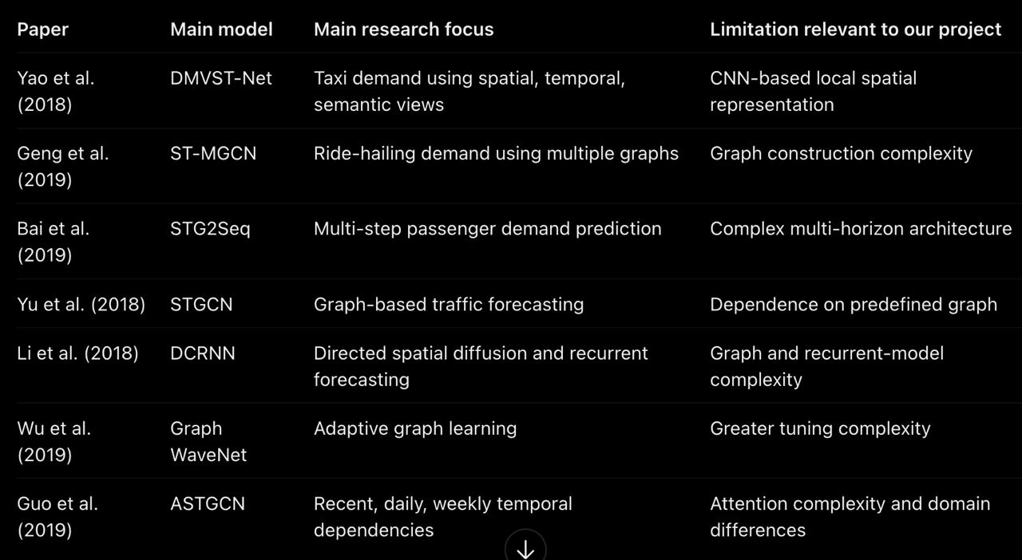
Based on these papers, I would frame your project's research gap as follows:
Existing studies demonstrate the effectiveness of deep learning and graph-based architectures for traffic and passenger-demand forecasting. However, forecasting performance depends on the representation of spatial relationships, temporal features, prediction horizons, and characteristics of the dataset.

Our project investigates these factors using a consistent experimental framework on 2025 NYC Yellow Taxi pickup records. We compare multiple graph-construction strategies and evaluate traditional machine learning, recurrent deep learning, and graph-based models across 1-, 3-, and 6-hour forecasting horizons.

The objective is not simply to demonstrate that GNNs outperform conventional methods, but to determine when and how spatial relationships improve forecasting accuracy, and whether their additional complexity is justified
I'd recommend reading Geng et al. (2019), Bai et al. (2019), and Wu et al. (2019) first. Together, they cover the three most important aspects of your work: multiple graph representations, multi-horizon demand prediction, and Graph WaveNet.Geng et al. is our BASE PAPER.

14.System Design


