APEX COMMERCIAL BANK · AI LEAD TECHNICAL ASSESSMENT

Architecture Document
Components, request lifecycle, LangGraph design, agents, RLM, hybrid retrieval, memory, tools and MCP, observability, failure handling and deployment

Document | DOC-02 — Architecture Document
Project | Enterprise AI Knowledge Assistant (LangGraph · FastAPI · Streamlit · Pinecone · LangSmith)
Version | 1.0
Generated | 04 November 2026
Source of truth | Every file path, setting and behaviour quoted here is read from the application code

How to read this document: each section opens with the essential idea, then gives the detail an engineer needs. Boxes labelled “In plain words” summarise a section without jargon; boxes labelled “Where in the code” point to the exact files so every statement can be verified.

Contents
Contents 2
1. Architecture at a glance 4
1.1 Design principles 4
2. Components 5
3. One chat turn, end to end 6
4. LangGraph design 7
4.1 Nodes and routing 7
4.2 The shared state 8
4.3 Streaming, checkpointing and the interrupt 8
5. The agents in detail 9
5.1 Supervisor agent 9
5.2 Retrieval agent 9
5.3 Research agent — the Recursive Language Model path 10
5.4 Tools agent 11
5.5 Response agent 11
5.6 Validation and human approval 11
6. Hybrid retrieval 12
6.1 Corpus and chunking 13
6.2 Dense channel 13
6.3 Sparse channel 13
6.4 Fusion, rerank and screening 13
7. Memory design 14
7.1 Decisions and reasons 14
8. Tools and the MCP server 15
8.1 Tool catalog 15
8.2 MCP server and client 15
8.3 Python Analysis tool 15
9. Observability 16
9.1 LangSmith 16
9.2 Structured logs 16
9.3 The Agent Activity Panel as an observability surface 17
10. Async engineering 17
11. Failure handling and the butterfly effect 17
12. Deployment 18
13. From POC to production 19

1. Architecture at a glance
One picture first; the rest of this document walks through it layer by layer.
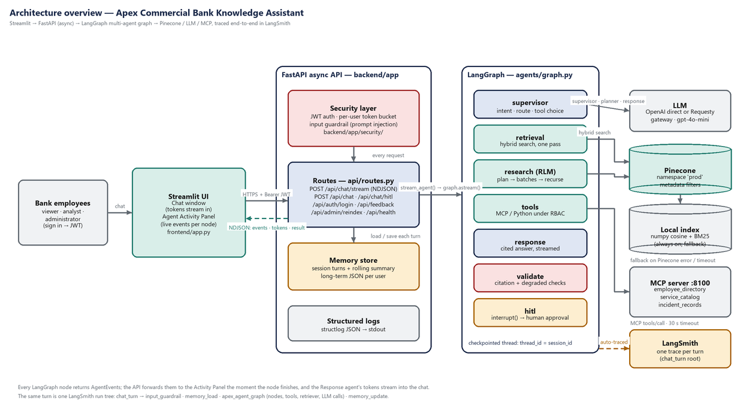
Figure 1. System architecture. Left to right: users and Streamlit UI, the async FastAPI service with its security layer, the LangGraph multi-agent graph, and the external services (LLM, Pinecone, MCP server, LangSmith).
IN PLAIN WORDS
A request enters through the API, is checked (identity, rate, prompt injection), enriched with memory, and handed to a graph of specialist agents. The Supervisor decides the route; a specialist gathers evidence (search, research or live tools); the Response agent writes a cited answer; Validation checks it; research answers wait for a human. Every step is streamed to the UI and traced in LangSmith.

1.1 Design principles
- Explainability over cleverness. Every decision the system makes (route, plan, tool, denial, repair) is an AgentEvent with its reasons, shown live and traced.
- Security in code, not in prompts. Authorisation and content screening run in Python inside the tool functions; the LLM may *propose* anything, it can *execute* only what the role allows.
- Degrade, don't crash. Each dependency (LLM, Pinecone, MCP) has a fallback and a visible degraded flag; validation always runs.
- Compact context. The LLM sees a short memory block and compact evidence, never whole documents or whole histories (the RLM and memory designs both follow from this).
- One code path. Streaming, blocking and HITL-resume all run through stream_agent(); tests exercise the same path the UI uses.

2. Components
Component | Responsibility | Technology | Code
Streamlit UI | Sign-in, chat with streaming answers, sources, feedback, HITL approval, Agent Activity Panel | Streamlit 1.41, httpx streaming | frontend/app.py, activity_panel.py, ui.py
API | Auth, rate limiting, chat (stream/blocking), HITL resume, feedback, admin reindex, health | FastAPI 0.115, Pydantic v2, uvicorn | backend/app/api/routes.py, main.py
Turn pipeline | Input guardrail → memory load → graph → memory update, inside one LangSmith root span | Python async generators | backend/app/agents/graph.py stream_agent
LangGraph graph | 7 nodes (supervisor, retrieval, research, tools, response, validate, hitl), conditional routing, checkpointing, interrupt | LangGraph 0.2.62 | agents/graph.py, agents/*.py
Hybrid retriever | Chunking, embeddings, Pinecone + local dense, BM25, RRF, rerank | Pinecone 5.4, rank_bm25, numpy | backend/app/retrieval/
Tools | Knowledge search, Python analysis (sandbox), MCP client | mcp 1.9 ClientSession, ast | backend/app/tools/
MCP server | Dummy enterprise data over the Model Context Protocol | FastMCP, Streamable HTTP, stateless JSON | mcp_server/main.py
Security | Users/JWT, HITL token, guardrails, token bucket | PyJWT, regex, asyncio | backend/app/security/
Memory | Session turns + summary; per-user long-term JSON | In-process + JSON file | backend/app/memory/store.py
Observability | structlog JSON; LangSmith config and traceable decorators | structlog, langsmith 0.2 | backend/app/observability/
Table 1. Components and their code.

3. One chat turn, end to end
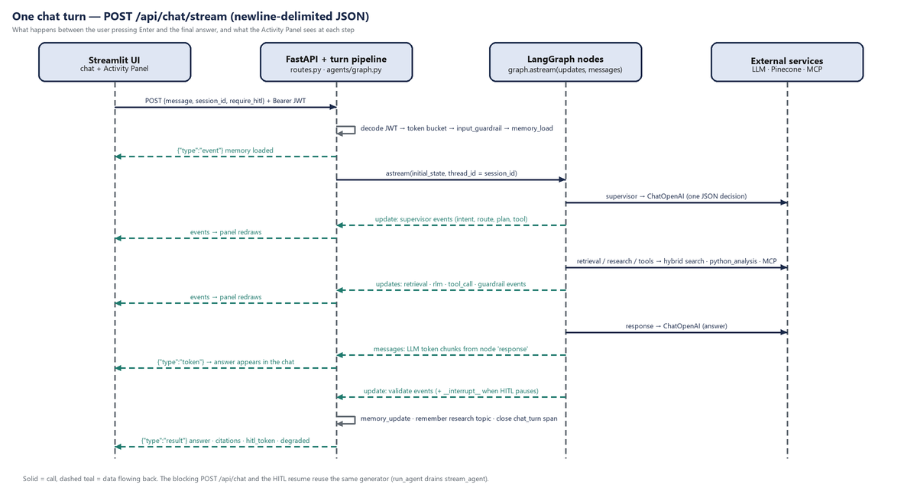
Figure 2. Sequence of one streaming turn. The panel receives events the moment each node finishes; answer tokens arrive while the Response agent is still writing.
- The UI posts {message, session_id, require_hitl} to POST /api/chat/stream with the Bearer JWT.
- get_current_user decodes the JWT; _enforce_rate_limit takes one token from the user's bucket (429 + Retry-After if empty).
- stream_agent() opens the LangSmith root span chat_turn (metadata user_id, role, session_id; tag role:<role>).
- validate_user_input runs (span input_guardrail). A blocked request yields a guardrail event and a safe refusal — the graph never runs.
- The user turn is written to session memory and context_block() builds the memory text (span memory_load); a memory event is streamed.
- graph.astream(initial_state, thread_id=session_id, stream_mode=["updates", "messages"]) runs the graph. Each updates chunk is one finished node: its events are forwarded as event lines and the rest of its state delta is merged into the turn result. messages chunks tagged with node response are forwarded as token lines.
- An __interrupt__ update (HITL) is converted into a hitl event and hitl_required=True.
- After the graph, the assistant turn is saved to memory (span memory_update), the research topic is remembered, the root span is closed with the outcome, and the result line is sent.
WHERE IN THE CODE
backend/app/agents/graph.py: stream_agent, _stream_turn, _drain_graph, _build_result; backend/app/api/routes.py: chat_stream, _finalize_turn.

4. LangGraph design
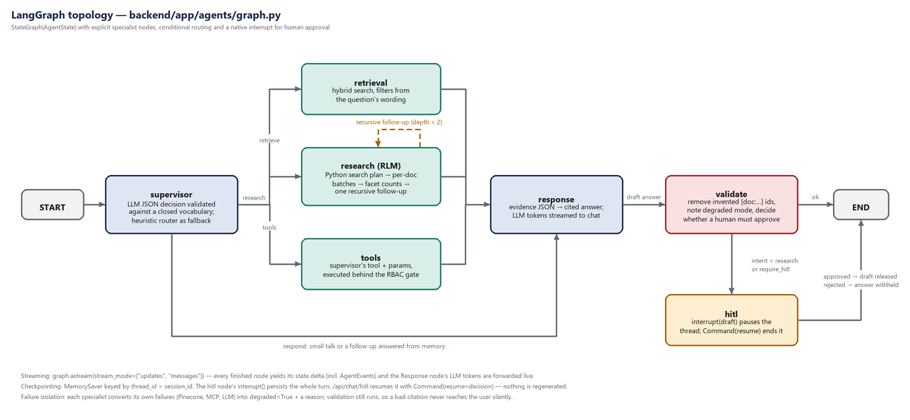
Figure 3. Graph topology from `build_graph()`. Solid edges are fixed; labelled fan-outs are conditional edges.

4.1 Nodes and routing
Node | Role in the turn | Reads from state | Writes to state | Next
supervisor | Understand intent, decompose into a short plan, choose route and (optionally) a tool + params | message, memory_context, role | intent, route, plan, selected_tool, tool_params | retrieval / research / tools / response (conditional)
retrieval | One hybrid search with metadata hints from the wording | message, role | retrieval_results, citations, degraded | response
research | RLM loop: plan → sub-searches → per-document batches → facet counts → recursion → aggregate | message, memory_context, role, recursion_depth | research_topic, research_batches, retrieval_results, citations, tool_results, recursion_depth | response
tools | Execute the supervisor's tool (MCP or Python) behind the RBAC gate; keyword fallback if none was chosen | selected_tool, tool_params, role | tool_results, degraded, degradation_reason | response
response | Turn evidence JSON into a cited answer (LLM); evidence-only summary on LLM failure | citations, research_batches, tool_results, memory_context, intent | draft_answer, final_answer | validate
validate | Remove hallucinated citations, mark unverified ids, note degraded mode, decide on human approval | draft_answer, citations, degraded, intent, hitl_required | final_answer, validation_ok, validation_notes, hitl_required, route | hitl or END (conditional)
hitl | interrupt() with a draft preview; on resume release or withhold the draft | final_answer, citations | final_answer, hitl_required=False | END
Table 2. Node contract.

4.2 The shared state
AgentState (backend/app/agents/state.py) is a TypedDict every node reads and partially writes. Grouped by purpose:
Group | Fields | Notes
Identity / request | user_id, role, session_id, raw_message, message | message is the guardrail-sanitised text
Routing | intent, route, plan, selected_tool, tool_params, active_node | Closed vocabularies: intent ∈ {qa, research, tool, admin, chitchat}; route ∈ {retrieve, research, tools, respond, hitl, end}
Evidence | research_topic, retrieval_results, research_batches, tool_results, citations | Citations are deduplicated per doc_id keeping the best score
Memory | memory_context | Compact text block, built before the graph
Output | draft_answer, final_answer, validation_ok, validation_notes | Validation may rewrite final_answer
Control / resilience | events, errors, degraded, degradation_reason, hitl_required, recursion_depth | events has no append reducer: it holds only the last node's events so the checkpoint stays small; the API accumulates per-node updates as they stream

4.3 Streaming, checkpointing and the interrupt
- Two stream modes at once. updates gives one chunk per finished node (its state delta, including events); messages gives LLM token chunks with the producing node in metadata. Only tokens from node response are forwarded to the chat, so supervisor/planner JSON never leaks into the answer.
- Checkpointer. The graph is compiled with MemorySaver and every run uses configurable.thread_id = session_id. This is what makes the HITL pause real: interrupt() persists the whole turn; /api/chat/hitl calls graph.aget_state() to confirm next == ('hitl',) and resumes with Command(resume=decision). Nothing is regenerated.
- Why custom nodes instead of `create_react_agent`/`create_supervisor`. The assessment asks the evaluator to *see* the active node, the RLM steps and the validation verdict. Explicit nodes make every transition an observable edge in LangGraph and a step in the panel; prebuilt agents would hide most of this inside one tool-calling loop.
- Run naming. run_name="apex_agent_graph" plus metadata and tags make every graph run filterable in LangSmith by user, role or session.
WHERE IN THE CODE
graph.py: build_graph, _graph_config, _drain_graph, _resume_turn, NoPendingApproval. Tests: tests/test_graph_and_api.py::test_research_pauses_at_hitl_and_resumes_without_regenerating, ::test_stream_contract_events_then_result.

5. The agents in detail

5.1 Supervisor agent
The Supervisor is the only place that decides *how* a request is handled. It sees three things and returns one JSON object:
Input | Why it is there
The user's message (sanitised) | Intent understanding
Conversation memory | Follow-ups such as “which theme was most common?” are routed to respond and answered from memory instead of re-running research
The tool catalog (tools/catalog.py) | So the LLM knows live MCP data exists and can choose tool + tool_params (e.g. mcp_employee_directory, q="payments on-call")
The caller's role (informational) | Routing is deliberately role-agnostic: a viewer asking for the on-call list *is* routed to the directory tool and *visibly denied* by the gate. Hiding tools per role would make RBAC invisible and would not be a security boundary anyway

{
"intent": "qa" | "research" | "tool" | "admin" | "chitchat",
"route": "retrieve" | "research" | "tools" | "respond",
"tool": <catalog tool name or null>,
"tool_params": { flat primitives only },
"plan": [ 2–4 short steps ],
"reason": "one sentence"
}

_validate_decision coerces every field: unknown intents/routes fall back to the heuristic router's answer, unknown tools become null, non-primitive params are dropped, a chosen tool pins its own route, and the plan is capped at six steps. If the LLM is unavailable or returns no JSON, the deterministic heuristic_intent() decides. The panel shows decided_by: llm | heuristic and the reason.
WHY IT MATTERS
Validating the LLM's output against a closed vocabulary means a prompt-injected or confused model can at worst pick a *legal* route — it cannot invent a node, a tool, or nested parameters.

5.2 Retrieval agent
Used for factual questions answerable from one or a few documents. It derives cheap metadata hints from the wording (incident/outage → document_type=incident, policy → policy, payment/upi/neft → department=payments), calls knowledge_search, reports guardrail drops, and converts hits to citations. Retrieval failures set degraded=retrieval_failure rather than raising.

5.3 Research agent — the Recursive Language Model path
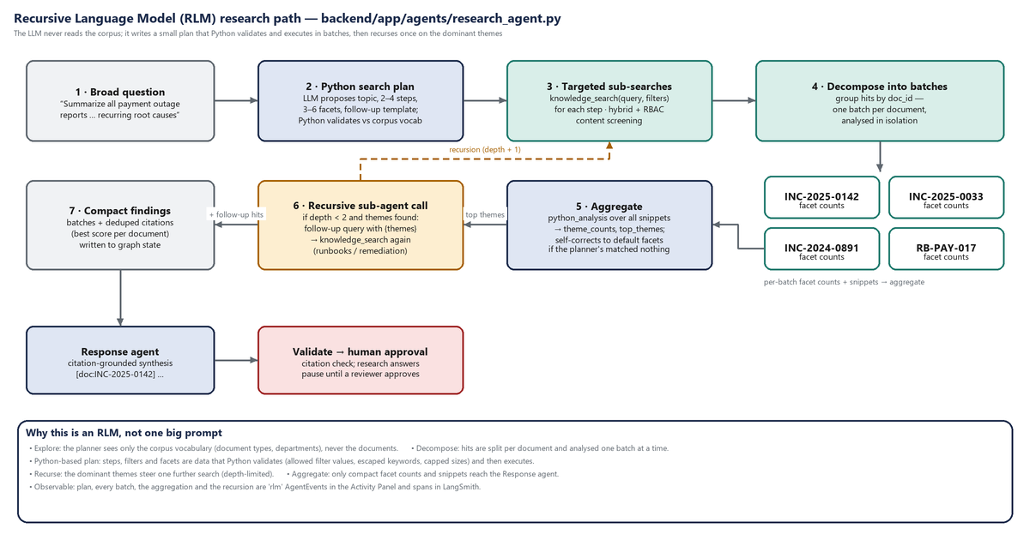
Figure 4. RLM research path. The LLM writes a plan; Python validates, executes, batches, counts, recurses and aggregates.
RLM concept (assignment) | Implementation | What the evaluator sees
1. Explore document collections | _corpus_vocabulary() collects the real document_type and department values from the index; the planner prompt lists them as the only allowed filters | rlm event “Recursion depth=0/2”, then the plan event
2. Generate Python-based search plans | generate_search_plan() asks the LLM for topic, 2–4 steps (label, query, filters), 3–6 themes (literal keywords) and a follow_up template containing {themes}; validate_plan() sanitises labels, caps lengths, keeps only allowed filter values, escapes keywords; deterministic_plan() is used when the LLM is offline | “Generated Python search plan (llm): 3 searches, 5 analysis facets” with the full plan JSON
3. Decompose large tasks | Each step runs knowledge_search(query, filters); hits are grouped by doc_id into one batch per document | “RLM sub-search: <label>” per step; “Analyzed batch <doc_id>” per document
4. Retrieve targeted sections | Hybrid search returns up to 5 reranked chunks (400-char snippets) per step, screened for the role | Batch detail shows chunks and titles
5. Call sub-agents recursively | If depth < 2 and themes were found, the follow-up template is filled with the top themes and searched again (typically runbooks/remediation); recursion_depth is incremented | “Recursive sub-agent call for supporting context” with the generated query
6. Aggregate results | python_analysis(snippets, theme_patterns) counts, per batch and across all batches, how many evidence chunks mention each facet; if the planner's facets match nothing, the node re-analyses with the default operational facets and says so | “Aggregated themes across batches” with theme_counts, top_themes, documents_analyzed
Table 3. RLM concepts mapped to `research_agent.py`.
Example plan the LLM produces for “Summarize all outage reports related to payment failures during the last year and identify recurring root causes” (validated shape):
{
"topic": "payment_outage_root_causes",
"steps": [
{"label": "payment_incidents", "query": "payment failure outage timeout settlement", "filters": {"document_type": "incident", "department": "payments"}},
{"label": "all_incidents", "query": "outage root cause payment gateway", "filters": {"document_type": "incident"}},
{"label": "remediation_policy","query": "customer remediation after payment incident", "filters": {"document_type": "policy"}}
],
"themes": {
"connection_pool": ["pool", "max_connections", "HikariCP", "Redis connection"],
"idempotency": ["idempotenc", "duplicate", "replay"],
"partner_timeout": ["partner", "issuer", "network latency"],
"capacity": ["festival", "traffic", "capacity", "spike"]
},
"follow_up": {"query_template": "{themes} remediation runbook procedure", "filters": {"document_type": "runbook"}}
}

Only compact findings reach the Response agent: the batch list (doc id, label, chunk count, facet counts, titles), the aggregate, and deduplicated citations. The planner's topic slug is written to the user's long-term memory.
IN PLAIN WORDS
Instead of pasting ten documents into one prompt and hoping, the agent writes a small, checkable search programme, runs it, studies each document on its own, counts what keeps coming up, looks one level deeper for fixes, and only then writes the summary.

5.4 Tools agent
Executes the Supervisor's selected_tool with its tool_params (selected_by: supervisor), or a keyword fallback when the LLM was offline (selected_by: keyword_fallback). MCP tools go through call_mcp_tool; python_analysis evaluates a sandboxed expression. The RBAC gate runs *inside* each tool, so a viewer routed here is denied with a guardrail event; MCP outages set degraded=mcp_failure and the Response agent is instructed to say live data is unavailable rather than guess.

5.5 Response agent
Builds an evidence JSON (citations, research_batches, tool_results, memory) capped at 12,000 characters and asks the LLM for a clear answer that cites [doc:<id>] only for ids present in the evidence, calls out recurring root causes when batches exist, states plainly when a tool was not permitted or unavailable, and answers follow-ups from memory. Small talk is answered without an LLM call. If the LLM fails, it returns an evidence-only bullet summary with degraded=llm_failure.

5.6 Validation and human approval
validate_node runs check_citations(): [doc:ID] citations not in the retrieved set are replaced by [citation-removed]; bare document ids (e.g. INC-2025-0999) that appear neither as a retrieved document nor inside any retrieved snippet are suffixed “(unverified reference)”. Ids mentioned inside evidence text remain allowed. Degraded turns get a note. Research answers (or any turn with require_hitl) route to hitl.
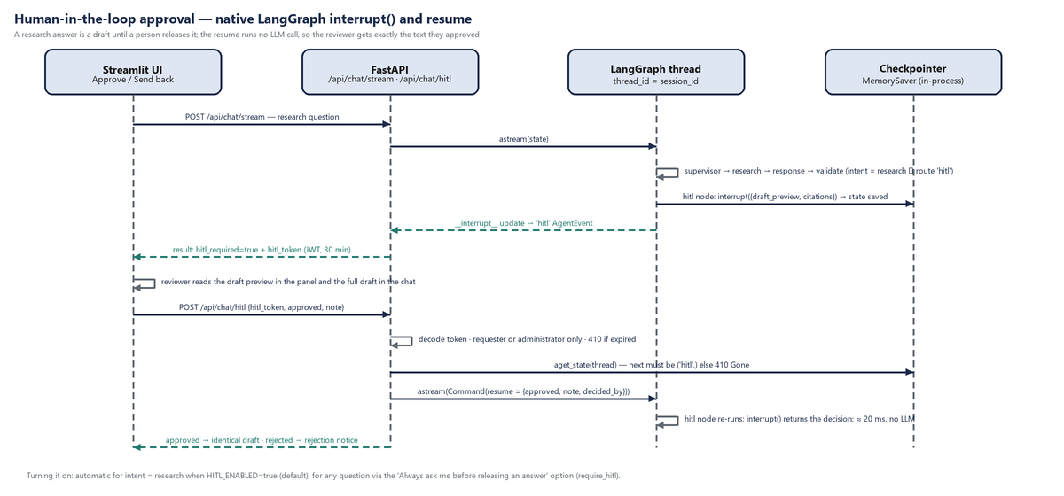
Figure 5. Human-in-the-loop: the thread pauses at `interrupt()`; the reviewer's decision resumes it without regenerating anything.
- The API issues a signed approval token (purpose=hitl, sub, sid, msg, 30-minute expiry). It says *who* may resume *which* session; the paused state itself lives in the checkpointer.
- Only the requester or an administrator may decide (403 otherwise). An expired token or a thread with nothing pending returns 410 with a plain-language message; the UI clears the stale prompt so the user simply asks again.
- On approval the user receives exactly the draft they saw; on rejection a fixed notice. Both outcomes are hitl events appended to the same turn in the panel.

6. Hybrid retrieval
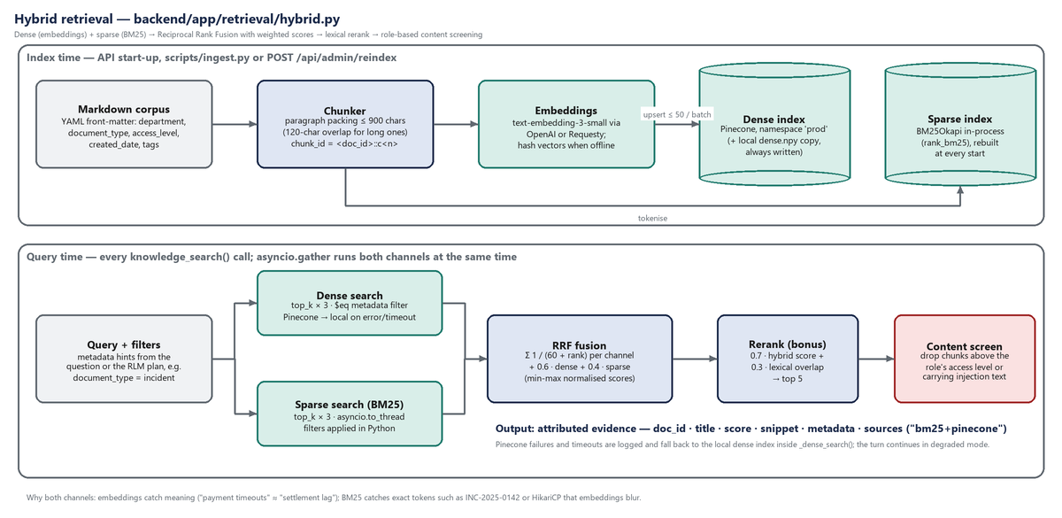
Figure 6. Index-time and query-time pipeline of `HybridRetriever`.

6.1 Corpus and chunking
10 markdown documents in data/documents/ carry YAML front-matter (doc_id, title, department, document_type, access_level, created_date, tags). document_loader.py packs paragraphs into chunks of at most 900 characters (long paragraphs are split with a 120-character overlap); chunk_id = <doc_id>::c<n>. Metadata is copied onto every chunk so filtering and access control work at chunk level.

6.2 Dense channel
Chunks are embedded with text-embedding-3-small through the same provider switch as the chat model (OpenAI or Requesty). With no key, a deterministic hash embedding keeps the pipeline runnable offline (quality drops; BM25 carries the demo). Vectors are always saved locally (data/index/dense.npy, chunks.json) and, when Pinecone is enabled, upserted in batches of 50 into namespace prod with the chunk metadata (text truncated to 3,500 chars, tags joined). The index apex-bank-knowledge is created as serverless (aws/us-east-1, cosine) if missing.
At query time the Pinecone query (top_k×3, include_metadata, $eq filters) runs in a worker thread under asyncio.wait_for(30s); any error or timeout is logged and the local numpy cosine search answers instead, so the turn continues.

6.3 Sparse channel
BM25Okapi is built in-process over tokenised chunks (lower-cased, / and - split) at every start. It is the channel that finds exact tokens — incident ids, product codes, component names — that embeddings blur. It runs via asyncio.to_thread concurrently with the dense query.

6.4 Fusion, rerank and screening
Stage | What happens | Why
RRF fusion | For each channel, score += 1/(60 + rank); plus 0.6 × min-max-normalised dense score and 0.4 × normalised BM25 score; hits found by both channels keep both scores and a sources list (e.g. bm25+pinecone) | Rank-based fusion is robust to incomparable score scales; the weighted term keeps the result explainable and tunable
Rerank (bonus) | rerank_score = 0.7 × hybrid + 0.3 × lexical overlap(query, chunk); top 5 returned | A cheap second opinion that favours chunks actually containing the question's terms; swappable for a cross-encoder behind the same hook
Content screening | screen_retrieved_content() drops chunks above the role's access ceiling and chunks containing instruction-override text; counts are returned and shown as a guardrail event | Defence in depth: even if the index returns it, the LLM never sees what the role may not, and a poisoned document cannot instruct the model
Attribution | Each result: doc_id, title, score, 400-char snippet, metadata, chunk_id | Citations in the UI and the [doc:…] check in validation rely on this

WHERE IN THE CODE
backend/app/retrieval/hybrid.py (search, _dense_search, _sparse_search, _rrf_fuse, _rerank), document_loader.py, embeddings.py; tools/knowledge_search.py. Tests: tests/test_retrieval.py.

7. Memory design
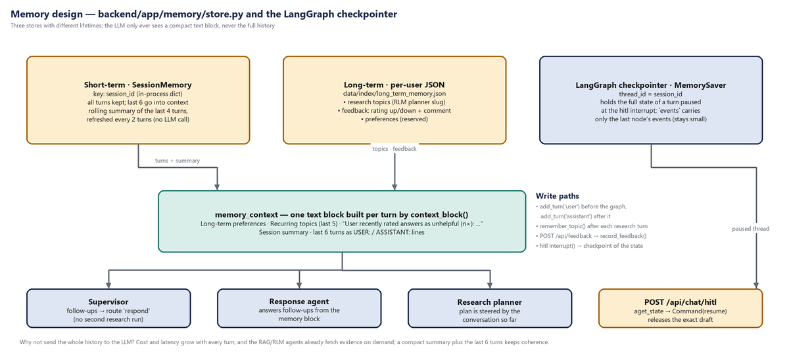
Figure 7. Three memory stores and the single compact text block the LLM sees.
Layer | Scope & lifetime | Contents | Used by
Short-term session memory | Per session_id; in-process for the API's lifetime | All turns (user + assistant); a rolling summary of the last 4 turns refreshed every 2 turns once 4 exist — a string heuristic, no LLM call | Supervisor (follow-up detection), Response agent, Research planner
Long-term user memory | Per user_id; persisted to data/index/long_term_memory.json | Research topics (planner slugs), feedback entries (rating, comment, session, message), preferences (reserved) | Context block: “Recurring topics: …”, “User recently rated answers as unhelpful (n×): … Address this.”
LangGraph checkpointer | Per thread_id = session_id; in-process MemorySaver | Full graph state of the latest run — what makes the HITL pause/resume possible | /api/chat/hitl via aget_state + Command(resume)
Table 4. Memory layers.

7.1 Decisions and reasons
- Compact context, not full history. context_block() emits long-term lines, the summary and the last 6 turns. Cost and latency stay flat as a conversation grows; the RAG/RLM agents fetch evidence on demand, so the history does not need to carry it.
- Heuristic summary instead of an LLM summary. Predictable, free and instant; good enough for follow-up routing in a POC. An LLM summariser can replace it inside add_turn() without touching the graph.
- Feedback is memory. Thumbs-down comments are injected into the next turns' context, closing the feedback loop without a training step.
- Checkpoint stays small. events is not accumulated across turns (no reducer); the API collects events per node as they stream. Long sessions do not bloat the thread state.
- Production path. Session dict → Redis; JSON file → a per-user table; MemorySaver → AsyncPostgresSaver/Redis saver. None of these change the graph or the agents.

8. Tools and the MCP server

8.1 Tool catalog
backend/app/tools/catalog.py is the one place that says which tools exist. The Supervisor prompt is rendered from it, the Tools agent maps names to executors through it, and the role matrix in config.py references the same names.
Tool | Route | Description | Parameters
knowledge_search | retrieve | Hybrid dense+BM25 search over internal documents (policies, incidents, runbooks, architecture, specs, meeting notes). | —
mcp_employee_directory | tools | Live enterprise directory: who someone is, their team, who is on-call. | q — name or team to filter by (optional)
mcp_service_catalog | tools | Live service catalog: systems, tier, owner, SLO. | tier — service tier number to filter by (optional)
mcp_incident_records | tools | Live incident ticket records (id, status open/closed, severity, service). Use for 'current/open incidents', not for narrative post-mortems. | status — 'open' or 'closed' (optional)
python_analysis | tools | Structured/quantitative analysis over retrieved evidence or a small arithmetic expression. | expression — safe Python expression to evaluate (optional)
Table 5. Tool catalog (read from the code).

8.2 MCP server and client
mcp_server/main.py is a real Model Context Protocol server built with the official mcp SDK (FastMCP): transport Streamable HTTP at POST /mcp, stateless JSON responses (no sticky sessions, so it scales horizontally and can be stopped for the outage demo). Each tool's JSON schema is derived from the Python signature, and the server validates incoming arguments against it. GET /health and read-only /rest/<tool> mirrors exist for humans and curl; the agent never uses them.
Catalog name | MCP tool | Data | Filter
mcp_employee_directory | employee_directory | 4 employees: name, role, team, email (includes a Payments SRE on-call) | q — tokens matched against name/team/role
mcp_service_catalog | service_catalog | 4 services: tier, owner, SLO | tier
mcp_incident_records | incident_records | 4 tickets: status, severity, service, opened | status open/closed

backend/app/tools/mcp_client.py speaks the protocol: initialize → tools/call → parse the JSON text block (isError becomes a structured error). The whole call is bounded by asyncio.wait_for(30s); connection errors (anyio exception groups) are unwrapped to their root cause so the log and the panel show *why*. Every failure mode returns {ok: false, error, degraded} instead of raising. In LangSmith each call appears as a tool span named after the concrete tool.

8.3 Python Analysis tool
Two modes behind one RBAC-gated function:
- Facet counting (analyze_themes): for a list of snippets and {theme: [keywords]} patterns, count how many snippets mention each theme (each snippet counts at most once — that is what “recurring” means). Keywords are regex-escaped; themes are capped at 12 with 8 keywords each. This is the RLM batch analyser.
- Expression evaluation: a tiny sandbox. The expression must parse in eval mode, use only allow-listed AST node types, reference only len, max, min, sum (plus comprehension variables), and touch only the attributes count, endswith, get, items, join, keys, lower, replace, split, startswith, strip, upper, values. It runs with __builtins__ emptied. Introspection chains such as ().__class__.__bases__[0].__subclasses__() are rejected (tested).

9. Observability

9.1 LangSmith
chat_turn (chain) ← one root per turn; metadata user_id / role / session_id; tag role:<role>
├── input_guardrail (chain)
├── memory_load (chain)
├── apex_agent_graph (chain) ← LangGraph run (auto-traced)
│ ├── supervisor (chain) → ChatOpenAI (llm)
│ ├── retrieval | research | tools (chain)
│ │ ├── knowledge_search (tool) → hybrid_search (retriever) → dense_search · bm25_search (retriever) · rerank (chain)
│ │ ├── python_analysis (tool)
│ │ └── mcp_employee_directory | mcp_service_catalog | mcp_incident_records (tool)
│ ├── response (chain) → ChatOpenAI (llm)
│ └── validate · hitl (chain)
└── memory_update (chain)
chat_turn_hitl_resume (chain) ← the approval, as its own root

- LangGraph nodes and ChatOpenAI calls are traced by LangChain callbacks. Tools and the retriever are plain async functions, so they are wrapped with langsmith.traceable (trace_tool, trace_retriever, trace_step in observability/tracing.py) — otherwise tool calls and retrieval operations would be invisible, which the assessment explicitly requires.
- configure_langsmith() sets both LANGCHAIN_* and LANGSMITH_* environment names from one key and clears langsmith's cached env lookup so spans are never silently dropped. stream_agent() wraps each turn in tracing_context(enabled=True, project_name=…) so the decision is explicit per turn.
- Inputs are compacted for readability (self dropped, long strings and lists truncated). A blocked request still produces a chat_turn root with its input_guardrail child.
- Filter in the LangSmith UI by metadata.session_id to see a whole conversation, or by tag role:viewer to see every denied tool attempt.

9.2 Structured logs
structlog renders JSON lines with ISO timestamps and level. Event names are stable identifiers (supervisor_routed, knowledge_search_ok, chunk_filtered_rbac, tool_rbac_denied, injection_blocked, rate_limited, mcp_timeout, pinecone_query_failed, hitl_decided, …) so they can be aggregated by any log pipeline.

9.3 The Agent Activity Panel as an observability surface
The panel is fed by the same AgentEvents the API returns. The readable layer groups consecutive events per node into a step with a summary title (e.g. “Research agent (RLM): 3 searches, 9 batches, top themes: connection pool exhaustion, duplicate processing”); the “Raw events” tab shows every event's full JSON; Developer view shows raw events everywhere. Panel and LangSmith are two views of one turn.

10. Async engineering
Where | Technique | Effect
API routes | async def; StreamingResponse over an async generator; Cache-Control: no-cache, X-Accel-Buffering: no | Many concurrent chats on one worker; tokens flush immediately through proxies
Graph execution | graph.astream() with async nodes | Nodes await tools; the event loop is free while waiting on I/O
Hybrid search | asyncio.gather(dense_task, sparse_task); BM25 in asyncio.to_thread | Dense and sparse channels overlap instead of running back to back
Pinecone (sync SDK) | asyncio.to_thread + asyncio.wait_for(timeout) for list/create/upsert/query | Index bootstrap and queries never block the loop; slow vector DB degrades to local
MCP client | Async ClientSession over Streamable HTTP; outer asyncio.wait_for | A hung server cannot stall a turn
Embeddings | AsyncOpenAI client | Batch embedding at start-up and per-query embedding are non-blocking
Rate limiter | asyncio.Lock around the bucket map | Safe under concurrent requests from the same user
LLM calls | ChatOpenAI.ainvoke with timeout | Per-call deadline; failures caught per node

11. Failure handling and the butterfly effect
The question behind “butterfly effect” is: when one dependency misbehaves, how far does the damage spread? The design answer is that each node converts its own failures into data (degraded, degradation_reason, an error event) and the rest of the graph keeps running on what it has. Validation is never skipped, so a degraded turn is still checked and is always *disclosed* in the answer and the panel.
Failure | Where it is caught | Behaviour | What the user sees
LLM unavailable / error (routing) | supervisor_node | Heuristic router decides; decided_by: heuristic; error event | Normal answer path; panel notes the fallback
LLM error (research planning) | generate_search_plan | Deterministic plan from the question's words and inferred filters | Research proceeds; plan event says deterministic
LLM error (answer) | response_node | Evidence-only bullet summary; degraded=llm_failure | “Partial answer: the language model failed…” + sources
Pinecone timeout / error | _dense_search | Local numpy index answers the dense channel; logged | No visible change except retrieval mode in health/trace
Retrieval exception | knowledge_search | ok=false, degraded=true; node sets retrieval_failure | Answer says evidence may be missing
MCP down / slow / protocol error | call_mcp_tool | Structured error with root cause; degraded=mcp_failure | “Live data is unavailable right now”; error event with the cause
Tool not permitted for role | validate_tool_params | ok=false with reason; guardrail event | Plain statement that the role is not authorised, with whom to contact
Prompt injection | validate_user_input | Graph does not run; guardrail event; traced | Safe refusal from Apex Commercial Bank
Invalid request body | FastAPI / Pydantic | 422 with field errors | UI error toast
Rate limit | _enforce_rate_limit | 429 + Retry-After | “That was a bit quick…” and the user turn is removed
API restart during a pending approval | _resume_turn | NoPendingApproval → 410 | “No draft is waiting for approval… ask the question again”
Unhandled exception mid-stream | chat_stream | {"type":"error"} line | Error message; chat stays usable
Table 6. Failure modes and containment.
WHERE IN THE CODE
Tests covering these paths offline: tests/test_graph_and_api.py (test_viewer_is_visibly_denied_mcp_tools, test_mcp_outage_degrades_gracefully_for_analyst, test_injection_is_blocked_before_the_graph_runs, test_api_rate_limit_returns_429_with_retry_after).

12. Deployment
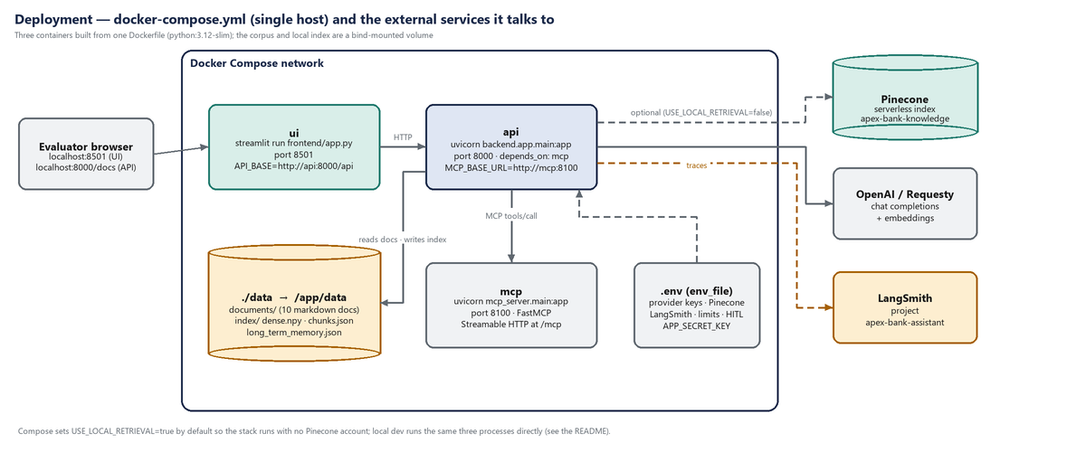
Figure 8. Docker Compose topology and external services.
- One Dockerfile (python:3.12-slim, PYTHONPATH=/app) builds the image for all three services; Compose runs ui (8501), api (8000) and mcp (8100).
- api reads .env via env_file, overrides MCP_BASE_URL=http://mcp:8100, defaults USE_LOCAL_RETRIEVAL=true, and mounts ./data so the corpus, the local index and long_term_memory.json persist across restarts.
- .dockerignore excludes .env, .venv, caches, docs/ and data/index/ (rebuilt at start) from the image.
- Locally the same three processes run from the repository root with PYTHONPATH=..

13. From POC to production
Concern | POC choice | Production step (no graph changes needed)
Identity | Hard-coded users + HS256 JWT | Keycloak/OIDC; map groups → roles; keep role_tool_map as the authorisation source of truth
State | In-process MemorySaver, session dict, JSON file, in-memory token bucket | Postgres/Redis checkpointer, Redis sessions and buckets, a user-memory table
Sparse retrieval | Local BM25 fused with Pinecone dense | Pinecone sparse-dense vectors or a hosted BM25; same _rrf_fuse contract
Rerank | Lexical overlap | Cross-encoder (e.g. bge-reranker) behind _rerank
Injection detection | Regex + sanitising + content screening | Add a classifier/LLM judge as a second opinion; keep regex as the fast first line
Analysis sandbox | AST allow-list in-process | Container/firecracker sandbox for richer Python
MCP | Unauthenticated server on a trusted network | SDK OAuth provider, per-department row filtering, mTLS
Scaling | Single uvicorn worker per container | Horizontal replicas behind a gateway; the stateless MCP transport already supports it

