LEAVE MANAGEMENT SYSTEM
UI / UX Design Document
A comprehensive design reference for the LMS web application — covering design strategy, information architecture, the visual design system, and screen-by-screen specifications for the Employee, Manager, and HR Administrator experiences.

PREPARED FOR
Small & Medium Business (SMB) Organizations
TECHNOLOGY STACK
Java • Spring Boot • React.js • MySQL • JWT Authentication
Prepared By: Sarthak Jain | Version 2.0 | August 2026

Document Control

Revision History
Version | Date | Author | Summary of Changes
1.0 | May 2026 | Sarthak Jain | Initial UI screen capture compilation.
2.0 | August 2026 | Sarthak Jain | Full UI/UX design documentation added: design strategy, personas, information architecture, visual design system, screen-by-screen specifications, user flows, accessibility and responsive guidelines.

Distribution
This document is intended for the product, engineering, and QA teams responsible for building and maintaining the LMS platform, as well as stakeholders who require a reference for the intended visual and interaction design.

Related Artifacts
- High-fidelity UI screens (embedded throughout Section 5)
- Functional/technical requirements document (referenced, maintained separately)
- Backend API specification (Spring Boot REST services)

Table of Contents
Document Control 2
Revision History 2
Distribution 2
Related Artifacts 2
Table of Contents 3
1. Introduction 5
1.1 Purpose of this Document 5
1.2 Project Overview 5
1.3 Scope 5
1.4 Target Audience 5
1.5 Technology Stack 5
2. UX Strategy & Design Principles 7
2.1 Design Goals 7
2.2 User Personas 7
2.3 Design Principles 8
3. Information Architecture 9
3.1 User Roles & Access Levels 9
3.2 Site Map 9
Authentication 9
Employee Portal 9
Manager Portal 9
HR / Admin Portal 10
4. Visual Design System 11
4.1 Color Palette 11
Primary & Neutral 11
Status & Semantic Colors 11
4.2 Typography 11
4.3 Core Components 12
4.4 Layout Grid 12
5. Screen-by-Screen Design Documentation 13
5.1 Authentication 13
AUTH-01 — Login 13
AUTH-02 — Forgot Password 15
AUTH-03 — Reset Password 17
5.2 Employee Portal 19
EMP-01 — Employee Dashboard 19
EMP-02 — Apply Leave 21
EMP-03 — My Requests 23
EMP-04 — Request Details (Employee View) 25
EMP-05 — Leave Ledger 27
EMP-06 — Comp-Off 29
EMP-07 — Holiday Calendar 31
EMP-08 — Notifications 32
EMP-09 — Profile 34
5.3 Manager Portal 36
MGR-01 — Manager Dashboard 36
MGR-02 — Approval Inbox 38
MGR-03 — Manager Request Details 40
MGR-04 — Team Calendar 42
MGR-05 — Team Members 43
MGR-06 — Delegation Management 44
5.4 HR / Admin Portal 46
HR-01 — Employee Management 46
HR-02 — Leave Policies 48
HR-03 — Leave Categories 50
HR-04 — Holiday Calendar (HR Admin) 52
HR-05 — Reports & Analytics 53
HR-06 — Audit Trail 55
HR-07 — Notification Queue 57
HR-08 — Settings 59
6. Key User Flows 62
6.1 Leave Application & Approval Flow 62
6.2 Authentication & Account Recovery Flow 62
6.3 Delegation Flow (Manager Unavailability) 62
7. Interaction & Usability Guidelines 64
7.1 Feedback & States 64
7.2 Forms 64
7.3 Tables & Lists 64
7.4 Notifications 64
8. Accessibility Guidelines 65
9. Responsive Design Considerations 66
10. Appendix 67
10.1 Screen Inventory Summary 67
10.2 Assumptions 67
10.3 Open Questions for Engineering Review 67
10.4 Glossary 67

1. Introduction

1.1 Purpose of this Document
This document defines the User Interface (UI) and User Experience (UX) design for the Leave Management System (LMS) — a web-based application that lets small and medium-sized organizations manage the full lifecycle of employee leave, from application through approval, tracking, and reporting. It captures the design rationale, information architecture, visual design system, and a screen-by-screen specification of every interface in the product, and is intended to be the shared reference point for design, engineering, and QA throughout development.

1.2 Project Overview
LMS replaces manual, spreadsheet- or email-driven leave tracking with a single system of record. It is built around three role-based experiences that share a common visual language:
- Employee Portal — apply for leave, track requests, view balances, and manage personal profile.
- Manager Portal — review and approve team requests, monitor team leave calendars, and delegate approval authority.
- HR / Admin Portal — configure policies and categories, manage the employee master, run organization-wide reports, and administer the system.

1.3 Scope
The scope of this document covers all screens delivered in the current design iteration: 3 authentication screens, 9 Employee Portal screens, 6 Manager Portal screens, and 8 HR/Admin Portal screens (26 screens total). Backend business logic, database schema, and API contracts are out of scope and are covered in the accompanying technical specification.

1.4 Target Audience
Audience | How they use this document
UI/UX Designers | Reference for design system consistency and rationale when extending the product.
Frontend Engineers | Source of truth for layout, component inventory, and screen-level behavior.
Backend Engineers | Context for the data and actions each screen requires from the API.
QA Engineers | Basis for writing UI test cases and validating expected states.
Product Owners / Stakeholders | Overview of functionality and user experience for sign-off.

1.5 Technology Stack
Layer | Technology
Backend | Java, Spring Boot
Frontend | React.js
Database | MySQL
Authentication | JWT (JSON Web Token)

2. UX Strategy & Design Principles

2.1 Design Goals
- Reduce the time and friction to apply for and approve leave to under a minute for routine requests.
- Give every role a single, trustworthy view of leave balances — eliminating the reconciliation employees and HR currently do by hand.
- Make approval decisions easy to make well, by surfacing the context (balance, policy, team impact) an approver needs at the point of decision.
- Scale from a 20-person team to a several-hundred-person organization without a redesign, through consistent, data-dense but scannable layouts.
- Present a professional, low-distraction visual language appropriate for daily workplace use.

2.2 User Personas
Employee — Individual contributor who applies for leave and tracks its status.
Goals
- Apply for leave without confusion about policy or balance
- Know at a glance where a pending request stands
- Avoid chasing a manager or HR for status updates
Key Traits
- Time-poor — wants the fastest path to submit a valid request
- May be on a shared or mobile device
Manager — People manager responsible for approving requests and planning team coverage.
Goals
- Clear a queue of pending approvals quickly and confidently
- See team-wide leave coverage before approving
- Delegate approvals when unavailable
Key Traits
- Approves from a queue mindset — needs batchable, scannable requests
- Cares about team impact as much as policy compliance
HR Administrator — Owns policy configuration, employee master data, and organization-wide reporting/compliance.
Goals
- Configure leave policies and categories without engineering support
- Audit and report on leave usage across the organization
- Maintain accurate employee records and control system settings
Key Traits
- Needs powerful filtering/search across large datasets
- Accountable for compliance — values audit trails and export

2.3 Design Principles
- Consistency over novelty — the same card, table, filter, and status-chip patterns repeat across all 26 screens so users transfer learning between modules.
- Progressive disclosure — summary cards and lists lead; detail panels and tabs hold depth so screens don’t overwhelm on first view.
- Context at the point of action — balances, policies, and team impact are shown next to the action that needs them (e.g., policy card beside the Apply Leave form), not in a separate help section.
- Status is always visible — color-coded chips and timelines make the state of any request unambiguous at a glance.
- Role-appropriate navigation — each portal has its own left-navigation group so users only ever see the actions available to them.

3. Information Architecture

3.1 User Roles & Access Levels
Role | Portal | Access Level
Employee | Employee Portal | Own leave data only — apply, view, and withdraw own requests; view own balances, ledger, and profile.
Manager | Manager Portal (+ Employee Portal for own leave) | Own leave data, plus read/approve access to direct reports’ requests, team calendar, and team roster.
HR Administrator | HR / Admin Portal (+ full read access) | Organization-wide configuration and data: employees, policies, categories, holidays, reports, audit, notifications, and system settings.

3.2 Site Map
Each role lands on a dedicated dashboard after login and has its own left-navigation group. Shared utility screens (Notifications, Profile) are available from every portal via the top bar.

Authentication
- Login
- Forgot Password
- Reset Password

Employee Portal
- Employee Dashboard
- Apply Leave
- My Requests → Request Details
- Leave Ledger
- Comp-Off
- Holiday Calendar
- Notifications
- Profile

Manager Portal
- Manager Dashboard
- Approval Inbox → Request Details
- Team Calendar
- Team Members
- Delegation Management
- Reports & Analytics (shared with HR, scoped to team)

HR / Admin Portal
- HR Dashboard
- Employee Management
- Leave Policies
- Leave Categories
- Holiday Calendar
- Reports & Analytics
- Audit Trail
- Notification Queue
- Settings

4. Visual Design System
The interface uses a consistent, restrained visual system across all three portals: a dark navy sidebar for navigation, a light neutral canvas for content, a single primary blue for actions, and a small, purposeful set of status colors. This section documents the design tokens as implemented in the current UI.

4.1 Color Palette

Primary & Neutral
Swatch | Token | Hex | Usage
 | Primary Blue | #2563EB | Primary buttons, active nav state, links, focus states
 | Primary Dark | #1D4ED8 | Button hover/pressed state, emphasis text
 | Navy (Sidebar) | #0F172A | Left navigation background across all three portals
 | Slate | #334155 | Secondary/body text
 | Slate Light | #64748B | Muted/helper text, placeholders, timestamps
 | Border | #CBD5E1 | Card borders, table dividers, input outlines
 | Background | #F1F5F9 | Page canvas, alternating table rows, subtle cards

Status & Semantic Colors
Swatch | Token | Hex | Usage
 | Success | #16A34A | Approved status, positive KPIs, success confirmations
 | Warning | #D97706 | Pending status, cautionary callouts, in-progress states
 | Danger | #DC2626 | Rejected/failed status, destructive actions, validation errors
 | Accent Purple | #7C3AED | Comp-Off and earned-leave accents, secondary chart series

4.2 Typography
A single sans-serif system typeface (Inter or an equivalent platform sans-serif) is used throughout for maximum legibility in dense, data-heavy layouts.
Style | Weight | Approx. Size | Usage
Page Title | Semi-Bold | 20–24px | Screen headings (e.g., “Apply Leave”)
Card Heading | Semi-Bold | 16–18px | Section/card titles within a screen
Body | Regular | 14px | Table content, form values, descriptions
Label / Caption | Medium | 12–13px | Field labels, table headers, meta text
KPI Figure | Bold | 22–28px | Dashboard summary numbers

4.3 Core Components
- Left Navigation Rail — fixed dark sidebar with icon + label items, active-state highlight, and a persistent “Contact Us / Need Help” support card pinned at the bottom.
- Top Bar — global search with keyboard shortcut affordance, notification bell with unread badge, and a user menu with avatar, name, and role.
- KPI Summary Card — icon, label, and large figure, used consistently across all three dashboards and most list screens.
- Data Table — filter bar above, zebra-striped rows, status chips, row-level overflow actions, and pagination below.
- Status Chip — pill-shaped, color-coded label (e.g., Approved / Pending / Rejected) reused for every status field in the product.
- Detail / Timeline Panel — vertical stepper showing a request’s lifecycle with actor, timestamp, and comment per stage.
- Callout / Note Card — tinted card with an icon used for policy reminders, system notes, and contextual guidance.
- Modal / Slide-over Panel — used for quick detail views (e.g., Approval Inbox request preview) without leaving the list.

4.4 Layout Grid
- Fixed-width left navigation (≈240px) + fluid content area, standard for all authenticated screens.
- Content area organized on a responsive card grid — typically a 2:1 primary/sidebar split (main content + contextual summary panel).
- 8px base spacing unit; cards and tables use consistent internal padding for visual rhythm across screens.
- Unauthenticated screens (Login, Forgot/Reset Password) use a 50/50 split-screen layout instead of the sidebar pattern.

5. Screen-by-Screen Design Documentation
Every screen below follows the same specification format: a summary table (screen ID, module, and applicable role), the design purpose, an inventory of key UI elements, implementation/design notes where relevant, and the annotated high-fidelity screen.

5.1 Authentication

AUTH-01 — Login
Screen ID | AUTH-01
Module | Authentication
Applicable Role | All Users (Employee / Manager / HR Admin)

Design Purpose
Entry point to the application. Authenticates the user and routes them to the dashboard that matches their assigned role. The left panel reinforces the product value proposition; the right panel contains the functional login form.
Key UI Elements
- Split-screen layout — brand/marketing panel (left) and functional form (right)
- Email address and password input fields with inline field icons
- Password visibility toggle
- “Remember Me” checkbox and “Forgot Password?” text link
- Primary “Login” call-to-action button (full width)
- Social single sign-on options — “Sign in with Google” and “Sign in with Microsoft”
- Trust indicators on the left panel: Secure (JWT-based authentication), Role Based access, Insightful reports

Design Note
JWT tokens issued on successful authentication are used for all subsequent API calls. Failed attempts should surface inline validation errors beneath the relevant field rather than a generic banner, so users can immediately see what to correct.
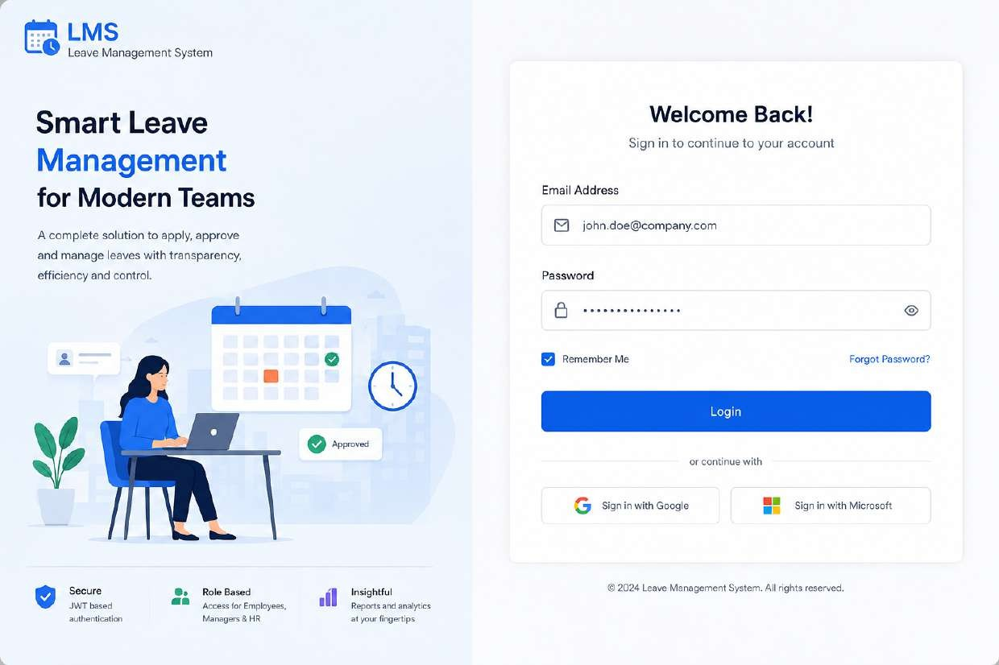
Figure AUTH-01 — Login

AUTH-02 — Forgot Password
Screen ID | AUTH-02
Module | Authentication
Applicable Role | All Users

Design Purpose
Self-service entry point for account recovery. Lets a user request a password reset without contacting HR/IT support directly.
Key UI Elements
- “Back to Login” link for quick return to the sign-in screen
- Single email address input with validation
- Informational callout clarifying that a reset link will be emailed, including a reminder to check spam/junk folders
- Primary “Send Reset Link” button
- Secondary “Need Help? Contact Support” action for users without email access

Design Note
The screen intentionally does not confirm whether an email address exists in the system, to avoid leaking account information (email enumeration).
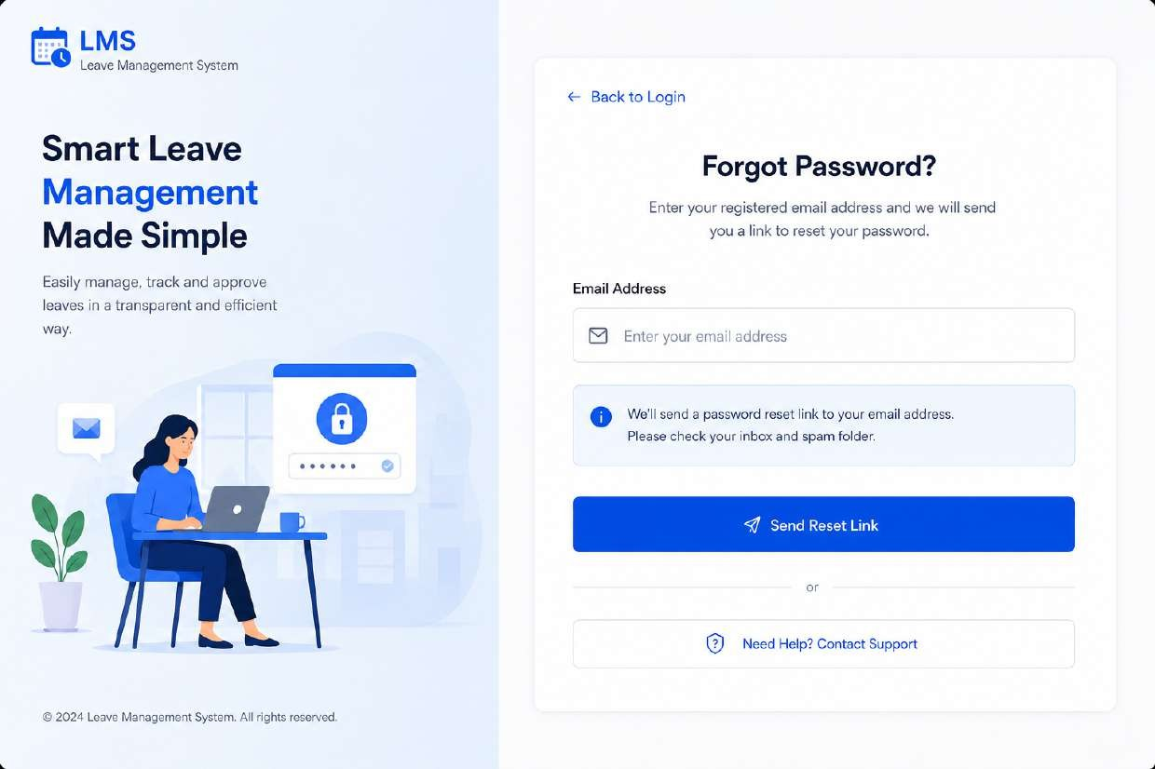
Figure AUTH-02 — Forgot Password

AUTH-03 — Reset Password
Screen ID | AUTH-03
Module | Authentication
Applicable Role | All Users

Design Purpose
Second step of the recovery flow. The user enters the one-time verification code sent to their email and sets a new password.
Key UI Elements
- 6-digit OTP input with a visible resend countdown timer (00:45)
- New Password field with a live strength meter (Weak / Medium / Strong)
- Real-time password policy checklist — minimum 8 characters, one uppercase letter, one number, one special character
- Confirm New Password field with match confirmation indicator
- Primary “Reset Password” button, disabled until all validation rules pass

Design Note
Progressive disclosure of password rules reduces failed submissions and support tickets by showing users exactly which rule is unmet in real time.
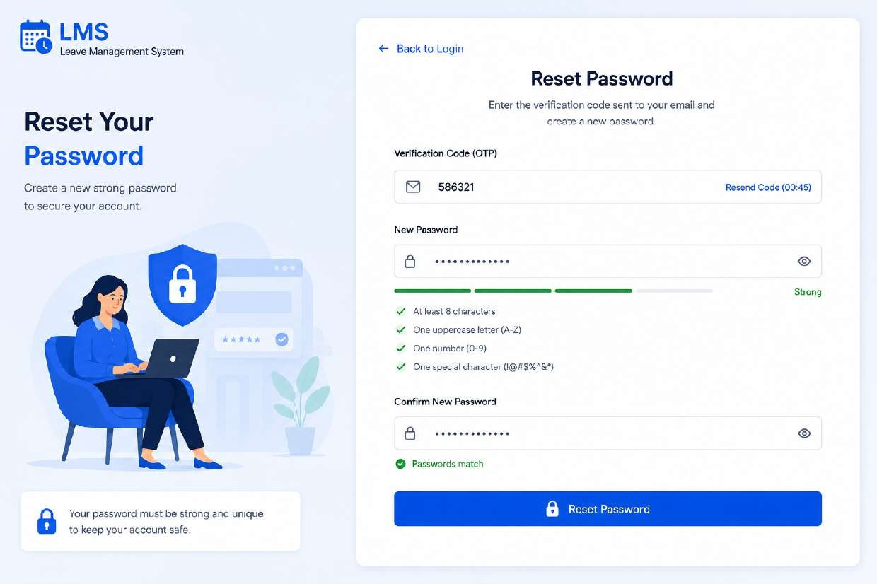
Figure AUTH-03 — Reset Password

5.2 Employee Portal

EMP-01 — Employee Dashboard
Screen ID | EMP-01
Module | Employee Portal
Applicable Role | Employee

Design Purpose
Landing screen after login for the Employee role. Gives an at-a-glance summary of leave balances, trends, and pending activity, and surfaces the most common actions.
Key UI Elements
- Persistent left navigation (Dashboard, Apply Leave, My Requests, Leave Ledger, Comp-Off, Holiday Calendar, Notifications, Profile, Logout)
- Global search bar with keyboard shortcut hint (Ctrl+K), notification bell with unread badge, and user avatar menu
- Four summary KPI cards: Available Leave, Used Leave, Pending Requests, Comp-Off Balance
- “Leave Usage Trend” line chart (This Year) and “Leave Distribution” donut chart
- “Upcoming Holidays” mini calendar widget
- “My Recent Requests” table with status chips and a “View All” link
- “Quick Actions” shortcuts (Apply Leave, Apply Comp-Off, My Requests, Leave Ledger)
- “Recent Activity” feed

Design Note
This is a data-dense dashboard; card-based grouping and consistent iconography (color-coded per leave type) keep it scannable. All KPI cards and quick actions deep-link directly to their respective modules.
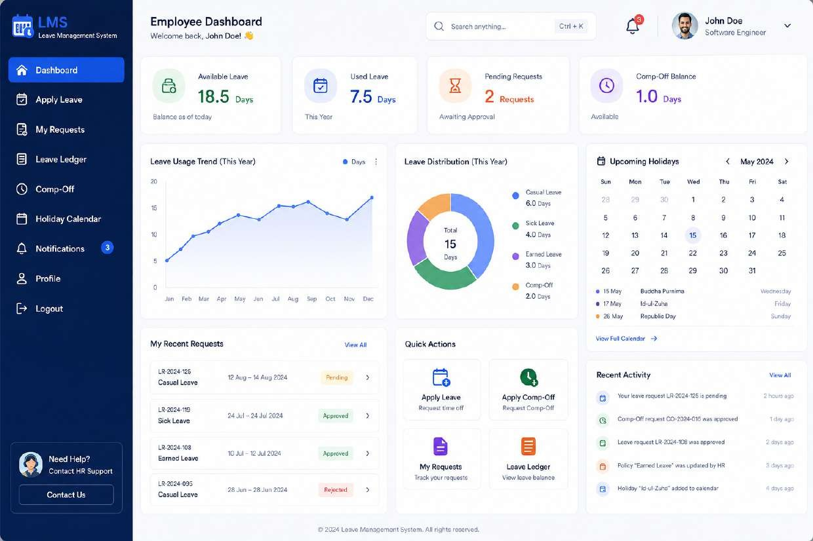
Figure EMP-01 — Employee Dashboard

EMP-02 — Apply Leave
Screen ID | EMP-02
Module | Employee Portal
Applicable Role | Employee

Design Purpose
Primary transactional screen where an employee submits a new leave request against their available balance and the applicable policy.
Key UI Elements
- Leave Application Form: Leave Type dropdown, Apply For (Full Day / Half Day) toggle, From/To date pickers with auto-calculated Total Days
- Multi-line Reason for Leave textarea with character counter
- File attachment control supporting multiple documents (e.g., medical proof)
- Primary actions: Cancel, Save Draft, Submit Request
- Contextual “Leave Balance Summary” sidebar showing balance / entitlement per leave type
- “Leave Policy for [Selected Type]” card — annual quota, carry forward, maximum continuous days, notice period, applicability
- “Important Notes” advisory callout

Design Note
Surfacing the relevant policy and live balance next to the form (rather than in a separate help page) reduces invalid submissions and back-and-forth with approvers.
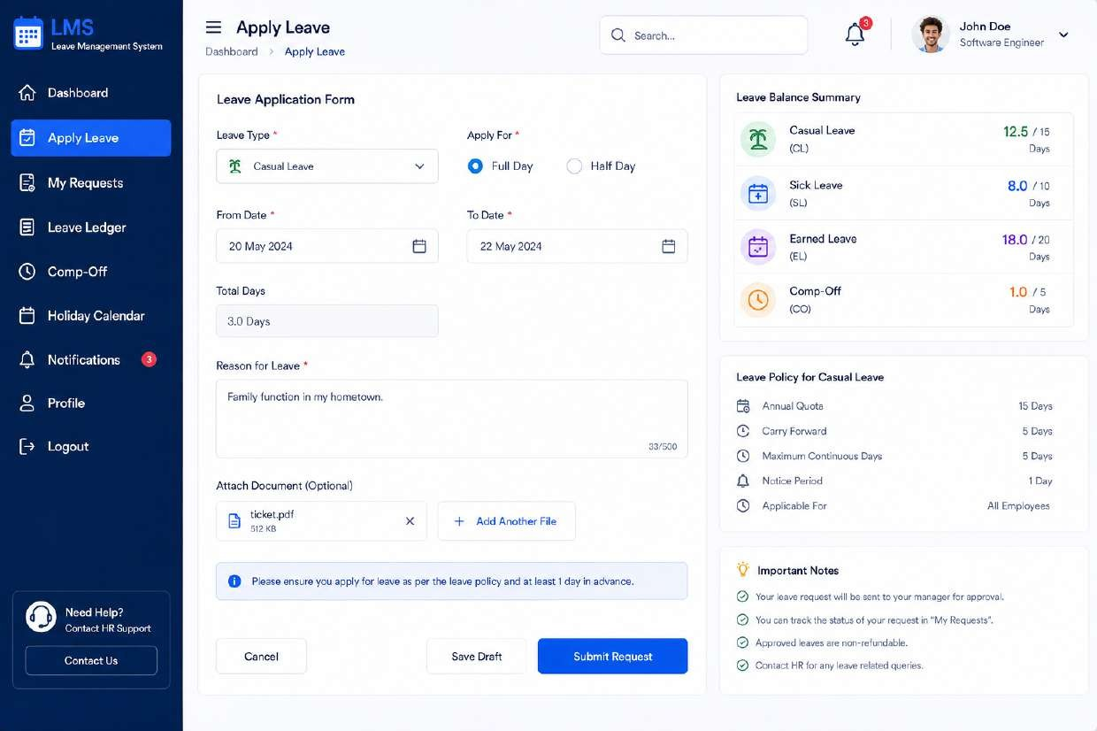
Figure EMP-02 — Apply Leave

EMP-03 — My Requests
Screen ID | EMP-03
Module | Employee Portal
Applicable Role | Employee

Design Purpose
Tracking view of every leave request an employee has submitted, with filtering to quickly locate a specific request.
Key UI Elements
- Filter bar: Status, Leave Type, From/To date range, Reset and Apply Filters controls
- Data table columns: Request ID, Leave Type, Duration, Total Days, Status, Current Approver, Applied On, row-level actions
- Color-coded status chips (Pending, Approved, Rejected, Cancelled)
- Pagination control and per-page row count selector
- Export action for offline record-keeping

Design Note
Row click or the overflow (⋮) action opens the Request Details screen for that record.
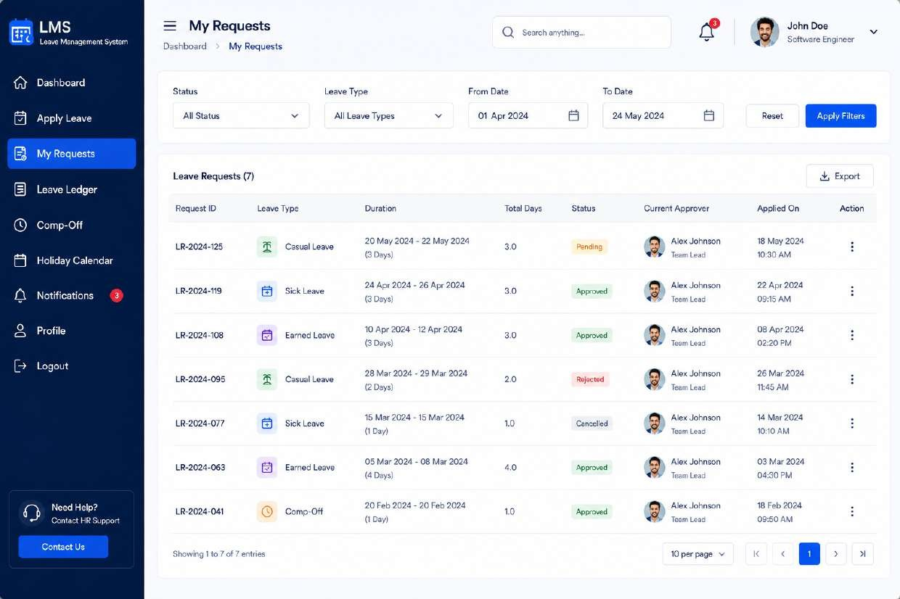
Figure EMP-03 — My Requests

EMP-04 — Request Details (Employee View)
Screen ID | EMP-04
Module | Employee Portal
Applicable Role | Employee

Design Purpose
Detailed, single-request view combining the submitted data with a visual approval timeline, so the employee always knows where their request stands.
Key UI Elements
- Header summary: leave type, duration, total days, current status badge
- Vertical “Approval Timeline” stepper — Submitted → Manager Approved → HR Approved → Completed, each with actor, timestamp and comment
- “Leave Details” card — dates, applied-for type, reason, contact number, address during leave
- “Employee Details” card — ID, department, manager, contact info
- “Leave Balance” snapshot as of the request date
- Attachments list with download affordance
- Comments thread between employee and approvers
- Contextual actions: Withdraw Request (only before final approval), Download as PDF

Design Note
The timeline pattern is reused (with role-appropriate actions) on the Manager Request Details screen, giving the product a consistent mental model for “where is this request in its lifecycle.”
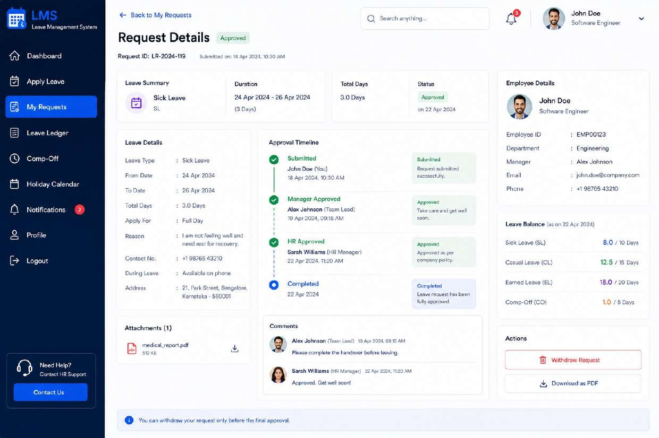
Figure EMP-04 — Request Details (Employee View)

EMP-05 — Leave Ledger
Screen ID | EMP-05
Module | Employee Portal
Applicable Role | Employee

Design Purpose
Financial-statement-style view of how each leave type balance was accrued and consumed over the selected year — the system of record the employee can audit against payroll/HR.
Key UI Elements
- Year selector and Export action
- “Leave Balance Summary” cards per leave type (Available / Total)
- “Leave Transaction History” table — Date, Leave Type, Description, Credits, Debits, Balance, Reference number
- Color legend explaining Credit / Debit / Balance row semantics
- Informational note on when the balance was last updated

Design Note
A running-balance ledger format (opening balance, credits, debits) mirrors patterns employees already recognize from bank statements, reducing the learning curve.
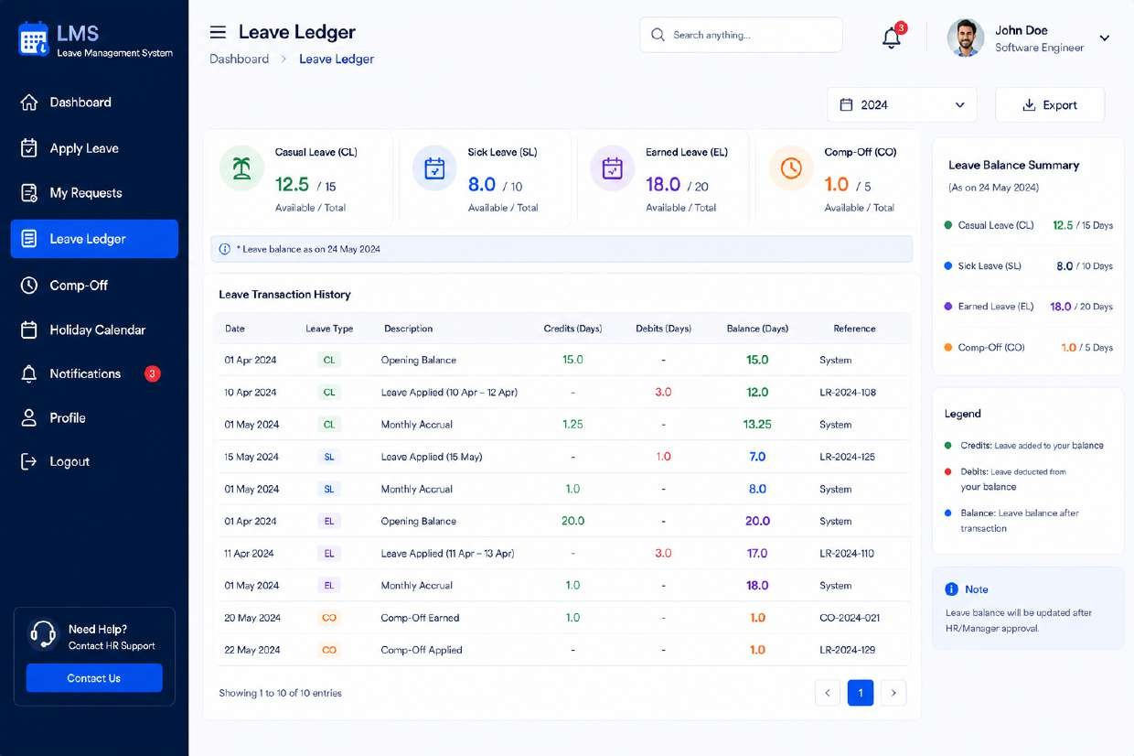
Figure EMP-05 — Leave Ledger

EMP-06 — Comp-Off
Screen ID | EMP-06
Module | Employee Portal
Applicable Role | Employee

Design Purpose
Dedicated workspace for compensatory-off credits earned from working on weekends/holidays — requesting, tracking, and understanding the rules that govern them.
Key UI Elements
- Summary cards: Comp-Off Earned (This Year), Avail Balance, Used, Pending Approval
- Tabs: Earned History, My Requests, Usage History
- “Earned History” table — date earned, reason/description, hours worked, comp-off earned, approved by, status
- Primary “Request Comp-Off” action
- “Comp-Off Rules” card outlining accrual and expiry policy
- “Important Notes” callout

Design Note
Kept as its own module (rather than folded into Apply Leave) because comp-off has a distinct earn-then-spend lifecycle and its own approval/expiry rules.
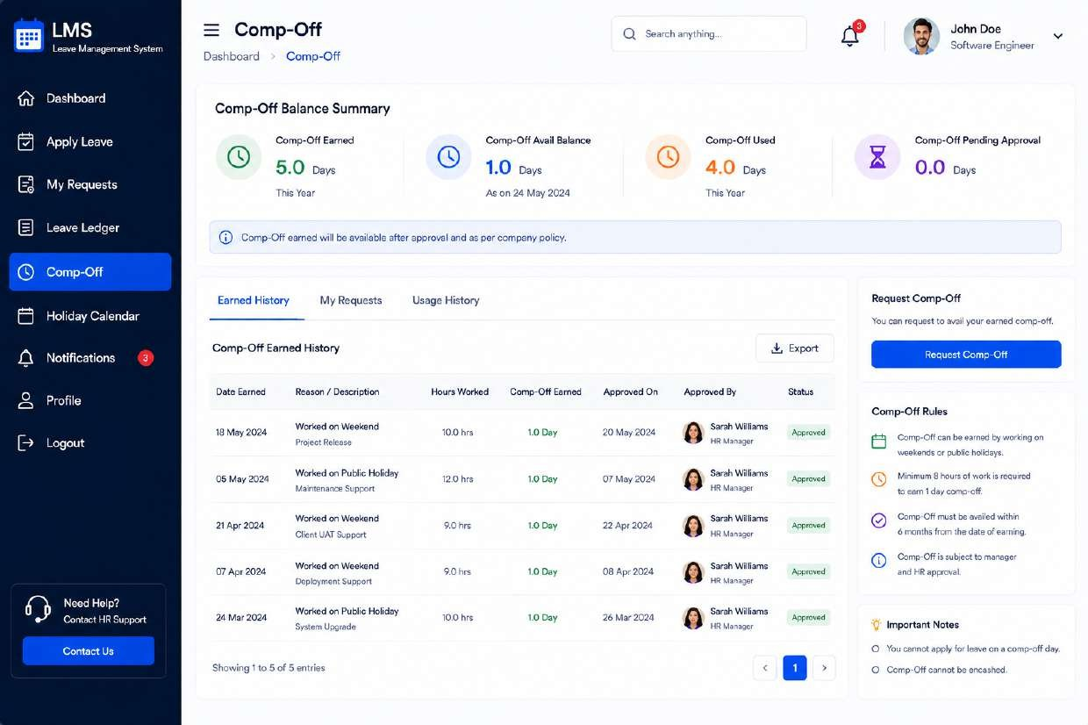
Figure EMP-06 — Comp-Off

EMP-07 — Holiday Calendar
Screen ID | EMP-07
Module | Employee Portal
Applicable Role | Employee

Design Purpose
Read-only calendar of company, national, and optional holidays so employees can plan leave around them.
Key UI Elements
- Month navigation (Today, previous/next) and Location filter (holidays can vary by office)
- Full month grid with color-coded holiday-type dots (National, Festival, Optional, Company, Restricted)
- “Upcoming Holidays” list panel with “View Full Holiday List” link
- Legend explaining each holiday-type color
- Note clarifying that holidays follow the employee’s office location and are subject to government notification
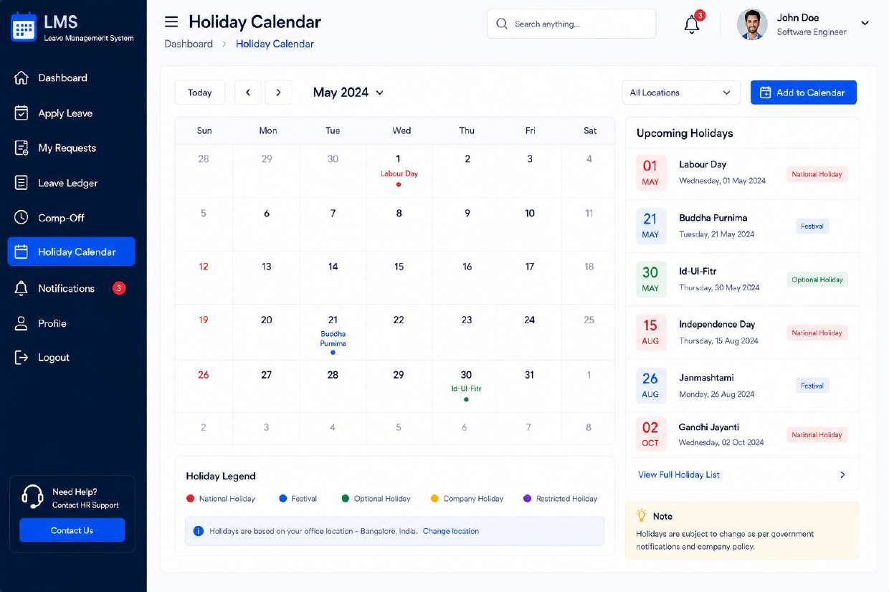
Figure EMP-07 — Holiday Calendar

EMP-08 — Notifications
Screen ID | EMP-08
Module | Employee Portal
Applicable Role | Employee

Design Purpose
Central inbox for all system-generated alerts relevant to the employee — approvals, reminders, and policy changes.
Key UI Elements
- Tabbed filters: All, Unread, Requests, Approvals, System, each with a count badge
- “Mark all as read” bulk action and a Filter control
- Notification list with type icon, title, description, and relative timestamp (Today / Yesterday / date)
- “Notification Preferences” panel with per-category toggle switches (Leave Request Updates, Approval Notifications, Comp-Off Updates, Policy Updates, System Notifications, Holiday Reminders)
- “Quick Actions” shortcuts
- Pagination for the notification list

Design Note
Putting preference toggles directly on the notifications screen (rather than burying them in account settings) lets users tune noise the moment they notice it.
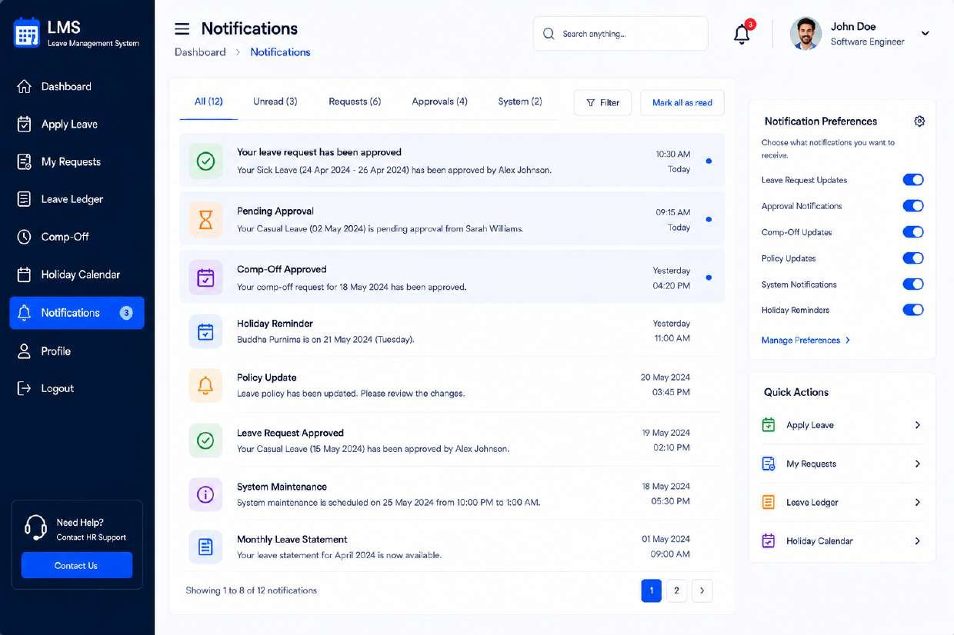
Figure EMP-08 — Notifications

EMP-09 — Profile
Screen ID | EMP-09
Module | Employee Portal
Applicable Role | Employee

Design Purpose
Self-service account and personal information management, including password change.
Key UI Elements
- Avatar with “Change Photo” action
- “Profile Information” card — full name, employee ID, email, phone, department, designation, date of joining, reporting manager, work location, employment type
- “Personal Information” card (editable) — date of birth, gender, blood group, address
- “Emergency Contact” card (editable) — name, relationship, phone, email
- “Change Password” form — current, new, confirm password with “Update Password” action
- “Account Information” panel — username, account created date, last login, account status
- Privacy & security footnote

Design Note
Employment fields (ID, department, manager) are shown read-only here; they can only be changed by HR from the Employee Management module, preserving a single source of truth.
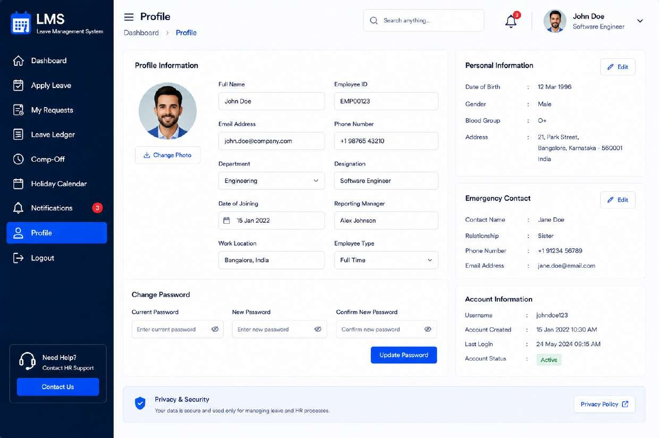
Figure EMP-09 — Profile

5.3 Manager Portal

MGR-01 — Manager Dashboard
Screen ID | MGR-01
Module | Manager Portal
Applicable Role | Manager

Design Purpose
Manager-role landing page focused on team oversight — how many people are on leave, what needs approval, and team-level leave trends.
Key UI Elements
- “Manager Portal” navigation group distinct from the employee-facing nav (Manager Dashboard, Approval Inbox, Team Calendar, Team Members, Delegation, Reports & Analytics, Settings)
- KPI cards: Total Team Members, Pending Approvals, Leaves This Month, Available Balance (avg per employee)
- “Leave Trend (Last 6 Months)” line chart and “Leave by Type This Month” donut chart
- “Team Leave Overview” table broken down by department
- “Pending Approvals” shortlist with direct “Go to Approval Inbox” link
- “Upcoming Leaves” list and “Quick Actions” panel

Design Note
Reuses the dashboard layout pattern from the Employee Dashboard for consistency, but every metric is scoped to “my team” rather than “me,” reinforcing the manager’s mental model.
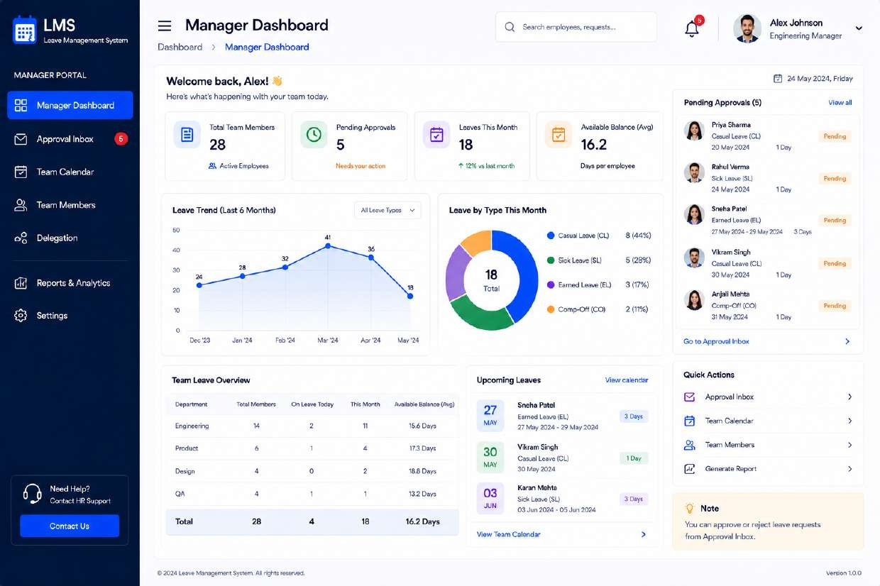
Figure MGR-01 — Manager Dashboard

MGR-02 — Approval Inbox
Screen ID | MGR-02
Module | Manager Portal
Applicable Role | Manager

Design Purpose
The manager’s primary work queue — every leave request awaiting a decision, with enough context to approve or reject without leaving the list.
Key UI Elements
- Status tabs: All Requests, Pending, Approved, Rejected, each with a count
- Filter and Sort By (Newest) controls
- Request list rows: employee avatar/name, leave type, duration, dates, reason, status, and inline Approve (✓) / Reject (✗) / View actions
- Slide-over “Request Details” panel — employee ID, leave type, dates, reason, applied on, reporting manager, attachments, and approval history
- Advisory note to review request details before approving or rejecting

Design Note
Inline approve/reject on the list, plus a detail panel for anything needing more context, lets managers clear routine requests quickly while still supporting careful review of edge cases.
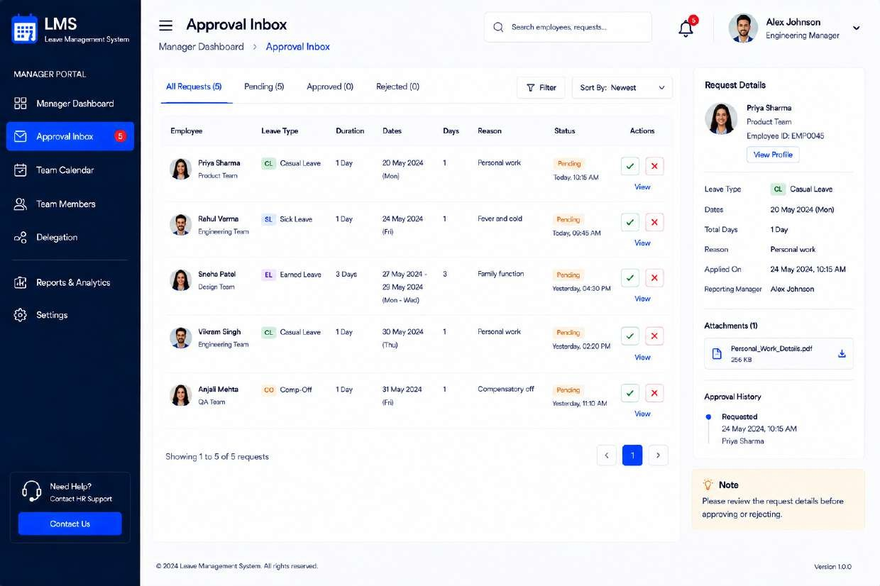
Figure MGR-02 — Approval Inbox

MGR-03 — Manager Request Details
Screen ID | MGR-03
Module | Manager Portal
Applicable Role | Manager

Design Purpose
Full-page version of the request review experience for cases that need deeper investigation — team impact, handover coverage, and history — before a decision is made.
Key UI Elements
- Tabs: Request Details, Comments, Team Impact, Policy & Eligibility
- “Request Details” tab — employee ID, department, designation, work location, contact/alternate contact, handover-to person, handover notes, availability while on leave
- “Employee Information” card with “View Full Profile” link and current “Leave Balance (As on [date])” per type
- “Attachments” and “Approval History” panels
- “Team Impact” advisory callout flagging overlapping commitments (e.g., sprint planning, module testing) and who is backing up the employee
- Manager Actions: Approve, Reject, Add Comment

Design Note
The dedicated “Team Impact” tab is a differentiator versus a generic approval screen — it directly supports the manager’s real decision criterion (“can the team absorb this absence”), not just policy compliance.
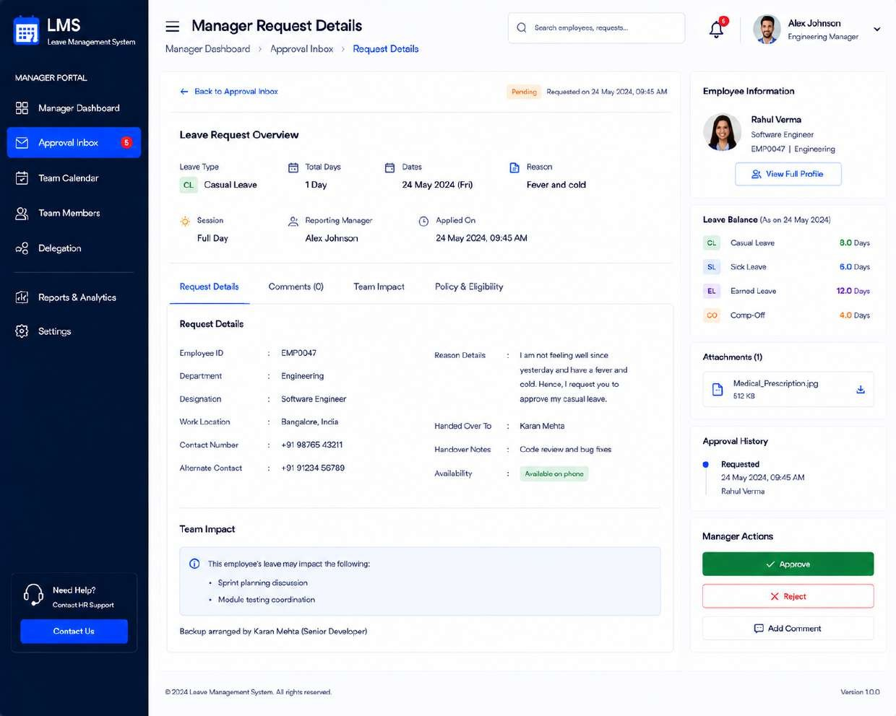
Figure MGR-03 — Manager Request Details

MGR-04 — Team Calendar
Screen ID | MGR-04
Module | Manager Portal
Applicable Role | Manager

Design Purpose
Visual, month-at-a-glance view of who on the team is on leave and when, to spot coverage conflicts before they happen.
Key UI Elements
- Month/Week view toggle and date navigation
- Leave-type legend (Casual, Sick, Earned, Comp-Off, Weekly Off, Holiday) used as color coding on calendar chips
- Calendar grid with per-day avatar chips showing who is on leave and which type
- “Team Leave Summary” sidebar totals per leave type for the month
- “Upcoming Leaves” list with “View All” link
- Filters: Department, Leave Type, “Show Weekends” toggle
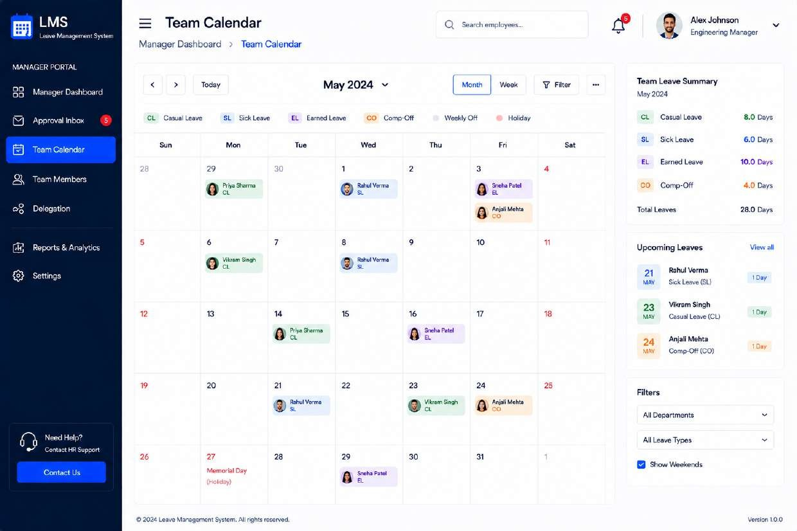
Figure MGR-04 — Team Calendar

MGR-05 — Team Members
Screen ID | MGR-05
Module | Manager Portal
Applicable Role | Manager

Design Purpose
Roster view of everyone reporting to the manager, with balances and status, plus the entry point for team administration actions.
Key UI Elements
- KPI cards: Total Members, On Leave Today, Available, Departments
- Filter by Department and text search
- “Add Member” primary action
- Member table — avatar/name, Employee ID, Department, Designation, Email, Phone, Status (Available / On Leave), row actions
- “Team Leave Balance Overview” sidebar aggregated by leave type
- “Quick Actions” — Invite New Member, Assign Leave Quota, Bulk Update, Export Member List
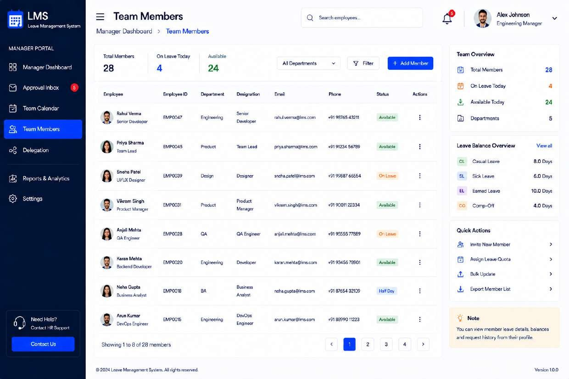
Figure MGR-05 — Team Members

MGR-06 — Delegation Management
Screen ID | MGR-06
Module | Manager Portal
Applicable Role | Manager

Design Purpose
Lets a manager temporarily hand off approval authority to another team member (e.g., during their own leave), so requests don’t stall.
Key UI Elements
- Explainer banner: “What is Delegation?” with a “Create Delegation” call to action
- Tabs: Active Delegations, Upcoming, Past, each with a count
- Delegation cards — delegate-to person, delegated-by, delegation period, scope (departments and leave types covered, or “All Types”), status, and actions
- “Delegation Summary” sidebar counts (Active / Upcoming / Past)
- “Quick Actions” — Create Delegation, My Delegations, Delegation Calendar
- “Important Notes” clarifying the delegating manager remains accountable and is notified of all actions taken on their behalf

Design Note
Scoping a delegation by department and/or leave type (rather than an all-or-nothing handoff) supports organizations where a manager may want a peer to only cover specific request types.
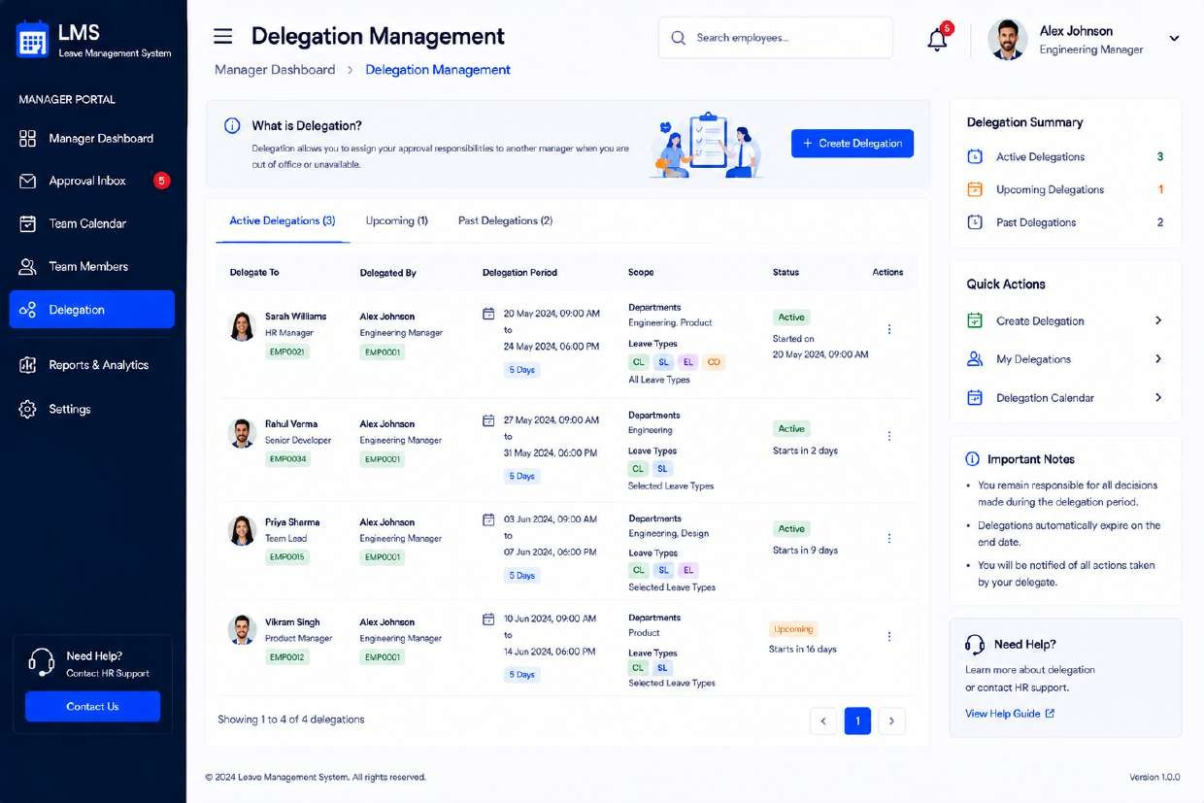
Figure MGR-06 — Delegation Management

5.4 HR / Admin Portal

HR-01 — Employee Management
Screen ID | HR-01
Module | HR / Admin Portal
Applicable Role | HR Admin

Design Purpose
System of record for the workforce — the HR admin’s console for onboarding, updating, and deactivating employee accounts.
Key UI Elements
- “HR Portal” navigation group (HR Dashboard, Employee Management, Leave Policies, Leave Categories, Holiday Calendar, Reports & Analytics, Audit Trail, Notification Queue, Settings)
- KPI cards: Total Employees, Active Employees, On Leave Today, Inactive Employees
- Search, Department / Designation / Status filters, and “Add Employee” primary action
- Employee table — avatar/name, Employee ID, Department, Designation, Email, Phone, Status, row actions
- “Quick Actions” — Add New Employee, Import Employees, Bulk Update, Manage Roles & Access, Employee Documents
- “Department Wise Count” horizontal bar breakdown
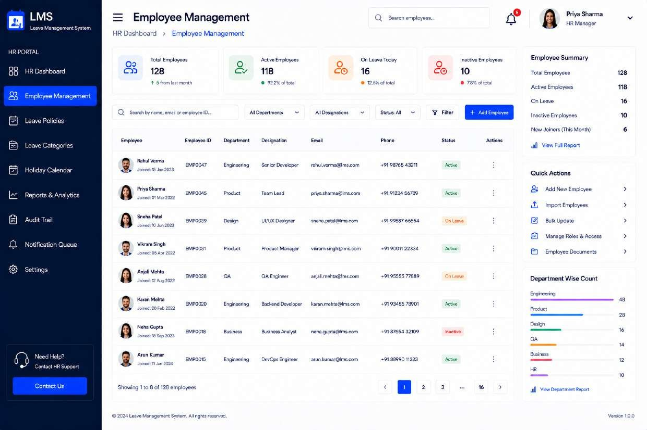
Figure HR-01 — Employee Management

HR-02 — Leave Policies
Screen ID | HR-02
Module | HR / Admin Portal
Applicable Role | HR Admin

Design Purpose
Configuration screen where HR defines the rules that drive validation and balances everywhere else in the system (e.g., what the Apply Leave screen enforces).
Key UI Elements
- Summary cards: Total Policies, Active Policies, Draft Policies, Archived Policies
- “Policy Overview” donut chart (Active / Draft / Archived split)
- Search, Status and “Applicable To” filters, “Create New Policy” action
- Policy table — Policy Name, Code, Leave Type, Applicable To, Accrual Frequency, Carry Forward, Status, row actions
- “Quick Actions” — Create New Policy, Policy Templates, Policy Approval Workflow, Policy History
- “Important Notes” on policy versioning and effective dates

Design Note
Policies are versioned rather than edited in place, so historical leave requests remain auditable against the rules that were in effect when they were submitted.
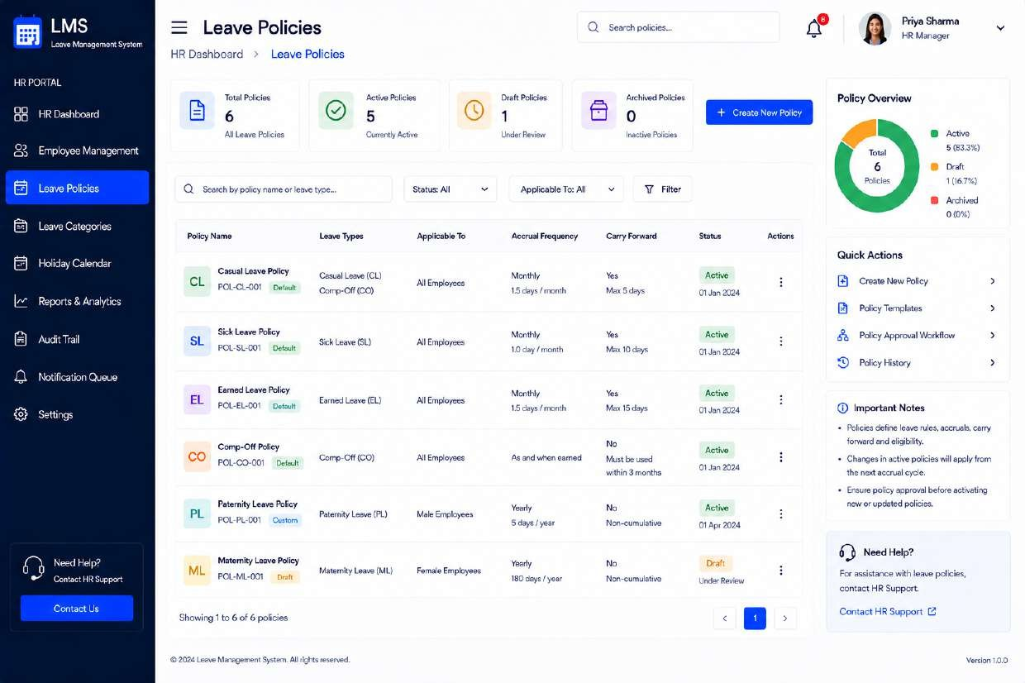
Figure HR-02 — Leave Policies

HR-03 — Leave Categories
Screen ID | HR-03
Module | HR / Admin Portal
Applicable Role | HR Admin

Design Purpose
Defines the master list of leave types available across the organization (Casual, Sick, Earned, Comp-Off, etc.) and their base attributes, which policies then build on.
Key UI Elements
- Summary cards: Total Categories, Active Categories, Inactive Categories, System Categories
- “Category Overview” donut chart (Standard / Accrual / Compensatory / Special / Other)
- Search, Status, Type, and “Applicable To” filters, “Add New Category” action
- Category table — Category Name, Code, Category Type, Applicable To, Paid/Unpaid, Status, row actions
- “Applicable To Summary” breakdown (All Employees, Male, Female, Department-Specific)
- “Quick Actions” and a note that system categories cannot be deleted, only deactivated

Design Note
Separating Leave Categories (the taxonomy) from Leave Policies (the rules) keeps the data model flexible — the same category can have different policies per employee segment.
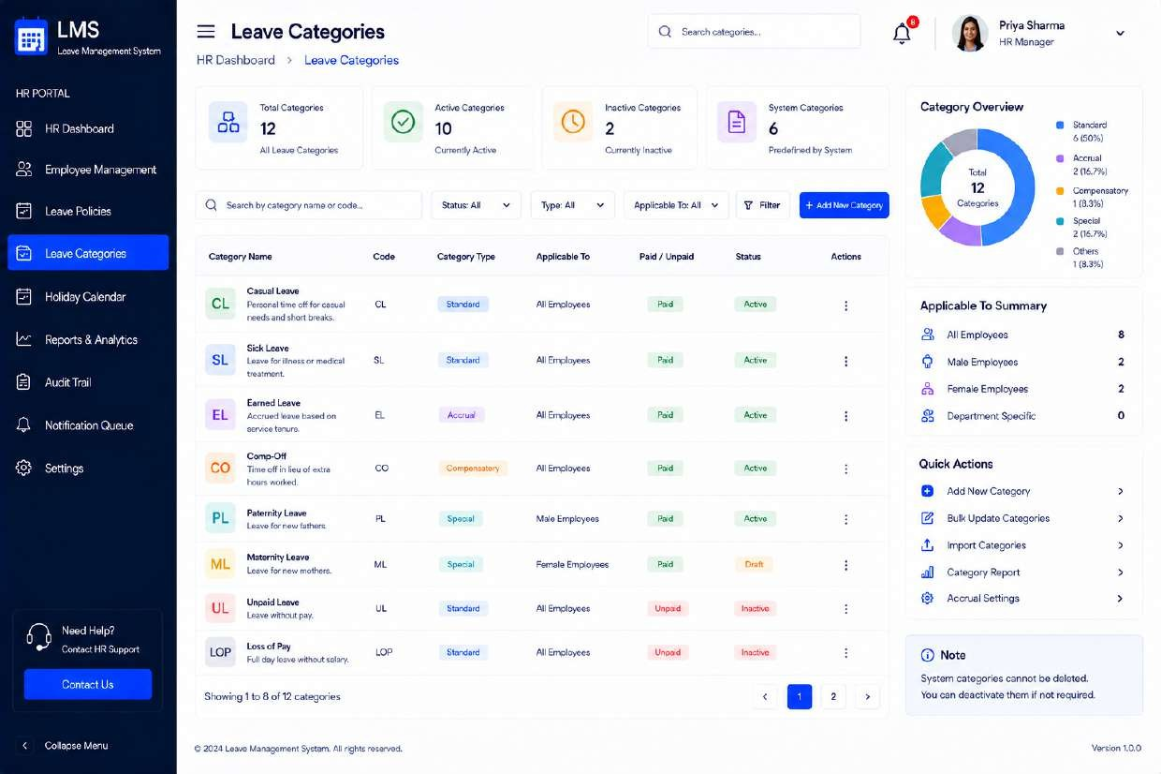
Figure HR-03 — Leave Categories

HR-04 — Holiday Calendar (HR Admin)
Screen ID | HR-04
Module | HR / Admin Portal
Applicable Role | HR Admin

Design Purpose
Administrative counterpart to the employee-facing Holiday Calendar — where HR creates and maintains the holiday list that every other role consumes read-only.
Key UI Elements
- Summary cards: Total Holidays, Upcoming Holidays, Optional Holidays, Restricted Holidays
- Year, Month, Location, and Holiday Type filters, “Add New Holiday” action
- Holiday table — Name, Date, Day, Holiday Type, Location, Applicable To, row actions
- Calendar view mirroring the employee-facing widget for visual confirmation
- “Quick Actions” — Add New Holiday, Import Holidays, Bulk Update, Holiday Settings, Export Calendar
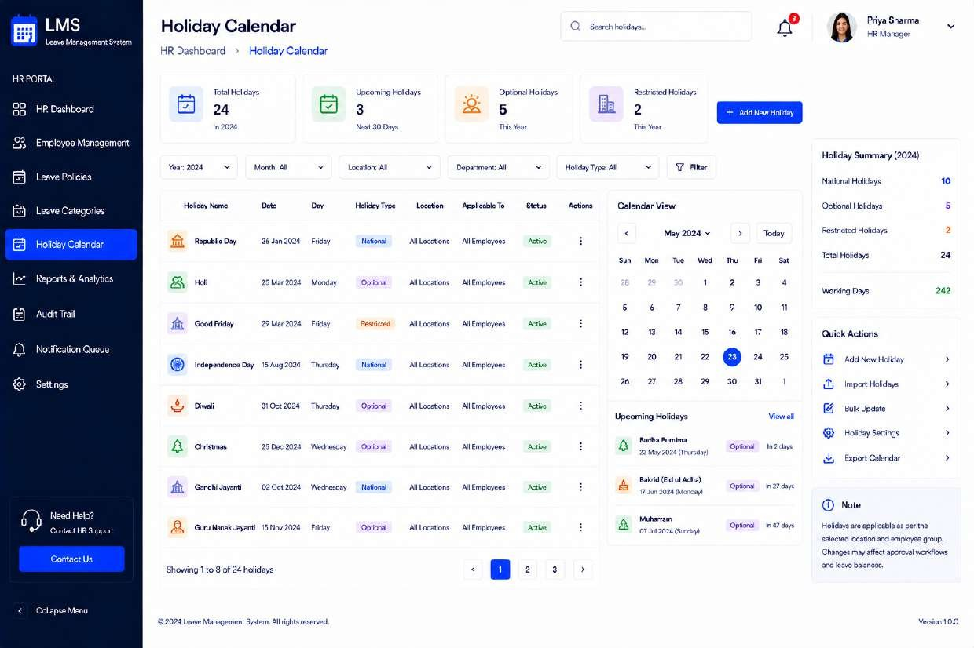
Figure HR-04 — Holiday Calendar (HR Admin)

HR-05 — Reports & Analytics
Screen ID | HR-05
Module | HR / Admin Portal
Applicable Role | HR Admin

Design Purpose
Organization-wide reporting console for HR leadership — leave consumption, utilization, and outliers across the company.
Key UI Elements
- Report Type, Date Range, Department, and Location filters, “Export Report” action
- KPI cards: Total Leaves Taken, Total Employees, Avg Leave / Employee, Approval Rate, Pending Requests
- “Leave Trend Overview” stacked area/line chart and “Leave Distribution by Type” donut chart
- “Leaves by Month” bar chart
- “Top 5 Employees by Leaves Taken” ranked list
- “Department Wise Leave Summary” table
- “Quick Reports” shortcuts and an “Insights & Observations” narrative callout auto-summarizing notable patterns

Design Note
The auto-generated “Insights & Observations” block turns raw charts into a plain-language takeaway, aimed at HR stakeholders who want the story, not just the numbers.
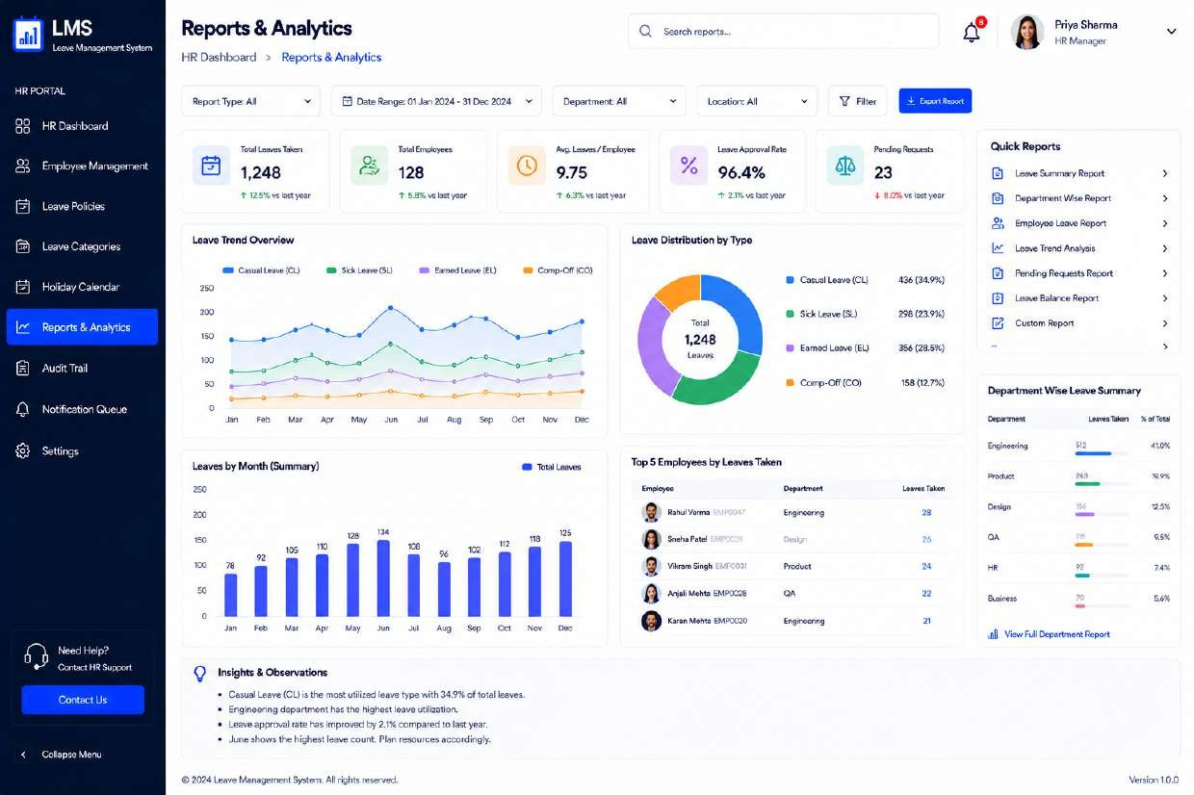
Figure HR-05 — Reports & Analytics

HR-06 — Audit Trail
Screen ID | HR-06
Module | HR / Admin Portal
Applicable Role | HR Admin

Design Purpose
Immutable, searchable log of every significant action in the system — a compliance and troubleshooting tool for HR and system administrators.
Key UI Elements
- Date range, User, Action, Module, and Status filters, plus keyword search
- Summary cards: Total Activities, Failed Actions, Unique Users
- “Top Actions” donut chart
- Audit table — Date & Time, User, Action (e.g., CREATE / UPDATE / APPROVE / DELETE), Module, Description, IP Address, Status
- “Export Log” action
- “Audit Info” panel — retention period, log integrity note, last/next backup

Design Note
Color-coded action badges (create/update/approve/delete) let an admin visually scan for a specific action type across thousands of rows.
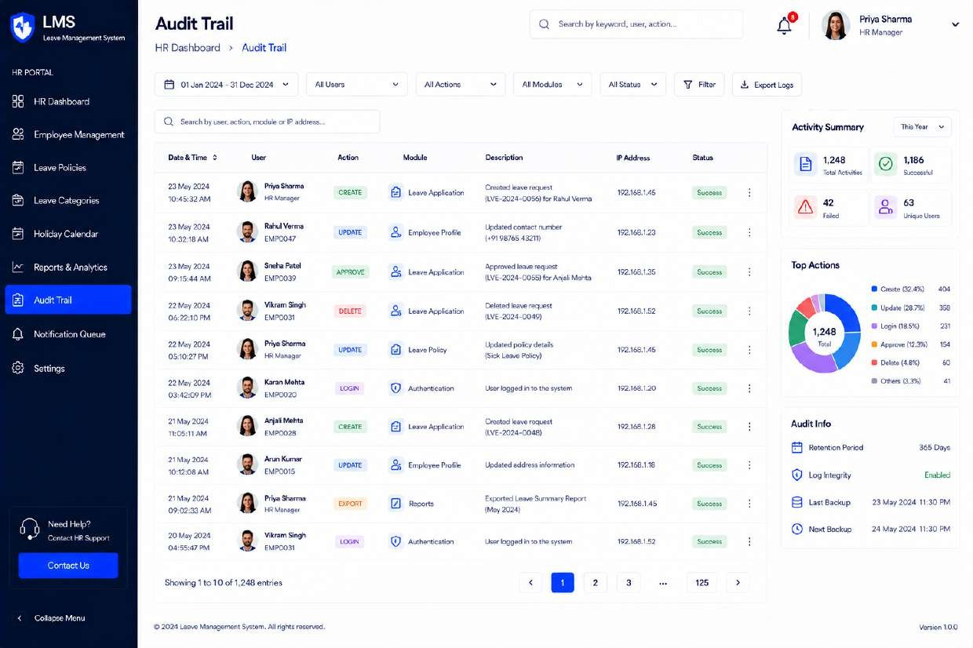
Figure HR-06 — Audit Trail

HR-07 — Notification Queue
Screen ID | HR-07
Module | HR / Admin Portal
Applicable Role | HR Admin

Design Purpose
Operational monitor for the system’s outbound communications (email/SMS) — confirms delivery and surfaces failures that need retrying.
Key UI Elements
- Summary cards: Total Queued, Sent Successfully, In Progress, Failed, Scheduled
- Status, Type, Channel, and date range filters, plus manual Refresh and “Retry Failed” actions
- Queue table — Notification ID, Type, Subject, Recipient, Channel, Status, Scheduled Time, row actions
- “Delivery Overview” donut chart (Sent / In Progress / Failed)
- “Notification Types” breakdown list
- “Quick Actions” — Retry Failed Notifications, Resend Selected, Cancel Scheduled, Export Queue Logs, Notification Settings
- Note that failed notifications auto-retry up to 3 times before requiring manual intervention
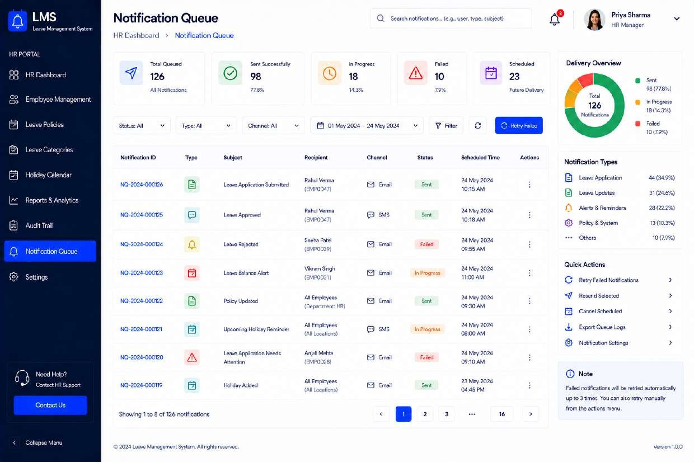
Figure HR-07 — Notification Queue

HR-08 — Settings
Screen ID | HR-08
Module | HR / Admin Portal
Applicable Role | HR Admin

Design Purpose
System-wide configuration console covering company profile, leave defaults, approvals, roles, notifications, security, and integrations.
Key UI Elements
- Tabbed sections: General, Leave Settings, Approval Workflows, Roles & Permissions, Notifications, Security, Integrations, System
- “General” tab — Company Settings (name, email, contact, logo, date/time format, timezone, language) with “Save Changes”
- “System Preferences” toggle list — Employee Self Registration, Leave Balance Display, Weekend Selection, Holiday Display, Auto-Approval for Small Leaves, Backdated Leave Restriction, Two-Step Approval
- “Leave Settings Summary” strip — Maximum Leave Days, Advance Leave Days, Cancellation Window, Minimum Notice Period, Probation Access, Carry Forward
- “System Information” panel — version, environment, database version, last updated by/when
- “Integrations” status list — Email (SendGrid), SMS (Twilio), Calendar (Google), SSO (Azure AD)
- “Quick Actions” — Backup Database, Clear System Cache, Export/Import System Settings, View Activity Logs

Design Note
Grouping dozens of configuration options into scoped tabs (rather than one long page) keeps the admin's cognitive load manageable and makes each setting easier to find via its category.
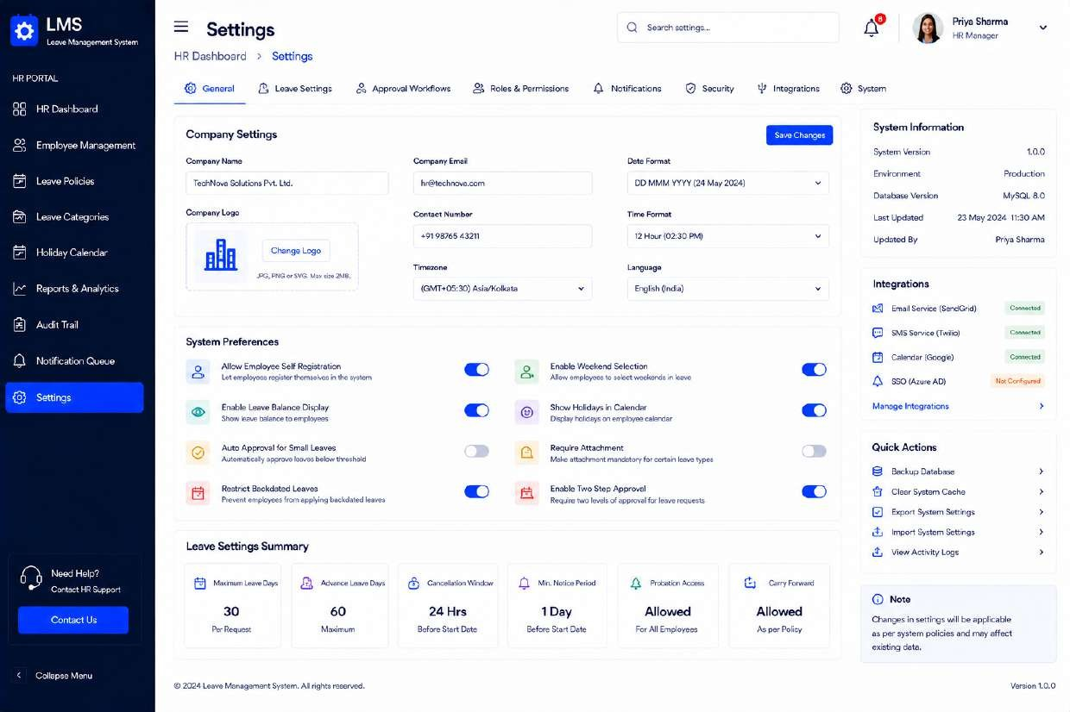
Figure HR-08 — Settings

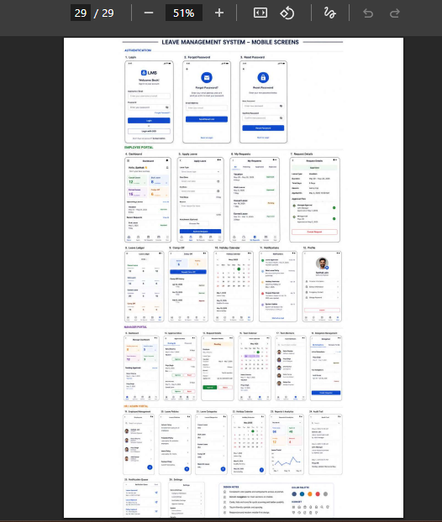

6. Key User Flows

6.1 Leave Application & Approval Flow
The primary end-to-end flow of the product, spanning the Employee and Manager (and, where configured, HR) portals:
1. Employee opens Apply Leave, selects a leave type, and sees their live balance and the relevant policy alongside the form.
2. Employee sets dates and duration (full/half day), enters a reason, optionally attaches a document, and submits.
3. Request appears in the employee’s My Requests with status Pending, and in the manager’s Approval Inbox.
4. Manager reviews the request — inline from the inbox list, or in full via Request Details for anything needing deeper context (team impact, handover coverage).
5. Manager approves or rejects, optionally with a comment. If the organization requires two-step approval (configurable in Settings), the request routes to HR next.
6. Employee is notified of the outcome; the request’s Approval Timeline updates; and, on approval, the Leave Ledger balance is debited automatically.

6.2 Authentication & Account Recovery Flow
1. User lands on Login and authenticates with email/password or a supported SSO provider (Google, Microsoft).
2. On success, a JWT is issued and the user is routed to the dashboard matching their role.
3. If the password is forgotten, the user requests a reset link from Forgot Password.
4. The user enters the emailed OTP and a new password (validated live against the policy checklist) on Reset Password.
5. User is returned to Login to sign in with the new credentials.

6.3 Delegation Flow (Manager Unavailability)
1. Manager opens Delegation Management and creates a delegation, choosing a delegate, a date range, and scope (all leave types/departments or a specific subset).
2. During the active window, incoming requests route to the delegate’s Approval Inbox in addition to (or in place of) the manager’s.
3. All actions taken by the delegate are logged and visible to the original manager, who remains accountable for the outcome.
4. The delegation automatically expires at the end date; the manager can also end it early or view it afterward under Past Delegations.

7. Interaction & Usability Guidelines

7.1 Feedback & States
- Every submit action shows an immediate, unambiguous result — inline field errors on failed validation, a success confirmation on completion, and a loading indicator on the action button while a request is in flight.
- Destructive or hard-to-reverse actions (Reject Request, Withdraw Request) require an explicit secondary confirmation.
- Empty states (e.g., no notifications, no pending approvals) use friendly, specific messaging rather than a blank table.

7.2 Forms
- Required fields are marked with an asterisk; validation runs on blur as well as on submit.
- Date pickers prevent selection of invalid ranges (e.g., To Date before From Date) at the input level rather than only on submit.
- Multi-step forms (Reset Password) show progress and never lose entered data on a validation error.

7.3 Tables & Lists
- Every data table exposes filtering, and most expose export; both are positioned consistently in the top-right of the table card.
- Status is always communicated with both color and text label (never color alone), so meaning isn’t lost for users with color-vision differences.
- Row-level primary actions are one click away (View/Approve/Reject icons); secondary actions live behind the overflow (⋮) menu.

7.4 Notifications
- In-app notifications are categorized (Requests, Approvals, System) and independently configurable per category so users can tune signal-to-noise.
- Time-sensitive alerts (pending approval, OTP) are also sent via email/SMS per the channel preferences configured in Settings.

8. Accessibility Guidelines
The product targets WCAG 2.1 Level AA conformance. Key requirements for implementation:
- Color contrast — text and interactive elements maintain a minimum 4.5:1 contrast ratio against their background; status is never conveyed by color alone (chips always carry a text label).
- Keyboard navigation — every interactive element (nav items, form fields, table row actions, modal controls) is reachable and operable via keyboard, with a visible focus indicator.
- Screen reader support — form fields have programmatically associated labels; icon-only buttons (e.g., table row actions) include accessible names; status chips and charts have text equivalents.
- Form errors — announced to assistive technology and associated with their field via ARIA attributes, not conveyed by color or position alone.
- Target size — interactive controls maintain a minimum comfortable touch/click target, particularly for row-level icon actions in dense tables.
- Motion — loading and transition animations are subtle and respect the user’s reduced-motion preference where supported by the browser.

9. Responsive Design Considerations
The design shown in this document reflects the desktop breakpoint (≥1280px), which is the primary usage context for both approvers and HR administrators working with dense tables and reports. The following adaptations apply at narrower breakpoints:
Breakpoint | Target Devices | Key Adaptations
≥1280px (Desktop) | Laptop / desktop monitors | Full layout as documented: persistent sidebar, multi-column dashboards, wide data tables.
768–1279px (Tablet) | Tablets, small laptops | Sidebar collapses to an icon rail or slide-out drawer; dashboard cards reflow from 3–4 columns to 2; tables gain horizontal scroll where columns can’t compress.
<768px (Mobile) | Phones | Sidebar becomes a hamburger-triggered overlay; dashboards and forms stack to a single column; tables convert to stacked record cards; the split-screen auth layout collapses to a single centered column.

Employees are expected to occasionally apply for or check leave from a phone; the Apply Leave, My Requests, and Notifications screens should therefore be prioritized for mobile-adaptation QA, while the denser HR/reporting screens are optimized primarily for desktop use.

10. Appendix

10.1 Screen Inventory Summary
Module | Screen Count | Screens
Authentication | 3 | Login, Forgot Password, Reset Password
Employee Portal | 9 | Dashboard, Apply Leave, My Requests, Request Details, Leave Ledger, Comp-Off, Holiday Calendar, Notifications, Profile
Manager Portal | 6 | Dashboard, Approval Inbox, Request Details, Team Calendar, Team Members, Delegation Management
HR / Admin Portal | 8 | Employee Management, Leave Policies, Leave Categories, Holiday Calendar, Reports & Analytics, Audit Trail, Notification Queue, Settings

10.2 Assumptions
- Leave balances, accrual, and carry-forward calculations are governed by policies configured in the HR/Admin Portal and are enforced server-side, not solely in the UI.
- Two-step (Manager + HR) approval is a configurable option in Settings and is not mandatory for every organization using the system.
- SSO (Google/Microsoft) is optional per deployment and depends on the organization’s identity provider configuration.

10.3 Open Questions for Engineering Review
- Confirm maximum file size/type for leave-request attachments referenced on the Apply Leave and Request Details screens.
- Confirm behavior when a delegate themselves goes on leave during an active delegation window.
- Confirm retention period for Audit Trail records referenced in the HR/Admin Portal.

10.4 Glossary
Term | Definition
Comp-Off | Compensatory time off earned by an employee for working on a weekend, holiday, or beyond scheduled hours.
Leave Ledger | The running, auditable record of leave credits and debits for an employee, per leave type.
Delegation | A temporary, scoped handoff of approval authority from one manager to another.
Leave Category | The master taxonomy of leave types (e.g., Casual, Sick, Earned) configured by HR.
Leave Policy | The specific rule set (quota, accrual, carry-forward, eligibility) applied to a leave category.

