**Smart Wearable Technology: Smart-Glass**

**Ayush Dev, Shubham Saxena, Siddhant Pandey and Sourav Das**

**Guided by : Prof. (Dr.) Nirmal Kumar Rout**

**Abstract -** *Studies on developing smart wearable technology are taking its boom in recent years making efforts towards better human life. Prime examples of smart wearable technologies are ‘Smart Glasses’ and ‘Smart Watches’. The integration of smart wearables with human well-being is becoming reality these days. The proposed smart glass is aimed to increase efficiency, productivity, and interlinking computing devices into our everyday lives by presenting the important information directly in front of his/her eyes for example: navigation information/directions, presenting critical data in medical operative procedures, gaming controls etc. Smart-glasses are also becoming useful for visually and hearing-impaired people. For blinds, several solutions are already available but they lack some functionalities and ease of use. In this paper, an effort in this direction is made, to rectify those problems.*

**Keywords -** Embedded systems, Internet of Things (IoT), Machine Learning (ML), Smart wearable, Smart glass

1. **Introduction**

The pace at which the technology sector is rising is enormous because of its widespread all over the world and with constant improvements in its services and quality. The research on developing smart technology has grown rapidly in recent years in contributing towards a smart and enhanced human life [1]. The term smart innovations specify the employment of hardware, software, integration in a very efficient and innovative manner. Smart wearables, such as smart glasses, smart jackets, smart textiles, fashion accessories, such as smart jackets, smart hats, and gaming gadgets, are among the most commonly utilized items in today's technology. The wearable technology that is proposed, is the integration of smart glass and smartwatch using IoT, embedded systems and machine learning technologies with human life for increasing efficiency, productivity, and interlinking computing devices into our everyday life*.* This system is capable of doing a wide range of computer tasks that a normal human cannot. Smart Glasses can also help those who are visually or hearing challenged. It can provide minimal assistance to these individuals. Several solutions for blinds are currently available, however, they lack some features and are difficult to operate [2].

1. **Technology used**

* **ESP 32 cam :** ESP32-CAM is a low cost, low-power 32-bit development board that we are using for our application. ESP32-CAM is the smallest Wi-Fi SoC with an onboard camera OV2640 [5], and some of its versions also have Bluetooth[4]. This MCU best fit for our project.
* **Display:** The display that we are planning to use for smart glass is the 128x56 transparent OLED display that supports parallel (8-bits), I2C, and SPI protocols to establish communication with the microcontroller.
* **MPU 6050:** InvenSense MPU6050 is a 6 axis gyro, accelerometer. MPU6050 will be used to track the user’s physical activity and for the gesture control. There will be some predefined gesture controls.[6]
* **MAX30100:** MAX30100 is an integrated pulse oximetry and heart rate monitoring sensor.
* **Eye blink sensor:** The eyeblink detection sensor uses IR light, If the eye is closed there is no reflection of IR light and thus it detects the eye blinking of human beings.
* **WIT AI:** Wit is a natural language interface for applications that are capable of turning sentences into structured data. It was developed by Facebook. It works with intents and entities. It is used to “Turn What Users Say Into Actions”.
* **Android Application:** The application will have complete access to the smart glass for keeping track of the user's health, for receiving calls and notifications, and for customization of the devices.
* **Storage:** For storing some image or video micro-secure digital cards (SD) are used. For transferring files from one device to another, file transfer protocol (FTP) is used.

1. **Proposed Model**

The main steps for the smart-glass to function are collecting and acquiring the data, processing the acquired data, storing the data at the local device, transmitting the data for other online services and for the better results for the machine learning models.

1. **Data Acquirement:** The Smart-glass requires various types of data for its functionalities like:

* Body Temperature which is being collected by the inbuilt temperature sensor of MPU6050.
* The user’s physical activity and energy loss will be calculated by using MPU6050 gyroscope accelerometer sensor data.
* The measurement of distance for a person who is blind, a small range of infra-red (IR) or ultrasonic transmitter and detector will be used.
* For Images and Videos, the ESP32 cam module will take the image data via its inbuilt 2-megapixel camera and will convert it to base-64 encoded bit.
* The percentage of oxygen in blood and heart rate will be measured using the pulse oximeter sensor MAX 30100 by Maxim Integrated.
* The eyeblink detection sensor is one type of infra-red sensor.

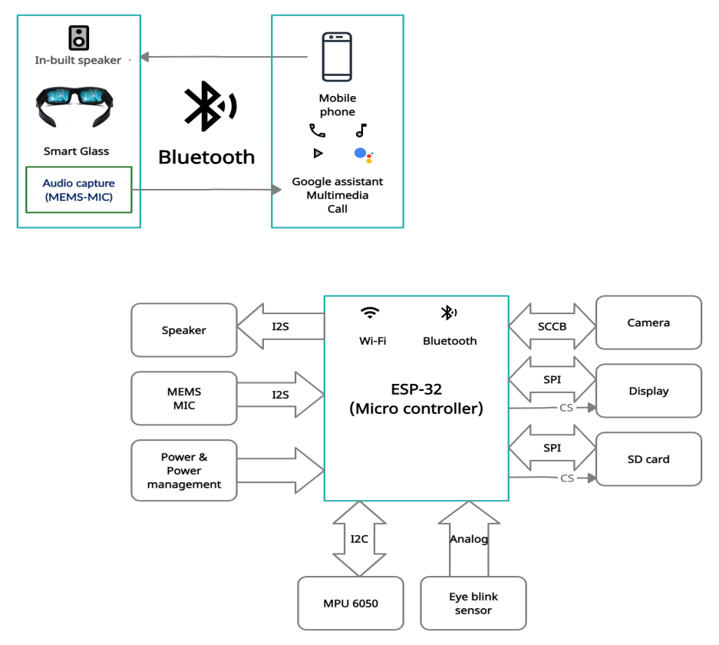

Fig. 1. Connection of peripherals of smart-glass

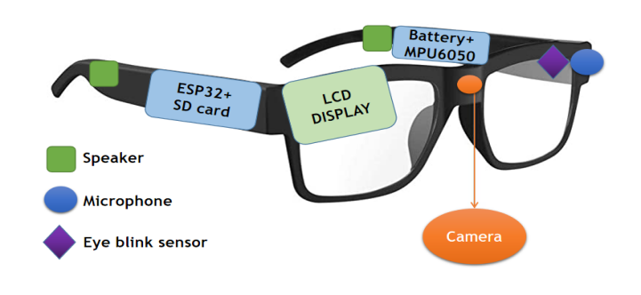

Fig. 2. Placement of components of smart-glass

1. **Data Processing:** The collected data needs to be processed for various results like object detection models, eye blink detection etc.

* ***Data Collected By Sensors:*** The data from sensors is collected by the microcontroller through GPIO peripheral in digital or analog format according to requirements and sensor output type.
* ***Photos and Videos Collected:*** The image captured by the ESP32 camera board will be further processed by both the android app and cloud image processing.

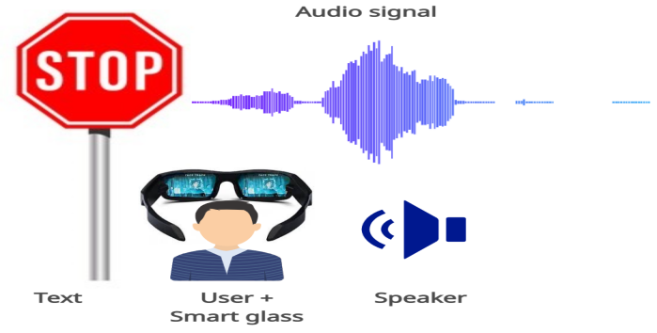

Fig. 4. Offline text to speech converting

Fig. 3. Online image and video processing and storing

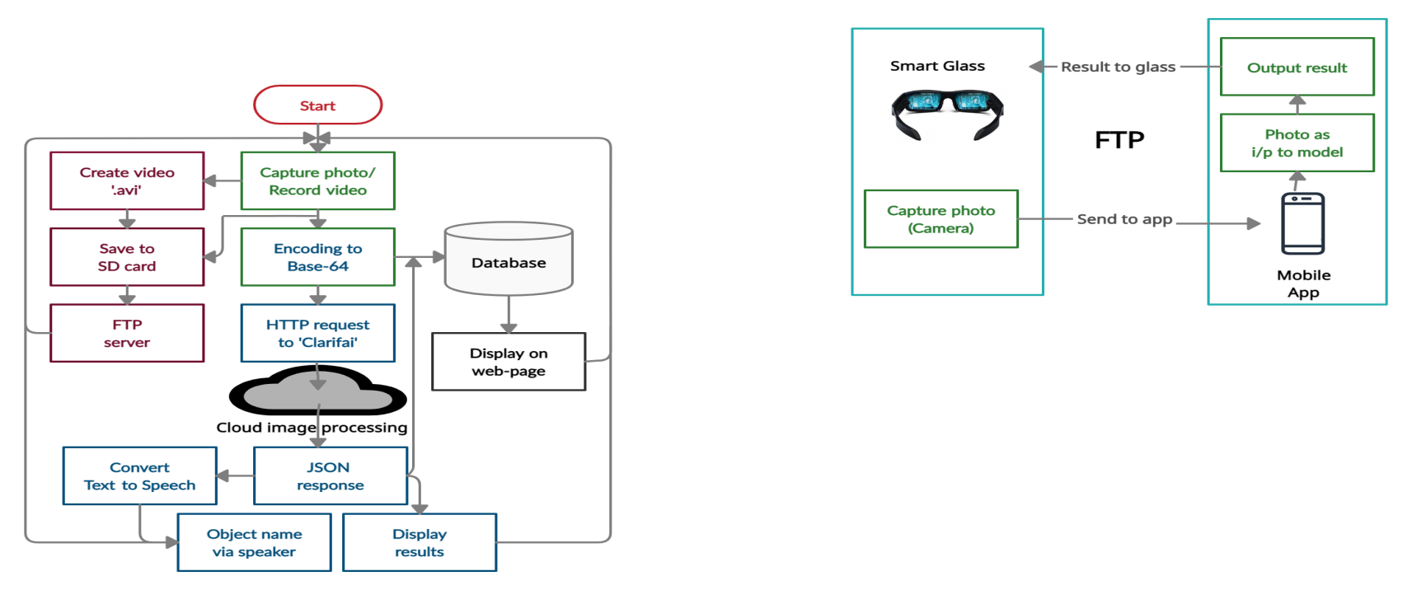

* ***Audio Input Collected:*** For the following task Python and its Various libraries will be used. GTTS(Google Text-to-Speech) library will be used.
* ***Mobile Application:*** An android application is being used which will be equipped with features like tracking the beneficial data like object detection and other related results, calls and messages notifications.

1. **Data Storage:** All the sensor data will be stored both in the local database and in the cloud database. All the data of a particular user will be stored in a particular cloud database table allocated to him/her and can access the data using appropriate authentication. The database will be used as a real-time database so that the user can access the current values of data through the application easily.
2. Data transmission: The data transmission is mainly done in two ways, data transmission between the MCU and the cloud database and the data transmission between the MCU and the smartphone. The sensor-based data is stored on the cloud database through transmission control protocol (TCP) protocol using in-built wifi (IEEE 802.11) of the MCU. The mobile application takes a maximum of the data from the cloud, and the image and video files are transferred between the MCU to the application directly through the file transfer protocol (FTP).
3. **RESULTS**

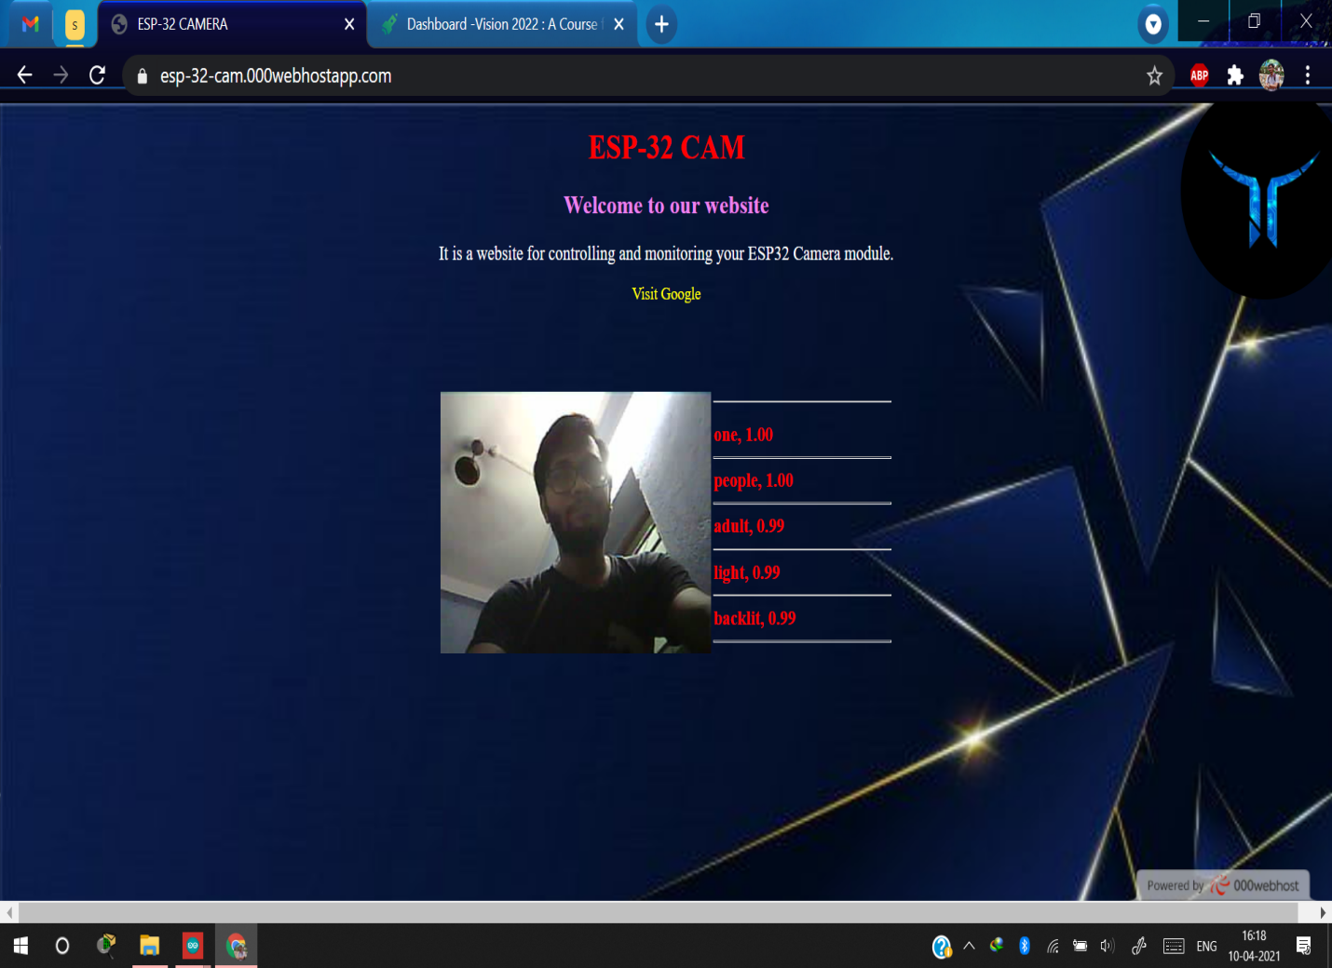

Fig. 5. Webpage displaying the predicted object/ person results

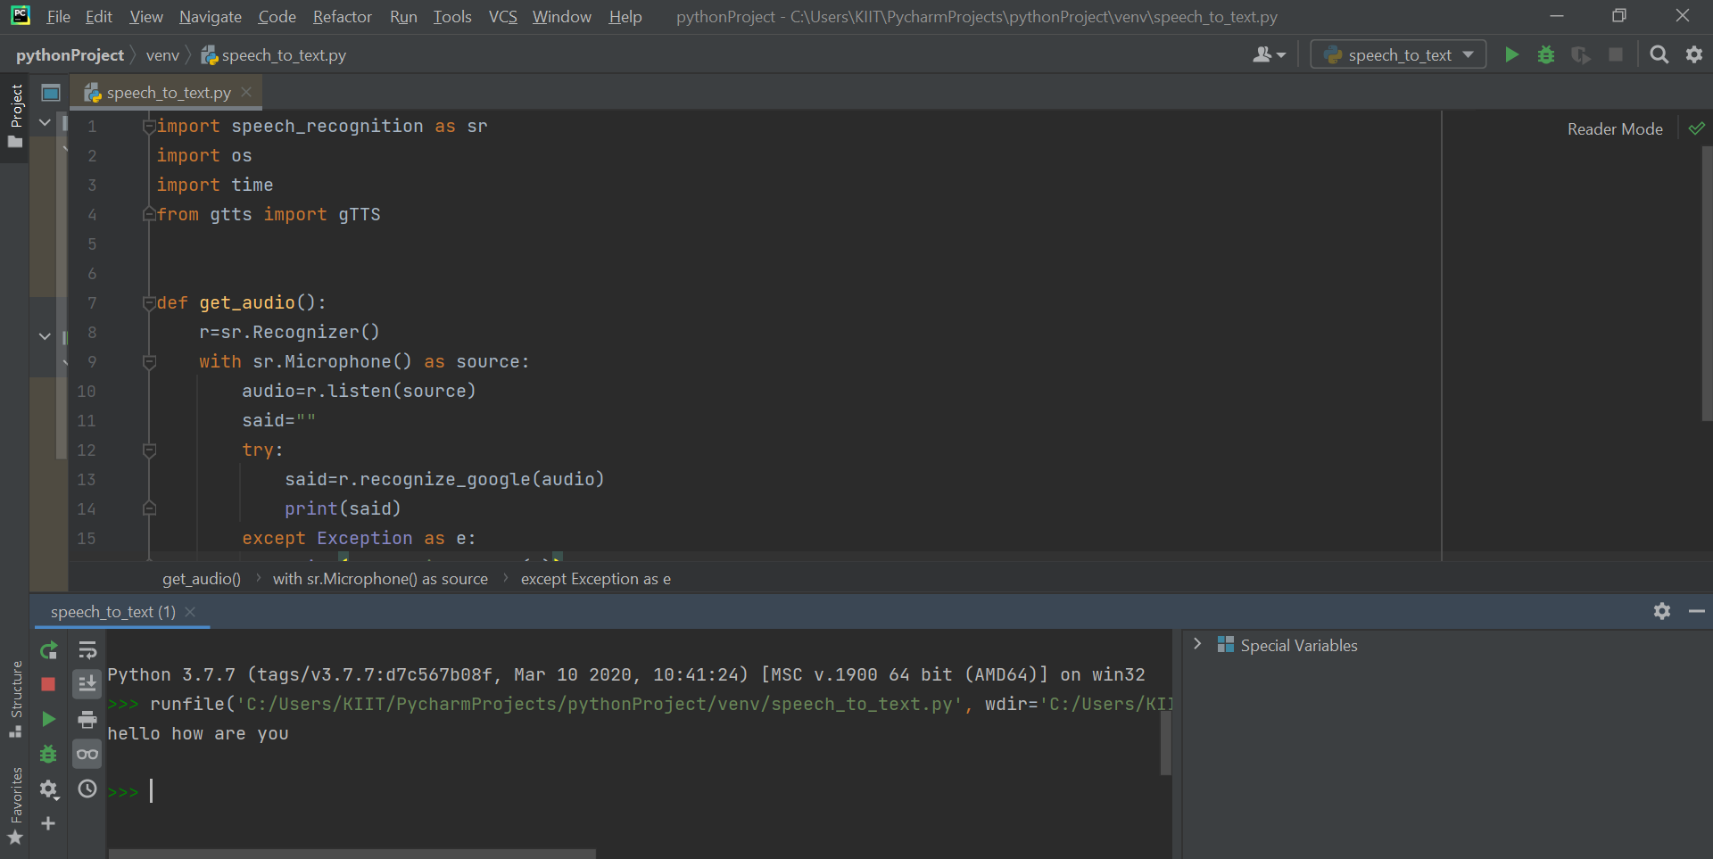

Fig. 6. Speech to text ML model output

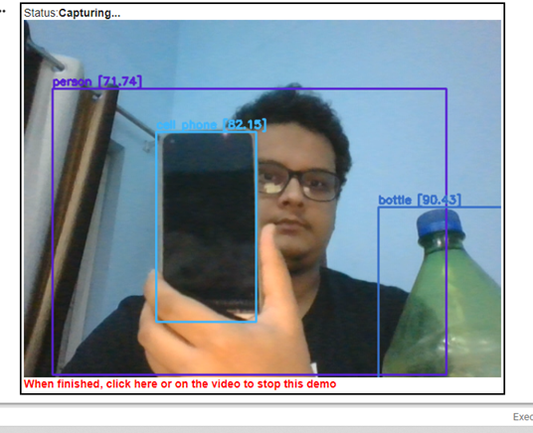 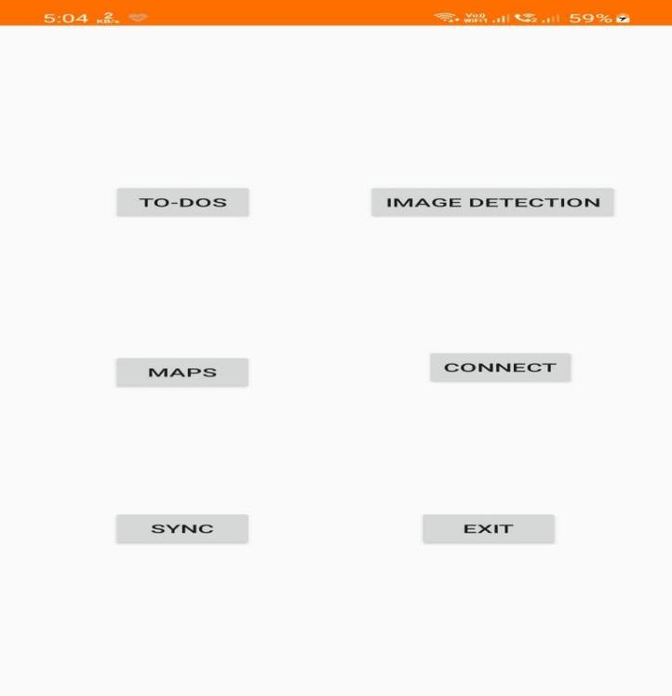

Fig.7. Object detection using live camera feed Fig.8. Android Application Home UI

**IV. CONCLUSION**

It appears that smart glasses have an outstanding opportunity for its growth along with its offerings in various regions. Discussions have been done in brief about the presently available smart-glass with its features, built factors, various uses, and difficulties that were recognized and considered in detail by the means of this paper. Technologies like smart glasses have proven to be a very important and beneficial invention for mankind. With its extraordinary capabilities and features, a smart-glass will soon be able to surpass daily life gadgets in becoming a daily-life accessory. With regular improvements over time, these technologies will keep on making lives easier. Proposed smart glass supports blind people in many ways, it has the potential to change their life.

**V. REFERENCES**

1. Dr. P. Howard-Jones, “The impact of digital technologies on human wellbeing”, A state of the art review, Nominet Trust, July 2011.
2. M. ÇİÇEK, “WEARABLE TECHNOLOGIES AND ITS FUTURE APPLICATIONS”, International Journal of Electrical, Electronics and Data Communication, ISSN: 2320-2084, Volume-3, Issue-4, April 2015.
3. GLASS ENTERPRISE EDITION 2, Glass, Google, <https://www.google.com/glass/start/>
4. Datasheet- Espressif Systems, ESP32 Series Datasheet, Version 3.7, 2021.
5. Datasheet- OmniVision Technologies, OV2640 Color CMOS UXGA (2.0 MegaPixel) CameraChip, Version 1.6, February 2006.
6. Datasheet- InvenSense Inc. MPU-6000 and MPU-6050 Product Specification. PS-MPU-6000A-00, Version 3.4, 2013.