

WATINAKAMA.LK: AI-POWERED VEHICLE INSPECTION AND VALUATION SYSTEM
INDIVIDUAL THESIS
Charuka A. L. D
IT22641274
Individual component: Market Value Analysis
Group ID: R26-IT-071

Report submitted in partial fulfilment of the requirements for the
Bachelor of Science (Hons) in Information Technology
Specialize in Information Technology
Department of Information Technology
Sri Lanka Institute of Information Technology
Sri Lanka
October 2026

ABSTRACT
Buying a used car in Sri Lanka is difficult for a buyer because there is no easy way to know whether the asking price is fair, and the available price tools do not consider the real condition of the vehicle. This thesis presents the market value analysis component of Watinakama.LK, a mobile vehicle inspection system. The component takes the basic details of a Suzuki Alto (2012 to 2017) together with the VIN status, body condition score and engine fault given by the other three components, and returns a fair value, a verdict on the asking price, a negotiation range and a short explanation. I collected 343 advertisements, cleaned them to 338 records, collected repair costs from five local sellers and repair centres, and generated a training dataset of 2,000 records that includes condition features. Four tree-based models were tuned and combined in a stacking ensemble, which was deployed as a Flask web service with token authentication. On a random test split the ensemble gave a mean absolute error of LKR 121,906, an R² of 0.716 and a MAPE of 3.32%. However, a stricter validation that keeps similar generated records together showed that this result was too optimistic. The more realistic error is about LKR 155,000 (R² about 0.52), and at this level the ensemble was not better than linear regression. The model also did not use the condition features accurately. The verdict was correct for more than 97% of listings priced 15% away from the market value, but it was less reliable near the 5% limits. The web service passed all API tests and responded in about 0.1 seconds. The study shows the risk of data leakage when generated data is used with a small dataset, and recommends applying condition deductions with rules and showing the value as a range.
Keywords: used car valuation, price prediction, stacking ensemble, data leakage, Sri Lanka
ACKNOWLEDGEMENTS
First, I would like to thank my supervisor, Dr. Dinuka Wijendra, and my co-supervisor, Miss. Jenny Krishara, for their guidance, feedback and encouragement throughout this research project.
I also thank the other members of our group R26-IT-071, who developed the VIN authentication, body condition and engine sound components and the mobile application. My component depends on their work and the integration was done together as a team.
I am thankful to the parts sellers and repair centers who shared their prices for the repair cost survey, and to the lecturers and panel members of the Sri Lanka Institute of Information Technology for their comments during the progress presentations.
Finally, I thank my family and friends for their support during this year.
TABLE OF CONTENTS
DECLARATION AND SUPERVISOR CERTIFICATION Error! Bookmark not defined.
ABSTRACT i
ACKNOWLEDGEMENTS ii
TABLE OF CONTENTS iii
LIST OF FIGURES vi
LIST OF TABLES vii
LIST OF ABBREVIATIONS viii
1 INTRODUCTION 1
1.1 Overall project context 1
1.2 Individual component context 2
1.3 Problem statement 3
1.4 Research gap 3
1.5 Aim and objectives 4
1.6 Research questions or hypotheses 4
1.7 Scope limitations and assumptions 5
1.8 Individual contribution 5
1.9 Thesis structure 6
2 LITERATURE REVIEW AND RELATED WORK 7
2.1 Review method and scope 7
2.2 Domain and theoretical foundations 7
2.3 Related research 8
2.4 Existing systems products and techniques 9
2.5 Gap synthesis and conceptual framework 9
3 RESEARCH METHODOLOGY 11
3.1 Research design 11
3.2 Data participants or study materials 11
3.3 Experimental or study procedure 16
3.4 Measures and evaluation metrics 17
3.5 Data analysis 18
3.6 Ethics privacy security and responsible AI 18
3.7 Reproducibility and research artefacts 19
4 PRODUCT AND SOLUTION DESIGN 20
4.1 Requirements 20
4.2 Component architecture within the complete solution 20
4.3 Design alternatives and decisions 22
4.4 Detailed design 23
4.5 Standards and professional practice 26
5 IMPLEMENTATION INTEGRATION AND TESTING 27
5.1 Development environment and technology stack 27
5.2 Component implementation 27
5.3 Integration with the other components 28
5.4 Verification and software testing 29
5.5 Deployment and operation 31
6 RESULTS AND VALIDATION 32
6.1 Research results 32
6.2 Product and technical results 35
6.3 User or stakeholder validation 36
6.4 Integration results 36
6.5 Summary of findings 37
7 DISCUSSION 38
7.1 Interpretation of findings 38
7.2 Comparison with literature baselines and existing solutions 39
7.3 Research contribution 39
7.4 Product contribution 40
7.5 Limitations and threats to validity 40
7.6 Implications 40
8 COMMERCIALISATION AND SUSTAINABILITY 42
8.1 Value proposition and target users 42
8.2 Market and competitive position 42
8.3 Business or sustainability model 42
8.4 Scalability intellectual property and compliance 43
8.5 Contribution to the Sustainable Development Goals 43
9 CONCLUSION AND FUTURE DIRECTIONS 44
9.1 Conclusion 44
9.2 Achievement of objectives 44
9.3 Individual research and product contributions 45
9.4 Future directions 45
REFERENCES 46
GLOSSARY 48
APPENDICES 49
Appendix A Extended results and specifications 49
Appendix B Academic integrity and AI use disclosure 50

LIST OF FIGURES
Figure 1.1: Overall architecture of Watinakama.LK and the position of Component 4 2
Figure 2.1: Conceptual framework of the valuation component 10
Figure 3.1: Research process followed for the component 11
Figure 3.2: Data cleaning and augmentation steps 13
Figure 3.3: Listed price by year of manufacture (n is the number of listings) 14
Figure 4.1: Internal architecture of the market value analysis component 21
Figure 4.2: Sequence of calls during a full inspection 22
Figure 4.3: Verdict bands compared with the predicted fair value 23
Figure 4.4: Structure of the stacking ensemble 24
Figure 4.5: Decision flow of the valuation function 25
Figure 5.1: Deployment view of the valuation service 31
Figure 6.1: Mean absolute error of each model on the test records 32
Figure 6.2: Predicted price against actual price on the test records (dashed lines show ±5%) 33
Figure 6.3: MAE of the ensemble with different validation methods 34
Figure 6.4: Drop in predicted value when the body score is reduced, compared with the deduction used in the training data 35

LIST OF TABLES
Table 2.1: Summary of related studies on used-car price prediction 8
Table 3.1: Summary of the cleaned listing data (338 records) 14
Table 3.2: Engine repair cost ranges from the survey 15
Table 3.3: Body damage levels and repair cost ranges 15
Table 3.4: Selected hyperparameters of the base models 17
Table 3.5: Main files of the component 19
Table 4.1: Functional requirements 20
Table 4.2: Non-functional requirements 20
Table 4.3: Features used by the model 23
Table 4.4: Endpoints of the valuation service 26
Table 5.1: Technology stack 27
Table 5.2: Values sent from the app to the valuation service 29
Table 5.3: Functional test cases and results 29
Table 5.4: Issues found during testing 30
Table 5.5: API test cases and results 30
Table 6.1: Model results on the 400 test records 32
Table 6.2: Results of the ensemble with different validation methods 33
Table 6.3: Verdicts for test records presented at different prices (% of 400 records) 35
Table 9.1: Achievement of objectives 44
Table A.1: Parts and service prices from the survey (LKR) 49
Table B.1: Disclosure of generative AI and automated tool use 50

LIST OF ABBREVIATIONS
Abbreviation | Meaning
API | Application Programming Interface
CRISP-DM | Cross-Industry Standard Process for Data Mining
FR | Functional requirement
FV | Fair value
GPU | Graphics Processing Unit
HTTP | Hypertext Transfer Protocol
JSON | JavaScript Object Notation
LKR | Sri Lankan rupee
MAE | Mean absolute error
MAPE | Mean absolute percentage error
NFR | Non-functional requirement
REST | Representational State Transfer
RMSE | Root mean squared error
RQ | Research question
SDG | Sustainable Development Goal
VIN | Vehicle Identification Number

1 INTRODUCTION

1.1 Overall project context
Buying a used car in Sri Lanka depends a lot on trust. A buyer sees an advertisement on a classifieds website, meets the seller, checks the car for a short time and then bargains from the price the seller is asking. The seller knows the full history of the car but the buyer only knows what can be seen in that short visit. Akerlof explained many years ago that when buyers cannot tell a good car from a bad one, the whole market suffers, because good cars and bad cars end up being sold at similar prices [1].
The situation in Sri Lanka became worse after vehicle imports were restricted in March 2020. The restriction stayed for nearly five years and was relaxed only from early 2025 [2]. During this time very few new vehicles came into the country, so the prices of used cars went up a lot, and even ten-year-old small cars were sold for very high prices. A normal buyer has no easy way to check whether an asking price is fair. The classifieds sites only show asking prices, and there is no public record of the prices at which cars were actually sold.
Our group project, Watinakama.LK (group R26-IT-071), tries to help this buyer by using a mobile phone. The system has four research components and a mobile application, as shown in Figure 1.1.
- Component 1 checks a photo of the VIN (Vehicle Identification Number) plate and says whether it looks original or altered.
- Component 2 checks five photos of the vehicle body, finds damage such as dents, scratches and rust, and gives a body condition score from 0 to 100.
- Component 3 records the engine sound with the phone microphone and detects whether the engine is healthy or has one of five faults.
- Component 4, which is my component, takes the vehicle details and the results of the other three components and gives the market value of the vehicle and a verdict on the asking price.
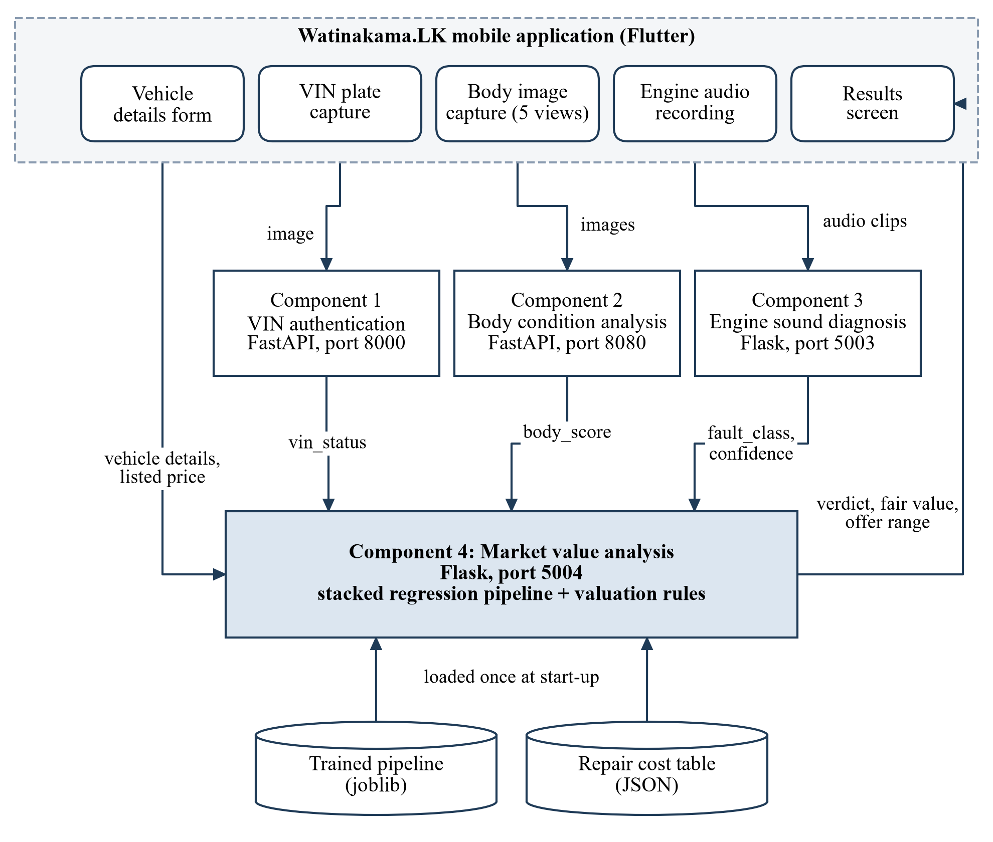
Figure 1.1: Overall architecture of Watinakama.LK and the position of Component 4
Each component runs as a separate web service. The mobile application collects the inputs, calls the first three services and sends their results to my service. So the valuation is the last step of the inspection and it is the result that the user is most interested in.

1.2 Individual component context
My component is the market value analysis service. In simple words, it answers two questions for the buyer: how much is this car worth, and is the asking price reasonable?
The service takes two kinds of input. The first kind is the basic details that are in any advertisement: year of manufacture, year of registration, mileage, number of previous owners, whether the car came to Sri Lanka brand new or reconditioned, and whether it has power shutters and power mirrors. The second kind comes from the other components: the VIN status, the body condition score, and the engine fault with its confidence value. The buyer also enters the asking price.
The service gives back a fair value in rupees, a verdict (good deal, fair price, overpriced or do not buy), a negotiation range with a recommended offer, the estimated repair costs and a short explanation.
The model was trained only for one vehicle type, the Suzuki Alto made between 2012 and 2017. I selected this car because it is one of the most common small cars advertised in Sri Lanka, so I could collect enough data for it by myself.

1.3 Problem statement
At present a buyer can check an asking price in a few ways, and all of them have problems. The buyer can compare with other advertisements, but that only shows what other sellers are asking and says nothing about the condition of this particular car. The buyer can ask a broker or a mechanic, but the answer depends on the person. Some online tools give a price from the year and mileage, but they do not know about a dent in the door or a noise in the engine.
There is also a data problem. No dataset is available that has the price of a used car together with a measured body condition and engine condition, because these checks are not normally done when a car is sold.
So the problem I worked on is this: how can we build a valuation service for the Sri Lankan used-car market, using a small number of advertised prices, that gives a reasonable value, adjusts it for the inspected condition, and shows the result in a way a normal buyer can understand?

1.4 Research gap
After reading the related research (chapter 2), I identified the following gaps.
- Most used-car price prediction studies use only advertisement details such as year, mileage and brand [3], [4], [5]. If condition is included, it is only a category typed by the seller. I could not find a study where the condition comes from an automatic inspection of the vehicle.
- Almost all the studies use data from other countries such as Germany, Pakistan, Mauritius and Bosnia. Sri Lankan prices behave differently because of import rules and taxes, and I could not find a published price model that uses Sri Lankan listings.
- The studies stop at the predicted price. They do not give a verdict, a negotiation range or an explanation, which are the things a buyer really needs.
- When a small dataset is enlarged with generated records, the model is usually tested on a random split of the enlarged data. This can make the results look better than they really are [6]. I found this problem in my own results as well, and it is discussed in chapter 6.

1.5 Aim and objectives
The aim of my component is to design, develop and evaluate a valuation service for used Suzuki Alto cars in Sri Lanka that considers the inspected condition of the vehicle and works with the Watinakama.LK mobile application.
The objectives are:
- To collect and clean a dataset of advertised prices of Suzuki Alto cars.
- To collect local repair costs for the engine faults and body damage levels detected by the other components.
- To prepare a training dataset where the price depends on body condition and engine condition as well as the advertised details.
- To train and compare several regression models and a stacking ensemble, and select the best one.
- To evaluate the selected model properly and check how it reacts to the inputs.
- To develop the valuation logic (verdict, negotiation range, explanation), build it as a secured web service and connect it to the mobile application.

1.6 Research questions or hypotheses
The research was guided by these questions.
RQ1. How accurately can the price of a used Suzuki Alto be predicted from the details given in an advertisement?
RQ2. Does a stacking ensemble give better predictions than single models?
RQ3. Can the outputs of the VIN, body and engine components be used in the valuation in a sensible way?
RQ4. Do the accuracy results change when the model is tested in a stricter way?
At the start I expected the ensemble to be clearly better than single models, because earlier studies reported this [4], [7]. The results in chapter 6 show that the answer is not that simple.

1.7 Scope limitations and assumptions
- The model is only for the Suzuki Alto made from 2012 to 2017. It should not be used for other vehicles.
- The prices in the dataset are asking prices from advertisements, not the final sale prices. Final prices are usually a little lower.
- Most of the listings were collected between November 2025 and March 2026, so the model represents the prices of that period.
- The body score and engine fault are taken from Components 2 and 3 as they are. If those components make a mistake, the valuation will also be affected.
- None of the real listings had a measured body score or engine fault. These values were generated, and their effect on the price was added using repair costs. This is explained in section 3.2.
- The repair costs were collected from only five sellers and repair centres, so they are approximate.

1.8 Individual contribution
All the work on Component 4 described in this thesis was done by me. My contributions are:
- collecting the 343 advertisements and entering them into a spreadsheet;
- doing the repair cost survey and preparing the repair cost table;
- writing the data cleaning and data augmentation scripts;
- training and comparing the models and building the final stacking ensemble;
- designing and coding the valuation logic, including the VIN check, verdict, negotiation range and explanation;
- developing the Flask web service with token authentication and connecting it to the mobile application together with the group member who developed the app;
- testing the service and writing the evaluation script used for the results in chapter 6.
Decisions that affected the whole system, such as port numbers and the field names shared between components, were made by the group.

1.9 Thesis structure
Chapter 2 reviews the related literature and existing systems. Chapter 3 explains the research methodology, including the data and how the models were trained and evaluated. Chapter 4 describes the design of the solution. Chapter 5 covers the implementation, integration and testing. Chapter 6 presents the results and chapter 7 discusses them. Chapter 8 looks at commercialization and sustainability. Chapter 9 gives the conclusion and future work.

2 LITERATURE REVIEW AND RELATED WORK

2.1 Review method and scope
I searched for related work mainly on Google Scholar and IEEE Xplore using keywords such as "used car price prediction", "vehicle valuation", "machine learning", "regression" and "ensemble". I selected papers that predict the price of used vehicles from tabular data and report their accuracy. I also read the original papers of the algorithms that I used. Studies on new-car prices and studies that predict price only from images were not included.

2.2 Domain and theoretical foundations
Information problem in the used-car market. Akerlof's well-known paper explains that the seller of a used car knows more about it than the buyer [1]. Because the buyer cannot be sure about the quality, the buyer is only willing to pay an average price, and this is unfair to the owners of good cars. An independent inspection is one way to reduce this problem. The idea of Watinakama.LK is to give the buyer some of this hidden information, and my component turns that information into a price.
Price as a function of features. Almost all the price prediction studies treat the price of a car as a function of its features such as age, mileage and brand. A machine learning model learns this function from past data. I followed the same idea. For the condition of the car I made a simple assumption: if a car needs a repair that costs a certain amount, a buyer will be willing to pay about that much less for it.
Tree-based models. A Random Forest builds many decision trees on random samples of the data and averages their predictions, which gives stable results [8]. Gradient Boosting builds trees one after another, where each new tree tries to correct the errors of the earlier trees [9]. XGBoost [10] and LightGBM [11] are faster and improved versions of gradient boosting. These models are widely used for tabular data like mine.
Stacking. Stacking is a way of combining several models. The predictions of the first-level models (base learners) are given as inputs to a second-level model (meta-learner), which learns how to combine them [12]. The expectation is that the combination is better than each single model.
Data leakage. Leakage happens when information from the test data reaches the model during training, so the test result looks better than it should [6]. One common reason is having the same or nearly the same record in both the training set and the test set. This is important when new records are generated from existing records, as I did in this project.

2.3 Related research
Table 2.1 gives a summary of the studies that are closest to my work.
Table 2.1: Summary of related studies on used-car price prediction
Study | Data | Methods | Main finding
Pudaruth (2014) [3] | Newspaper advertisements, Mauritius | Linear regression, k-nearest neighbours, decision tree, naive Bayes | All methods gave similar, moderate accuracy. The small dataset was the main limitation.
Peerun et al. (2015) [13] | Online advertisements, Mauritius | Neural network, support vector regression, linear regression | The neural network was slightly better, but the differences were small.
Noor and Jan (2017) [14] | Online listings, Pakistan | Multiple linear regression | A few selected features were enough for a good linear model.
Monburinon et al. (2018) [7] | Online listings, Germany | Linear regression, random forest, gradient boosted trees | Gradient boosted trees gave the lowest error.
Gegic et al. (2019) [4] | Listings collected from a website, Bosnia and Herzegovina | Neural network, support vector machine, random forest | A combination of the three models was better than each single model.
Pal et al. (2019) [5] | Public listing dataset, Germany | Random forest | Random forest fitted the training data very well, with lower accuracy on the test data.

From these studies I noted a few points. First, the most important features are almost always the age (or year), mileage, brand and engine size. In my case the brand and engine size are the same for all cars, so year and mileage are the main features. Second, when the dataset is large, tree-based models and ensembles perform better than linear regression [7], [5]. Third, when the dataset is small, the difference between methods is small, and the authors say that the amount of data limited their results [3], [13]. Fourth, none of these studies had a measured condition of the vehicle. They only had what the seller wrote.
I also noticed that several papers report one "accuracy" percentage for a regression problem without explaining how it was calculated. In the early stage of our project I did the same thing and reported 96.7% accuracy, which is actually 100 minus the percentage error. In this thesis I report the error measures clearly, as defined in section 3.4.

2.4 Existing systems products and techniques
In countries such as the United States there are well-known websites like Kelley Blue Book and Edmunds that give a value for a used car based on its make, model, year, mileage and a condition level selected by the user. They can do this because they have a very large amount of sales data. A student project cannot get that kind of data.
In Sri Lanka the main sources of price information are classifieds websites such as riyasewana.lk and ikman.lk [15]. A buyer can search for the same model and year and see the asking prices, but the sites do not give a value for a particular car. Banks, leasing companies and insurance companies use human valuers. As far as I know, there is no local mobile tool that adjusts the price based on an inspection of the actual vehicle.
So, compared with the existing options, the new thing in my component is that it uses local prices, considers the inspected body and engine condition, checks the VIN before valuing, and gives a verdict and a negotiation range on the phone.

2.5 Gap synthesis and conceptual framework
In summary, the theory says hidden condition affects the price, the existing research can predict price from advertisement details but does not have a measured condition, and the existing products that consider condition need human inspectors. My component tries to fill this gap by using the condition measured by the other components as inputs to the valuation.
Figure 2.1 shows the conceptual framework. The advertisement details, VIN status, body score, engine fault and local repair costs are the inputs. A machine learning model predicts the price, and a rule layer handles the things that cannot be learned from data, such as stopping the valuation for an altered VIN and deciding the verdict.
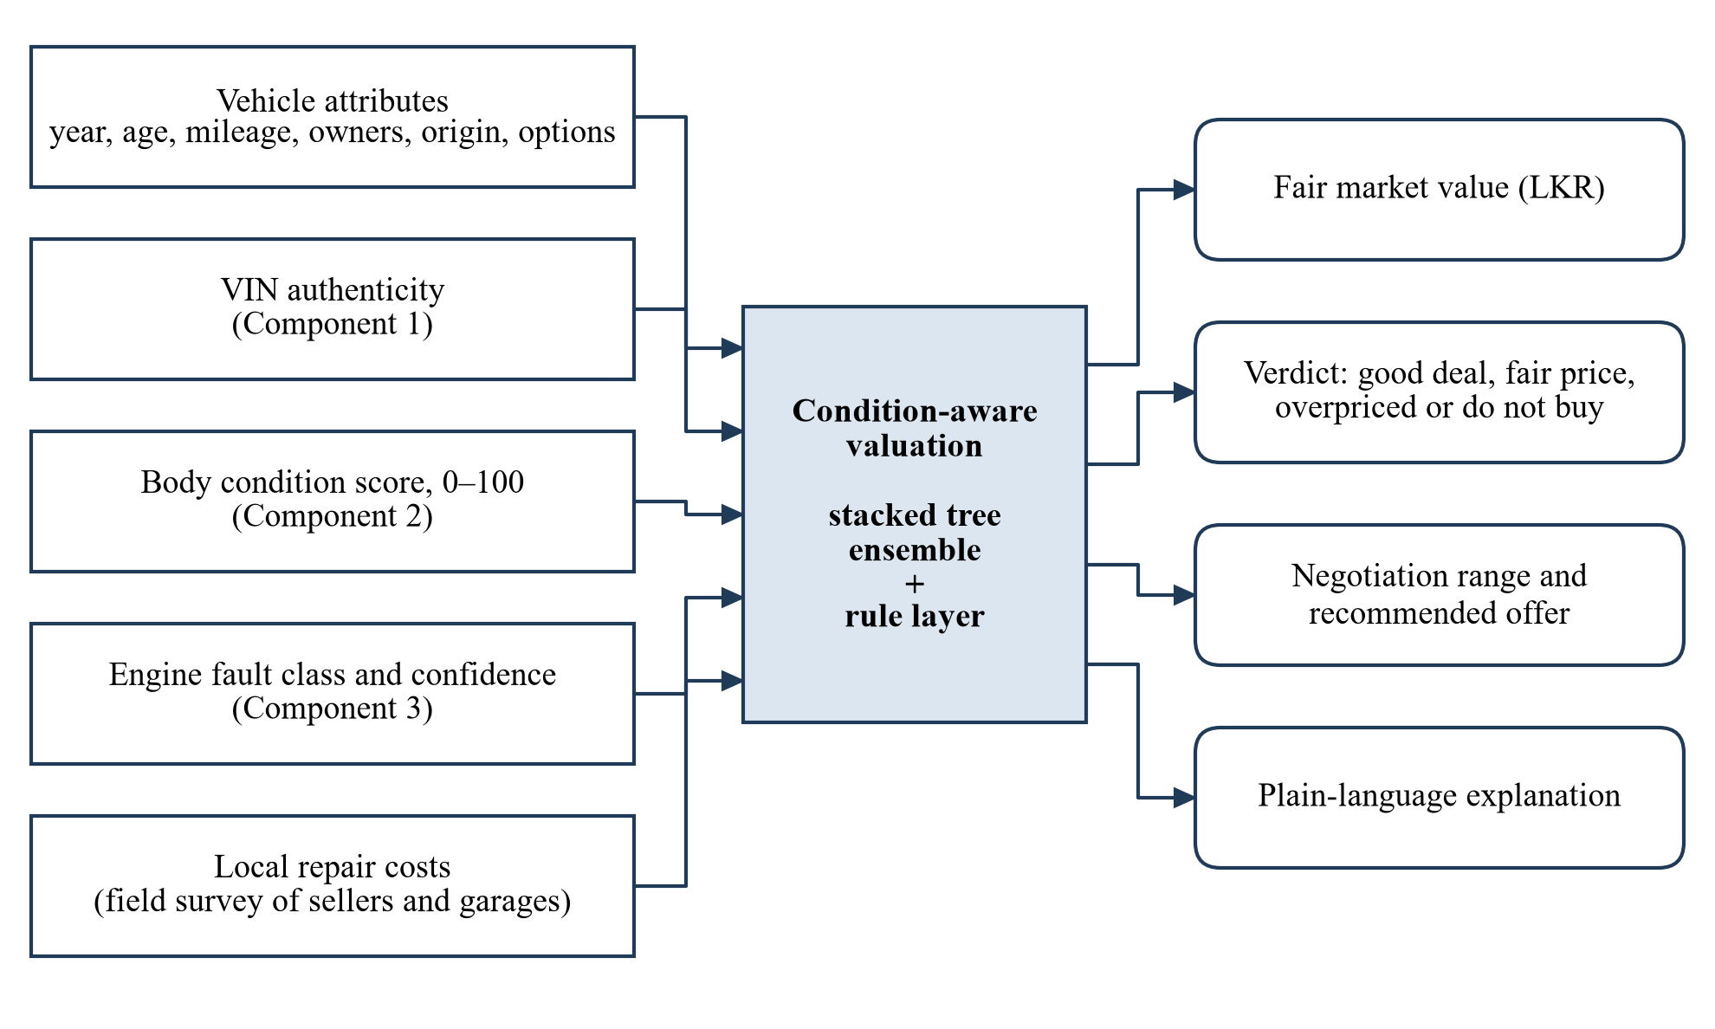
Figure 2.1: Conceptual framework of the valuation component

3 RESEARCH METHODOLOGY

3.1 Research design
This is an applied, quantitative research. I built a working system and evaluated it using numerical measures. For the data and modelling work I followed the steps of the CRISP-DM process, which are business understanding, data understanding, data preparation, modelling, evaluation and deployment [16]. Figure 3.1 shows the steps I followed.
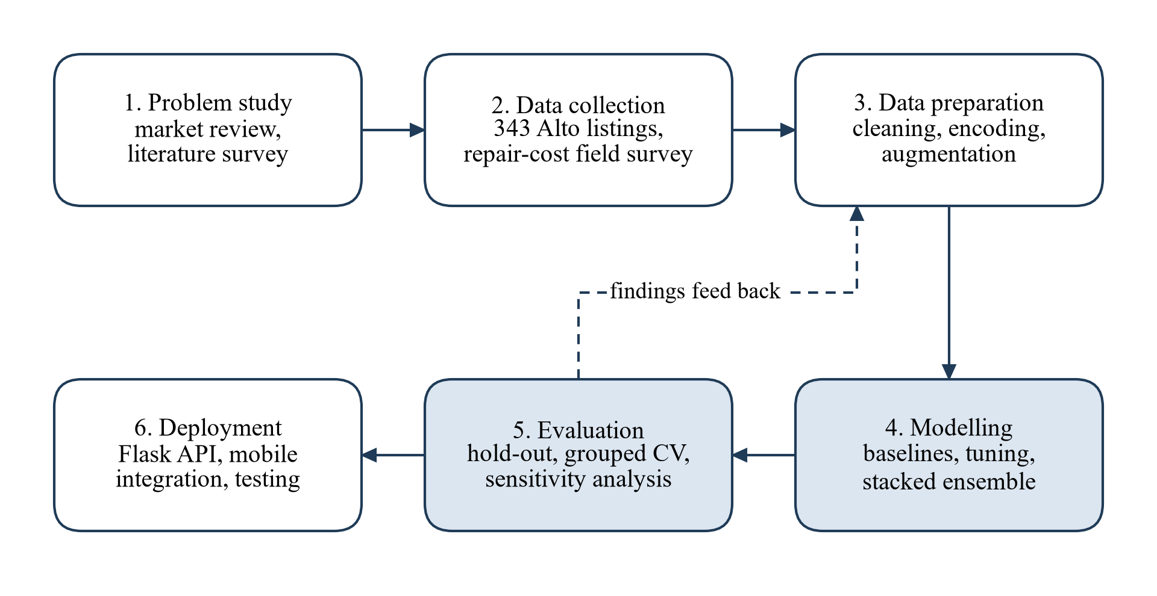
Figure 3.1: Research process followed for the component
The dashed arrow in the figure shows that I had to go back. My first models used only the advertisement details. Later, when the other components were ready, I went back to the data preparation step and added the condition features. The evaluation of that second version made me do some extra checks, which are reported in chapter 6.

3.2 Data participants or study materials
Listing data. I collected 343 advertisements of the Suzuki Alto from riyasewana.lk and entered them into an Excel sheet by hand. Most of them (335) were listed between November 2025 and March 2026. For each advertisement I recorded the year of manufacture, year of registration, mileage, asking price, number of previous owners, whether the car was brand new or reconditioned when imported, power shutters, power mirrors and the month of the advertisement. The registration number was noted only to avoid entering the same car twice and it was removed during cleaning.
Data cleaning. The cleaning steps are shown in the top part of Figure 3.2. Two records had prices above LKR 30 million, which are clearly typing mistakes, so they were removed. Three records were outside the 2012 to 2017 range and were also removed. This left 338 records. The owner count was taken from text such as "2 nd owner", and missing values were filled with the median. Brand new was coded as 0 and reconditioned as 1. Yes and no values were coded as 1 and 0. One missing mileage was filled with the median mileage of the same year. I also added two new columns: vehicle age (2026 minus the year of manufacture) and registration gap (the difference between the registration year and the manufacture year).
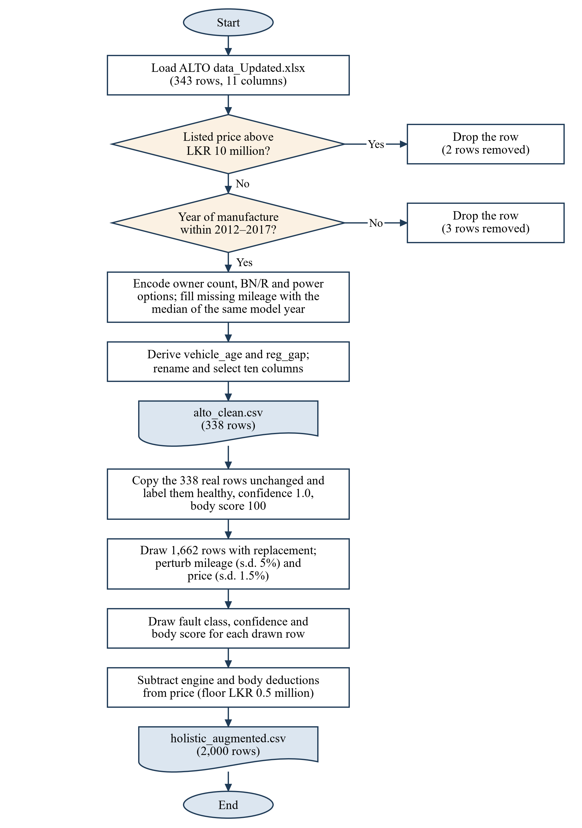
Figure 3.2: Data cleaning and augmentation steps
Table 3.1 gives a summary of the cleaned data and Figure 3.3 shows the price for each year of manufacture.
Table 3.1: Summary of the cleaned listing data (338 records)
Variable | Mean | Std. dev. | Minimum | Maximum
Price (LKR million) | 3.746 | 0.285 | 2.920 | 4.490
Mileage (km) | 118,462 | 34,738 | 37,100 | 247,561
Year of manufacture | 2014.8 | 0.96 | 2012 | 2017
Previous owners | 2.86 | 1.64 | 1 | 8

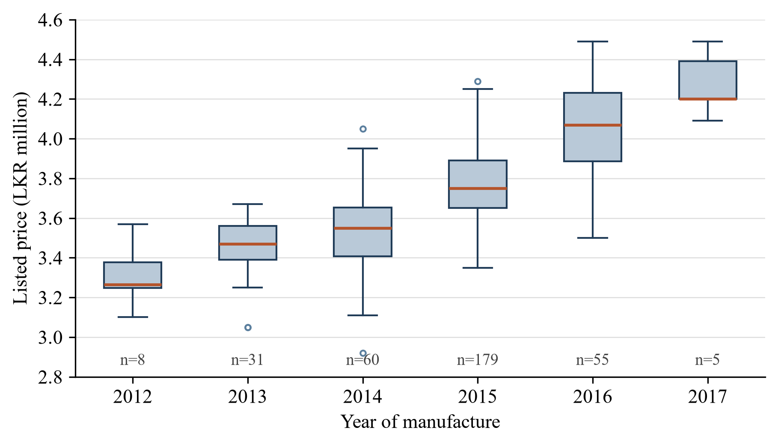
Figure 3.3: Listed price by year of manufacture (n is the number of listings)
Some points about the data are important. The dataset is small, and more than half of the cars (179) are from 2015, while 2012 and 2017 have only eight and five cars. The prices are in a narrow range, from LKR 2.92 million to LKR 4.49 million. Even cars of the same year have quite different prices. Price has the strongest relationship with the year of manufacture (correlation 0.70), then mileage (−0.45). Only three cars are reconditioned, so that feature cannot help much.
Repair cost survey. To give a rupee value to defects, I surveyed five parts sellers and repair centres in early 2026 and asked for the price range of the repairs related to each engine fault and body damage. Table 3.2 and Table 3.3 show the values. The prices of individual body parts are given in Appendix A. I stored these costs in a separate JSON file so they can be updated easily.
Table 3.2: Engine repair cost ranges from the survey
Fault | Minimum (LKR) | Maximum (LKR) | Usual repair
Healthy | 0 | 0 | None
Knocking | 35,000 | 85,000 | Bearing or piston repair
Misfiring | 8,000 | 25,000 | Spark plugs, ignition coil or injector cleaning
Tappet noise | 5,000 | 18,000 | Valve clearance adjustment
Rotational imbalance | 8,000 | 30,000 | Engine mount replacement or balancing
Battery or starting fault | 25,500 | 40,000 | Battery, and starter motor if needed

Table 3.3: Body damage levels and repair cost ranges
Level | Minimum (LKR) | Maximum (LKR) | Description
None | 0 | 0 | No visible damage
Minor | 10,000 | 25,000 | Scratches, small dents, paint chips
Moderate | 25,000 | 80,000 | Dented panels, broken lights, damaged bumpers
Severe | 80,000 | 200,000 | Many damaged panels, door or bonnet replacement, full repaint

Preparing the training dataset. The cleaned data has no information about body or engine condition. So I generated a larger dataset of 2,000 records that includes these features. The steps are in the bottom part of Figure 3.2.
First, the 338 real records were kept as they are and marked as healthy engine, confidence 1.0 and body score 100. Then 1,662 new records were generated. For each new record, one real record was picked randomly and small random changes were made to its mileage (about 5%) and price (about 1.5%). Then an engine fault was assigned randomly (60% healthy and 8% for each of the five faults), with a confidence between 0.60 and 1.00, and a body score was assigned randomly with an average of 85.
Finally the price was reduced according to the condition. The engine deduction is the middle value of the repair range multiplied by the confidence:
$D_{e} = c × \frac{r_{min} + r_{max}}{2}$ (3.1)
where c is the confidence and the r values are the minimum and maximum repair costs for that fault. The body deduction is the middle value of the repair range of the damage level, where a score of 80 or more is no damage, 60 to 79 is minor, 40 to 59 is moderate and below 40 is severe. Both deductions were subtracted from the price.
One thing should be noted here because it becomes important later. Each real listing was used to make about five generated records on average, and these are very similar to the original record.

3.3 Experimental or study procedure
I did the experiments in stages. In the first stage I trained Random Forest, Gradient Boosting and Linear Regression using only the eight advertisement features, and also tried simple combinations of them. This showed that tree-based models and combinations worked better on my data, so I continued in that direction.
The final model was trained on the 2,000-record dataset with fourteen features: the eight advertisement features, the three condition features (fault class, confidence, body score) and three calculated features (mileage per year, log of mileage and log of age). The steps were:
- The data was divided randomly into 80% for training (1,600 records) and 20% for testing (400 records).
- Numeric features were scaled and the fault class was one-hot encoded.
- Four models (Random Forest, Gradient Boosting, XGBoost and LightGBM) were tuned using randomised search with 3-fold cross-validation. Table 3.4 shows the selected parameters.
- The four tuned models were combined into a stacking ensemble with Ridge regression as the meta-learner.
- The final pipeline was trained on the training set, tested on the test set and saved to a file.
Table 3.4: Selected hyperparameters of the base models
Model | Values tried | Selected
Random Forest | Trees: 100, 200, 300; max depth: none, 10, 20; min samples split: 2, 5, 10 | 300 trees, depth 10, split 2
Gradient Boosting | Trees: 100, 200, 300; learning rate: 0.01, 0.05, 0.1; max depth: 3, 4, 5 | 200 trees, rate 0.05, depth 5
XGBoost | Trees: 100, 200, 300; learning rate: 0.01, 0.05, 0.1; max depth: 3, 5, 7 | 100 trees, rate 0.1, depth 7
LightGBM | Trees: 100, 200, 300; learning rate: 0.01, 0.05, 0.1; leaves: 31, 50, 100 | 200 trees, rate 0.05, 50 leaves

After the model was connected to the app, I wrote a separate evaluation script. It loads the saved model and repeats the same test, and it also does the extra checks described in section 3.5.

3.4 Measures and evaluation metrics
I used four common measures for regression. Here y is the actual price, ŷ is the predicted price and n is the number of records. The Mean Absolute Error (MAE) is the average size of the error in rupees:
$\text{MAE} = \frac{1}{n}\sum_{i=1}^{n}{\left|y_{i} - {\hat{y}}_{i}\right|}$ (3.2)
The Root Mean Squared Error (RMSE) is similar but gives more weight to large errors:
$\text{RMSE} = \sqrt{\frac{1}{n}\sum_{i=1}^{n}{{\left(y_{i} - {\hat{y}}_{i}\right)}^{2}}}$ (3.3)
The R² score shows how much of the variation in price is explained by the model, where 1 is perfect and 0 means the model is no better than always predicting the average:
$R^{2} = 1 - \frac{\sum_{i=1}^{n}{{\left(y_{i} - {\hat{y}}_{i}\right)}^{2}}}{\sum_{i=1}^{n}{{\left(y_{i} - \overline{y}\right)}^{2}}}$ (3.4)
The Mean Absolute Percentage Error (MAPE) is the average error as a percentage of the price:
$\text{MAPE} = \frac{100}{n}\sum_{i=1}^{n}{\left|\frac{y_{i} - {\hat{y}}_{i}}{y_{i}}\right|}$ (3.5)
MAPE has to be read carefully for my data. Because all the prices are in a narrow range, even a very simple method gets a low MAPE. So I mainly look at MAE and R². I also report the percentage of predictions that are within 5% of the actual price.
For the web service I checked the HTTP status codes for correct and incorrect requests and measured the response time.

3.5 Data analysis
The following analyses were done with the evaluation script.
- Baselines. Two simple methods were tested for comparison: predicting the average price of cars of the same year, and a linear regression.
- Base models. Each of the four models inside the ensemble was tested separately to see how much the stacking helps.
- Stricter validation. The ensemble was tested again in two stricter ways. In the first, grouped 5-fold cross-validation was used, where all records generated from the same real listing are kept together in either the training part or the test part. In the second, only the 338 real listings were used with 5-fold cross-validation.
- Sensitivity check. I took one example car and changed one input at a time (body score, engine fault) to see how the predicted price changes.
- Verdict check. The test records were given to the verdict logic at their actual price and at prices 10% and 15% higher or lower, to see how often the verdict is correct.
- Software tests. The valuation function and the web service were tested with a set of test cases, which are reported in chapter 5.

3.6 Ethics privacy security and responsible AI
The listing data was taken from public advertisements. I did not collect names, phone numbers or addresses. The registration number was used only to avoid duplicates and was removed in the cleaning step, so the processed data and the model do not contain personal data as defined in the Personal Data Protection Act [17]. In the repair cost survey I only asked for prices and did not record any personal details.
The service does not store any request. It calculates the result and sends it back.
I also considered the responsible use of the result. A price shown on a phone can look more exact than it really is, so the service gives a range and not only one number. The "do not buy" result for an altered VIN is a serious message, so the wording talks about the VIN status and does not blame the seller, and a softer warning is given when the VIN check is not sure. The use of generated condition data is stated clearly in this thesis and in the data source field of the response.
The valuation endpoint needs a bearer token, which is kept in an environment file that is not uploaded to the repository.

3.7 Reproducibility and research artefacts
All the code and data of the component are in the group's Git repository inside the component4-market-valuation folder. Table 3.5 lists the main files. A fixed random seed (42) is used in all scripts, so running the scripts again gives the same dataset and the same results.
Table 3.5: Main files of the component
File | Purpose
data/raw/ALTO data_Updated.xlsx | The 343 collected listings
data/repair_costs.json | Repair cost survey results
preprocessing/clean_data.py | Data cleaning
preprocessing/augment_holistic.py | Generates the 2,000-record training dataset
models/advanced_model_optimization.py | Tunes, trains and saves the final model
inference/valuate.py | Valuation logic
api/app.py | Flask web service
thesis/analysis/evaluate_component.py | Evaluation script for chapters 5 and 6
thesis/diagrams/*.drawio | Diagrams used in this thesis

4 PRODUCT AND SOLUTION DESIGN

4.1 Requirements
The requirements were identified from group discussions about the results screen of the app and from the inputs and outputs of the other three components. Table 4.1 and Table 4.2 list them.
Table 4.1: Functional requirements
ID | Requirement
FR1 | Accept the vehicle details and the listed price of one vehicle.
FR2 | Accept the VIN status, body score, engine fault and confidence from the other components. If they are not given, assume the vehicle is in good condition.
FR3 | Return the predicted fair market value in rupees.
FR4 | If the VIN is altered, do not give a value and return a warning.
FR5 | Give a verdict: good deal, fair price or overpriced.
FR6 | Return a negotiation range and a recommended offer.
FR7 | Return the repair cost range for any engine fault or body damage, with a short explanation.
FR8 | Provide a health check endpoint so the app can check that the service is running.

Table 4.2: Non-functional requirements
ID | Quality | Requirement
NFR1 | Performance | Respond to a valuation request within one second.
NFR2 | Security | Reject requests that do not have the correct bearer token.
NFR3 | Reliability | Return a clear JSON error message for wrong requests.
NFR4 | Maintainability | Keep the repair costs and the trained model as separate files that can be replaced.
NFR5 | Interoperability | Use JSON over HTTP with the field names agreed by the group.

4.2 Component architecture within the complete solution
Figure 4.1 shows the internal architecture of my component. It has two parts. The offline part prepares the data and trains the model. The online part is the web service that answers the requests from the app.
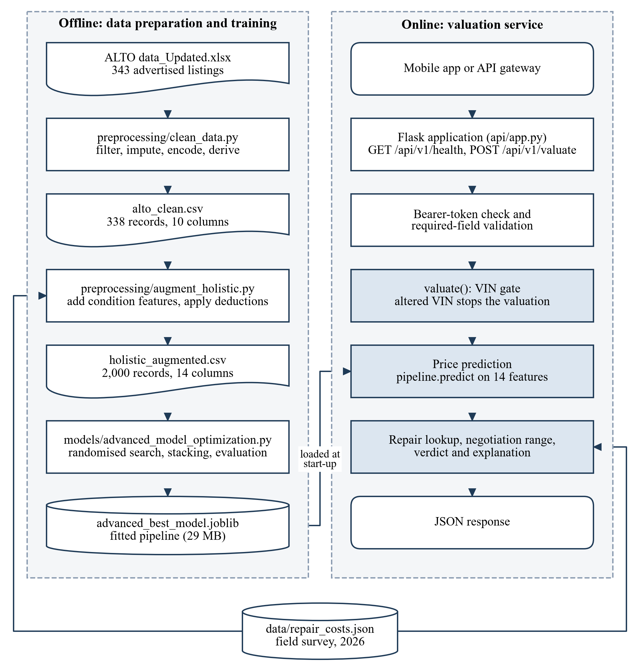
Figure 4.1: Internal architecture of the market value analysis component
The two parts share two files. The trained model file is created by the offline part and loaded by the service when it starts. The repair cost file is used when the training data is generated and also when the service prepares the explanation.
The online part has three layers. The Flask application handles the HTTP request, the token check and the input check. The valuation function has all the logic. The model pipeline does the price prediction. Figure 4.2 shows the order of calls in a full inspection.
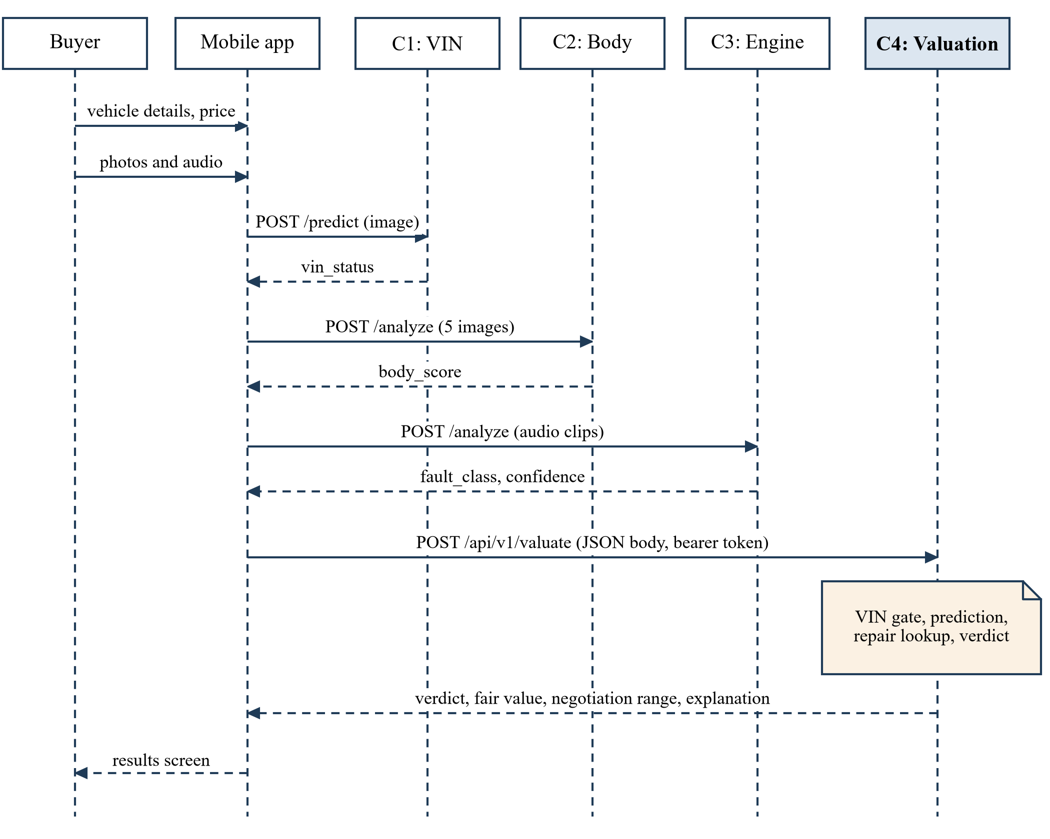
Figure 4.2: Sequence of calls during a full inspection

4.3 Design alternatives and decisions
How to include the condition. This was the main design decision. I considered two options. Option A was to train the model only on the advertisement details and then subtract the repair costs from the predicted price using rules. Option B was to train the model on data that already has the condition features and the reduced prices, so the model itself gives the final value. I selected Option B because I thought it would be easier to improve in the future: if real data with condition becomes available, the model can just be retrained. However, the results in chapter 6 show that Option B did not work as well as I expected, and I discuss this in chapter 7.
Choice of algorithm. Linear regression was used as a baseline because it is simple and was used in earlier studies [3], [14]. For the final model I selected tree-based models because they can learn non-linear relationships and the literature shows they perform well on this kind of data [7], [5]. I did not use neural networks because my dataset is too small for them. Stacking was used to combine the models because it learns the weight for each model automatically [12].
Verdict thresholds. The verdict is decided by comparing the listed price with the fair value (FV), as shown in Figure 4.3. If the listed price is within 5% of the fair value it is a fair price. I selected 5% because for a car of around LKR 3.75 million it is about LKR 190,000, which is a normal amount for bargaining.
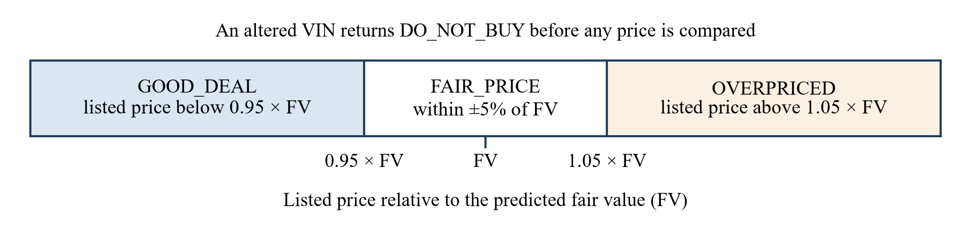
Figure 4.3: Verdict bands compared with the predicted fair value
Web framework. I used Flask because the service is small with only two endpoints, and Component 3 also uses Flask, so we could keep the authentication and error format the same.

4.4 Detailed design
Features. Table 4.3 shows the fourteen features used by the model. The app sends the vehicle details and the condition values, and the service calculates the rest.
Table 4.3: Features used by the model
Feature | From | Description
maf_year | App | Year of manufacture
mileage_km | App | Mileage in kilometres
previous_owners | App | Number of previous owners
is_reconditioned | App | 1 if reconditioned, 0 if brand new
power_shutters, power_mirrors | App | 1 if available
vehicle_age | Service | 2026 minus year of manufacture
reg_gap | Service | Registration year minus manufacture year
fault_class | Component 3 | Engine fault label (default: healthy)
confidence | Component 3 | Confidence of the fault, 0 to 1 (default: 1.0)
body_score | Component 2 | Body condition score, 0 to 100 (default: 100)
mileage_per_year | Service | Mileage divided by (age + 1)
log_mileage_km, log_vehicle_age | Service | Logarithm of mileage and of age

Model pipeline. Figure 4.4 shows the structure of the model. The preprocessing and the stacking model are saved together as one pipeline, so the service only has to pass the feature values and it gets the price.
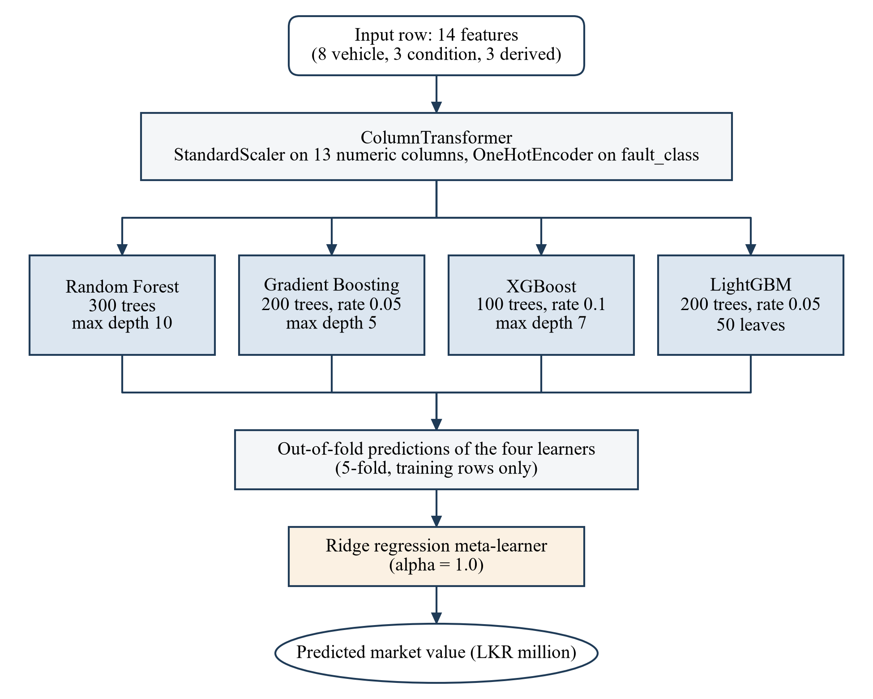
Figure 4.4: Structure of the stacking ensemble
Valuation logic. Figure 4.5 shows the logic of the valuation function. The VIN is checked first, because there is no point in giving a price for a vehicle whose identity is doubtful. Then the price is predicted and the repair cost ranges are looked up. The negotiation range is calculated around the fair value using the minimum and maximum repair costs: if the repair turns out to be expensive the buyer should pay less, and if it is cheap the buyer can pay a little more. The recommended offer is the middle of this range. If the verdict is a good deal, the recommended offer is simply the listed price.
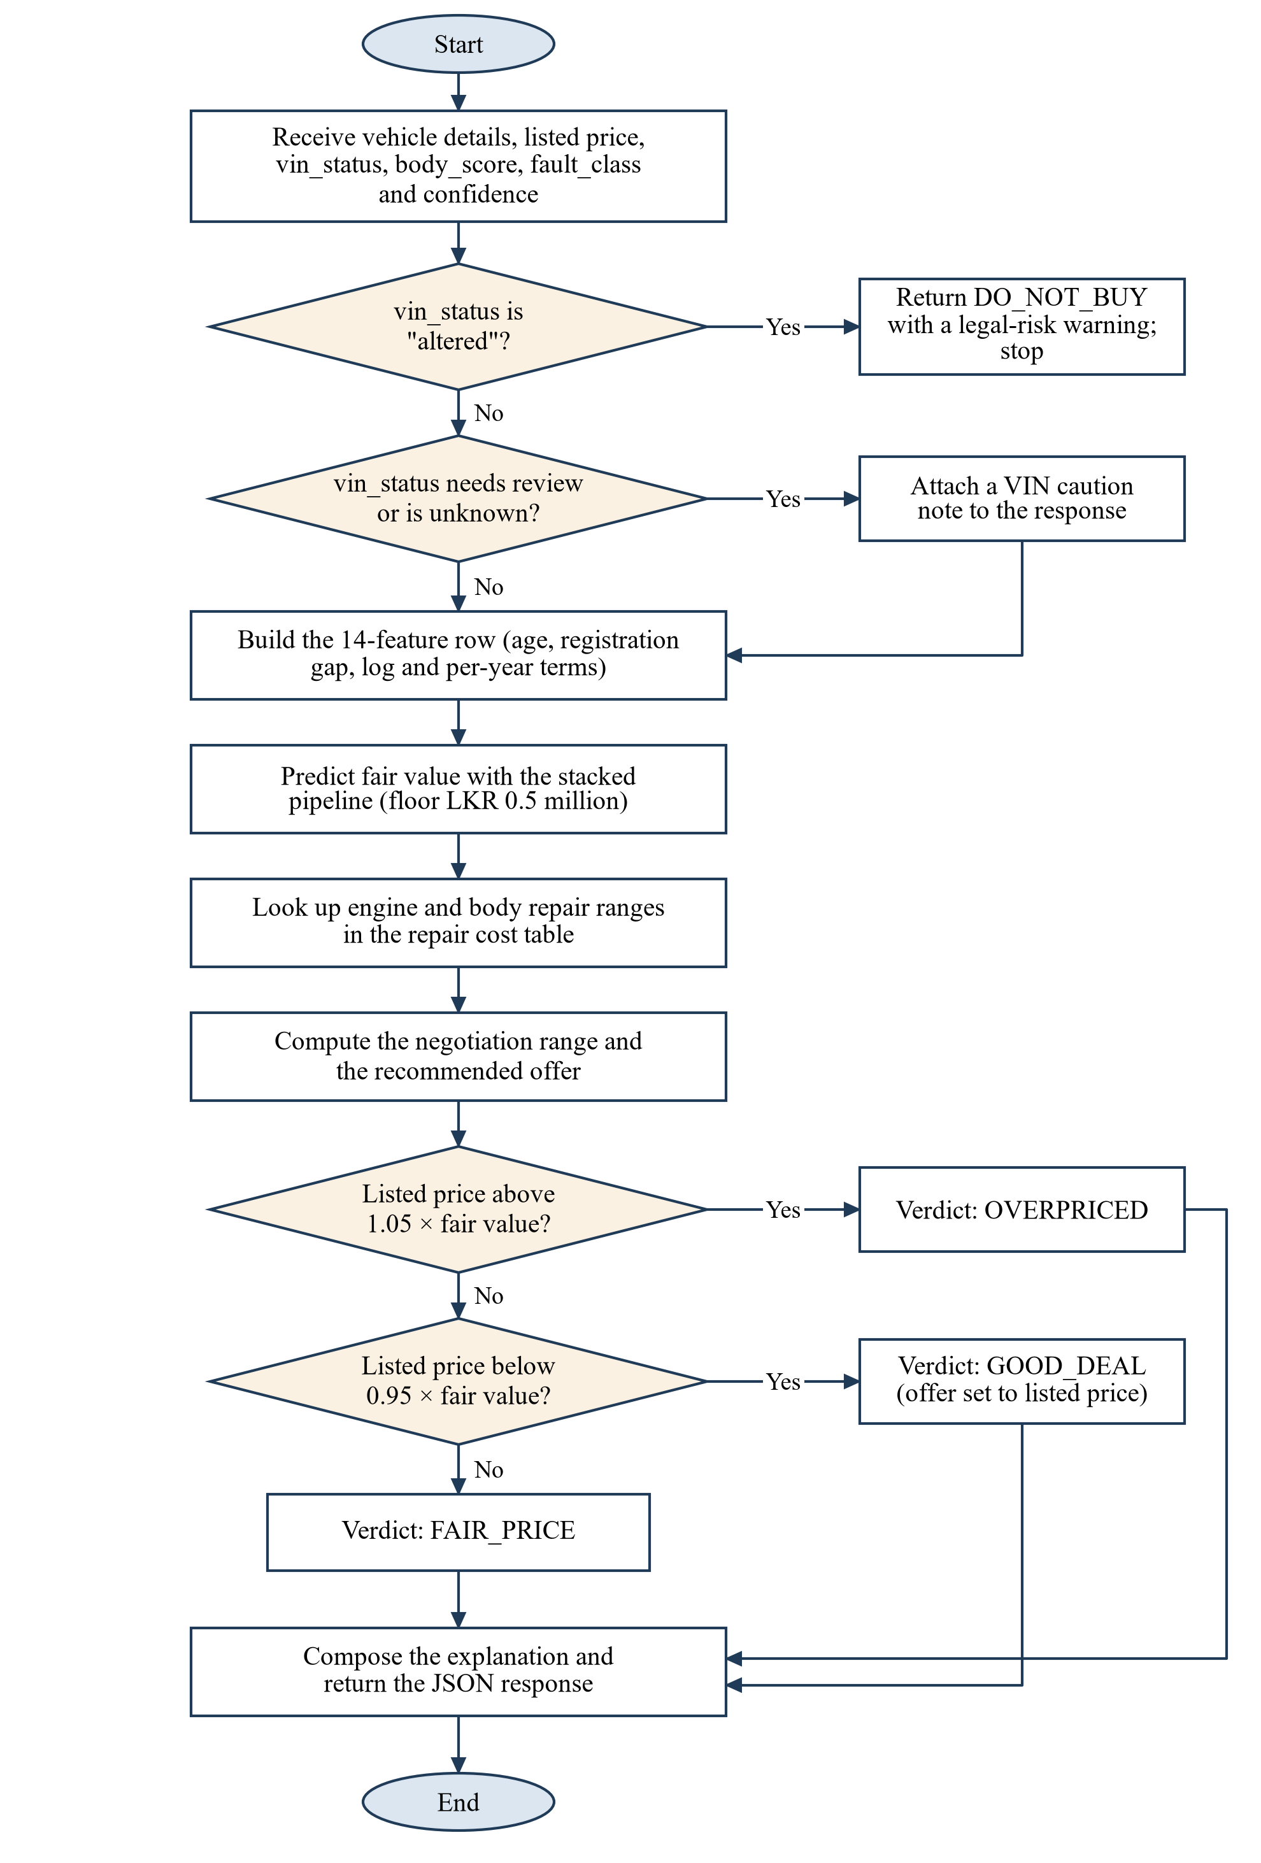
Figure 4.5: Decision flow of the valuation function
Service interface. The service has two endpoints, shown in Table 4.4. An example request and response are given in Appendix A.
Table 4.4: Endpoints of the valuation service
Path | Method | Authentication | Description
/api/v1/health | GET | None | Returns the status of the service and whether the model is loaded.
/api/v1/valuate | POST | Bearer token | Checks the JSON input, runs the valuation and returns the result. Returns 400 for a wrong input and 401 for a wrong token.

4.5 Standards and professional practice
The service follows the REST style, where the URL identifies the resource, the HTTP method shows the action and the status code shows the result. The URL has a version number (v1) so the response can be changed later without breaking the app. The endpoints are documented with Swagger using the flasgger library. The code is kept in Git, the secret token is kept in an environment file outside the repository, and the required libraries are listed in a requirements file. Each task has its own Python module, as shown in Figure 4.1.

5 IMPLEMENTATION INTEGRATION AND TESTING

5.1 Development environment and technology stack
The component was developed in Python on Windows 11, using a separate virtual environment so that its libraries do not conflict with the other components. Table 5.1 shows the main technologies. A GPU is not needed. Training the final model, including the parameter tuning, took about 42 seconds on my laptop.
Table 5.1: Technology stack
Technology | Version | Used for
Python | 3.12 | Programming language
pandas, NumPy | 3.0, 2.5 | Data cleaning and data generation
scikit-learn [18] | 1.9 | Preprocessing, Random Forest, Gradient Boosting, stacking, evaluation
XGBoost, LightGBM | 3.4, 4.7 | Base models
joblib |  | Saving and loading the model
Flask, flask-cors, flasgger | 3.1 | Web service and Swagger documentation
matplotlib |  | Charts
Git and GitHub |  | Version control
draw.io |  | Diagrams

5.2 Component implementation
Data scripts. The cleaning script does the steps described in section 3.2 and prints a summary of how many records were removed and how many remain. The augmentation script generates one new record from one real record. The main part of it is shown below.
fault = rng.choice(FAULTS, p=FAULT_PROBS)
confidence = float(rng.uniform(0.60, 1.00))
if fault == "healthy":
confidence = 1.0
body_score = int(np.clip(int(rng.normal(85, 15)), 10, 100))

eng_deduction = get_engine_deduction(fault, confidence)
body_deduction = get_body_deduction(body_score)
final_price = base_price_million - (eng_deduction + body_deduction) / 1_000_000

Training script. The training script tunes the four base models, combines them with a StackingRegressor and saves the whole pipeline as one file.
stacking_regressor = StackingRegressor(
estimators=best_estimators, # tuned rf, gb, xgb, lgbm
final_estimator=Ridge(), cv=5, n_jobs=-1)

final_pipeline = Pipeline(steps=[
('preprocessor', preprocessor), # scaler + one-hot encoder
('model', stacking_regressor)])
final_pipeline.fit(X_train, y_train)
joblib.dump(final_pipeline, BEST_MODEL_PATH)

Valuation module. This module has functions to load the model and repair costs, predict the price, look up the engine and body repair costs, and prepare the explanation. The main function calls them in the order shown in Figure 4.5. The explanation is made from fixed sentences: one about the price, and others about the engine, body and VIN if there is a problem with them.
Web service. The Flask application loads the model once when it starts. The valuation route is protected by a decorator that checks the bearer token:
def require_auth(f):
@wraps(f)
def decorated(*args, **kwargs):
auth_header = request.headers.get('Authorization')
if not auth_header or not auth_header.startswith('Bearer '):
return jsonify({"error": "Missing or invalid authorization header",
"status_code": 401}), 401
token = auth_header.split(" ")[1]
if token != API_TOKEN:
return jsonify({"error": "Unauthorized: Invalid API token",
"status_code": 401}), 401
return f(*args, **kwargs)
return decorated

The route checks that the request is JSON and that the vehicle details and the listed price are there. The condition values are optional. All errors are returned as JSON with an error message and the status code.

5.3 Integration with the other components
The integration was done in two steps. First, our group wrote a small script that calls the four services one after another from the command line. With this I could test my service with the agreed field names before the app screens were ready.
Second, the mobile app was connected. The results screen of the app collects the values from the earlier steps and sends them to my service, as shown in Table 5.2.
Table 5.2: Values sent from the app to the valuation service
Source | Value | Request field
Vehicle details screen | Year, registration year, mileage, owners, brand new or reconditioned, options, asking price | maf_year, reg_year, mileage_km, previous_owners, is_reconditioned, power_shutters, power_mirrors, listed_price_million
Component 1 | Original, altered or needs review | vin_status
Component 2 | Body condition score | body_score
Component 3 | Fault label and confidence | fault_class, confidence

We had to agree on a few small things during integration. The confidence value sometimes came as a fraction and sometimes as a percentage, so the app converts it to a fraction before sending. If the valuation service cannot be reached, the app shows the other results with an error message and a retry button, and it does not show any price. The app also calls the health endpoint of every service at the start.

5.4 Verification and software testing
I tested the component at three levels: the valuation function, the web service, and the full flow through the app.
Functional tests. Eight test cases were run on the valuation function using the same example car (2015, 85,000 km, two owners) with different prices and conditions. Table 5.3 shows the results. All the verdicts were as expected, and the altered VIN case stopped the valuation correctly.
Table 5.3: Functional test cases and results
ID | Test case | Verdict | Fair value (LKR)
TC-01 | Good car listed at 3.95 million | FAIR_PRICE | 3,774,000
TC-02 | Good car listed at 4.60 million | OVERPRICED | 3,774,000
TC-03 | Good car listed at 3.30 million | GOOD_DEAL | 3,774,000
TC-04 | Knocking fault (confidence 0.87), body score 82, listed at 3.89 million | OVERPRICED | 3,687,000
TC-05 | VIN altered | DO_NOT_BUY | Not calculated
TC-06 | VIN needs review, listed at 3.95 million | FAIR_PRICE with a VIN warning | 3,774,000
TC-07 | Body score 45, listed at 3.95 million | OVERPRICED | 3,709,000
TC-08 | Unknown fault name, listed at 3.95 million | OVERPRICED | 3,761,000

When I read the full responses carefully I found some issues, which are listed in Table 5.4. They do not change the verdict in the test cases, but they should be fixed. I have not changed the code yet, because the results in chapter 6 were measured with the current version.
Table 5.4: Issues found during testing
ID | Issue | Reason
D1 | For a body score of 45 the response says "severe" damage, but the model was trained with 45 as "moderate". | The score limits for damage levels are different in the data generation script (80, 60, 40) and in the valuation module (100, 80, 60).
D2 | When the verdict is FAIR_PRICE, the explanation text still says the vehicle is "overpriced" by a small amount. The app shows the verdict message, which is correct. | The explanation has only two cases: good deal and everything else.
D3 | An unknown fault name is accepted and the explanation shows a repair cost of "LKR 0-0". | Unknown fault names are not rejected.
D4 | Values outside the valid range (for example a year outside 2012 to 2017) are accepted. | Only the presence and type of the fields are checked, not the range.

API tests. Eleven requests were sent to the web service using the Flask test client. Table 5.5 shows that all of them returned the expected status code.
Table 5.5: API test cases and results
ID | Request | Expected | Actual | Result
API-01 | GET /api/v1/health | 200 | 200 | Pass
API-02 | Valuate without Authorization header | 401 | 401 | Pass
API-03 | Valuate with a wrong token | 401 | 401 | Pass
API-04 | Valuate with correct token and full input | 200 | 200 | Pass
API-05 | Valuate without mileage_km | 400 | 400 | Pass
API-06 | Valuate without listed_price_million | 400 | 400 | Pass
API-07 | Valuate with a body that is not JSON | 400 | 400 | Pass
API-08 | Valuate with a price that is not a number | 400 | 400 | Pass
API-09 | Valuate with altered VIN | 200 | 200 | Pass
API-10 | Request to an unknown URL | 404 | 404 | Pass
API-11 | Valuate with only the vehicle details and price | 200 | 200 | Pass

Response time. I called the service 200 times with the same request. The average response time was 97 ms and the slowest was 149 ms, without counting the network time. This is well below the one second in NFR1.

End-to-end test. With all four services running on one computer and the app on a phone in the same Wi-Fi network, our group did full inspections using saved test images and audio. I checked that the values from the other components reached my service correctly, that the verdict and price were displayed correctly, that an altered VIN showed the blocked message, and that an error was shown when my service was stopped. These checks were done manually and they worked.

5.5 Deployment and operation
Figure 5.1 shows how the system was deployed for development and demonstrations. All four services run on one computer and the phone connects to them through the local network.
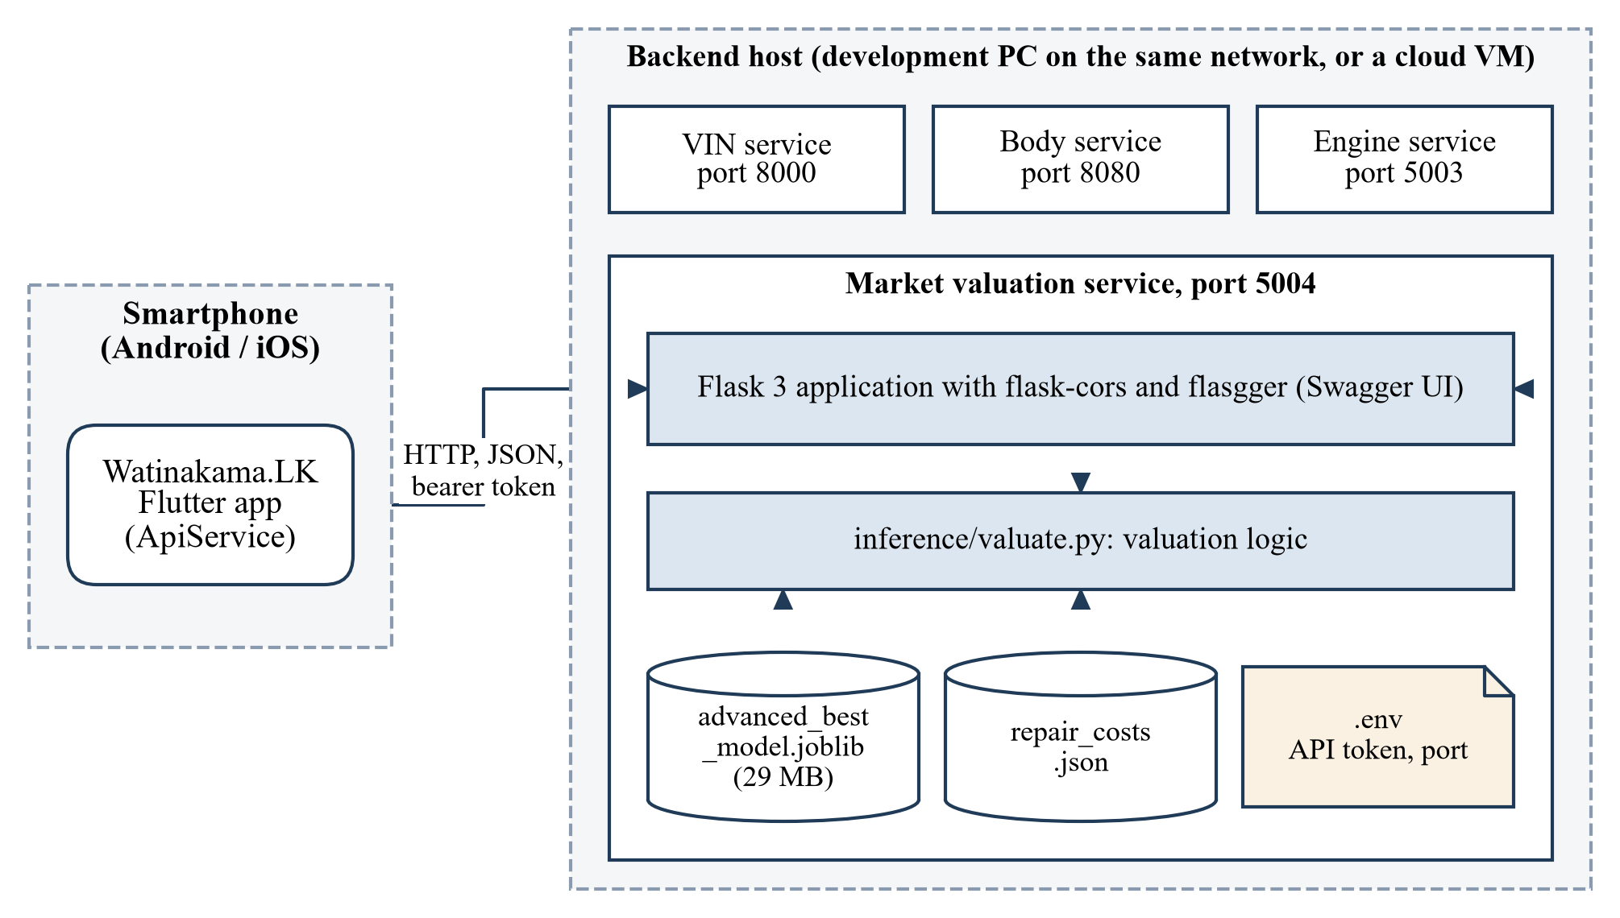
Figure 5.1: Deployment view of the valuation service
To run the service, the environment file is created from the example file, the libraries are installed in a virtual environment and the application is started. It runs on port 5004. The trained model file is included in the component, so the service can be started without training again.
At the moment the service uses the built-in Flask server, which is only suitable for development. For a real deployment it should run on a production server such as Gunicorn or Waitress with HTTPS. Also, the model should be retrained from time to time with new listings because vehicle prices change, and the repair costs should be updated when prices change.

6 RESULTS AND VALIDATION

6.1 Research results
Results on the test set. Table 6.1 shows the results of the baselines, the four base models and the stacking ensemble on the 400 test records. Figure 6.1 shows the MAE of each model.
Table 6.1: Model results on the 400 test records
Model | MAE (LKR) | RMSE (LKR) | R² | MAPE (%) | Within 5% (%)
Average price of same year | 169,716 | 215,428 | 0.462 | 4.64 | 64.3
Linear Regression | 157,491 | 202,996 | 0.522 | 4.30 | 65.3
LightGBM | 136,864 | 174,955 | 0.645 | 3.73 | 72.0
Gradient Boosting | 130,476 | 168,116 | 0.672 | 3.55 | 75.0
Random Forest | 124,234 | 158,941 | 0.707 | 3.38 | 76.5
XGBoost | 124,652 | 158,679 | 0.708 | 3.39 | 76.5
Stacking ensemble (final) | 121,906 | 156,416 | 0.716 | 3.32 | 77.3

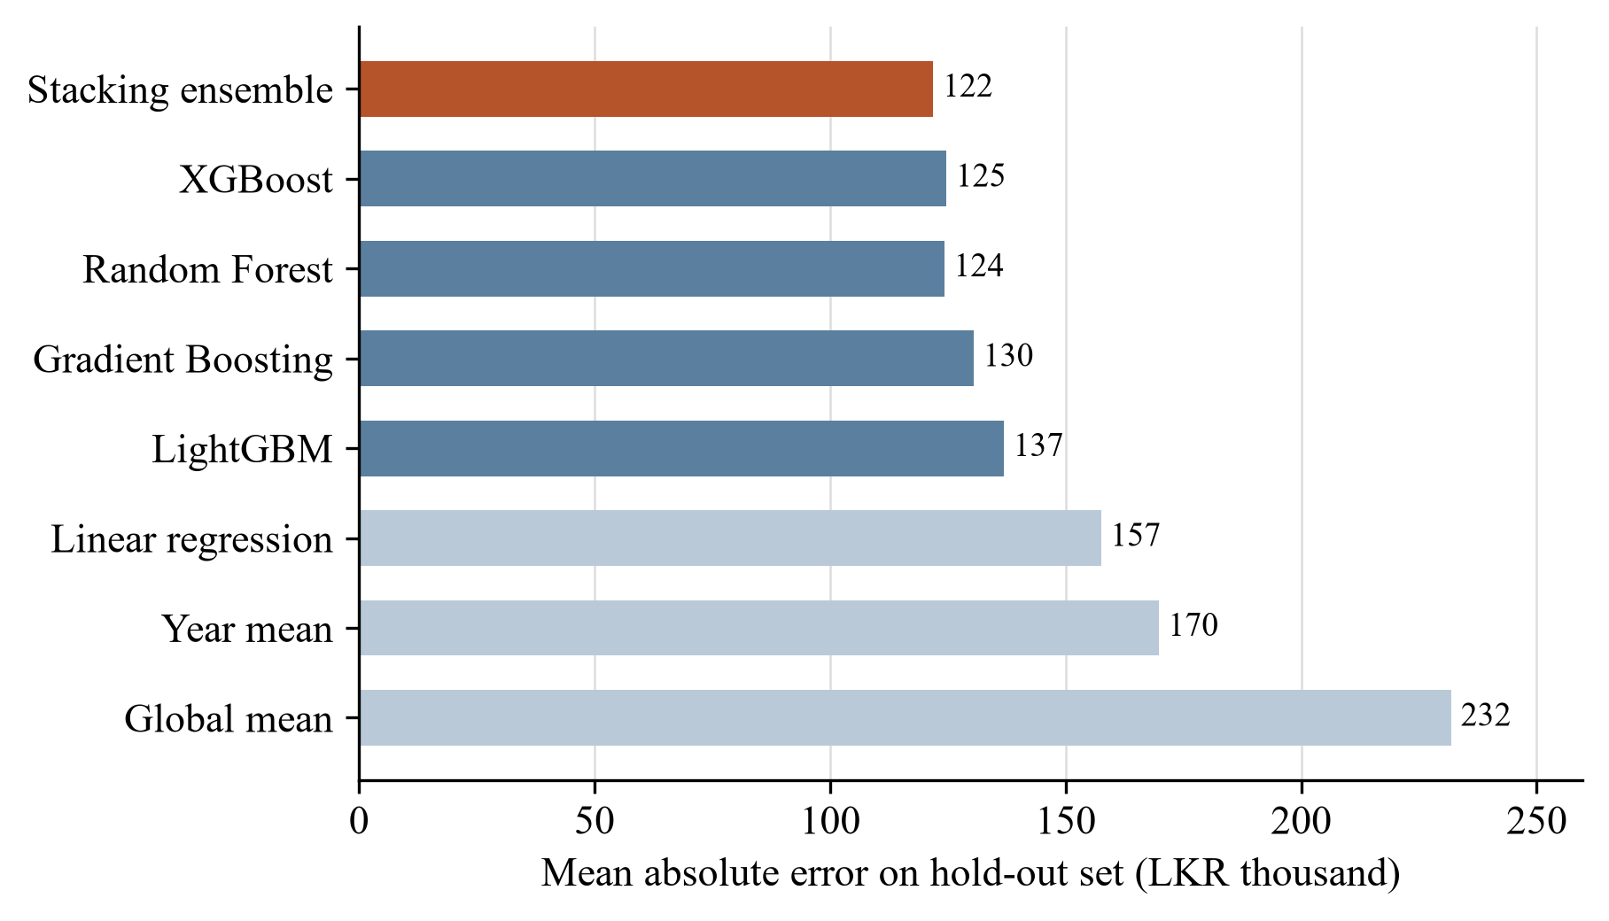
Figure 6.1: Mean absolute error of each model on the test records
The stacking ensemble gave the best result, with an MAE of LKR 121,906, an R² of 0.716 and a MAPE of 3.32%. The tree-based models were clearly better than linear regression. The ensemble was only a little better than Random Forest and XGBoost alone (about LKR 2,300 lower MAE). Figure 6.2 shows the predicted prices against the actual prices. Most of the points are close to the line, and 77% of the predictions are within 5% of the actual price. The largest error was about LKR 508,000.
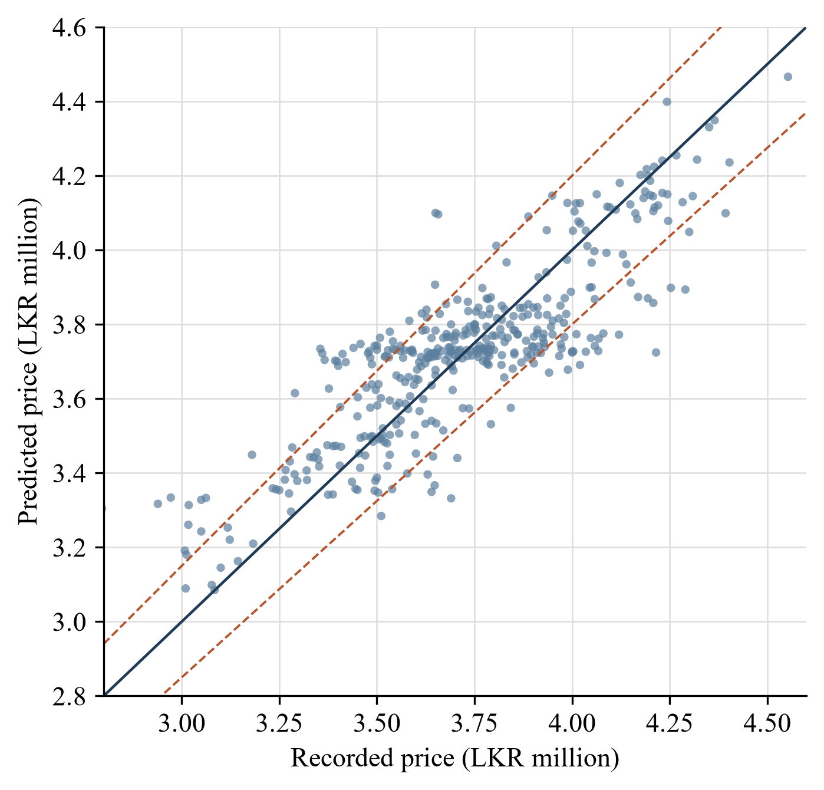
Figure 6.2: Predicted price against actual price on the test records (dashed lines show ±5%)
Results with stricter validation. As explained in section 3.2, each real listing was used to generate about five similar records. When the data is split randomly, these similar records go to both the training set and the test set. I checked this and found that 99.75% of the test records had at least one "sibling" record in the training set. This means the model had already seen a very similar car for almost every test record, which is a kind of data leakage [6].
To check how much this affected the results, I tested the same ensemble in the stricter ways described in section 3.5. Table 6.2 and Figure 6.3 show the results.
Table 6.2: Results of the ensemble with different validation methods
Validation method | MAE (LKR) | R² | MAPE (%) | Within 5% (%)
Random test split (original) | 121,906 | 0.716 | 3.32 | 77.3
Random 5-fold cross-validation | 119,562 | 0.722 | 3.23 | 78.3
Grouped 5-fold cross-validation | 157,669 | 0.532 | 4.24 | 65.9
5-fold on the 338 real listings only | 154,914 | 0.518 | 4.17 | 67.8
Linear Regression, 338 real listings only | 151,929 | 0.515 | 4.09 | 71.0

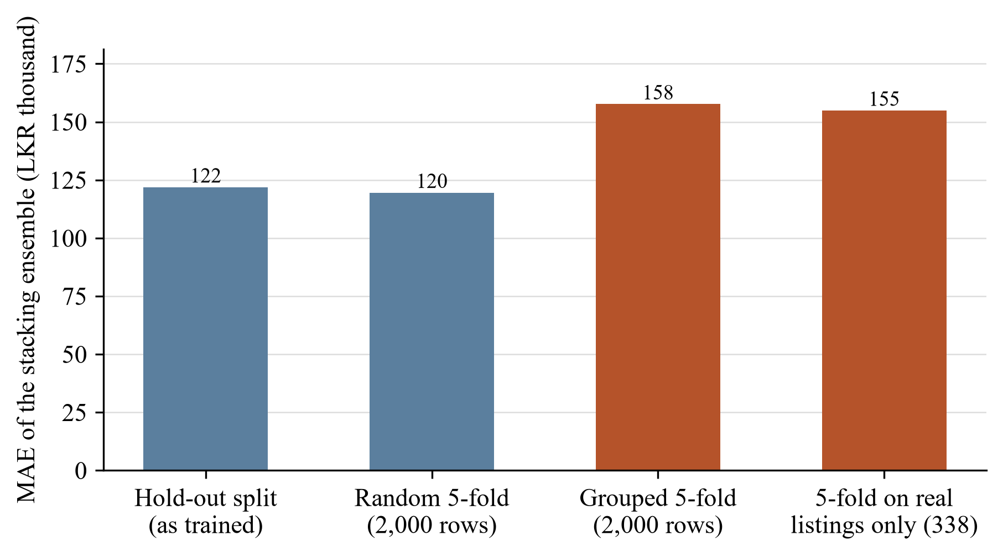
Figure 6.3: MAE of the ensemble with different validation methods
When the similar records were kept together (grouped validation), the MAE increased from about LKR 122,000 to about LKR 158,000 and R² dropped from 0.72 to 0.53. Testing only on the real listings gave almost the same values. So the more realistic error of the model for a car it has never seen is around LKR 155,000, which is a little more than 4% of the price.
The last row of the table shows another finding. On the real listings, a simple linear regression performed about the same as the stacking ensemble. This means the advantage of the tree-based models in Table 6.1 mostly came from the similar records in the training and test sets, and not from really understanding the prices better.
Important features. I also checked which features the model depends on by shuffling one feature at a time and measuring how much the error increases. The year of manufacture was the most important feature by far, followed by the number of owners, age and mileage. The three condition features (body score, fault class and confidence) had almost no effect on the accuracy.
Reaction to condition inputs. To see this more clearly, I took one example car (2015, 100,000 km, two owners, healthy, body score 100), for which the model predicts LKR 3,727,000, and changed the body score step by step. Figure 6.4 shows the result.
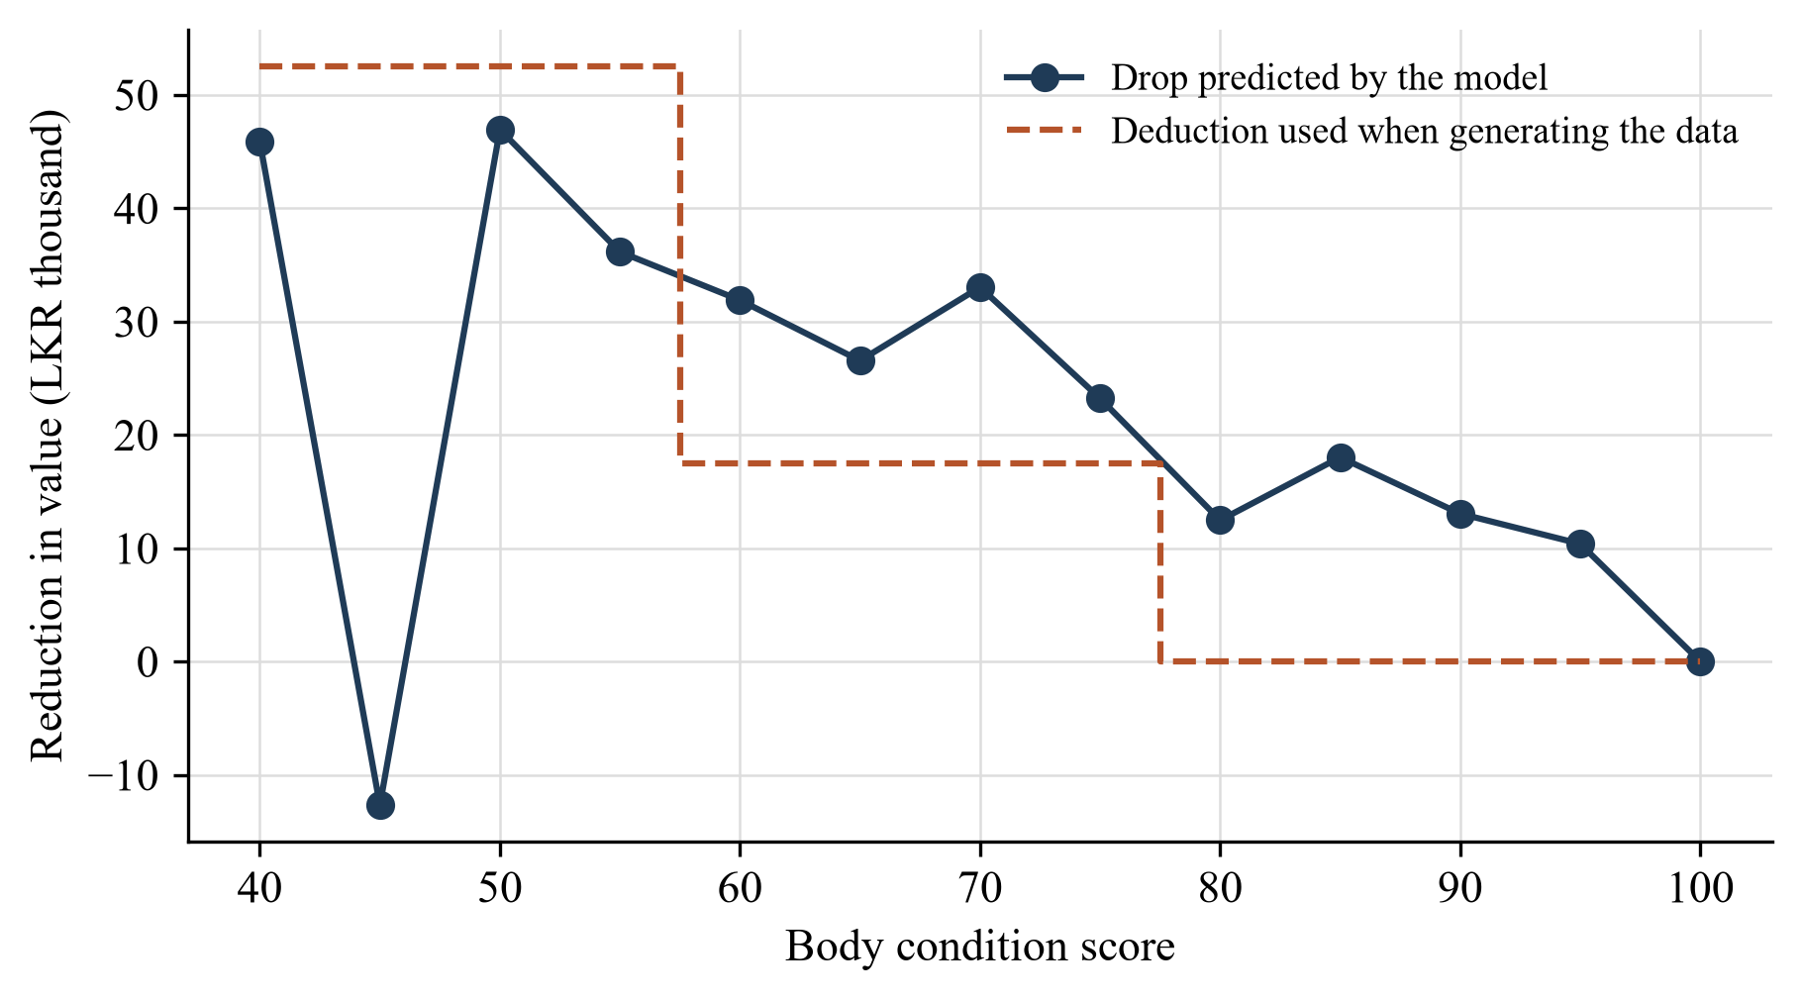
Figure 6.4: Drop in predicted value when the body score is reduced, compared with the deduction used in the training data
The predicted value generally goes down when the body score goes down, which is the correct direction. For example, at a score of 50 the value drops by about LKR 47,000, close to the LKR 52,500 used in the training data. But the line is not smooth, and at a score of 45 the predicted value is even slightly higher than for a perfect body. I did the same for the engine faults. Every fault reduced the predicted value by about LKR 23,000 to 37,000, but the amounts did not match the repair costs. For example, knocking is the most expensive fault, but it gave the smallest drop.
The reason is that the deductions (around LKR 10,000 to 50,000) are small compared with the normal price differences between similar cars, so the model could not learn them accurately.

6.2 Product and technical results
Verdict check. Table 6.3 shows the verdicts given for the 400 test records when they were presented at different prices.
Table 6.3: Verdicts for test records presented at different prices (% of 400 records)
Listed price given | GOOD_DEAL | FAIR_PRICE | OVERPRICED
15% below actual price | 99.8 | 0.3 | 0.0
10% below actual price | 90.8 | 9.3 | 0.0
At actual price | 11.3 | 78.3 | 10.5
10% above actual price | 0.3 | 13.0 | 86.8
15% above actual price | 0.0 | 2.5 | 97.5

When the price was 15% higher or lower than the actual price, the verdict was correct in almost all cases. At 10% it was correct about nine times out of ten. But when the price was equal to the actual price, only 78% were shown as a fair price. So the verdict is reliable when the price is clearly too high or too low, and less reliable when the price is close to the 5% limits.
Requirements. All the functional and non-functional requirements in section 4.1 were met, as shown by the tests in section 5.4. The only exception is the explanation in FR7, which is partly affected by issues D1 and D2. The service responds in about 0.1 seconds, rejects requests without the correct token, and returns clear error messages.

6.3 User or stakeholder validation
The repair cost values used in the component came from five local parts sellers and repair centres, so that part of the system is based on real information from people in the field. The design of the results screen, such as showing the verdict first and blocking the valuation for an altered VIN, was decided in our group discussions.
I was not able to do a proper user study with real buyers or a professional valuer within the project time. This is a limitation and it is included in the future work.

6.4 Integration results
The valuation service worked correctly with the other three components through the mobile app. The values from the other components were received in the agreed format, and test API-11 shows that the service still gives a valuation when only the vehicle details are sent, so it can work even if another component is not available.
However, as shown in section 6.1, the predicted price itself depends mostly on the vehicle details and very little on the body score and engine fault. The condition results do reach the user through the repair cost ranges, the damage description, the negotiation range and the VIN check, which are produced by the rule-based part of the service.

6.5 Summary of findings
- On the random test split, the stacking ensemble had an MAE of LKR 121,906, R² of 0.716 and MAPE of 3.32%, and it was the best model.
- With stricter validation, the MAE is about LKR 155,000 and R² is about 0.52. The first result was too optimistic because of similar records in the training and test sets.
- On the real listings, the ensemble was not better than linear regression. The year of manufacture explains most of the price.
- The model reacts to body score and engine fault in the right direction on average, but not accurately.
- The verdict is reliable for prices that are 10% to 15% away from the market value, and less reliable near the 5% limits.
- The web service passed all the API tests and responds in about 0.1 seconds. Four small issues were found in the valuation logic and input checking.

7 DISCUSSION

7.1 Interpretation of findings
RQ1. The price of a used Alto can be predicted from advertisement details with an average error of about LKR 155,000, which is about 4% of the price. This looks good, but simply taking the average price of the same year gives nearly the same error. So for one vehicle model, most of what we can know from an advertisement comes from the year. I think there are two reasons for this. Sellers decide their asking prices in different ways, so two similar cars can be advertised at quite different prices. And the things that really make one car different from another, such as how well it was maintained or accident history, are not in the advertisement.
RQ2. On the random split the stacking ensemble was slightly better than the single models. With the stricter validation there was no real difference between the ensemble and linear regression. With only 338 real records there is not enough data for a complex model to show its advantage. This matches what Pudaruth and Peerun found with their small datasets [3], [13].
RQ3. The condition outputs of the other components are used in the service, and the rule-based part (VIN check, repair costs, negotiation range) works as expected. But the machine learning model did not learn the condition effect well. Since I added that effect to the training data using a rule, the model could only learn a rough copy of the same rule. Looking back, Option A in section 4.3 (predict the price of a good car and then subtract the repair cost with a rule) would have been simpler and more accurate for the data I have. Option B will be useful only when real data with measured condition and price is available.
RQ4. The validation method made a big difference. The MAE changed by about 30% and the ranking of the models also changed. If I had only used the random split, I would have reported that the ensemble is clearly the best and that the accuracy is 96.7%, which gives the wrong impression. This was the most important lesson for me in this research.
What it means for the app. Because the real error is about 4% and the fair-price band is 5%, some normally priced cars are shown as overpriced or as a good deal. I suggest increasing the fair band to around 8 to 10% and showing the fair value as a range.

7.2 Comparison with literature baselines and existing solutions
It is difficult to compare my numbers directly with the other studies, because they used many brands and a wide range of prices. In such data the brand and engine size explain a large part of the price, so R² values above 0.8 are common [5], [7]. My data has only one model, so that easy part is not there.
Still, two comparisons can be made. The studies with large datasets found that tree-based models and ensembles are better than linear models [4], [7]. My random-split results agree with this but my stricter results do not, most likely because my dataset is much smaller. The studies with small datasets found little difference between methods [3], [13], and my results on real listings agree with them.
Compared with the existing sources of price information in Sri Lanka, my component adds the inspection-based adjustments, the VIN check and the verdict. At the moment the reliable part of the condition adjustment is the one done by the rules, not the one learned by the model.

7.3 Research contribution
- I showed with real numbers how generating new records from existing records can cause data leakage in a regression problem, and how much it changed the results in my case (about 30% in MAE).
- I showed that for one vehicle model in the Sri Lankan market, advertisement details can explain only about half of the price variation, and the year of manufacture is the main factor.
- I found that adding a rule-based condition effect to the training data and expecting the model to learn it does not work well when the effect is small.
- I prepared a cleaned dataset of 338 local listings and a repair cost table that can be used by future students.

7.4 Product contribution
On the product side, I delivered a working and tested valuation service that completes the Watinakama.LK inspection flow. It converts the technical outputs of the other components into things a buyer can understand: a value, a verdict, a recommended offer and a reason. It also stops the valuation when the VIN is altered, which protects the buyer from a serious risk. The model and the repair costs are separate files, so they can be updated without changing the code.

7.5 Limitations and threats to validity
- The prices are asking prices, not actual selling prices, so the fair value may be a little higher than what people really pay.
- The body score and engine fault in the training data were generated, not measured from real cars. The assumption that damage reduces the price by the repair cost was not tested with real sales.
- The dataset is small (338 real listings), covers only one model and six years, and comes from one website during a few months.
- The model parameters were tuned using the random split, so the tuning was also affected by the leakage. I did not tune again with grouped validation.
- The repair costs are from only five places, and details such as mileage and number of owners are as stated by the sellers.
- The four issues in Table 5.4 are still open, and the end-to-end tests were done manually.
- No user study was done.

7.6 Implications
For our project, the results suggest some practical changes: apply the condition deductions with rules after predicting the base price, increase the fair-price band, show the value as a range, fix the four issues and use a simpler model that is easier to retrain.
For other students who work with small datasets, my main advice is to be careful when generating extra data. The generated records and their original records should be kept on the same side of the split, and the model should also be tested on real data only. It is also useful to always compare with a very simple baseline, because it shows how much the model really adds.

8 COMMERCIALISATION AND SUSTAINABILITY

8.1 Value proposition and target users
The valuation is the part of Watinakama.LK that gives the most direct value to the user, because it tells what the inspection results mean in rupees. The main value for a buyer is a quick second opinion on the asking price, available on the phone at the time of seeing the vehicle, from a neutral source.
The main target users are private buyers of small, budget cars, who have the highest risk of paying too much. Sellers can also use the report to support their asking price. Small dealers, leasing officers and insurance assessors could use it as a quick first estimate before the final decision.

8.2 Market and competitive position
I did not do a market survey, so I cannot give market size figures. In general, the classifieds websites have the listings and the users, but they do not inspect the vehicles. Human valuers give a trusted opinion, but they are not available immediately and they charge a fee. The advantage of our product is the combination of local prices and an inspection done with the buyer's own phone.
Based on the results in chapter 6, the service should be presented honestly. It can reliably point out a listing that is far from the market price and it can list the likely repair costs, but it cannot yet give an exact price for a specific car.

8.3 Business or sustainability model
A few business models are possible:
- Pay per report, where a buyer pays a small fee for a full inspection report with the valuation.
- A free basic verdict, with a paid detailed report including the repair costs and negotiation range.
- A monthly subscription for dealers, leasing companies and insurers to use the valuation service through the API.
- A partnership with a classifieds website, which would also help to get new listing data for retraining.
The running cost of my component is low. It does not need a GPU, the model file is about 29 MB and one request takes about 0.1 seconds, so a small cloud server is enough. The main ongoing cost is collecting new listings and repair costs and retraining the model regularly.

8.4 Scalability intellectual property and compliance
The service does not store any data between requests, so more copies can be run if the number of users increases. To support other vehicle models, new listing data must be collected for each model, and the make and model can be added as features.
The code was written by me and uses open-source libraries (scikit-learn, XGBoost, LightGBM and Flask) that allow commercial use. The listing data was collected from a public website, so the terms of that website should be checked before any commercial use. The service does not process personal data now, but if user accounts are added in the future, the Personal Data Protection Act will apply [17]. A commercial version should also clearly state that the value is only an estimate.

8.5 Contribution to the Sustainable Development Goals
My component is related to the following United Nations Sustainable Development Goals [19].
- Goal 12 (Responsible consumption and production): when buyers know the repair costs before buying, older cars are more likely to be repaired and used longer, and owners who maintain their vehicles well can get a better price.
- Goal 9 (Industry, innovation and infrastructure): the work applies machine learning to a local problem using local data.
- Goal 16 (Peace, justice and strong institutions): warning the buyer about an altered VIN helps to reduce vehicle fraud.

9 CONCLUSION AND FUTURE DIRECTIONS

9.1 Conclusion
In this research I developed a market valuation service for used Suzuki Alto cars in Sri Lanka as the fourth component of the Watinakama.LK system. The service takes the vehicle details and the outputs of the VIN, body and engine components, and returns a fair value, a verdict, a negotiation range and an explanation in about 0.1 seconds. It is connected to the mobile app and passed all the API tests.
The first results looked very good, with an MAE of about LKR 122,000 for the stacking ensemble. When I tested more carefully, I found that this was too optimistic because similar generated records were in both the training and test sets. The more realistic error is about LKR 155,000, and at that level the ensemble is not better than a simple linear regression. I also found that the model does not use the body and engine condition accurately, and that the condition-related information the user gets comes mainly from the rule-based part.
Even though the final accuracy is lower than what I reported at the beginning, I think the research was successful, because the service works, its real accuracy is now known, and the reasons for the weaknesses and the ways to fix them are clear.

9.2 Achievement of objectives
Table 9.1 shows how each objective was achieved.
Table 9.1: Achievement of objectives
Objective | Description | Status | Where
O1 | Collect and clean listing data | Achieved | Section 3.2
O2 | Collect local repair costs | Achieved | Section 3.2
O3 | Prepare a training dataset with condition | Achieved, with limitations | Sections 3.2, 6.1
O4 | Train and compare models, select the best | Achieved | Sections 3.3, 6.1
O5 | Evaluate the model properly | Achieved | Sections 6.1, 6.2
O6 | Valuation logic, web service, app integration | Achieved, four issues open | Chapters 4 and 5

9.3 Individual research and product contributions
My research contributions are the finding about data leakage when generated data is used, the evidence about how well the price of one vehicle model can be predicted from advertisement details in Sri Lanka, and the finding that a rule-based condition effect is not learned well by the model. My product contributions are the valuation service, the repair cost table, the valuation logic that gives the verdict and negotiation range, and the evaluation script that can be reused to test future models.

9.4 Future directions
- Fix the four issues found in testing (damage level limits, explanation text, unknown fault names and input range checks).
- Change the design so that the model predicts the price of a car in good condition using real listings only, and the engine and body deductions are applied afterwards using the repair cost table.
- Increase the fair-price band and show the fair value as a range.
- Collect more listings regularly, add the listing date as a feature and extend the model to other popular vehicle models.
- Collect real data by inspecting cars that are actually for sale and recording the final price, so the effect of condition on price can be learned from real data.
- Use grouped validation when training and tuning the model.
- Do a user study with buyers and a professional valuer.
- Deploy the service on a production server with HTTPS.

REFERENCES
[1] G. A. Akerlof, "The market for 'lemons': Quality uncertainty and the market mechanism," The Quarterly Journal of Economics, vol. 84, no. 3, pp. 488–500, 1970.
[2] Central Bank of Sri Lanka, Annual Economic Review 2024. Colombo, Sri Lanka: Central Bank of Sri Lanka, 2025.
[3] S. Pudaruth, "Predicting the price of used cars using machine learning techniques," International Journal of Information and Computation Technology, vol. 4, no. 7, pp. 753–764, 2014.
[4] E. Gegic, B. Isakovic, D. Keco, Z. Masetic, and J. Kevric, "Car price prediction using machine learning techniques," TEM Journal, vol. 8, no. 1, pp. 113–118, 2019.
[5] N. Pal, P. Arora, P. Kohli, D. Sundararaman, and S. S. Palakurthy, "How much is my car worth? A methodology for predicting used cars' prices using random forest," in Advances in Information and Communication Networks (FICC 2018), Advances in Intelligent Systems and Computing, vol. 886. Cham, Switzerland: Springer, 2019, pp. 413–422.
[6] S. Kaufman, S. Rosset, C. Perlich, and O. Stitelman, "Leakage in data mining: Formulation, detection, and avoidance," ACM Transactions on Knowledge Discovery from Data, vol. 6, no. 4, Art. no. 15, 2012.
[7] N. Monburinon, P. Chertchom, T. Kaewkiriya, S. Rungpheung, S. Buya, and P. Boonpou, "Prediction of prices for used car by using regression models," in Proc. 5th International Conference on Business and Industrial Research (ICBIR), Bangkok, Thailand, 2018, pp. 115–119.
[8] L. Breiman, "Random forests," Machine Learning, vol. 45, no. 1, pp. 5–32, 2001.
[9] J. H. Friedman, "Greedy function approximation: A gradient boosting machine," The Annals of Statistics, vol. 29, no. 5, pp. 1189–1232, 2001.
[10] T. Chen and C. Guestrin, "XGBoost: A scalable tree boosting system," in Proc. 22nd ACM SIGKDD International Conference on Knowledge Discovery and Data Mining, San Francisco, CA, USA, 2016, pp. 785–794.
[11] G. Ke, Q. Meng, T. Finley, T. Wang, W. Chen, W. Ma, Q. Ye, and T.-Y. Liu, "LightGBM: A highly efficient gradient boosting decision tree," in Advances in Neural Information Processing Systems 30, 2017, pp. 3146–3154.
[12] D. H. Wolpert, "Stacked generalization," Neural Networks, vol. 5, no. 2, pp. 241–259, 1992.
[13] S. Peerun, N. H. Chummun, and S. Pudaruth, "Predicting the price of second-hand cars using artificial neural networks," in Proc. 2nd International Conference on Data Mining, Internet Computing, and Big Data (BigData 2015), Reduit, Mauritius, 2015, pp. 17–21.
[14] K. Noor and S. Jan, "Vehicle price prediction system using machine learning techniques," International Journal of Computer Applications, vol. 167, no. 9, pp. 27–31, 2017.
[15] Riyasewana, "Vehicles for sale in Sri Lanka." [Online]. Available: https://riyasewana.com. [Accessed: Month Day, Year].
[16] R. Wirth and J. Hipp, "CRISP-DM: Towards a standard process model for data mining," in Proc. 4th International Conference on the Practical Applications of Knowledge Discovery and Data Mining, Manchester, UK, 2000, pp. 29–39.
[17] Parliament of the Democratic Socialist Republic of Sri Lanka, Personal Data Protection Act, No. 9 of 2022. Colombo, Sri Lanka: Department of Government Printing, 2022.
[18] F. Pedregosa et al., "Scikit-learn: Machine learning in Python," Journal of Machine Learning Research, vol. 12, pp. 2825–2830, 2011.
[19] United Nations General Assembly, "Transforming our world: The 2030 Agenda for Sustainable Development," Resolution A/RES/70/1, New York, NY, USA, 2015.

GLOSSARY
Asking price. The price the seller mentions in the advertisement. The final selling price is usually lower.
Base learner. One of the first-level models in a stacking ensemble.
Body condition score. A value from 0 to 100 given by Component 2 for the condition of the vehicle body, where 100 means no damage.
Data leakage. When information about the test data reaches the model during training, so the test results look better than they should.
Grouped cross-validation. Cross-validation where related records are always kept in the same fold.
Meta-learner. The second-level model in a stacking ensemble that combines the predictions of the base learners.
Tappet noise. A ticking noise from the engine valves, usually because the valve clearance is too large.

APPENDICES

Appendix A Extended results and specifications
A.1 Example request and response. The request below is test case TC-04.
POST /api/v1/valuate
Authorization: Bearer <token>

{
"maf_year": 2015, "reg_year": 2015, "mileage_km": 85000,
"previous_owners": 2, "is_reconditioned": 0,
"power_shutters": 1, "power_mirrors": 0,
"listed_price_million": 3.89,
"fault_class": "knocking", "confidence": 0.87,
"body_score": 82, "vin_status": "original"
}

The main fields of the response are shown below.
{
"status": "success",
"verdict": "OVERPRICED",
"verdict_message": "This vehicle is listed LKR 203,000 above fair market value.",
"fair_value_lkr": 3687000,
"listed_price_lkr": 3890000,
"negotiation_min_lkr": 3646700,
"negotiation_max_lkr": 3711700,
"recommended_offer_lkr": 3680000,
"engine_fault": "knocking",
"engine_repair_min_lkr": 35000,
"engine_repair_max_lkr": 85000,
"engine_deduction_lkr": 52200,
"body_score": 82,
"body_damage_category": "minor",
"body_deduction_lkr": 17500,
"vin_status": "original",
"vin_warning": null
}

A.2 Parts and service prices from the repair cost survey. Table A.1 shows the individual prices that were used to decide the body damage levels.
Table A.1: Parts and service prices from the survey (LKR)
Item | Minimum | Maximum | Type
Head light | 6,500 | 15,000 | Replacement
Tail light | 4,500 | 6,750 | Replacement
Fender | 4,000 | 8,000 | Replacement
Rear door panel | 25,000 | 30,000 | Replacement
Front door panel | 32,000 | 32,000 | Replacement
Back door | 15,000 | 55,000 | Replacement
Side mirror | 4,000 | 7,850 | Replacement
Front bumper | 5,000 | 19,000 | Replacement
Rear bumper | 6,500 | 12,500 | Replacement
Bonnet | 22,000 | 28,779 | Replacement
Full body paint | 120,000 | 120,000 | Service
Panel repair | 10,000 | 35,000 | Service
Battery (35 Ah) | 25,500 | 28,000 | Replacement
Starter motor | 12,000 | 18,000 | Replacement

Appendix B Academic integrity and AI use disclosure
Coding support. It was used while developing the engine sound component, to help write, debug and refactor the Python code for preprocessing, training, inference and the web service, and for the integration with the mobile application and gateway.
Other software tools (not generative AI)
draw.io was used to draw and edit the diagrams. Figma was used to design the user interface of the mobile application. Android Studio was used to develop and test the mobile application

Table B.1: Disclosure of generative AI and automated tool use
Tool | Purpose | Verification carried out | Sections or files affected
[Tool name and version] | [Purpose] | [How the output was checked] | [Sections or files]
[Tool name and version] | [Purpose] | [How the output was checked] | [Sections or files]

