WATINAKAMA.LK: AI-POWERED VEHICLE INSPECTION AND VALUATION SYSTEM
INDIVIDUAL THESIS
[Student full name]
([Student ID])
Individual component: Market Value Analysis
Group ID: R26-IT-071

Report submitted in partial fulfilment of the requirements for the
Bachelor of Science (Hons) in Information Technology
[Specialisation, if applicable]
Department of [Department name]
Sri Lanka Institute of Information Technology
Sri Lanka
[Month Year]

DECLARATION AND SUPERVISOR CERTIFICATION
Candidate declaration. I declare that this thesis is my own work and does not incorporate, without acknowledgement, material previously submitted for a degree or diploma at any university or institute of higher learning. To the best of my knowledge, it contains no material previously published or written by another person except where acknowledgement is made in the text. I grant the Sri Lanka Institute of Information Technology the non-exclusive right to reproduce and distribute this thesis, in whole or in part, in print, electronic, or other media, while retaining the right to use the content in future work.
Academic integrity and AI disclosure. I have disclosed all use of generative AI and other automated tools in accordance with the module policy. I remain responsible for the accuracy, originality, citations, code, data, analyses, and conclusions in this thesis.
Student name: [Full name]
Student ID: [Student ID]
Signature: ______________________________ Date: ____________

Supervisor certification. The above candidate carried out this research for the bachelor's degree thesis under my supervision.
Role and name | Signature | Date
Supervisor: [Name]
Co-supervisor: [Name]
ABSTRACT
Buyers of used cars in Sri Lanka negotiate from an asking price with little independent information about what the vehicle is worth, and the price tools that exist take no account of the condition of the particular car. This thesis presents the market value analysis component of Watinakama.LK, a mobile vehicle inspection system. The component receives the advertised attributes of a Suzuki Alto (2012 to 2017) together with a VIN authenticity status, a body condition score and an engine fault diagnosis from three other components, and returns a fair value, a verdict on the asking price, a negotiation range and a short explanation. A dataset of 343 advertisements was collected and cleaned to 338 records, repair costs were obtained from a survey of five local businesses, and a 2,000-record training set with simulated condition features was generated. Four tuned tree-based regressors were combined in a stacking ensemble and deployed behind an authenticated Flask service. On a random hold-out the ensemble achieved a mean absolute error of LKR 121,906 (R² 0.716, MAPE 3.32%). Further evaluation showed this to be optimistic: when records derived from the same listing were kept together, or when only real listings were used, the error rose to about LKR 155,000 (R² about 0.52), the ensemble no longer outperformed linear regression, and the condition features contributed nothing measurable to accuracy. The verdict rule identified listings priced 15% away from market in over 97% of cases but was unreliable near its 5% thresholds. The service met its response-time, security and interface requirements, answering in about 95 ms. The thesis contributes a reproducible case of validation leakage caused by data augmentation, evidence on the limits of price prediction within one model line, and a working valuation service, and recommends applying condition deductions by rule and reporting value as a range.
Keywords: used car valuation, price prediction, stacking ensemble, data leakage, Sri Lanka
ACKNOWLEDGEMENTS
I am grateful to my supervisor, [Supervisor name], and co-supervisor, [Co-supervisor name], for their guidance throughout this project and for pressing me to question results that looked better than they should have.
I thank the other members of group R26-IT-071, who built the VIN authentication, body condition and engine sound components and the mobile application. The valuation service depends on their work, and the integration reported here was a shared effort.
My thanks also go to the parts sellers and repair centres who gave their time and their prices for the repair cost survey, and to the academic staff of the Sri Lanka Institute of Information Technology who reviewed the project at its progress evaluations.
Finally, I thank my family for their patience and support during the year.
TABLE OF CONTENTS
DECLARATION AND SUPERVISOR CERTIFICATION i
ABSTRACT ii
ACKNOWLEDGEMENTS iii
TABLE OF CONTENTS iv
LIST OF FIGURES ix
LIST OF TABLES xi
LIST OF ABBREVIATIONS xiii
1 INTRODUCTION 1
1.1 Overall project context 1
1.2 Individual component context 3
1.3 Problem statement 3
1.4 Research gap 4
1.5 Aim and objectives 5
1.6 Research questions or hypotheses 5
1.7 Scope limitations and assumptions 6
1.8 Individual contribution 6
1.9 Thesis structure 7
2 LITERATURE REVIEW AND RELATED WORK 8
2.1 Review method and scope 8
2.2 Domain and theoretical foundations 8
2.2.1 Information asymmetry in the used-car market 8
2.2.2 Hedonic pricing 9
2.2.3 Tree ensembles for tabular data 9
2.2.4 Stacked generalisation 9
2.2.5 Validation, leakage and synthetic data 10
2.3 Related research 10
2.4 Existing systems products and techniques 12
2.5 Gap synthesis and conceptual framework 13
3 RESEARCH METHODOLOGY 15
3.1 Research design 15
3.2 Data participants or study materials 15
3.2.1 Listing data 15
3.2.2 Cleaning 16
3.2.3 Repair cost survey 19
3.2.4 Construction of the training set 20
3.3 Experimental or study procedure 21
3.4 Measures and evaluation metrics 23
3.5 Data analysis 24
3.6 Ethics privacy security and responsible AI 25
3.7 Reproducibility and research artefacts 25
4 PRODUCT AND SOLUTION DESIGN 27
4.1 Requirements 27
4.2 Component architecture within the complete solution 28
4.3 Design alternatives and decisions 29
4.3.1 How condition enters the valuation 29
4.3.2 Choice of learning algorithm 30
4.3.3 Verdict thresholds 31
4.3.4 Web framework 31
4.4 Detailed design 31
4.4.1 Feature set 31
4.4.2 Model pipeline 32
4.4.3 Valuation logic 33
4.4.4 Service interface 34
4.5 Standards and professional practice 35
5 IMPLEMENTATION INTEGRATION AND TESTING 36
5.1 Development environment and technology stack 36
5.2 Component implementation 36
5.2.1 Data preparation scripts 36
5.2.2 Training script 37
5.2.3 Valuation module 37
5.2.4 Web service 38
5.3 Integration with the other components 38
5.4 Verification and software testing 39
5.4.1 Functional tests of the valuation logic 39
5.4.2 Interface tests 41
5.4.3 Response time 42
5.4.4 End-to-end checks 43
5.5 Deployment and operation 43
6 RESULTS AND VALIDATION 45
6.1 Research results 45
6.1.1 Hold-out performance 45
6.1.2 Effect of the validation scheme 47
6.1.3 Model comparison on real listings 48
6.1.4 What the model relies on 49
6.1.5 Response to individual inputs 50
6.2 Product and technical results 53
6.2.1 Verdict behaviour 53
6.2.2 Requirements met 53
6.3 User or stakeholder validation 54
6.4 Integration results 55
6.5 Summary of findings 55
7 DISCUSSION 57
7.1 Interpretation of findings 57
7.2 Comparison with literature baselines and existing solutions 58
7.3 Research contribution 59
7.4 Product contribution 60
7.5 Limitations and threats to validity 60
7.6 Implications 61
8 COMMERCIALISATION AND SUSTAINABILITY 62
8.1 Value proposition and target users 62
8.2 Market and competitive position 62
8.3 Business or sustainability model 62
8.4 Scalability intellectual property and compliance 63
8.5 Contribution to the Sustainable Development Goals 64
9 CONCLUSION AND FUTURE DIRECTIONS 65
9.1 Conclusion 65
9.2 Achievement of objectives 65
9.3 Individual research and product contributions 66
9.4 Future directions 66
REFERENCES 68
GLOSSARY 72
APPENDICES 74
Appendix A Extended results and specifications 74
Appendix B Academic integrity and AI use disclosure 76
Appendix C Questionnaire prepared for the stakeholder study 76

LIST OF FIGURES
Figure 1.1: Overall architecture of Watinakama.LK and the position of Component 4 2
Figure 2.1: Conceptual framework of the condition-aware valuation 14
Figure 3.1: Research process followed for the component 15
Figure 3.2: Data cleaning and augmentation steps 17
Figure 3.3: Listed price by year of manufacture in the cleaned data, with the number of listings per year 18
Figure 3.4: Listed price against mileage for the 338 cleaned listings, shaded by year of manufacture 19
Figure 4.1: Internal architecture of the market value analysis component 28
Figure 4.2: Sequence of calls during a full inspection 29
Figure 4.3: Verdict bands relative to the predicted fair value 31
Figure 4.4: Structure of the deployed stacking pipeline 32
Figure 4.5: Decision flow of the valuation function 33
Figure 5.1: Deployment view of the valuation service 43
Figure 6.1: Mean absolute error of each model on the hold-out records 45
Figure 6.2: Predicted against recorded price on the hold-out records; dashed lines mark ±5% 46
Figure 6.3: Distribution of prediction errors on the hold-out records 47
Figure 6.4: Mean absolute error of the stacking pipeline under four validation schemes 48
Figure 6.5: Permutation importance of each feature on the hold-out records (20 repeats; bars show the mean, lines one standard deviation) 50
Figure 6.6: Predicted value of the reference car as mileage (left) and year of manufacture (right) are varied 51
Figure 6.7: Reduction in predicted value as body score falls, compared with the deduction used to generate the training data 52
Figure 6.8: Reduction in predicted value for each engine fault at 0.9 confidence, compared with the deduction used to generate the training data 52

LIST OF TABLES
Table 2.1: Earlier studies on used-car price prediction 11
Table 2.2: Comparison of the proposed component with existing sources of price information 13
Table 3.1: Columns of the raw listing dataset (343 records) 16
Table 3.2: Summary of the cleaned listing data (338 records) 18
Table 3.3: Engine repair cost ranges from the field survey 19
Table 3.4: Body damage levels and their repair cost ranges 20
Table 3.5: Hyperparameter search spaces and selected values 22
Table 3.6: Research artefacts of the component 26
Table 4.1: Functional requirements 27
Table 4.2: Non-functional requirements 27
Table 4.3: Features used by the deployed model 31
Table 4.4: Endpoints of the valuation service 34
Table 5.1: Technology stack of the component 36
Table 5.2: Mapping of inspection outputs to the valuation request 39
Table 5.3: Functional test scenarios and results 40
Table 5.4: Defects found during testing 41
Table 5.5: Interface tests of the web service 42
Table 5.6: Response time over 200 calls (milliseconds) 42
Table 6.1: Performance on the 400 hold-out records of the augmented dataset 45
Table 6.2: Stacking pipeline under four validation schemes 47
Table 6.3: Five-fold cross-validation on the 338 real listings (eleven features) 49
Table 6.4: Verdicts returned for hold-out records presented at known price positions (% of 400 records) 53
Table 6.5: Status of requirements 54
Table 9.1: Achievement of objectives 66
Table A.1: Individual parts and service prices from the field survey (LKR) 75
Table A.2: Model response and imposed deduction for the reference car (LKR) 75
Table B.1: Disclosure of generative AI and automated tool use 76

LIST OF ABBREVIATIONS
Abbreviation | Meaning
API | Application Programming Interface
BN | Brand new (vehicle imported unused)
CRISP-DM | Cross-Industry Standard Process for Data Mining
CV | Cross-validation
FR | Functional requirement
FV | Fair value
GPU | Graphics Processing Unit
HTTP | Hypertext Transfer Protocol
JSON | JavaScript Object Notation
LKR | Sri Lankan rupee
MAE | Mean absolute error
MAPE | Mean absolute percentage error
NFR | Non-functional requirement
R | Reconditioned (vehicle imported after use abroad)
REST | Representational State Transfer
RMSE | Root mean squared error
RQ | Research question
SDG | Sustainable Development Goal
TLS | Transport Layer Security
VIN | Vehicle Identification Number
WSGI | Web Server Gateway Interface

1 INTRODUCTION

1.1 Overall project context
Buying a used car in Sri Lanka is still largely a matter of trust. A buyer finds an advertisement on a classifieds site, meets the seller, looks the car over, perhaps brings along a mechanic who is a friend of the family, and then negotiates from the asking price. The seller knows the history of the car. The buyer knows what is visible in half an hour. Akerlof described this imbalance more than fifty years ago and showed that, left alone, it drags down both the price and the quality of what is traded [1]. Genesove later found evidence of the same effect in wholesale used-car auctions [2].
The local market makes the problem sharper than in most countries. Sri Lanka restricted the import of motor vehicles in March 2020 to protect foreign reserves and kept the restriction in place for close to five years, relaxing it in stages from early 2025 [3]. With almost no new stock entering the country, ten-year-old small cars sold for more than they had cost new, and prices moved with exchange-rate news as much as with the state of the vehicle. A buyer in this market has few reference points. The classifieds sites show asking prices only, there is no public record of completed sales, and there is no published guide of the kind that buyers in the United States take for granted.
Watinakama.LK is a final-year group project (group R26-IT-071) that tries to give that buyer a second opinion from a phone. The name comes from the Sinhala word for value. The system has four research components and a mobile application that ties them together, as shown in Figure 1.1:
- Component 1 checks whether a photographed Vehicle Identification Number (VIN) plate looks original or tampered with, using a fine-tuned convolutional network.
- Component 2 looks at five photographs of the body, detects dents, scratches, rust and panel misalignment, and reduces what it finds to a body condition score between 0 and 100.
- Component 3 listens to the engine through the phone microphone during start-up, idle and acceleration and classifies the sound as healthy or as one of five fault types.
- Component 4, the subject of this thesis, takes the basic details of the vehicle together with the outputs of the other three components and returns a fair market value, a verdict on the asking price and a negotiation range.
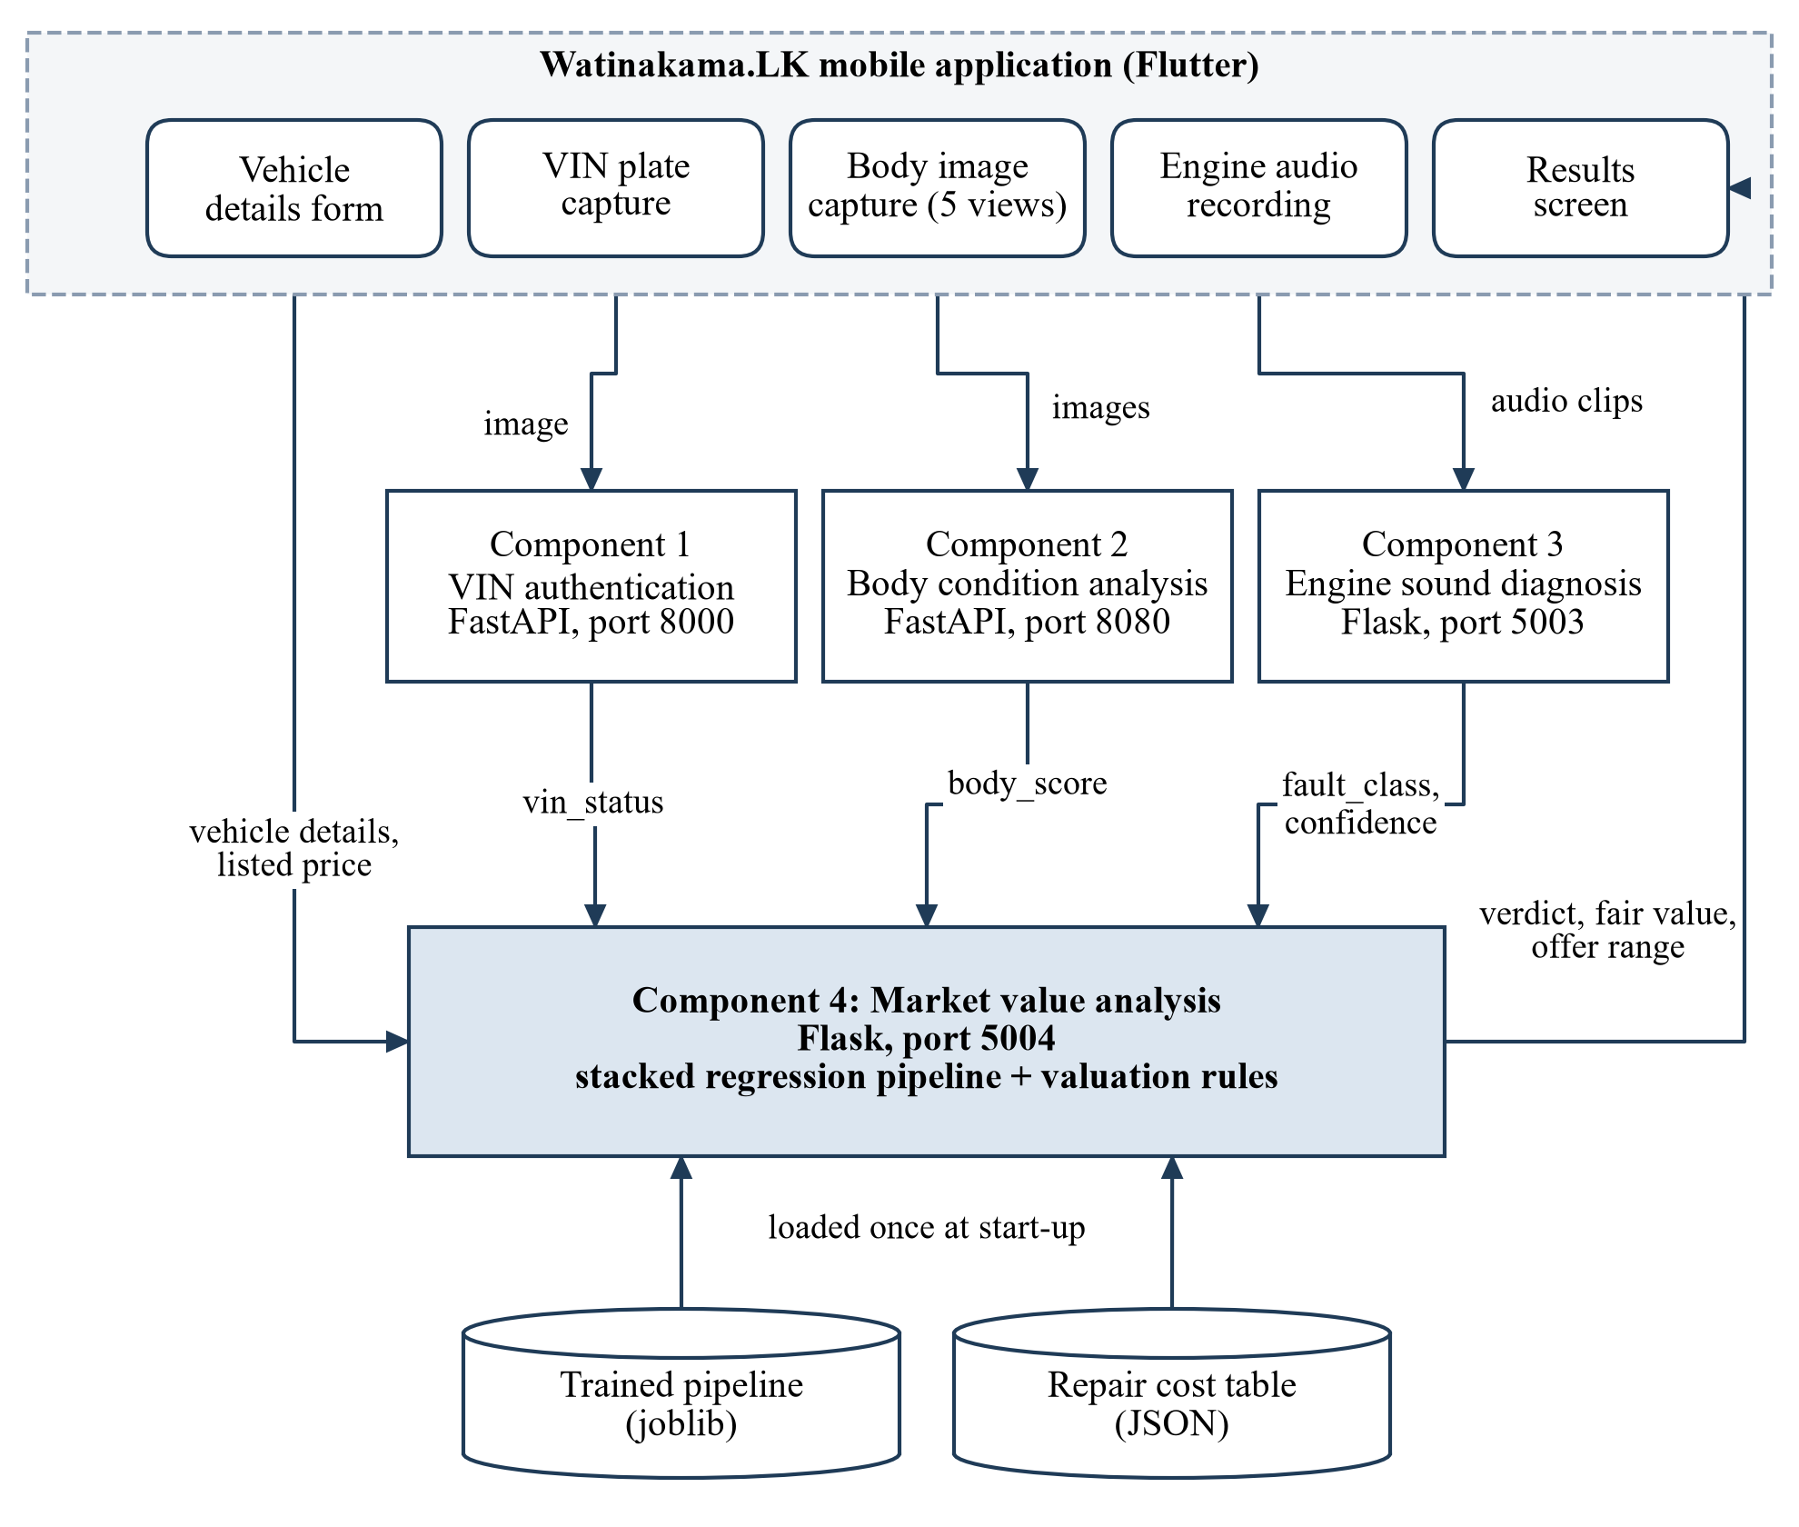
Figure 1.1: Overall architecture of Watinakama.LK and the position of Component 4
Each component runs as its own web service. The Flutter application collects the inputs, calls the first three services, and passes their results to the fourth. The valuation is therefore the last step of an inspection and the only number most users will remember, which is why its accuracy and its honesty about uncertainty matter more than those of any other part.

1.2 Individual component context
My component is the market value analysis service. Its job can be stated in one sentence: given what the buyer can type in and what the other components have measured, say what the car is worth and whether the asking price is reasonable.
The inputs fall into two groups. The first group is what any advertisement gives: year of manufacture, year of first registration, mileage, number of previous owners, whether the car was imported brand new or reconditioned, and whether it has power shutters and power mirrors. The second group arrives from the other components: a VIN status (original, altered or needing review), a body score, and an engine fault class with the classifier's confidence. The buyer also enters the listed price.
The outputs are a predicted fair value in rupees, one of four verdicts (good deal, fair price, overpriced, or do not buy), a negotiation range with a single recommended offer, the repair cost ranges behind any deduction, and two or three plain sentences that explain the result.
The scope of the trained model is deliberately narrow. It covers one model line, the Suzuki Alto manufactured between 2012 and 2017, which is among the most frequently advertised small cars in the country. Limiting the work to one model removed make and model effects from the data and let me collect enough listings by hand to say something about a single segment, at the cost of generality. Section 1.7 sets out this and the other limits.

1.3 Problem statement
A buyer who wants to check an asking price today has three options, and each fails in a different way. Comparing against other advertisements gives a range of asking prices for cars of the same year but says nothing about the particular car in front of the buyer. Asking a broker or a mechanic gives an opinion that depends on who is asked and on whose side they are. Online price estimators, where they exist for the local market, take year and mileage and return an average; they do not see the dent in the rear door or hear the tappet noise.
The technical problem behind this has two parts. The first is ordinary price prediction: learn the relationship between a small set of attributes and the price at which such cars are advertised. The second part is less ordinary. No public dataset anywhere pairs the sale price of a used car with a machine-assessed body score, an acoustic engine diagnosis and a VIN authenticity check, because such assessments are not made at the point of sale. A valuation that responds to them has to be built without direct supervision.
The problem this thesis addresses is therefore: how can a valuation service for a narrow segment of the Sri Lankan used-car market be built from a few hundred advertised prices so that it gives a defensible estimate of value, adjusts that estimate for inspected condition, and reports its result in terms a buyer can act on?

1.4 Research gap
Chapter 2 reviews the literature in detail. Four gaps come out of that review.
First, published used-car price models use advertisement attributes almost exclusively. Condition appears, if at all, as a self-reported category such as "good" or "excellent" typed by the seller [4], [5], [6]. I found no study in which the condition inputs come from automated inspection of the vehicle itself.
Second, almost all of the work uses data from Germany, India, the United States, Pakistan or Mauritius. Sri Lankan prices are shaped by import policy and taxation in ways that make models trained elsewhere unusable, and I could not find a peer-reviewed price model built on Sri Lankan listings.
Third, the output of these studies is a number. They stop at the predicted price and do not turn it into a decision, a range or an explanation, although a buyer needs all three.
Fourth, and this became the most important point in my own results, studies that enlarge a small dataset with synthetic records usually evaluate on a random split of the enlarged set. When synthetic records are derived from real ones, a random split places near-copies of the same vehicle on both sides, and the reported error is too low [7]. The literature on used-car pricing rarely discusses this.

1.5 Aim and objectives
The aim of the component is to design, build and evaluate a condition-aware valuation service for used Suzuki Alto cars in Sri Lanka that can be called from the Watinakama.LK mobile application.
The specific objectives are:
- O1. To collect and clean a dataset of advertised prices for the target segment and describe its structure.
- O2. To collect local repair costs for the engine faults and body damage levels that Components 2 and 3 can report.
- O3. To construct a training set in which price depends on body score and engine fault as well as on the advertised attributes.
- O4. To train and compare tree-based regressors and a stacked ensemble of them, and select a model for deployment.
- O5. To evaluate the selected model with more than one validation scheme, including one that keeps all records derived from the same listing together, and to examine how its predictions respond to each input.
- O6. To wrap the model in a rule layer that produces the verdict, negotiation range and explanation, expose it as an authenticated web service and integrate it with the mobile application.

1.6 Research questions or hypotheses
The work was guided by four questions.
- RQ1. How accurately can the advertised price of a used Suzuki Alto be predicted from the attributes a buyer can read in an advertisement?
- RQ2. Does a stacked ensemble of tree-based learners predict price better than its individual members and better than simple baselines?
- RQ3. Can the outputs of the VIN, body and engine components be built into the valuation so that the estimate responds to condition in a sensible direction and by a sensible amount?
- RQ4. How much do reported error figures change when the validation scheme accounts for the way the augmented dataset was constructed?
I expected a positive answer to RQ2 on the basis of earlier studies [5], [8], and expected RQ4 to show a visible but modest difference. Chapter 6 shows that the second expectation was wrong: the difference is large enough to change the conclusion about RQ2.

1.7 Scope limitations and assumptions
The following boundaries apply to everything reported here.
- The model covers the Suzuki Alto with a year of manufacture between 2012 and 2017. It should not be used for other models or years, and the service does not currently refuse such requests (section 5.4 records this as an open defect).
- The price data are asking prices taken from advertisements. Completed sale prices are not published in Sri Lanka, so "fair market value" in this thesis means the price at which comparable cars are advertised, less estimated repair costs. Actual transaction prices are normally somewhat lower.
- The listings were collected between November 2025 and March 2026, apart from seven older ones. The model describes that period. Prices in this market move quickly and the model will need retraining.
- Body score, engine fault and confidence are taken as given. Errors made by Components 2 and 3 pass straight through into the valuation. Their accuracy is evaluated in my colleagues' theses, not here.
- No real vehicle in the dataset has a measured body score or engine diagnosis. These features were simulated, and the effect of condition on price was imposed through repair costs. Section 3.2 describes how, and section 7.5 discusses what follows from it.
- Repair costs come from a small field survey of five sellers and repair centres and are indicative only.

1.8 Individual contribution
All of the work described in chapters 3 to 6 on Component 4 is my own. In summary, I:
- collected the 343 advertisements and recorded their attributes in a spreadsheet;
- carried out the repair cost survey and compiled the cost table;
- wrote the cleaning script and the two data augmentation scripts;
- ran the model experiments, from single regressors through voting ensembles to the tuned stacking pipeline;
- designed and implemented the valuation logic, including the VIN gate, verdict thresholds, negotiation range and explanation text;
- built the Flask service with token authentication and interactive documentation, and worked with the group member responsible for the mobile application to connect the results screen to it;
- wrote the evaluation script that produced the grouped validation, permutation importance, sensitivity and verdict analyses in chapter 6, and the functional and interface tests in chapter 5.
Decisions that affected the whole system, such as the service ports, the field names passed between components and the layout of the results screen, were taken by the group together.

1.9 Thesis structure
Chapter 2 reviews the theory of used-car pricing, earlier prediction studies and existing valuation products, and derives the conceptual framework for the component. Chapter 3 describes the research method: the data, the construction of the training set, the experimental procedure and the evaluation measures. Chapter 4 presents the design of the service and the reasoning behind the main design choices. Chapter 5 covers implementation, integration with the other components and testing. Chapter 6 reports the results. Chapter 7 interprets them, compares them with the literature and sets out the limitations. Chapter 8 considers commercialisation and sustainability. Chapter 9 concludes and lists future work.

2 LITERATURE REVIEW AND RELATED WORK

2.1 Review method and scope
The review had three purposes: to understand what determines the price of a used car, to see which prediction methods have worked on data of the kind I could collect, and to find out how existing products present a valuation to a user.
I searched IEEE Xplore, the ACM Digital Library, SpringerLink, ScienceDirect and Google Scholar with combinations of the terms "used car", "second-hand car", "vehicle", "price prediction", "valuation", "machine learning", "regression", "ensemble", "stacking" and "Sri Lanka". Titles and abstracts were screened first, then full texts. I kept studies that predicted a price or price class for individual used vehicles from tabular data and reported at least one error measure, together with the original papers for each algorithm I used and a small number of sources on validation practice and on synthetic data. Work on new-car pricing, on price forecasting for a whole market, and on image-only valuation was set aside. The economics papers in section 2.2 were found by following citations backwards from the prediction studies.

2.2 Domain and theoretical foundations

2.2.1 Information asymmetry in the used-car market
Akerlof's argument is the usual starting point [1]. If buyers cannot tell good cars from bad, they will pay only the price of an average car. Owners of good cars then have less reason to sell, the average quality on offer falls, and the price follows it down. The mechanisms that hold this spiral in check in practice are warranties, dealer reputation and independent inspection. In the private-sale market that most Sri Lankan buyers use, the first two are absent. Genesove's study of dealer auctions found that the type of seller affected the price paid in a way consistent with adverse selection, which is direct evidence that buyers do price in what they cannot see [2]. The purpose of Watinakama.LK as a whole is to move some of the hidden information to the buyer's side. The valuation component is where that information is converted into money.

2.2.2 Hedonic pricing
The standard way to model the price of a differentiated good is Rosen's hedonic framework, in which the price is a function of the characteristics of the item and the coefficients are read as implicit prices of those characteristics [9]:
$P_{i} = f\left(x_{i1}, x_{i2}, …, x_{ik}\right) + ε_{i}$ (2.1)
Here P is the price of vehicle i, the x terms are its attributes and the last term collects everything unobserved. Every study reviewed in section 2.3 is an application of this idea, whether the function is linear or a forest of trees. The framework also explains the approach I took to condition. If a body repair costs a known amount, a rational buyer should be willing to pay about that much less for the unrepaired car, so repair cost is a reasonable first estimate of the implicit price of damage. It is only a first estimate: buyers also discount for inconvenience and for the suspicion that visible damage signals worse damage underneath.

2.2.3 Tree ensembles for tabular data
Random forests average many decision trees grown on bootstrap samples with a random subset of features considered at each split, which reduces variance without much increase in bias [10]. Gradient boosting builds trees in sequence, each one fitted to the residual errors of the ensemble so far [11]. XGBoost adds regularisation and a number of engineering improvements to the same idea [12], and LightGBM grows trees leaf-wise on histogram-binned features, which makes it fast on large data [13]. On tabular problems of small and medium size these methods remain hard to beat. Grinsztajn and colleagues compared them with deep networks across 45 datasets and found the tree ensembles ahead in most cases [14], and Shwartz-Ziv and Armon reached a similar conclusion [15].

2.2.4 Stacked generalisation
Stacking combines several models by training a second-level model on their predictions [16]. Breiman showed that the combination works well when the first-level predictions fed to the second level are produced out of fold, so that the second level cannot simply reward whichever first-level model has memorised the training data most thoroughly [17]. With base learners h and a linear second level, the prediction is
$\hat{y}\left(x\right) = β_{0} + \sum_{m=1}^{M}{β_{m}h_{m}\left(x\right)}$ (2.2)
where the weights are learned from the out-of-fold predictions. Van der Laan and colleagues later proved that this "super learner" performs asymptotically as well as the best of its members [18]. The proof is asymptotic. On a few hundred records the guarantee means little, a point I return to in chapter 7.

2.2.5 Validation, leakage and synthetic data
Cross-validation estimates the error a model will make on new data by holding out part of the data in turn [19]. The estimate is honest only if the held-out part is independent of the part used for training. Kaufman and colleagues define leakage as the introduction of information about the target into training that would not be available in use, and list duplicated or near-duplicated records across the split among its common causes [7]. Where records come in related groups, the remedy is to split by group, so that all members of a group are either in training or in test [20].
This matters for synthetic data. Methods such as SMOTE create new records by interpolating between real ones [21], and simpler schemes add noise to copies of real records. Either way each synthetic record has a real parent. Jordon and colleagues stress that the usefulness of synthetic data has to be judged against the task and that evaluation should fall on real data wherever possible [22].

2.3 Related research
Table 2.1 summarises the studies closest to this work.
Table 2.1: Earlier studies on used-car price prediction
Study | Data | Methods | What it showed
Listiani (2009) [23] | Leasing company records, Germany | Support vector regression, multiple regression | Support vector regression predicted residual values more accurately than regression on a large feature set.
Pudaruth (2014) [4] | Newspaper advertisements, Mauritius | Multiple linear regression, k-nearest neighbours, decision tree, naive Bayes | All four methods gave comparable, moderate accuracy; the author attributed this to the small number of records.
Peerun et al. (2015) [24] | Online advertisements, Mauritius | Neural network, support vector regression, linear regression | The neural network was slightly better on average but none of the methods handled expensive cars well.
Noor and Jan (2017) [25] | Online listings, Pakistan | Multiple linear regression with feature selection | A small set of selected attributes was enough for a well-fitting linear model.
Sun et al. (2017) [26] | Online used-car platform, China | Back-propagation neural network | An optimised network was proposed as the pricing core of an online evaluation system.
Monburinon et al. (2018) [8] | German e-commerce listings | Multiple linear regression, random forest, gradient boosted trees | Gradient boosted trees had the lowest mean absolute error of the three.
Gegic et al. (2019) [5] | Scraped listings, Bosnia and Herzegovina | Neural network, support vector machine, random forest, combined | Single classifiers performed poorly on price classes; a combination of the three was clearly better.
Pal et al. (2019) [6] | Public listing dataset, Germany | Random forest | A forest of 500 trees fitted the training data closely, with noticeably lower accuracy on the test set.

A few patterns stand out. The earliest studies treat the problem as classification into price bands [4], [5], which wastes information; later ones regress on price directly. Tree ensembles overtake linear models once the dataset reaches tens of thousands of listings covering many makes [8], [6]. On small, single-market datasets the gap between methods is narrow, and Pudaruth and Peerun both say plainly that the amount of data limited what any method could achieve [4], [24]. That observation is easy to pass over when reading the larger studies, and it turned out to apply to my data as well.
The attributes that carry most of the predictive weight are consistent across the studies: age or year, mileage, engine capacity, make and model. In my setting make, model and engine capacity are fixed by design, which leaves year and mileage as the dominant variables and makes the secondary ones (owners, options, origin) relatively more visible.
Condition is the weak point throughout. Where it is present it is a category entered by the seller, and sellers do not describe their own cars as poor. None of the reviewed studies had an independent measurement of condition, and none attempted to link the price to a diagnosis of the engine or an inspection of the body.
Evaluation practice in these studies is simple: a single random split or a random k-fold, with accuracy or R² as the headline figure. Several report a single percentage "accuracy" for a regression task without defining it. I was guilty of the same shorthand in the project's early documentation, where the figure of 96.7% is one minus the mean absolute percentage error, not a classification accuracy. Section 3.4 defines the measures used in this thesis and section 6.1 gives the full picture.

2.4 Existing systems products and techniques
Consumer valuation tools are well established in large markets. Kelley Blue Book and Edmunds in the United States publish value ranges by make, model, year, mileage and a self-assessed condition grade, drawing on very large volumes of dealer and auction transactions [27], [28]. In India, platforms such as Cars24 pair an online estimate with a physical inspection by their own staff before making an offer. These services rest on two things a student project cannot have: transaction data at national scale and an inspection workforce.
In Sri Lanka the main sources of price information are the classifieds sites riyasewana.lk and ikman.lk [29], [30]. They let a buyer filter advertisements by model and year and so see the spread of asking prices, and that is as far as they go. Banks, leasing companies and insurers rely on valuation reports prepared by human assessors. To my knowledge, at the time of writing no locally available consumer tool adjusts a price estimate for the inspected condition of a particular vehicle.
Table 2.2 places the proposed component beside these alternatives.
Table 2.2: Comparison of the proposed component with existing sources of price information
Capability | Classifieds sites | Overseas price guides | Human valuer | Earlier research models | This component
Uses local (Sri Lankan) prices | Yes | No | Yes | No | Yes
Gives a single estimate for a specific car | No | Yes | Yes | Yes | Yes
Adjusts for inspected body condition | No | Self-reported only | Yes | No | Yes
Adjusts for engine condition | No | No | Sometimes | No | Yes
Checks vehicle identity before valuing | No | No | Sometimes | No | Yes
Gives a verdict and negotiation range | No | Range only | Verbal | No | Yes
Available on a phone at the roadside | Yes | Yes | No | No | Yes

2.5 Gap synthesis and conceptual framework
Putting the previous sections together: the theory says that hidden condition depresses prices and that revealing it has value; the prediction literature shows that tree ensembles work on listing data but has no measured condition to work with; and the products that do account for condition depend on human inspectors. The gap this component addresses lies where the three meet: a valuation that takes machine-measured condition as an input, built for a market with little data.
Figure 2.1 shows the conceptual framework. Advertised attributes, VIN authenticity, body score, engine diagnosis and local repair costs enter on the left. A learned model supplies the price level; a rule layer applies what cannot be learned from the available data (the legal significance of an altered VIN, the thresholds for a verdict) and converts the estimate into outputs a buyer can use.
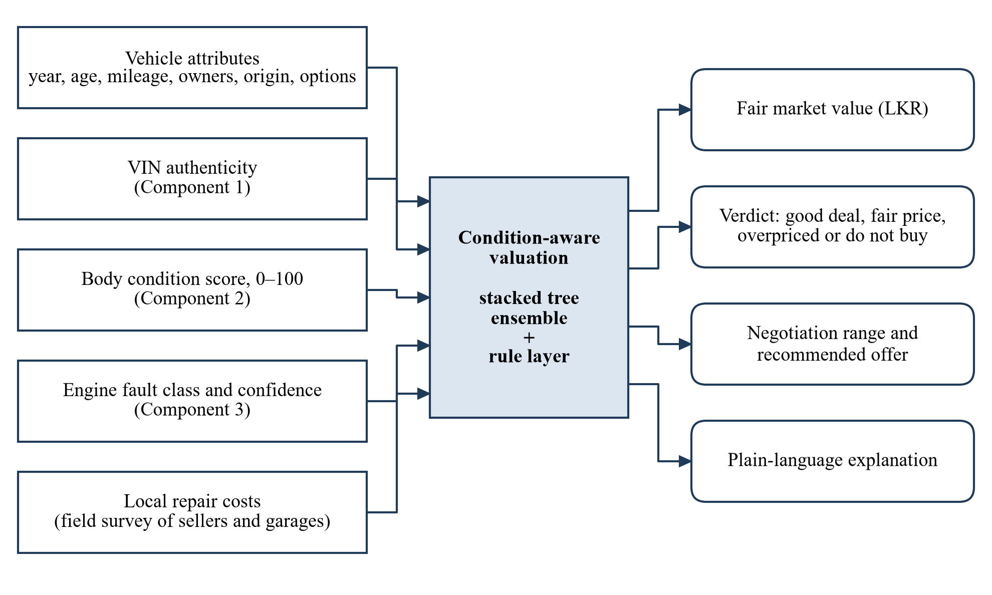
Figure 2.1: Conceptual framework of the condition-aware valuation
The framework carries one assumption that should be stated openly: that repair cost is an acceptable proxy for the effect of damage on price. Section 2.2.2 gave the economic reason for adopting it and its weakness. Testing it properly would need sale prices for cars with known defects, which is listed as future work in chapter 9.

3 RESEARCH METHODOLOGY

3.1 Research design
The work follows the design science approach, in which knowledge is produced by building an artefact that addresses a practical problem and evaluating it rigorously [31], [32]. The artefact here is the valuation service; the evaluation is quantitative. For the data work inside that frame I followed the stages of CRISP-DM, from business understanding through data preparation and modelling to evaluation and deployment [33]. Figure 3.1 shows the sequence as it was actually carried out.
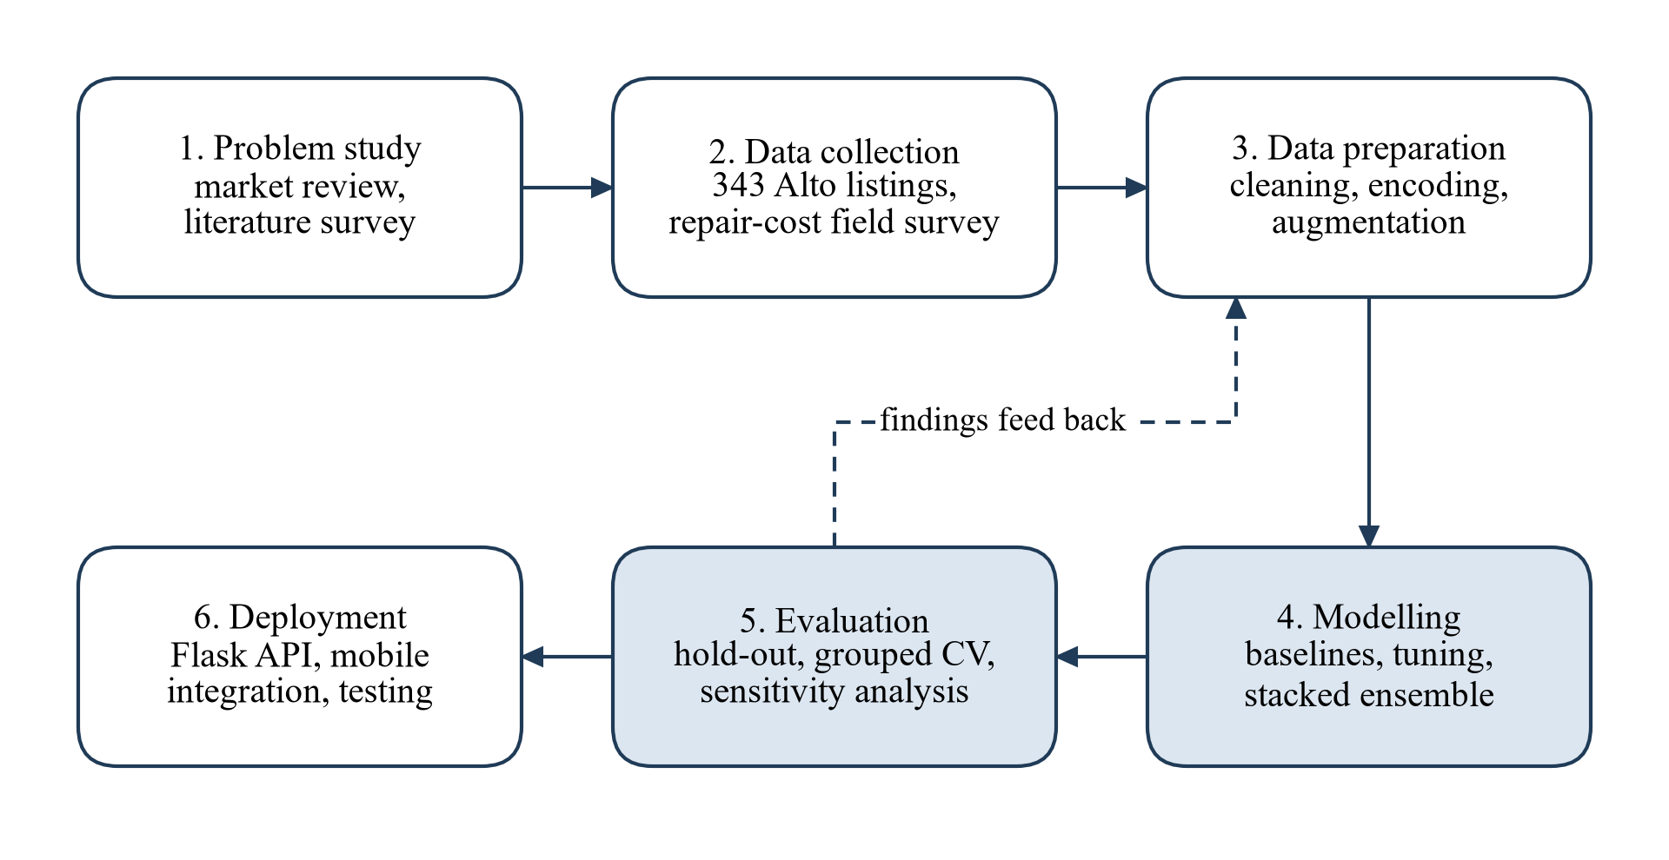
Figure 3.1: Research process followed for the component
The dashed arrow in Figure 3.1 is not decoration. The first round of modelling used only advertised attributes. When the other components began to produce outputs, I went back to data preparation to add condition features, and the evaluation of that second round led to the additional validation reported in section 6.1.
The research is experimental in the sense used in machine learning: the same data are given to several methods under controlled conditions and the methods are compared on held-out records. There were no human participants in the quantitative study.

3.2 Data participants or study materials

3.2.1 Listing data
Between late 2025 and March 2026 I recorded 343 advertisements for the Suzuki Alto from riyasewana.lk, entering each into a spreadsheet by hand. The site's free-text descriptions had to be read to extract owner count and options reliably, which is why the collection was manual. Of the 343 records, 335 were listed between November 2025 and March 2026; seven date from early 2024 and one has no listing month.
Table 3.1 lists the columns recorded and how complete each was.
Table 3.1: Columns of the raw listing dataset (343 records)
Column | Content | Missing values
Vehicle ID | Running number assigned during collection | 0
Reg No | Registration number as shown in the advertisement | 0
MAF Date | Year of manufacture | 0
Reg Date | Year of first registration in Sri Lanka | 0
MileAge (km) | Odometer reading stated by the seller | 1
Price Listed (Million) | Asking price in millions of rupees | 0
# of previous owners | Text such as "2 nd owner" | 19
BN/ R | Imported brand new (BN) or reconditioned (R) | 3
Power shutters | Yes or no | 1
Power mirrors | Yes or no | 1
Year/month listed to sell | Month in which the advertisement appeared | 1

Registration numbers were used only to avoid recording the same car twice and were dropped during cleaning. They do not appear in any processed file.

3.2.2 Cleaning
The cleaning script applies the steps shown in the upper half of Figure 3.2. Two records with prices of 34.9 and 36.5 million rupees were removed; both are almost certainly 3.49 and 3.65 with a misplaced decimal point, but I preferred to drop them than to guess. Three records fell outside the 2012 to 2017 range (one each from 2003, 2010 and 2018) and were removed because a single car cannot represent a model year. This left 338 records.
The owner count was extracted as the first digit of the text and missing values were filled with the median, which is two. Origin was coded 0 for brand new and 1 for reconditioned, and the two option columns were coded 1 for yes and 0 for no; the few missing entries in these columns were set to 0. The one missing mileage was filled with the median mileage of cars from the same year. Two derived columns were added: vehicle age, as 2026 minus the year of manufacture, and registration gap, as the year of registration minus the year of manufacture, floored at zero.
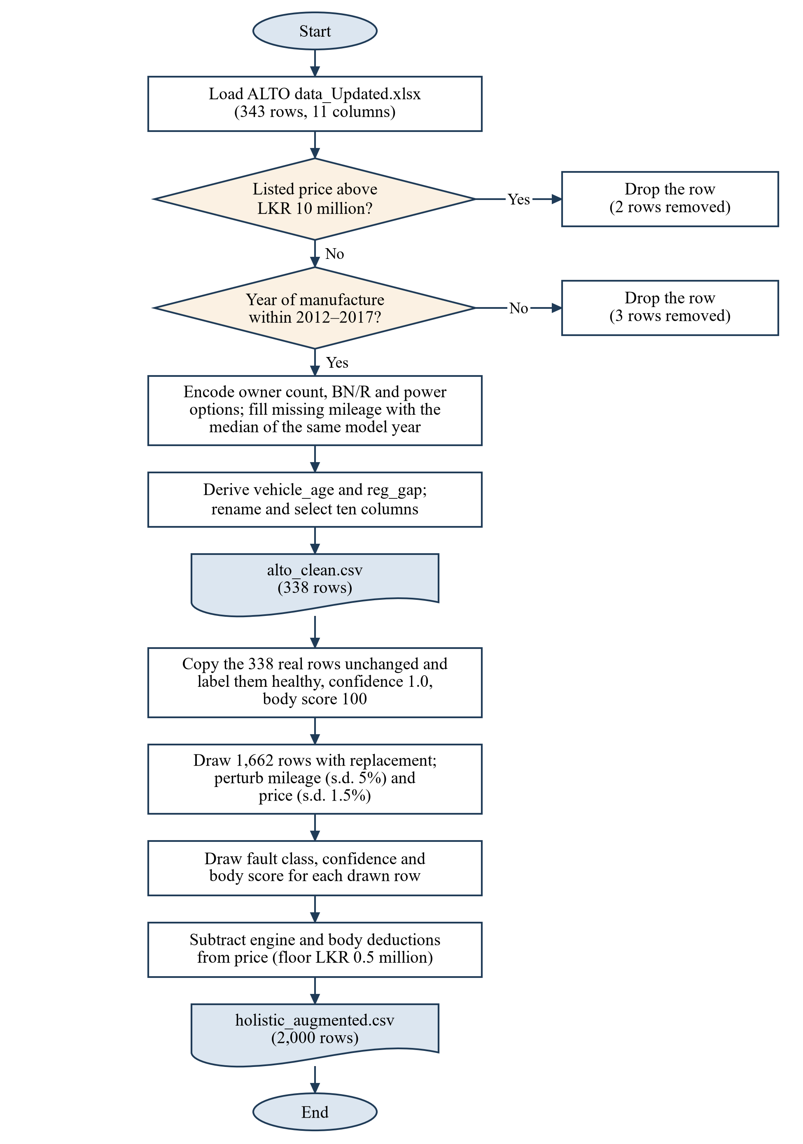
Figure 3.2: Data cleaning and augmentation steps
Table 3.2 describes the cleaned data and Figure 3.3 shows how price varies with year of manufacture.
Table 3.2: Summary of the cleaned listing data (338 records)
Variable | Mean | Std. dev. | Minimum | Maximum
Price (LKR million) | 3.746 | 0.285 | 2.920 | 4.490
Mileage (km) | 118,462 | 34,738 | 37,100 | 247,561
Year of manufacture | 2014.8 | 0.96 | 2012 | 2017
Previous owners | 2.86 | 1.64 | 1 | 8
Registration gap (years) | 0.13 | 0.36 | 0 | 2
Power shutters (share with) | 0.864 |  | 0 | 1
Power mirrors (share with) | 0.095 |  | 0 | 1
Reconditioned (share) | 0.009 |  | 0 | 1

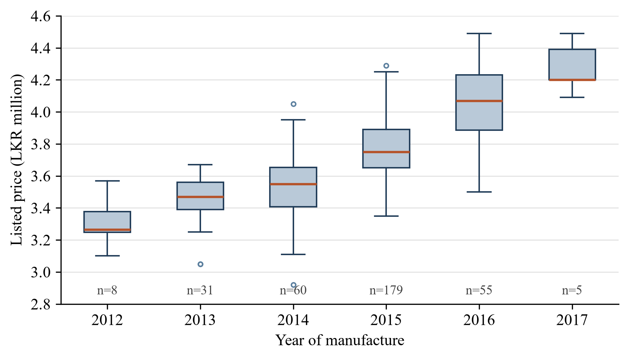
Figure 3.3: Listed price by year of manufacture in the cleaned data, with the number of listings per year
Three features of the data shaped everything that followed. The sample is small and unbalanced across years: 179 of the 338 cars are from 2015, while 2012 and 2017 have eight and five. The price range is narrow, with a standard deviation of LKR 285,000 around a mean of LKR 3.75 million, so a model that predicted the mean for every car would already be within 10% four times out of five. And within a year the spread is still wide: the 2015 cars alone range from LKR 3.35 million to LKR 4.29 million. Figure 3.4 shows that mileage explains part of that spread but far from all of it. The correlation of price with year of manufacture is 0.70 and with mileage is −0.45; for owner count it is −0.18, and for power mirrors 0.24. Only three cars are reconditioned, so that variable can contribute almost nothing.
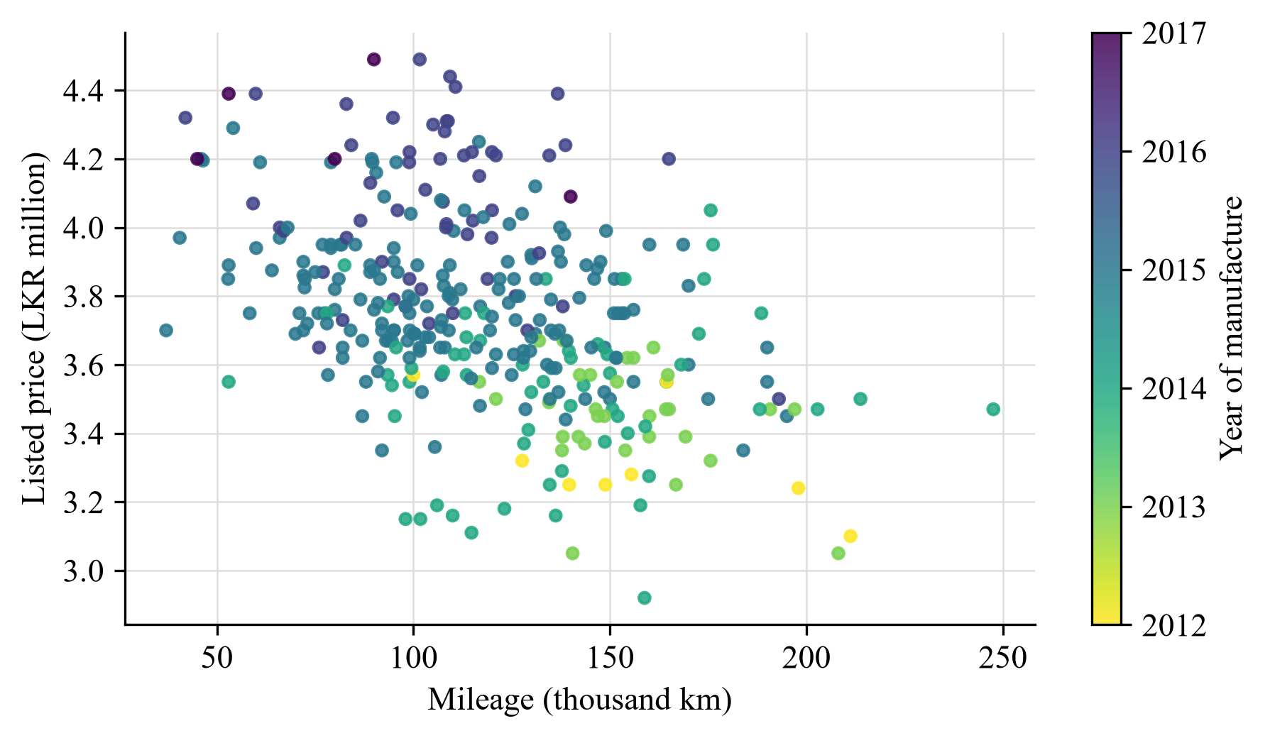
Figure 3.4: Listed price against mileage for the 338 cleaned listings, shaded by year of manufacture

3.2.3 Repair cost survey
To put a rupee value on defects I surveyed five parts sellers and repair centres in early 2026 and asked for the price range of each repair that corresponds to an output of Components 2 and 3. The respondents were asked about prices only, no personal information was recorded, and they are not identified. Table 3.3 gives the engine figures. For body work I collected prices for twelve individual parts and services (listed in Appendix A) and combined them into four damage levels, shown in Table 3.4.
Table 3.3: Engine repair cost ranges from the field survey
Fault class | Minimum (LKR) | Maximum (LKR) | Typical repair
Healthy | 0 | 0 | None
Knocking | 35,000 | 85,000 | Bearing or piston work requiring a strip-down
Misfiring | 8,000 | 25,000 | Spark plugs, ignition coil or injector cleaning
Tappet noise | 5,000 | 18,000 | Valve clearance adjustment
Rotational imbalance | 8,000 | 30,000 | Engine mount replacement or balancing
Battery or starting fault | 25,500 | 40,000 | Battery, and starter motor if required

Table 3.4: Body damage levels and their repair cost ranges
Level | Minimum (LKR) | Maximum (LKR) | Description
None | 0 | 0 | No visible damage
Minor | 10,000 | 25,000 | Surface scratches, small dents, paint chips
Moderate | 25,000 | 80,000 | Dented panels, broken lights, damaged bumpers
Severe | 80,000 | 200,000 | Several damaged panels, door or bonnet replacement, full repaint

Five respondents are too few for the ranges to be more than indicative. They are stored in a separate JSON file so that they can be revised without touching the model or the code.

3.2.4 Construction of the training set
The cleaned data contain no information on condition. To give the model something to learn from, I generated a second dataset of 2,000 records in which body score, engine fault and classifier confidence are present and the price has been adjusted for them. The lower half of Figure 3.2 shows the steps.
The 338 real records were kept unchanged and labelled as healthy with confidence 1.0 and body score 100, on the reasoning that an advertised price is the seller's claim for a car in sound condition. A further 1,662 records were then produced. For each, a real record was drawn at random with replacement; its mileage was perturbed with Gaussian noise of standard deviation 5% and its price with noise of standard deviation 1.5%; and with probability 0.2 its owner count was increased by one. A fault class was drawn with probability 0.60 for healthy and 0.08 for each of the five faults. Confidence was set to 1.0 for healthy and drawn uniformly between 0.60 and 1.00 otherwise. Body score was drawn from a normal distribution with mean 85 and standard deviation 15, rounded and limited to the range 10 to 100.
The price was then reduced by two deductions. The engine deduction is the midpoint of the repair range for the fault, scaled by the classifier's confidence:
$D_{e} = c × \frac{r_{min} + r_{max}}{2}$ (3.1)
where c is the confidence and the two r terms are the limits of the repair range for the fault. The body deduction is the midpoint of the range for the damage level, with scores of 80 and above treated as no damage, 60 to 79 as minor, 40 to 59 as moderate and below 40 as severe. The target price of a synthetic record is
$P' = max\left(0.5, P\left(1 + ε\right) - \frac{D_{e} + D_{b}}{{10}^{6}}\right)$ (3.2)
in millions of rupees, where P is the price of the parent record and the noise term has standard deviation 0.015. The floor of half a million was never reached in practice.
The resulting file has 1,350 healthy records and between 127 and 131 of each fault. Body scores range from 38 to 100; 604 records have a score of exactly 100, 793 fall between 80 and 99, 525 between 60 and 79, and 78 below 60.
Two consequences of this construction need to be kept in mind when reading the results. On average each real listing is the parent of about five synthetic records, which differ from it only by small perturbations. And the effect of condition on price is small by construction: the largest typical deduction is around LKR 100,000, less than the unexplained spread in price between otherwise similar cars.
An earlier dataset of 1,000 records (the 338 real ones plus 662 perturbed copies, without condition features) was used for the first round of experiments and then set aside.

3.3 Experimental or study procedure
The experiments ran in three rounds.
In the first round I trained a random forest, a gradient boosting regressor and a linear regression on the eight advertised attributes using the 1,000-record dataset, and compared them on a 20% hold-out. In the second round I tried equal-weight voting combinations of those three models in pairs and all together. These two rounds established that tree ensembles fitted the augmented data better than a linear model and that combining models helped a little. Their saved outputs were overwritten by the third round and I do not report their figures.
The third round, which produced the deployed model, used the 2,000-record dataset and fourteen features: the eight advertised attributes, the three condition features, and three derived terms (mileage per year of age, the logarithm of mileage and the logarithm of age):
$\text{mileage per year} = \frac{\text{mileage (km)}}{\text{vehicle age + 1}}$ (3.3)
The procedure was as follows.
- The data were split 80:20 at random with a fixed seed of 42, giving 1,600 training and 400 hold-out records.
- Numeric features were standardised and fault class was one-hot encoded inside a column transformer, so that the same preprocessing is applied at training and at prediction.
- Four base learners (random forest, gradient boosting, XGBoost and LightGBM) were tuned separately by randomised search [34], with ten parameter settings each, three-fold cross-validation on the training records, and mean absolute error as the criterion. Table 3.5 gives the search spaces and the selected values.
- The four tuned learners were combined in a stacking regressor with five-fold internal cross-validation and a ridge regression as the second level [35].
- The complete pipeline was fitted on the training records, scored once on the hold-out records and saved.
Table 3.5: Hyperparameter search spaces and selected values
Learner | Search space | Selected
Random forest | Trees: 100, 200, 300; maximum depth: none, 10, 20; minimum samples to split: 2, 5, 10 | 300 trees, depth 10, split 2
Gradient boosting | Trees: 100, 200, 300; learning rate: 0.01, 0.05, 0.1; maximum depth: 3, 4, 5 | 200 trees, rate 0.05, depth 5
XGBoost | Trees: 100, 200, 300; learning rate: 0.01, 0.05, 0.1; maximum depth: 3, 5, 7 | 100 trees, rate 0.1, depth 7
LightGBM | Trees: 100, 200, 300; learning rate: 0.01, 0.05, 0.1; leaves: 31, 50, 100 | 200 trees, rate 0.05, 50 leaves

After the model was integrated, I wrote a separate evaluation script that reads the saved pipeline and the data files without changing either. It reproduces the hold-out split and adds the analyses that the training script did not include: reference baselines, scores for each base learner, three further validation schemes, permutation importance, a sensitivity analysis and a simulation of the verdict logic. Section 3.5 describes them.

3.4 Measures and evaluation metrics
Four measures are reported for every model. With y the recorded price, ŷ the prediction and n the number of records, the mean absolute error is
$\text{MAE} = \frac{1}{n}\sum_{i=1}^{n}{\left|y_{i} - {\hat{y}}_{i}\right|}$ (3.4)
and the root mean squared error is
$\text{RMSE} = \sqrt{\frac{1}{n}\sum_{i=1}^{n}{{\left(y_{i} - {\hat{y}}_{i}\right)}^{2}}}$ (3.5)
Both are in rupees. MAE is the typical size of an error and is the figure a buyer would care about; RMSE weights large errors more heavily [36], [37]. The coefficient of determination
$R^{2} = 1 - \frac{\sum_{i=1}^{n}{{\left(y_{i} - {\hat{y}}_{i}\right)}^{2}}}{\sum_{i=1}^{n}{{\left(y_{i} - \overline{y}\right)}^{2}}}$ (3.6)
is the share of the variance in price that the model accounts for. It is the most informative of the four on this dataset, because the narrow price range makes rupee and percentage errors look small for any model. The mean absolute percentage error is
$\text{MAP}\text{E} = \frac{100}{n}\sum_{i=1}^{n}{\left|\frac{y_{i} - {\hat{y}}_{i}}{y_{i}}\right|}$ (3.7)
MAPE is easy to explain but has known weaknesses [38]. In particular, a figure such as "96.7% accuracy" obtained as 100 minus MAPE says little here: predicting the average price for every car gives 93.6% on the same scale.
Two further measures relate to how the service is used. The share of predictions within 5% and within 10% of the recorded price shows how often the estimate would be close enough for a negotiation. The verdict agreement rate, defined in section 3.5, shows how often the three-way verdict would be right for a listing whose true position relative to the market is known.
For the service itself I measured the HTTP status returned for valid and invalid requests and the time taken to answer a request.

3.5 Data analysis
Reference baselines. Three simple predictors were scored on the hold-out records for comparison: the mean training price, the mean training price of cars from the same year, and an ordinary linear regression on the same fourteen features.
Base learners. Each of the four fitted base learners inside the stack was scored on the hold-out records, to show what stacking adds.
Validation schemes. The stacking pipeline was re-estimated under three schemes in addition to the original hold-out: random five-fold cross-validation on the 2,000 records; grouped five-fold cross-validation on the same records, in which every record derived from the same real listing is kept in the same fold [20]; and five-fold cross-validation on the 338 real listings alone, using the eleven features that exist for them. For the grouped scheme I regenerated the 2,000-record file with the original script and seed while recording the parent of each synthetic record, and confirmed that the regenerated prices and fault labels match the saved file exactly.
Permutation importance. Each feature in turn was shuffled in the hold-out records, twenty times, and the increase in MAE recorded [10], [39]. A feature the model relies on produces a large increase; one it ignores produces none.
Sensitivity analysis. A reference car was fixed (2015, 100,000 km, two owners, brand new import, power shutters, no power mirrors, healthy, body score 100) and one input at a time was varied across its range. The change in predicted value was compared with the deduction that had been applied to the training data for the same change.
Verdict simulation. Each hold-out record was submitted to the verdict rule with a listed price equal to its recorded price, and then with the recorded price raised or lowered by 10% and 15%. A listing at its recorded price should be judged fair; one raised by 15% should be judged overpriced. The proportion of correct verdicts is the agreement rate.
Functional and interface tests. The valuation function was called with eight scenarios chosen to exercise each branch of its logic, and the web service with eleven requests covering authentication, validation and routing. Chapter 5 reports these.

3.6 Ethics privacy security and responsible AI
The listing data were taken from public advertisements. The only field that could identify an owner indirectly is the registration number, which was recorded to prevent duplicates and is dropped by the cleaning script. No names, telephone numbers or addresses were collected. The processed files and the trained model contain no personal data within the meaning of the Personal Data Protection Act [40]. The repair cost survey asked businesses for prices and recorded nothing about the individuals who answered.
The service itself stores nothing. A request contains vehicle attributes and component outputs, and the response is computed and returned without being written to disk.
Three matters of responsible use deserve mention. The first is over-reliance. A valuation shown to two decimal places on a phone looks more certain than it is, and section 6.1 shows that about one prediction in five is more than 5% away from the recorded price. The response therefore carries a range as well as a point estimate, and I argue in chapter 7 that the range should be widened. The second is the "do not buy" verdict for an altered VIN. A false alarm from Component 1 could cost a seller a sale and expose the project to complaint, so the wording refers to the detected status of the plate, makes no accusation against the seller, and a separate caution is given when the VIN check is inconclusive. The third is the use of simulated condition data, which is disclosed in the response's data source field and throughout this thesis.
The service requires a bearer token on the valuation endpoint. The token is read from an environment file that is excluded from version control.

3.7 Reproducibility and research artefacts
All code and data for the component are in the group's Git repository under the directory component4-market-valuation. Table 3.6 lists the artefacts.
Table 3.6: Research artefacts of the component
Artefact | Purpose
data/raw/ALTO data_Updated.xlsx | The 343 collected listings
data/repair_costs.json | Repair cost survey results
preprocessing/clean_data.py | Cleaning; writes alto_clean.csv
preprocessing/augment_data.py | First-round augmentation (1,000 records)
preprocessing/augment_holistic.py | Condition-aware augmentation (2,000 records)
models/train_model.py, models/ensemble_experiment.py | First- and second-round experiments
models/advanced_model_optimization.py | Tuning, stacking and saving of the deployed pipeline
inference/valuate.py | Valuation logic
api/app.py | Web service
thesis/analysis/evaluate_component.py | Evaluation reported in chapters 5 and 6; writes results.json and the result charts
thesis/diagrams/*.drawio | Editable sources of the diagrams in this thesis

Random seeds are fixed at 42 in every script. Rerunning the augmentation script reproduces the saved dataset exactly, and rerunning the evaluation script on the saved pipeline reproduces the hold-out figures recorded when the model was trained (MAE of LKR 121,906 and R² of 0.716). The software versions are given in section 5.1.

4 PRODUCT AND SOLUTION DESIGN

4.1 Requirements
Requirements were gathered from three sources: discussion within the group about what the results screen had to show, the interfaces of the other three components, and the practical constraints of running four services on a student budget. Table 4.1 and Table 4.2 list them.
Table 4.1: Functional requirements
ID | Requirement
FR1 | Accept the seven vehicle attributes and the listed price for a single vehicle.
FR2 | Accept the VIN status, body score, engine fault class and confidence produced by the other components, and assume a sound vehicle when any of them is absent.
FR3 | Return a predicted fair market value in rupees.
FR4 | Refuse to value a vehicle whose VIN is reported as altered and return a clear warning instead.
FR5 | Attach a caution to the valuation when the VIN check is inconclusive.
FR6 | Classify the listed price as a good deal, a fair price or overpriced.
FR7 | Return a negotiation range and a single recommended offer.
FR8 | Return the repair cost range and description for any engine fault or body damage.
FR9 | Return a short explanation in plain English.
FR10 | Report the service's health without authentication so that the mobile application can check availability.

Table 4.2: Non-functional requirements
ID | Quality | Requirement
NFR1 | Performance | Answer a valuation request in under one second on the development machine, so that the results screen appears without a noticeable wait.
NFR2 | Security | Reject valuation requests that do not carry the agreed bearer token.
NFR3 | Reliability | Return a structured JSON error, never a stack trace, for malformed requests.
NFR4 | Maintainability | Keep repair costs and the trained model as replaceable files, separate from the code.
NFR5 | Interoperability | Use JSON over HTTP with field names agreed with the other components.
NFR6 | Transparency | State the source of the price data and the repair costs in every response.
NFR7 | Portability | Run on any machine with Python 3.9 or later, without a GPU.

4.2 Component architecture within the complete solution
Figure 1.1 in chapter 1 showed where the component sits in the whole system. Figure 4.1 shows its internal structure, which separates into an offline part that prepares data and trains the model, and an online part that answers requests.
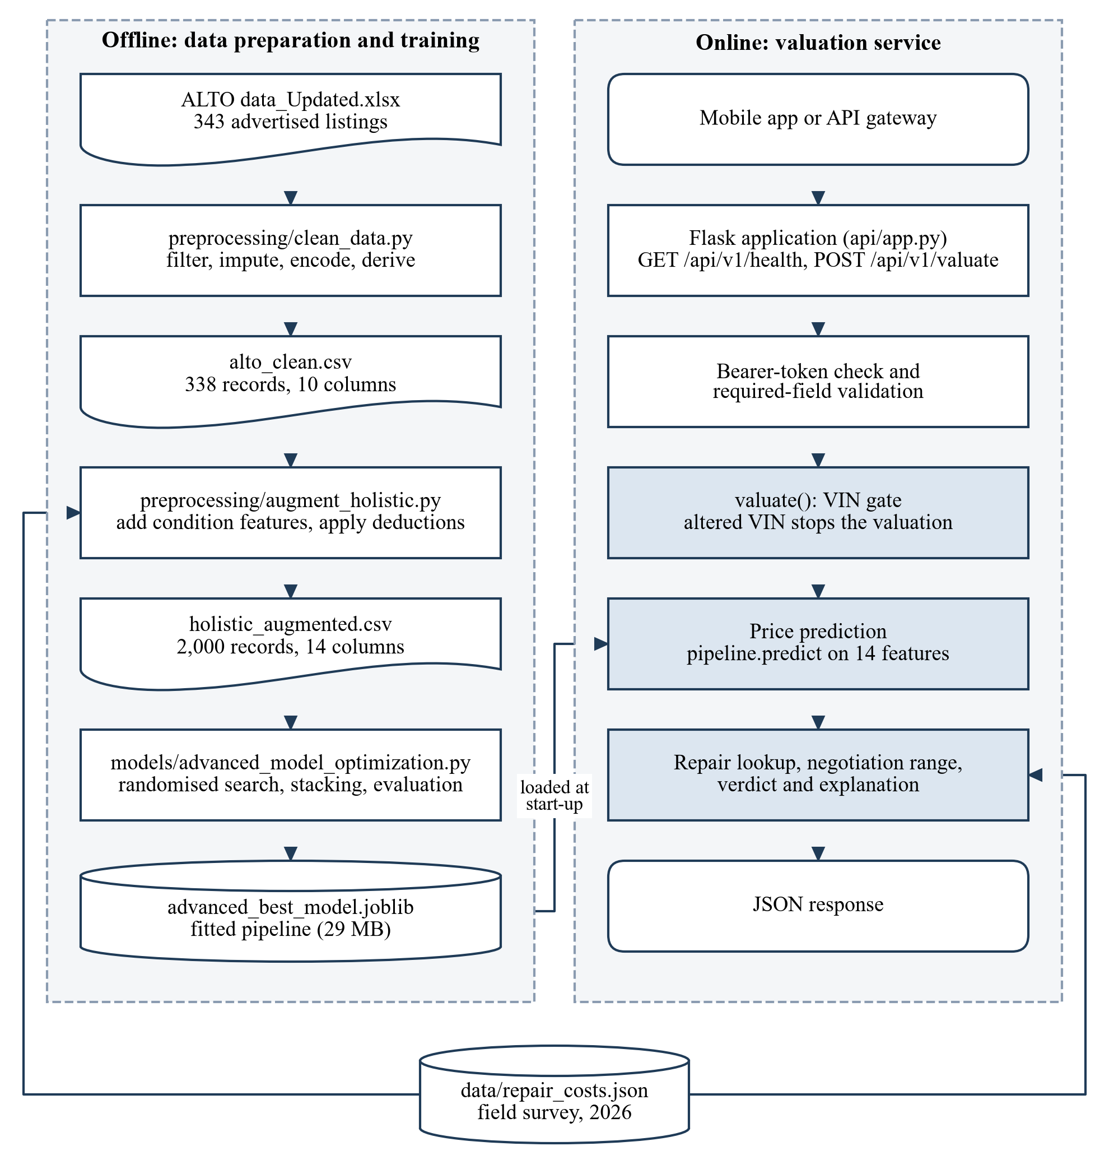
Figure 4.1: Internal architecture of the market value analysis component
The two parts share only two files. The trained pipeline is written by the offline part and read once when the service starts. The repair cost table is read by the augmentation script when the training set is built and by the valuation logic when a response is composed. This means the same cost figures inform both what the model learned and what the user is told, provided both sides interpret the table in the same way. Section 5.4 reports a case where they did not.
The online part has three layers. The Flask application handles HTTP, authentication and field checking. The valuation function contains all the decision logic and has no knowledge of HTTP, so it can be called directly from tests. The pipeline object does the numerical prediction. Figure 4.2 shows the order of calls during an inspection.
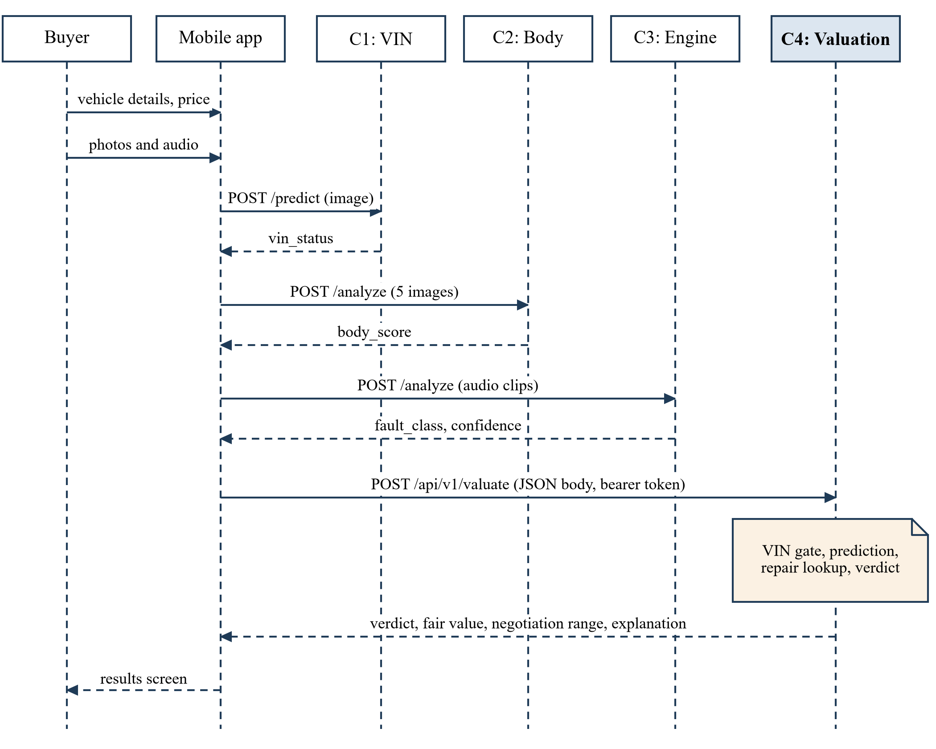
Figure 4.2: Sequence of calls during a full inspection
The mobile application acts as the coordinator: it calls each component in turn and carries the results forward. An alternative would have been a gateway service that the application calls once. The group wrote a prototype of such a gateway as a script, which was useful for demonstrating the chain from a terminal, but kept the coordination in the application so that the user sees each result as it arrives and can retry a single failed step.

4.3 Design alternatives and decisions

4.3.1 How condition enters the valuation
This was the central design choice and I considered three options.
- Option A: train the price model on advertised attributes only and subtract repair costs from its prediction by rule.
- Option B: train the price model on a dataset in which condition features are present and the price already reflects them, so that the model's prediction is the final value.
- Option C: a hybrid, in which the model predicts the price of a sound car and a second learned model predicts the discount.
Option C needs real discount data and was ruled out. Between A and B the argument at the time was that B is closer to how the system would work if real data on condition and price were available one day: the model could simply be retrained on the new data with no change to the service. B also allows interactions, for instance that a given fault might cost more on a newer car. I chose B, and the deployed model is of that kind.
Chapter 6 shows the cost of that choice. With simulated condition data, the model can at best re-learn the rule that generated the data, and in practice it re-learns a blurred version of it. Section 7.1 argues that Option A would have been the better engineering decision for the data available, and section 9.4 proposes it as the first change to make.

4.3.2 Choice of learning algorithm
Linear regression was the obvious baseline and is the method of several earlier studies [4], [25]. Tree ensembles were preferred for the deployed model because they capture non-linear effects of age and mileage without manual feature design, and because the literature favours them on tabular data [14]. Neural networks were not tried: with a few hundred real records there was no reason to expect them to do better, and earlier studies on small datasets found no advantage [24].
Stacking was chosen over simple averaging because it learns how much weight to give each member. A ridge regression was used as the second level because the four members' predictions are highly correlated, and an unpenalised linear model on correlated inputs gives unstable weights [35].

4.3.3 Verdict thresholds
The verdict compares the listed price with the fair value. A band of 5% either side of the fair value is treated as fair, as shown in Figure 4.3. The figure was chosen by judgement before any error analysis was done: on a car worth LKR 3.75 million it corresponds to about LKR 190,000, which seemed a reasonable margin for ordinary negotiation. Section 6.2 examines how well the band matches the model's actual error.
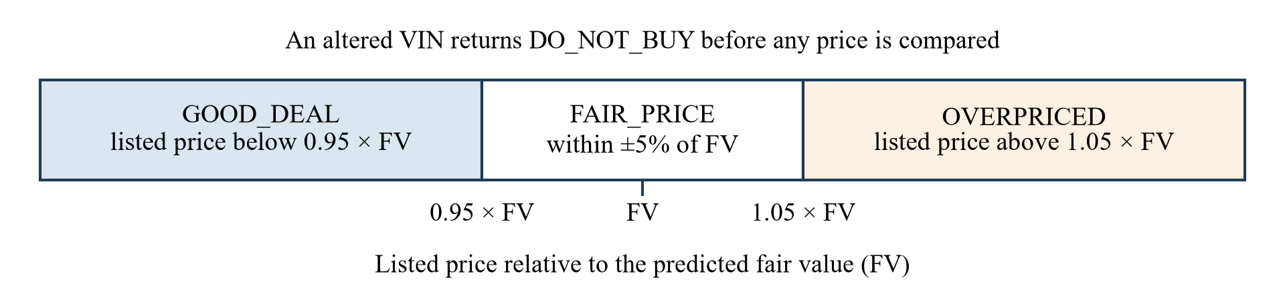
Figure 4.3: Verdict bands relative to the predicted fair value

4.3.4 Web framework
Components 1 and 2 use FastAPI and Component 3 uses Flask. I used Flask because the service has two endpoints, needs no asynchronous processing, and Flask was already familiar from Component 3's code, which made the authentication decorator and error format easy to keep consistent between the two. Interactive documentation, which FastAPI provides automatically, was added with the flasgger extension.

4.4 Detailed design

4.4.1 Feature set
Table 4.3 lists the fourteen features the model receives. The client supplies the first seven vehicle fields and, optionally, the three condition fields. The service computes the remaining five.
Table 4.3: Features used by the deployed model
Feature | Supplied by | Definition
maf_year | Client | Year of manufacture
mileage_km | Client | Odometer reading in kilometres
previous_owners | Client | Number of previous owners
is_reconditioned | Client | 1 if imported reconditioned, 0 if brand new
power_shutters | Client | 1 if fitted
power_mirrors | Client | 1 if fitted
vehicle_age | Service | 2026 minus year of manufacture
reg_gap | Service | Year of registration minus year of manufacture, not below zero
fault_class | Component 3 | One of six labels; default healthy
confidence | Component 3 | Classifier confidence, 0 to 1; default 1.0
body_score | Component 2 | Body condition score, 0 to 100; default 100
mileage_per_year | Service | Mileage divided by (age + 1)
log_mileage_km | Service | Natural logarithm of (1 + mileage)
log_vehicle_age | Service | Natural logarithm of (1 + age)

The year of registration is the seventh field supplied by the client. It is used only to compute the registration gap.

4.4.2 Model pipeline
Figure 4.4 shows the pipeline. Preprocessing and the stacked model are saved together as one object, so the service passes a single-row table of raw feature values and receives a price. This removes the risk of applying different scaling at training and at prediction, which exists when the scaler is saved as a separate file, as it was in the first round.
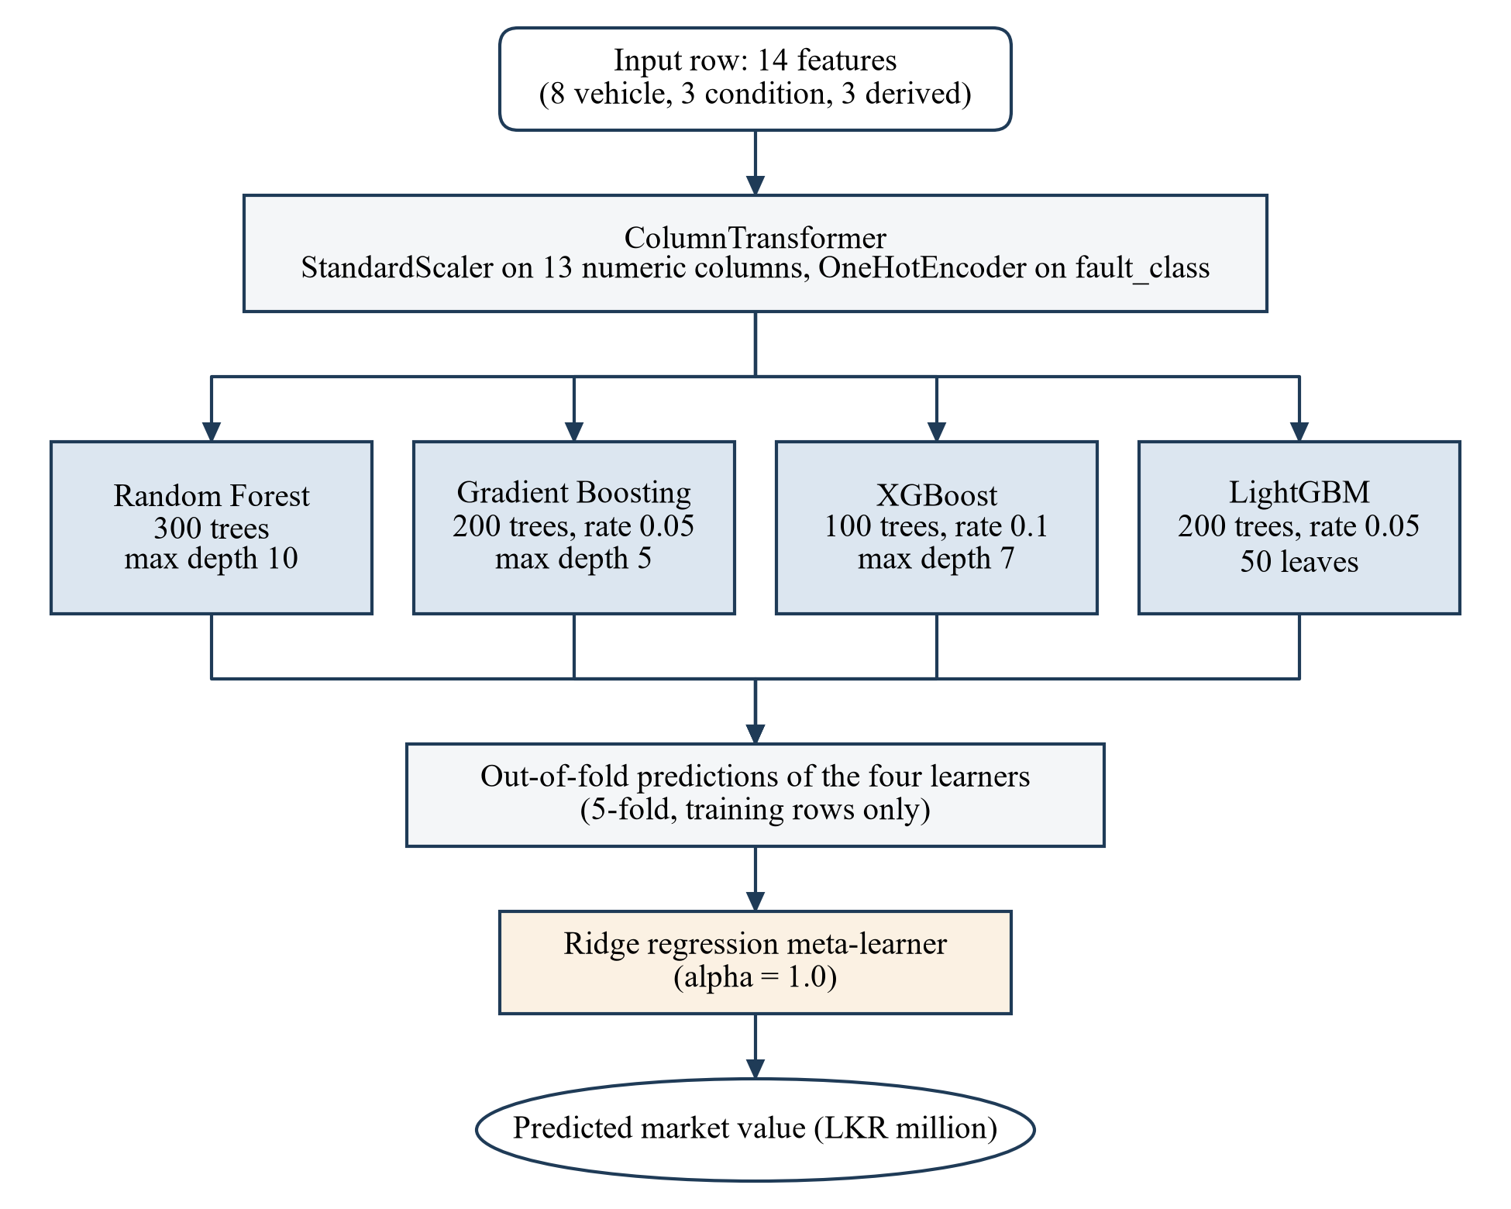
Figure 4.4: Structure of the deployed stacking pipeline

4.4.3 Valuation logic
Figure 4.5 shows the logic of the valuation function. The VIN gate comes first because no price is meaningful for a vehicle whose identity is in doubt, and because skipping the model call makes the refusal immediate.
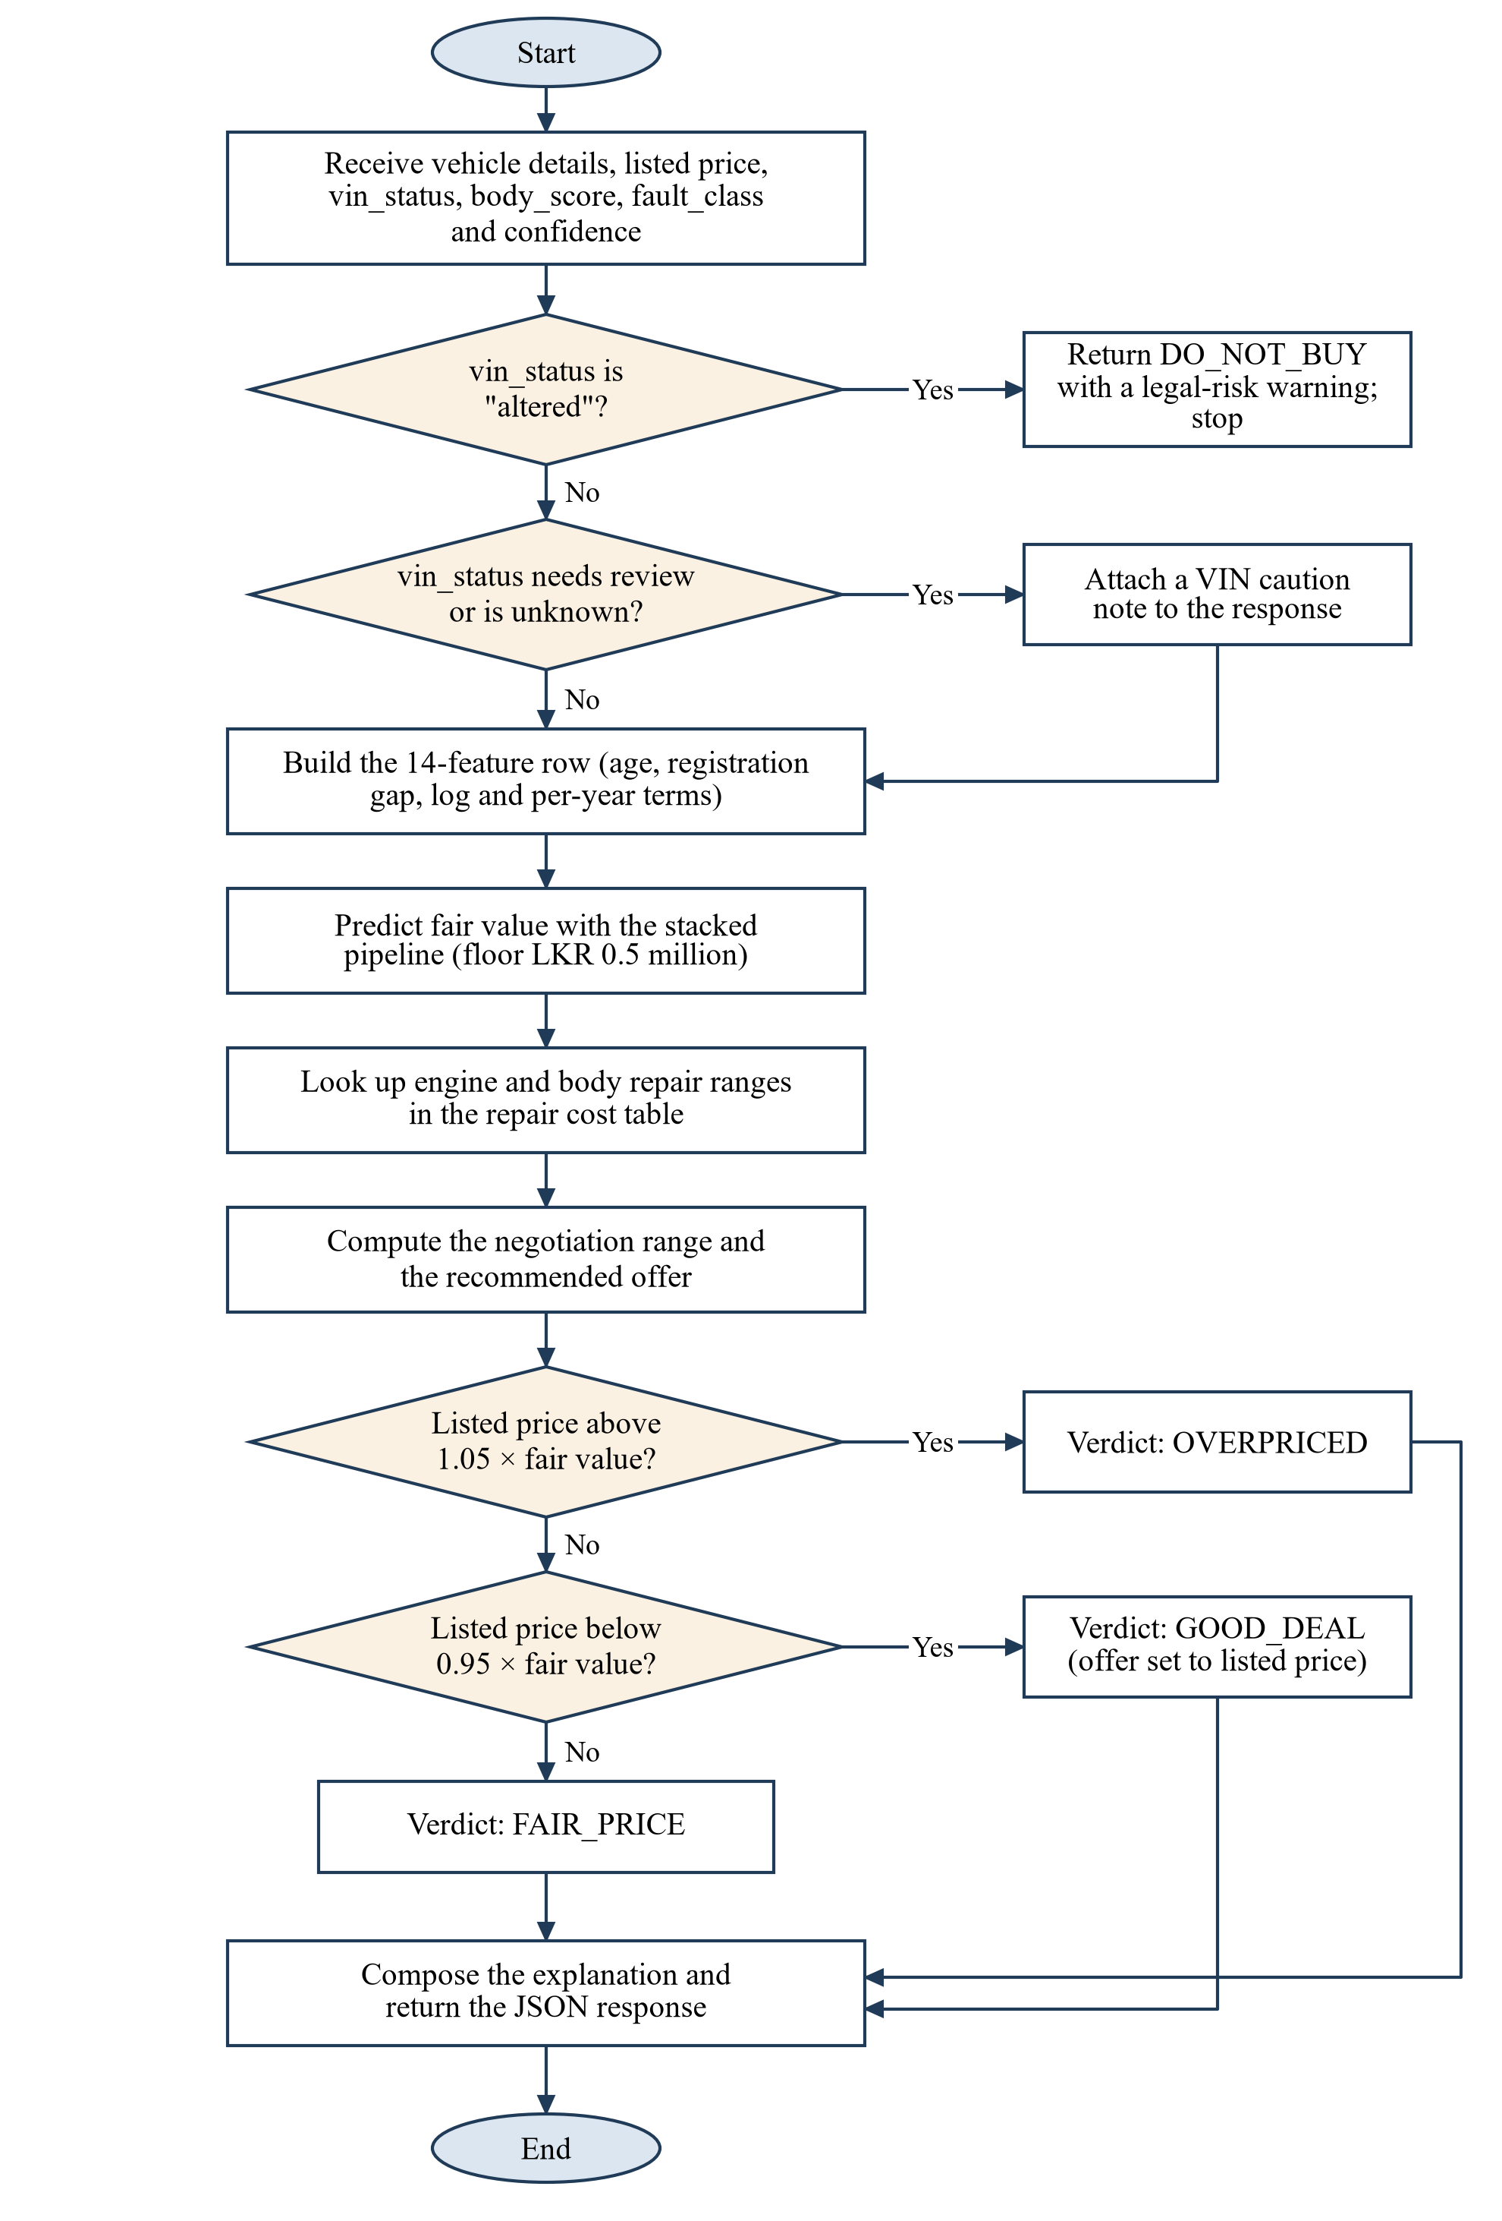
Figure 4.5: Decision flow of the valuation function
The fair value FV is the model's prediction, with a floor of LKR 500,000. For the explanation and the negotiation range, the function looks up the repair range of the engine fault and the damage level of the body. Writing the two ranges as minimum and maximum repair costs for the engine and for the body, and D for the corresponding deductions (the midpoint, scaled by confidence for the engine), the negotiation range is
$N_{min} = FV - \left(r_{e,max} - D_{e}\right) - \left(r_{b,max} - D_{b}\right)$ (4.1)
$N_{max} = FV - \left(r_{e,min} - D_{e}\right) - \left(r_{b,min} - D_{b}\right)$ (4.2)
The reasoning is that the fair value already allows for a typical repair. If the repair turns out to cost the maximum, the buyer should have paid less by the difference; if it costs the minimum, the buyer could have paid more. The recommended offer is the midpoint of the range rounded to the nearest LKR 10,000. For a car with no faults both ranges are zero and the range collapses to the fair value. When the verdict is a good deal, the offer and both ends of the range are set to the listed price, since there is no reason to advise offering more than the seller is asking.

4.4.4 Service interface
The service exposes two endpoints, described in Table 4.4. Appendix A contains a full example request and response.
Table 4.4: Endpoints of the valuation service
Path | Method | Authentication | Behaviour
/api/v1/health | GET | None | Returns service name, version and whether the model is loaded.
/api/v1/valuate | POST | Bearer token | Validates the JSON body, runs the valuation and returns the result. Returns 400 for a missing or malformed field and 401 for a missing or wrong token.
/apidocs/ | GET | None | Interactive Swagger documentation generated from the endpoint descriptions.

The response is a flat JSON object. The fields the mobile application reads are the verdict, the verdict message, the fair value, the two ends of the negotiation range, the engine description, the body damage level, the two deductions and the VIN warning. The remaining fields (repair ranges, recommended offer, data source) are available for a future version of the results screen.

4.5 Standards and professional practice
The interface follows the conventions of REST as described by Fielding: resources are addressed by URL, the HTTP method carries the intent and the status code carries the outcome [41]. The path includes a version number so that a changed response format can be introduced without breaking the installed application. The endpoint descriptions follow the OpenAPI format [42].
The quality attributes in Table 4.2 were chosen with reference to the product quality model of ISO/IEC 25010 [43]. Code is kept under version control with one commit per unit of work, secrets are held in an environment file outside the repository, and dependencies are pinned to minimum versions in a requirements file. Python code follows PEP 8 naming, with one module per responsibility as shown in Figure 4.1.

5 IMPLEMENTATION INTEGRATION AND TESTING

5.1 Development environment and technology stack
The component was developed on Windows 11 in its own Python virtual environment so that its dependencies do not collide with those of the other three services. Table 5.1 lists the main libraries and the versions installed in the environment in which the reported results were produced.
Table 5.1: Technology stack of the component
Library or tool | Version | Use
Python | 3.12.10 | Language and runtime
pandas | 3.0.5 | Reading the spreadsheet, cleaning, building feature rows
NumPy | 2.5.2 | Random number generation for augmentation, numerical work
scikit-learn | 1.9.0 | Preprocessing, random forest, gradient boosting, stacking, ridge, model selection [44]
XGBoost | 3.4.1 | Base learner [12]
LightGBM | 4.7.0 | Base learner [13]
joblib | bundled with scikit-learn | Saving and loading the fitted pipeline
Flask | 3.1.3 | Web service [45]
flask-cors, flasgger | current | Cross-origin requests from the app; Swagger documentation
python-dotenv | current | Reading the token and port from the environment file
matplotlib | current | Result charts
Git and GitHub |  | Version control and collaboration
draw.io |  | Diagrams

No GPU is needed. Training the deployed pipeline, including the hyperparameter search, took about 42 seconds on the development laptop.

5.2 Component implementation

5.2.1 Data preparation scripts
The cleaning script is a single function of about a hundred lines that carries out the steps of section 3.2.2 in order and prints a summary of what it removed and what remains. The summary was the main check during development: after each change I compared the counts with the spreadsheet.
The augmentation script takes one real row and a random generator and returns one synthetic row. Keeping the generator as an argument means the whole dataset is determined by the seed. The core of the function is short:
fault = rng.choice(FAULTS, p=FAULT_PROBS)
confidence = float(rng.uniform(0.60, 1.00))
if fault == "healthy":
confidence = 1.0
body_score = int(np.clip(int(rng.normal(85, 15)), 10, 100))

eng_deduction = get_engine_deduction(fault, confidence)
body_deduction = get_body_deduction(body_score)
final_price = base_price_million - (eng_deduction + body_deduction) / 1_000_000
new_row['price_million'] = round(max(0.5, final_price), 3)

5.2.2 Training script
The training script builds the column transformer, tunes each base learner with a randomised search, assembles the stacking regressor from the best estimators and wraps preprocessing and model in one pipeline:
stacking_regressor = StackingRegressor(
estimators=best_estimators, # tuned rf, gb, xgb, lgbm
final_estimator=Ridge(),
cv=5, n_jobs=-1)

final_pipeline = Pipeline(steps=[
('preprocessor', preprocessor), # scaler + one-hot encoder
('model', stacking_regressor)])
final_pipeline.fit(X_train, y_train)
joblib.dump(final_pipeline, BEST_MODEL_PATH)

The script writes three files: the pipeline, the ordered list of feature names, and a small JSON file of hold-out metrics. The pipeline file is 29 MB, most of it the 300 trees of the random forest.

5.2.3 Valuation module
The valuation module contains five functions: one loads the pipeline, the feature list and the repair costs; one builds the feature row and calls the pipeline; two look up the engine and body repair information; one composes the explanation; and the main function ties them together in the order shown in Figure 4.5. The main function accepts the loaded assets as an argument, so the service loads them once at start-up and passes them to every call.
The explanation is assembled from fixed sentence templates. A sentence about the price position always comes first; a sentence about the engine is added if a fault was reported, one about the body if damage was found, and one about the VIN if its status is not original. The result is cut to three sentences to fit the card on the results screen.

5.2.4 Web service
The Flask application is about two hundred lines. Authentication is a decorator applied to the valuation route:
def require_auth(f):
@wraps(f)
def decorated(*args, **kwargs):
auth_header = request.headers.get('Authorization')
if not auth_header or not auth_header.startswith('Bearer '):
return jsonify({"error": "Missing or invalid authorization header",
"status_code": 401}), 401
token = auth_header.split(" ")[1]
if token != API_TOKEN:
return jsonify({"error": "Unauthorized: Invalid API token",
"status_code": 401}), 401
return f(*args, **kwargs)
return decorated

The route checks that the body is JSON, that the seven vehicle fields and the listed price are present, and that numeric fields convert cleanly. The three condition fields and the VIN status are optional and default to a sound, original vehicle. Error handlers for the 400, 401, 404 and 500 statuses return JSON in the same shape, an error message and the status code, so the application can handle all failures in one place.
If the model files cannot be loaded at start-up the process exits with a message. I preferred that to a service that starts and then fails on every request.

5.3 Integration with the other components
Integration was done in two steps. First, the group wrote a small orchestration script that calls the four services in order from the command line, falling back to fixed values when one of the first three is not running. This allowed the valuation service to be exercised against the agreed field names before the application screens were ready.
Second, the application's service class gained a method that posts the valuation request. The results screen builds the request from the route arguments accumulated during the inspection, as Table 5.2 shows.
Table 5.2: Mapping of inspection outputs to the valuation request
Source | Value produced | Request field | Default if absent
Vehicle details screen | Year of manufacture, year of registration, mileage, owners, origin, options, asking price | maf_year, reg_year, mileage_km, previous_owners, is_reconditioned, power_shutters, power_mirrors, listed_price_million | Form defaults
Component 1 | Original, altered or needs review | vin_status | original
Component 2 | Body condition score, 0 to 100 | body_score | 100
Component 3 | Fault label and classifier confidence | fault_class, confidence | healthy, 1.0

Three points needed agreement between the component owners. The confidence from Component 3 can arrive as a fraction or as a percentage string depending on the code path, so the application normalises it to a fraction before sending. The VIN status is compared in lower case, and both "need review" and "needs review" are accepted, because the two spellings were both in use at different times. And when the valuation call fails, the results screen shows the VIN, body and engine results it already has together with an explicit error and a retry button, and does not display a price. An earlier version substituted a default price in that situation, which the group agreed was unacceptable in a tool whose purpose is to be trusted.
The application also calls the health endpoint of each service when it starts and warns the user if any of the four is unreachable.

5.4 Verification and software testing
Testing was carried out at three levels: the valuation function, the web service, and the complete chain through the application. The first two are automated in the evaluation script and can be rerun at any time. The third was done by hand.

5.4.1 Functional tests of the valuation logic
Eight scenarios were run against the valuation function with the deployed model. All use the same car (2015, registered 2015, 85,000 km, two owners, brand new import, power shutters, no power mirrors) and differ in asking price and condition inputs. Table 5.3 gives the inputs and what was returned.
Table 5.3: Functional test scenarios and results
ID | Scenario | Verdict returned | Fair value (LKR) | Negotiation range (LKR)
TC-01 | Sound car listed at 3.95 million | FAIR_PRICE | 3,774,000 | 3,774,000 (single value)
TC-02 | Sound car listed at 4.60 million | OVERPRICED | 3,774,000 | 3,774,000 (single value)
TC-03 | Sound car listed at 3.30 million | GOOD_DEAL | 3,774,000 | 3,300,000 (listed price)
TC-04 | Knocking at 0.87 confidence, body score 82, listed at 3.89 million | OVERPRICED | 3,687,000 | 3,646,700 to 3,711,700
TC-05 | VIN altered | DO_NOT_BUY | Not computed | Not computed
TC-06 | VIN needs review, listed at 3.95 million | FAIR_PRICE with VIN caution | 3,774,000 | 3,774,000 (single value)
TC-07 | Body score 45, listed at 3.95 million | OVERPRICED | 3,709,000 | 3,649,000 to 3,769,000
TC-08 | Fault label not known to the model, listed at 3.95 million | OVERPRICED | 3,761,000 | 3,761,000 (single value)

Every scenario returned a verdict consistent with the thresholds in Figure 4.3, and the altered VIN stopped the valuation before the model was called. The arithmetic of the negotiation range in TC-04 was checked by hand against the two equations in section 4.4.3: the knocking deduction is 60,000 times 0.87, or LKR 52,200, and the minor body deduction is LKR 17,500, which gives the two limits shown.
Reading the full responses, and not only the verdicts, exposed four defects. They are recorded in Table 5.4. None of them changes a verdict in the eight scenarios, but each affects what the user is told.
Table 5.4: Defects found during testing
ID | Observation | Cause | Status
D1 | In TC-07 the response describes a body score of 45 as severe damage with a deduction of LKR 140,000, yet the fair value fell by only LKR 65,000 against the sound car. In TC-04 a score of 82 is described as minor damage. | The valuation module maps scores to damage levels at 100, 80 and 60. The augmentation script that built the training data used 80, 60 and 40. The description and the model disagree by one level. | Open. One function must be changed to match the other and the model retrained if the training side is changed.
D2 | In TC-01 and TC-06 the verdict is FAIR_PRICE but the explanation reads "This vehicle is overpriced by LKR 176,000". | The explanation template has a branch for a good deal and one for everything else. A fair price falls into the second. | Open. The application displays the verdict message, which is correct, in preference to the explanation, so users do not currently see the wrong sentence.
D3 | In TC-08 an unrecognised fault label is accepted. The explanation mentions the fault with a repair estimate of "LKR 0-0". | The cost lookup falls back to the healthy entry and the encoder ignores unknown categories, both silently. | Open. The service should reject labels outside the six known classes with a 400 response.
D4 | Requests for years outside 2012 to 2017, negative mileage, or a body score above 100 are accepted and valued. | The route checks presence and type of fields but not their range. | Open. Range checks are needed, together with a refusal for vehicles outside the trained segment.

I have left these open in the submitted code and reported them here, because the evaluation in chapter 6 was run against the deployed model and I did not want to change the system under test after measuring it. All four are small changes and are the first items of future work.

5.4.2 Interface tests
Eleven requests were sent to the service through Flask's test client, which runs the full request handling without a network. Table 5.5 lists them. All eleven returned the expected status.
Table 5.5: Interface tests of the web service
ID | Request | Expected status | Actual status | Result
API-01 | GET /api/v1/health | 200 | 200 | Pass
API-02 | POST /api/v1/valuate without an Authorization header | 401 | 401 | Pass
API-03 | POST /api/v1/valuate with a wrong token | 401 | 401 | Pass
API-04 | POST /api/v1/valuate with a valid token and complete body | 200 | 200 | Pass
API-05 | As API-04 with mileage_km removed | 400 | 400 | Pass
API-06 | As API-04 with listed_price_million removed | 400 | 400 | Pass
API-07 | Valid token, body that is not JSON | 400 | 400 | Pass
API-08 | As API-04 with a non-numeric price | 400 | 400 | Pass
API-09 | As API-04 with vin_status set to altered | 200, DO_NOT_BUY | 200, DO_NOT_BUY | Pass
API-10 | GET on a path that does not exist | 404 | 404 | Pass
API-11 | Valid token, vehicle fields and price only | 200 | 200 | Pass

The error messages name the problem ("Missing required field: mileage_km"), which made the mobile-side debugging quicker.

5.4.3 Response time
The valuation function was called 200 times in a loop with the model already loaded, and the same request was sent 200 times through the test client. Table 5.6 gives the timings. Almost all of the time is spent inside the four tree ensembles; request parsing and the rule layer add about a millisecond.
Table 5.6: Response time over 200 calls (milliseconds)
Path measured | Mean | Median | 95th percentile | Maximum
Valuation function called directly | 96.9 | 94.0 | 113.3 | 129.9
Full request through the Flask test client | 97.0 | 94.8 | 109.8 | 148.8

These figures exclude network time between the phone and the server. On the local network used for demonstrations the valuation appears on the results screen without a perceptible delay, and the requirement of one second (NFR1) is met with a wide margin.

5.4.4 End-to-end checks
With all four services running on the development machine and the application on a phone on the same network, the group ran complete inspections using stored test images and audio clips. For the valuation component the checks were that the request built by the results screen carried the values produced by the other components, that the verdict chip and price card matched the service response, that an altered VIN produced the blocked-valuation card, and that stopping the valuation service produced the error card and not a price. These checks passed. They were not scripted and I have no counts to report for them.

5.5 Deployment and operation
Figure 5.1 shows the deployment used during development and demonstration. The four services run on one machine and the phone reaches them over the local network by IP address.
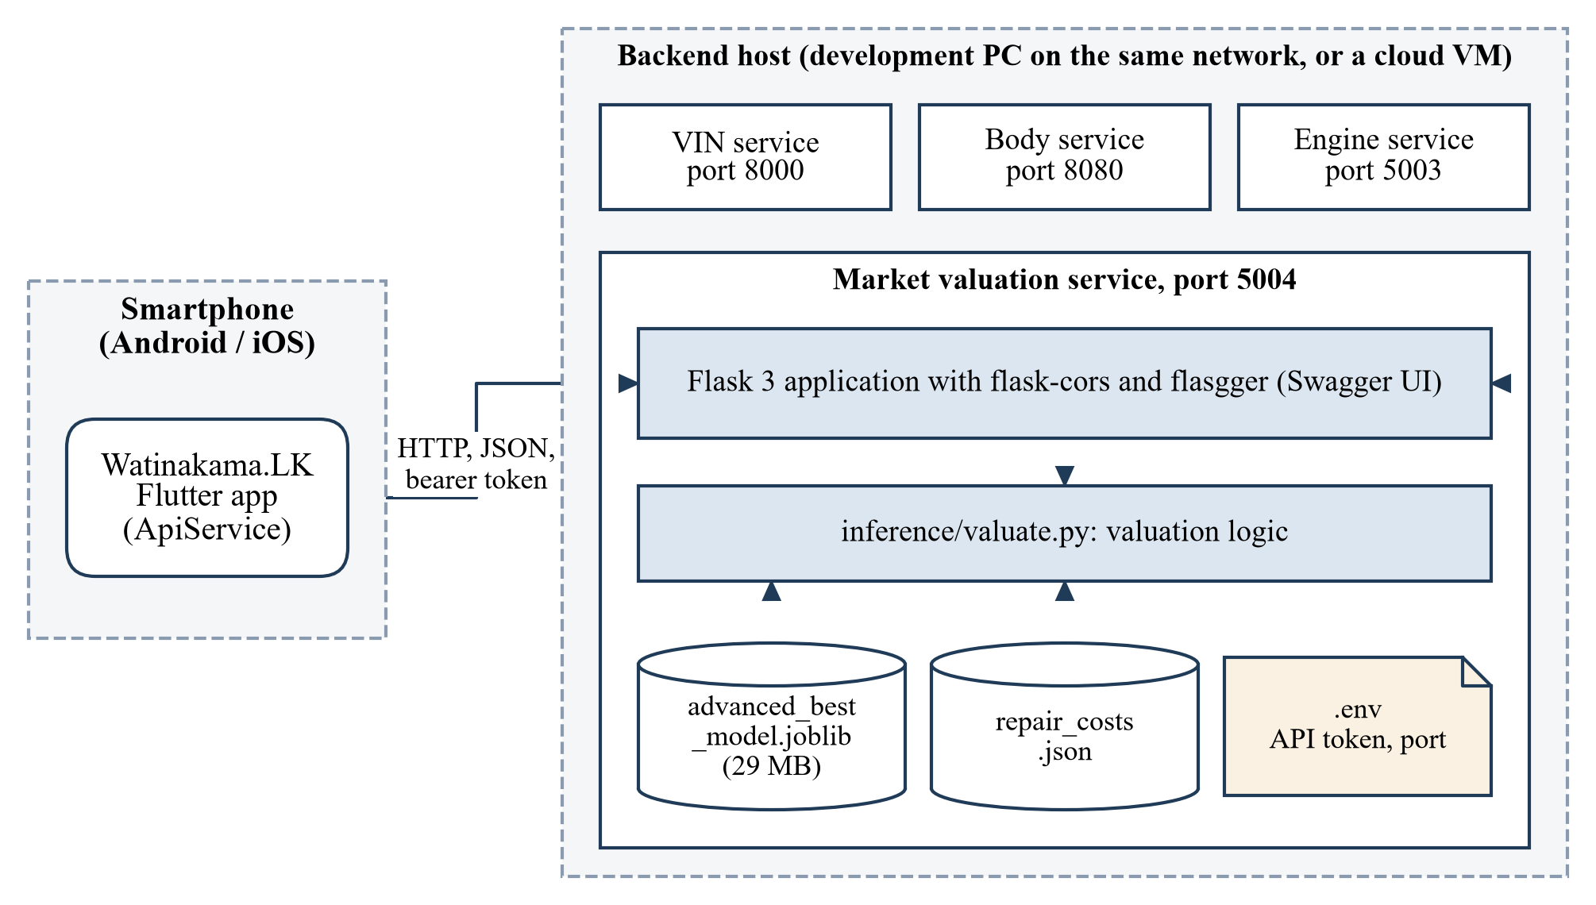
Figure 5.1: Deployment view of the valuation service
To start the service, the environment file is copied from the supplied example and edited to set the token, the dependencies are installed into a virtual environment, and the application module is run. The service listens on port 5004 on all interfaces. The saved pipeline is included with the component, so a fresh checkout can serve valuations without running any training script.
The service as it stands uses Flask's built-in server, which is intended for development. For any public deployment it should run behind a production WSGI server such as Waitress or Gunicorn, with TLS terminated in front of it. The code falls back to a default token when none is configured; that fallback is convenient in development and should be removed before deployment so that a missing token stops the service from starting.
Operation involves two recurring tasks. The repair cost file should be revised when prices change. Under the present design the explanation picks up new figures as soon as the file is edited, but the model does not until the training data are regenerated and the model is retrained. This coupling is one more argument for the alternative design discussed in section 7.1. And the model should be retrained on fresh listings at intervals, because the listing prices it learned from describe a few months of a fast-moving market. The current year is a constant in the cleaning script and in the valuation module and must be updated at the same time.

6 RESULTS AND VALIDATION

6.1 Research results

6.1.1 Hold-out performance
Table 6.1 gives the performance of the deployed stacking pipeline, of each base learner inside it and of three reference baselines on the 400 hold-out records. Figure 6.1 shows the same comparison for MAE.
Table 6.1: Performance on the 400 hold-out records of the augmented dataset
Model | MAE (LKR) | RMSE (LKR) | R² | MAPE (%) | Within 5% of recorded price (%)
Mean price (baseline) | 231,863 | 294,367 | −0.004 | 6.36 | 48.5
Mean price of same year (baseline) | 169,716 | 215,428 | 0.462 | 4.64 | 64.3
Linear regression | 157,491 | 202,996 | 0.522 | 4.30 | 65.3
LightGBM | 136,864 | 174,955 | 0.645 | 3.73 | 72.0
Gradient boosting | 130,476 | 168,116 | 0.672 | 3.55 | 75.0
Random forest | 124,234 | 158,941 | 0.707 | 3.38 | 76.5
XGBoost | 124,652 | 158,679 | 0.708 | 3.39 | 76.5
Stacking ensemble (deployed) | 121,906 | 156,416 | 0.716 | 3.32 | 77.3

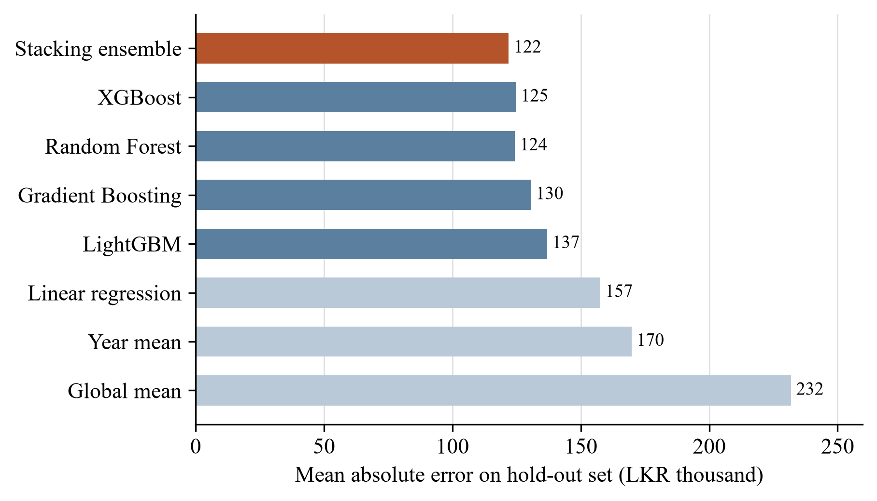
Figure 6.1: Mean absolute error of each model on the hold-out records
On this split the ordering is what the literature would lead one to expect. The tree ensembles are well ahead of the linear model, and the stack is slightly ahead of its best member. The gain from stacking over the random forest alone is LKR 2,300 in MAE, under 2%. The ridge second level gave weights of 0.64 to the random forest and 0.32 to XGBoost, 0.09 to gradient boosting and a slightly negative weight to LightGBM, so in effect the stack is a blend of two models.
On the training records the same pipeline has an MAE of LKR 81,301 and an R² of 0.863. The gap between training and hold-out is a sign of some overfitting, which is examined below.
Figure 6.2 plots predictions against recorded prices and Figure 6.3 shows the distribution of errors. The errors are centred close to zero, with a mean of LKR 3,400, and 90% of them lie between −276,000 and +258,000. The scatter plot shows that the model compresses the range: the cheapest cars are over-predicted and the dearest under-predicted. This is the usual behaviour of averaging methods on a small sample. The largest single error on the hold-out is LKR 508,500.
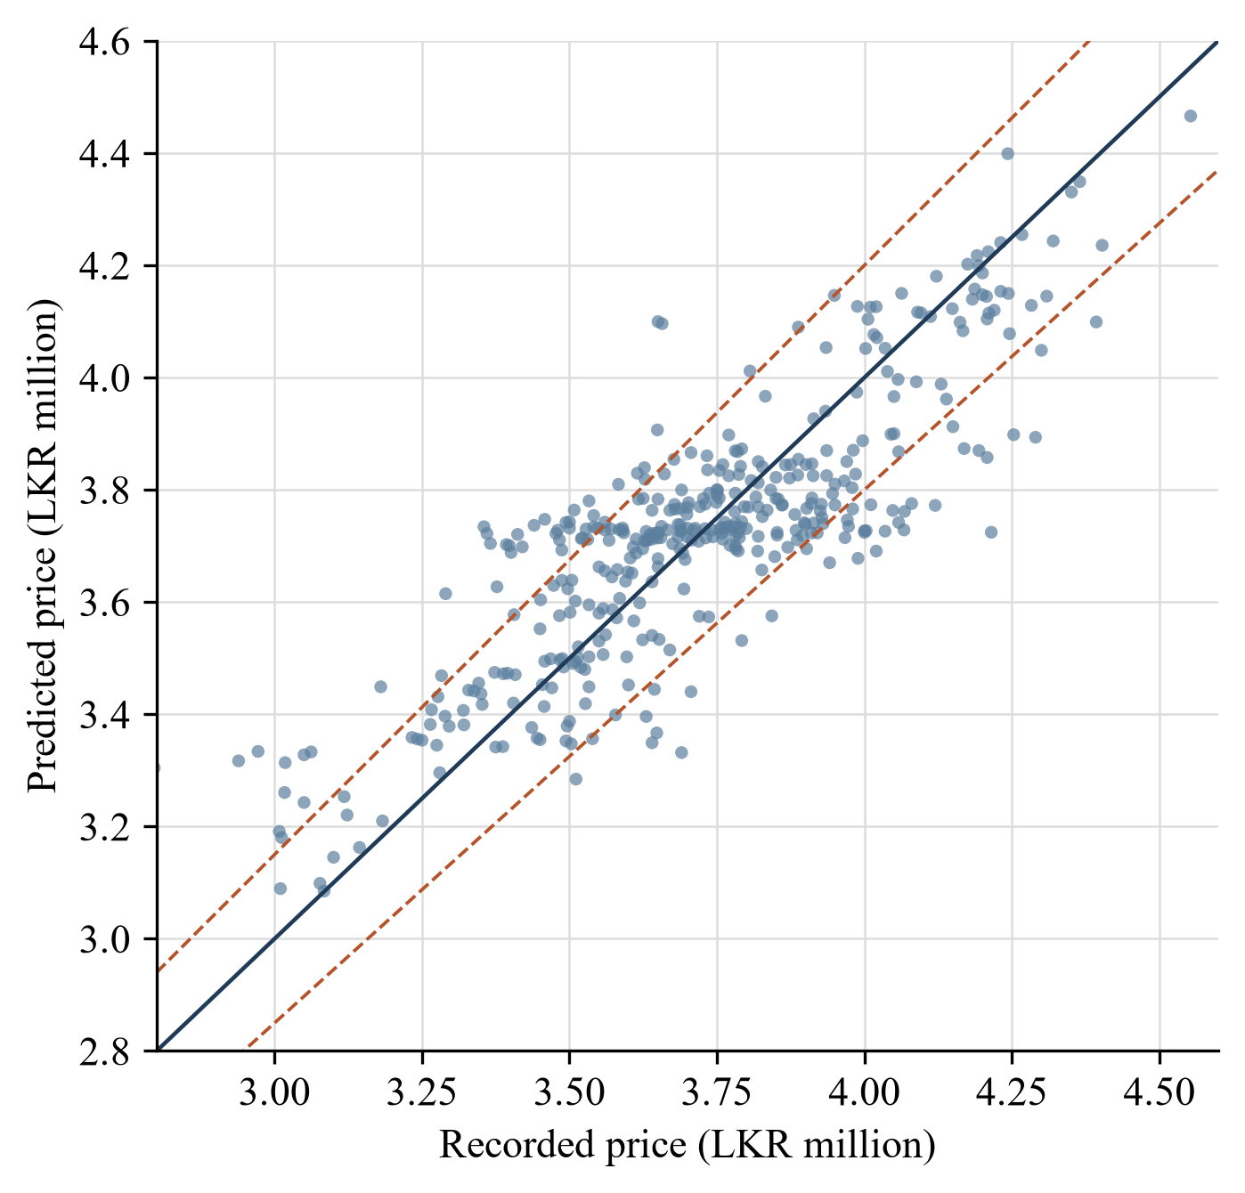
Figure 6.2: Predicted against recorded price on the hold-out records; dashed lines mark ±5%
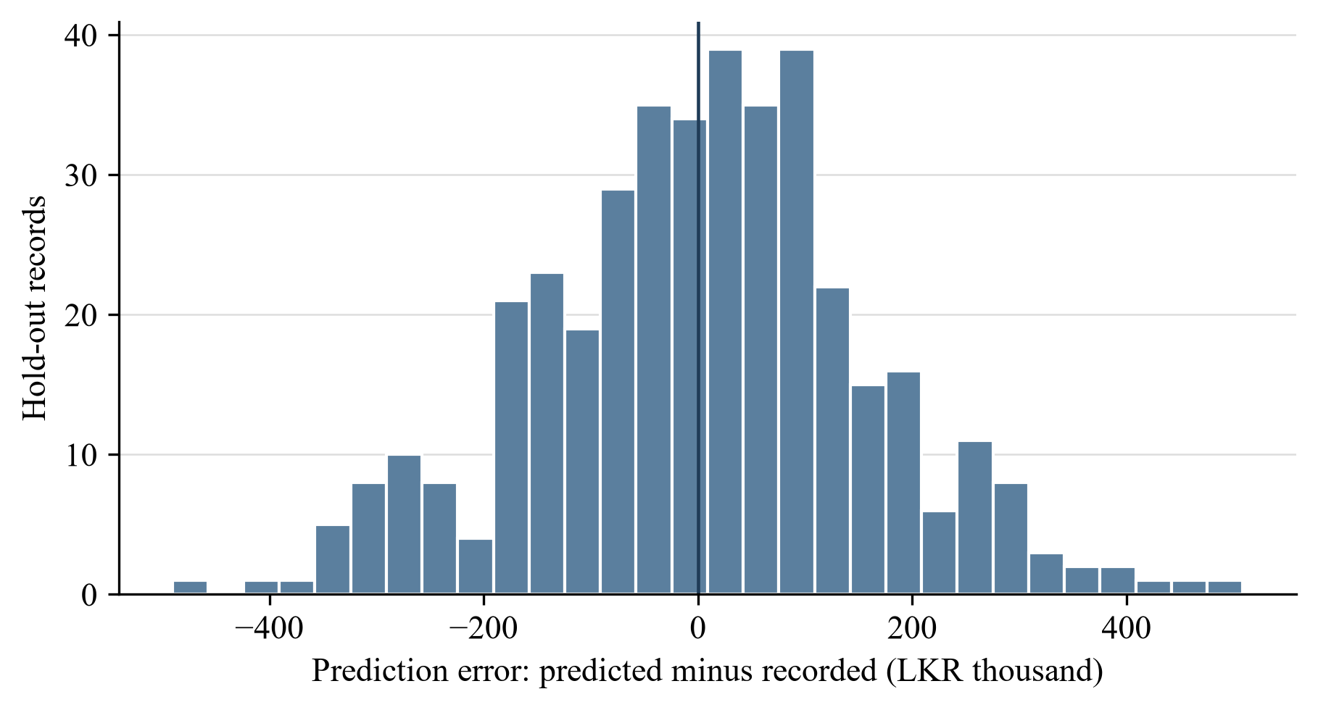
Figure 6.3: Distribution of prediction errors on the hold-out records
The hold-out contains 78 unmodified real listings and 322 synthetic records. The pipeline's MAE is LKR 118,132 on the former and LKR 122,820 on the latter, so there is no sign that the synthetic records are easier or harder to predict than the real ones within this split.

6.1.2 Effect of the validation scheme
The hold-out figures above come from a random split of the 2,000 records. Because each real listing is the parent of about five synthetic records on average, a random split almost never separates a record from its relatives: 99.75% of the hold-out records have at least one record derived from the same listing in the training part. The model has, in effect, seen a slightly perturbed copy of nearly every car it is tested on.
Table 6.2 and Figure 6.4 compare four ways of estimating the error of the same stacking pipeline.
Table 6.2: Stacking pipeline under four validation schemes
Scheme | MAE (LKR) | R² | MAPE (%) | Within 5% of recorded price (%)
Random hold-out, 2,000 records (as trained) | 121,906 | 0.716 | 3.32 | 77.3
Random 5-fold, 2,000 records | 119,562 | 0.722 | 3.23 | 78.3
Grouped 5-fold, 2,000 records | 157,669 | 0.532 | 4.24 | 65.9
5-fold on the 338 real listings only | 154,914 | 0.518 | 4.17 | 67.8

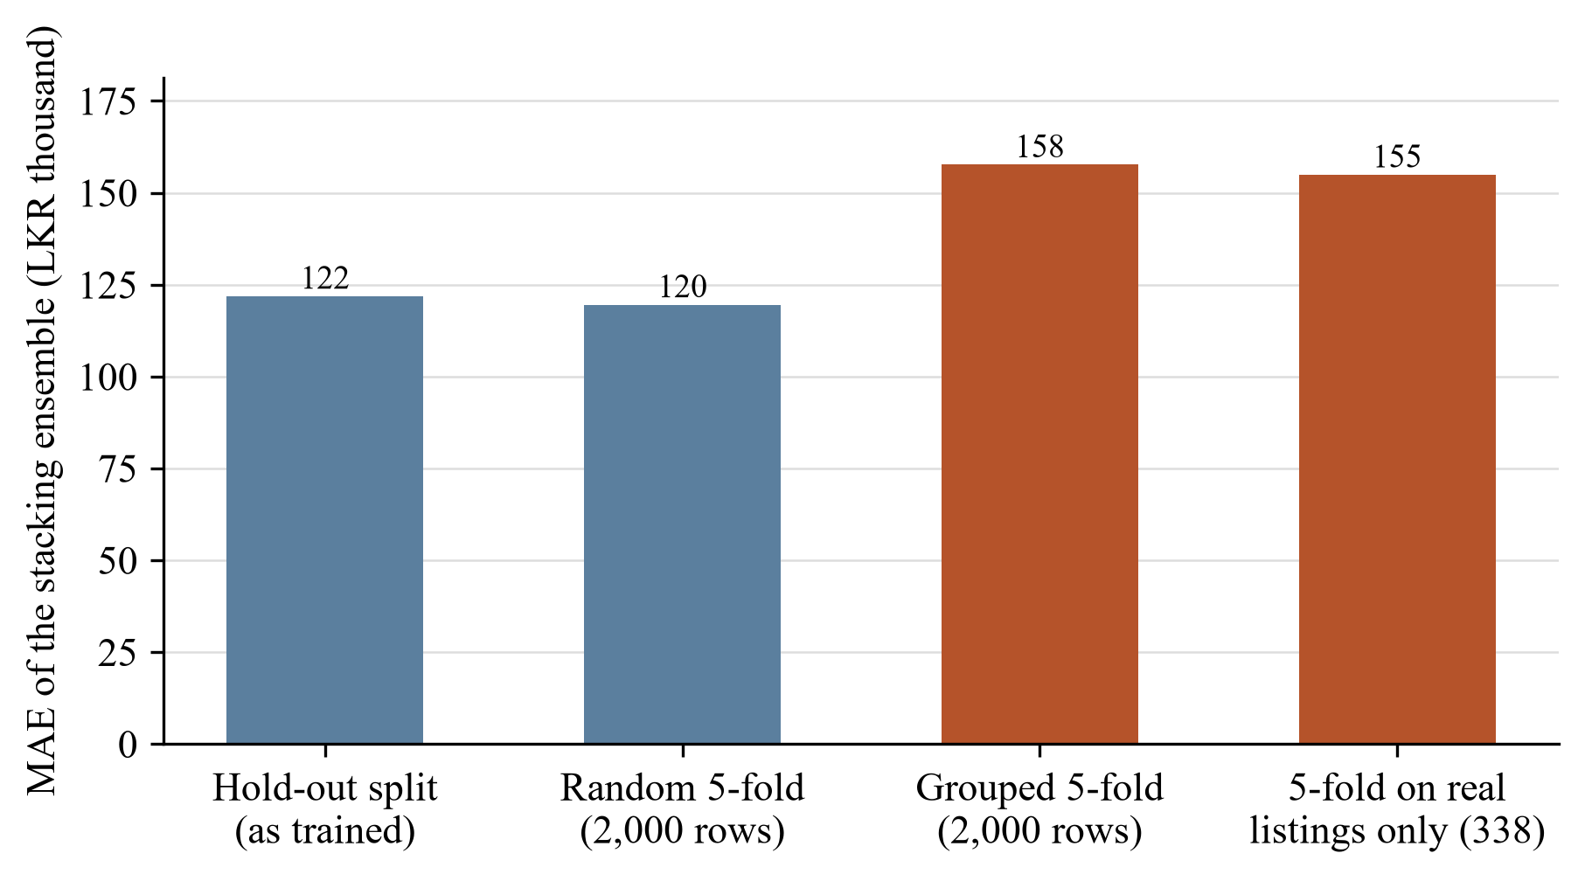
Figure 6.4: Mean absolute error of the stacking pipeline under four validation schemes
Random five-fold cross-validation agrees with the hold-out, with a fold-to-fold standard deviation of only LKR 2,600. When all records derived from the same listing are kept in the same fold, the MAE rises by about 30% to LKR 157,700 and R² falls from 0.72 to 0.53. Training and testing on the real listings alone gives almost the same answer: LKR 154,900 and 0.52. The two leakage-free estimates agree with each other and disagree with the random split.
The conclusion is that the honest estimate of the model's error on a car it has not seen is about LKR 155,000 to 158,000, or a little over 4% of the price, with an R² of a little over 0.5. The figure of LKR 121,906 describes how well the model reproduces cars that are near-copies of those it was trained on.

6.1.3 Model comparison on real listings
The same exercise was repeated for every model using the 338 real listings and five-fold cross-validation, with the hyperparameters selected earlier. Table 6.3 gives the result.
Table 6.3: Five-fold cross-validation on the 338 real listings (eleven features)
Model | MAE (LKR) | RMSE (LKR) | R² | MAPE (%)
Linear regression | 151,929 | 198,508 | 0.515 | 4.09
Random forest | 153,895 | 196,358 | 0.525 | 4.14
Stacking ensemble | 154,914 | 197,948 | 0.518 | 4.17
Mean price of same year (baseline) | 158,574 | 200,231 | 0.506 | 4.26
Gradient boosting | 159,953 | 202,035 | 0.497 | 4.29
LightGBM | 165,637 | 210,276 | 0.456 | 4.45
XGBoost | 166,039 | 213,125 | 0.441 | 4.46

The ordering in Table 6.1 disappears. Linear regression has the lowest MAE; the random forest and the stack are within LKR 3,000 of it; the boosted models are worse than simply quoting the average price for the year. The spread between the best model and the year-mean baseline is LKR 6,600, about 4%. With 338 records and folds of 68 these differences are within what one would expect from the choice of folds, and I do not claim that linear regression is truly the best. The supported statement is narrower: on real data, none of the learned models is clearly better than the others, and none improves much on knowing the year.
The advantage of the tree ensembles in Table 6.1 therefore came from their capacity to memorise parent listings, which a linear model cannot do.

6.1.4 What the model relies on
Figure 6.5 shows the permutation importance of each feature on the hold-out records.
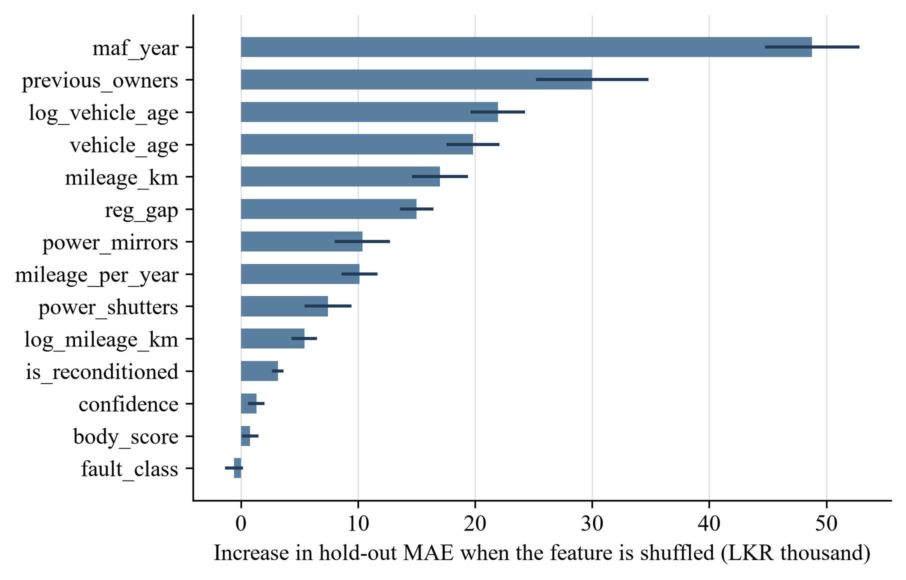
Figure 6.5: Permutation importance of each feature on the hold-out records (20 repeats; bars show the mean, lines one standard deviation)
Year of manufacture dominates: shuffling it raises MAE by LKR 48,800. The number of previous owners comes next at LKR 30,000, followed by the two age terms, mileage and registration gap at between LKR 15,000 and 22,000 each. The two option flags contribute LKR 7,500 to 10,400.
The three condition features are at the bottom. Shuffling confidence raises MAE by LKR 1,300, body score by LKR 800, and fault class by nothing measurable. On the hold-out data the model's accuracy would be unchanged if the outputs of Components 2 and 3 were replaced with random values.
The high rank of owner count is larger than its correlation with price in the raw data (−0.18) would suggest. A likely reason is that owner count, having eight levels, helps the trees to identify which parent listing a synthetic record came from. This is consistent with the memorisation seen above. I have not tested it directly.

6.1.5 Response to individual inputs
Permutation importance measures contribution to accuracy. A feature could contribute little to accuracy and still move the prediction in the right direction, so the sensitivity analysis looks at the predictions directly. For the reference car the model predicts LKR 3,727,000.
Figure 6.6 shows the response to mileage and to year. The response to year is monotonic and steep, from LKR 3.46 million for 2012 to LKR 4.31 million for 2017, in line with the yearly means in the raw data. The response to mileage falls overall, from about LKR 3.86 million at 40,000 km to LKR 3.66 million at 200,000 km, but not smoothly: the prediction at 60,000 km is higher than at 40,000 km, and it is flat between 100,000 and 160,000 km. A buyer comparing two otherwise identical cars would be surprised to be told that the one with more kilometres is worth more. The irregularity reflects the small number of low-mileage cars in the sample.
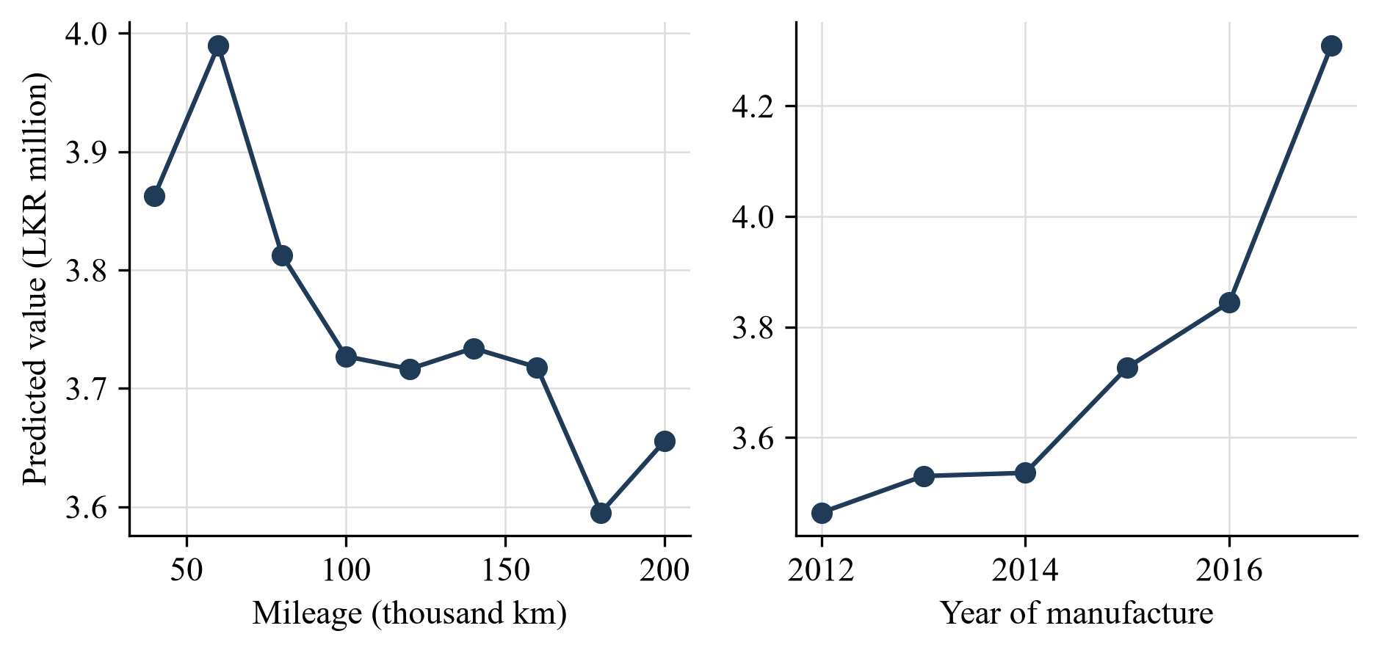
Figure 6.6: Predicted value of the reference car as mileage (left) and year of manufacture (right) are varied
Figure 6.7 compares the fall in predicted value as body score is lowered with the deduction that was built into the training data. The model has learned the general direction: a score of 50 lowers the value by LKR 47,000, close to the LKR 52,500 that was imposed. But the response is noisy. It begins to fall as soon as the score drops below 100, although no deduction was applied above 80; it is not monotonic; and at a score of 45 the predicted value is LKR 12,700 higher than for a perfect body.
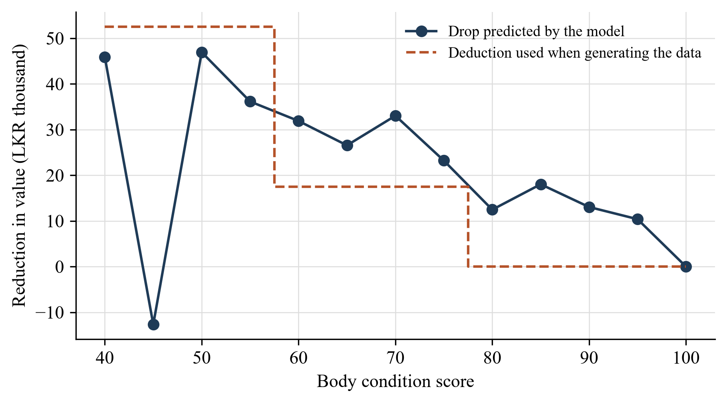
Figure 6.7: Reduction in predicted value as body score falls, compared with the deduction used to generate the training data
Figure 6.8 does the same for engine faults at a confidence of 0.9. Every fault lowers the prediction, by between LKR 23,000 and 37,000. The amounts do not follow the repair costs. Knocking, the most expensive fault with an imposed deduction of LKR 54,000, produces the smallest fall of the five (LKR 22,800). Tappet noise, the cheapest at LKR 10,350, produces a fall of LKR 29,800. The model has learned that a faulty engine is worth somewhat less than a healthy one and has not learned which faults are serious.
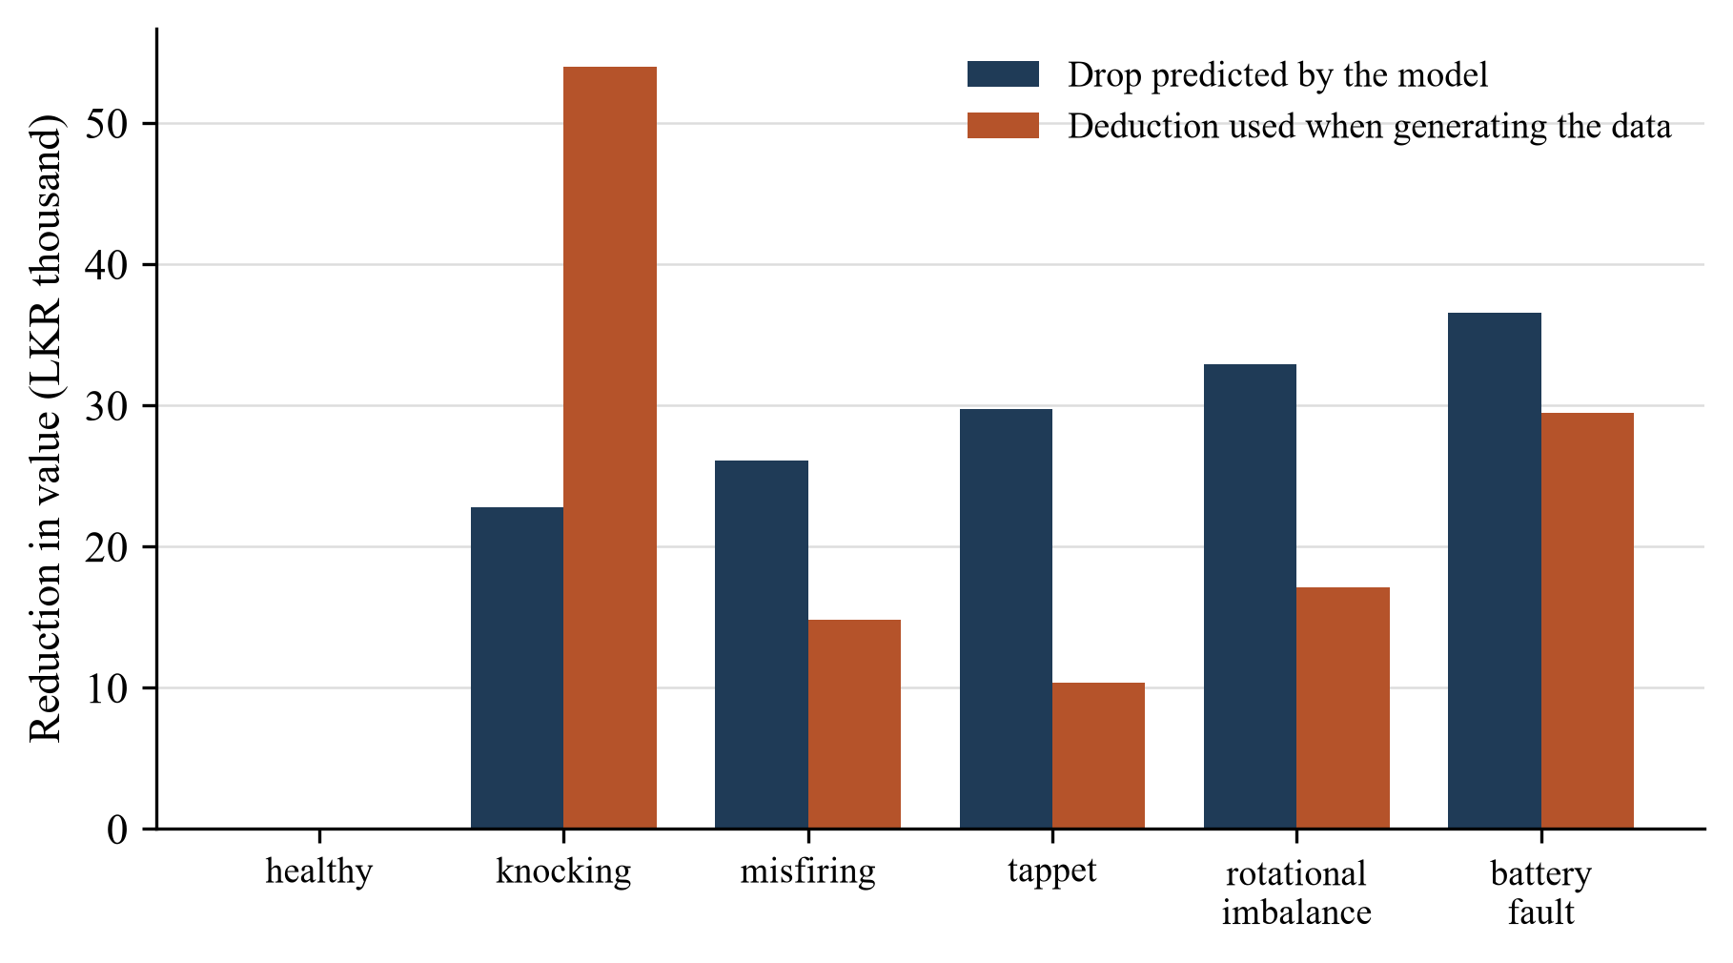
Figure 6.8: Reduction in predicted value for each engine fault at 0.9 confidence, compared with the deduction used to generate the training data
The explanation for both figures is the same. The deductions are of the order of LKR 10,000 to 50,000. The price noise added to each synthetic record has a standard deviation of about LKR 56,000, and the unexplained variation between real cars is larger still. With around 130 examples of each fault, the signal is too weak for the trees to recover reliably.

6.2 Product and technical results

6.2.1 Verdict behaviour
The user sees the verdict before the number, so the behaviour of the verdict rule matters as much as the regression error. Table 6.4 gives the verdicts returned for the 400 hold-out records when each is presented at its recorded price and at four known mark-ups and mark-downs.
Table 6.4: Verdicts returned for hold-out records presented at known price positions (% of 400 records)
Listed price presented | GOOD_DEAL | FAIR_PRICE | OVERPRICED
15% below recorded price | 99.8 | 0.3 | 0.0
10% below recorded price | 90.8 | 9.3 | 0.0
At recorded price | 11.3 | 78.3 | 10.5
10% above recorded price | 0.3 | 13.0 | 86.8
15% above recorded price | 0.0 | 2.5 | 97.5

A listing at its recorded price is judged fair 78% of the time. Listings 15% away from it are classified correctly in almost every case, and listings 10% away about nine times in ten. The rule is therefore reliable at flagging prices that are well out of line and much less reliable near the boundary: roughly one normally priced car in five is labelled overpriced or a good deal purely because of model error.
These percentages inherit the optimism of the random split. Under grouped validation only 66% of predictions fall within 5% of the recorded price (Table 6.2), so for a car the model has not seen, about one fairly priced listing in three would receive the wrong label. The implication for the product is discussed in section 7.1.

6.2.2 Requirements met
Table 6.5 summarises the status of each requirement against the evidence in chapter 5 and this chapter.
Table 6.5: Status of requirements
Requirement | Status | Evidence
FR1 to FR3 | Met | API-04, API-11; TC-01 to TC-04
FR4, FR5 | Met | TC-05, TC-06, API-09
FR6 | Met, with reduced reliability near the thresholds | TC-01 to TC-03; Table 6.4
FR7 | Met | TC-04, TC-07 checked by hand
FR8 | Partly met | Ranges returned; damage level inconsistent with training (defect D1)
FR9 | Partly met | Explanation wrong for fair-price verdicts (defect D2)
FR10 | Met | API-01
NFR1 | Met | Median response 94 ms (Table 5.6)
NFR2 | Met | API-02, API-03
NFR3 | Met | API-05 to API-08, API-10
NFR4, NFR5, NFR7 | Met | Design and deployment (sections 4.2, 5.5)
NFR6 | Met | Data source field present in every successful response

6.3 User or stakeholder validation
Stakeholder input to this component came from two sources. The repair cost ranges were obtained from five local parts sellers and repair centres (section 3.2.3), so the monetary side of the condition adjustment reflects what practitioners quoted and not my own estimates. And the content of the results screen, in particular the decision to lead with a verdict and to block the valuation for an altered VIN, was settled in group discussion.
I have not carried out a structured evaluation with prospective buyers, and I do not want to present informal reactions to demonstrations as if they were data. A proper study would ask buyers and at least one professional valuer to judge a set of real advertisements and would compare their figures with the service's output. Appendix C contains the questionnaire prepared for that study. It is listed under future work.

6.4 Integration results
The valuation service works with the other three components through the mobile application as designed. The field names and value formats in Table 5.2 were exercised in the end-to-end checks of section 5.4.4 and in interface test API-11, which confirms that the service returns a valuation when only the vehicle fields are supplied and so remains usable if one of the upstream components is unavailable.
The more important integration result is negative. Section 6.1.4 showed that the deployed model makes almost no use of body score and engine fault. The components are connected and data flow from one to the next, but the number at the end of the chain is determined almost entirely by the form the user fills in at the start. The condition inputs do reach the user through the rule layer: the repair ranges, the damage description, the width of the negotiation range and the VIN gate all depend on them. So the integration is real at the level of the response and weak at the level of the price.

6.5 Summary of findings
- F1. On a random split of the augmented data the deployed stacking pipeline has an MAE of LKR 121,906, an R² of 0.716 and a MAPE of 3.32%, and is marginally better than its best member.
- F2. That figure is optimistic. With records derived from the same listing kept together, or with real listings only, the MAE is about LKR 155,000 to 158,000 and R² is about 0.52 to 0.53.
- F3. On real listings no learned model clearly outperforms linear regression or the mean price for the year. Year of manufacture carries most of the explainable variation.
- F4. The condition features contribute nothing measurable to accuracy. The model's response to them has the right sign on average but is noisy, is not monotonic, and does not rank engine faults by cost.
- F5. The verdict rule separates listings 15% above or below market almost perfectly and listings 10% away about nine times in ten. Near the 5% thresholds it mislabels between one in five and one in three fairly priced cars.
- F6. The service meets its performance, security and interface requirements, answering in about 95 ms. Testing found four defects in the rule layer and input validation, none of which alters a verdict in the test scenarios.

7 DISCUSSION

7.1 Interpretation of findings
RQ1: how accurately can price be predicted from advertised attributes? To within about LKR 155,000 on average, or a little over 4% (F2, F3). That sounds good until it is set against the baseline: quoting the average price for the car's year gets within LKR 159,000. The honest reading is that, for a single model line over six model years, the year tells a buyer most of what can be known from an advertisement, and mileage, owner count and options together add only a few thousand rupees of precision.
There are two reasons why more cannot be extracted. Asking prices are set by sellers with different levels of optimism, so two identical cars can be advertised LKR 300,000 apart. And the things that most distinguish one eleven-year-old Alto from another (how it was maintained, whether it has been in an accident, the state of the interior) are not in the advertisement fields I recorded. An R² of about 0.5 is probably close to the ceiling for these inputs. Pudaruth and Peerun reached similar conclusions on data of similar size [4], [24].
RQ2: does stacking help? On the random split, slightly (F1). On leakage-free validation, no (F3). The theoretical guarantee for stacking is asymptotic [18], and with 338 independent observations there is not enough information for a second-level model to learn stable weights, nor enough signal for four similar tree ensembles to disagree usefully. The simplest adequate model for this dataset is a regularised linear regression or a small random forest.
RQ3: can condition be built into the valuation? In the service, yes; in the learned model, not by the route I took (F4). The design decision of section 4.3.1 was to let the model learn the effect of condition from data in which I had planted it. The model recovered a blurred copy of what was planted. A blurred copy of a known rule is strictly worse than the rule. Applying the deductions directly after predicting the price of a sound car (Option A in section 4.3.1) would give deductions that are exactly monotonic, that rank faults correctly, that can be updated by editing the cost file, and that can be explained to the user line by line. The learned route only becomes worthwhile when there are real observations of price and measured condition together, because only then can the model discover something the rule does not already contain.
The rule layer, on the other hand, does what was intended. The VIN gate, the repair ranges and the negotiation range respond correctly to the component outputs, subject to the threshold inconsistency recorded as defect D1.
RQ4: how much does the validation scheme matter? A great deal (F2). The MAE differs by 30% and R² by almost 0.2 between a random and a grouped split of the same data, and the ranking of models changes. If I had stopped at the random split, as the project's early documentation did, I would have reported that a stacking ensemble predicts prices with "96.7% accuracy" and outperforms simpler models. Neither claim survives.
Implications for the product. A fairly priced car should not be labelled overpriced one time in three. Two changes follow from F5. The fair band should be widened from 5% to roughly the size of the model's typical error on unseen cars, which the grouped results put nearer 8 to 10%. And the fair value should be shown as a range of that width and not as a single figure, with the point estimate inside it. The service would then say less, and what it said would be right more often.

7.2 Comparison with literature baselines and existing solutions
Direct comparison of error figures with earlier studies is not meaningful, since they cover many makes and price ranges spanning an order of magnitude, where year, make and engine size explain most of the variance and R² values above 0.8 are normal [6], [8]. Within one model line that variance is absent by design, and what remains is the hard part.
Two qualitative comparisons can be made. The first is with the general finding that ensembles of trees beat linear models on used-car data [5], [8], [6]. My random-split results agree with it and my grouped results do not. The difference is one of scale: those studies had thousands to hundreds of thousands of independent listings. The second comparison is with the small-data studies from Mauritius, which found little difference between methods and blamed the sample size [4], [24]. My results on real listings are in line with theirs.
On method, the result supports the warnings of Kaufman and colleagues about leakage through related records [7] and the advice of Jordon and colleagues to evaluate on real data [22]. None of the used-car studies in Table 2.1 reports a grouped or otherwise leakage-aware evaluation. Most did not need one because they did not augment, but the practice of augmenting small tabular datasets is spreading, and the risk travels with it.
Against existing products, the comparison in Table 2.2 stands with one correction. The component does adjust for condition and identity, which the classifieds sites and overseas guides do not; but at present the adjustment that can be trusted is the one made by the rule layer, not the one made by the model.

7.3 Research contribution
The component makes three contributions to knowledge, of different weight.
- A measured case of validation leakage from augmentation in tabular regression. The dataset, the generator and the evaluation script are available, so the 30% gap between random and grouped validation can be reproduced exactly. To my knowledge this has not been documented for used-car pricing.
- Evidence on the limits of price prediction within a single model line in the Sri Lankan market: an R² of about 0.5 from advertisement fields, with year of manufacture carrying most of it.
- A negative result on learning simulated condition effects. Planting a rule-based effect in training data and asking a flexible model to learn it returns a degraded version of the rule when the effect is small relative to the noise.
There are also two smaller outputs of use to others working on the local market: a cleaned set of 338 listings and a table of repair cost ranges tied to machine-detectable fault classes.

7.4 Product contribution
On the product side the component delivers a working, documented and tested valuation service that completes the Watinakama.LK inspection chain. It turns three technical outputs (a VIN classification, a body score and a fault label) into the things a buyer asks for: a value, a verdict, an offer and a reason. It refuses to value a car with an altered VIN, which is the single most consequential piece of advice the system gives. Its repair costs and model are replaceable files, and its valuation logic is separated from the web layer so that the design change recommended in section 7.1 can be made without touching the interface that the application depends on.

7.5 Limitations and threats to validity
Construct validity. The target variable is an asking price. Sellers ask for more than they accept, and the margin is unknown and probably varies with how long the car has been advertised. "Fair value" as computed here is therefore biased upwards relative to transaction prices. Body score and engine fault were simulated independently of every other attribute, whereas in reality older and higher-mileage cars have more defects. And the assumption that damage lowers price by the cost of repair has not been tested.
Internal validity. The hyperparameters were selected by a search that used random three-fold splits of the augmented training data and so was itself affected by leakage; the selected settings (deep trees, many leaves) favour memorisation. The grouped and real-only evaluations reused those settings, so they are a fair assessment of the deployed model but not of what a model tuned under grouped validation could achieve. I expect the difference to be small given how little signal there is, but I have not measured it. The comparison among models on 338 records is subject to considerable sampling variation and I have not attached confidence intervals to it.
External validity. The model covers one model line, six model years and a few months of listings from one website. Seven of the listings are two years older than the rest and were not treated differently. The age feature is computed from a fixed current year. Nothing in the results says how the approach would perform on other models, although the finding about validation is general.
Reliability of inputs. The repair cost survey has five respondents. The mileage, owner count and options are as stated by sellers and were not verified. Owner count in particular is known to be understated in advertisements.
Implementation. The four open defects in Table 5.4 affect what users are told. The end-to-end checks were manual. There is no monitoring of the deployed service.

7.6 Implications
For the project, the practical implication is a short list of changes: move the condition deductions out of the model and into the rule layer, widen the fair band, present the value as a range, fix the four defects, and replace the stack with a simpler model that is cheaper to retrain and easier to explain. None of these alters the interface.
For researchers working with small tabular datasets, the implication is methodological. When records are generated from other records, the split must respect the parentage, and a real-data-only evaluation should be reported alongside. A simple baseline, such as the mean of the obvious grouping variable, should be included: without the year-mean baseline in Table 6.3 the models would have looked much more capable than they are.
For anyone building consumer tools on top of predictive models, the implication is that the presentation layer should be designed around the model's measured error. The verdict thresholds in this component were set before the error was known. They should have been set after.

8 COMMERCIALISATION AND SUSTAINABILITY

8.1 Value proposition and target users
The valuation is the part of Watinakama.LK that a user would pay for. The other components produce findings; this one says what the findings are worth. The proposition to a private buyer is a second opinion on an asking price, available at the roadside in the time it takes to walk around the car, that takes account of what the inspection found and comes from a party with no stake in the sale.
Three groups of users are in view. Private buyers of budget cars are the primary group: they are the most exposed to overpaying and the least likely to have access to a trusted mechanic. Private sellers form a second group, who could use the same report to support an asking price. Small dealers, leasing officers and insurance assessors form a third, for whom a consistent, documented first-pass valuation would save time even if a human makes the final decision.

8.2 Market and competitive position
I have not carried out market research and make no claim about market size. The competitive position can be described qualitatively from Table 2.2. The classifieds sites own the audience and the listing data, and could add an estimator of their own; what they cannot easily add is an inspection. Human valuers offer judgement and accountability but not immediacy or price. Overseas price guides do not cover the local market. The position available to this product is therefore the combination: local prices together with machine inspection, on the buyer's own phone.
The results in chapter 6 limit what can responsibly be sold today. The service can say with confidence that a listing is far out of line with comparable advertisements, and it can itemise likely repair costs. It cannot yet price a specific car to within a few percent, and it should not be marketed as if it could.

8.3 Business or sustainability model
Several revenue models are possible and they are not mutually exclusive.
- Pay per report. A buyer pays a small fee for a full inspection report including the valuation. This suits the occasional user who is about to make one large purchase.
- Free basic valuation, paid detail. The verdict is free and the repair breakdown and negotiation range are paid. This builds an audience but gives away the most-wanted output.
- Business subscription. Dealers, leasing companies and insurers pay monthly for access to the valuation service through its API. This is the model the service-based architecture supports most directly, since the interface in Table 4.4 is already what such a customer would call.
- Partnership with a classifieds site, in which valuations appear beside listings. This solves the data problem as well, because the site holds the listings needed for retraining.
The costs of running the valuation component are low. It needs no GPU, the model is 29 MB, and a request takes about a tenth of a second of one processor core, so a small virtual machine could serve a large number of users. The real recurring cost is data: listings have to be collected and the model retrained regularly, and repair costs have to be re-surveyed. Any plan to operate the product has to budget for that work or secure a data partner.

8.4 Scalability intellectual property and compliance
Scalability. The service is stateless, so capacity can be added by running more copies behind a load balancer. Extending coverage to other models is a matter of data, not architecture: the pipeline and the service would handle a make and model feature without structural change, but each new model line needs its own few hundred listings at minimum, and chapter 6 suggests that many more are needed for the estimates to be precise.
Intellectual property. The code was written for this project and uses open-source libraries under permissive licences (BSD for scikit-learn and Flask, Apache 2.0 for XGBoost, MIT for LightGBM), which permit commercial use. The listing data were compiled from a public website; before commercial use, the terms of that site would have to be reviewed and, ideally, a data agreement reached. The repair cost table is original survey data.
Compliance. The service processes no personal data in its present form. If user accounts and saved reports are added to the valuation service, the Personal Data Protection Act would apply to it [40]. A commercial valuation also carries a duty of care that a student prototype does not. Reports would need a clear statement that the figure is an estimate based on advertised prices, and the altered-VIN warning in particular would need legal review, since it could be read as an allegation.

8.5 Contribution to the Sustainable Development Goals
The component relates most directly to three of the United Nations Sustainable Development Goals [46].
- Goal 12, responsible consumption and production. A buyer who knows the likely repair costs before purchase is more likely to repair and keep a serviceable older car than to be caught out and abandon it. More broadly, a used-car market that prices condition properly rewards owners who maintain their vehicles and extends the useful life of the existing fleet.
- Goal 9, industry, innovation and infrastructure. The work applies machine learning to a local consumer problem using local data, and makes its dataset and evaluation method available for others to build on.
- Goal 16, peace, justice and strong institutions, in the limited sense of making one kind of fraud harder. Refusing to value a vehicle with an altered identity, and telling the buyer why, removes one avenue for passing on stolen or rebuilt cars.
The environmental footprint of the component itself is negligible: training takes under a minute on a laptop and inference needs no specialised hardware.

9 CONCLUSION AND FUTURE DIRECTIONS

9.1 Conclusion
This thesis set out to build a valuation service for used Suzuki Alto cars in Sri Lanka that responds to inspected condition, and to find out how good such a service can be when it is built from a few hundred advertisements.
The service was built and works. It accepts the details of a car and the outputs of the VIN, body and engine components, and returns a fair value, a verdict, a negotiation range and an explanation in about a tenth of a second. It blocks the valuation of a car with an altered VIN. It is integrated with the mobile application and has passed its interface tests.
The evaluation gave a more sober picture than the first results suggested. The stacked ensemble's reported error of about LKR 122,000 was produced by a validation scheme that let the model see near-copies of its test cases. Measured properly, the error is about LKR 155,000, the ensemble is no better than a linear regression, and neither is much better than quoting the average price for the year. The model does not use the condition features in any dependable way; the condition-related advice that reaches the user comes from the rule layer and the repair cost table.
I regard the second paragraph as a more useful outcome than the first. The service can be corrected with modest changes that are already identified. The method by which its weaknesses were found (grouped validation, a real-data-only check, simple baselines, permutation importance and a sensitivity analysis) applies to any project that enlarges a small dataset, and would have saved me from an overstated claim had I applied it from the start.

9.2 Achievement of objectives
Table 9.1 sets the outcome against each objective from section 1.5.
Table 9.1: Achievement of objectives
Objective | Summary | Status | Evidence
O1 | Collect and clean listing data | Achieved | 343 listings collected, 338 retained; sections 3.2.1, 3.2.2
O2 | Collect local repair costs | Achieved, small sample | Survey of five businesses; Table 3.3, Table 3.4
O3 | Build a condition-aware training set | Achieved as built; found to be of limited value | Section 3.2.4; findings F2, F4
O4 | Train and compare models; select one | Achieved | Sections 3.3, 6.1.1; the selection was not confirmed by later validation
O5 | Evaluate under several validation schemes and examine responses | Achieved | Sections 6.1.2 to 6.1.5
O6 | Rule layer, web service and mobile integration | Achieved, with four open defects | Chapters 4 and 5; Table 5.4

9.3 Individual research and product contributions
My research contributions are the documented leakage case with a reproducible measurement of its size, the evidence on the limits of price prediction within one model line in this market, and the negative result on learning planted condition effects. My product contributions are the valuation service itself, the repair cost table, the valuation logic that converts component outputs into a verdict and a negotiation range, and the evaluation script that anyone continuing the project can run to check a new model against the same tests.

9.4 Future directions
The work that should follow is listed roughly in order of priority.
- Correct the four open defects: align the body score thresholds, fix the explanation for fair-price verdicts, reject unknown fault labels, and validate input ranges including the model and year of the vehicle.
- Restructure the valuation as a base price model plus rule-based deductions. Train the price model on real listings only, apply engine and body deductions from the cost table after prediction, and remove the simulated features from training. The response format need not change.
- Recalibrate the presentation. Widen the fair band to match the grouped-validation error and report the fair value as an interval. Prediction intervals from quantile regression or conformal prediction would give a principled width.
- Enlarge and extend the data. Collect listings continuously, record the listing date as a feature so that price movements over time can be modelled, and add further model lines. Automating collection in agreement with a classifieds site would address both volume and currency.
- Obtain real condition data. Run complete inspections on cars that are actually for sale and record the final price where the buyer will share it. Even a few hundred such records would allow the repair-cost assumption to be tested and a learned condition effect to be estimated.
- Adopt grouped or time-based validation as the default in the training script, including in the hyperparameter search, so that model selection is no longer affected by leakage.
- Carry out the stakeholder study outlined in Appendix C, comparing the service's valuations with those of buyers and a professional valuer on the same vehicles.
- Harden the deployment: a production WSGI server, TLS, removal of the default token, request logging and basic monitoring.

REFERENCES
[1] G. A. Akerlof, "The market for 'lemons': Quality uncertainty and the market mechanism," The Quarterly Journal of Economics, vol. 84, no. 3, pp. 488–500, 1970.
[2] D. Genesove, "Adverse selection in the wholesale used car market," Journal of Political Economy, vol. 101, no. 4, pp. 644–665, 1993.
[3] Central Bank of Sri Lanka, Annual Economic Review 2024. Colombo, Sri Lanka: Central Bank of Sri Lanka, 2025.
[4] S. Pudaruth, "Predicting the price of used cars using machine learning techniques," International Journal of Information and Computation Technology, vol. 4, no. 7, pp. 753–764, 2014.
[5] E. Gegic, B. Isakovic, D. Keco, Z. Masetic, and J. Kevric, "Car price prediction using machine learning techniques," TEM Journal, vol. 8, no. 1, pp. 113–118, 2019.
[6] N. Pal, P. Arora, P. Kohli, D. Sundararaman, and S. S. Palakurthy, "How much is my car worth? A methodology for predicting used cars' prices using random forest," in Advances in Information and Communication Networks (FICC 2018), Advances in Intelligent Systems and Computing, vol. 886. Cham, Switzerland: Springer, 2019, pp. 413–422.
[7] S. Kaufman, S. Rosset, C. Perlich, and O. Stitelman, "Leakage in data mining: Formulation, detection, and avoidance," ACM Transactions on Knowledge Discovery from Data, vol. 6, no. 4, Art. no. 15, 2012.
[8] N. Monburinon, P. Chertchom, T. Kaewkiriya, S. Rungpheung, S. Buya, and P. Boonpou, "Prediction of prices for used car by using regression models," in Proc. 5th International Conference on Business and Industrial Research (ICBIR), Bangkok, Thailand, 2018, pp. 115–119.
[9] S. Rosen, "Hedonic prices and implicit markets: Product differentiation in pure competition," Journal of Political Economy, vol. 82, no. 1, pp. 34–55, 1974.
[10] L. Breiman, "Random forests," Machine Learning, vol. 45, no. 1, pp. 5–32, 2001.
[11] J. H. Friedman, "Greedy function approximation: A gradient boosting machine," The Annals of Statistics, vol. 29, no. 5, pp. 1189–1232, 2001.
[12] T. Chen and C. Guestrin, "XGBoost: A scalable tree boosting system," in Proc. 22nd ACM SIGKDD International Conference on Knowledge Discovery and Data Mining, San Francisco, CA, USA, 2016, pp. 785–794.
[13] G. Ke, Q. Meng, T. Finley, T. Wang, W. Chen, W. Ma, Q. Ye, and T.-Y. Liu, "LightGBM: A highly efficient gradient boosting decision tree," in Advances in Neural Information Processing Systems 30, 2017, pp. 3146–3154.
[14] L. Grinsztajn, E. Oyallon, and G. Varoquaux, "Why do tree-based models still outperform deep learning on typical tabular data?" in Advances in Neural Information Processing Systems 35, 2022, pp. 507–520.
[15] R. Shwartz-Ziv and A. Armon, "Tabular data: Deep learning is not all you need," Information Fusion, vol. 81, pp. 84–90, 2022.
[16] D. H. Wolpert, "Stacked generalization," Neural Networks, vol. 5, no. 2, pp. 241–259, 1992.
[17] L. Breiman, "Stacked regressions," Machine Learning, vol. 24, no. 1, pp. 49–64, 1996.
[18] M. J. van der Laan, E. C. Polley, and A. E. Hubbard, "Super learner," Statistical Applications in Genetics and Molecular Biology, vol. 6, no. 1, Art. no. 25, 2007.
[19] R. Kohavi, "A study of cross-validation and bootstrap for accuracy estimation and model selection," in Proc. 14th International Joint Conference on Artificial Intelligence (IJCAI), Montreal, Canada, 1995, pp. 1137–1143.
[20] T. Hastie, R. Tibshirani, and J. Friedman, The Elements of Statistical Learning: Data Mining, Inference, and Prediction, 2nd ed. New York, NY, USA: Springer, 2009.
[21] N. V. Chawla, K. W. Bowyer, L. O. Hall, and W. P. Kegelmeyer, "SMOTE: Synthetic minority over-sampling technique," Journal of Artificial Intelligence Research, vol. 16, pp. 321–357, 2002.
[22] J. Jordon, L. Szpruch, F. Houssiau, M. Bottarelli, G. Cherubin, C. Maple, S. N. Cohen, and A. Weller, "Synthetic data – what, why and how?" arXiv preprint arXiv:2205.03257, 2022.
[23] M. Listiani, "Support vector regression analysis for price prediction in a car leasing application," M.S. thesis, Hamburg University of Technology, Hamburg, Germany, 2009.
[24] S. Peerun, N. H. Chummun, and S. Pudaruth, "Predicting the price of second-hand cars using artificial neural networks," in Proc. 2nd International Conference on Data Mining, Internet Computing, and Big Data (BigData 2015), Reduit, Mauritius, 2015, pp. 17–21.
[25] K. Noor and S. Jan, "Vehicle price prediction system using machine learning techniques," International Journal of Computer Applications, vol. 167, no. 9, pp. 27–31, 2017.
[26] N. Sun, H. Bai, Y. Geng, and H. Shi, "Price evaluation model in second-hand car system based on BP neural network theory," in Proc. 18th IEEE/ACIS International Conference on Software Engineering, Artificial Intelligence, Networking and Parallel/Distributed Computing (SNPD), Kanazawa, Japan, 2017, pp. 431–436.
[27] Kelley Blue Book, "What's my car worth?" [Online]. Available: https://www.kbb.com/whats-my-car-worth/. [Accessed: Month Day, Year].
[28] Edmunds, "Appraise your car." [Online]. Available: https://www.edmunds.com/appraisal/. [Accessed: Month Day, Year].
[29] Riyasewana, "Vehicles for sale in Sri Lanka." [Online]. Available: https://riyasewana.com. [Accessed: Month Day, Year].
[30] ikman, "Vehicles for sale in Sri Lanka." [Online]. Available: https://ikman.lk. [Accessed: Month Day, Year].
[31] A. R. Hevner, S. T. March, J. Park, and S. Ram, "Design science in information systems research," MIS Quarterly, vol. 28, no. 1, pp. 75–105, 2004.
[32] K. Peffers, T. Tuunanen, M. A. Rothenberger, and S. Chatterjee, "A design science research methodology for information systems research," Journal of Management Information Systems, vol. 24, no. 3, pp. 45–77, 2007.
[33] R. Wirth and J. Hipp, "CRISP-DM: Towards a standard process model for data mining," in Proc. 4th International Conference on the Practical Applications of Knowledge Discovery and Data Mining, Manchester, UK, 2000, pp. 29–39.
[34] J. Bergstra and Y. Bengio, "Random search for hyper-parameter optimization," Journal of Machine Learning Research, vol. 13, pp. 281–305, 2012.
[35] A. E. Hoerl and R. W. Kennard, "Ridge regression: Biased estimation for nonorthogonal problems," Technometrics, vol. 12, no. 1, pp. 55–67, 1970.
[36] C. J. Willmott and K. Matsuura, "Advantages of the mean absolute error (MAE) over the root mean square error (RMSE) in assessing average model performance," Climate Research, vol. 30, no. 1, pp. 79–82, 2005.
[37] T. Chai and R. R. Draxler, "Root mean square error (RMSE) or mean absolute error (MAE)? Arguments against avoiding RMSE in the literature," Geoscientific Model Development, vol. 7, no. 3, pp. 1247–1250, 2014.
[38] R. J. Hyndman and A. B. Koehler, "Another look at measures of forecast accuracy," International Journal of Forecasting, vol. 22, no. 4, pp. 679–688, 2006.
[39] C. Molnar, Interpretable Machine Learning: A Guide for Making Black Box Models Explainable, 2nd ed. 2022. [Online]. Available: https://christophm.github.io/interpretable-ml-book/
[40] Parliament of the Democratic Socialist Republic of Sri Lanka, Personal Data Protection Act, No. 9 of 2022. Colombo, Sri Lanka: Department of Government Printing, 2022.
[41] R. T. Fielding, "Architectural styles and the design of network-based software architectures," Ph.D. dissertation, University of California, Irvine, CA, USA, 2000.
[42] OpenAPI Initiative, "OpenAPI Specification." [Online]. Available: https://spec.openapis.org/oas/latest.html. [Accessed: Month Day, Year].
[43] Systems and software engineering – Systems and software Quality Requirements and Evaluation (SQuaRE) – System and software quality models, ISO/IEC 25010:2011, International Organization for Standardization, Geneva, Switzerland, 2011.
[44] F. Pedregosa et al., "Scikit-learn: Machine learning in Python," Journal of Machine Learning Research, vol. 12, pp. 2825–2830, 2011.
[45] Pallets, "Flask documentation." [Online]. Available: https://flask.palletsprojects.com/. [Accessed: Month Day, Year].
[46] United Nations General Assembly, "Transforming our world: The 2030 Agenda for Sustainable Development," Resolution A/RES/70/1, New York, NY, USA, 2015.

GLOSSARY
Asking price. The price stated by the seller in an advertisement. It is usually higher than the price at which the car is eventually sold.
Augmentation. Enlarging a dataset by generating additional records from existing ones, here by adding random noise to copies of real listings.
Base learner. One of the first-level models in a stacked ensemble.
Body condition score. A number from 0 to 100 produced by Component 2 summarising visible body damage; 100 means no damage detected.
Brand new import. A car first registered in Sri Lanka as a new vehicle, as opposed to one imported after use abroad (reconditioned).
Fair value. In this thesis, the price at which comparable cars are advertised, adjusted for estimated repair costs.
Grouped cross-validation. Cross-validation in which all records belonging to the same group, here all records derived from the same real listing, are placed in the same fold.
Hold-out set. Records set aside before training and used once to estimate the error of the finished model.
Leakage. Any route by which information about the test records reaches the model during training, making the measured error too low.
Meta-learner. The second-level model in a stacked ensemble, which combines the predictions of the base learners.
Permutation importance. The increase in a model's error when the values of one feature are shuffled, used as a measure of how much the model depends on that feature.
Registration gap. The number of years between manufacture and first registration in Sri Lanka.
Tappet noise. A ticking sound from the valve train of an engine, usually caused by excessive valve clearance.

APPENDICES

Appendix A Extended results and specifications
A.1 Example request and response. The request below is test scenario TC-04 as sent to the valuation endpoint. The Authorization header carries the bearer token.
POST /api/v1/valuate
Content-Type: application/json
Authorization: Bearer <token>

{
"maf_year": 2015, "reg_year": 2015, "mileage_km": 85000,
"previous_owners": 2, "is_reconditioned": 0,
"power_shutters": 1, "power_mirrors": 0,
"listed_price_million": 3.89,
"fault_class": "knocking", "confidence": 0.87,
"body_score": 82, "vin_status": "original"
}

The service returned the following (fields reordered and the data source text shortened for the page).
{
"status": "success",
"verdict": "OVERPRICED",
"verdict_message": "This vehicle is listed LKR 203,000 above fair market value.",
"fair_value_lkr": 3687000,
"listed_price_lkr": 3890000,
"price_difference_lkr": 203000,
"negotiation_min_lkr": 3646700,
"negotiation_max_lkr": 3711700,
"recommended_offer_lkr": 3680000,
"engine_fault": "knocking",
"engine_confidence_percent": "87%",
"engine_repair_min_lkr": 35000,
"engine_repair_max_lkr": 85000,
"engine_deduction_lkr": 52200,
"engine_description": "Engine bearing or piston repair - requires workshop strip-down",
"body_score": 82,
"body_damage_category": "minor",
"body_repair_min_lkr": 10000,
"body_repair_max_lkr": 25000,
"body_deduction_lkr": 17500,
"vin_status": "original",
"vin_warning": null,
"explanation": "This vehicle is overpriced by LKR 203,000 relative to its fair market value of LKR 3,687,000. The knocking engine fault requires repairs estimated between LKR 35,000-85,000. Body condition is rated as minor damage, adding LKR 17,500 in estimated costs.",
"data_source": "Repair costs: field survey, 5 local sellers, 2026. Price model: 338 Suzuki Alto listings 2012-2017."
}

A.2 Parts and service prices from the repair cost survey. Table A.1 lists the individual prices from which the body damage levels in Table 3.4 were formed.
Table A.1: Individual parts and service prices from the field survey (LKR)
Item | Minimum | Maximum | Type
Head light | 6,500 | 15,000 | Replacement
Tail light | 4,500 | 6,750 | Replacement
Fender | 4,000 | 8,000 | Replacement
Rear door panel | 25,000 | 30,000 | Replacement
Front door panel | 32,000 | 32,000 | Replacement
Back door | 15,000 | 55,000 | Replacement
Side mirror | 4,000 | 7,850 | Replacement
Front bumper | 5,000 | 19,000 | Replacement
Rear bumper | 6,500 | 12,500 | Replacement
Bonnet | 22,000 | 28,779 | Replacement
Full body paint | 120,000 | 120,000 | Service
Panel repair | 10,000 | 35,000 | Service
Battery, 35 Ah | 25,500 | 28,000 | Replacement
Starter motor | 12,000 | 18,000 | Replacement

A.3 Sensitivity analysis values. Table A.2 gives the figures plotted in Figure 6.7 and Figure 6.8.
Table A.2: Model response and imposed deduction for the reference car (LKR)
Input changed | Predicted value | Fall predicted by model | Deduction in training data
Body score 95 | 3,716,686 | 10,377 | 0
Body score 90 | 3,714,025 | 13,039 | 0
Body score 80 | 3,714,604 | 12,459 | 0
Body score 70 | 3,694,036 | 33,028 | 17,500
Body score 60 | 3,695,182 | 31,881 | 17,500
Body score 50 | 3,680,130 | 46,933 | 52,500
Body score 45 | 3,739,744 | −12,680 | 52,500
Body score 40 | 3,681,210 | 45,853 | 52,500
Knocking, confidence 0.9 | 3,704,268 | 22,796 | 54,000
Misfiring, confidence 0.9 | 3,700,977 | 26,086 | 14,850
Tappet noise, confidence 0.9 | 3,697,312 | 29,751 | 10,350
Rotational imbalance, confidence 0.9 | 3,694,149 | 32,914 | 17,100
Battery fault, confidence 0.9 | 3,690,513 | 36,550 | 29,475

A.4 Reproducing the results. From the component directory, with the virtual environment active:
python preprocessing/clean_data.py # writes data/processed/alto_clean.csv
python preprocessing/augment_holistic.py # writes data/processed/holistic_augmented.csv
python models/advanced_model_optimization.py # tunes, trains and saves the pipeline
python thesis/analysis/evaluate_component.py # writes thesis/analysis/results.json and charts
python thesis/analysis/build_diagrams.py # regenerates the diagrams
python api/app.py # starts the service on port 5004

Appendix B Academic integrity and AI use disclosure
[To be completed by the candidate before submission, in accordance with the module policy. List every generative AI or automated tool used, what it was used for, how its output was checked, and which sections or artefacts were affected.]
Table B.1: Disclosure of generative AI and automated tool use
Tool | Purpose | Verification carried out | Sections or artefacts affected
[Tool name and version] | [Purpose] | [How the output was checked] | [Sections or files]
[Tool name and version] | [Purpose] | [How the output was checked] | [Sections or files]

Appendix C Questionnaire prepared for the stakeholder study
The following instrument was prepared for the study described in section 6.3 and has not yet been administered. Each participant would be shown the advertisement, photographs and inspection results for five vehicles before answering.
Part 1: About you
- Have you bought or sold a used car in the last five years? (Yes / No)
- How would you describe your knowledge of cars? (None / Some / Good / I work in the motor trade)
Part 2: For each vehicle, before seeing the valuation
- What do you think this car is worth, in rupees?
- Is the asking price too high, about right, or low?
- How confident are you in your answer? (1, not at all, to 5, very)
Part 3: For each vehicle, after seeing the valuation
- Does the fair value shown seem reasonable to you? (1, far too low, to 5, far too high; 3 is about right)
- Did the explanation help you understand how the value was reached? (1 to 5)
- Would the negotiation range change what you would offer? (Yes / No; if yes, how?)
Part 4: Overall
- Would you use a tool like this when buying a car? (1, definitely not, to 5, definitely)
- What, if anything, would make you trust the valuation more?
- What information was missing?

