**Assignment 5 Problem 4**

1. Construct the last occurrence function *L* for pattern *P* = *adobodoa* where Σ =

*a, b, c, d, o, t*.

1. Trace the search for *P* in *T* = *dotadotadotdotadobodoadot* using the Boyer-Moore algorithm. Indicate in a table such as Table **2** which characters of *P* were compared with which characters of *T* . Follow the example from the lecture video in Module

9. Place each character of *P* in the column of the compared-to character of *T* . Put brackets around the character if they are known to match from the previous step (similar to the examples in the slides). Use a new row when sliding the pattern. You may not need all rows in the table. Add more rows to the table if you need more.

1. For any *m* 1 and any *n m*, give a pattern *P* and a text *T* such that the Boyer- Moore algorithm looks at exactly Θ(*n/m*) characters. Justify your answer.

*≥ ≥*

Solution:

1. L(a) = 7

L(b) = 3

L(c) = -1

L(d) = 5

L(o) = 6

L(t) = -1



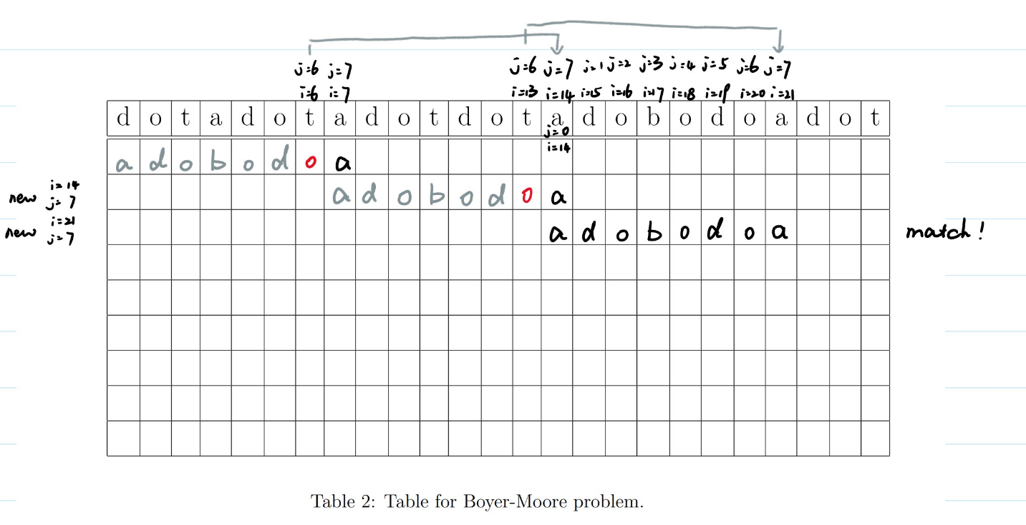

1. For any pattern P of length m, and text T of length n. If all characters on position p in T where ($p≡ m-1 mod m$) are the characters that does not occur in P (i.e. L(T[p]) = -1). Then the Boyer-Moore algorithm looks at exactly $Θ\left(n/m\right)$ characters because in this case, Boyer-Moore algorithm will only look at the characters that are in position p, and will find that it does not occur, then it will shift i into $i+m$. Since each time it shifts m position, totally, it will only check $Θ\left(n/m\right)$ times.