PART IV RESEARCH PROJECT REPORT

AI-Use Disclosure Governance and Contributor Compliance in Open-Source Software

Minseo Kim

Co-worker: Anna Chibel
Supervisor: Dr. Kelly Blincoe

18 October 2026

Department of Electrical, Computer, and Software Engineering
The University of Auckland


AI-Use Disclosure Governance and Contributor Compliance in Open-Source Software

Minseo Kim

ABSTRACT

Open-source software (OSS) projects are introducing rules for AI-assisted contributions, but it is unclear how the location of these rules relates to contributor disclosures. This study examined AI-related policies in 38 GitHub repositories and used AI_Analyzer to analyse 41,338 eligible closed pull requests (PRs). The tool identified AI-related disclosures in 11,598 PRs (28.06%). Mean repository disclosure rates were 12.02% for low-visibility policies, 21.53% for moderate visibility, and 51.24% for high visibility. Policy visibility had a significant positive association with observed disclosure rates (Spearman’s ρ = 0.6181, p < 0.001, n = 38). The findings suggest that where policies appear in contribution workflows may matter, although PR templates may also make disclosures easier to detect. This study measured visible statements, not verified AI use or policy compliance.

SIGNED STATEMENT OF CONTRIBUTION
Student

I hereby declare that:

- This report is the result of the final year project work carried out by my project partner (Anna Chibel) and I under the guidance of our supervisor (Kelly Blincoe) in the 2026 academic year at the Department of Electrical, Computer, and Software Engineering, Faculty of Engineering and Design, University of Auckland.
- This report is not the outcome of work done previously.
- Except for the collaboration with my project partner identified above and any collaboration with a project sponsor disclosed in this report, this report is not the outcome of other collaborative work.
- This report is not the same as any report, thesis, conference article or journal paper, or any other publication or unpublished work in any format.

Signature: 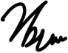 Date: 18 October 2026

Supervisor
I confirm that the project work undertaken by this student in the 2026 academic year is
/ is not (strikethrough as appropriate) part of a continuing project, components of which have been completed previously. Comments, if any:
Signature:  Date: 16 Oct 202

Table of Contents
Acknowledgements 5
Glossary of Terms 6
Abbreviations 6

1. Introduction 1
1.1. Background and Motivation 1
1.2. Research Questions and Objectives 1
1.3. Research Scope and Contributions 2
2. Literature Review 2
2.1 AI-Assisted Development in Open-Source Software 2
2.2 AI Transparency, Disclosure, and Accountability 3
2.3 Open-Source Governance and AI Disclosure Policies 3
2.4 Policy Visibility and Disclosure Detection in GitHub Pull Requests 4
2.5. Research Gap 5
3. Research Methodology 5
3.1 Overall Research Design 5
3.2 Data Collection 6
3.2.1 Repository Selection and Dataset Construction 6
3.2.2 Pull Request Collection and Preprocessing 7
3.3 AI Disclosure Governance Analysis 8
3.3.1 Policy Identification and Coding 8
3.3.2 Policy Visibility and Governance Mechanisms 9
3.4 Automated Disclosure Detection and Validation 10
3.4.1. AI_Analyzer Implementation and Disclosure Detection 10
3.4.2. Manual Validation and Inter-Rater Reliability 11
3.4.3. Detector Performance Evaluation 12
3.5. Governance and Disclosure Rate Analysis 12
4. Results 13
4.1. Dataset Overview 13
4.2. AI-Related Contribution Governance Across Repositories (RQ1) 14
4.2.1 Stated Policy Rationales 15
4.2.2 Stated Consequences 15
4.3. Disclosure Detector Validation 15
4.4. Observed AI-Use Disclosure in Pull Requests (RQ2) 16
4.5. Policy Visibility and Observed Disclosure Rates (RQ3) 18
4.6. Exploratory Comparisons of Other Governance Characteristics (RQ3) 19
5. Discussion 21
5.1. Interpretation of Findings and Comparison with Existing Research 21
5.2. Implications for Open-Source Maintainers 22
5.3. Limitations and Threats to Validity 22
6. Conclusions and Future Work 23
References 24
Appendix A Supplementary Governance Figures 27

,-

Acknowledgements
I would like to express my sincere gratitude to my supervisor, Dr. Kelly Blincoe, for her invaluable guidance, constructive feedback, and continuous support throughout this research project.
I am also deeply grateful to Anna Chibel for her significant contributions, close collaboration, and thoughtful insights throughout the research process.
I would also like to thank Alex Suho Yoo for his encouragement and insightful discussions during the early stages of this research.
I am especially grateful to my parents, Hyunsoo Kim and Hyewon Cho, for their unconditional love, patience, and unwavering support. I would also like to thank my family and friends for their prayers throughout this journey.
Above all, I give all glory to God for His grace, wisdom, and strength that have sustained me every step of the way.

Glossary of Terms
Term | Definition
AI-related contribution governance | Documented rules governing AI-assisted OSS contributions, including disclosure, responsibilities, attribution, and restrictions.
AI-use disclosure | An observable contributor response concerning whether AI was used in preparing a PR; it does not independently verify AI use.
Positive disclosure | A detector-assigned declaration indicating that AI assistance was used.
Negative disclosure | A detector-assigned declaration indicating that AI assistance was not used.
Ambiguous disclosure | An AI-related response that does not clearly establish whether AI was used.
Disclosure rate | The number of eligible PRs with a detected AI-related disclosure divided by all eligible PRs in the relevant group.
Policy visibility | How directly AI-related guidance is presented in the contribution workflow, scored from 0 (no policy found) to 3 (directly in PR submission).
PR template | A reusable form or set of prompts presented to contributors when creating a pull request.

Abbreviations
Abbreviation | Full term
AI | Artificial Intelligence
API | Application Programming Interface
CLA | Contributor License Agreement
DCO | Developer Certificate of Origin
GenAI | Generative Artificial Intelligence
LLM | Large Language Model
OSS | Open-Source Software
PR | Pull Request
RQ | Research Question

Introduction

Background and Motivation
Open-source software (OSS) development relies on distributed collaboration, with contributors proposing changes that are evaluated before integration into shared codebases [1]. GitHub pull requests (PRs) provide a structured mechanism for submitting, discussing, and reviewing contributions [1]. Code review supports defect identification, knowledge sharing, and the evaluation of proposed changes, making it an essential part of collaborative software development [2].
The emergence of generative artificial intelligence (GenAI) is changing how software contributions are produced. Large language models can generate source code from natural language instructions [3], while AI coding assistants such as GitHub Copilot help developers implement solutions and explore alternative approaches [4]. However, AI-generated code can introduce security vulnerabilities [5], and recent research on OSS projects adopting Cursor found that short-term development gains were accompanied by increased code complexity and static analysis warnings [6].
These developments create new challenges for OSS communities. Although AI can reduce the effort required to generate code, reviewing and validating contributions remains an important human responsibility [2], [6]. Research examining developer discussions has also identified concerns that low-quality AI-generated submissions increase review friction and place additional demands on maintainers [7]. Consequently, OSS projects must reconsider how they communicate expectations for transparency, accountability, and responsible AI-assisted development [8].
In response, OSS communities have begun introducing AI-related contribution policies addressing disclosure requirements, contributor responsibilities, acceptable AI use, and restrictions on generated contributions [8], [9]. However, the existence of a policy does not establish whether contributors will encounter its requirements during submission or provide the requested information. This raises questions about the relationship between documented governance expectations and observable disclosure behaviour.

Research Questions and Objectives
This study aims to examine how open-source software (OSS) projects govern AI-assisted contributions and how contributors respond to AI disclosure requirements in GitHub pull requests (PRs). It also investigates whether policy visibility and other governance characteristics are related to observed disclosure rates.
The study addresses three research questions:
- RQ1: How are OSS projects adapting contribution governance practices in response to AI-assisted development?
- RQ2: To what extent do contributors comply with AI disclosure policies through observable disclosures in OSS pull requests?
- RQ3: How do policy visibility and governance characteristics relate to observed AI-use disclosure rates across OSS repositories?
To address these questions, the study has four objectives:
- Identify and classify AI-related contribution policies across 38 OSS repositories, including their requirements, restrictions, and visibility.
- Develop and evaluate an automated detector to identify observable AI-related disclosures in GitHub PRs.
- Examine disclosure practices across 41,338 eligible PRs and assess what these observations can reveal about contributor compliance with AI disclosure policies.
- Investigate the relationship between policy visibility, other governance characteristics, and repository-level disclosure rates.

Research Scope and Contributions
Research scope. This study examines 38 GitHub OSS repositories with identifiable AI-related contribution policies and 41,338 eligible closed PRs collected over a four-month period ending in September 2026. It combines manual policy analysis with automated disclosure detection. Repositories were selected deliberately to study relevant governance practices [11], so the findings should not be treated as a representative estimate of all GitHub projects.
The study focuses on documented policies and explicit contributor statements about AI use or non-use. Disclosure rates thus reflect observable statements rather than actual AI usage. Independently identifying undisclosed AI assistance, evaluating the quality of AI-generated code, investigating individual contributor motivations, and verifying actual policy enforcement fall outside its scope. The study examines associations between governance characteristics and disclosure rates rather than establishing causal effects.
Research contributions. Building on emerging research into OSS AI governance, this study makes three contributions.
First, it offers a structured comparison of AI-related contribution requirements, including disclosure expectations, accountability, restrictions, stated consequences, and policy rationales. It additionally distinguishes policy visibility from policy content, providing a workflow-oriented perspective on how governance requirements are communicated to contributors.
Second, it provides evidence of observable AI-related declarations across 41,338 PRs using a manually evaluated automated detector. Both declarations of AI use and declarations of non-use were counted.
Third, it examines how policy visibility and governance characteristics relate to repository-level disclosure rates. These findings may inform how OSS maintainers decide where and how to present AI-related contribution requirements within their contribution workflows.

Literature Review

2.1 AI-Assisted Development in Open-Source Software
AI assistants are changing how developers write code, but their benefits and risks need to be considered together. Chen et al. [3] demonstrated that large language models can generate code, while Barke et al. [4] observed two ways developers use such tools: to speed up a known task or to explore unfamiliar solutions. These studies address different questions—what the models can produce and how programmers work with them. Neither tells us whether AI involvement will be visible to the people reviewing an open-source contribution.
Evidence about quality also comes from different settings. Pearce et al. [5] found security weaknesses in some Copilot-generated programs, while He et al. [6] reported temporary productivity gains alongside higher code complexity and more static-analysis warnings after Cursor adoption. Baltes et al. [7] examined developer discussions and found concerns about review burden and low-quality AI submissions. These results should not be treated as one shared estimate of AI's effect: they measure generated code, repository outcomes, and expressed experiences, respectively.
Together, this research suggests a gap between making code faster and making it easier to review responsibly. In OSS, where maintainers depend on PR descriptions and code review to assess external contributions [1], [2], knowing whether AI assistance was involved may help provide context. This motivates examining how projects ask for such information, rather than assuming that the presence of an AI tool can be recognised from the code itself.

2.2 AI Transparency, Disclosure, and Accountability
Transparency can mean different things: saying that AI was used, identifying the tool, or explaining which parts of a contribution it helped create. Kashif et al. [12] analysed 613 self-declared AI-generated code snippets and surveyed 111 practitioners; 76.6% of their respondents said they disclosed at least sometimes. Participants linked disclosure to later review, debugging, and ethics, but some saw little need to declare code that they had heavily edited. The survey captures people's reported practices and reasons, not disclosure rates for all submitted PRs.
Xiao et al. [13] used a different approach, locating 1,292 self-admitted GenAI-use mentions in 156 OSS repositories. These appeared in several artifacts, including commit messages, code comments, and documentation. Their categories show that contributors describe AI assistance in many ways. Unlike the survey by Kashif et al. [12], this work examines records visible in repositories; however, neither approach can independently verify whether undisclosed AI was used.
The two studies therefore address complementary questions: why developers say they disclose and where evidence of disclosure can be found. The present study focuses on the narrower setting of GitHub PRs and records declarations of both AI use and AI non-use. A 'no AI used' response is a declaration, but it is not evidence of AI-generated code; similarly, silence cannot be treated as proof that no AI was used. This difference in definitions matters when comparing percentages across studies [12], [13].
Disclosure must also be distinguished from accountability. Hora et al. [9] found that policies often required human involvement even when they did not require an AI-use declaration. Explaining, checking, and taking responsibility for submitted code are different obligations from naming an AI tool [8], [9]. For this reason, our governance coding measures disclosure requirements separately from responsibility, attribution, and restrictions.

2.3 Open-Source Governance and AI Disclosure Policies
Recent OSS research agrees that AI governance involves more than a simple choice to allow or ban AI, but the studies examine different parts of that picture. Yang et al. [8] studied 67 projects to identify broad governance approaches and 12 strategies. Hora et al. [9] instead classified 281 policies and found that permissions, disclosure requirements, human involvement, and accountability were not always specified together. Yang et al. help explain the types of rules being developed; Hora et al. show how varied those written requirements are.
Chen et al. [10] moved beyond policy descriptions by analysing AI policy adoption across GitHub repositories and its associations with disclosure, developer activity, and quality. Their TRACE framework groups governance content into transparency, responsibility, attribution, constraints, and enforcement. This adds an outcome-focused perspective to the policy categories described by Yang et al. [8] and Hora et al. [9]. However, the studies use different samples and methods, so their numbers are not directly comparable.
An important distinction remains. A policy can ask for detailed information yet be difficult to find, while a short policy notice in a PR template may be seen during submission. Chen et al.'s transparency dimension mainly concerns what the policy requires [10]. Our visibility measure instead asks where contributors can encounter the requirement. Keeping these two features separate allows us to examine a question not answered by policy content alone.
The existing evidence also has limits for the present study. Hora et al. [9] recorded changes to some policies over time, and Chen et al. [10] examined adoption-related outcomes, whereas our study examines a snapshot of policy guidance alongside observed PR declarations. It therefore tests an association between visibility and disclosure rates, not whether moving a policy into a template causes contributors to change their behaviour.

2.4 Policy Visibility and Disclosure Detection in GitHub Pull Requests
The way rules are communicated may matter alongside what those rules say. Elazhary et al. [14] found that actual GitHub contribution activity often differed from documented guidelines. Zhang et al. [15], by contrast, showed how PR templates can organise the information contributors submit and were associated with smoother review processes in their study. The studies connect written expectations with workflow design, but neither tests AI disclosure specifically.
GitHub offers several places for guidance: CONTRIBUTING.md explains repository rules, while PR templates can place questions directly in front of contributors [16], [17]. These mechanisms create different chances for a contributor to see an AI-related request. We therefore distinguish guidance held outside the repository, guidance within repository documentation, and guidance shown during PR submission. Visibility measures the opportunity to encounter a rule, not whether it was read or followed.
Where disclosures are measured is equally important. Kashif et al. [12] studied declarations in code, Xiao et al. [13] identified admissions across software artifacts, and Chen et al. [10] examined disclosure activity in GitHub PRs. Their methods detect different forms of evidence, so rates based on them cannot be compared without considering the artifact and what counts as a statement. In particular, an unanswered template question is not a contributor's declaration.
Yang et al. [18] found that coding agents rarely retrieved applicable contribution rules unless prompted. Their subjects were autonomous agents, not human PR authors, so their results cannot directly predict human behaviour. Nonetheless, the study supports the need to ask whether governance guidance is available at the moment a contribution is prepared.
Together, these studies show that AI disclosure involves both contributor practices and the ways projects communicate their requirements. However, they provide limited evidence of how policy content and visibility relate to observable disclosure behaviour across OSS repositories.

2.5. Research Gap
Existing research provides valuable insights into AI-assisted development and OSS governance, but the relationship between written AI policies and observable contributor behaviour remains incompletely understood.
Yang et al. [8] and Hora et al. [9] examined how OSS projects are responding to AI-assisted contributions by introducing different governance requirements. Their work helps explain what these policies contain, but provides limited evidence of how contributors respond to them in practice. Studies of AI self-disclosure by Kashif et al. [12] and Xiao et al. [13] offer evidence of disclosure practices, although they do not directly assess those practices against repository-specific contribution policies.
More recently, Chen et al. [10] investigated the adoption of AI governance policies and reported associations with disclosure and development outcomes. Their work considers governance dimensions such as transparency, responsibility, attribution, constraints, and enforcement. However, the visibility of these policies within the contribution workflow remains a distinct question. For example, a policy stored in external documentation and a disclosure prompt displayed during PR submission may provide different opportunities for contributors to encounter AI-related requirements.
This study addresses these gaps by combining manual governance analysis with automated detection of AI-related declarations in GitHub PRs. It examines the governance practices adopted by OSS projects, the observable disclosures associated with their policies, and the relationship between policy visibility, governance characteristics, and disclosure rates. As the study cannot independently verify actual AI use or whether every PR satisfies its policy, it distinguishes observable disclosure behaviour from confirmed compliance.

Research Methodology

3.1 Overall Research Design
This study used an empirical observational design to examine AI-related contribution governance in open-source software (OSS) projects and its relationship with observable AI-use disclosure in GitHub pull requests (PRs). It combined manual policy analysis with automated PR data collection and quantitative comparison across repositories. The design used two units of analysis: the repository for documented governance characteristics and the individual PR for disclosure observations.
The research questions were addressed through complementary forms of evidence: written policies captured expectations and permitted comparisons of governance design, while PR records captured statements visible in the contribution process. A repository-level disclosure rate was defined using the number of PRs with detected disclosures relative to the number of eligible PRs in that repository. The detector evaluation and the statistical relationship between the two levels of data are specified later in this chapter.
The research proceeded in five stages. First, repositories containing identifiable AI-related contribution policies were selected. Second, their contributor-facing policies were manually coded to capture disclosure requirements, visibility, and other governance mechanisms. Third, eligible closed PRs were collected and analysed using the Java-based AI_Analyzer tool. Fourth, automated disclosure detection was assessed using manually reviewed PR samples and inter-rater reliability procedures. Finally, repository-level disclosure rates were compared with governance characteristics. Sections 3.2 and 3.3 describe sampling and policy coding; automated detection, validation, and statistical analysis are detailed in Sections 3.4 and 3.5.
At PR level, the study measured observable AI-related disclosures rather than actual AI use. Detected responses were classified as positive when they indicated AI use, negative when they indicated non-use, or ambiguous when an AI-related response did not clearly establish whether AI was used. Eligible responses in all three categories were counted as disclosure-present, while unanswered template questions and incidental AI mentions were excluded. These observations could not independently establish whether contributors had used AI or fully complied with their repository's policies. Governance policies and PR disclosures were therefore analysed separately, since detecting a statement did not establish whether disclosure was required for that particular PR.

3.2 Data Collection

3.2.1 Repository Selection and Dataset Construction
Repositories were selected purposively because the study focused on OSS projects with publicly documented AI-related contribution policies [11]. Candidate projects were initially identified using the Open-source AI Contribution Policies collection maintained by Melissa Weber Mendonça [19]. Each candidate was then checked manually against the repository selection criteria, including its GitHub information and contribution documentation. Policy classifications in the collection were not accepted without checking the original policy documents.
Repositories were considered for inclusion if they were public, licensed GitHub projects with English-language contribution guidance and an identifiable policy covering AI-assisted contributions. The screening criteria are summarised in Table 3.1, including project activity and popularity. The sample was deliberately chosen to study repositories with AI-related rules; it was not intended to represent GitHub projects as a whole. Policies were not assumed to require a disclosure in every PR, because some addressed restrictions or contributor responsibilities instead.
Table 3.1. Repository screening criteria
Criterion | Operational requirement
Availability and licence | Public GitHub repository with a recognised OSS licence
Activity | More than 20 commits during the previous 12 months
Contribution workflow | Supports contributions through GitHub pull requests
Popularity | More than 500 GitHub stars
Documentation | Contributor-facing documentation available in English
AI-related policy | Identifiable guidance regulating AI-assisted or AI-generated contributions
The final sample comprised 38 repositories. Repository identifiers were standardised using the OWNER/REPO format because repository names alone may not be unique across GitHub. This format allowed each repository to be identified consistently and helped ensure that its governance coding was matched with the correct PR records. For each project, the policy had to apply to contributors to that repository; simply mentioning AI in project documentation was not sufficient. The repository list used for collection was stored in repos.txt.
Two complementary repository-level datasets were maintained to separate policy source information from detailed governance coding. The Policy Tracker recorded repository identifiers, URLs, stars, licences, policy locations, PR templates, and visibility scores. The Governance Coding Sheet recorded disclosure requirements, contributor responsibilities, attribution, AI-use restrictions, stated consequences, and policy rationales. Keeping these records separate made it easier to trace coding decisions back to their policy sources. All governance characteristics were coded manually rather than generated by AI_Analyzer.
Relevant evidence was located in README.md, CONTRIBUTING.md, dedicated AI policy files, PR templates, linked project documentation, and external contributor guidance. When policies were distributed across several sources, those sources were considered together. Repository URLs and available policy links were retained to make coding decisions traceable. The resulting sample was designed for comparison among projects with documented AI governance, rather than as a representative sample of all GitHub OSS projects.

3.2.2 Pull Request Collection and Preprocessing
PR records were collected using AI_Analyzer, a custom Java 17 application built with Maven. The tool read repository identifiers from repos.txt and retrieved closed PRs through the GitHub REST API [20]. Requests used state=closed, sort=updated, and pagination of up to 100 records per page. These settings determined how PRs were retrieved; the four-month observation window and eligibility rules determined which PRs were included in the study.
The tool collected available closed PRs and applied the same eligibility rules to each repository. A PR was included when its GitHub closed_at timestamp fell within the four-calendar-month observation window. Both dates were inclusive, and both merged and closed-without-merging PRs were eligible. Open PRs, records with invalid closure dates, and duplicate repository–PR identifiers were excluded. The closed_at timestamp was used because it provides a common endpoint for both merged PRs and PRs closed without merging. In contrast, merged_at would exclude unmerged contributions, while created_at would select PRs based on when they were opened rather than when their contribution process ended. Using closed_at allowed the study to include both outcomes within the same observation window.
The analysis began on 22 September 2026 at 09:58:43 UTC. The corresponding observation window began on 22 May 2026 at the same time. The resulting dataset contained 41,338 eligible closed PRs from 38 repositories. Manual detector validation used a different sampling window, from 1 May to 31 August 2026, as explained in Section 3.4.
Automated accounts were excluded using GitHub account metadata and username heuristics. The filter removed accounts identified as type Bot and usernames matching recognised automation patterns, including [bot] suffixes and common bot or application names. These rules operationally identified non-bot accounts; they did not independently establish whether every retained contribution was written entirely by a human.
For each eligible PR, the tool collected the repository identifier, PR number and URL, title, author, creation and closure timestamps, merge timestamp, and final status. The PR body supplied the initial content for disclosure detection, with rendered GitHub PR pages used by the detection workflow when additional visible evidence was needed. The classification rules and handling of disclosure evidence will be explained in Section 3.4.
Retained PRs were ordered by closure time, with PR number used to break ties. The tool included retry handling for selected API failures and recorded unsuccessful repository collection attempts. PR-level records were exported to pr_dataset_output.csv, while repo_compliance_summary.csv contained repository-level counts and detected disclosure rates. Despite its filename, the summary did not provide verified policy-compliance measurements.
The collected dataset included both merged and closed-unmerged PRs, along with automated AI-disclosure detection results. However, the AI Disclosure Required field was not populated with information from the Governance Coding Sheet and remained marked as MANUAL_REVIEW_REQUIRED. Therefore, the results indicated whether AI disclosure was detected in PRs, but did not determine whether each PR complied with its repository's AI-related policies.

3.3 AI Disclosure Governance Analysis

3.3.1 Policy Identification and Coding
Governance analysis examined what repositories explicitly instructed contributors to do regarding AI-assisted work. Coding was performed manually at repository level using the policy sources identified during dataset construction. Statements regulating contributor behaviour were distinguished from documentation that merely mentioned AI technologies. The policy's wording and context determined its classification; the presence of an AI-related policy alone did not establish an obligation to disclose every possible use of AI.
The Governance Coding Sheet used separate variables rather than a single overall governance score. These variables covered disclosure requirements, contributor responsibility, attribution, AI-use restrictions, stated consequences, and policy rationales. Similar governance dimensions have been examined in previous OSS research [8]–[10]. Table 3.2 summarises the categories used in this study. The governance characteristics were kept separate because they describe different aspects of a policy. For example, requiring contributors to name an AI tool is different from requiring them to test AI-generated code. Combining these requirements into one score could hide such differences and imply that the categories have equal importance. The numerical codes were therefore used to classify policies, not to calculate an overall measure of governance strength.
Table 3.2. Principal governance coding variables
Variable | Recorded categories
Disclosure detail | 1: basic statement; 2: identify tool; 3: explain AI use; 4: detailed traceability
Disclosure location | Separate 0/1 indicators for an explicit requirement in PRs and in commits
Responsibility | 0: none; 1: general accountability; 2: explain/justify work; 3: review or testing required
Attribution | 0: none; 1: general IP duty; 2: licensing, DCO or CLA; 3: documented provenance
AI-use constraints | 0: none; 1: bulk/low-effort restriction; 2: specific contexts; 3: general prohibition
Stated consequence | 0: none; 1: correction/review; 2: rejection/closure; 3: participation restriction
Policy rationale | Six independent binary indicators, described below
Disclosure requirements and content. The disclosure-detail code described what a repository requested, not what any contributor actually wrote. A basic statement about AI use or non-use was distinguished from naming the tool, describing its use, or providing more detailed traceability information. The coding sheet also separately recorded whether disclosure was explicitly required in a PR description or submission form and whether it was required in a commit message or trailer. These binary fields captured documented locations of required disclosure, not a complete repository-wide classification of mandatory, recommended, and optional AI-use disclosure.
As all selected repositories had identifiable AI-related contribution policies, the disclosure-detail framework was defined using a 1–4 scale rather than including a separate score of 0 for policy absence. A score of 1 represented the most basic level of disclosure detail, while higher scores indicated increasingly specific information requirements. N/A was assigned where a policy primarily addressed AI-use restrictions or prohibitions without a classifiable disclosure-detail requirement. The coding framework distinguished general instructions to use AI responsibly from specific requirements to identify AI tools or explain their use. Where policy wording was ambiguous, stronger disclosure obligations were not assumed without explicit evidence. Similarly, requirements concerning AI-generated material were not automatically extended to all forms of AI assistance unless explicitly stated.
Contributor responsibility, attribution, and restrictions. Responsibility codes differentiated a general statement that contributors remain accountable from stronger provisions requiring explanation, review, testing, or validation of AI-assisted material. Attribution was coded separately: merely naming an AI tool for transparency did not automatically count as documenting authorship, legal rights, or provenance. Likewise, restrictions on bulk low-effort submissions, specified forms of AI assistance, and generally prohibited AI-generated contributions were distinguished from policies that allowed AI use subject to disclosure. These classifications could coexist within the same repository because they captured different obligations.
Stated consequences. Consequences were coded according to the explicit policy provisions defined in Table 3.2. General project-wide rejection rules were not automatically classified as AI-related consequences unless the wording or context established a clear connection. Missing and non-applicable values were distinguished from code 0, which indicated that no relevant consequence was stated. These codes represented documented consequences rather than evidence of enforcement in practice.
Policy rationales. Six non-exclusive binary indicators were used to examine the reasons explicitly communicated in repository policies for adopting AI-related contribution requirements. These indicators captured transparency, code quality, reviewer workload, human accountability, rights/provenance, and other stated justifications. Each indicator was coded 1 when the corresponding rationale was explicitly stated and 0 when it was not identified in the examined material. Multiple rationales could be recorded for a single repository. Coding was based on documented explanations rather than motivations inferred by the researchers from the presence of disclosure requirements or AI-use restrictions.
Coding procedure and documentation. The Governance Coding Sheet was completed collaboratively by two researchers during joint review sessions. Both researchers examined the relevant policy documents together, cross-checked their interpretations, and discussed coding decisions to ensure consistent application of the coding framework. Policy URLs and notes were retained alongside the assigned codes, with dedicated fields for supporting evidence excerpts and coding justifications. However, these excerpts were not consistently populated in the coding sheet, making the recorded policy URLs important for tracing and reviewing individual coding decisions. This collaborative coding and cross-checking process was distinct from the formal inter-rater reliability assessment conducted for PR disclosure labels in Section 3.4.2.

3.3.2 Policy Visibility and Governance Mechanisms
Policy visibility was coded separately from policy content because the study aimed to distinguish what a policy required from where contributors could encounter it. Each repository received an ordinal score from 0 to 3, as defined in Table 3.3. When AI-related guidance appeared in multiple locations, the highest applicable visibility score was assigned. This reflected the most direct opportunity for contributors to encounter the guidance during the contribution process. For example, a policy appearing in both external documentation and a PR template was classified as Level 3 because the template presented the guidance during PR submission.
Table 3.3. Policy visibility scoring framework
Score | Definition
0 | No identifiable AI-related contribution policy
1 | Policy in external or separate organisational guidance requiring independent discovery
2 | Policy in repository documentation, such as CONTRIBUTING.md or a dedicated AI policy file, without a direct PR-workflow requirement
3 | AI-related policy or disclosure requirement displayed directly in the submission workflow, such as a PR template, form, or required checklist
Visibility was assessed using AI-related guidance available in contributor-facing documentation and submission workflows, rather than the presence of a generic PR template. Level 3 included explicit disclosure prompts, AI-related policy notices, and links presented directly in the PR submission process. An explicit disclosure question was not required for this classification. Visibility scores were recorded in both the Policy Tracker and Governance Coding Sheet, with the latter used for analysis. These scores represented opportunities to encounter guidance, not evidence that contributors had read or followed it.
Policy visibility was distinguished from the broader governance characteristics assessed in this study. While visibility measured how directly contributors could encounter AI-related policies, governance coding examined what those policies required, including disclosure expectations, contributor responsibilities, AI-use restrictions, and stated consequences. The presence of a disclosure prompt or a stated consequence was not treated as evidence of active enforcement. As implemented enforcement was not consistently measured across repositories, it was not included as a separate quantitative variable. Policy visibility and governance characteristics were therefore retained as distinct repository-level variables for comparison with observed disclosure rates in Section 3.5.

3.4 Automated Disclosure Detection and Validation

3.4.1. AI_Analyzer Implementation and Disclosure Detection
A custom Java 17 application, AI_Analyzer, was developed to identify observable AI-related disclosures in GitHub PRs. Automated detection was necessary because manually reviewing all 41,338 PRs would have been impractical. A rule-based approach was chosen because the study focused on explicit declarations that could be identified through specific wording, completed template responses, and attribution fields. This approach also allowed the researchers to inspect the text that triggered each detection and investigate incorrect classifications during validation.
The implementation separates data collection from disclosure detection. GitHubClient retrieves PR data through the GitHub REST API, PrAnalyzer manages PR processing, and AiDisclosureDetector identifies disclosure evidence. The detector first examines the PR body returned by the API and, if no disclosure is identified, uses the rendered GitHub PR page as a fallback. This was intended to capture relevant evidence that might be absent from the initial API response.
Before classification, the detector filters hidden HTML comments, unanswered template questions, unchecked checkboxes, and placeholder text. This preprocessing reduces false positives because PR templates may contain AI-related questions even when contributors have not answered them.
Detection uses regular expressions and contextual rules to recognise explicit AI-use statements, declarations of non-use, completed template responses, tool references, and structured attribution fields such as Generated-by, Assisted-by, and Co-authored-by. Repository-specific rules accommodate differences in disclosure formats. Responses were classified as positive when they indicated AI use, negative when they indicated AI non-use, or ambiguous when a contributor's AI-related response did not clearly distinguish between these two outcomes, such as a combined statement containing alternative conditions. Positive, negative, and eligible ambiguous responses were all counted as disclosure-present because the study measured observable AI-related declarations rather than verified AI use. Incidental mentions and unanswered prompts were not automatically treated as disclosures.
The tool retained disclosure classifications, matched evidence, and evidence sources to support manual validation and error analysis.
The main analysis began on 22 September 2026 and continued through 23 September. A four-month observation window was applied, beginning on 22 May 2026 at the same UTC time as the analysis start. Fixing this cutoff ensured consistent PR eligibility throughout data collection.

3.4.2. Manual Validation and Inter-Rater Reliability
Manual validation established human-coded reference labels against which automated predictions could be evaluated. This was necessary because disclosure wording and template formats varied across repositories, creating risks of both missed disclosures and incorrect detections.
Initial validation and inter-rater reliability. Two researchers independently reviewed the same 150 PRs, comprising 50 each from Homebrew/brew, sympy/sympy, and kubernetes/kubernetes. Using shared criteria, they labelled disclosure presence (Yes/No) and classification (Positive/Negative/Ambiguous/None).
Inter-rater reliability was measured using Cohen's kappa, which accounts for agreement that could occur by chance [21]. Both researchers independently reviewed the same 150 PRs and agreed on all disclosure-presence and classification labels. This resulted in 100% observed agreement and κ = 1.00 for both variables. The result indicates consistent labelling within this initial sample; it does not measure agreement for PRs reviewed by only one researcher.
A further 200 PRs from four additional repositories were reviewed by one researcher, producing an initial detector-validation sample of 350 PRs. These additional records were excluded from the inter-rater reliability calculation because they were not independently reviewed by both researchers.
Expanded validation. Initial evaluation revealed repository-specific disclosure formats that the detector sometimes missed. Validation was therefore expanded across the selected repositories to assess detection performance under more diverse contribution practices.
The validation sample size was planned using a conventional benchmark for estimating a population proportion. At a 95% confidence level with a ±5 percentage-point margin of error, approximately 385 observations are required under simple random sampling when a conservative proportion of 0.5 is assumed [22]. We aimed to exceed this benchmark while also including PRs from repositories of different sizes.
Rather than sampling randomly from all PRs as one group, up to 20 eligible PRs were randomly selected from each repository. This approach was chosen because PR volumes differed greatly between repositories. A sample drawn from the combined PR population would be dominated by the largest projects and might include very few examples from smaller repositories. Sampling across repositories allowed the detector to be evaluated against a wider range of disclosure formats. A fixed random seed of 42 was used so that the sampling process could be repeated.
The validation sample covered PRs closed between 1 May and 31 August 2026 and contained 708 PRs from the final 38 repositories. Because repositories were not sampled in proportion to their PR volumes, the conventional ±5 percentage-point margin of error cannot be directly applied to the reported detector accuracy.
After the initial agreement check, the researchers divided the expanded manual review: one labelled 361 PRs and the other labelled 347. Their labels were combined using unique PR identifiers. The 708 PRs were not all independently labelled by both researchers.
This approach prioritised broader validation while maintaining consistent coding procedures. However, κ = 1.00 applies only to the initial 150 independently reviewed PRs, as inter-rater reliability was not reassessed for the expanded sample.

3.4.3. Detector Performance Evaluation
Detector performance was evaluated by comparing automated disclosure-presence predictions with human-coded labels. A confusion matrix recorded true positives (TP), true negatives (TN), false positives (FP), and false negatives (FN).
Five performance metrics were calculated: accuracy, precision, recall, specificity, and F1 score. Accuracy measured overall agreement, while precision and recall were particularly important for estimating disclosure rates. False positives could overestimate disclosure by counting unrelated AI references, whereas false negatives could underestimate it by missing valid statements. Specificity assessed correct identification of PRs without disclosure, and F1 balanced precision and recall.
An initial evaluation of 350 PRs led to further inspection of missed declarations and false matches. These cases informed refinements to template handling and repository-specific rules.
The revised detector was evaluated against 708 manually labelled PRs from the final 38 repositories. Section 4.3 gives the confusion matrix and performance results.
The initial 350-PR evaluation was used to identify errors and refine the detector's rules. The revised detector was subsequently assessed using 708 manually labelled PRs from the selected repositories. Since the two evaluations used separately assembled samples, their performance figures should not be interpreted as a controlled before-and-after comparison.

3.5. Governance and Disclosure Rate Analysis
To address RQ3, each repository’s coded policy information was linked to its detected PR disclosure rate. The main statistical analysis focused on policy visibility: whether guidance appeared outside the repository, within its documentation, or directly during PR submission. Other governance features were compared with disclosure rates as a secondary, exploratory analysis.
For each repository, disclosure rate was calculated as:
Disclosure rate (%) = (eligible PRs with detected AI-related disclosure / all eligible PRs in the repository) × 100.
The numerator included positive and negative declarations, as well as ambiguous AI-related responses where a contributor had provided a response but the wording did not clearly indicate AI use or non-use. Ambiguous responses were included because the study measured the presence of observable AI-related disclosure responses, rather than only confirmed statements of AI use or non-use. Dividing by eligible PRs gave a rate for each repository. The overall pooled rate was calculated to describe disclosure across all eligible PRs. However, repository-level rates were used when comparing disclosure with governance characteristics because policies were coded at repository level. Treating individual PRs as separate policy observations would incorrectly give repositories with more PRs greater influence in the governance analysis. Using one disclosure rate per repository kept the units of analysis consistent.
Policy visibility was coded separately from policy content. Disclosure detail, contributor responsibility, attribution, restrictions, and stated consequences describe what a policy asks of contributors; visibility describes where contributors might encounter those rules. The categories were kept separate because they measure different aspects of governance and cannot be combined meaningfully into a single score.
Spearman's rank correlation was used to examine the relationship between policy visibility and disclosure rate [23]. This method was suitable because visibility was measured using three ordered levels, and each repository contributed one disclosure-rate observation. Spearman's ρ indicates both the direction and strength of the relationship between the ranked variables.
We also compared mean disclosure rates across visibility groups and calculated Cliff's delta to describe the difference between Levels 3 and 1 [24]. Cliff's delta compares all possible pairs of repository disclosure rates between two groups, measuring the difference between the proportions of pairs in which one group's rate is higher or lower than the other's. Tied pairs contribute neither direction. These measures help describe the size of the observed relationships but do not establish that policy visibility causes higher disclosure rates.
The remaining governance characteristics were originally coded to describe the policies used by OSS projects (RQ1). Once that coding was available, we also examined how disclosure rates differed across those categories. This was an exploratory extension of RQ3, rather than a set of planned hypothesis tests. We compared the distributions and group means descriptively and did not test each characteristic for statistical significance.

Results
This chapter presents results for 38 OSS repositories and 41,338 eligible GitHub pull requests (PRs). Section 4.1 describes the dataset, Section 4.2 reports the governance patterns (RQ1), and Section 4.3 reports detector validation. Section 4.4 examines detected AI-related declarations (RQ2), while Sections 4.5 and 4.6 compare disclosure rates with policy visibility and other governance features (RQ3). The findings concern visible declarations, not independently verified AI use or policy compliance.

4.1. Dataset Overview
The sample comprised 38 GitHub repositories with identifiable policies on AI-assisted contributions and 41,338 eligible closed PRs. All PRs were taken from the same four-month observation window. Repository identifiers were used consistently in the governance coding and the PR dataset, and the analysis used one final set of 38 projects throughout.
Repository sizes differed greatly. Eligible PR counts ranged from one to 18,748. llvm/llvm-project contributed 18,748 PRs, or 45.35% of the dataset. Three repositories had fewer than 20 eligible PRs, including two with only one PR. These projects met the original project-level selection criteria, but had little qualifying PR activity during the observation window. Their individual disclosure rates are therefore sensitive to even one additional PR. For policy comparisons, the 38 repositories (not the 41,338 individual PRs) were used as the observations
Table 4.1. Dataset characteristics
Characteristic | Result
Repositories with AI-related contributor policies | 38
Eligible closed PRs | 41,338
PRs with detected disclosure presence | 11,598
PRs without detected disclosure presence | 29,740
Repositories with fewer than 20 eligible PRs | 3
Largest repository PR volume | 18,748 (`llvm/llvm-project`)
Manually labelled validation PRs | 708

4.2. AI-Related Contribution Governance Across Repositories (RQ1)
The 38 policies set out different expectations for AI-assisted contributions. Twenty-two repositories (57.89%) explicitly required AI disclosure in PRs, while four (10.53%) specified disclosure in commit messages. These requirements could overlap. Twenty-one repositories (55.26%) had a PR template, although not every template asked about AI. Having an AI-related policy therefore did not mean that a declaration was required in every PR.
Policies also differed in how much detail they requested. Seven repositories asked for a basic statement (Level 1), 13 requested the AI tool (Level 2), 12 requested an explanation of AI involvement (Level 3), and three requested detailed traceability (Level 4). Three repositories had no applicable disclosure-detail level. These scores describe the instructions written in the policy, not the information provided in PRs.
Other rules concerned the contributor's responsibility and acceptable AI use. Twenty-four repositories were assigned the highest responsibility code (review or testing required), eight required an explanation of the work, four stated general responsibility, one had no such provision, and one was not applicable. For attribution, 21 repositories were coded Level 0, three Level 1, and 14 Level 2; none was Level 3. AI-use restrictions were coded Level 0 in 15 repositories, Level 1 in three, Level 2 in 19, and Level 3 in one. These are different policy features and should not be combined into one overall score.
Table 4.2. Selected governance characteristics in the 38 repositories
Governance characteristic | Category | Repositories (n)
PR disclosure explicitly required | Yes / No | 22 / 16
Commit disclosure explicitly required | Yes / No | 4 / 34
PR template present | Yes / No | 21 / 17
Disclosure detail | Levels 1 / 2 / 3 / 4 / N/A | 7 / 13 / 12 / 3 / 3
Responsibility | Levels 0 / 1 / 2 / 3 / N/A | 1 / 4 / 8 / 24 / 1
Attribution | Levels 0 / 1 / 2 / 3 | 21 / 3 / 14 / 0
AI-use constraints | Levels 0 / 1 / 2 / 3 | 15 / 3 / 19 / 1
Stated consequence | None / Rejection / Participation restriction / N/A | 9 / 13 / 15 / 1

4.2.1 Stated Policy Rationales
The most frequently stated policy rationale was reviewer workload (20 repositories; 52.63%). Other stated reasons appeared in 14 repositories (36.84%). Human accountability, rights or provenance, and code quality each appeared in 13 (34.21%), followed by transparency in seven (18.42%) (Figure 4.1). Repositories could mention several reasons. A reason not written in the policy should not be interpreted as unimportant to the maintainers.
Figure 4.1. Number of explicitly stated policy rationales (multiple codes permitted).
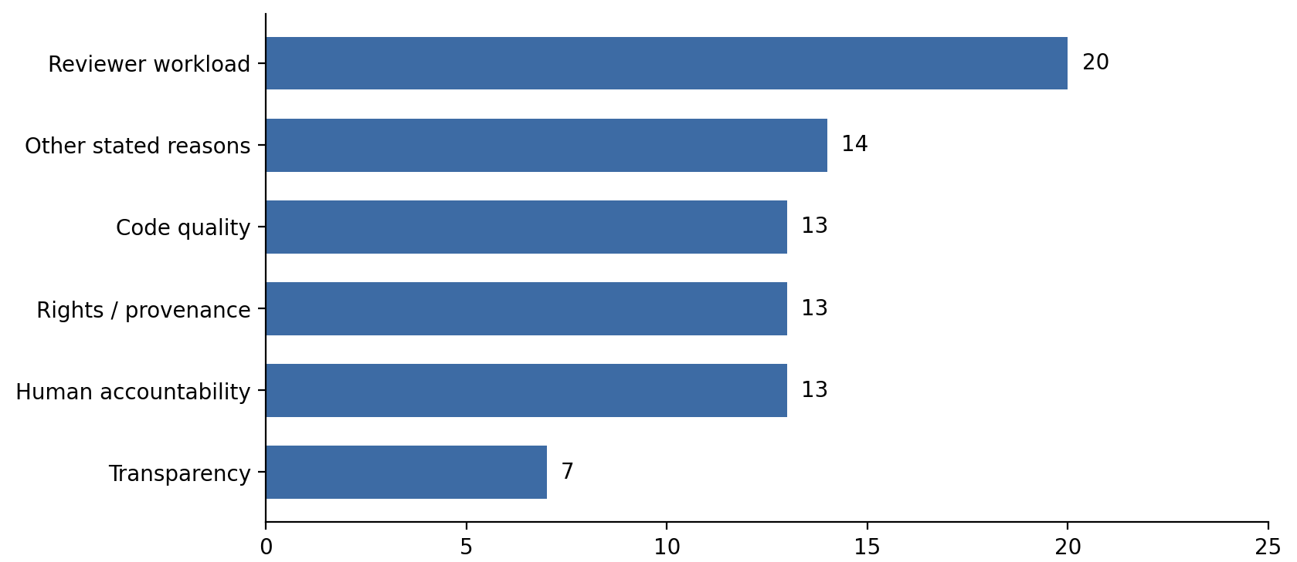

4.2.2 Stated Consequences
The policies also differed in what they said would happen after a violation. Fifteen repositories (39.47%) mentioned participation restrictions, 13 (34.21%) mentioned rejection or closure of a contribution, and nine (23.68%) stated no relevant consequence. One was not applicable, and none was coded in the correction/review category (Figure 4.2). These are written rules; this study did not measure whether maintainers enforced them.
Figure 4.2. Distribution of stated AI-related policy consequences.
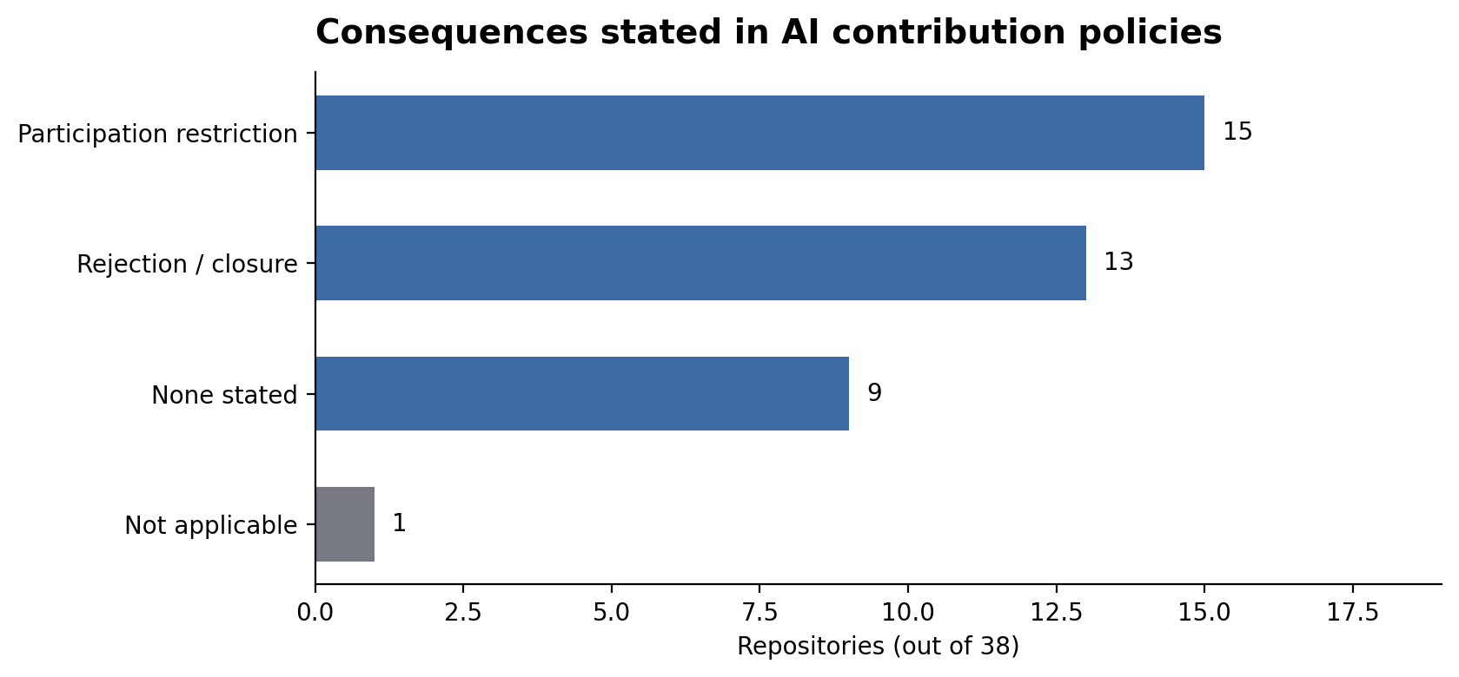

4.3. Disclosure Detector Validation
The detector was evaluated against 708 manually labelled PRs from the 38 repositories. It recorded 278 true positives, 425 true negatives, one false positive, and four false negatives. The resulting accuracy was 99.29%, precision 99.64%, recall 98.58%, specificity 99.77%, and F1-score 99.11% (Table 4.3). These figures describe agreement on the evaluated sample; some of its examples had also informed rule development, so it was not a fully independent test.
Table 4.3. Binary disclosure-presence evaluation (n = 708; not a fully held-out test)
Measure | Result
True positives (TP) | 278
True negatives (TN) | 425
False positives (FP) | 1
False negatives (FN) | 4
Accuracy | 99.29%
Precision | 99.64%
Recall | 98.58%
Specificity | 99.77%
F1-score | 99.11%

An initial 350-PR evaluation reported 82.29% accuracy. Its errors were reviewed and used to improve detection rules. The later 708-PR evaluation used a different sample, so the two percentages are not directly comparable as an experiment.
Two researchers initially reviewed the same 150 PRs independently and agreed on all disclosure-presence and subtype labels (Cohen’s κ = 1.00). The remaining expanded sample was divided between them. The agreement figure therefore applies to the initial 150 PRs only, not all 708.

4.4. Observed AI-Use Disclosure in Pull Requests (RQ2)
Of the 41,338 eligible PRs, 11,598 contained a detected AI-related disclosure (28.06%); 29,740 (71.94%) did not. Disclosure was counted when the detector recognised a statement of AI use, non-use, or an eligible ambiguous response. This figure is not the proportion of PRs actually created using AI and is not a verified policy-compliance rate.
Among the 22 repositories that explicitly required AI disclosure in PRs, 8,602 of 31,763 eligible PRs (27.08%) contained a detected disclosure. This provides a more focused observation of disclosure practices in repositories with explicit PR-level requirements. However, it does not represent a verified compliance rate, since the study did not determine whether each PR involved AI use or whether the policy required a declaration in that particular case.
Disclosure rates varied widely across the 38 repositories (Figure 4.3). The average of the 38 separate repository rates was 34.13%, with a median of 31.15% and an interquartile range of 9.17%–56.21%. For example, searxng/searxng had 288 detected disclosures in 326 PRs (88.34%), while curl/curl had 15 in 1,073 PRs (1.40%). Three repositories had no detected disclosures, but each had only one to four eligible PRs; their 0% rates should therefore be interpreted with care.
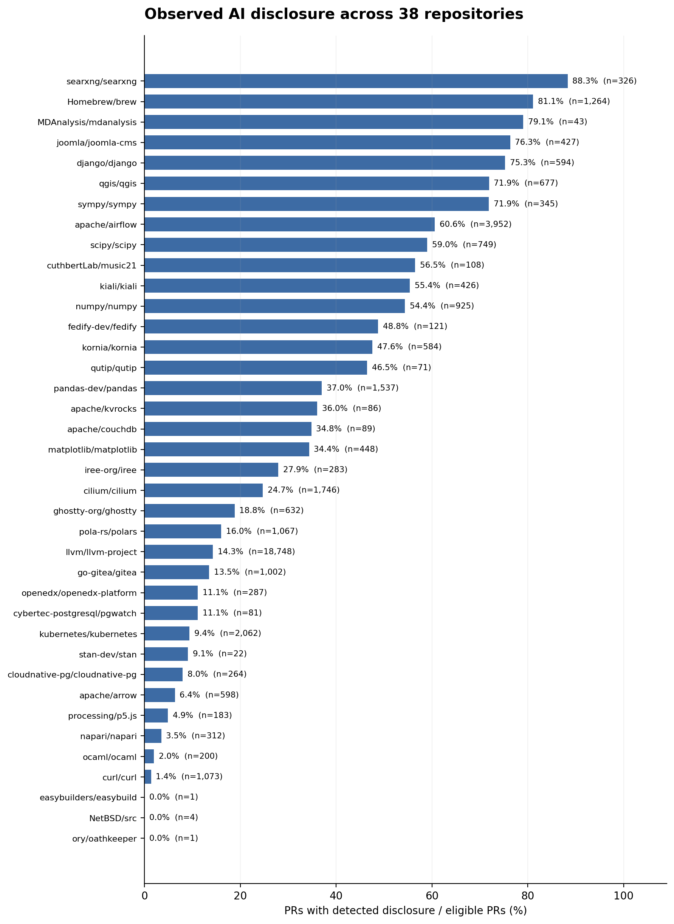
Figure 4.3. Detected disclosure rates for 38 repositories
The pooled disclosure rate (28.06%) is lower than the average repository rate (34.13%) because projects contributed different numbers of PRs. For example, llvm/llvm-project contributed 18,748 PRs (45.35% of the dataset), but its disclosure rate was 14.30% (2,681 PRs). Thus, its size strongly affects the pooled percentage. By contrast, the repository mean treats each project equally.
Among the 11,598 disclosure-present PRs, 9,166 (79.03%) were classified as positive statements of AI use, 1,785 (15.39%) as negative statements of non-use, and 647 (5.58%) as ambiguous (Table 4.4). As shares of all eligible PRs, these represent 22.17%, 4.32%, and 1.57%. These are detector-assigned declarations, not proof of actual AI use or non-use. In Homebrew, checked either/or wording is interpreted using additional tool information; in Joomla, some policy responses remain ambiguous.
Table 4.4. Detected PR disclosure classifications (n = 41,338 eligible PRs)
Classification | PR count | % of detected disclosures | % of eligible PRs
Positive disclosure | 9,166 | 79.03% | 22.17%
Negative disclosure | 1,785 | 15.39% | 4.32%
Ambiguous disclosure | 647 | 5.58% | 1.57%
All disclosure present | 11,598 | 100.00% | 28.06%
No detected disclosure | 29,740 | — | 71.94%

4.5. Policy Visibility and Observed Disclosure Rates (RQ3)
Policy visibility was rated per repository: Level 1 for external AI guidance, Level 2 for guidance in repository documentation, and Level 3 for AI guidance shown during PR submission. The sample included 9, 10, and 19 repositories at Levels 1, 2, and 3, respectively. Level 0 did not occur because all selected repositories had AI-related guidance.
Table 4.5. Disclosure rates by policy visibility
Visibility level | Repositories (n) | Mean repository rate | Median repository rate | Pooled PR rate
Level 1 — Low | 9 | 12.02% | 9.41% | 13.39%
Level 2 — Moderate | 10 | 21.53% | 11.28% | 20.13%
Level 3 — High | 19 | 51.24% | 54.38% | 51.73%

The mean repository disclosure rate rose from 12.02% at Level 1 to 21.53% at Level 2 and 51.24% at Level 3 (Table 4.5; Figure 4.4). The difference between the Level 3 and Level 1 means was 39.22 percentage points. However, the median changed only slightly from Level 1 (9.41%) to Level 2 (11.28%). By comparison, the Level 3 median (54.38%) was much higher than the Level 2 median and even exceeded Level 2's upper quartile (41.28%). This suggests a clearer upward shift in the distribution at Level 3. These are differences between groups of repositories, not measured effects of changing a policy.
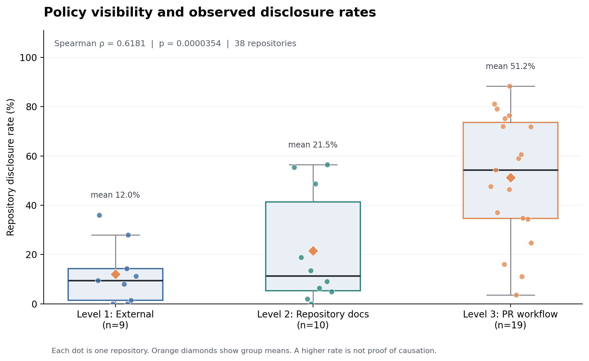
Figure 4.4. Policy visibility and repository disclosure rates.
Using the standard 1.5 × interquartile range (IQR) rule for box plots [25], apache/kvrocks was identified as an outlier in the Level 1 group. Its disclosure rate of 36.05% was above the group's upper threshold of 33.65%. No outliers were identified at Levels 2 or 3. This repository remained in the analysis because its rate was based on eligible PRs and no data error was identified.
To check whether repositories with more visible AI guidance also tended to have higher disclosure rates, we used Spearman's rank correlation, with one data point per repository. The result was ρ = 0.6181 (two-sided p = 0.00003542, n = 38). The coefficient ρ (rho) describes the direction and strength of the relationship: the positive sign means that repositories with higher visibility generally had higher disclosure rates, while its size indicates a moderately strong rank association in this sample. The p-value indicates how unusual a correlation at least this large in absolute value would be if there were no rank association, under the assumptions of the statistical test. Because it is well below 0.05, the result provides statistical evidence of an association. Here, n = 38 means that the test compared 38 repositories—not the 41,338 individual PRs.
The correlation coefficient is itself an effect size: it describes how strongly the repository rankings align. For a separate comparison of the highest and lowest visibility groups, Cliff’s delta was 0.813. Of the 171 possible pairs between Level 3 and Level 1 repositories, 155 (90.6%) had a higher rate in Level 3. This confirms that the two groups differed substantially in the observed sample, without showing why they differed.
Level 3 guidance appears within the PR submission process, often as a template question or checklist. This may make it easier for contributors to provide a declaration, but the standard wording may also make those declarations easier for the detector to find. The correlation cannot distinguish between these explanations.

4.6. Exploratory Comparisons of Other Governance Characteristics (RQ3)
After coding the governance characteristics for RQ1, we explored whether the same categories were accompanied by different disclosure rates. The comparisons covered PR disclosure requirements, PR templates, disclosure detail, responsibility, attribution, AI-use restrictions, stated consequences, and policy rationales. These were descriptive comparisons, not additional significance tests.
Repositories explicitly requiring AI disclosure in PRs (n = 22) had an average repository rate of 38.23%, compared with 28.49% among the other 16 repositories (a difference of 9.74 percentage points; Figure 4.5). When PRs were pooled within each group, however, the rates were 27.08% and 31.29%, respectively. The direction changed because repositories contributed different numbers of PRs. This comparison is descriptive, not a separate statistical test.
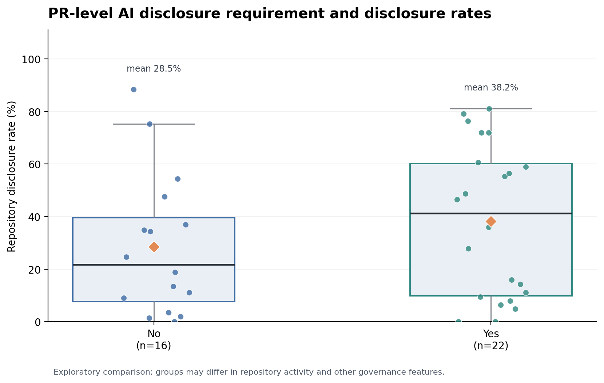
Figure 4.5. PR-level AI disclosure requirement and disclosure rate
Repositories with a PR template (n = 21) had an average disclosure rate of 48.63%, versus 16.23% without a template (n = 17), a difference of 32.40 percentage points (Figure 4.6). This does not show that templates caused higher disclosure: templates differed in their AI questions, and template presence overlapped with visibility.
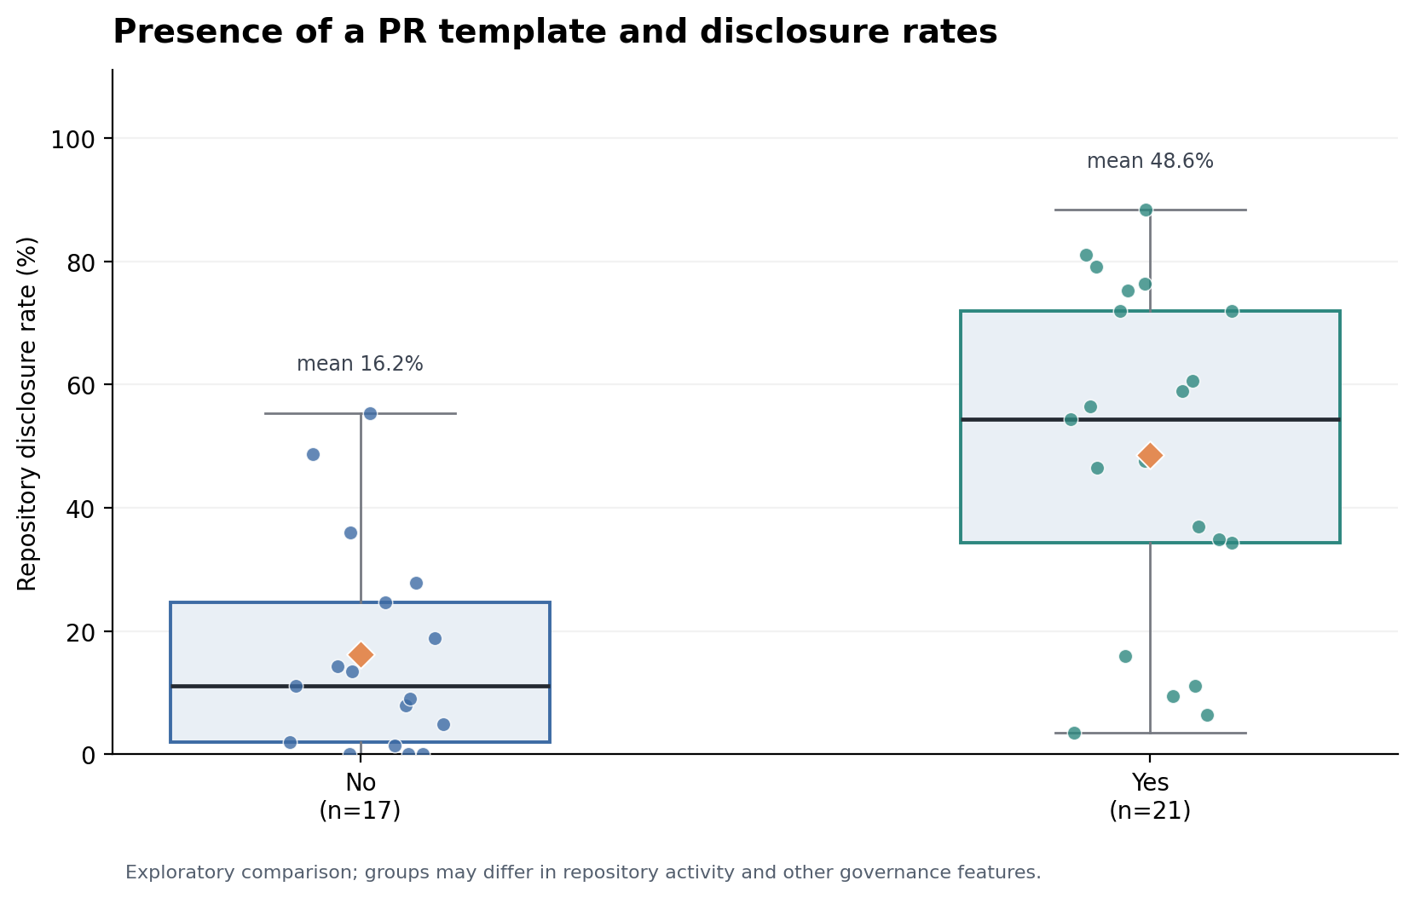
Figure 4.6. Presence of PR template and disclosure rates.
The remaining policy characteristics did not show a consistent increase in disclosure rates across their coded levels. For example, the average rates for disclosure detail were 38.60% (Level 1), 36.00% (Level 2), 27.93% (Level 3), and 61.76% (Level 4). The last group contained only three repositories. For stated consequences, the averages were 47.07% with participation restrictions, 24.14% with rejection or closure, and 29.56% with no stated consequence. These differences vary across categories rather than following a clear order.
Appendix A shows the additional governance comparisons. These plots illustrate how repository rates varied within categories and are intended as descriptive evidence only.
PR template presence was associated with a substantial difference in mean repository disclosure rates. Repositories with explicit PR disclosure requirements also showed different group averages, although the direction of that comparison reversed when PRs were pooled. The other coded characteristics showed no clear, consistent descriptive pattern. Because these features overlap and were not assessed with additional statistical tests or adjusted models, the analysis cannot conclude that they have no relationship with disclosure, or that visibility matters more than policy content.

Discussion
This chapter considers what the findings mean for OSS governance and what the data cannot establish. It draws on earlier research to discuss disclosure as a contribution practice, the role of policy visibility, and the limits of measuring declarations from PR text.

5.1. Interpretation of Findings and Comparison with Existing Research
The governance findings show that OSS projects are responding to AI-assisted development through more than permission or prohibition. Policies also address disclosure, contributor responsibility, attribution, and the review of AI-assisted work, consistent with the governance patterns identified by Yang et al. [8] and Hora et al. [9]. Reviewer workload was the most frequently stated rationale in our sample, suggesting that some policies are intended to address the practical burden of assessing AI-assisted contributions. This concern is also reflected in developer discussions examined by Baltes et al. [7]. Although many policies specified consequences such as PR rejection or participation restrictions, these provisions describe what maintainers may do rather than what they actually enforce. The findings therefore illustrate how projects define expectations for contributors, while leaving open how consistently those expectations are applied.
The disclosure findings provide a partial answer to RQ2. Among repositories explicitly requiring AI disclosure in PRs, 27.08% of eligible PRs contained a detected AI-related response. However, this percentage cannot be interpreted as a compliance rate. Some PRs may not have involved AI use or may not have been subject to a disclosure obligation, while a detected response does not necessarily satisfy every requirement of the policy. Unlike studies relying on surveys or self-admitted AI use in other software artifacts [12], [13], our analysis examined statements visible in PR records, including declarations of AI non-use and ambiguous responses. It therefore provides evidence of what contributors communicated through the contribution workflow, but not whether every contributor complied with the applicable rules.
The visibility result points to a difference between publishing a policy and presenting it when someone submits a PR. Moving from external guidance to repository documentation may make a rule easier to find, but the contributor still has to look for it. A prompt in the submission workflow makes the guidance available at the point when contributors are asked to provide information, although this study cannot establish whether individual contributors noticed or read it. This could help explain why the observed separation was clearer between Levels 2 and 3 than between Levels 1 and 2. Research on documented contribution practices and PR templates highlights the importance of that workflow context [14], [15].
At the same time, a PR prompt can affect what the detector sees. Templates often turn an open-ended answer into a predictable checkbox or sentence, which may be easier to recognise automatically. Higher detected rates could therefore reflect both what contributors choose to disclose and how projects collect those responses. Projects that use AI-related submission prompts may also differ in their contributor practices, review culture, or policy maturity. Without accounting for these differences or examining policy changes over time, the study cannot determine whether higher disclosure rates reflect policy visibility itself, easier automated detection, or other repository characteristics.
The extra comparisons with governance content were added after the policies had been coded for RQ1. They did not show a clear progression in disclosure rates for policy detail, responsibility, attribution, restrictions, or stated consequences, even though template use and PR disclosure requirements showed some differences in group averages. This does not mean those rules have no relationship with disclosure: the comparisons were exploratory, several groups were small, and the policy features often overlap. Rather, it suggests that where contributors encounter guidance deserves attention alongside what the policy requires. The contrast between pooled and repository-level percentages is another reminder that large projects and small projects contribute very differently to the dataset.

5.2. Implications for Open-Source Maintainers
For maintainers, one practical option is to make AI-related instructions visible when contributors open a PR. A short, specific prompt or link can bring the policy into the submission workflow. This is a reasonable design choice based on the observed association, but this study did not test whether adding such a prompt would increase disclosure.
Second, the wording of disclosure questions matters. A single checked statement such as 'I did not use AI, or I disclosed my use below' leaves two possible meanings. Separate choices for 'AI used', 'AI not used', and 'unable to determine or explain' would be easier for reviewers to understand. If tool names or descriptions are needed, the form should ask for them explicitly rather than interpreting a blank field as a declaration of non-use. These are design suggestions, not approaches tested for effectiveness in this study.
Third, disclosure should not replace review responsibility. AI tool names do not show whether code works, was tested, or meets licence requirements. Projects can explain both what contributors should report about AI assistance and what they remain responsible for checking. This keeps transparency and code quality as related but distinct expectations [8]–[10].

5.3. Limitations and Threats to Validity
The sample includes 38 repositories selected because they had identifiable AI-related contribution policies. It is not representative of all OSS projects and cannot show whether adopting a policy leads to more disclosure. Governance categories were coded collaboratively, but no separate independent agreement statistic was calculated for the full set of repository policies.
The data also cover a limited period. PRs were selected by their closure dates over four months in 2026, while policies were coded from accessible documents rather than reconstructed as they existed on the date of every PR. We therefore cannot say whether an individual author saw the current wording or how disclosure changed after a policy was introduced. Repositories differed greatly in PR volume; three had fewer than 20 eligible PRs, including two with only one PR. Their rates can change sharply with a single additional declaration.
A more direct limitation is that the detector measures text, not the development process. It cannot identify AI use that was not declared, verify whether a positive or negative statement is true, or decide whether every PR met its repository's rules. Conditional checkboxes and policy acknowledgements are especially difficult to classify. In some Homebrew cases, a tool name helps choose between two branches of a combined declaration, but an omitted tool name alone does not prove that no AI was used. The summary counts are complete, yet the exported PR-level labels do not provide an equally detailed subtype for every positive case, limiting direct auditing of all assignments.
The binary detector evaluation used 708 manually labelled PRs and showed high agreement with the manual labels. However, the sample was drawn across repositories rather than proportionally to their PR volumes. Therefore, the conventional 95% confidence level and ±5 percentage-point margin of error used for sample-size planning cannot be directly claimed for the overall detector accuracy. Earlier validation examples also informed rule development, limiting the independence of the evaluation. Furthermore, binary accuracy does not establish whether positive, negative, and ambiguous subtypes were always classified correctly. Cohen's κ = 1.00 applies only to the initial 150 PRs independently reviewed by both researchers. Evaluation on a fully held-out sample, with independently checked subtype labels, would provide stronger evidence of detector performance.
Finally, this is an observational study. Repository size, contributor habits, policy age, and submission formats may influence the observed rates. Visibility was tested across 38 repositories, but the exploratory comparisons of other governance characteristics were descriptive and did not control for overlapping features. The absence of a consistent pattern in those comparisons is not evidence that the characteristics have no effect. Larger and longitudinal studies would be needed to separate these factors.

6. Conclusions and Future Work
This study examined AI-related contribution governance in 38 OSS repositories and analysed observable AI-related disclosures across 41,338 eligible GitHub PRs. The findings provide evidence of how OSS projects are adapting their contribution policies, how contributors respond through observable declarations, and how these disclosures relate to governance characteristics.
For RQ1, the results show that OSS projects have adopted different approaches to governing AI-assisted contributions. These include disclosure requirements, contributor responsibilities, AI-use restrictions, and stated consequences. Reviewer workload was the most frequently documented policy rationale, highlighting the practical concerns that maintainers face when reviewing AI-assisted contributions. However, the study examined written policies rather than how consistently these rules were enforced.
For RQ2, AI-related disclosures were detected in 11,598 of 41,338 eligible PRs (28.06%). Among the 22 repositories explicitly requiring AI disclosure in PRs, 8,602 of 31,763 eligible PRs (27.08%) contained a detected response. These findings describe observable disclosure practices, not verified compliance. The study could not determine whether every PR involved AI use, whether a disclosure requirement applied to each contribution, or whether the information provided fully satisfied the relevant policy.
For RQ3, repositories with more visible AI-related guidance generally had higher observed disclosure rates, with a positive association between visibility and repository disclosure rates (Spearman's ρ = 0.6181, n = 38). The exploratory comparisons of other governance characteristics did not reveal consistent patterns across their categories. However, these findings do not establish that visibility causes contributors to disclose more frequently or that policy content is less important. AI-related submission prompts may influence contributor responses while also making them easier for automated detection tools to recognise.
Overall, the study highlights the importance of considering both what AI contribution policies require and how those requirements are presented to contributors. Future research could examine policy changes over time, evaluate disclosure detection on fully independent samples, and investigate whether individual PRs satisfy the specific requirements applicable to them. These steps would help distinguish observable declarations from actual policy compliance and provide stronger evidence about the effectiveness of AI disclosure governance in OSS.

References
[1] G. Gousios, M. Pinzger, and A. van Deursen, “An exploratory study of the pull-based software development model,” in Proc. 36th Int. Conf. Software Engineering (ICSE), 2014, pp. 345–355, doi: 10.1145/2568225.2568260.
[2] A. Bacchelli and C. Bird, “Expectations, outcomes, and challenges of modern code review,” in Proc. 35th Int. Conf. Software Engineering (ICSE), 2013, pp. 712–721, doi: 10.1109/ICSE.2013.6606617.
[3] M. Chen et al., “Evaluating large language models trained on code,” arXiv preprint arXiv:2107.03374, 2021. [Online]. Available: https://arxiv.org/abs/2107.03374
[4] S. Barke, M. B. James, and N. Polikarpova, “Grounded Copilot: How programmers interact with code-generating models,” Proceedings of the ACM on Programming Languages, vol. 7, no. OOPSLA1, Art. no. 78, 2023, doi: 10.1145/3586030.
[5] H. Pearce, B. Ahmad, B. Tan, B. Dolan-Gavitt, and R. Karri, “Asleep at the keyboard? Assessing the security of GitHub Copilot’s code contributions,” in Proc. IEEE Symposium on Security and Privacy (SP), 2022, pp. 754–768, doi: 10.1109/SP46214.2022.9833571.
[6] H. He, C. Miller, S. Agarwal, C. Kästner, and B. Vasilescu, “Speed at the cost of quality: How Cursor AI increases short-term velocity and long-term complexity in open-source projects,” in Proc. 23rd Int. Conf. Mining Software Repositories (MSR), 2026, pp. 181–193, doi: 10.1145/3793302.3793349
[7] S. Baltes, M. Cheong, and C. Treude, “‘An Endless Stream of AI Slop’: How Developers Discuss the Burden of AI-Assisted Software Development,” arXiv preprint arXiv:2603.27249, 2026. [Online]. Available: https://arxiv.org/abs/2603.27249
[8] W. Yang, R. He, and M. Zhou, “Beyond banning AI: A first look at GenAI governance in open source software communities,” arXiv preprint arXiv:2603.26487, 2026. [Online]. Available: https://arxiv.org/abs/2603.26487
[9] A. Hora, R. Robbes, and S. Zacchiroli, “‘We Permit the Use of AI, but [...]’: The Landscape of AI Policies in Popular Open Source Projects,” arXiv preprint arXiv:2609.07542, 2026. [Online]. Available: https://arxiv.org/abs/2609.07542
[10] Y. Chen, T. Zimmermann, and B. Trinkenreich, “Making AI visible, not vanished: How AI policies reshape developer experience on GitHub,” arXiv preprint arXiv:2608.03329, 2026. [Online]. Available: https://arxiv.org/abs/2608.03329
[11] S. Baltes and P. Ralph, “Sampling in software engineering research: A critical review and guidelines,” Empirical Software Engineering, vol. 27, no. 4, Art. no. 94, 2022, doi: 10.1007/s10664-021-10072-8.
[12] S. M. Kashif, P. Liang, and A. Tahir, “On developers’ self-declaration of AI-generated code: An analysis of practices,” ACM Transactions on Software Engineering and Methodology, vol. 35, no. 7, Art. no. 200, pp. 1–37, 2026, doi: 10.1145/3771937.
[13] T. Xiao, Y. Fan, F. Calefato, C. Treude, R. G. Kula, H. Hata, and S. Baltes, “Self-admitted GenAI usage in open-source software,” IEEE Transactions on Software Engineering, vol. 52, no. 6, pp. 1891–1910, 2026, doi: 10.1109/TSE.2026.3681886.
[14] O. Elazhary, M.-A. Storey, N. Ernst, and A. Zaidman, “Do as I do, not as I say: Do contribution guidelines match the GitHub contribution process?” in Proc. IEEE Int. Conf. Software Maintenance and Evolution (ICSME), 2019, pp. 286–290, doi: 10.1109/ICSME.2019.00043.
[15] M. Zhang, H. Liu, C. Chen, Y. Liu, and S. Bai, “Consistent or not? An investigation of using Pull Request Template in GitHub,” Information and Software Technology, vol. 144, Art. no. 106797, 2022, doi: 10.1016/j.infsof.2021.106797.
[16] GitHub, “Creating a pull request template for your repository,” GitHub Docs. [Online]. Available: https://docs.github.com/en/communities/using-templates-to-encourage-useful-issues-and-pull-requests/creating-a-pull-request-template-for-your-repository. [Accessed: Oct. 15, 2026].
[17] GitHub, “Setting guidelines for repository contributors,” GitHub Docs. [Online]. Available: https://docs.github.com/en/communities/setting-up-your-project-for-healthy-contributions/setting-guidelines-for-repository-contributors. [Accessed: Oct. 15, 2026].
[18] W. Yang, R. He, and M. Zhou, “A first look at coding agents’ compliance with AI contribution rules in open-source communities,” arXiv preprint arXiv:2607.26819, 2026. [Online]. Available: https://arxiv.org/abs/2607.26819
[19] M. W. Mendonça, “open-source-ai-contribution-policies,” GitHub repository. [Online]. Available: https://github.com/melissawm/open-source-ai-contribution-policies. [Accessed: Oct. 18, 2026].
[20] GitHub, “REST API endpoints for pull requests,” GitHub Docs. [Online]. Available: https://docs.github.com/en/rest/pulls/pulls. [Accessed: Oct. 18, 2026].
[21] J. Cohen, “A coefficient of agreement for nominal scales,” Educational and Psychological Measurement, vol. 20, no. 1, pp. 37–46, 1960, doi: 10.1177/001316446002000104.
[22] W. G. Cochran, Sampling Techniques, 3rd ed. New York, NY, USA: John Wiley & Sons, 1977.
[23] C. Spearman, “The proof and measurement of association between two things,” The American Journal of Psychology, vol. 15, no. 1, pp. 72–101, 1904, doi: 10.2307/1412159.
[24] N. Cliff, “Dominance statistics: Ordinal analyses to answer ordinal questions,” Psychological Bulletin, vol. 114, no. 3, pp. 494–509, 1993, doi: 10.1037/0033-2909.114.3.494.
[25] NIST/SEMATECH, “1.3.3.7. Box Plot,” e-Handbook of Statistical Methods, National Institute of Standards and Technology. [Online]. Available: https://www.itl.nist.gov/div898/handbook/eda/section3/boxplot.htm. [Accessed: Oct. 17, 2026].

Appendix A Supplementary Governance Figures
The following plots show descriptive comparisons between governance categories and repository disclosure rates. Every point represents a repository from the same 38-project sample. No separate significance tests were performed for these comparisons.
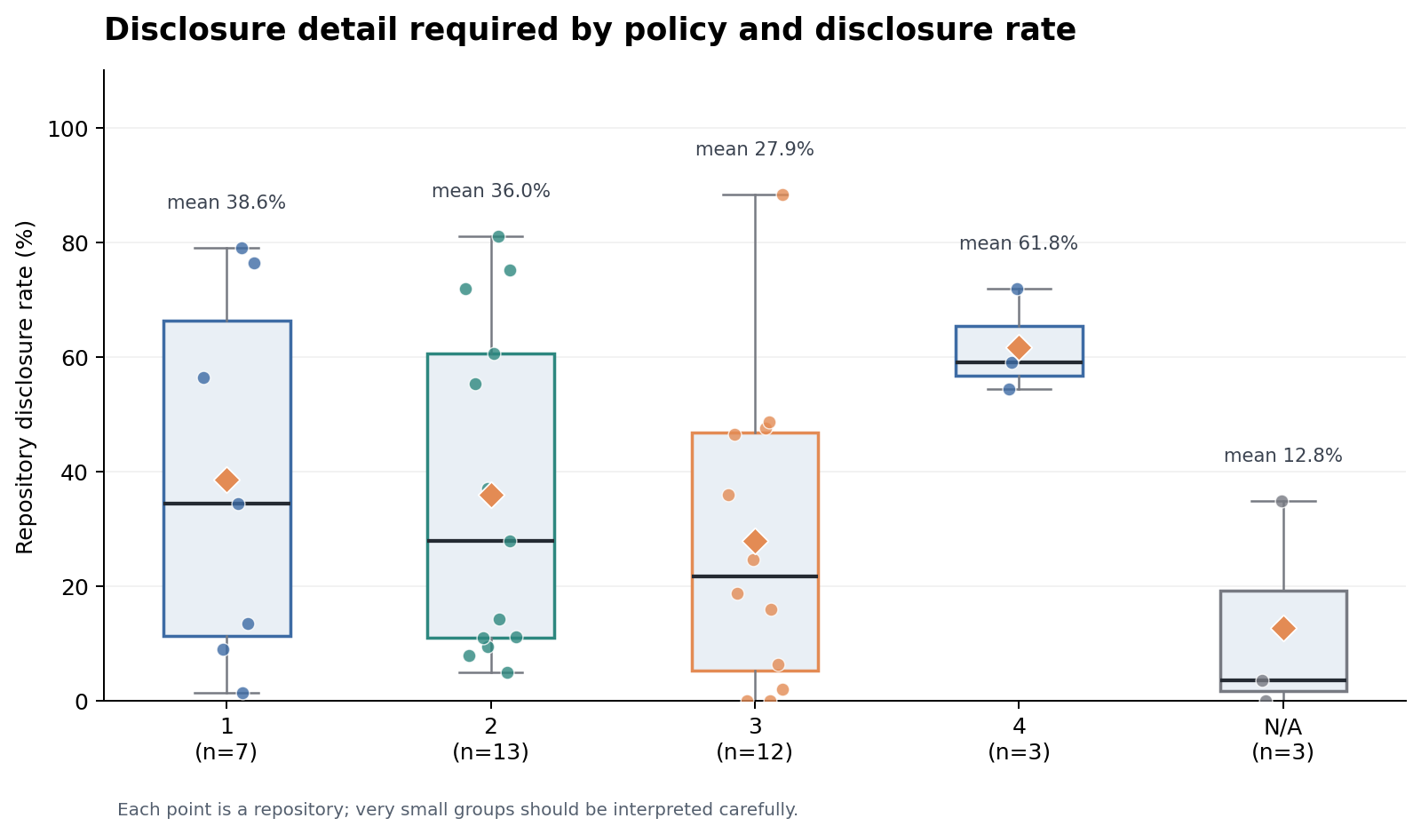
Figure A.1. Disclosure detail required by policy and observed repository disclosure rates.
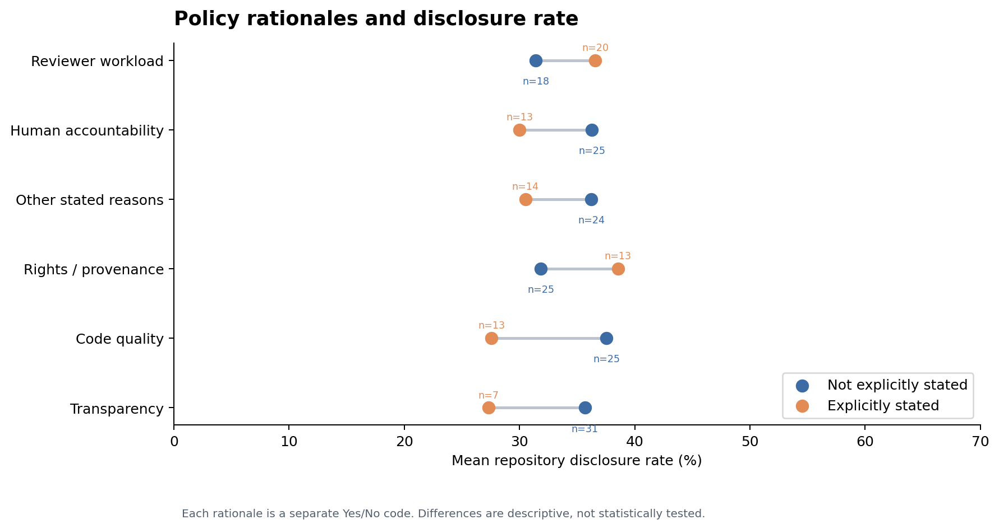
Figure A.2. Stated policy rationales and observed repository disclosure rates.

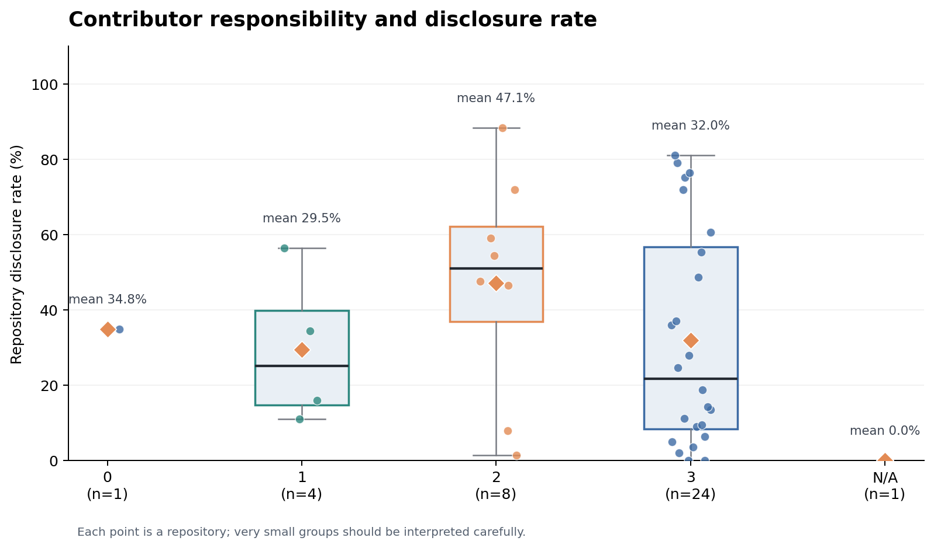
Figure A.3. Contributor responsibility and observed repository disclosure rates.
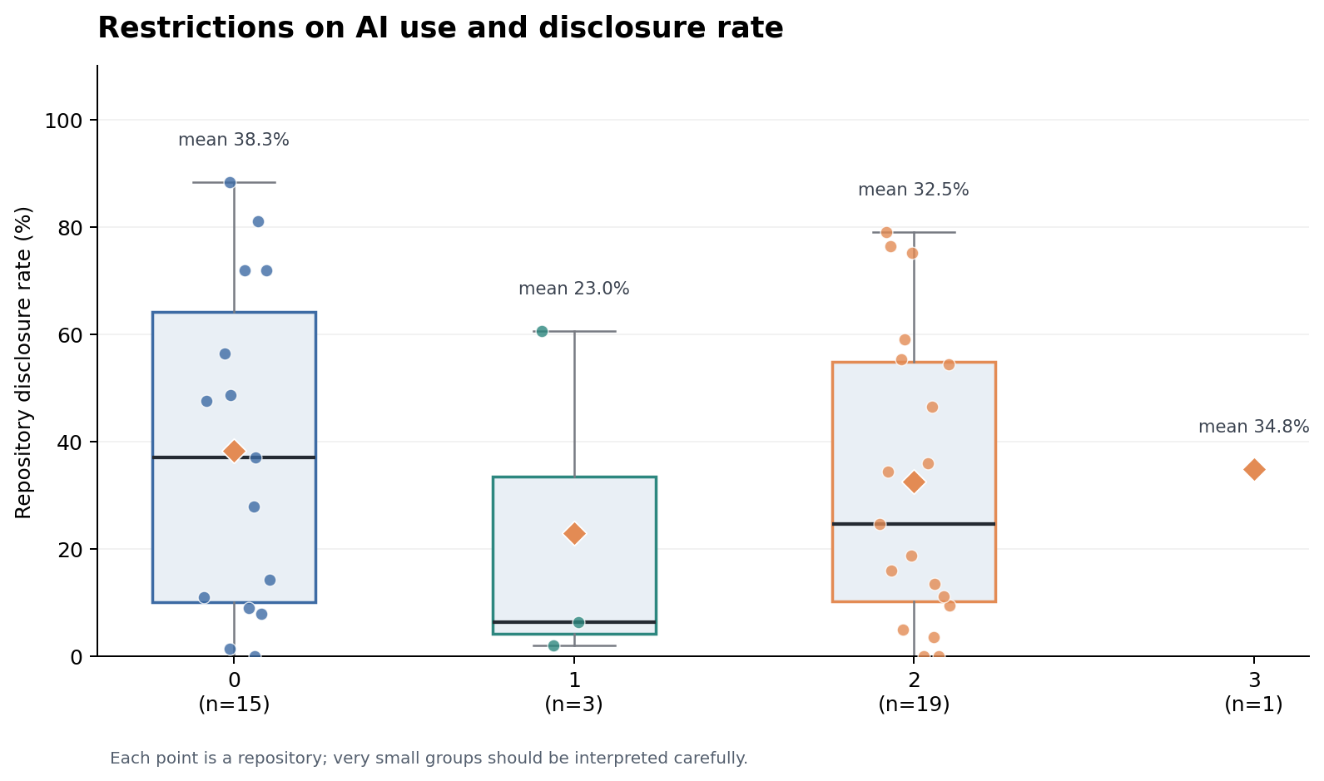
Figure A.4. AI-use restrictions and observed repository disclosure rates.

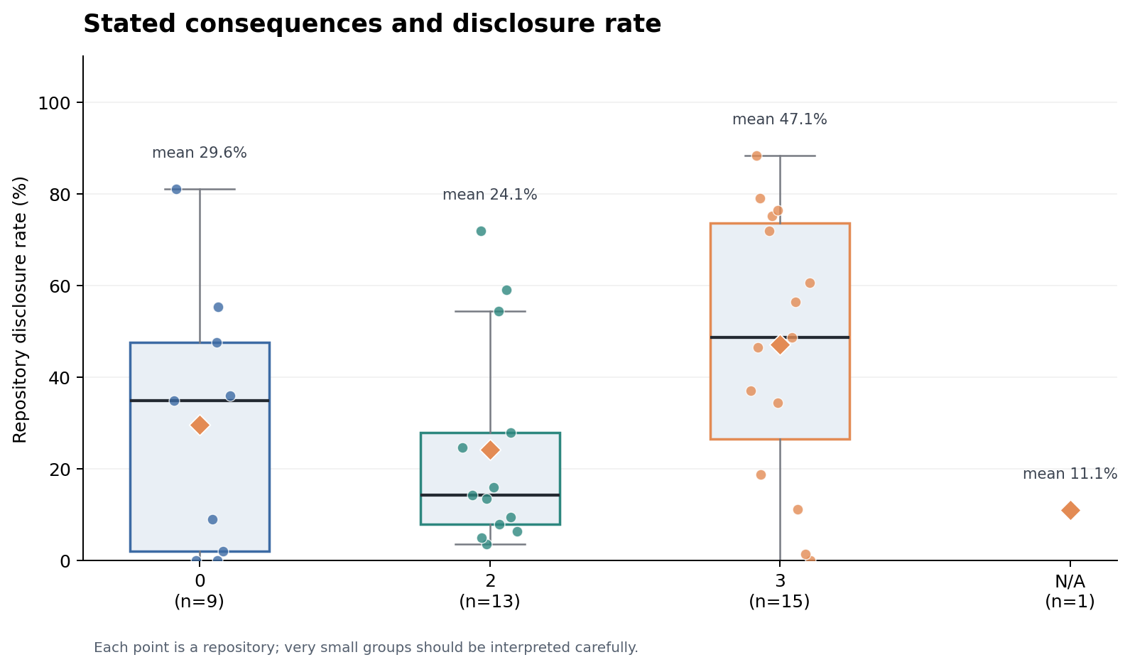
Figure A.5. Stated consequences and observed repository disclosure rates.
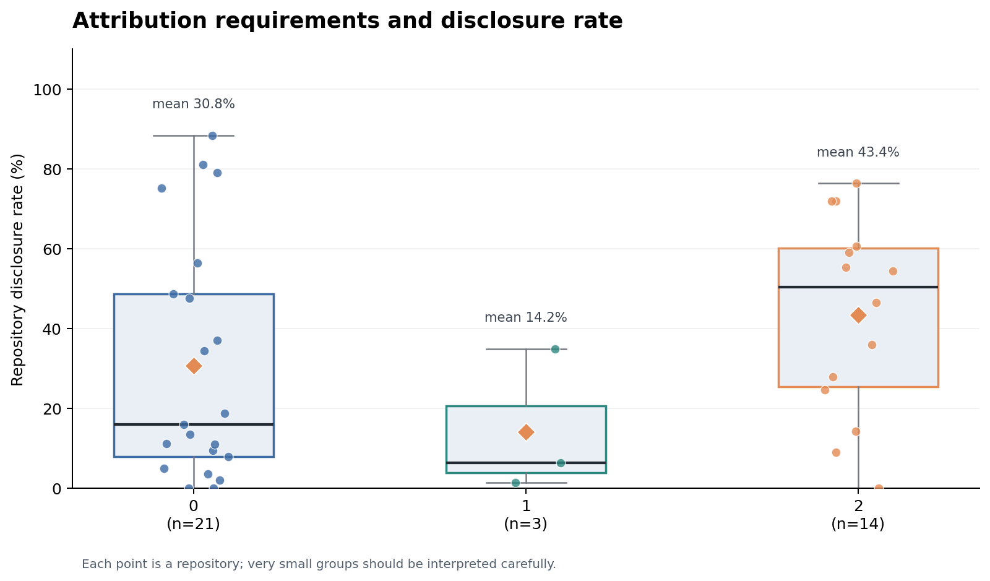
Figure A.6. Attribution requirements and observed repository disclosure rates.

