Academic Supervisor

**Mr. MOHAMADOU Alhadji** Lecture at AICS-Cameroon

Academic Year 2023 - 2024

PERSONAL REPORT

REPUBLIC OF CAMEROON

Peace-Work-Fatherland

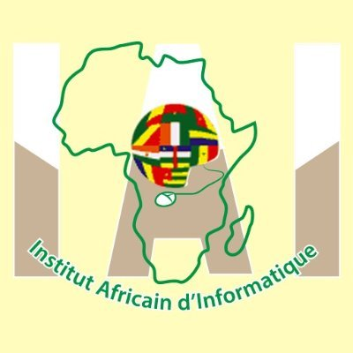

AFRICAN INSTITUTE OF COMPUTER

SCIENCE-CAMEROON OFFICE

PAUL BIYA TECHNOLOGICAL CENTER OF EXCELLENCE

P.O.Box: 13719 Yaoundé

Tel: +237.242.729.957 Fax: 22729958

E-mail:contact@iaicameroun.com

DEVELOPMENT OF AN ON-LINE JOB BOARD PLATFORM

Written by:

**MINSILI MINETTE DIANE**

Level III Software Engineering student