**Test Star Data**

Test DIM_EMPLOYEES_SCD

Data in the table DIM_EMPLOYEES_SCD before changing source data

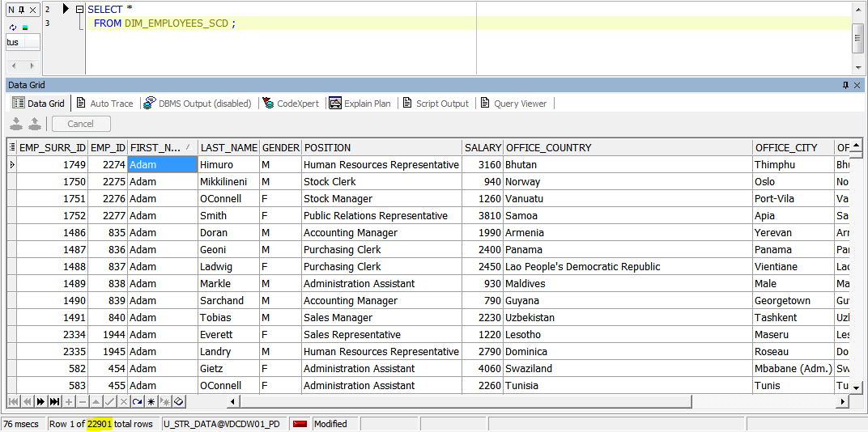

Change source data

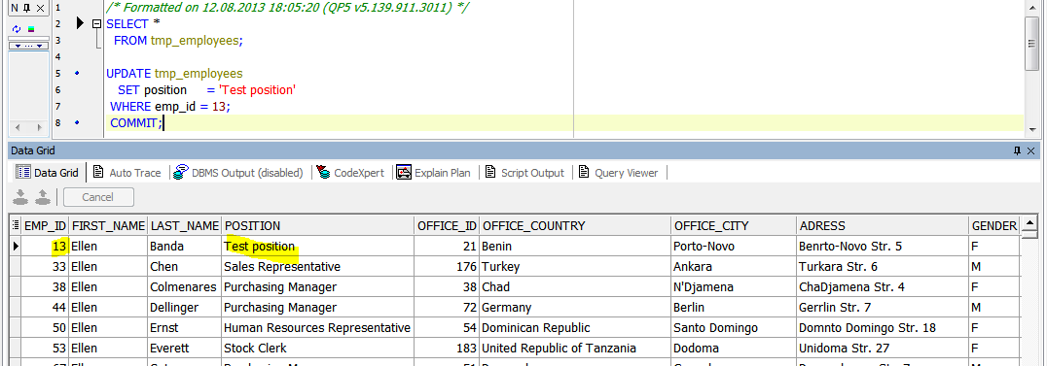

Run all packages to refresh data in DIM_EMPLOYEES_SCD.

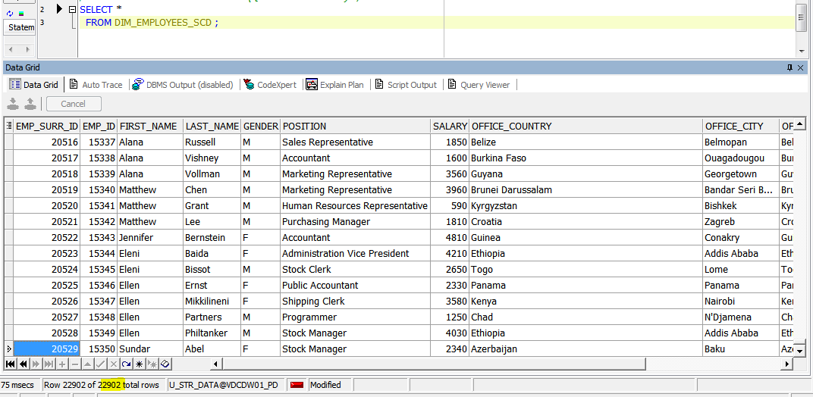

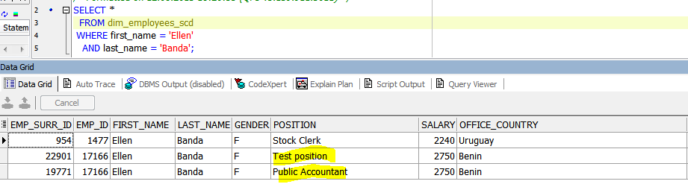

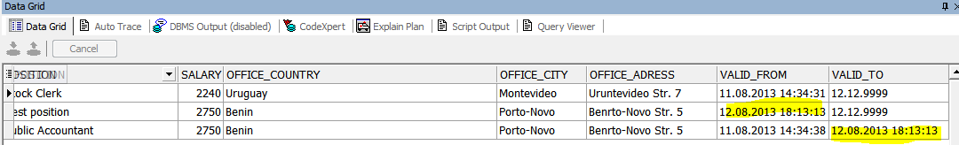

After refreshing data in the table DIM_EMPLOYEES_SCD there is a new record with new information about employee.

Test DIM_GEO_LOCATIONS_SCD

Data in the table DIM DIM_GEO_LOCATIONS_SCD before changing source data

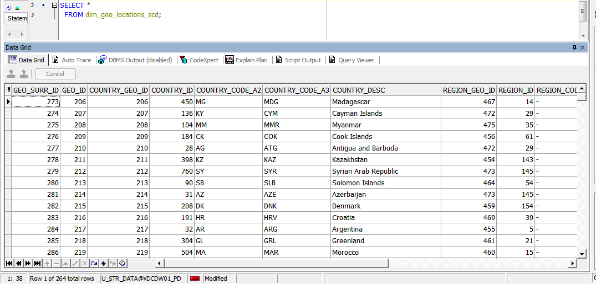

Change table T_GEO_OBJECTS_LINKS

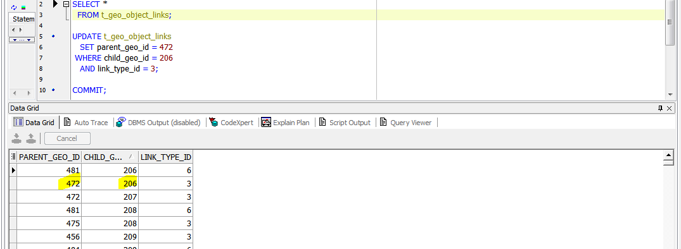

Run all packages to refresh data in star scheme.

Table DIM_GEO_LOCATIONS_SCD after refreshing data.

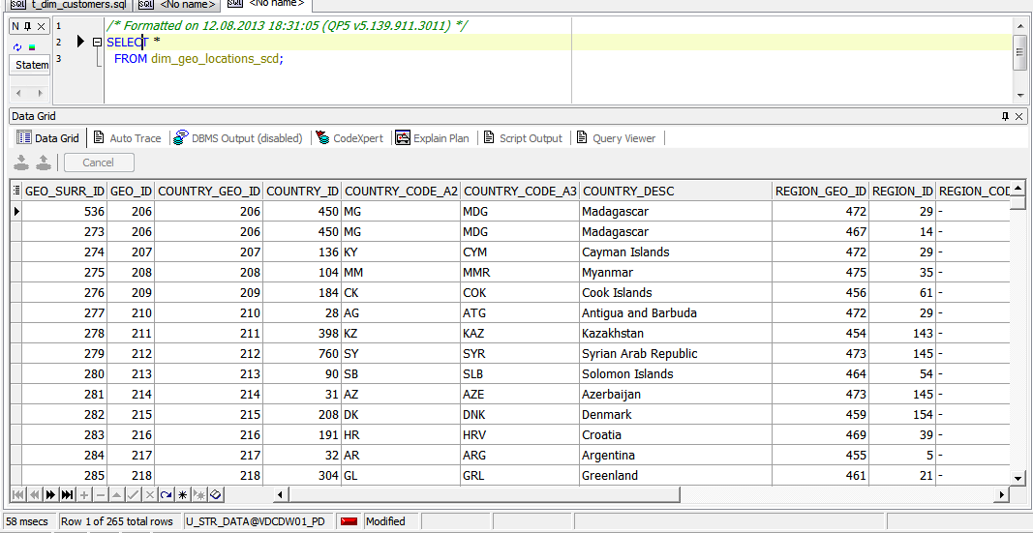





There is a new record in the table.

Test common dimensions

Table DIM_CARS

Data before changing source data

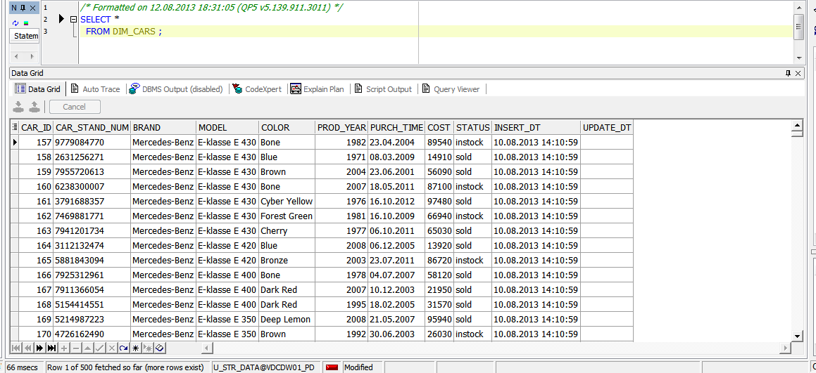

Change some date in the source table

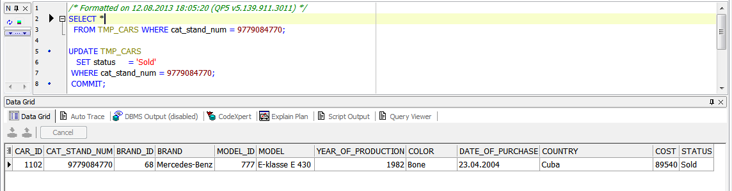

After running packages

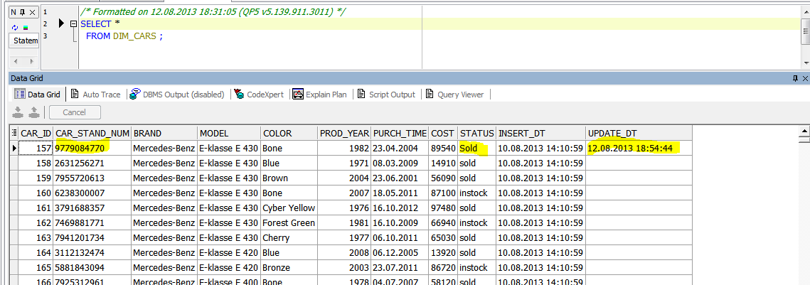

Table DIM_CUSTOMERS

After changing source data 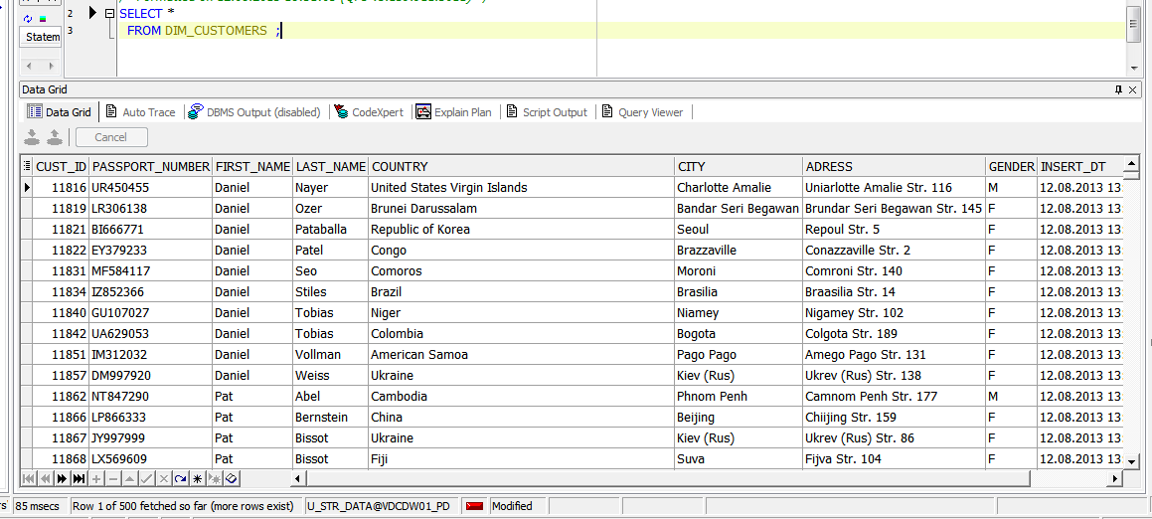

Change some source data

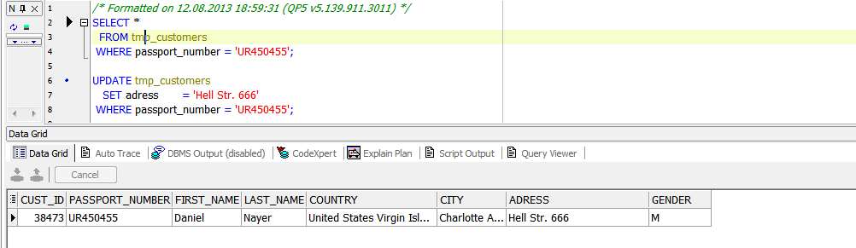

Run packages and check updating information in the star scheme

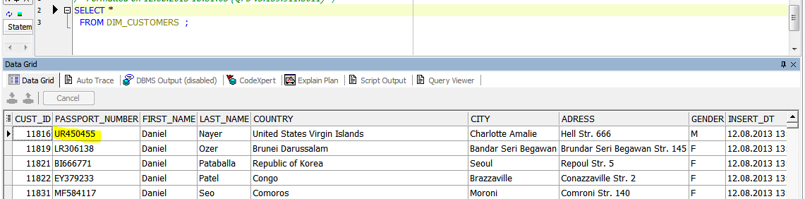

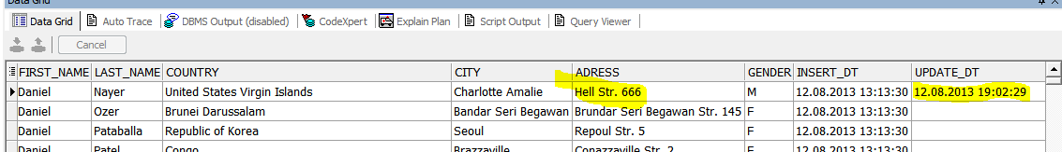

**Performance comparison**

|  |  |  |  |
| --- | --- | --- | --- |
| № | Source Type | Explain Plan - Statistics | Time, Sec. |
| 1 | Advancing Grouping |  | 0.38 |
| 2 | Model Clause |  | 1 |
| 3 | Star Schema |  | 0.29 |