Monthly Report (Group by)

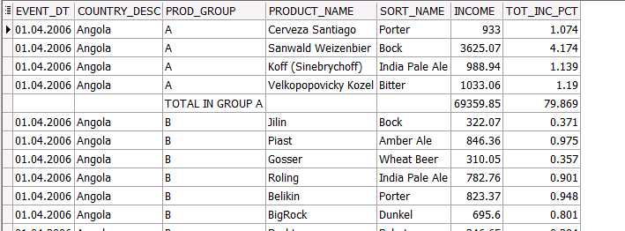

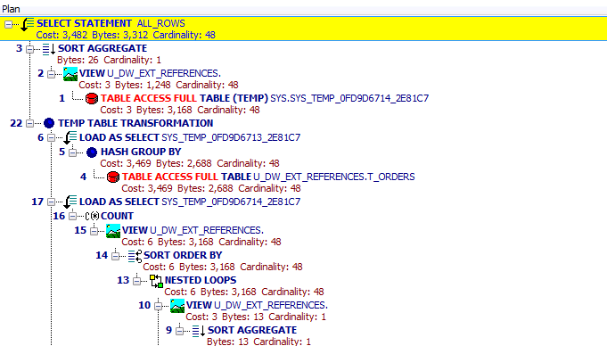

|  |
| --- |
| Execution Time - 18secs |

Monthly Report (Star)

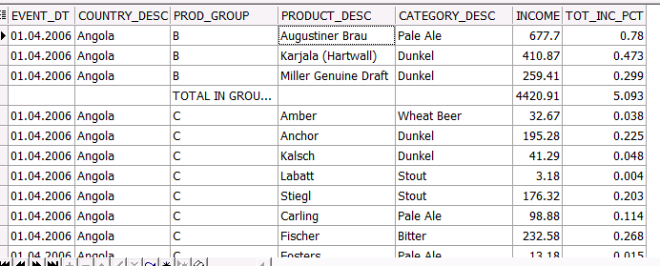

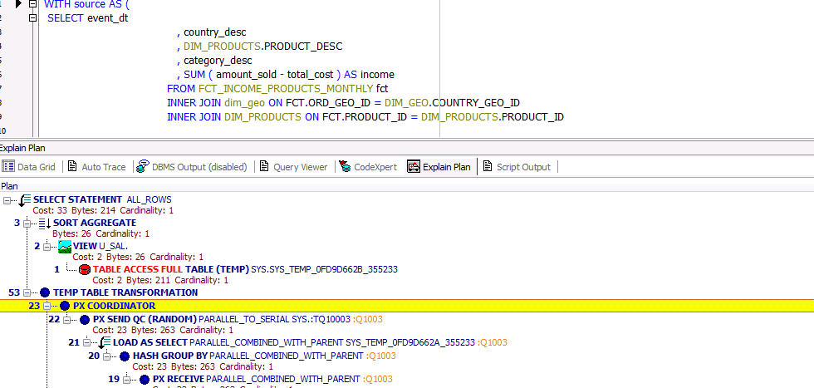

|  |
| --- |
| Execution Time - 1sec |

|  |  |  |
| --- | --- | --- |
| Query | Cost | Execution Time |
| Group By | 3482 | 18 |
| Star(with group by) | 33 | 1 |

P.S. Query using model clause returning dataset like previous two queries was absolutely inefficient because of the report logic. So Query using model clause doesn’t give correlate comparison in this case. Queries with model clauses can give advantage while making complex calculations. They will be more productive than queries with group by