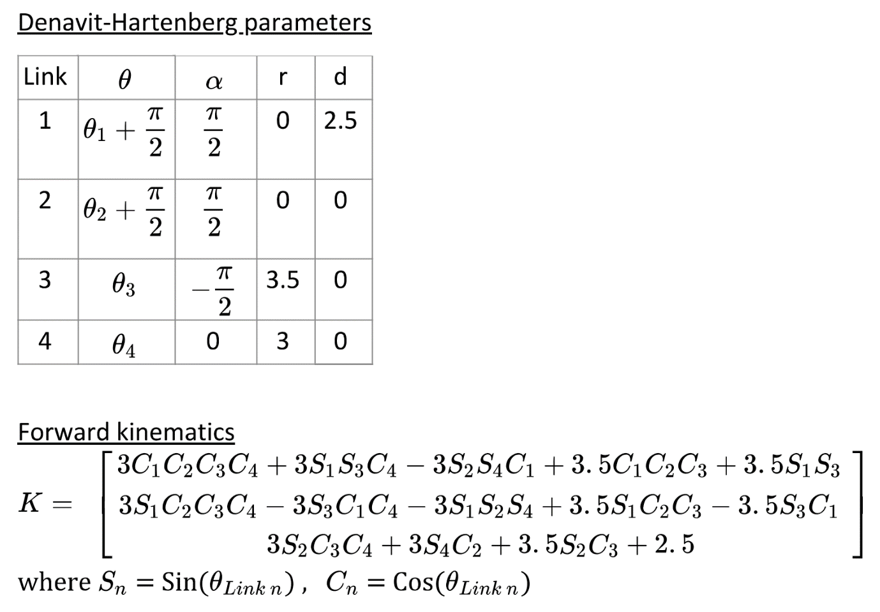

Estimated end-effector position

|  |  |  |  |
| --- | --- | --- | --- |
| Point ($θ_{1}, θ_{2}, θ_{3}, θ_{4}$) | Via the image  (x, y, z) m | Via FK  (x, y, z) m | Error |
| 0.65, 0.57, 0.47, 0.3 | 4.981, -1.685, 7.068(m) | 4.6, -1.288, 6.8(m) | 0.38, 0.4, 0.27(m) |
| 0.06, 0.74, 0.12, 0.24 | 1.786, -5.061, 6.661 | 1.056, -4.766, 6.722 | 0.73, 0.29, 0.06 |
| 0.64, 0.99, 0.58, 0.86 | 6.355, -3.234, 1.918 | 5.423, -2.276, 3.104 | 0.93, 0.96, 1.19 |
| 0.74, 0.99, 0.35, 0.61 | 6.489, -4.008, 3.512 | 5.3, -2.774, 4.135 | 1.19, 1.23, 0.62 |
| 0.45, 0.02, 0.3, 0.11 | 1.997, 0.464, 8.629 | 1.922, 0.425, 8.685 | 0.08, 0.04, 0.06 |
| 0.35, 0.08, 0.25, 0.53 | 2.389, -1.498, 8.165 | 2.095, -1.346, 8.259 | 0.28, 0.15, 0.09 |
| 0.33, 0.31, 0.54, 0.7 | 4.517, -2.746, 6.649 | 3.906, -2.21, 6.644 | 0.61, 0.54, 0 |
| 0.52, 0.07, 0.67, 0.89 | 4.314, -0.784, 6.489 | 4.206, -0.612, 6.55 | 0.11, 0.17, 0.06 |
| 0.79, 0.57, 0.82, 0.94 | 5.443, -0.036, 3.352 | 5.539, -0.064, 4.219 | 0.1, 0.03, 0.87 |
| 0.59, 0.59, 0.65, 0.53 | 5.070, -1.630, 5.897 | 5.263, -1.238, 5.684 | 0.19, 0.39, 0.21 |

