Block diagram:

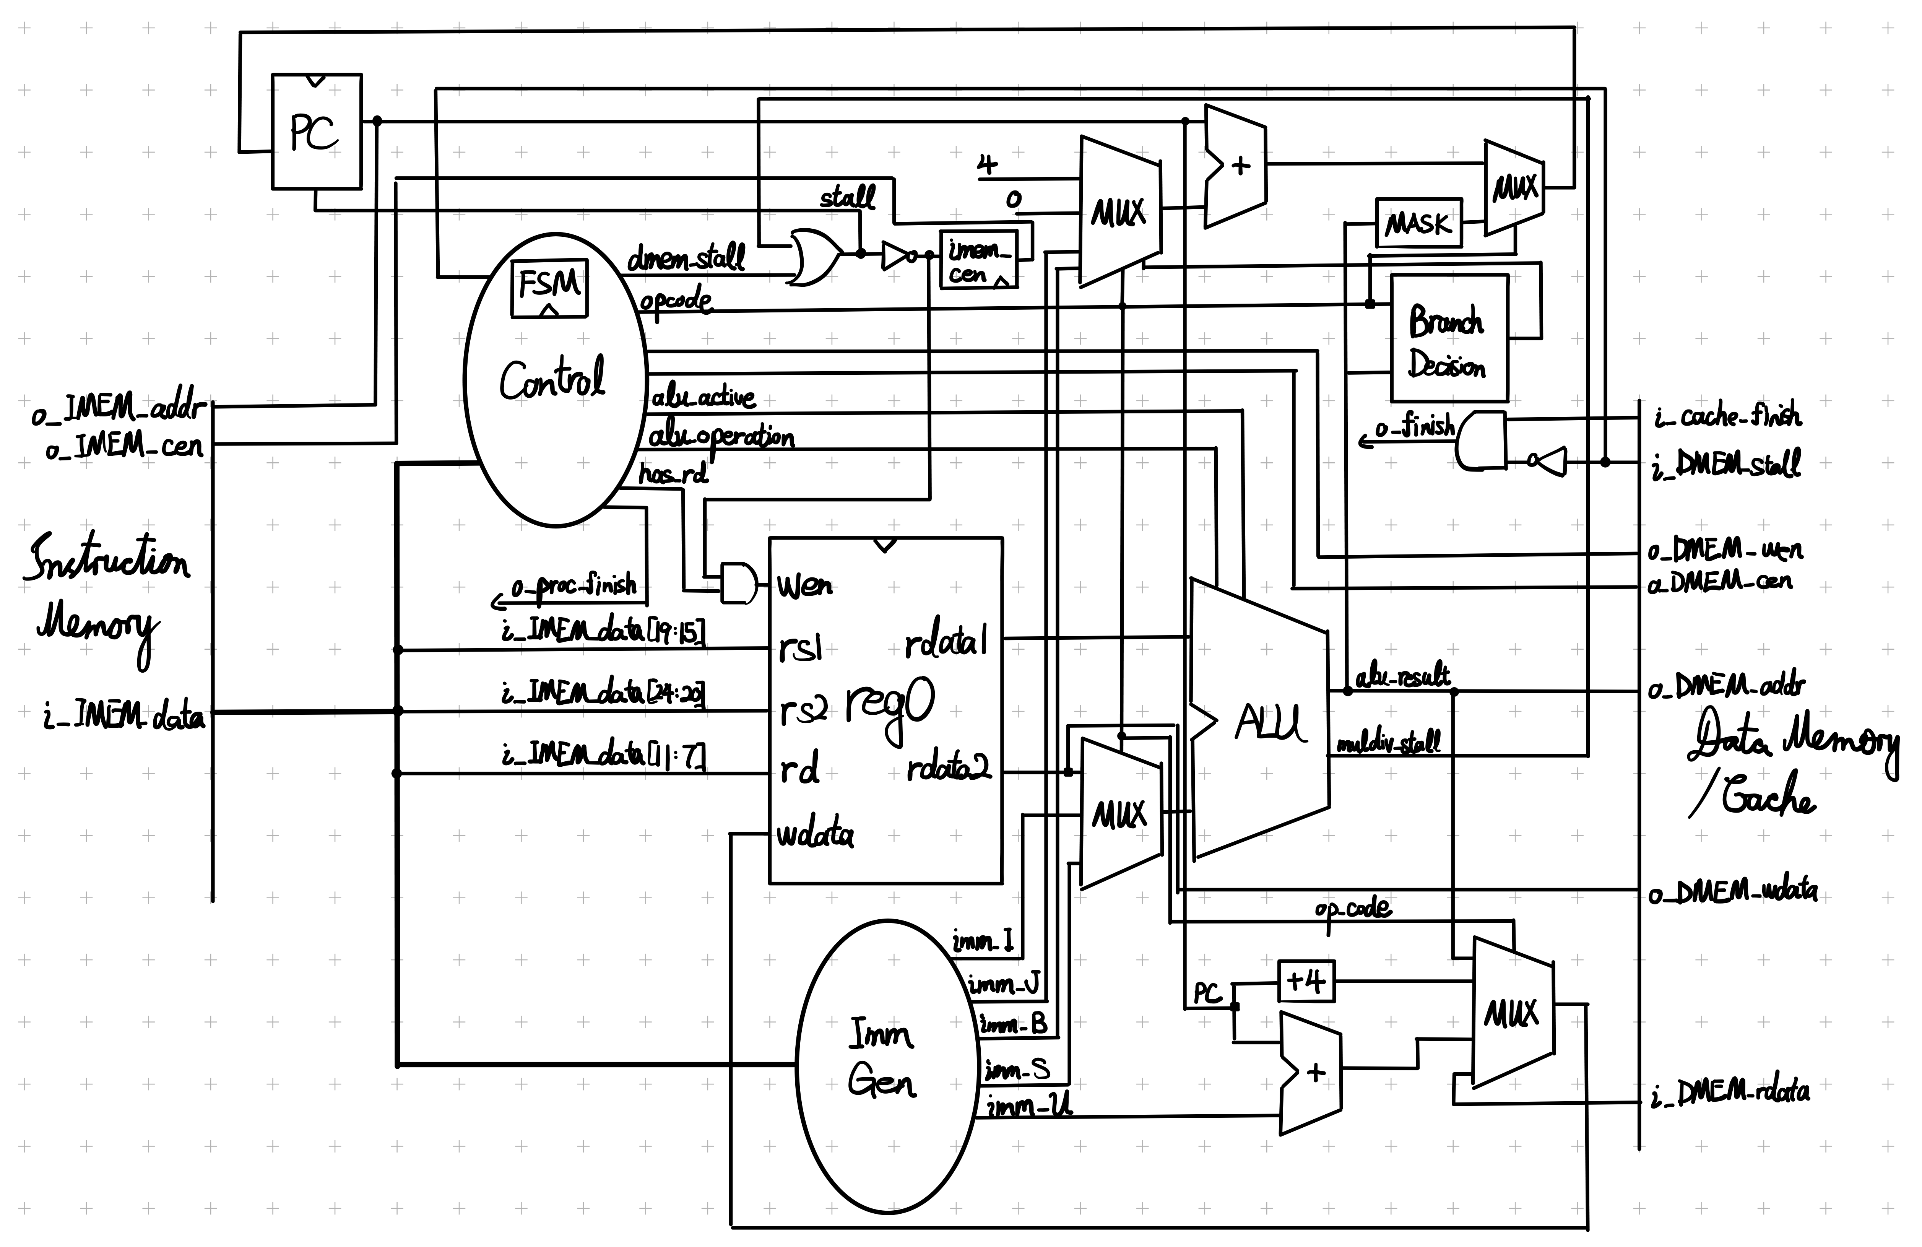

FSM: arrow format:

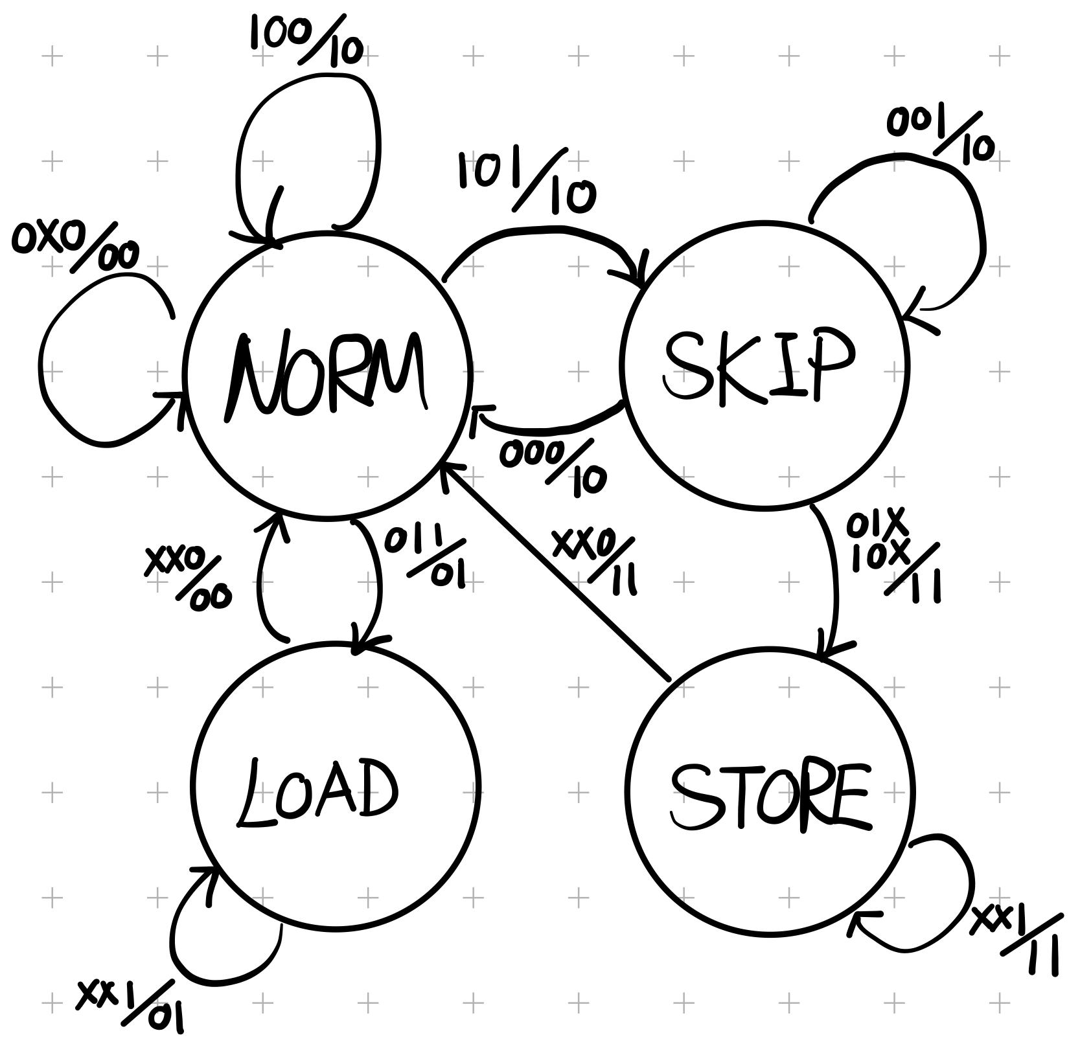

For JAL, write PC+4 to R[rd], and PC increment by imm_J.

For JALR, write PC+4 to R[rd] while ALU sums R[rs1] and imm_I. Then the result has its LSB masked and stored to PC.

For AUIPC, write PC+imm_U to R[rd].

For ECALL, set o_proc_finish, stop PC incrementation, and set o_finish to !i_DMEM_stall && i_cache_finish.

For multicycle instruction, we stall PC, register file and instruction memory if needed, until the stalling signal turns low.

Since no write-back is needed when storing data to memory, we may skip waiting for !i_DMEM_stall until memory access is needed for the current instruction. This is implemented by the above Mealy machine.

It is observed that the data memory requires the input write enable signal to be kept high in order to produce an accurate stall signal, so o_DMEM_wen is also produced by the FSM.