

CY2002
Digital Forensics

AI CHAT BOT FOR WINDOWS LOG ANALYSIS

Submitted by:
Jibran Hanan i221732
Fateh Kirmani i221590
Kumail Haider i221723
Ibrahim Jamil i221633
Class: CY-D
Date: 16/11/2024
Table of Contents
Introduction 3
Setup 3
Creating Virtual Environment 4
Code 4
tune_script.py 5
Code Overview 5
Purpose 5
ui_py 5
Code Overview 5
Purpose 7
train_data.json & val_data.json 7
Structure and Content Overview 7
Example of Data Entries 7
Sample Entry 8
Purpose of Data 8
How to Run 8
Context Parsing 9
Front End 10
Query Handling 10
Limitation 11
Conclusion 11

Introduction
This Project features an AI Chat Bot for Windows Event Analysis. We used a pre-trained LLM, deepset/roberta-base-squad2 for this assignment. The was trained to take windows log and take its context to answer forensics-based questions.

Setup
deepset/roberta-base-squad2 resource link: https://huggingface.co/docs/transformers/en/model_doc/roberta
To install all the dependences, we used python version 3.10.0. All the dependences were listed in the requirement.txt.
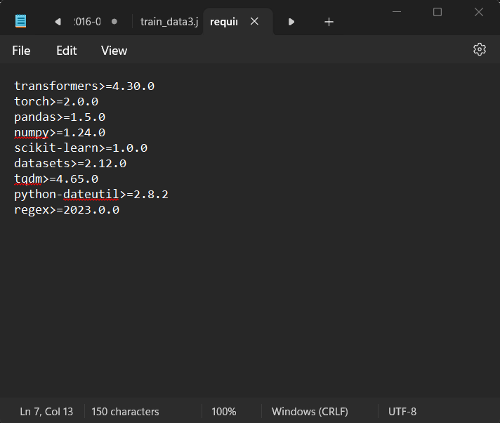
Figure 1(Requirments)
The above figure shows all the dependencies to setup the LLM.

Creating Virtual Environment
Open command prompt as Administrator and change directory to make env folder.
Run the following command to start the virtual environment: python -m venv env
Use the command activate to start the virtual environment.

This will create a folder as shown in the figure below.

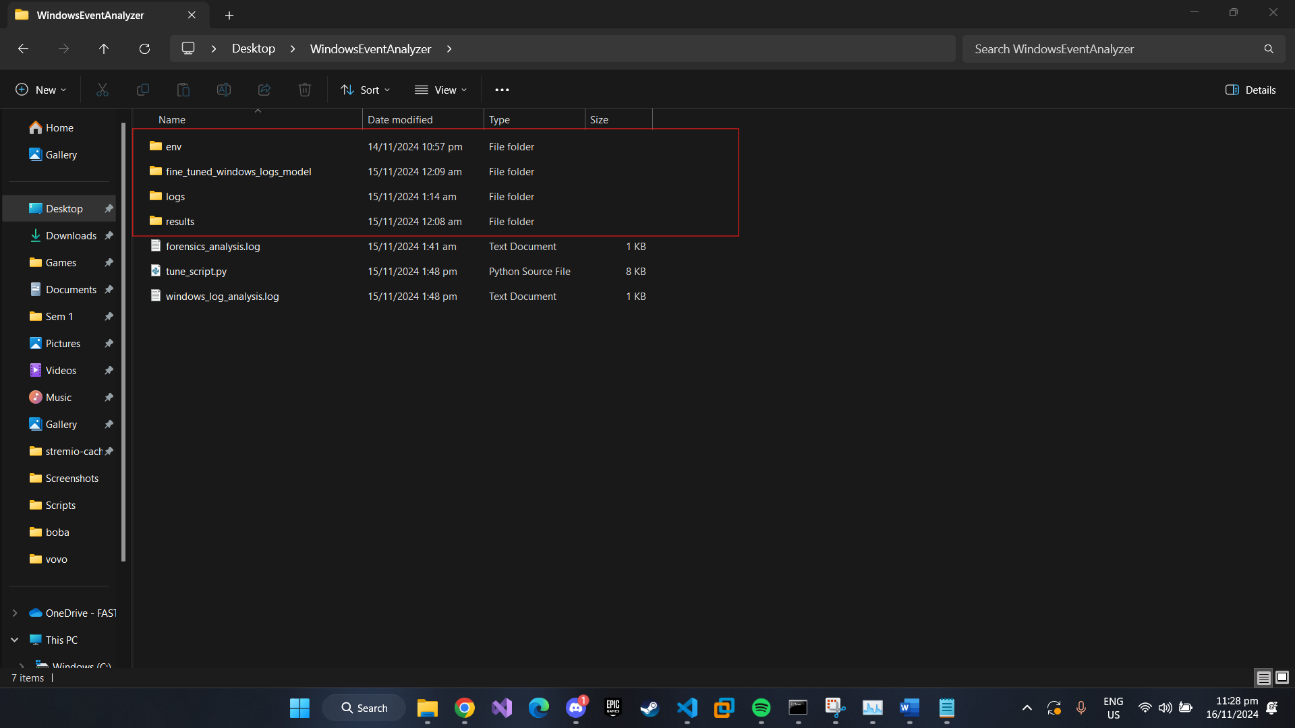
Figure 2
Inside the env folder this is a script folder where we will add our code to train the pre-trained model.

Code
We need to make 4 files:
- tune_script.py – To tune our model
- ui.py – To run the interface for the model
- train_data.json – To train the data
- val_data.json – To validate the trained model

tune_script.py

Code Overview
- Library Imports: The script begins by importing essential components from the transformers library, including AutoModelForQuestionAnswering, Trainer, TrainingArguments, and AutoTokenizer. Additionally, load_dataset from the dataset’s library is used for loading training and validation data.

- Model and Tokenizer Initialization: The model deepset/roberta-base-squad2, which is designed for QA tasks, is loaded using the from_pretrained() method. The corresponding tokenizer is initialized similarly to handle text tokenization and preprocessing.

- Loading the Dataset: The script loads training and validation data from JSON files named train_data4.json and val_data4.json using the load_dataset function. This step prepares the data for processing.

- Preprocessing Function: A function named preprocess_function is defined to handle data preprocessing:

  - Questions are stripped of leading and trailing whitespace.
  - The tokenizer processes the input pairs of questions and context passages. This step includes:
    - Padding sequences to a uniform length for consistent input size.
    - Enabling return_offsets_mapping to map original text positions to token indices, aiding in answer extraction.
- Offset Mapping and Position Calculation: Within the preprocessing function, start_positions and end_positions lists are initialized to store token indices marking the beginning and end of answers. The script iterates through each example's offset_mapping to determine the correct token boundaries for the provided answers, ensuring that the model learns accurate start and end positions during training.

Purpose
This script is structured to prepare and fine-tune a transformer-based QA model that can effectively read passages and generate answers based on the input queries. The combination of data preprocessing and offset mapping ensures that training data is aligned correctly, enabling precise learning of answer boundaries.

ui_py

Code Overview
This Python script sets up a question-answering (QA) application using Gradio for user interaction, a fine-tuned transformer model from transformers, and pandas for data handling. Below is a detailed explanation of each section:
- Library Imports: The script imports gradio for creating a user interface, transformers for building a QA pipeline, and pandas for reading and processing CSV files.

- Model Loading: The script loads a fine-tuned model and tokenizer from a specified path (./fine_tuned_model6). These are initialized using AutoTokenizer.from_pretrained() and AutoModelForQuestionAnswering.from_pretrained().

- QA Pipeline Setup: The code creates a QA pipeline using pipeline("question-answering"), which integrates the model and tokenizer to process queries and extract answers from provided contexts.

- Chat History Initialization: A chat_history list is initialized to store previous user queries and their corresponding answers, allowing for continuous interaction within the Gradio interface.

- CSV Parsing Function (parse_csv_to_context):

  - This function reads an uploaded CSV file using pandas.read_csv() and checks for essential columns (Date, Time, Component, Content, EventId).
  - If any of the required columns are missing, an error message is returned.
  - If successful, it constructs a narrative context from the data, with each entry formatted as:
    - "On [Date] at [Time], the [Component] component with Event ID [EventId] [Content]."
  - The generated context string is printed to the terminal for verification and returned for further processing.
- Question-Answering Function (answer_question):
  - This function accepts a CSV file and a user question as inputs.
  - It calls parse_csv_to_context() to create context from the CSV file.
  - If an error occurs during CSV parsing, it returns the error message and existing chat history.
  - If the context is successfully created, the QA pipeline is executed with the provided question and context.
  - The answer generated by the pipeline is added to chat_history, which is updated with the new question-answer pair.
  - The function returns the answer and updated chat history.

- Gradio Interface (iface):

  - The Gradio Interface object is set up to link user inputs (CSV file and question) with outputs (answer and chat history).
  - The title and description provide context to the user about the application's purpose, which is to allow users to upload CSV log files and ask questions based on the data.
  - The launch() method runs the interface, and share=True allows external sharing of the application link.

Purpose
This script creates an interactive web-based tool named "BATA BOT" that processes uploaded CSV log files, constructs a narrative context from the logs, and enables users to ask questions about the data. The fine-tuned QA model provides relevant answers, facilitating investigation and analysis of CSV logs in an intuitive way. The interface supports a dynamic chat history to keep track of the interaction, making it user-friendly and informative.

train_data.json & val_data.json
The train_data4.json and val_data4.json files are used for training and validating a question-answering model. Below is an analysis of the structure and data included in these files:

Structure and Content Overview
- JSON Format:

  - point used for training or validation purposes in a question-answering model.

- Key Components:

  - context: A narrative or block of text detailing system logs or event information. This is typically a description of events that occurred on specific dates and times, with technical details on processes and outcomes.
  - question: A question related to the provided context. The model is trained to answer these questions based on the information in the context.
  - answers:
  - text: The exact text string representing the answer within the context.
  - answer_start: The starting index of the answer in the context, indicating the character position where the answer begins.

Example of Data Entries
The files include complex log details, such as:
- Log entries describing components (e.g., CBS and CSI) performing tasks like loading servicing stacks, initializing services, or handling event IDs.

- Technical messages including version information (e.g., Servicing Stack version v6.1.7601.23505 or wcp.dll version 0.0.0.6).

- Specific Event IDs marking significant events like initialization success, warnings, or failures (e.g., E23, E37, E43).

Sample Entry
- Context: A detailed log that might read: "On 2016-09-28 at 4:30:30, the CBS component with Event ID E23 Loaded Servicing Stack v6.1.7601.23505 with Core: ...".

- Question: "What was the version of Servicing Stack?"

- Answer:
  - Text: ["v6.1.7601.23505"]
  - Answer Start: [83]

This entry illustrates the model's ability to locate and return specific information within a log entry.

Purpose of Data
These datasets are structured for use in fine-tuning a QA model with machine learning frameworks like transformers. By training the model with this data, it learns to read and comprehend logs or event narratives and answer related questions accurately.

The structure ensures that the QA model can align questions with contexts to find precise answers, enhancing its applicability in analysing log files and system events for forensics or troubleshooting.

How to Run
First, we have to run the tune_script.py file to tune our bot with train_data.json and val_data.json.
After the tuning is successful the code will make tune.log which will run every time we access the AI bot.
Next, we will the ui.py which will open server to host the our ai chat bot.

Context Parsing
The LLM converts has the capability to convert the structured log data to context understood to the AI. The following figures shows the log form of the data and converted context form.
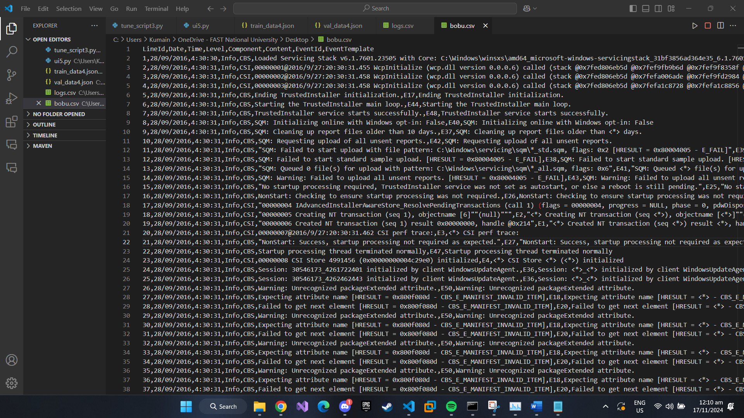
Figure 3(Structured log.csv file)
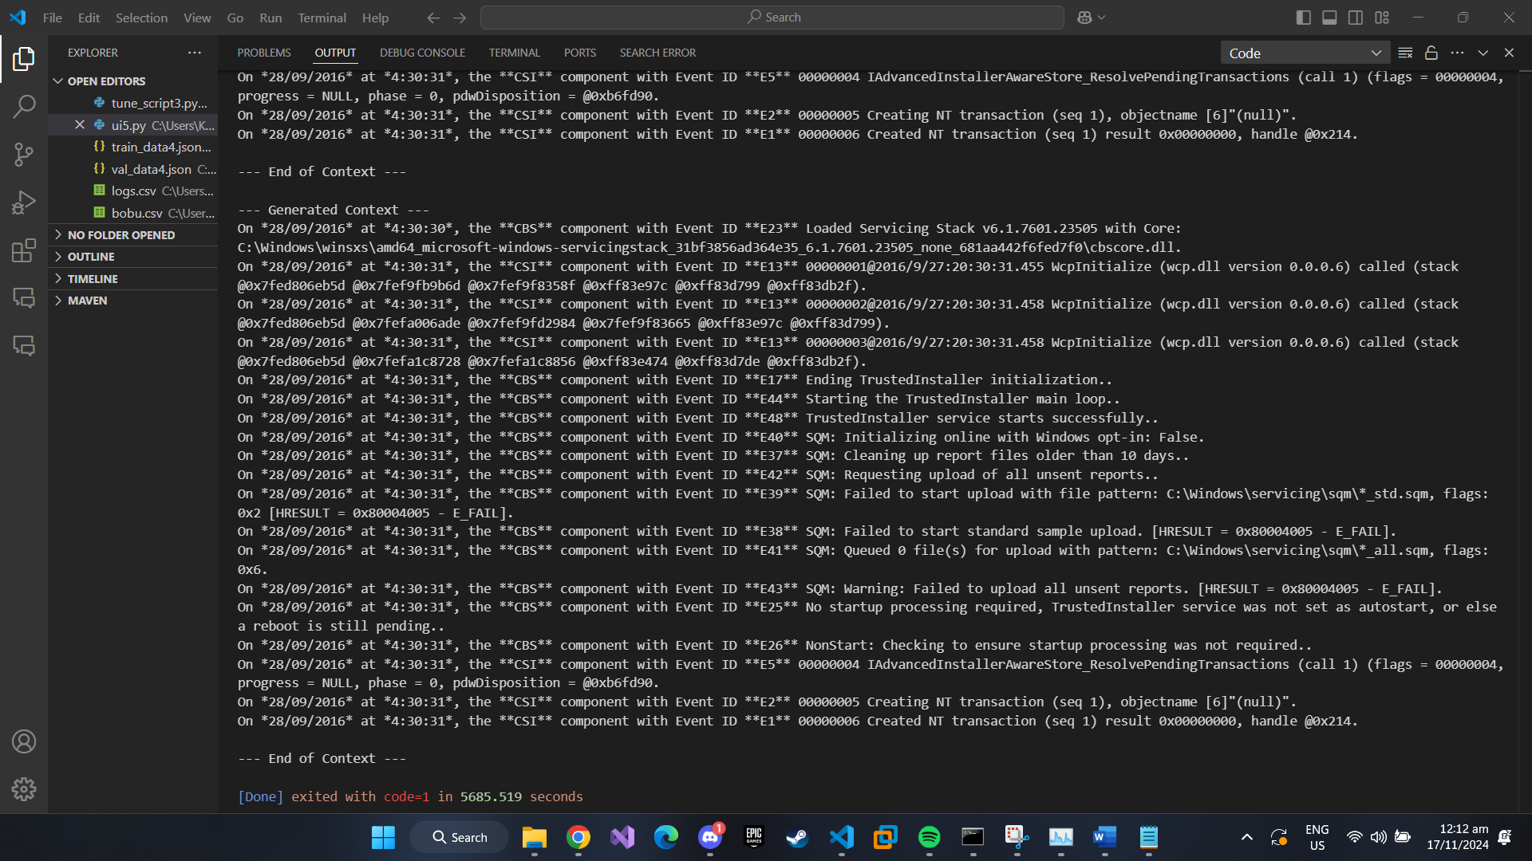
Figure 4(Context Form)

The context is used by the ai we trained to understand the log to answer the question based on it.

Front End
We used gradio to integrate our ai bot with a frontend. The following figure shows the front end of the AI chat bot.
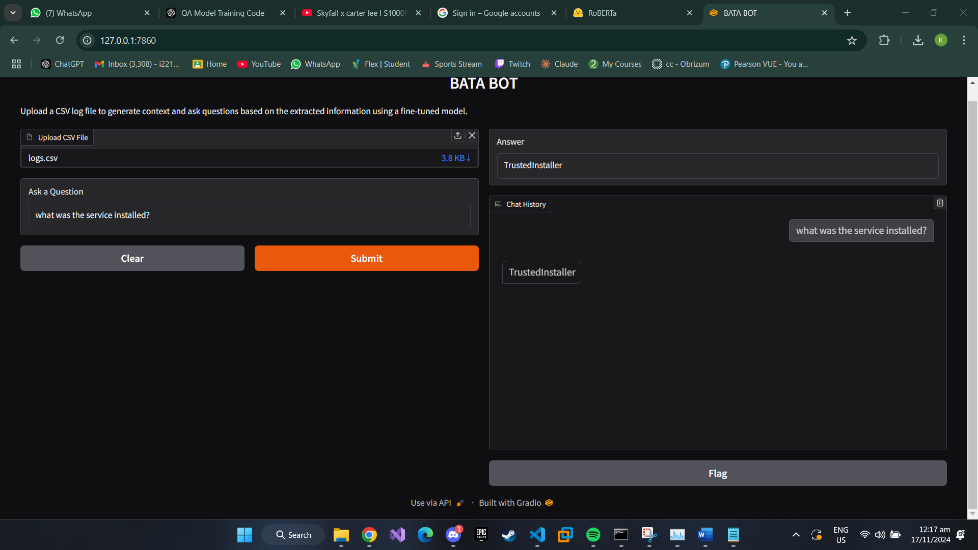
Figure 5(Front End)

Query Handling
The user will upload a log file which will be parsed into a context understood by the ai using the function parse_csv_to_context() present in ui.py file.
The context will be used to answer the queries as shown in the figure below.
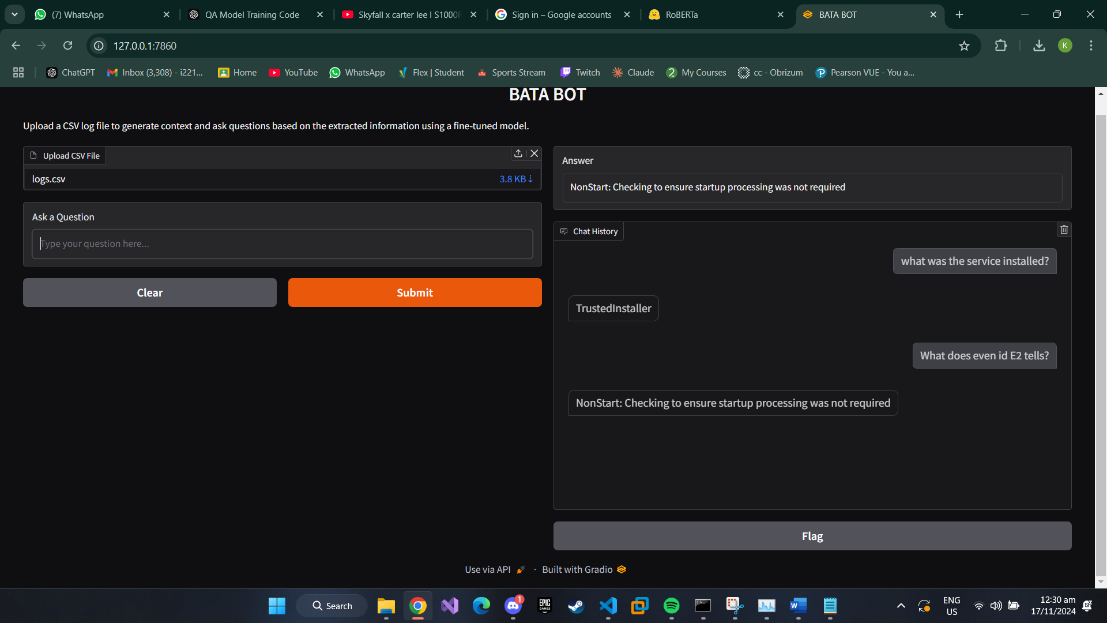
Figure 6(Query Handling of AI Bot)

Limitation
During the process of developing our AI Bot we faced some limitations.
- The efficient AI like Azure were not available in our region despite the free trial.
- Open-AI API integrations are very helpful for creating chatbot, but they are paid.
- deepset/roberta-base-squad2 is limited to understand mathematical context. It requires context to be in English like format.
- Processing Limitation, as tuning large amount of context and quires require higher system requirements.
- Large logs will take more time to process because processing is limited by the free model version.

Conclusion
In this project, we successfully designed and implemented an AI chatbot, "BATA BOT," for Windows Event Log analysis. By leveraging a pre-trained model, deepset/roberta-base-squad2, and utilizing Python with essential libraries like Transformers, Gradio, and Pandas, we created a robust tool capable of parsing structured log data and facilitating user interaction. The chatbot's functionality includes transforming complex event logs into coherent context, allowing users to query and receive precise answers that assist in forensic investigations and troubleshooting. The structured approach of fine-tuning, data preprocessing, and interactive interface development ensures that "BATA BOT" serves as an effective and user-friendly solution for analyzing and understanding system logs.

