User Guide for Windows Event Analysis Chatbot Web Application

1. Launching the Application
1. Start the Chatbot Server:
- Open a terminal and navigate to the folder where the files are located.
- Run the following command:
python ui5.py
- As seen in the image above, the terminal will display a URL (e.g., http://127.0.0.1:5000) where the chatbot can be accessed. Both a local and a public URL is available.
2. Open the Web Application:
- Copy the URL and open it in a web browser.
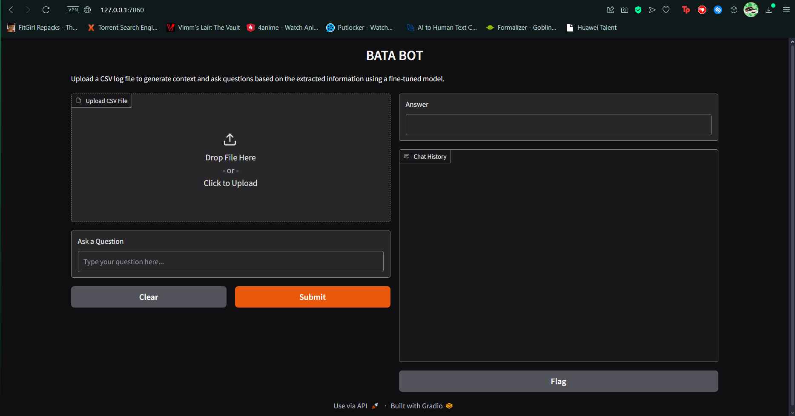

2. Navigating the Interface
The application interface consists of:
1. Input Field: A text box to type your query about Windows Event logs.
2. Upload Section: A button to upload event log files in CSV format for analysis.
3. Response Area: A section where the chatbot provides detailed answers to your queries.
4. Chat History: A section showing chat history of all questions asked from the bot and all answers received.

3. Example Workflow
1. Open the application in your browser.
2. Upload a CSV file containing logs to be analyzed.
3. Enter a question like:
What was the version of the servicing stack?
3. Click Submit.
4. The chatbot processes your query and provides an answer, e.g.:
v6.1.7601.23505.
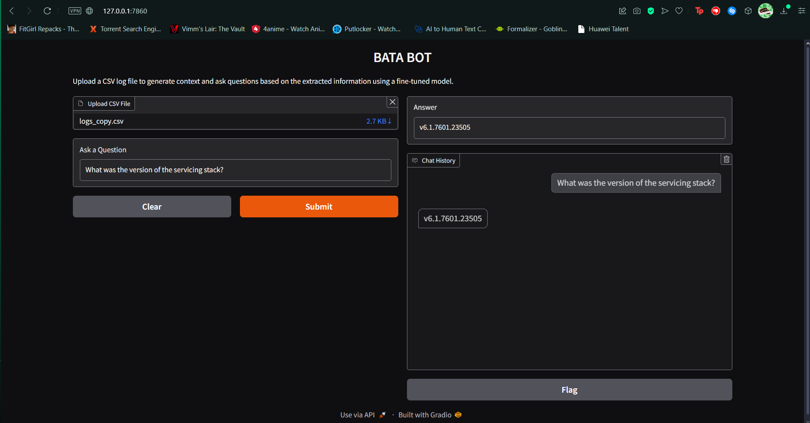

4. Troubleshooting
- Issue: The server is not running.
- Solution: Ensure Python is installed and dependencies are correctly set up in the virtual environment. Start the server again.
- Issue: The chatbot is not responding.
- Solution: Check the terminal for errors and restart the application.

5. Advanced Features
- The application allows multiple log file uploads for batch analysis.
- You can query the chatbot for specific event IDs, components, or dates based on the logs.

