Title page

Q1

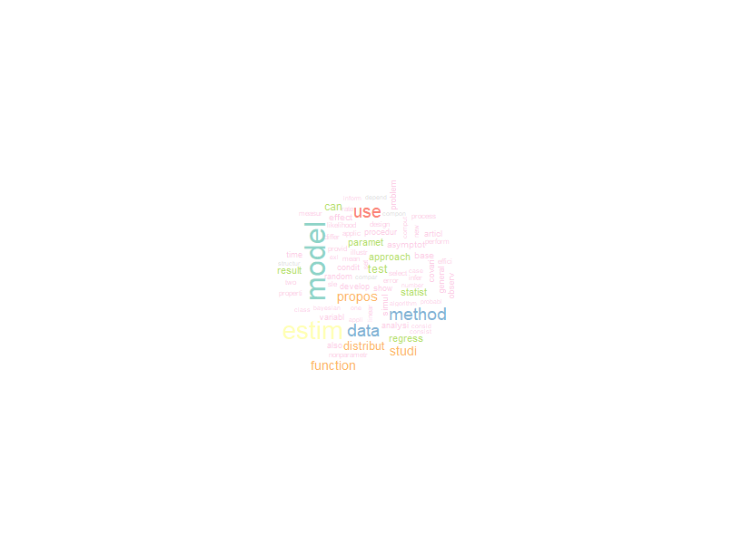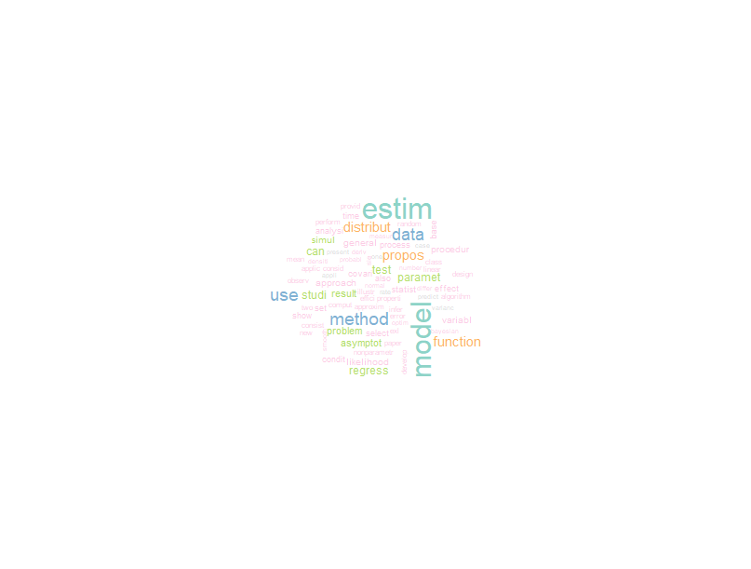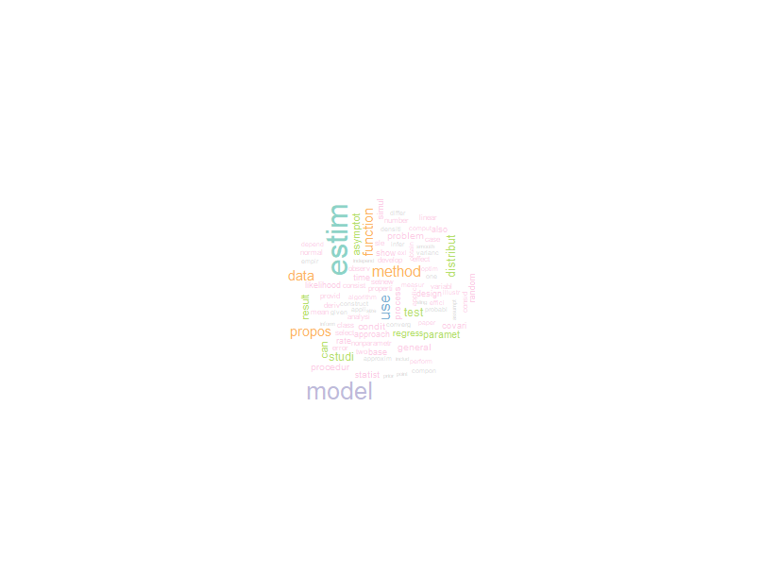Q2

2006-2008 keywords

2003-2005 keywords

2009-2012 keywords

The words ‘method’ and ‘estim’ have always been widely used. The word ‘use’ as been used more often starting 2006. ‘Model’ and ‘data’ have been used less often as time goes, but they are still one of the most popular keywords.

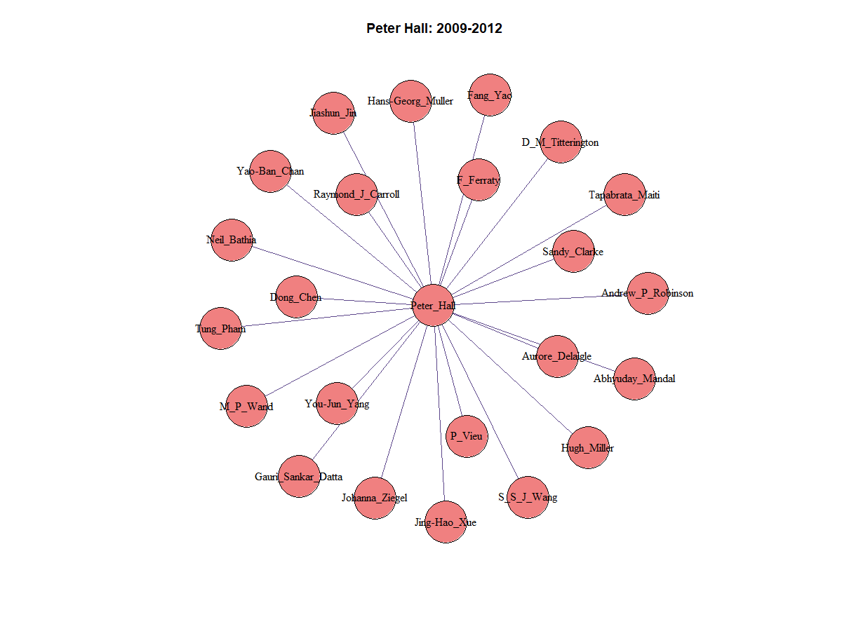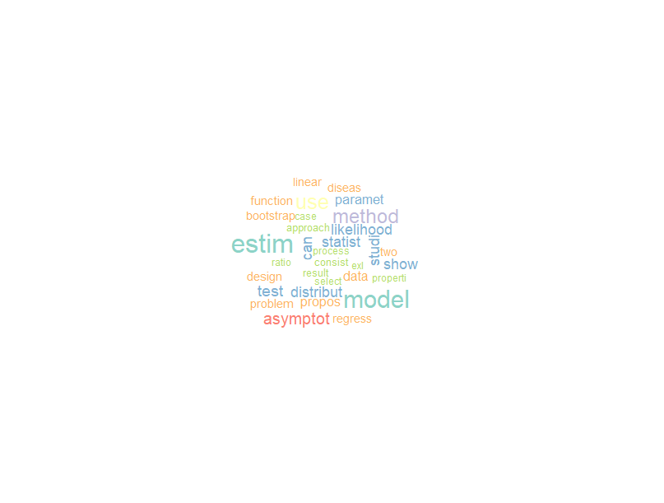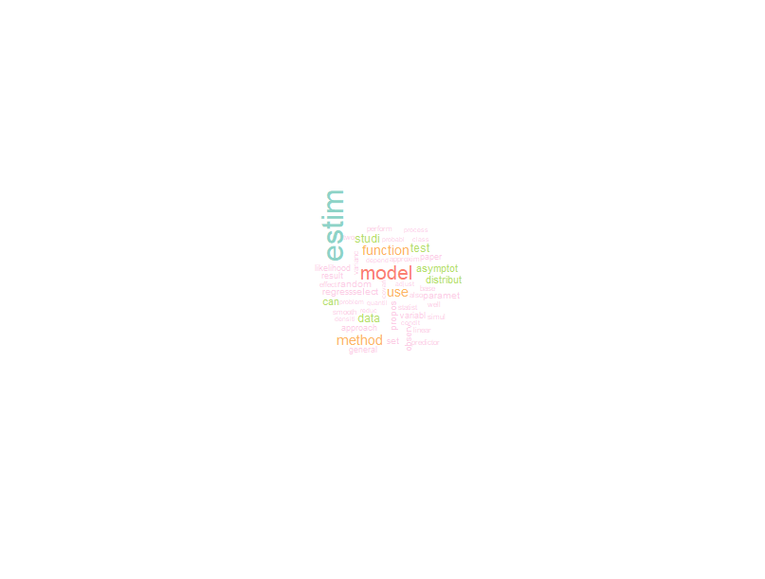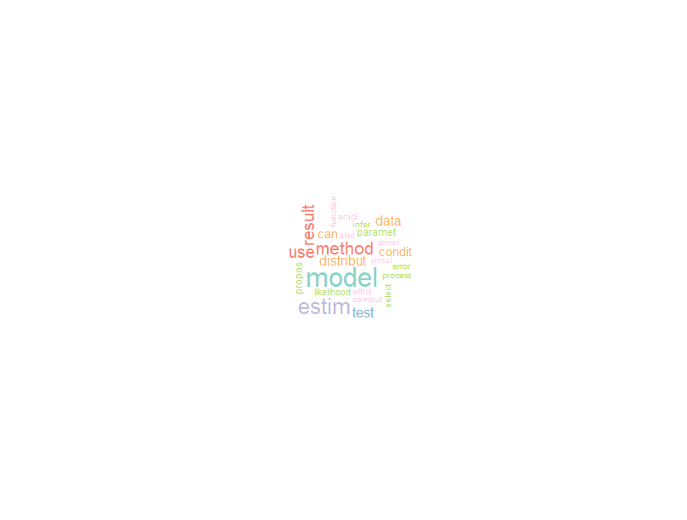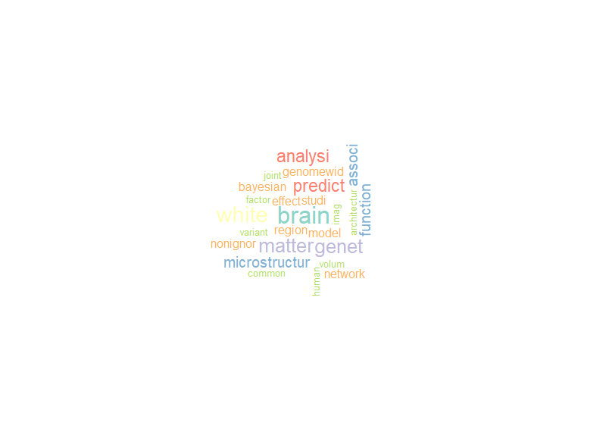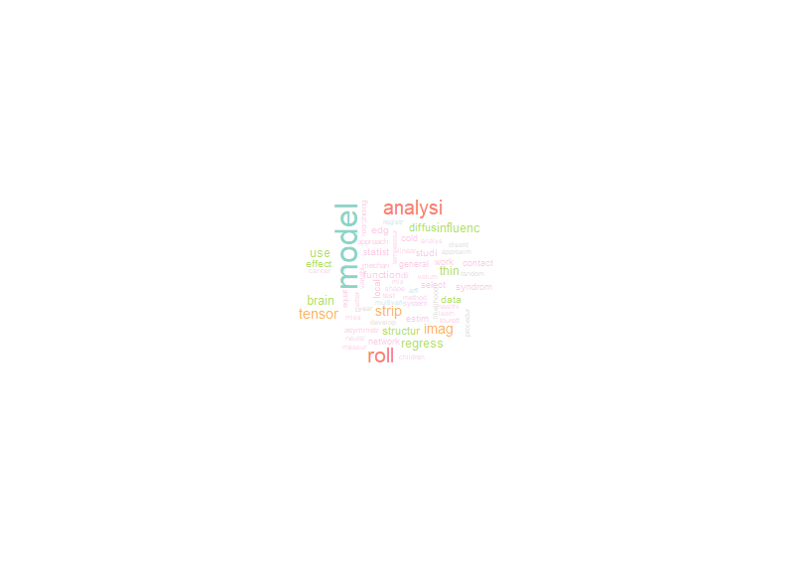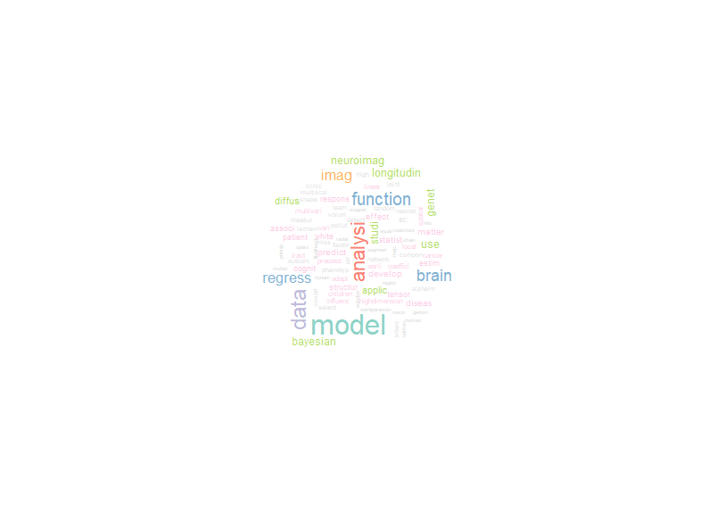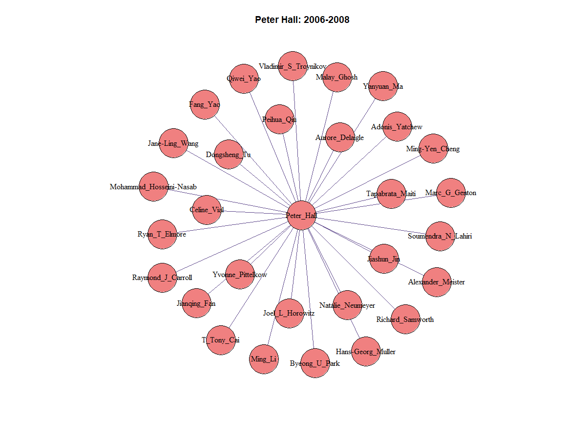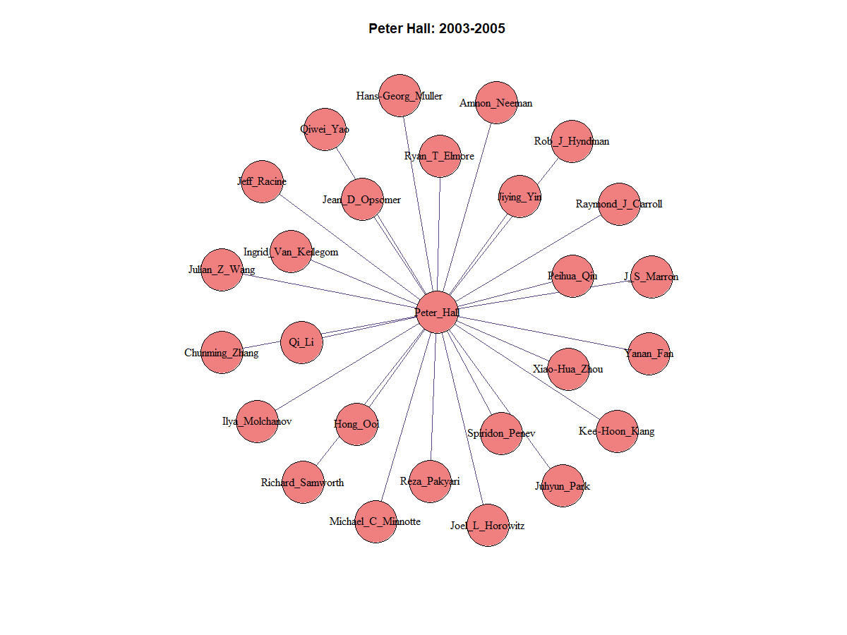

Hongtu Zhu has the sixth highest collaborators. He used the keywords ‘model’ and ‘data’ more frequently overtime, while keywords ‘brain’, ‘matter’ and ‘predict’ were used less frequently over time. The frequency of keyword ‘analysi’ doesn’t change much over time. Comparing Zhu with Hall, they both use word ‘model’ extensively. While Hall use ‘method’ and ‘estim’ often, Zhu doesn’t and instead, he uses ‘data’ and ‘analysis’ more often. Generally speaking, Hall’s keyword use doesn’t change significantly over time, while Zhu’s keyword use experience major change from 1997-2005 to 2006-2013.

Peter Hall has the largest number of collaborators. From 2003 to 2008, he has been collaborating with roughly the same amount of people, with a slight increase in number (from 26 to 29 collaborators) from 2003-2005 to 2006-2008. Starting 2009, he seemed to collaborate a little less, as the average number of collaborators decreases from 10 (29/3) per year to 8 (31/4) per year. Hall worked with the same two authors (Hans-Georg Müller and Raymond J. Carroll) in all three time periods. There were four authors that he worked with twice from 2003-2005 to 2006-2008 (Peihua Qin, Qiwei Yao, Richard Samworth, and Ryan T. Elmore), and he worked with three same authors (Aurore Delagle, Fang Yao, and Jiashun Jin) in 2006-2008 and 2009-2012. Since he has been working with slightly fewer people, to expand this pattern, he may collaborate with fewer people in the future, possibly around 6 people per year. He can possibly collaborate with Hans-Georg Müller and Raymond J. Carroll in the future because they have collaborated extensively before.

2003-2005 Peter Hall keywords

2006-2008 Peter Hall keywords

2009-2012 Peter Hall keywords

Comparing to the global visualization, we can see that the most used keywords are very similar for the time period from 2003 to 2005, i.e., “method”, “model”, “estim”, “data”, and “use”. Hall’s trend is also similar to the global trend in terms of the wide use of the word “estim”, “method”, and “model” in all times. The decrease of using “data” over time occurs both in the global trend and in Hall’s trend. However, comparing to the decrease use of “model” as time goes in the global trend, Hall’s trend shows a decrease use of this word in the period of 2006-2008, but he soon came back to widely using this word in the visualization of keywords from 2009 to 2012.

2014-2021 Hongtu Zhu keywords

2006-2013 Hongtu Zhu keywords

1997-2005 Hongtu Zhu keywords

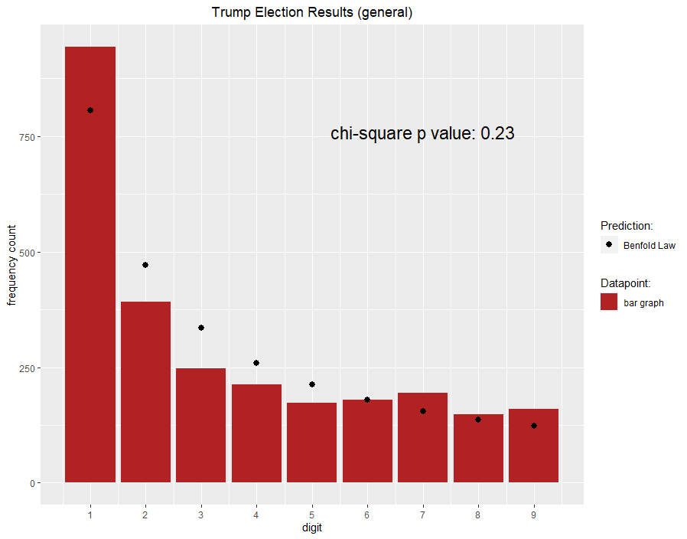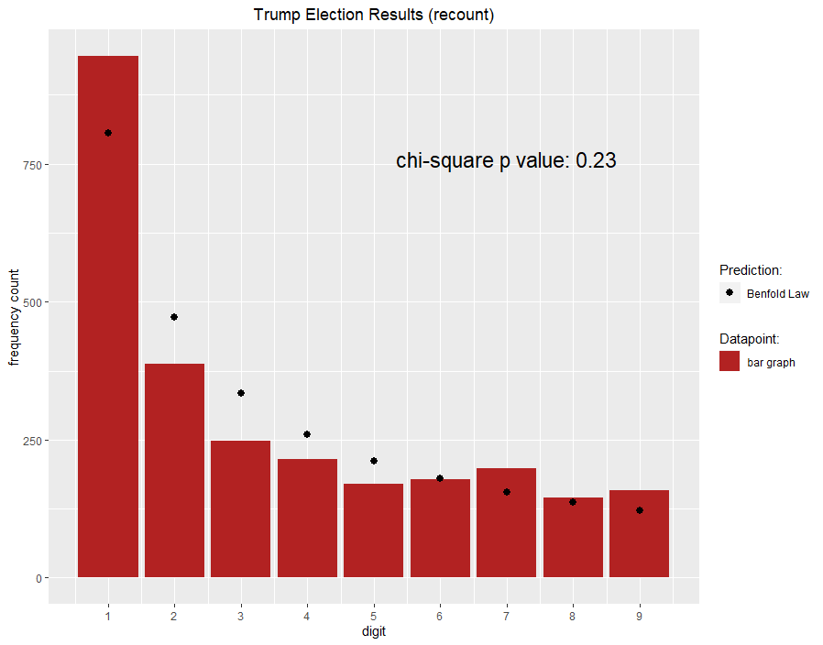Q3

Part 1:

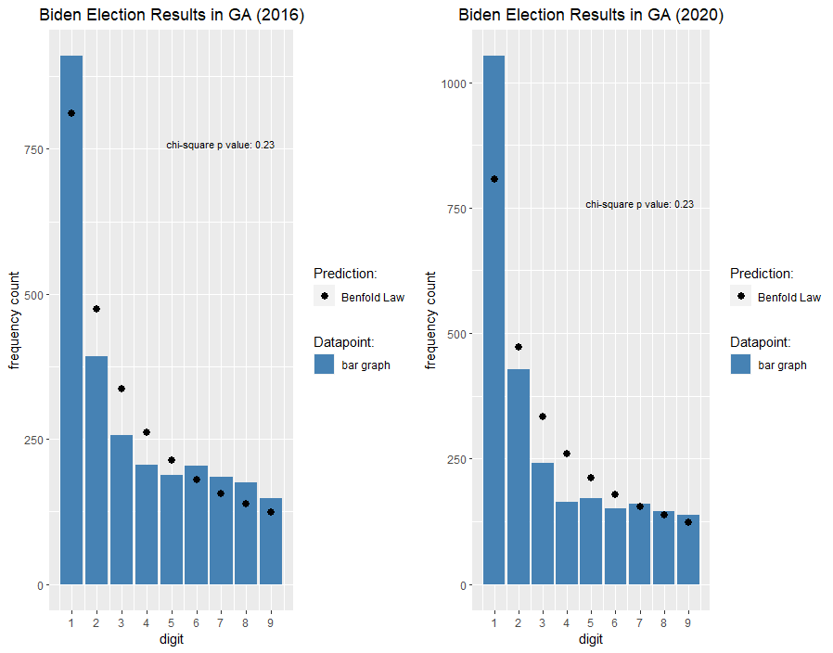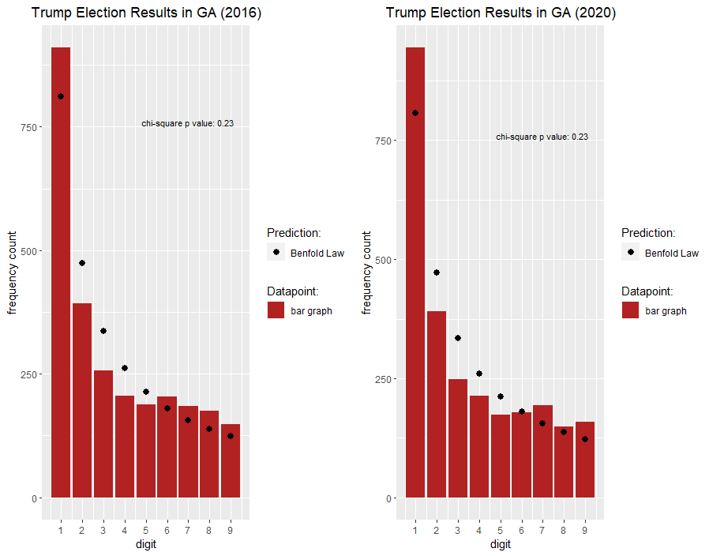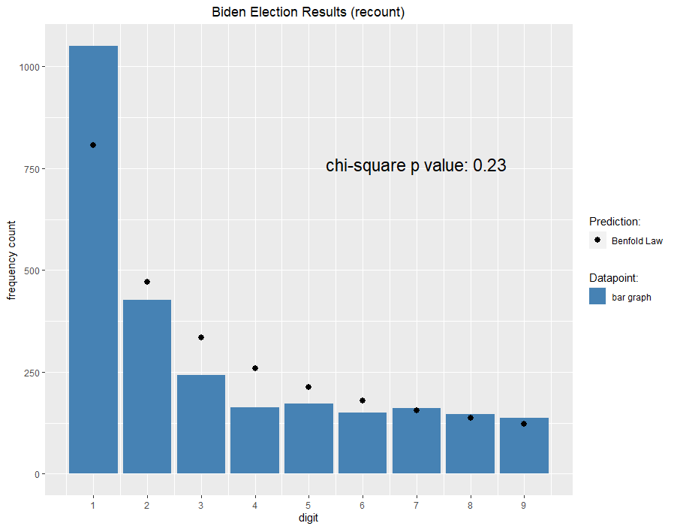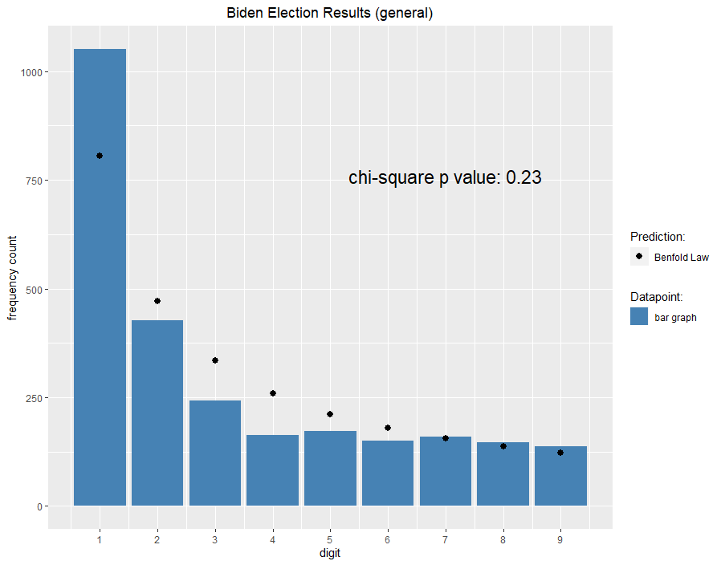

Since Benfold’s Law isn’t violated, there is not significant evidence to show that fraud exists.

In addition, Trump’s and Biden’s 2020 election voting pattern are similar to their own voting patterns in 2016 respectively. Since there is no evidence saying there is fraud in the 2016 election for Trump and Biden, it indicates that the 2020 election result doesn’t imply cheating for Trump or Biden. Trump’s voting pattern is similar to Biden’s voting pattern as well, which makes it unlikely for one of them to cheat while the other one didn’t.

The voting results from GA for both Biden and Trump roughly follow the Benfold’s law(black dots), for both general election and recount. Since the chi square values are greater than 0.05 for both general and recount, there is no significant evidence showing that Benfold’s law is violated for Trump or Biden.

Part 2