**Description**

WHAT IS S-Din?

’S-Din integrated Search Engine and Design Platform developed specifically for Synthetic Biology. With the power of our Algorithm, we provide a one-stop solution to start Your project’

*To be better,*

*We don’t have to create more.*

*We choose S-Din*

***Make better project with S-Din.***

WHY S-Din?

Background

The science research is now facing an increasingly severe problem that most researches were ignored and not evaluated properly. Numbers of research articles are published every year. How to utilize the previous work to help solve maybe part of the current problem should be considered by everyone.

This year, SYSU-Software try to change this situation in Synthetic Biology, exploring the treasures buried in the ocean of projects.

To make full use of the works done by predecessors in Synthetic Biology. We divided it into two problems.

1) How to find the project you need much faster and more accurate?

2) How to integrate the project you find into your own work?

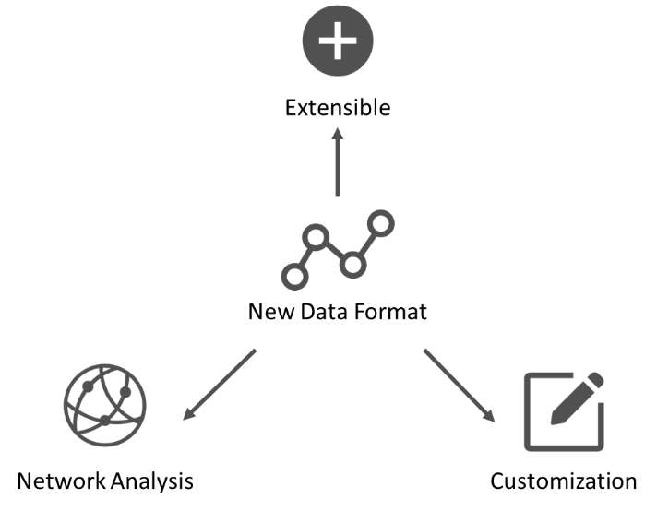

Follow the standardization in Synthetic Biology, we standardize the previous projects, no matter came from articles or iGEM projects, into a New data format to display you a better result when using our search engine.

Network analysis: designed to uncover the potential connection between projects, help user located exactly what they need.

Customization: The most exciting part of S-Din is that the search and the design are seamless. Once you find a project that might be useful, you can start editing in design platform as soon as you find it. Or you can just simply create one from scratch.

Extensible: To ensure the database can be updated, new information can be added by man or ‘Spider’.

Inspiration

People complain, solving obstacles in project is easy, but deciding what to do is tolerance. Catching your muse is like grab fading smoke.

We made S-Din further not only satisfying the need of starting a project but choosing a project.

Therefore, the tree of words and interaction analysis are developed to inspire users. Part of the reason we made search and design seamlessly is to enable you to start design once you catch your muse.

S-Din is mimetic, sounds exactly when you come up with a good idea. And here comes S-Din, to inspire you, to do more in Synthetic Biology.

DONT BE LIMITED, Unleash your imagination.

Want to solve Energy Crisis with Carbon dioxide? Search for circuits that can take in Carbon Dioxide and try to combine a energy generated circuit together to create your own circuits.

Why not Google?

Undoubtedly, Google is the most powerful search engine in the world. Let’s see what happen when Google meets S-Din.

VIDEO HERE

**Design (How we make S-Din work? How each part functioned?)**

* Introduction

Words from designer: Science research are facing a problem of how to utilising the previous researches, some of them are ignored, some of them are underestimated. We‘ve always wanted to make some difference in Synthetic Biology. With the help of our search engine, our users are able to view previous projects and works at a different angle and will be inspired by it. The gap between searching and designing are now seamless. Once you catch the muse, your design can be finished instantly.

This is a search engine built specifically for Synthetic Biology that allow you to view previous projects and works in a standardized style. While your search, we provide network analysis services to help find your results faster and inspire you.

Once you find your preferred project, you are allowed to edit it simultaneously in our design platform. More parts can be added by the search tools provided on the left or you can just drag in a circuits that you collected in your favourite before.

The design can be uploaded, downloaded or shared for collaborations between different accounts. Once you finish the design, you can run simulation program to check if it works well and then export it as plasmid and we will generate the sequences for synthesis.

* Database

We collect data from many channels, most of the project data and all of the Parts data come from the iGEM Projects published on article are collected on various synthetic biology Journals, usage permissions are granted by the publication groups.

Most of the data are collected by ‘Spider’ and corrected manually. All data of circuits are converted with manually with the help of our design platform.

* Algorithm (数模，简要说明即可)
  + Search Algorithm
  + Recommend Algorithm
* Network Analysis
  + Search analysis （锦然，熊大）
  + Interaction analysis

When you click interaction analysis on a part on the design platform, any other parts or protein that might interact with the chosen part will be displayed which can be added on the platform. We build an interaction database ourselves, the sources of data come from iGEM Registry and STRING Database. Scores for parts come from the STRING Database.

- Simulation （数模）

- Plasmid Design

**Features**

- Seamless Search & Design

The moment you’re inspired by one of the projects, you can edit it instantly. Combining different function parts together to fulfil your need. Or you can do a de novo design.

- Network analysis

We developed a series of algorithms to generate network composites of project, parts and keywords for analysis aiming to help user explore the treasure buried in the ocean of articles.

- The Best Design Platform

The needs in Designing a Circuits were considered seriously to achieve the best user experience. Simple operation logic, beautiful UI.

- Inspiration

The tree of words

Simply by clicking the words, you will see the subordinated words. After few repeats, you will finally get the projects that you want. This function is designed to help specify your need, help you understand your idea better.

Interaction analysis

This function is implanted in the design platform which will tell you the potential interaction parts with the chosen one. Use your imagination, think of how to utilize these interactions.

- Simulation

Even though it’s difficult to develop a model that fit all the circuits, it worth a shoot. Our modeler developed a general model to allow user to simulate any circuits.

- Techniques (程序组)

Web design:

Back-end design:

**Wet-Lab Validation （梓蔚）**

**Demonstrate (Proof of Robustness of software) （程序）**

**多平台测试？多浏览器支持？等等**