**Tutorial – JavaScript**

**Exercise 01**

Create a JavaScript program to display the date and time of a client computer?

<html>

<head>

<title> Display Date and Time </title>

</head>

<body>

<div>

<h1>Date and Time:</h1>

<p id="datetime"></p>

</div>

<script>

function updateDateTime()

{

const dateTimeElement = document.getElementById('datetime');

const now = new Date();

const dateTimeString = now.toLocaleString();

dateTimeElement.textContent = dateTimeString;

}

updateDateTime();

setInterval(updateDateTime, 1000);

</script>

</body>

</html>

**Exercise 02**

Using JavaScript enable/disable the embedded video. (The video should play when the mouse is over the video)

<html>

<head>

<title>Enable/Disable Video on Mouseover</title>

</head>

<body>

<div>

<h1>Mouse over the video to play</h1>

<video id="myVideo" width="320" height="240" controls>

<source src="MAVKA. THE FOREST SONG. Official Trailer.mp4" type="video/mp4"> </video>

</div>

<script>

function enableVideo() {

const video = document.getElementById('myVideo');

video.play();

}

function disableVideo() {

const video = document.getElementById('myVideo');

video.pause();

}

const videoElement = document.getElementById('myVideo');

videoElement.addEventListener('mouseover', enableVideo);

videoElement.addEventListener('mouseout', disableVideo);

</script>

</body>

</html>

**Exercise 03**

Write a JavaScript function to add rows to a table.

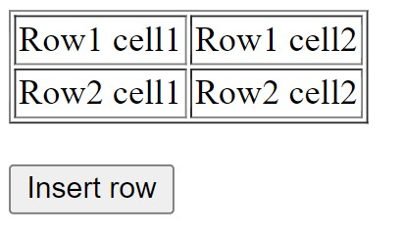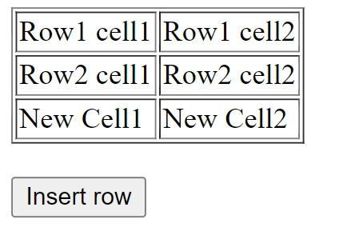

<html>

<head>

<title> Add Rows to Table </title>

</head>

<body>

<table id="myTable" border="1">

<tr>

<td> Row 1 cell 1 </td>

<td> Row 1 cell 2 </td>

</tr>

<tr>

<td> Row 2 cell 1 </td>

<td> Row 2 cell 2</td>

</tr>

</table>

<button onclick="addRow()"> Insert row </button>

<script>

function addRow() {

const table = document.getElementById("myTable");

const newRow = table.insertRow(table.rows.length);

const cell1 = newRow.insertCell(0);

const cell2 = newRow.insertCell(1);

cell1.innerHTML = "New Cell 1";

cell2.innerHTML = "New Cell 2";

}

</script>

</body>

</html>

**Exercise 04**

Write a JavaScript program to remove items from a dropdown list.

<html>

<head>

<title> Remove Items from Dropdown List </title>

</head>

<body>

<h2> Dropdown List </h2>

<select id="dropdownList">

<option value="option1">Option 1</option>

<option value="option2">Option 2</option>

<option value="option3">Option 3</option>

<option value="option4">Option 4</option>

<option value="option5">Option 5</option>

</select>

<button onclick="removeItem()"> Remove Item </button>

<script>

function removeItem() {

const dropdownList = document.getElementById('dropdownList');

const selectedIndex = dropdownList.selectedIndex;

if (selectedIndex !== -1) {

dropdownList.remove(selectedIndex);

} else {

alert("Please select an item to remove.");

}

}

</script>

</body>

</html>

**Exercise 05**

Write a JavaScript program to change the border of a table.

<html>

<head>

<title> Change Table Border </title>

</head>

<body>

<form>

<label for="borderInput"> Enter border value (0 or greater): </label>

<input type="number" id="borderInput" min="0" step="1">

<button type="button" onclick="changeTableBorder()"> Apply Border </button>

</form>

<br>

<table id="myTable" border="1">

<tr>

<td> Cell 1 </td>

<td> Cell 2 </td>

<td> Cell 3 </td>

</tr>

<tr>

<td> Cell 4 </td>

<td> Cell 5 </td>

<td> Cell 6 </td>

</tr>

</table>

<script>

function changeTableBorder() {

const borderInput = document.getElementById('borderInput');

const newBorderValue = parseInt(borderInput.value);

if (!isNaN(newBorderValue) && newBorderValue >= 0) {

const myTable = document.getElementById('myTable');

myTable.style.border = `${newBorderValue}px solid black`;

} else {

alert("Please enter a valid border value (0 or greater).");

}

}

</script>

</body>

</html>