WEEK 2 PROJECT REPORT: CORE FUNCTIONALITY DEVELOPMENT

NAME: MINURANISAHU, ANANYA, RITHIKA
DATE: 31/01/2026

Overview:
The focus of Week 2 was to develop and integrate the core functionality of the Recipe Finder application. This phase concentrated on improving user interaction, enhancing data handling from the API, and ensuring the application works reliably through testing and logging.

Objectives:
To allow users to search recipes using ingredients.
- To apply dietary filters such as vegetarian and vegan.

- To display complete recipe details clearly.

- To implement logging for monitoring API activity and errors.

- To test and refine API response handling.

Work Completed:
- A search feature was implemented to fetch recipes based on user-entered ingredients.

- Dietary filters were added to narrow down recipe results according to user preferences.

- Detailed recipe information including recipe image, ingredients list, and preparation steps was displayed.

- Logging functionality was enabled to track API requests, user actions, and errors, which helped in debugging.

- API responses were tested thoroughly and data extraction was refined to ensure correct and consistent output.

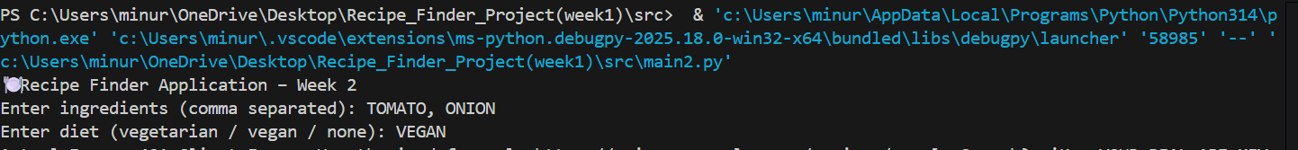

CHALLENGES FACED AND SOLUTIONS

Challenge 1: Handling API response errors

Some API responses returned incomplete or unexpected data.
Solution: Error handling mechanisms were added to validate responses before displaying data.

Challenge 2: Implementing accurate filters

Applying dietary filters correctly to API results was challenging.
Solution: Filter logic was refined to match dietary parameters accurately.

Challenge 3: Debugging application issues

Identifying the source of errors during API calls was difficult.
Solution: Logging was implemented to record errors and requests, making debugging more efficient.

Conclusion:
Week 2 successfully enhanced the Recipe Finder application by adding essential features and improving stability. The application is now more user-friendly, reliable, and prepared for further enhance

