WEEK 4- PROJECT REPORT
TITLE: NUTRITON ANALYZER APPLICATION
NAME: MINURANISAHU, ANANYA, RITHIKA DATE: 02/07/2026

INTRODUCTION
The Nutrition Analyzer project is designed to collect, process, and visualize nutrition data for different foods. The application uses Python programming, with Pandas for data handling and Matplotlib for visualization.
The goal of the project is to convert raw nutritional data into a structured format and display it graphically, allowing users to easily understand nutrient distribution.
In Week 4, the focus was on testing the application, documenting the project properly, implementing error handling, and providing setup instructions to ensure smooth execution on any system.

SOFTWARE REQUIREMENTS
The system requires Python to be installed for executing the program. A code editor such as Visual Studio Code or Command Prompt is required to run the application. The program also requires external Python libraries such as Pandas and Matplotlib.
The following software components are required to run the project successfully:
- Python (3.x or above)
- Visual Studio Code/ Any Python IDE
- Pandas Library (for data handling and analysis)
- Matplotlib Library (for data visualization)
- CSV/ JSON dataset file (Nutrition data)

HARDWARE REQUIRED
- Computer or Laptop o Minimum 4 GB RAM
- Windows/ Linux/ Mac Operating System

SETUP INSTRUCTIONS
To successfully setup and run the Nutrition Analyzer project, follow the steps bellow:

INSTALLATION STEPS
To run the application, the required Python libraries must be installed. The libraries can be installed using pip commands in the command prompt or terminal.
pip install pandas pip install matplotlib

PROJECT EXECUTION STEPS:
- Open the project folder in Visual Studio Code or any Python supported editor. o Open the terminal or command prompt.
- Navigate to the project directory. o Run the main program file using the following command:
python main.py

EXECUTION OUTPUT
After running the program, the nutritional data will be displayed in the terminal. A bar chart visualization will also be generated to represent the nutritional values graphically.

ERROR HANDLING
If the required libraries are not installed, the program will show an error. This can be resolved by installing the missing libraries using pip. If incorrect or mismatched data is provided, the program may display an error message, ensuring that invalid data is detected.
TESTING AND VALIDATION

TESTING PROCESS
The application was tested to ensure that all modules were working correctly. The testing process included running the program, verifying output results, and checking error handling.
The program was executed using Visual Studio Code terminal. The system successfully displayed the nutritional information of the sample data. The data was structured using the Pandas Data Frames, which made the information easy to read and understand.
Matplotlib was used to generate a bar chart visualization of the nutritional values. The visualization correctly displayed different nutrients such as calories, protein, carbohydrates, fat and fibre.

ERROR HANDLING TESTING
The application was tested by providing incorrect or missing input data to verify error handling capability. The application was tested with incorrect and mismatched data values. During testing, Pandas generated an error when data format was incorrect. This helped verify that the program properly detects invalid data structures.

OUTPUT VERIFICATION
The output generated by the program was compared with the input sample data to ensure accuracy. The Data Frame displayed correct nutritional values, and the bar chart visualization represented the data properly.

SCREENSHORTS
Screenshots of the program's execution, terminal output, and graphical visualization were captured as proof of successful testing.
Figure 1: Recipe Finder GUI Window
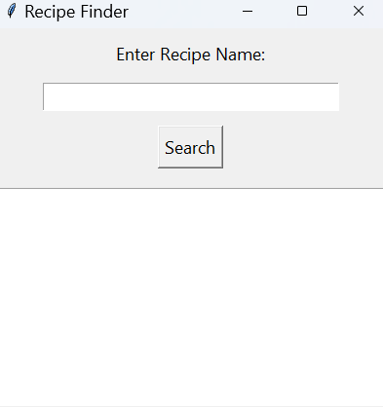

Figure 2: Output For Valid Recipe Search

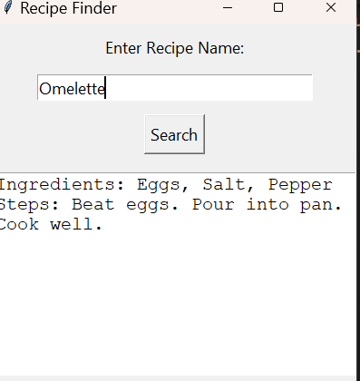

Figure 3: Error Displayed for Invalid Recipe
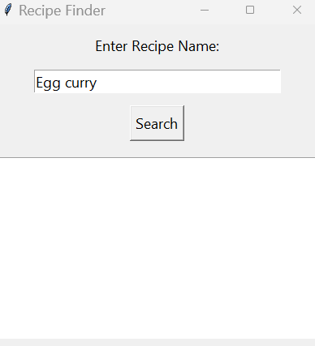

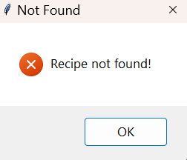
Figure 4: Warning Displayed When Input Is Empty
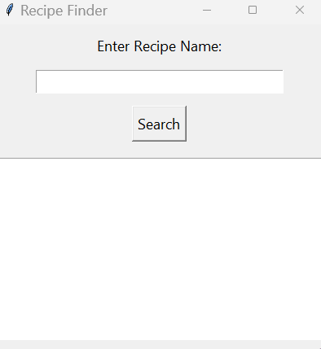
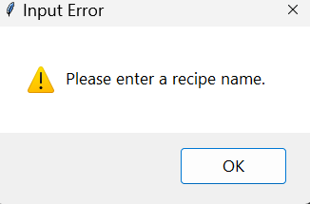

CONCLUSION
This project successfully demonstrated the implementation of data analysis and visualization techniques using Python. The system was designed to collect and process nutrition-related data and present it in a structured and understandable format. By using libraries such as Pandas and Matplotlib, raw data was converted into meaningful tables and graphical representations.
Throughout the development process, various challenges such as handling unstructured data, managing errors, and presenting outputs effectively were addressed. The project enhanced understanding of Python programming, data handling, and visualization concepts. It also helped in improving problem-solving and logical thinking skills.
Overall, the project achieved its objectives by providing an efficient and user-friendly way to analyse and visualize nutrition data. The knowledge gained during this project will be helpful for future software development and data analysis tasks.

