WEEK 2 TASK
Prototype Design for E-Governance Application
Municipal Citizen Service Request & Complaint Management System
Report. Track. Resolve.

Prepared by | Minuddin Chowdhury Hridoy
Task | Week 2 - Prototype Design
Project Type | E-Governance Digital Service Platform
Repository | github.com/MinuddinChowdhuryHridoy/e-governance-digital-service
Deliverable | UI/UX research, wireframes, mockups, user flows and design rationale

Executive Summary
This Week 2 report presents the prototype design for the Municipal Citizen Service Request & Complaint Management System. The prototype translates the requirements defined during Week 1 into a visual and interactive design for citizens, municipal officers, department supervisors and system administrators. The design is intended to solve a practical public-service problem: citizens often have a way to submit a complaint, but they may have limited visibility after submission, while municipal staff need structured information and clear tools for processing, escalation and resolution.
The work includes UI/UX research, a 13-screen low-fidelity wireframe set, a corresponding 13-screen high-fidelity mockup set, four key user-flow diagrams, annotated screen explanations, and measurable usability and accessibility targets. Concrete examples are used throughout the report so that each major interface decision is connected to a real municipal-service scenario rather than being included only for visual appearance.

Deliverables Covered
- Low-fidelity wireframes for 13 core screens.
- High-fidelity mockups for the same 13 screens.
- Four user-flow diagrams covering request submission, tracking/feedback, officer processing and supervisor escalation.
- Screen annotations explaining important functions and interactions.
- Design rationale and UX considerations with measurable design targets.

Contents
1. Introduction
2. UI/UX Research
3. Design Goals and Principles
4. Screen Inventory and Navigation
5. Wireframes and High-Fidelity Mockups
6. User Flow Diagrams
7. Screen Annotations and Interaction Rationale
8. UX, Accessibility and Measurable Design Targets
9. Design Validation Against Real-World Scenarios
10. Conclusion
References

1. Introduction
The purpose of Week 2 is to turn the planning and requirement analysis from Week 1 into a prototype that demonstrates how the proposed e-governance platform could work from a user-interface and user-experience perspective. The prototype does not claim that the system has already been implemented; instead, it provides a visual specification that can guide later development and usability testing.

1.1 Main Design Problem
The design focuses on the service lifecycle after a municipal issue is reported. Citizens need to know whether a request was received, which department is responsible, what its current status is, whether there is a delay, and how the issue was resolved. Municipal officers need a structured workspace for review and progress updates, supervisors need escalation and workload visibility, and administrators need role-based configuration tools.

1.2 Target Users
- Citizen - reports issues, tracks requests, views updates and provides feedback.
- Municipal Officer - reviews assigned requests, updates progress, records delays and completes work.
- Department Supervisor - monitors department workload, delayed cases and escalations.
- System Administrator - manages users, roles, departments, categories, permissions and settings.

2. UI/UX Research
The prototype was informed by common patterns used in public digital-service platforms and government design systems. The research focused on clarity, status visibility, structured forms, role-based navigation, accessibility and transparent service progress.
Reference / Pattern | What Was Learned | How It Influenced the Prototype
Open311 / GeoReport | Structured service requests benefit from consistent categories, location information and unique request identifiers. | Applied through category selection, location fields and tracking IDs.
NYC311 | Citizens expect to submit non-emergency service requests and later check request status. | Applied through My Requests, Track Request and Request Details screens.
Bangladesh Grievance Redress System (GRS) | Tracking numbers, status visibility and escalation are useful patterns in government grievance handling. | Applied through tracking IDs, progress history, delayed status and supervisor escalation.
U.S. Web Design System (USWDS) | Government interfaces benefit from clear labels, consistent components, accessible forms and predictable navigation. | Applied through labelled form controls, repeated navigation patterns and visible error/status states.
WCAG principles | Information should remain understandable without depending only on color and should support readable contrast and keyboard-friendly interaction. | Applied through text status labels, readable hierarchy and proposed accessibility targets.

3. Design Goals and Principles
Transparency: Important request information should be visible without forcing citizens to contact the municipality for basic updates.
Task Efficiency: Common actions such as reporting, tracking and processing a request should require few navigation steps.
Role-Based Simplicity: Each user group should see tools that match its responsibilities rather than one overloaded interface.
Error Prevention: Required fields, validation messages and preserved form data should help users recover from mistakes.
Accessibility: Labels, contrast, text status indicators and responsive layouts should support users with different abilities and devices.
Consistency: Buttons, forms, status wording, tables and navigation should behave consistently across related screens.

4. Screen Inventory and Navigation
ID | Screen | Primary User | Purpose
W/M01 | Landing / Login | Citizen / Staff entry | Authentication and clear service entry point
W/M02 | Citizen Dashboard | Citizen | Overview, primary actions and recent requests
W/M03 | Submit Service Request | Citizen | Structured issue submission
W/M04 | Submission Confirmation | Citizen | Confirmation and tracking ID
W/M05 | My Requests | Citizen | Search/filter submitted requests
W/M06 | Request Details / Tracking | Citizen | Progress, department, delay and resolution visibility
W/M07 | Feedback | Citizen | Post-resolution rating and comment
W/M08 | Officer Dashboard | Municipal Officer | Assigned workload and priority visibility
W/M09 | Officer Request Processing | Municipal Officer | Assignment, progress, delay and resolution actions
W/M10 | Supervisor Dashboard | Supervisor | Department workload and delayed cases
W/M11 | Escalated Request Review | Supervisor | Escalation history and supervisor action
W/M12 | Administrator Dashboard | Administrator | System overview and management shortcuts
W/M13 | Management Screen | Administrator | Users, roles, departments, categories and settings

4.1 Main Navigation Logic
- Citizen: Dashboard -> Submit Request / My Requests / Track Request / Feedback.
- Officer: Dashboard -> Assigned Requests -> Request Processing -> Status/Progress Update -> Resolution.
- Supervisor: Dashboard -> Delayed/Escalated Requests -> Review -> Supervisor Action -> Return to processing.
- Administrator: Dashboard -> Users/Roles/Departments/Categories/Settings.

5. Wireframes and High-Fidelity Mockups
Each pair below shows the progression from low-fidelity structural planning to a high-fidelity interface. The wireframe focuses on layout and task hierarchy; the mockup adds visual hierarchy, consistent styling and status treatment without changing the core workflow.

5.1 W01/M01 - Landing / Login
Problem addressed: Citizens need a clear starting point without being distracted by administrative features.

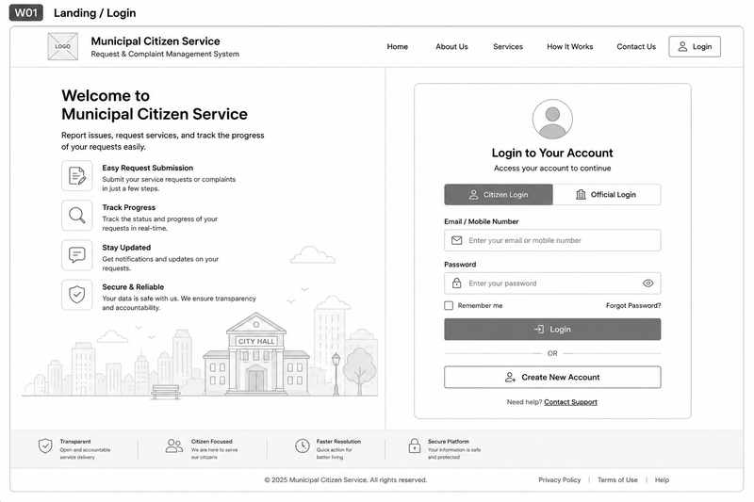
Figure 1. W01 - Landing / Login wireframe
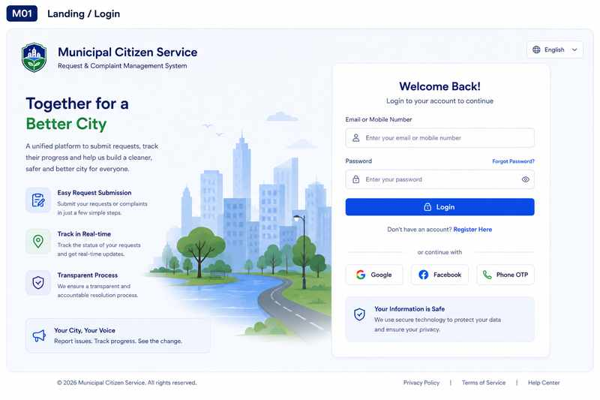
Figure 2. M01 - Landing / Login high-fidelity mockup
Key annotations:
- Simple authentication fields with clear labels.
- Prominent entry to citizen services and registration.
- Separate staff access keeps roles understandable.
- Help and privacy information remain visible.
Concrete example: A citizen reporting a broken streetlight can quickly identify how to access the service and continue to the reporting process.

5.2 W02/M02 - Citizen Dashboard
Problem addressed: Citizens need one place to understand current requests and reach common actions.
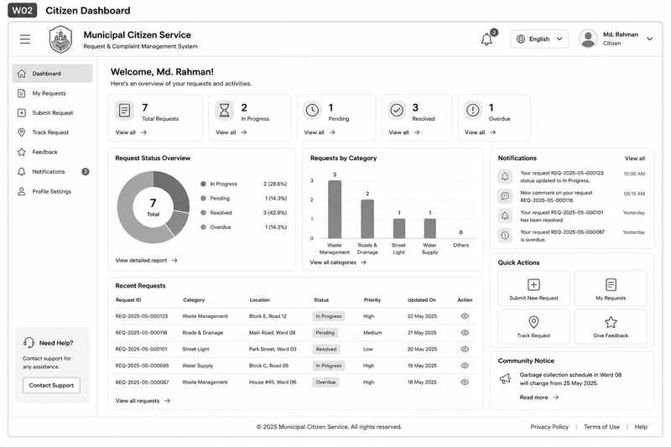
Figure 3. W02 - Citizen Dashboard wireframe
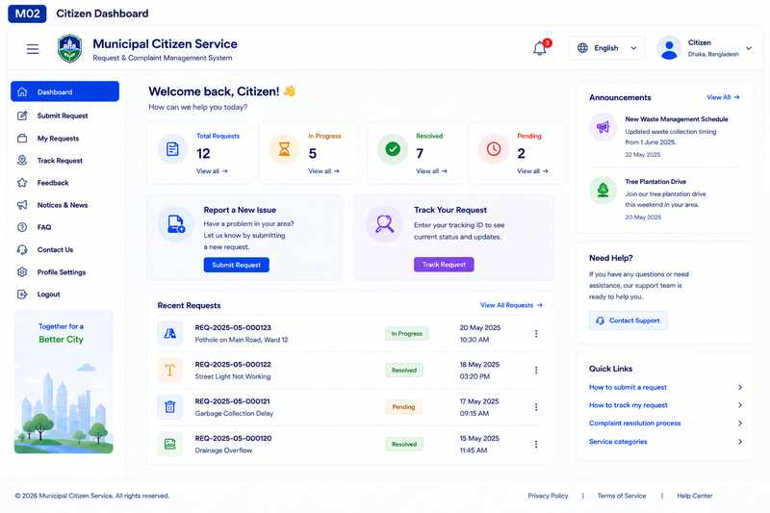
Figure 4. M02 - Citizen Dashboard high-fidelity mockup

Key annotations:
- Report New Issue and Track Request are high-priority actions.
- Status summaries expose pending, in-progress, delayed and resolved work.
- Recent Requests reduces repeated searching.
- Notifications surface important updates.
Concrete example: A citizen can see that a drainage complaint is In Progress and open its details without searching through several menus.

5.3 W03/M03 - Submit Service Request
Problem addressed: Incomplete or vague complaints slow down municipal processing.
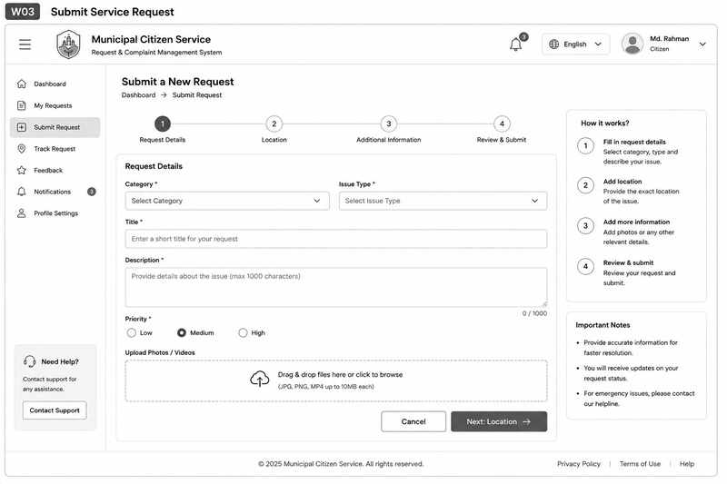
Figure 5. W03 - Submit Service Request wireframe
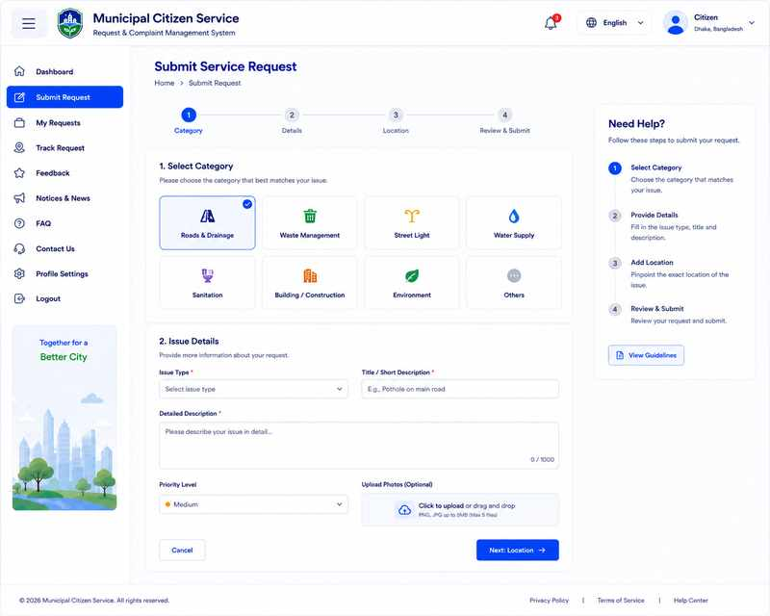
Figure 6. M03 - Submit Service Request high-fidelity mockup

Key annotations:
- Structured category, title, description and location fields.
- Required fields are visually identified.
- Photos remain optional so they do not block access.
- Validation should preserve previously entered information.
Concrete example: A pothole report can include category, description, exact location and an optional supporting photo.

5.4 W04/M04 - Submission Confirmation
Problem addressed: Citizens need evidence that a submission was received.
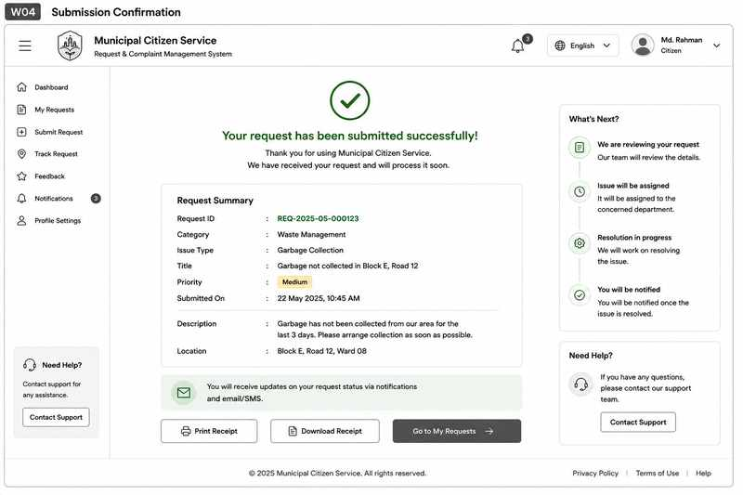
Figure 7. W04 - Submission Confirmation wireframe

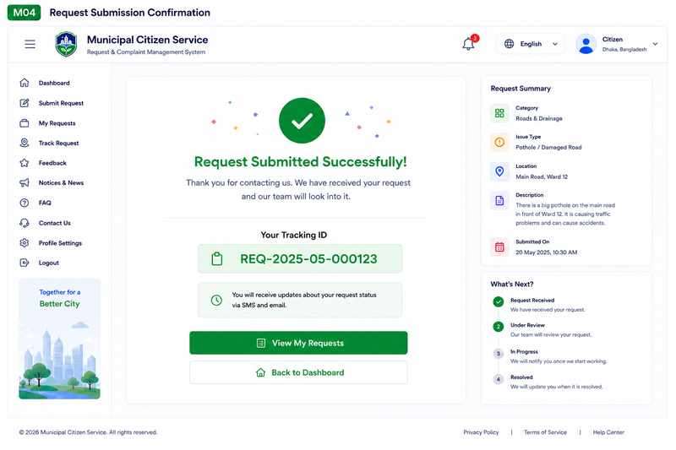
Figure 8. M04 - Submission Confirmation high-fidelity mockup

Key annotations:
- Clear success state.
- Tracking ID shown prominently.
- Request summary lets the user verify key details.
- Next-step guidance explains what happens after submission.
Concrete example: After submitting a waste complaint, the citizen immediately receives a reference number that can be used later.

5.5 W05/M05 - My Requests
Problem addressed: Citizens with several reports need a consolidated history.
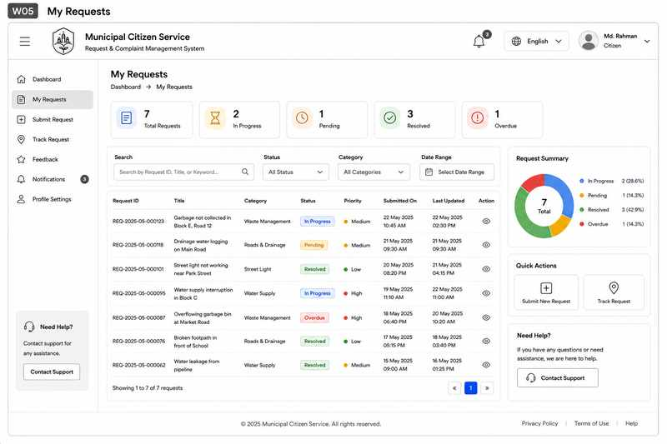
Figure 9. W05 - My Requests wireframe
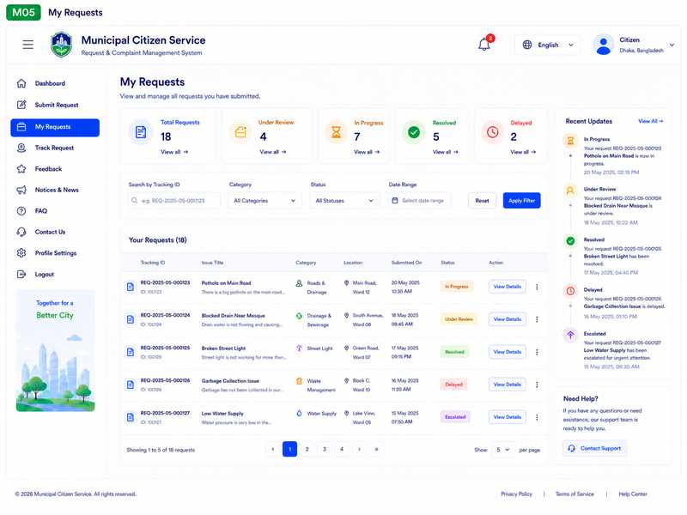
Figure 10. M05 - My Requests high-fidelity mockup

Key annotations:
- Search by tracking ID or keyword.
- Filters by category, status and date.
- Status labels are text-based as well as visual.
- View Details opens the complete lifecycle.
Concrete example: A citizen can locate an older streetlight request without manually remembering its tracking ID.

5.6 W06/M06 - Request Details / Tracking
Problem addressed: The main real-world problem is lack of visibility after submission.
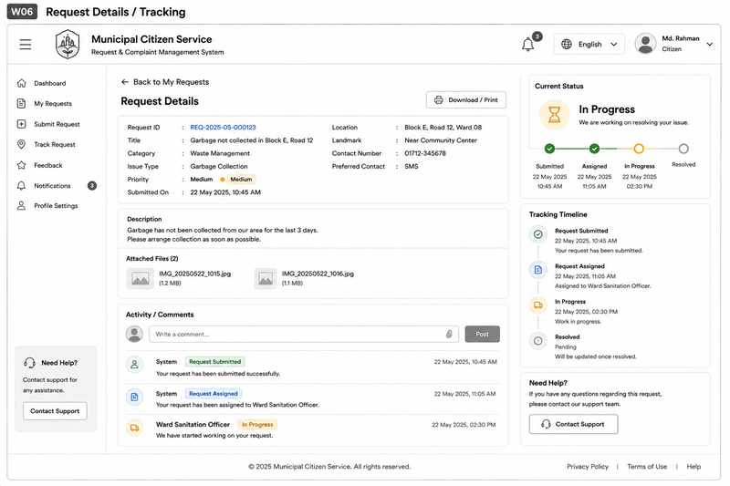
Figure 11. W06 - Request Details / Tracking wireframe

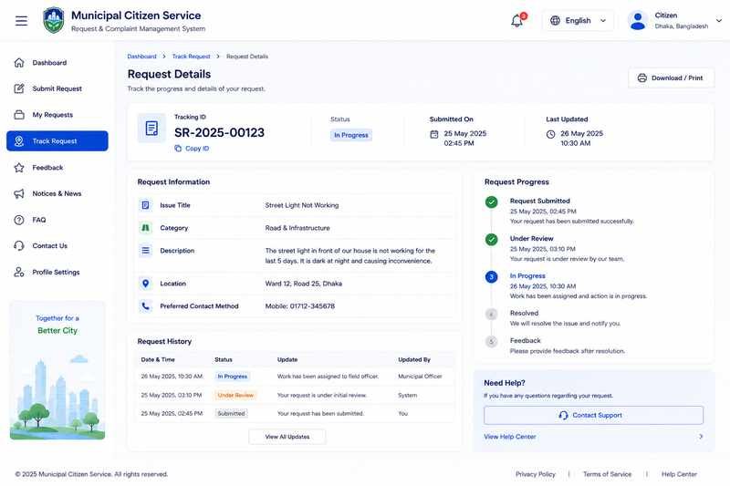
Figure 12. M06 - Request Details / Tracking high-fidelity mockup

Key annotations:
- Tracking ID and current status are prominent.
- Responsible department and progress history are visible.
- Delay information can be shown when applicable.
- Resolution details can be added after completion.
Concrete example: A citizen can see that a pothole report was reviewed, assigned and is currently being worked on.

5.7 W07/M07 - Feedback
Problem addressed: Authorities need a simple way to understand service experience.
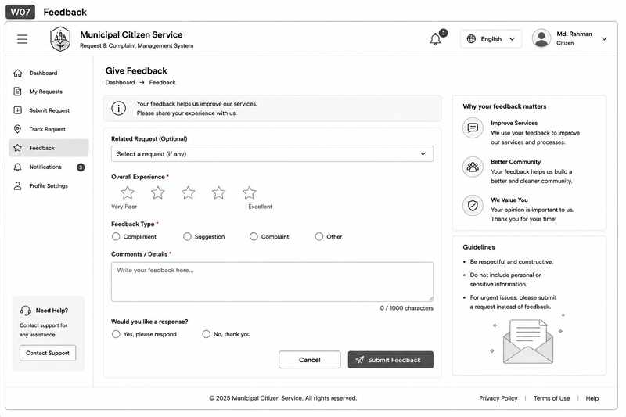
Figure 13. W07 - Feedback wireframe

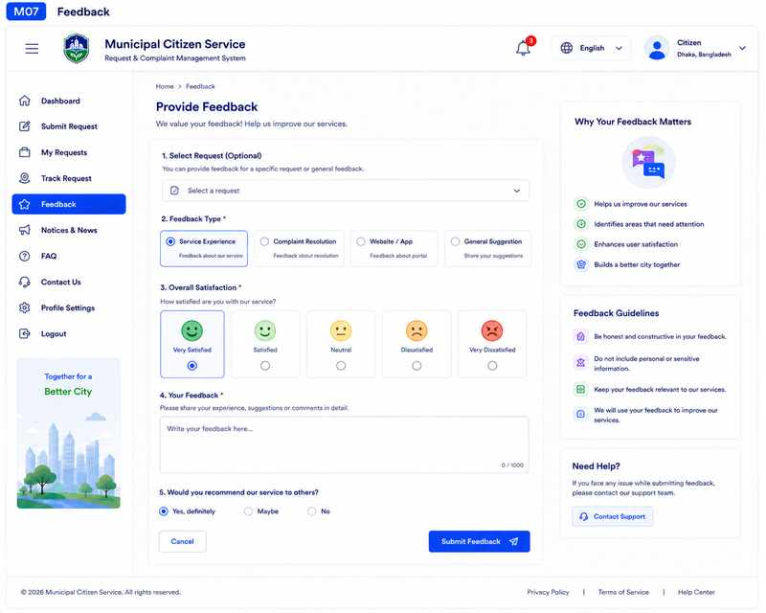
Figure 14. M07 - Feedback high-fidelity mockup

Key annotations:
- Feedback can be linked to a resolved request.
- Short rating scale supports quick completion.
- Comment is optional.
- Guidelines discourage sensitive or irrelevant content.
Concrete example: A citizen rates a completed streetlight repair and adds a short note about the service delay.

5.8 W08/M08 - Municipal Officer Dashboard
Problem addressed: Officers need to identify workload and urgent cases quickly.
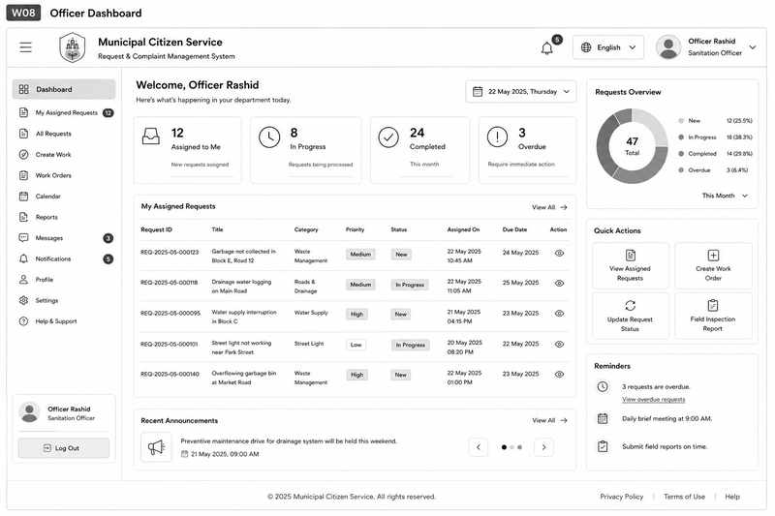
Figure 15. W08 - Municipal Officer Dashboard wireframe
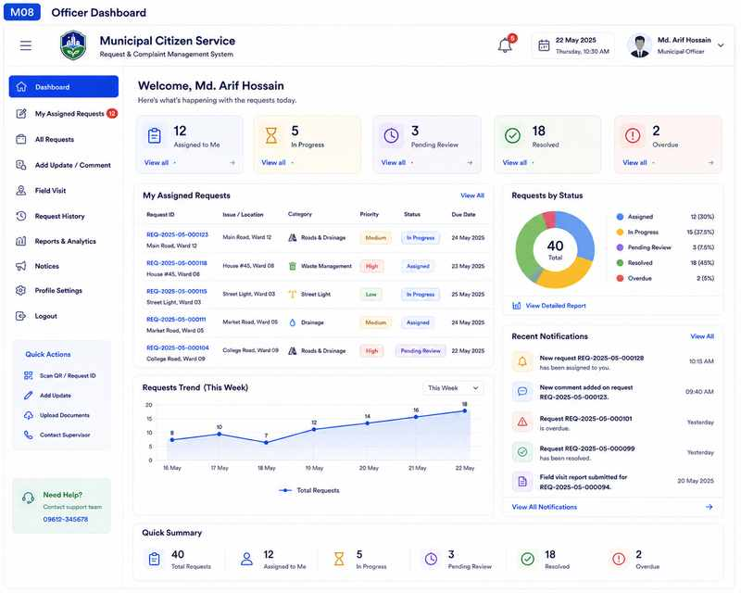
Figure 16. M08 - Municipal Officer Dashboard high-fidelity mockup

Key annotations:
- Assigned, pending, active, delayed and resolved summaries.
- Search/filter for operational triage.
- Request table links directly to processing.
- Overdue cases are easy to identify.
Concrete example: At the start of the day, an officer filters delayed cases and opens the oldest one first.

5.9 W09/M09 - Officer Request Processing
Problem addressed: Officers need operational controls, not only a read-only request view.
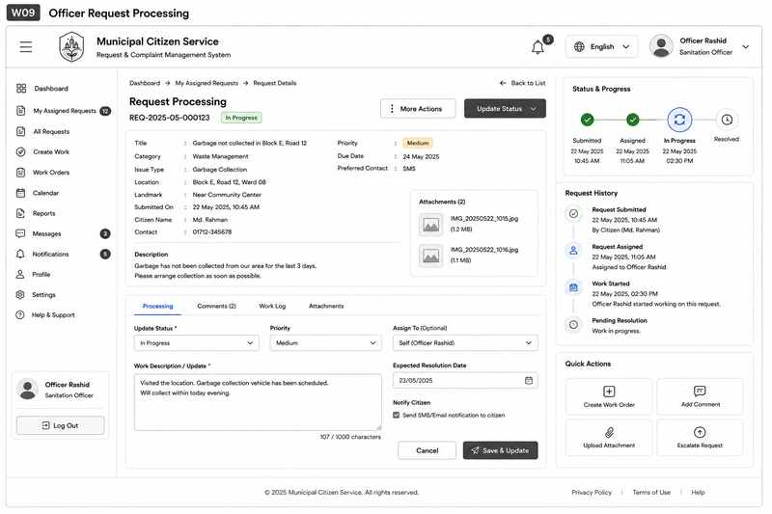
Figure 17. W09 - Officer Request Processing wireframe

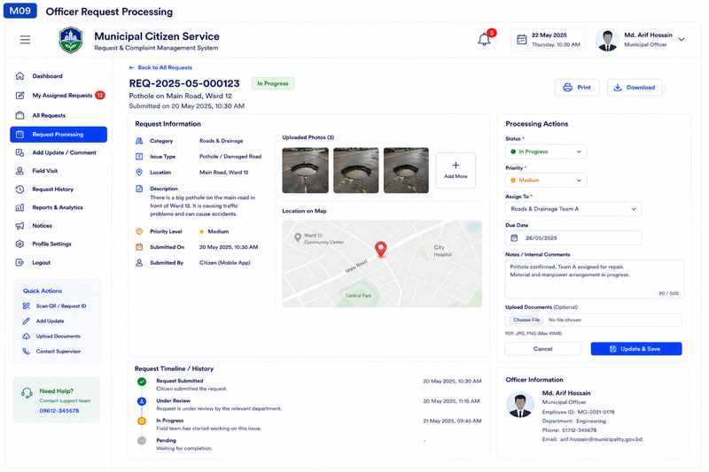
Figure 18. M09 - Officer Request Processing high-fidelity mockup

Key annotations:
- Request information and evidence remain visible while processing.
- Assignment and status controls are in one workspace.
- Progress notes and expected completion information can be recorded.
- Resolution evidence supports accountable closure.
Concrete example: An officer verifies a road report, assigns a field team, adds a progress update, and later uploads completion evidence.

5.10 W10/M10 - Supervisor Dashboard
Problem addressed: Supervisors need department-level visibility and workload awareness.
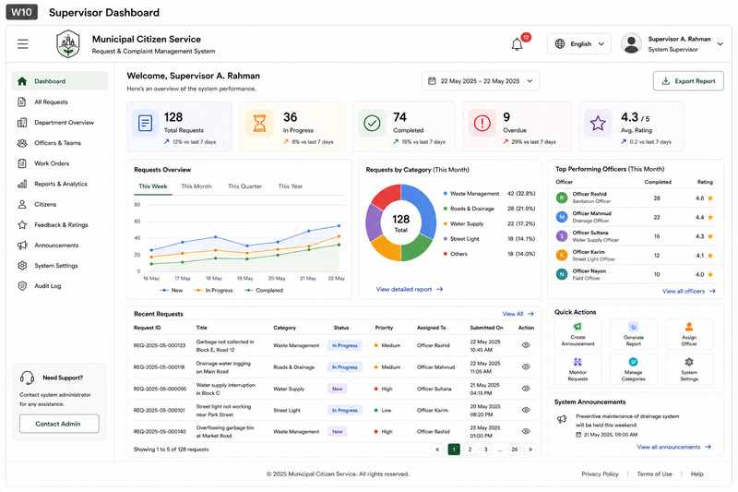
Figure 19. W10 - Supervisor Dashboard wireframe
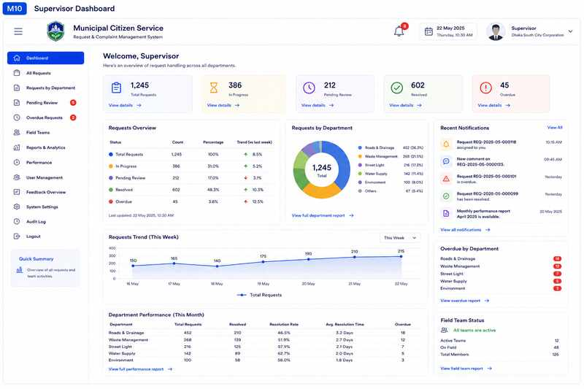
Figure 20. M10 - Supervisor Dashboard high-fidelity mockup

Key annotations:
- Summary of active, delayed and escalated work.
- Department/team workload supports balancing decisions.
- Performance indicators support monitoring.
- Direct access to cases needing intervention.
Concrete example: A supervisor notices that one team has several overdue requests and checks whether reassignment is needed.

5.11 W11/M11 - Escalated Request Review
Problem addressed: An escalation should be reviewed with full context before action is taken.
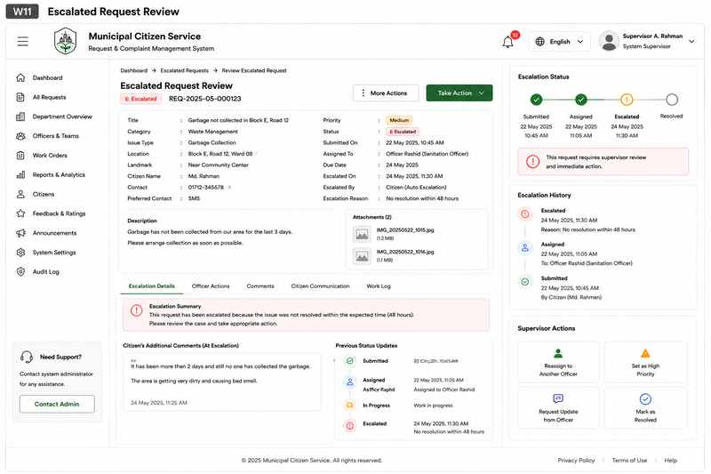
Figure 21. W11 - Escalated Request Review wireframe
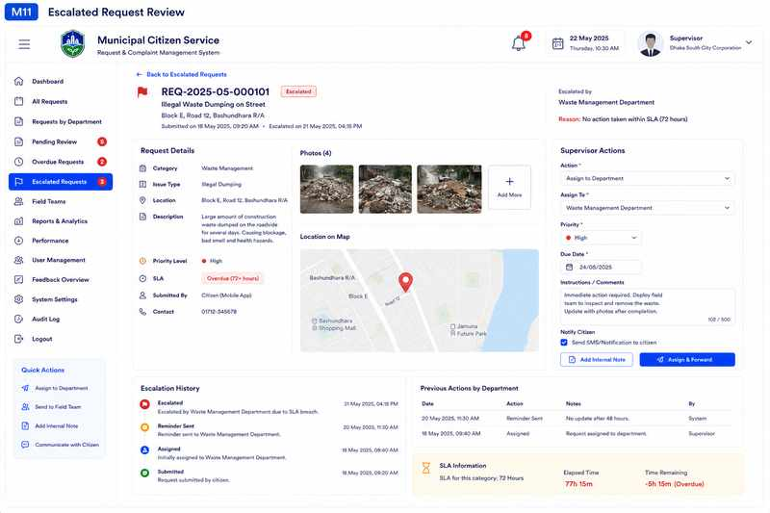
Figure 22. M11 - Escalated Request Review high-fidelity mockup

Key annotations:
- Delay reason and status history are visible.
- Assigned officer/team and previous notes are retained.
- Supervisor can reassign, raise priority or request an update.
- Supervisor actions become part of the case history.
Concrete example: A delayed waste request can be reassigned when the original team is unavailable.

5.12 W12/M12 - Administrator Dashboard
Problem addressed: Administrators need a platform-wide view and shortcuts to management areas.
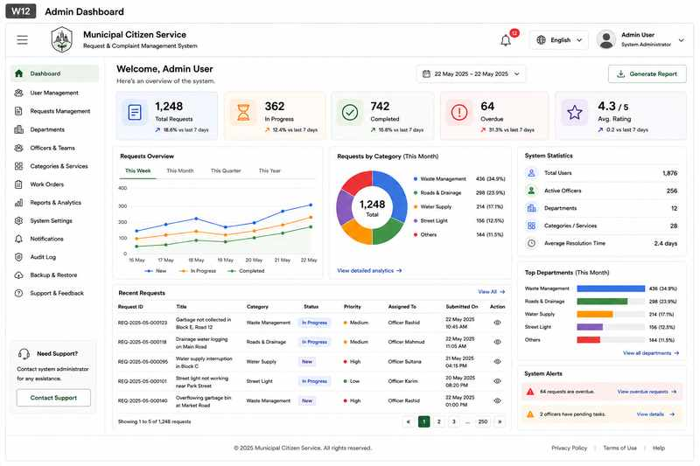
Figure 23. W12 - Administrator Dashboard wireframe
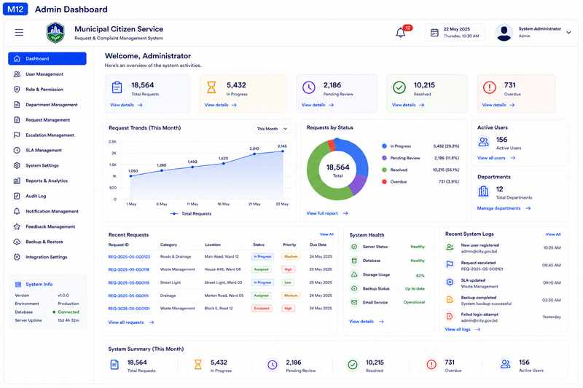
Figure 24. M12 - Administrator Dashboard high-fidelity mockup

Key annotations:
- High-level system and request summaries.
- Users, departments and service categories are visible.
- Recent activity can reveal operational or configuration issues.
- Management shortcuts reduce navigation.
Concrete example: An administrator can notice an unconfigured department and open the appropriate management area directly.

5.13 W13/M13 - Management Screen
Problem addressed: Configuration must remain controlled as services and teams change.

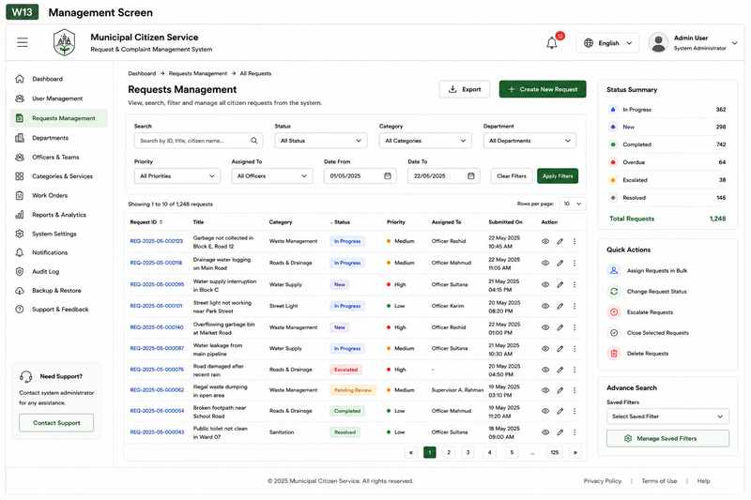

Figure 25. W13 - Management Screen wireframe

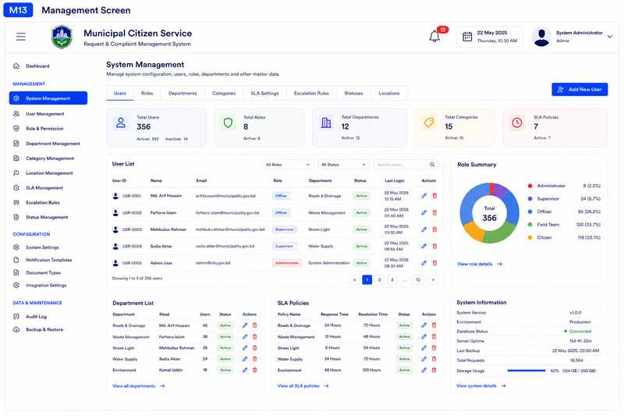
Figure 26. M13 - Management Screen high-fidelity mockup
Key annotations:
- Centralized user/role management.
- Department and category maintenance.
- Permission and settings controls.
- Search and filters support larger administrative datasets.
Concrete example: When a new Tree Maintenance service is introduced, the administrator can add the category and assign it to the responsible department.

6. User Flow Diagrams
Four key user journeys were mapped because they represent the most important service lifecycle interactions. Decision points are included where real systems require validation, waiting, delay handling or escalation rather than assuming every request follows a perfect straight path.

6.1 UF01 - Citizen Request Submission
Shows submission, validation and tracking-ID generation. Missing required information returns the user to the form without discarding entered data.
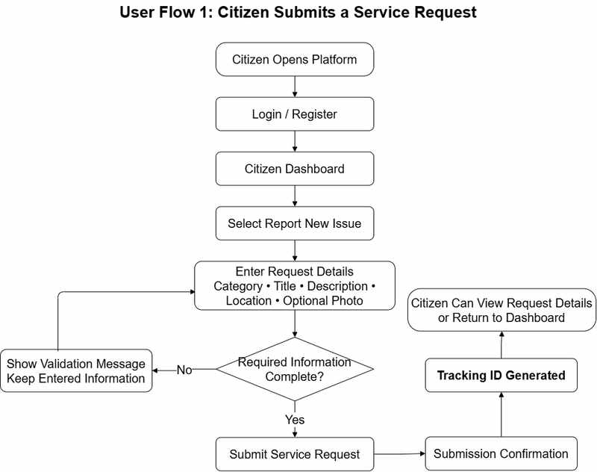

Figure 27. UF01 - Citizen Request Submission

6.2 UF02 - Citizen Tracking and Feedback
Shows how a citizen follows a request until resolution and then provides feedback.

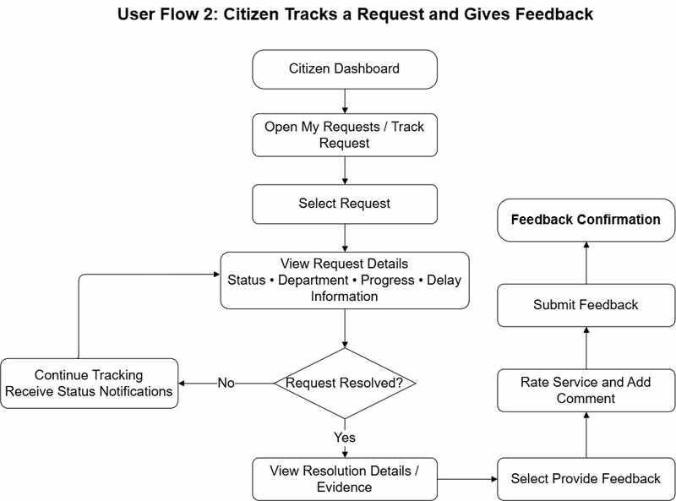
Figure 28. UF02 - Citizen Tracking and Feedback

6.3 UF03 - Officer Request Processing
Shows review, information clarification, assignment, progress updates, delay handling and completion.
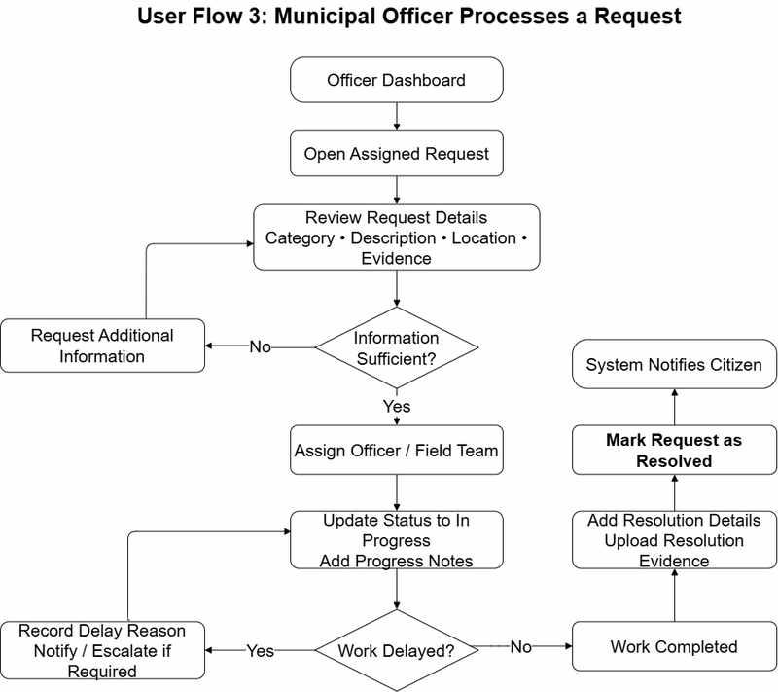
Figure 29. UF03 - Officer Request Processing

6.4 UF04 - Supervisor Escalated Request
Shows escalation review, monitoring and intervention options before returning a case to processing.

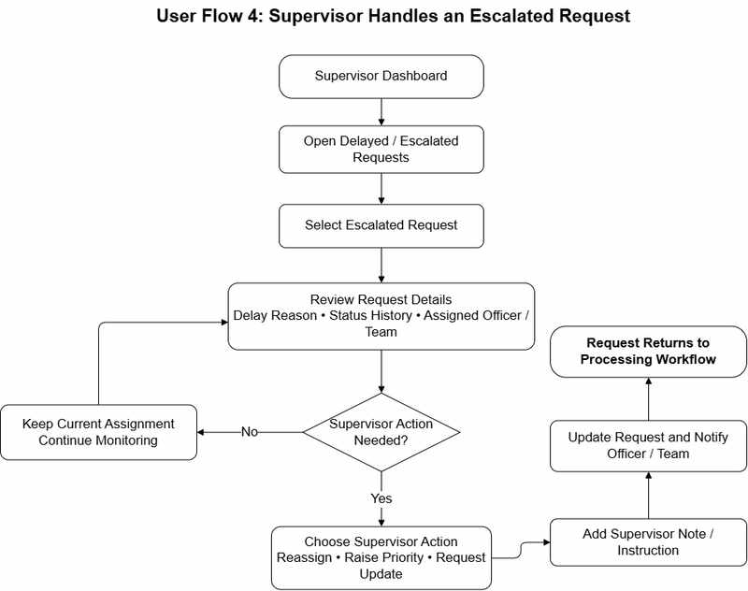
Figure 30. UF04 - Supervisor Escalated Request

7. Screen Annotations and Interaction Rationale
The annotations below summarize how the prototype connects interface choices to practical user needs. The same design logic is used consistently across the wireframes and high-fidelity mockups.

7.1 M01 - Landing / Login
Problem: Citizens need a clear starting point without being distracted by administrative features.
Design decision: Simple authentication fields with clear labels. Prominent entry to citizen services and registration. Separate staff access keeps roles understandable. Help and privacy information remain visible.
Example: A citizen reporting a broken streetlight can quickly identify how to access the service and continue to the reporting process.
UX benefit: The screen keeps the required information and actions close to the user task, reducing unnecessary navigation and making the current state easier to understand.

7.2 M02 - Citizen Dashboard
Problem: Citizens need one place to understand current requests and reach common actions.
Design decision: Report New Issue and Track Request are high-priority actions. Status summaries expose pending, in-progress, delayed and resolved work. Recent Requests reduces repeated searching. Notifications surface important updates.
Example: A citizen can see that a drainage complaint is In Progress and open its details without searching through several menus.
UX benefit: The screen keeps the required information and actions close to the user task, reducing unnecessary navigation and making the current state easier to understand.

7.3 M03 - Submit Service Request
Problem: Incomplete or vague complaints slow down municipal processing.
Design decision: Structured category, title, description and location fields. Required fields are visually identified. Photos remain optional so they do not block access. Validation should preserve previously entered information.
Example: A pothole report can include category, description, exact location and an optional supporting photo.
UX benefit: The screen keeps the required information and actions close to the user task, reducing unnecessary navigation and making the current state easier to understand.

7.4 M04 - Submission Confirmation
Problem: Citizens need evidence that a submission was received.
Design decision: Clear success state. Tracking ID shown prominently. Request summary lets the user verify key details. Next-step guidance explains what happens after submission.
Example: After submitting a waste complaint, the citizen immediately receives a reference number that can be used later.
UX benefit: The screen keeps the required information and actions close to the user task, reducing unnecessary navigation and making the current state easier to understand.

7.5 M05 - My Requests
Problem: Citizens with several reports need a consolidated history.
Design decision: Search by tracking ID or keyword. Filters by category, status and date. Status labels are text-based as well as visual. View Details opens the complete lifecycle.
Example: A citizen can locate an older streetlight request without manually remembering its tracking ID.
UX benefit: The screen keeps the required information and actions close to the user task, reducing unnecessary navigation and making the current state easier to understand.

7.6 M06 - Request Details / Tracking
Problem: The main real-world problem is lack of visibility after submission.
Design decision: Tracking ID and current status are prominent. Responsible department and progress history are visible. Delay information can be shown when applicable. Resolution details can be added after completion.
Example: A citizen can see that a pothole report was reviewed, assigned and is currently being worked on.
UX benefit: The screen keeps the required information and actions close to the user task, reducing unnecessary navigation and making the current state easier to understand.

7.7 M07 - Feedback
Problem: Authorities need a simple way to understand service experience.
Design decision: Feedback can be linked to a resolved request. Short rating scale supports quick completion. Comment is optional. Guidelines discourage sensitive or irrelevant content.
Example: A citizen rates a completed streetlight repair and adds a short note about the service delay.
UX benefit: The screen keeps the required information and actions close to the user task, reducing unnecessary navigation and making the current state easier to understand.

7.8 M08 - Municipal Officer Dashboard
Problem: Officers need to identify workload and urgent cases quickly.
Design decision: Assigned, pending, active, delayed and resolved summaries. Search/filter for operational triage. Request table links directly to processing. Overdue cases are easy to identify.
Example: At the start of the day, an officer filters delayed cases and opens the oldest one first.
UX benefit: The screen keeps the required information and actions close to the user task, reducing unnecessary navigation and making the current state easier to understand.

7.9 M09 - Officer Request Processing
Problem: Officers need operational controls, not only a read-only request view.
Design decision: Request information and evidence remain visible while processing. Assignment and status controls are in one workspace. Progress notes and expected completion information can be recorded. Resolution evidence supports accountable closure.
Example: An officer verifies a road report, assigns a field team, adds a progress update, and later uploads completion evidence.
UX benefit: The screen keeps the required information and actions close to the user task, reducing unnecessary navigation and making the current state easier to understand.

7.10 M10 - Supervisor Dashboard
Problem: Supervisors need department-level visibility and workload awareness.
Design decision: Summary of active, delayed and escalated work. Department/team workload supports balancing decisions. Performance indicators support monitoring. Direct access to cases needing intervention.
Example: A supervisor notices that one team has several overdue requests and checks whether reassignment is needed.
UX benefit: The screen keeps the required information and actions close to the user task, reducing unnecessary navigation and making the current state easier to understand.

7.11 M11 - Escalated Request Review
Problem: An escalation should be reviewed with full context before action is taken.
Design decision: Delay reason and status history are visible. Assigned officer/team and previous notes are retained. Supervisor can reassign, raise priority or request an update. Supervisor actions become part of the case history.
Example: A delayed waste request can be reassigned when the original team is unavailable.
UX benefit: The screen keeps the required information and actions close to the user task, reducing unnecessary navigation and making the current state easier to understand.

7.12 M12 - Administrator Dashboard
Problem: Administrators need a platform-wide view and shortcuts to management areas.
Design decision: High-level system and request summaries. Users, departments and service categories are visible. Recent activity can reveal operational or configuration issues. Management shortcuts reduce navigation.
Example: An administrator can notice an unconfigured department and open the appropriate management area directly.
UX benefit: The screen keeps the required information and actions close to the user task, reducing unnecessary navigation and making the current state easier to understand.

7.13 M13 - Management Screen
Problem: Configuration must remain controlled as services and teams change.
Design decision: Centralized user/role management. Department and category maintenance. Permission and settings controls. Search and filters support larger administrative datasets.
Example: When a new Tree Maintenance service is introduced, the administrator can add the category and assign it to the responsible department.
UX benefit: The screen keeps the required information and actions close to the user task, reducing unnecessary navigation and making the current state easier to understand.

8. UX, Accessibility and Measurable Design Targets
The following are proposed targets for future implementation and usability testing. They are design goals, not claims that the prototype has already achieved measured performance.

Area | Proposed Design Target
Navigation | Report New Issue and My Requests should be directly reachable from the Citizen Dashboard. Major screens should provide a predictable route back to Dashboard or the previous list.
Form efficiency | Required fields should be clearly identified; optional evidence should not block submission; validation errors should appear near the affected field.
Status clarity | Use text labels such as Submitted, Under Review, Assigned, In Progress, Delayed and Resolved. Do not rely on color alone.
Tracking transparency | A citizen should be able to understand current status, responsible department, progress history, expected resolution information and delay reason from one request-details screen.
Accessibility | Use readable type sizes, sufficient contrast, clear form labels, keyboard-friendly controls during implementation and meaningful focus states.
Responsive design | Login, submission, tracking, request details and feedback should remain usable at common mobile and desktop widths.
Error recovery | Validation should preserve already entered data and explain what must be corrected.
Role-based simplicity | Citizens, officers, supervisors and administrators should see functions relevant to their role.
Feedback efficiency | A resolved-request feedback form should fit on one screen and require only a rating plus an optional comment.
Workload visibility | Officer and supervisor dashboards should expose assigned, pending, in-progress, delayed and resolved request counts.

8.1 Proposed Usability Checks
Task | Proposed Usability Goal
Citizen login | User completes login without assistance.
Submit service request | User completes the main form without unnecessary navigation.
Find previous request | User locates a request through My Requests or tracking search.
Understand request status | User identifies current status from the Request Details screen.
Officer processing | Officer reaches processing directly from assigned requests.
Supervisor escalation | Supervisor identifies delayed/escalated cases from the dashboard.
Citizen feedback | User completes feedback on one screen after resolution.

9. Design Validation Against Real-World Scenarios

Scenario A - Incomplete report
Situation: A citizen attempts to submit a drainage complaint without a location.
Prototype response: The form highlights the missing location field, keeps all other entered information and prevents submission until the required field is completed.

Scenario B - Citizen checks progress
Situation: A citizen reported a broken streetlight two days earlier.
Prototype response: My Requests shows the case as In Progress; Request Details shows the responsible department and progress timeline.

Scenario C - Delayed work
Situation: A road repair cannot be completed within the expected time.
Prototype response: The officer records a delay reason. The request appears in supervisor delayed/escalated views for review.

Scenario D - Supervisor intervention
Situation: A field team is unavailable and the case remains overdue.
Prototype response: The supervisor reviews history, reassigns the work and adds an instruction that becomes part of the request record.

Scenario E - Closure and feedback
Situation: A waste collection issue is completed.
Prototype response: The officer records resolution details, the citizen is notified, and the citizen can provide a rating and optional comment.

10. Conclusion
The Week 2 prototype turns the Week 1 requirements into a practical UI/UX plan for a municipal e-governance service. The 13 wireframes define screen structure and navigation, while the 13 high-fidelity mockups demonstrate a consistent visual system for citizens and municipal staff. Four user-flow diagrams document important branching behavior such as validation, delay handling and escalation.
The design focuses on transparency after submission, structured request information, clear status communication, role-based interfaces and manageable staff workflows. Proposed usability and accessibility targets provide a concrete basis for implementation and later evaluation. The prototype can therefore serve as a visual specification for the next phase of frontend and backend development.

References
- Open311. GeoReport v2 specification. https://wiki.open311.org/GeoReport_v2/
- NYC311. Official citizen service portal. https://portal.311.nyc.gov/
- Bangladesh Grievance Redress System (GRS). https://grs.gov.bd/
- U.S. Web Design System (USWDS). https://designsystem.digital.gov/
- W3C Web Accessibility Initiative. Web Content Accessibility Guidelines (WCAG) overview. https://www.w3.org/WAI/standards-guidelines/wcag/

