General Information

# Playtest Questions

1. Which font is the most appealing to the player?

# Data

## First Pilot Study

|  |  |
| --- | --- |
| **Time:** | 10/30/2020 | 2:20pm – 2:28pm |
| **Who:** | 1 Roommate |
| **Where:** | First pilot test – Physical Sheet |

Participant was asked, “Rate each image based on how appealing it is to you. 1 being the most appealing, 8 being the least appealing.”

|  |  |
| --- | --- |
|  | * Most appealing? * 3,6,8 – hanging fonts * Makes him not like it * None are centered in the bottom number * 7 is the best * 1 and 2 likes the font shop of 6 but all is disliked * 1 – likes it but very generic * 8, 5 - font looks the same but one more boded. 5 more bold than 8 * Seems like just a shade lighter than edges of it. * Not sure if meant like that * Bottom right side of each image. |

## Second Pilot Study

|  |  |
| --- | --- |
| **Time:** | 11/10/2020| 5:31pm – 5:50pm |
| **Who:** | 1 Roommate |
| **Where:** | First pilot test – Physical Sheet |

Participant was asked, “Rate each image based on how appealing they are to you. 1 being the most appealing, 4 being the least appealing.”

|  |  |
| --- | --- |
|  | * 1- Seems appealing. Most aligned one. Return feels off * 2- Return far to the right. Font does not fit with the theme. Feels modern rather than 80s or 90s thing. Feels like a bar or a shop. * 3- Doodle jump. That is what popped into his mind when they saw that image. Feels like a mobile app. Looks like kind of drawn, clean and concise rather than stylized. Feels aligned with theme. Alignment issues. * 4-Stylized issues of 1 and 2. But more aligned with them. More cleanly written on. return is off. Maybe not. Perfectly aligned.   5:38pm |

|  |  |
| --- | --- |
|  | * 8 – wants shoop instead of shop. Bubbly, school esque rather than written font. $ is misaligned. Feels themed. But kid esque with it. * 5 – spray painted tag. Everything fits inside less on theme than others. “1” looks sad. * 6 – feels on theme. Stylized. Pleasing to look at. Annoyed with going off the line. Subtle differences with all the 10 gradients. Looks nice. Nice stylization. * All are different UI elements because all of them have subtle changes to them.   5:43 |

|  |  |
| --- | --- |
|  | * 1,6,7 – feel more stylized than 4. * 6 – good font but misaligned. Why dollar sign twice as big than the numbers. * 7 – read what’s there but catches the eye to see its existance at all. * 1 – it’s as if I were to write it out. Picture self with physically writing it out like that. Styled but readable. More bold and more noticeable. * 5:50pm |

## Mass playtest

|  |  |
| --- | --- |
| **Who:** | 2 Roommates, 7 people from DigiPen testing lab |
| **Where:** | Google Forms |

It is obvious which font wins, it’s the first image.

|  |
| --- |
|  |
|  |

Image 1: Mermaid Swash Caps

Image 2: Jim Nightshade

Image 3: Marck Script

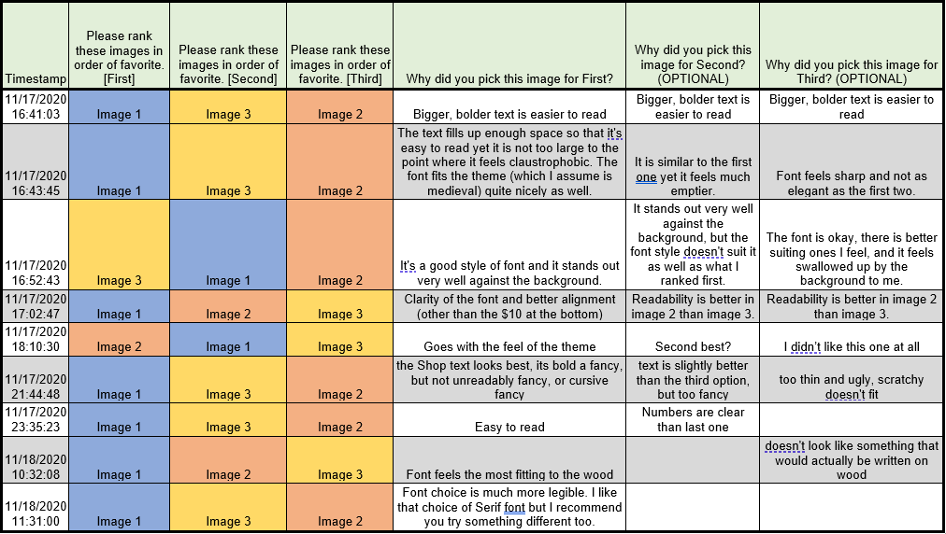

## Analysis

Most users seem to favorite image 1 because the bigger and bolder text as well as it fits with the background. However, one of the users did say that it gave a medieval look. Keep in mind, that all of these users are designers, so they prefer something that is obvious and readable than something that looks nice.

Image 1 was no user’s least favorite making it the best option. However, Image 1 is on the left of the collage of images so, that might have caused some bias towards image 1.

Image 2 seems like the least favorited by most users, but a user did comment that it felt like it matched the theme of the game more.

Image 3 is the in the middle of favoritism of both images.

## Mass playtest part 2

Looking at the best font for narrative representation.

|  |
| --- |
|  |
|  |

|  |  |  |  |  |  |  |
| --- | --- | --- | --- | --- | --- | --- |
| Timestamp | Please rank these images in order of favorite. [First] | Please rank these images in order of favorite. [Second] | Please rank these images in order of favorite. [Third] | Why did you pick this image for First? | Why did you pick this image for Second? (OPTIONAL) | Why did you pick this image for Third? (OPTIONAL) |
| 11/17/2020 16:41:03 | Image 2 | Image 3 | Image 1 | Bolder text is easier to read | Bigger/bolder text for greetings/leave is easier to read | HELLO and then I cannot read the others very well |
| 11/17/2020 16:43:45 | Image 2 | Image 3 | Image 1 | The font is bold enough to be easily read but small enough for it to fit. | Font isn't as bold as Image 2. | The text is way too large. |
| 11/17/2020 16:52:43 | Image 2 | Image 3 | Image 1 | It stands out well, which I think is paramount, and has an attractive font. | The font is very attractive, but it doesn't stand out as much; if it was a bit thicker I would rank it first. | Only a few words stand out, it doesn't feel consistent, and the font is okay but could be more attractive. |
| 11/17/2020 17:02:47 | Image 2 | Image 1 | Image 3 | The readability is superior in image 2. | Readability is better in image 1 than image 3. | Readability is better in image 1 than image 3. |
| 11/17/2020 18:10:30 | Image 3 | Image 2 | Image 1 | Nice font | Bold and clear but not the best | I had to squint too much |
| 11/17/2020 21:44:48 | Image 2 | Image 1 | Image 3 | I like the big bold letters, their readable, but not too squashed on the screen | big bold letters for the hello, but smaller for the other words, a bit small, thin and hard to read | all too small, all too thin, strangely fancy? I don't like it |
| 11/17/2020 23:35:23 | Image 2 | Image 1 | Image 3 | Easy to read | Can feel the tone |  |
| 11/18/2020 10:32:08 | Image 2 | Image 1 | Image 3 | easiest to read, which is important for a card like that | only "Hello" is easy to read | hardest to read |
| 11/18/2020 11:31:00 | Image 2 | Image 1 | Image 3 | Again, it's a serif font that is much more legible than the rest. |  |  |

Based on the players results Image 2 won with a land slide for the font used in narrative.

Image 1: Eagle Lake

Image 2: Aladin

Image 3: Jim Nightshade

# Conclusion

Through the many tests of multiple tiers of font we narrowed down the font’s for the text both for written signs and potentially books, and narrative script.   
  
**Written text:** Mermaid Swash Caps (Need to donate to the creator to get the certificate)

**Speech text:** Aladin (DigiPen Library)

We now know what fonts fit best using the context of the art style and usage. We can now move forward with putting the selected fonts into the game in their appropriate places.