* Select a location on your machine where kafka would be executed. For eg. C:\Work
* Download <https://packages.confluent.io/archive/6.2/confluent-6.2.0.zip> in this location & unzip it to get folder confluent-6.2.0
* Inside folder confluent-6.2.0 create folder “data” & then inside “data” 4 folders -: zk,kfk1,kfk2,kfk3
* Type *env* in windows run to open environment variables window
* Click on Path & then edit button
* 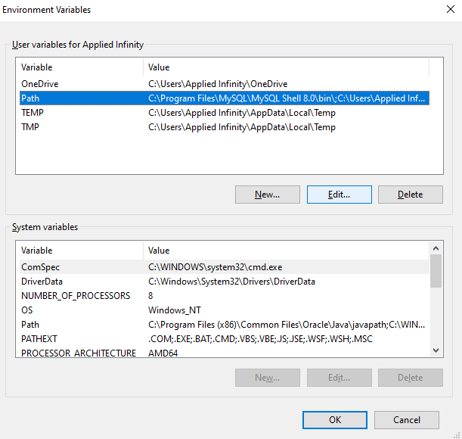
* Click on New after Edit button click and enter the path according to your location
* 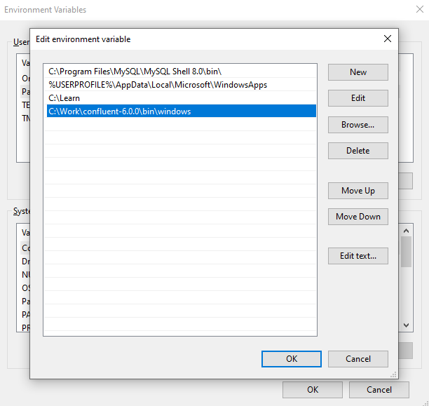
* Type *network* in windows run to open network status window & click on properties
* 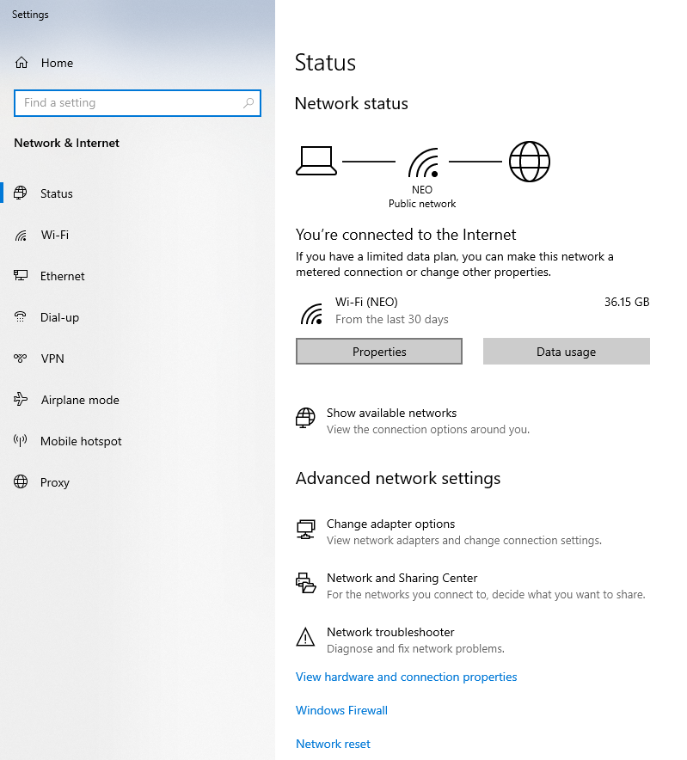
* In properties section note down ip4 address
* 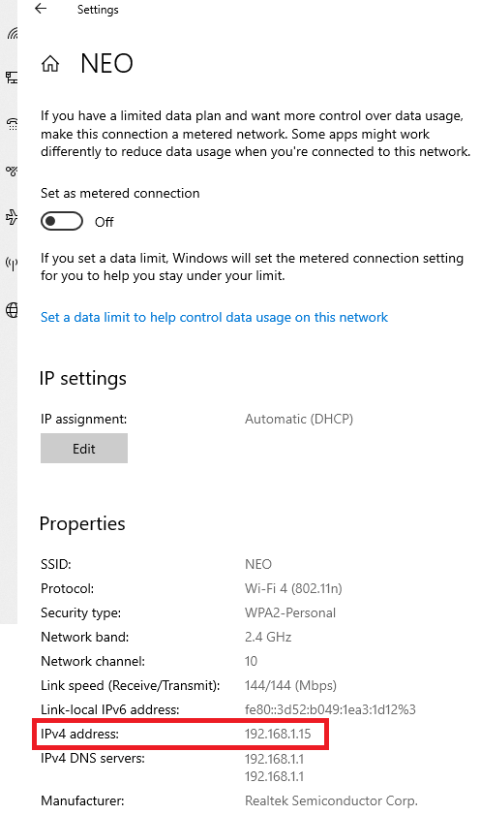
* Go to folder confluent-6.2.0 and inside folder bin-> windows open kafka-run-class.bat file in NOTEPAD / Notepad++
* Press enter on line no 45 where you will see this written -:
  + rem Classpath addition for kafka-core dependencies
* add the following below it & save the file

*if exist %BASE_DIR%\share\java\kafka\* (*

*call:concat %BASE_DIR%\share\java\kafka\\**

*)*

* open <https://bit.ly/contactrkk-training> in browser & from inside KFK folder download
  + server1.properties
  + server2.properties
  + server3.properties
  + zookeeper.properties
* open zookeeper.properties and on line 16 change path according to your location
* open server1.properties, server2.properties, server3.properties & replace all occurrences of 192.168.1.15 with your IP address.
* On line no 60 in all three files above set path according to your location
* Go to folder confluent-6.2.0 and inside folder etc-> kafka copy/replace all above 4 files.
* Open up multiple command prompts
* 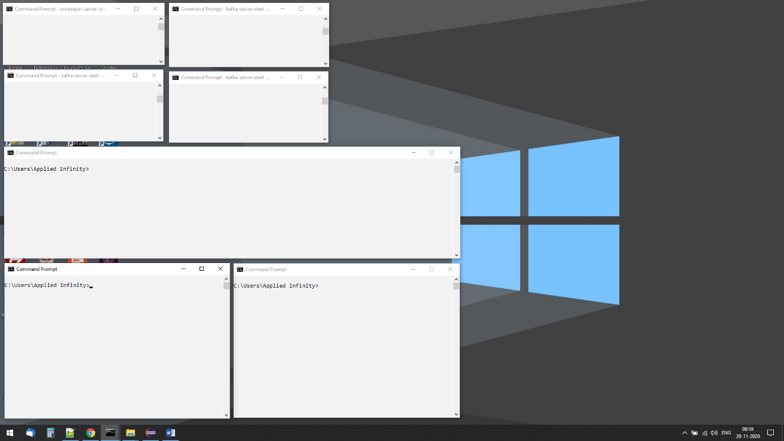
* On terminal 1 run following command with path according to your location
  + zookeeper-server-start C:\Work\confluent-6.2.0\etc\kafka\zookeeper.properties
* On terminal 2 run following command with path according to your location
  + kafka-server-start C:\Work\confluent-6.2.0\etc\kafka\server1.properties
* On terminal 3 run following command with path according to your location
  + kafka-server-start C:\Work\confluent-6.2.0\etc\kafka\server2.properties
* On terminal 4 run following command with path according to your location
* kafka-server-start C:\Work\confluent-6.2.0\etc\kafka\server3.properties
* 3 NODE KAFKA CLUSTER IS UP & RUNNING !!!