SMART ENVIRONMENTAL MONITORING USING IOT

IMPLEMENTATION OF DESIGN:  
  
             The main goal of the project is to monitor indoor air quality continuously and accurately. The primary objective is to implement a cost effective IoT-based system that encompass a network of low-cost sensor devices strategically placed indoors, capable of measuring parameters such as co2, particulate matter, temperature, pressure and humidity. Additionally, noise level can also be included in the part of the project. The data collected from these sensors will be processed, analysed, and made accessible through an intuitive user interface.  
  
A detailed breakdown of the steps involved in the project are explained below:  
  
STEP 1. PROJECT PLANNING AND REQUIREMENT ANALYSIS:  
  
         The objective of the project have been discussed and concluded with the crew members. Since the domain of environment monitoring is vast, the air quality in indoors is made the goal of the project. Sensors and other hardware requirements are choose based on brainstorming the positives and negatives of the components available in the market. The main aspects considered are the cost, durability and accuracy. The acquired data is backed up in a cloud platform for easy access of past records and to manage the data with security.  
  
STEP 2. HARDWARE SELECTION:  
  
          After brainstorming and collecting data about all the viable choices have been narrowed down. IoT based monitoring system requires hardware components, including microcontrollers, sensors (i.e., CO2, PM 2.5, temperature, humidity). The power efficiency, durability, accuracy, and low cost are some of the attributes considered while selection of the hardware.  
  
STEP 3. SELECTED HARDWARE:  
  
          The following are the selected hardware components for the project:  
  
      1. BME680 Sensor: The BME680 is a versatile environmental sensor manufactured by Bosch sesortec. It is designed to measure multiple environmental parameters simultaneously. Parameters are temperature, pressure, humidity, and gas quality i.e., volatile organic compounds (VOCs) and air quality index (IAQ). The sensor operates between 1.7V to 3.6V. The standby power consumption is between 0.15 to 1 micro ampere. It offers high accuracy and precision in its measurements. Its compact size and low power consumption adds to its advantages.

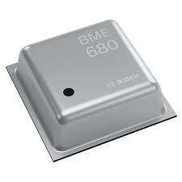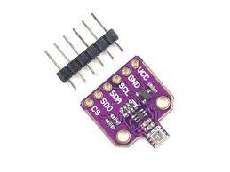

                Gas: IAQ, VOC, CO2  
                Temperature:  -40 to 85 degrees Celsius  
                Humidity: 0-100 %  
                Air quality index: 0-500 ppm  
       
      2. Wemos D1 Mini Board: The board has ESP8266-12E Chip, which is a 32 bit highly advanced and fast controller. The chip has a built-in Wi-Fi chip that has the ability to upload the data to the internet or server using a Wi-Fi Network.

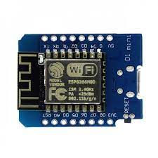

      3. Breadboard: Breadboards are often used in the prototyping phase of IoT projects for monitoring environmental systems. They are versatile prototyping tools. We plan to use it for Sensor Integration, Microcontroller connectivity and power supply. Although they are very easy to work with, they are more suitable for temporary environment of work.

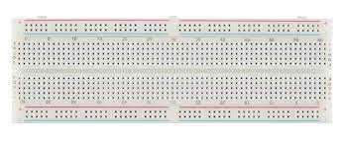

4. Micro USB Cable and Connecting wires: Both of these components are used for connecting various parts as well as to connect the set up into a laptop for programming purposes.

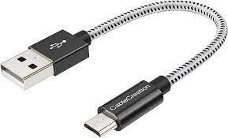

STEP 4. WORKING:

Below is a schematic illustrating the connection between the Wemos D1 Mini or ESP8266 and the BME680 Sensor. Connect the BME680's SCL and SDA pins to the D4 and D3 pins on the Wemos Board, respectively. Supply power to the sensor by connecting the 3.3V VCC to the 3.3V Pin on the Wemos Board.

Ensure that you connect the SDO pin to the Ground (GND). This connection is crucial as the original code is configured to operate with the alternative I2C address (0x77) when the SDO pin is grounded. By linking the SDO pin to the Ground, you can access this specific I2C address on the BME680 sensor.

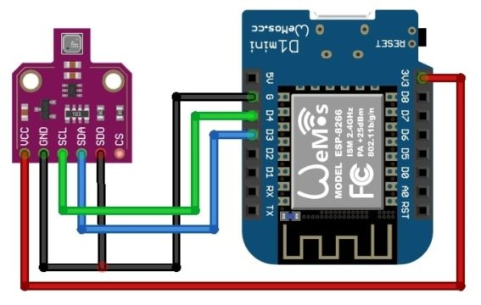   
   

        PROTOTYPE MODEL:  
             
            I am planning to prototype a smart environment monitoring system using IoT without acquiring hardware, I can utilize simulation tools like Wokwi, Tinkercad or other similar platforms to create a software model. Next step is to create virtual components that represent the sensors and other IoT devices. write code or scripts to simulate the behaviour of the virtual devices, this code must mimic the real-world functionality of the sensors. Finally, pseudo data is collected from the dataset and analysed for the performance.  
  
STEP 5. SOFTWARE DEVELOPMENT:  
  
          To facilitate the presentation of the gathered data to users, we will create a dedicated software application. This application will efficiently summarize the various environmental parameters. Since we are exclusively focusing on the software aspect, we will feed the collected dataset into the application to generate a user-friendly representation of pollutant levels. This information will be easily accessible and displayed on a connected mobile phone through the utilization of the Blynt App.

STEP 6. CLOUD INTEGRATION:

          Cloud can be integrated with the system to back up the past observations of the system. A cloud-based server is set up to save the database and manage the incoming data from multiple devices. Either IBM Cloud or AWS is viable choices. IBM Cloud is known for its focus on hybrid cloud solutions, which enable organizations to integrate on-premises and cloud-based resources seamlessly. It offers various deployment models, including public cloud, private cloud, and hybrid cloud, to cater to different business needs. AWS is known for its global presence, with data centres in numerous regions worldwide, allowing businesses to deploy resources close to their target audience for reduced latency.  
  
  
STEP 7. TESTING AND VALIDATION:  
  
           The output produced by the simulation is observed and ensured that readings is being recorded. The code is then tested for errors and other faults.  
  
STEP 8. DOCUMENTATION:  
  
           The source code and simulation will be documented and stored for future uses. Development of the prototype into a physical model will be discussed among the team and executed accordingly.  
  
  
OUTCOME OF THE PROJECT:

The envisioned result of this project is the development of an affordable indoor air monitoring system within the scope of IoT technology. Given the tendency for indoor air quality to be overlooked and the prohibitive costs associated with current monitoring systems in the market, the primary objective of this project is to deliver precise and reliable results, all while ensuring affordability, thus enabling broader accessibility for the general public.