# **PRD: AppBundle**

## **Vision**

AppBundle will provide the heavy mobile users a simple, fast and reliable storage solution for their applications and data without an overhead of memory shortage. Existing solutions do not provide an easy way to store the entire application on cloud. AppBundle will do this for the user’s by storing the APK of the application on the cloud servers, allowing the users to retrieve it as and when required; giving the feel like the application is working on the local device.

## **Motivation**

**Background**

The mobile application industry is booming, with more than 2.7 billion smartphone users and 1.35 billion tablet users worldwide. If you spend a second during the day looking around, I believe you will find everyone’s eyes on their mobile devices. That being said, about 90% of mobile time is spent on apps. This is inspiring for anyone who owns or plans to develop applications. In order to succeed in this area, users need to download and use your application. The problem on users' side was they would receive a warning message of "**Insufficient storage space**". Multiple categories of applications are downloaded by the users based on their preference. Amongst them the major category that consumes large chunks of memory are: games, business, market, visual designs, social media etc. All of this cannot be installed due to insufficient memory.

## **Customer Segments**

In the United States, the most popular smartphone operating systems/platforms are Google’s Android and Apple's IOS. On an average, as of April 2018, U.S. adults aged 35 to 54 years accessed mobile apps 7.7 times per day. The national average daily mobile app access rate was 8.3 times per day. The most frequently used group is millennium, aged 18 to 34，The second largest group is teenagers, aged 13 to 17.

The statistics provide the percentage of U.S. mobile device users who downloaded apps at least once a month as of April 2018, broken down by age. During the survey, 74% of millennial users downloaded apps to their mobile devices every month. Therefore, the target users are the group with high coverage of mobile phone use: the young and middle-aged mobile phone users mentioned above

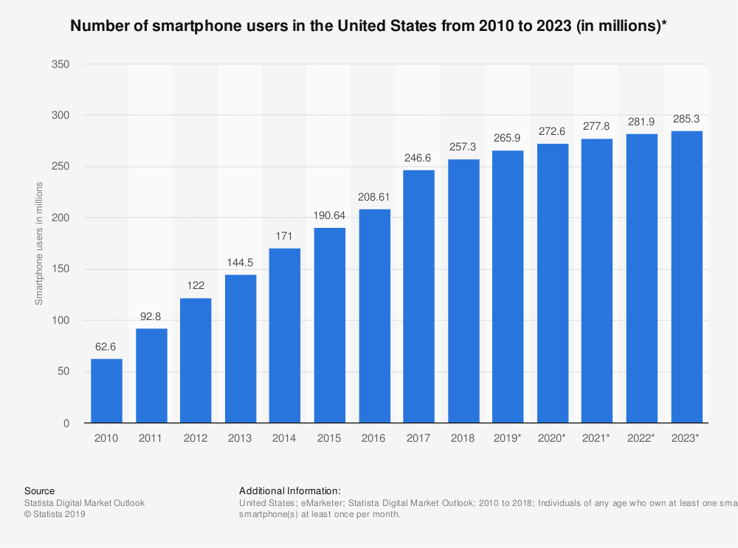

**Number of Smartphone user in U.S. from 2010 - 20123(in millions)**

## **Unmet Needs**

Observations indicate that the underlying operating system takes up a lot of space, which leaves users with fewer options to play with memory. With the advancement of technology, the operating system now consumes relatively little memory, but it is still not efficient enough. This makes us only rely on external resources such as SD cards or hard drives to store our data, which is very troublesome. In addition, it is inconvenient to use multiple SD cards. In recent years, the image quality of any smartphone has far exceeded imagination and eventually took up a lot of space. Automatic updates, unmanaged applications, undeleted files, etc. are common problems faced by everyone today, and ultimately lead to a major problem: insufficient memory.

Users not only need to save the data on the cloud server, but also need to save the application APK on the cloud to avoid storage problems. AppBundle will stream data and code resources from the cloud server to the application when necessary, allowing the application to save memory on the phone. This technology is particularly suitable for applications with scarce resources wrt to games, videos or graphics, so it is more useful to users. The concept of on-demand services will be implemented, which will make users feel that the application is stored locally on the device instead of being called from some external source.

## **Existing Solutions**

Cloud platform is an excellent resource that can keep data safe and available anytime, anywhere. DropBox, Google Drive, SugarSync, IDrive, Amazon Drive and other applications allow us to store application data on cloud services. But the point is, why is it just data? Why not store the application itself on the cloud that generated this data? The problem with these applications is that they are all developed for desktop applications so they are not advanced enough in mobile applications. Amazon has released Drive for mobile applications to make the process faster. But this is a read-only file with synchronization issues. The file being viewed cannot be edited or moved from the mobile device. This puts restrictions on users, and in fact does not achieve the main purpose of using this application.

## **Storyboards & Verbal Use Cases**

Use Case :

A college student,Sara, who is very sociable and often frustrated by the lack of space on her phone, the constant need to delete files and apps, and was looking for a cheap cloud storage plan.

1.After she installs AppBundle, she easily creates an account and logs in .

2.Firstly,she goes to the menu and clicks help to chat with customer services and find use instructions.

3.Then she clicks Apps to see what’s new and finds interesting Apps and add to her favorites 4.And she goes to drives to select files to share with friends from contacts.

5.After that,she goes to the backup page from the menu on the home page ,and finds backup files to download and delete.

6.In addition,she opens the subscription page to see if there is any great plan,and view plans’ details to find the most appropriate plan and pay for it to subscribe successfully.

7.Then she goes to manage her new plan and enjoy all the privileges her plan includes.

8.Next,she finds settings to set specific settings to make AppBundle more suitable for her to use.

## **Detailed Design & Features Description**

**Design principles**

* ***Designed for 80% of mobile users***
* ***Servers available for disposal***
* ***Adaptive, Scalable and Robust***
* ***Self managed servers with well encrypted security***
* ***100% uptime and service availability***
* ***High Performance Computing***
* ***Continuous integration and deployment***
* ***Modern/clean***
* ***Backward function***
* ***Operational excellence***
* ***Intuitive to users***
* ***Personalized Settings to increase user compatibility***

## 

## **Information Architecture**

## 

## **Features & Functions**

|  |  |  |
| --- | --- | --- |
| **Feature** | **Detail** | **Dependencies** |
| **Home View** | Users can view the home page, which is divided into several sections  1) Login and registration entry  2) Apps view  3) Icon entries  4) Menu options | Correct download and installation of application |
| **Menu Options** | 1) My Account  2) Settings  3) Backup  4) Subscription  5) Trash  6) Help |  |
| **SignUp** | Users can register to AppBundle by providing the following information   * Username * Password * Confirm Password * Email ID * Phone Number * Avatar(Profile picture) * Security Question | 1) Accept correct terms and conditions and get legal approvals to store the user’s information.  2) Criteria fulfillment for the required info |
| **Login** | Users will be able to log into the AppBundle by username and password  The user name and password will be validated. | Credential validation should pass |
| **Reset Password** | The user will be able to reset their password in case they forget by using the registered email address, phone number or security question. | Should meet the the credential requirements of password set by AppBundle |
| **Update your profile** | 1) The user will be able to edit/update their profile.  2) Username and Password  3) Subscription  4) Space speed  5) Phone Number  6) Email ID | Validate the updated information through the email sent on registered email id |
| **Apps** | Users will be able to enter the category view through the “Apps” icon on the home page and will be able to search and view today's apps |  |
| **My Drive** | Users will be able to access the views of drives from the “My Drive” icon on the home page, and will be able to search and select files to rename, delete, copy, move, share, and download |  |
| **Share files and chat with friends** | Users will be able to select the file after the choice of sharing mode and then choose the friends to share the file and chat |  |
| **My Favorites** | Users will be able to enter favorites through the "Favorites" icon on the home page, and will be able to search for Apps to add favorites |  |
| **Settings** | Users will be able to go to the Settings feature page through the Settings option in the home page menu option, make different personalized Settings according to different Settings options |  |
| **Backups** | Users will be able to go to the backup feature page through the backups option in the home page menu option and personalize it differently depending on the backup option |  |
| **Subscriptions** | Users will be able to access the subscription feature page through the subscription option in the home page menu option, to view the details of various subscription plans and to successfully subscribe, manage their subscribed plans to change or delete | The subscription in user management is consistent with the plan that the user subscribed to |
| **Make payments** | Users can select the payment method and fill in the payment information, and then pay for selected plan | The payment method must be set in the database and must be authentic |
| **Trash** | Users will be able to add to push unwanted files to trash through the “Trash” option on the home page menu option, delete and recover deleted files as well as empty the entire trash space |  |
| **Help** | Users will be able to seek help through the “Help” option on the home page menu option, can select questions according to the topic to get the answers, can choose to chat with customer service, send questions, select hot questions and upload files for more info |  |
| **Content pages –**  **AboutUs, Policy, Permission** | The content pages such as about us, Policy, Permission consist of official content and more about app info |  |

## **MVP: Minimum Viable Product**

Priority 0 – Critical Features

* Can create Account and Login AppBundle
* Can edit personal profile
* Can create payment method (credit card info OR paypal info )
* Can view apps based on featured and search
* Can view drives and backups and share with contacts
* Can add file in favorites and edit and search
* Can view plans and pay to subscribe successfully (by credit card OR paypal )
* Can view personal subscription and details
* Can view trash and clean up space
* Can view settings based on features
* Can contact help center
* Maximum Security

Priority 1 – Nice to have features

* Can add, copy, move, delete drives, backups and favorites while in view
* Can add, edit, delete credit card info & paypal info while in view
* Can stop and change subscriptions while in view
* Can delete and recover files in trash based on selection and features while in view
* Can add associated account based on contact methods
* Minimum latency

vNext

* Can have multiple subscription plan
* Can change the period of validity in trash
* Notifications customerization
* Robust and concurrent data
* On the go updates with minimum lag

vLongTerm

* Intelligent customer service
* Recommended Apps and subscription plans
* Coupon code activity
* Can provide a platform for advertising
* Community groups

## **User Walkthroughs: Visual Use Case Walkthroughs with Comments**

**After AppBundle is installed, the user goes to the home page**

|  |  |
| --- | --- |
| “**Login & SignUp**”: Enter on login page  **“Menu”**: Shows the main menu-  **“Apps”, “Drive”, “Home”, “Favorites”**: Go to corresponding function page | **1&2:** Sign In by filling in account information  **3:** Create a new account  **4:** Back to Home page  **5:** Choose a third-party platform to sign in |
| **Click the create account button to enter the sign up page**    **1:** Fill in the registration information  **2:** Upload picture from local storage as profile picture  **3:** Create and Save Successfully. Redirect to login page  **4:** Go back | **After clicking the menu icon, the home page displays all menu items**    Each of the six items in the menu goes to the corresponding function page |
| **After clicking Apps icon on Home page, user enters into categories page**    **1:** Today icon to see Today’s Apps page  **2:** Apps icon to see Apps page  **3:** Search icon to see search page  **4:** Go back to Home page | **After clicking Today icon into Today’s Apps page**    **1:** Show today’s Apps  **2&3&4:** Go to corresponding pages  **5:** Go back |
| **Input ”Dancing” in search box and click search on Apps page, it shows search results**    **1:** Input “Dancing” as search content  **2:** Click search button to search and show results  **3:** Click to go to Today’s Apps page  **4:** Click to go to category page  **5:** Click to go back to Home Page | **After clicking MyDrive icon on Home page, user enters into MyDrive page**    **1:** Click to go to settings page  **2:** Input search content and click button to search  **3:** Click to go to Trash page  **4:** Click to show all functions items of selected file  **5:** Click to go back to Home page |
| **After inputting and clicking search link, user enters into search result page**    **1:** Click to go to settings page  **2:** Search results  **3:** Go back | **After click functions of selected file,all items show on page**    **1:** Items go to corresponding function page  **2:** Click Close to close all functions items on this page |
| **After clicking share item,the page shows all share methods selections**    **1:** Methods items: AppBundle Friends/Facebook Friends/Googlecloud Friends/Through Link/Through QR code  **2:** Click to close share items  **3:** Go back to Home Page | **After selecting item of AppBundle logo, user enters into the Select page**    **1:** To create a new share  **2:** To share with selected friend  **3:** Go back |
| **After clicking “Create a new share”,user enters into the Contacts page**    **1:** Switch between different address books  **2:** Choose one or several friends to select  **3:** Click to confirm to share file | **After clicking confirm to share, user enters into the Friend chat page and see file shared success**    **1:** Shared file success  **2:** Input message to chat with friend  **3:** Click to upload files to share with friend  **4:** Go back to contacts page |
| **After clicking MyFavorites icon on Home page**    **1:** Input and Click search to see search results  **2:** Choose sort methods(default is by time)  **3:** Select files to be favorite filles  **4:** Go back to Home page | **After clicking sort by name on MyFavorites page , it shows sort results**    **1:** Choose sort methods(sort by name) and show results as follow  **2:** Go back |
| **After input”App2” in search box and click search on My Favorites page ,it shows search results**    **1:** search for results  **2:** results as searched  **3:** go back | **After clicking MyAccount item in the menu of Home page, user enters into Profile page**    **1:** Click to make editions of profile  **2:** All informations of profile  **3:** Click to change account status  **4:** Click to logout  **5:** Click to delete this account  **6:** Go back to Home page |
| **After clicking Settings Item in menu on Home page ,user enters into Settings page**    **1:** Click settings items go to corresponding page  **2:** Click AppBundle logo to go to Home page  **3:** Go back to Home page | **After clicking Account Management item on Settings Page ,user enters into Account Management settings page**    **1:** Click to detect account security score  **2:** Click items to go to corresponding account management settings pages  **3:** Go back to Settings page |
| **After clicking “Login password “on Account Management Settings Page ,user enters into Login password Settings page**    **1:** Input and edit new password  **2:** Click to confirm to change password  **3:** Go back to Account Management Settings page | **After clicking “Bind email“on Account Management Settings Page ,user enters into Change email Settings page**    **1:** Click to change email address  **2:** Go back to Account Management Settings page |
| **After clicking “Bind mobile phone number“on Account Management Settings Page ,user enters into Change phone number Settings page**    1:click to change phone number  2:go back to Account Management Settings page | **After clicking “Associated account“on Account Management Settings Page ,user enters into Associated account Settings page**    **1:** Choose search method to find associated account  **2:** Go back to Account Management Settings page |
| **After clicking Network Settings item on Settings Page ,user enters into Network Settings page**    **1:** Click radios to change statuses of each items  **2:** Go back to Settings page | **After clicking Message Reminder Settings item on Settings Page ,user enters into Message Reminder Settings page**    1:click radios to change statuses of each items  2:go back to Settings page |
| **After clicking Message Reminder Settings item on Settings Page ,user enters into Message Reminder Settings page**    1:click to view policy agreement  2:click to view permission description  3:go back to Settings page  4:go back to Home page | **After clicking permission description on About Us Page, user can view**    1:go back to Settings page |
| **After clicking Backups item in menu on Home page ,user enters into Backups page**    1:click to see file functions  2:go back to Home page | **After clicking functions icon of selected file,it shows all functions items**    1:choose items go to corresponding functions pages  2:click to close functions items |
| **After clicking rename function,user can edit selected file name**    1:click to input content to rename file  2:go back to Backups page | **After clicking Subscription item in menu of Home page ,user enters into Subscription page**    1:click to manage subscriptions  2:click price buttons to make a payment  3:click to see details  4:click to see policy  5:go back to Home page |
| **After clicking “Policy” on Subscriptions page , user enters into Policy page**    1:go back to Subscriptions page | **After clicking “My subscriptions” on Subscriptions page ，user enters into manadement page**    1:click specific privileges to see details  2:click to stop the existing subscription and go back to Subscription page  3:go back to Subscription page to subscribe another plan  4:go back to Subscription page |
| **After clicking “Want to see Details?” on Subscriptions page ，user enters into details of plan page**    1:click specific privileges to see details  2:click to subscribe this plan and go to payment page  3:go back to Subscriptions page | **After clicking “Subscribe now” button on Details page ,user enters into payment page**    1:click to not use credit card  2:input and edit informations  3:click to change payment method to go to paypal payment page  4:click to pay fo plan  5:go back to Subscription page |
| **After clicking “Want to use paypal?” on Payment page, user enters into paypal payment page**    1:click to not use paypal  2:input and edit informations  3:click to change payment method to go to credit card payment page  4:click to pay fo plan  5:go back to Subscription page | **After clicking Trash item in menu of Home page ,user enters into Trash page**    1:click items to choose file to delete  2:click to clean up all space  3:click to recover all files in trash  4:go back to Home page |
| **After clicking “Delete All”on Trash page, user enters into empty Trash page**    1:go back to Trash page | **After clicking Help item in menu of Home Page ,user enters into Help page**    1:input and search help questions  2:choose topics to see questions items  3:click to chat  4:choose ways to contact  5:footer items go to corresponding page 6:go back Home page |
| **After clicking “Chat with us “on Help Page, user enters into chat page**    1:choose hot issues to send  2:input messages to chat  3:upload files to send in chat  4:go back to Help page  5:click to refresh to change issues |  |

## **Roadmap / Timing**

## The product is launched with the splash page where customers can register themselves in order to take part in our beta application launch. The customer’s email address and contact details are collected through the registration and they will be notified with the new features, updates and versions of the application. After the launch customers can use the new application, its features, report bugs, and give feedback.

## 

## **Alpha Launch:** Based on the initially designed wireframe we built all the pages to our AppBundle application. Initially all the features are built into the app given all the teams in order to test and report the bugs. This is not the official launch of the application but rather an internal demo to get a better idea of the status of the application. The reported bugs will be fixed and tested again which will take a few weeks in the timeframe. Once the alpha version of the application is launched and receives enough feedback from the customers, fix them and release our beta version which is our Minimum Viable Product. This is carried out in the first quarter of the year.

## 

## **Beta Launch:** In this beta launch, we will fix all the bugs from alpha launch and add additional new features. After the launch, the application is tested by the testing team for the second round and provides feedback on the technical team. This is carried out in the second quarter of the year and the development team gets to

## Add or change features and functionalities according to the user needs.

## Make room for more new features that can be developed in the future.

## Fix bugs in the beta version and test to make a fully functional application before it is fully launched with its features.

## 

## **Version 2:** After the beta launch, the major features of the application will be working because we have carried out various rounds of bug fixing, application testing, and feedback have been taken seriously. The application went through various rigorous quality assurance and testing of its features. A lot of importance is given to increase encryption and authentication on the server side in this version. The privacy standards have increased by giving a lot of priority to them as the user base is increasing and this will be released in the third quarter.

## 

## **Version 3:** The New features and some additional features that are having a lot of demand from the customers will be added in this version. The feedback from the testing team will also be considered during this enhancement. The app is marketed through PR campaigns, social media advertisements and digital marketing campaigns. This will be released in the fourth quarter.

## **Metrics**

## These metrics are applicable to both the IOS users and Android mobile users. The Key Metrics and its computation are as follows:

## 1. User Traffic to the application: In the early stages of the product, the traffic into the application will determine the outreach to its customers. This is important in order to increase the market for AppBundle. The traffic is analyzed over time to see the growth of the application.

## 2. User adoption: The number of times the application is downloaded and used. The total number of downloads are taken down every month, quarter and a year and this is analyzed over time. The total time spent by the user everyday on the application is collected and synthesized to know the user adoption.

## 3. The Network Latency: We wish to give the customers a feel that they are running the application from their local device itself. This can be achieved if there is no lag when handling the application and the operations done with it. Hence we have to measure this metric and keep no latency and in order to access the service quickly.

## Capacity of the server: Capacity is the size of the workload compared to the available infrastructure. It's a key to balance supply and demand. It is important to measure this metric because if there is a surge in the number of users we should have a capacity to handle it. A good capacity should be ensured in order to actually deliver the seamless service to the customers.

## 5. Purchases: We have to estimate the cost it takes to give the cloud service for every customer. The repetitive expense of all engineering, support, account management, customer service, and billing activities in addition to all physical infrastructure and systems required to keep up a present customer, including completely stacked work costs gives the total service cost. We have to keep the cost as low as possible by considering all the expenses and market changes, in order to attract more customers for premium subscriptions. As the purchases increase due to low cost, the sales, revenue generation and the profit also increase. These are examined over time to see the growth of the app.

## 

## **International**

## Everyone uses mobile phones nowadays and most of the work is done through them. So, people will be looking for alternatives in order to solve insufficient storage. At the same time, we can’t launch the application worldwide. First, we are testing the application for the state of Massachusetts and then slowly launch it to other states of the United States. Meanwhile we can increase the capacity of the cloud servers. The states are having different rules in order to comply with user’s data security and meet the security standards of that state. Once we launch to all of the US markets and look forward to stabilizing the demand from the users with the capacity of the servers.

## 

## After the application is launched and branded all over US markets, in the next 2- 3 years we launch it to Canada and Mexico based on collected feedback, user demand, and make all the necessary security changes in order to comply with their country’s security standards. Later we look into markets of the different continents and make the application available for more customers. We tend to keep the free promotional offers as the application gets launched into new markets. So that customers can experience the application with promotions.

## **Projected Costs**

## We anticipate a team start the business and has the estimated human resources as：

## The chief executive officer who is playing the role of project manager that manages the overall operations and resource of whole products (approximately $200,000 salary),

## The marketing manager who is good at networking and knows customer needs (roughly $75,000 salary),

## The person who combined prototype designer and developer(roughly $90,000 salary),

## The person who plays a role as database administrator and management (approximately $80,000 salary),

## The person who played the role of Finance and operation, and managed the requirement cost and infrastructure (approximately $70,000 salary).

## As a team, we estimated our machine requirement as:

## two laptops with i5 core processor and at least 8 GB RAM to support data processing and regular files processing(approximately $1200 each)

## three laptops with i7 core processor and 16 GB RAM to support the technology requiring(approximately $1700 each).

## In short, the estimated cost for the first year is around $522,000.

## **Operational Needs**

For AppBundle to be fully functional, support is essential from different fields. It contains:

1. **Development and design Team:**
   1. Designer: the role is designing the App and giving some ideas of the function for the application.
   2. Tester: the role of the tester is testing the App implementation and figuring out the problems.
   3. Developer: the role of the developer implements those ideas from a designer and creates the Application.
2. **Marketing Team:**
   1. The Marketing Team would be good at networking and knows customer needs and would provide constructive suggestions based on customer surveys and interviews.
3. **Finance Team:**
   1. The finance team collaborates with other teams, evaluates costs and manages the finance plan to support the operations.
4. **Operation Team:**
   1. The role of managing the overall operations and resources of the whole product.

## **Addressing Caveats/Risks**

## **Strategic Risks:**

## **Privacy concerns** – AppBundle must like the highest level of security and protect the integrity of the customers and their valuable data. It must be protected from any third party and should be disclosed only after users’ approval.

## **Technological complexity** – We hope to create a comfortable and efficient cloud application. It will automatically identify the file’s form and classify the data. As such, we would require completing algorithms to determine data and the amount of data to assist with algorithms to implement an intelligent interaction.

**Feature risks:**

**Version conflict** - We hope to create a real-time upgrade or suited version planform when people are planning to share their Application to other people. For example, a person owns an iPhone 5 or iPhone 5s. However, Apple currently no longer provides an operating system upgrade for it. Based on this reason, some people are not allowed to update or use some Applications. At this moment, his or her friend who owns the newest iPhone and using AppBundle, then shares an App to them. They are allowed to use AppBundle to match a suited version to use those apps without any fussy processing. It will automatically match and provide a suited version to users.

**Operating system conflict -** We hope to create a flexible version Application platform when people are using a different operating system. It will automatically identify or realize the operating system, furthermore, based on the users operating system to match the best version of the App. For instance, a person uses the ios operating system and shares an App to his or her friend, who is using the Android system. The AppBundle will atomically match the user's operating system and provide the App in their operating system or match a similar App to them.

## **Appendix:**

**Survey Results**

**Most of the users prefer cloud storages in order to deal with the storage problem on their mobile devices.**

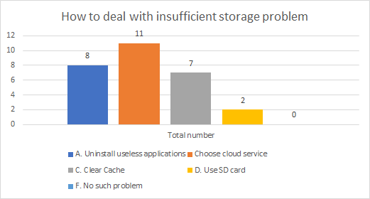

**About 2/3rd of the users think Safety and Cost are the biggest concerns to use cloud services.**

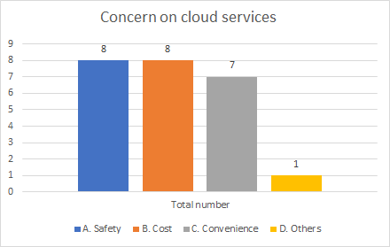

**According to our survey, 37% of the use social media applications more than any other category and followed by Entertainment. It is likely that these categories of applications consume more space on mobile devices.**

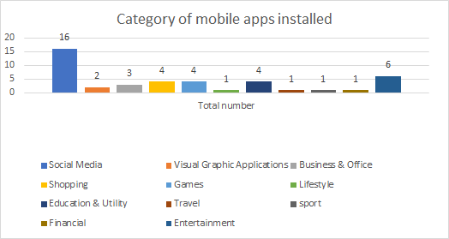

## 

**References:**

<https://www.statista.com/statistics/201182/forecast-of-smartphone-users>

<https://www.statista.com/statistics/243856/daily-app-use-by-us-mobile-app-users/>

<https://www.networkworld.com/article/2982326/the-problems-with-cloud-storage-services-formobile-phones.html>

<https://androidforums.com/threads/moving-apps-to-a-cloud-to-free-up-usb-storage.577764/>

<https://www.iqvis.com/blog/best-cloud-storage-apps-for-android-and-ios/>

<https://www.ubuntupit.com/best-cloud-computing-examples-and-uses/>