# Drexel University

College of Computing and Informatics **INFO 532 – Software Development** Programming Assignment Week 8

**Due Date: Nov. 20, 2022**

Name: Minyi Li Drexel email ID: ml3754

Include screenshots of following the action A.~D. as described below, and attach the screenshots **together** with the corresponding title A.~D. in your word document:

1. (without submitting the form) Click on “**No**” option to the question “Have you ever received vaccine?” take a screenshot;

Then Click on “**Yes**” option to the same question, take another screenshot. Show them as a comparison.

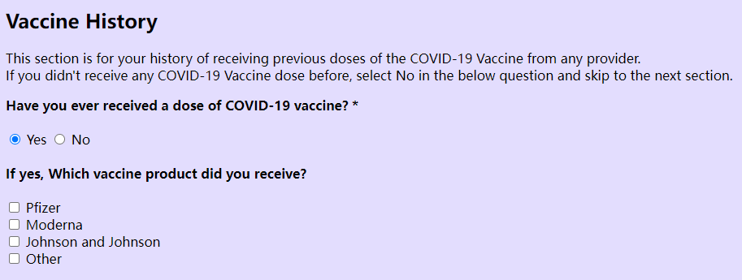

1. Leave ALL other fields **unfilled** or **unselected**, ONLY fill the email as “**abc.123@123.**” and fill the phone number as “**(123)45-67890**”, **submit** the form, and

take a screenshot on the result that showing all warning messages on the form;

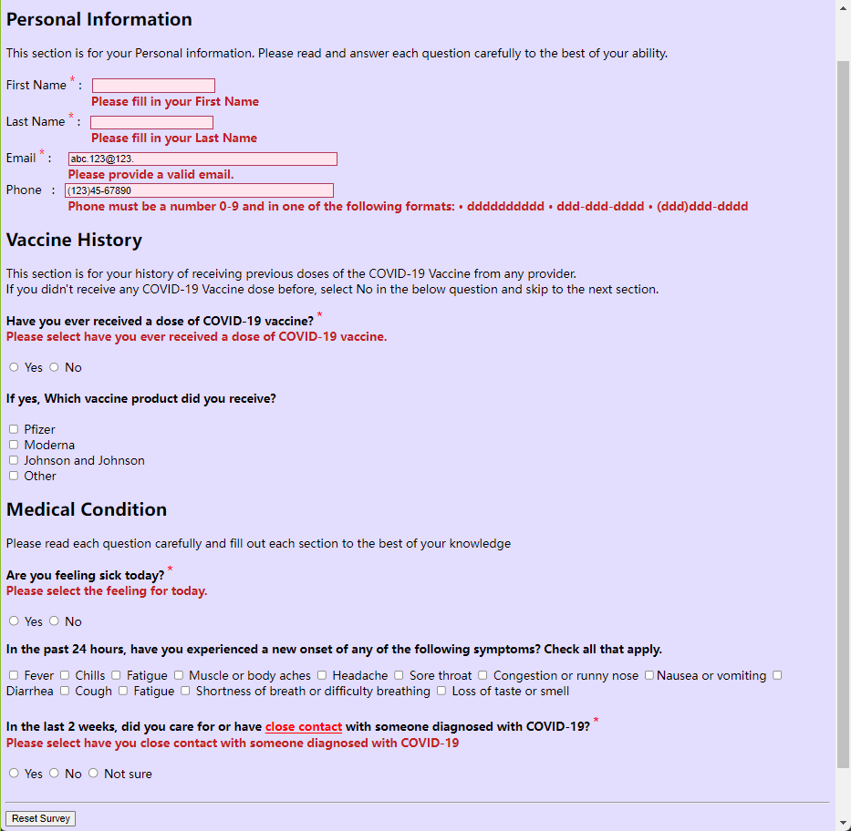

1. Fill your **actual** first and last name, all in lowercase, and

fill your **actual** drexel email **id** but a dummy host “@drexel.edu.org” (*e.g. abc123@drexel.edu.org*), and

**fill ALL** other fields including required and non-required fields, before submitting the form.

Take a screenshot on the “Confirmation page”

