EC450-hw4

* Graph from Picoscope

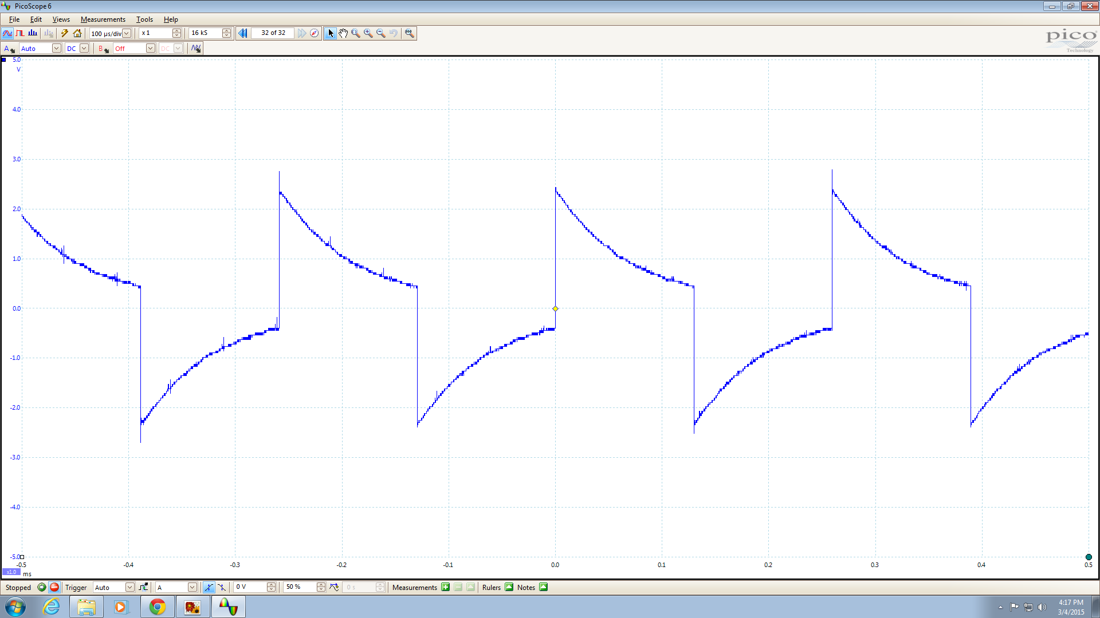

From the graph we know that 1 toggle takes about 0.13ms. And every toggle takes 512 cycles. Therefore per cycle takes 1.3e-4/512 = 2.539e-7 seconds, equals to 3.94e6 Hz = 3.94MHz.

* Implementation

- Known DCO is defined by RSEL, DCO and MOD.

- From table on MSP430 Family Reference Manual page 29, know that DCO frequency (11, 3) provides 4.25MHz.

- Set RESL to 11, DCO to 3 and MOD to 0.

- RESL is bit (0-3) in BCSCTL1, 11 = 1011; DCO is bit (7-5) in DCOCLK, 3 = 011; MOD is 0.

- I used bit by bit implementation, but this can also be achieved by using hex.

- BCSCTL1 = 0x0B, DCOCTL = 0xA0