* My code is based on example timetume4.cpp.
* Buttons Schematic :
  + P1.2 => switch between different songs
  + P1.3 => start/pause
  + P1.4 => speed up
  + P1.5 => slow down
  + P1.7 => replay
  + Graph example:

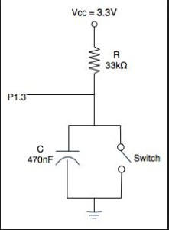

* I made a 2D array to store two different songs, this makes it easier when I have to switch between two songs and keep all the functionalities.
* Once soundOn mode is turned on, it will be on for all of the other functions until start/pause button is pushed down again and soundOn = 0;

I manipulate the states to achieve different functionalities:

Replay => set state to 0, set replay = 0 and play in the play module

Speedup => keep the current state, but when I read the duration from duration array, half the duration, set speedup to 0, then continue to play in play module

Slowdown => keep the current state, double the duration, set slowdown=0, continue to play

Select => if select is pressed down, the row index for the 2D array the stores songs and their duration toggles between 0 and 1, so the microprocessor will play different songs.

* Limitations:
  + Because I used 2D array, two songs has to have the same size array, one can be longer than the other one but they will have empty elements.
  + There’s no proper spacing between different notes, so three of the same notes right next to each other will sound like a very long note.
  + There’s no debouncer, so when I press buttons it sometime doesn’t reads it correctly
* Virtues
  + It works!! It can speed up and slow down and replay and switch between songs…..