Lab 09: Ray Tracing
Intel Core i5-11400H; 12 threads; MSVC 19.42
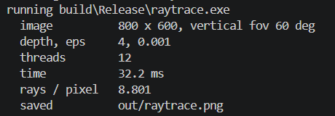
Part I: A Tiny Ray Tracer

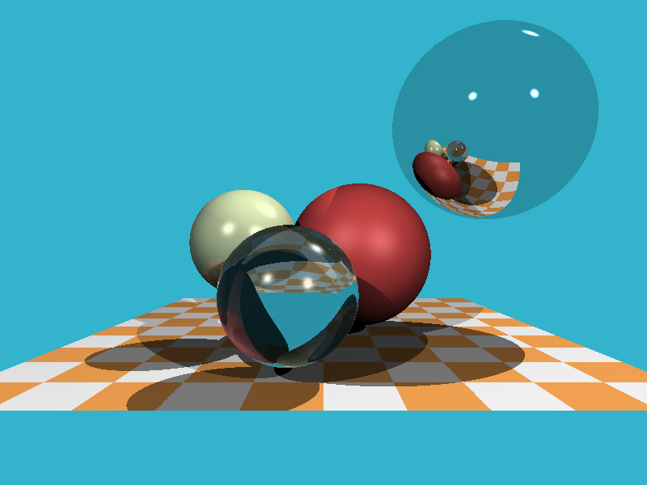

Write-up 1:
1. Run --probe. The chapter's worked example for EQ-10.02 (10.1.2: ray from (0, 0, 0) along (0, 0, -1), sphere at (0, 0, -5), R = 1) computes b = 10 and concludes that neither root is valid. What does your ray_sphere say? Redo the example by hand with Equation 3, find the slip, and give both roots. Then check the chapter's second example (the ray from (0, 0, 3)) the same way.
Ans Equation 3 gives a = 1, b = −10, c = 24, and discriminant 4. The roots are 4 and 6; --probe returns t = 4. The chapter has the wrong sign for b = 2d·(o − c). From (0, 0, 3), a = 1, b = −16 and c = 63, giving roots 7 and 9; the probe returns t = 7.

2. Run --eps 0 and explain Figure 2 at the level of floating point: where does a shadow ray start, and what does it hit first? The floor is the one surface without speckles: read how scene.cpp intersects it, and say why. EPS is a length: if this scene were modelled in millimetres (every coordinate times 1000), what would 0.001 do?
Ans With EPS = 0, rounding can place the hit point slightly inside the sphere. A new shadow ray immediately hits that same sphere at a tiny positive t, incorrectly blocking the light and producing speckles. The floor uses an analytic y = −4 plane intersection and rejects t <= EPS, including the immediate t = 0 hit. Scaling coordinates by 1000 makes EPS = 0.001 relatively 1000 times smaller; use EPS = 1.0 to preserve the original offset.
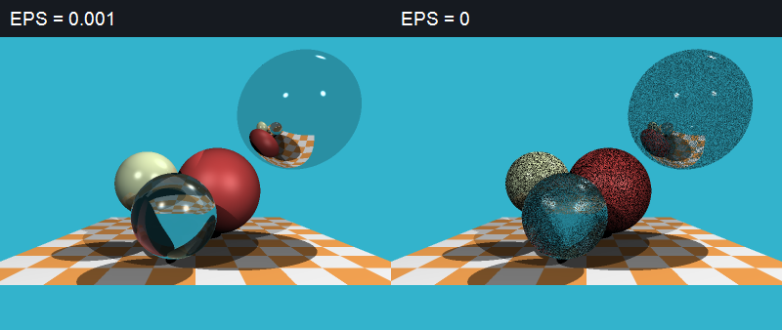
Figure 1

3. Rays per pixel for --depth 0, 1, 2, 3, 4 in a table, and the time of each. The chapter's ray tree (Figure F-10.01) grows 1 → 3 → 9. Your numbers grow differently: explain them from what your cast_ray casts at each hit (how many shadow rays? does it cast reflected and refracted rays whose weight a₂ or a₃ is zero?) and from rays that leave the scene. Which rays could you skip without changing a single pixel, and what would it save?
Ans Medians of three Release runs at 800 × 600 with 12 threads:

Maximum depth | Rays per pixel | Median time (ms)
0 | 2.095 | 9.7
1 | 3.652 | 16.1
2 | 5.173 | 20.0
3 | 6.889 | 25.4
4 | 8.801 | 32.2

Each hit casts three shadow rays, a reflected ray, and a refracted ray when valid, even if its weight is zero. Shadows do not recurse, and many recursive rays miss. Calls beyond depth > MAX_DEPTH return the background before intersection, so the count does not grow as 1 → 3 → 9.
Skipping zero-weight recursive branches preserves every pixel and reduces rays/pixel from 8.801 to 3.566 (59.5% fewer). A separate paired test reduced median time from 29.0 to 12.3 ms, saving 16.7 ms.
4. Inside the glass sphere there is a dark wedge (Figure 1, stage 6). Make it go away and come back by changing one line, and say what it is, using Equation 4. Where does that light really go, and what does this ray tracer do with it instead?
Ans Equation 4 predicts total internal reflection when k < 0; glass-to-air has a critical angle of about 41.8°. Light should reflect internally, but this tracer drops the transmission contribution instead of transferring its weight to reflection.
However, my default run recorded zero TIR failures in 825,532 refraction calls; replacing the failure return with reflection changed zero pixels. Inserting the one line “ior = 1.0f;” removes bending and rearranges the dark pattern; removing it restores the image. Thus I cannot attribute this image’s wedge to TIR, despite the handout’s suggestion.
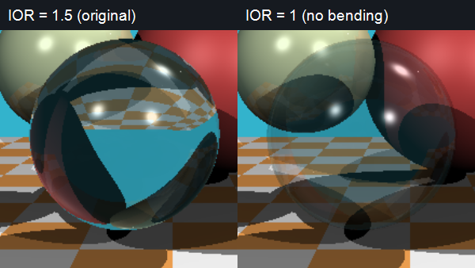
Figure 2

Part II: Triangles
Write-up 2:
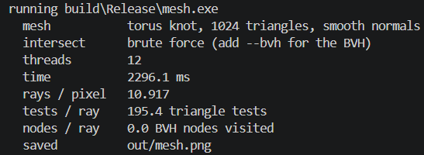
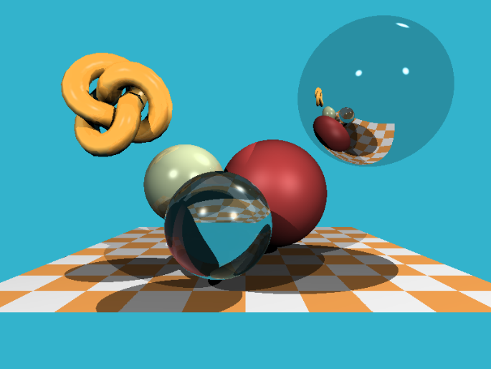
Prediction
I predict brute-force render time and triangle tests per ray will grow approximately linearly with triangle count N, giving log–log slopes close to 1. Tests per ray should be fN, with f below 1 because rays missing the knot’s bounding sphere skip all triangles.
For BVH traversal, I predict triangle tests and render time will grow much more slowly with N, with fitted log–log slopes below 1. Traversal and memory costs mean that O(log N) does not imply a fixed count of 30 operations per ray.
I predict SAH will take longer to build and test fewer triangles than median splitting. Based on the supplied tree structure and the basic rendering checks, I expect median traversal to be faster for the smaller knots because its reduction in node visits can outweigh SAH’s reduction in triangle tests.
For 16k triangles at 320 × 240, I predict a BVH primary-ray render of roughly 5–15 ms, above the chapter’s 5 ms target. Brute force should be substantially slower. At 800 × 600, the same primary-ray workload has 6.25 times as many pixels, so I expect roughly that scaling if per-pixel cost remains similar. These are predictions to compare with measurements, not measured sweep results.
1. The sweep, as a table and as a log-log plot of render time and of triangle tests per ray against N. Fit the slopes. Brute force's tests per ray is not N: compute what fraction of the rays reach the knot's bounding sphere. The chapter says a BVH over 10M triangles needs about 30 operations per ray, and its lab plan asks for “10K+ triangles in under 5 ms per image”. Extrapolate your brute force (and your BVH, if you wrote it) to 10⁷ triangles, and say how far the 16k knot is from 5 ms on your machine, at 320 × 240 and at 800 × 600.
Ans Tables and plots use medians of three Release sweeps (12 threads); build time is excluded from render time. B/M/S means brute force / median BVH / SAH BVH.
Triangles | Render ms (B / M / S) | Tests/ray (B / M / S)
1,024 | 48.5 / 3.0 / 3.8 | 322.0 / 3.2 / 2.6
2,048 | 89.9 / 3.1 / 4.0 | 634.2 / 3.2 / 2.5
4,096 | 173.1 / 3.1 / 3.8 | 1273.6 / 2.9 / 2.2
16,384 | 675.2 / 3.0 / 3.8 | 5056.0 / 2.7 / 1.9
65,536 | — / 4.1 / 4.0 | — / 2.6 / 1.7
262,144 | — / 4.2 / 4.6 | — / 2.5 / 1.7
OLS log–log slopes (B/M/S) are 0.953 / 0.066 / 0.026 for time and 0.994 / -0.048 / -0.085 for tests/ray. The sphere-reach fraction is tests/N: 322/1024 = 31.45%, ranging from 30.86–31.45% across the brute-force rows. Refinement reduces BVH triangle tests slightly; these fitted slopes are not general complexity bounds.
Power-law extrapolation to 10⁷ triangles gives about 300.1 s (B), 5.27 ms (M), and 4.76 ms (S). These are uncertain extrapolations beyond the measured range; node visits and triangle tests each contain many machine operations, so they cannot establish “30 operations per ray.”
16k primary-ray scene | Brute (ms) | Median (ms) | SAH (ms)
320 × 240 | 675.2 | 3.0 | 3.8
800 × 600 | 4216.4 | 15.8 | 18.1
Only the 320 × 240 BVHs meet 5 ms. At 800 × 600, median and SAH take 3.16× and 3.62× that budget. My 5–15 ms prediction for the small 16k render was too pessimistic.
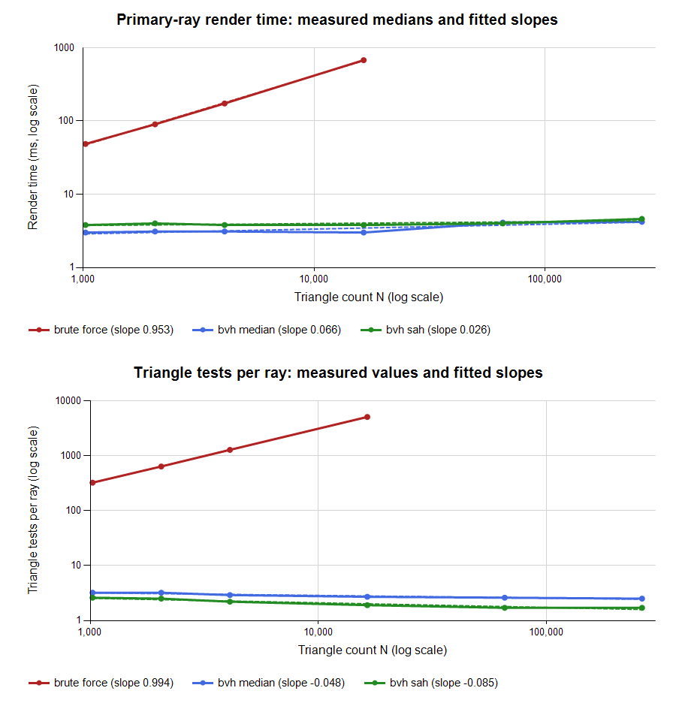
Part II, Figure A.

2. --flat against the default: the same triangles, a different picture. Explain from Equation 6 why u and v are “free”, and what else you could interpolate with them.
Ans Möller–Trumbore already computes u and v to test triangle containment, so their calculation adds no extra intersection work. Smooth shading normalizes (1 − u − v)n₀ + un₁ + vn₂; --flat uses the face normal instead, exposing facets while preserving geometry. The same weights interpolate UVs, colors or other vertex attributes.
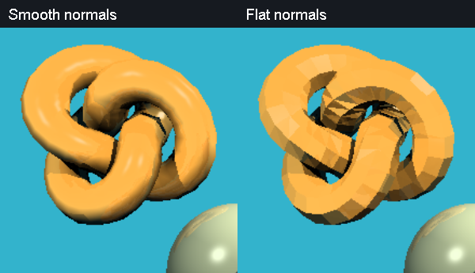
Part II, Figure B.
3. Back-face culling: change your test from |a| < 10⁻⁸ to a < 10⁻⁸ and render the default knot. What changes, and why? Which way do the knot's triangles face? Now render it with --glass, with and without culling, and explain the difference. Can a GPU cull the triangles of a glass object?
Ans All 1,024 faces wind outward. Culling keeps the front-facing entry surfaces, so the opaque appearance is mostly unchanged; small secondary-ray differences affect 1,132 pixels. With glass, culling removes the exit surfaces needed to refract back into air, producing the much lighter, incorrect result (23,111 changed pixels). A GPU can cull mechanically, but a closed refractive object must retain both interfaces or handle exits separately.
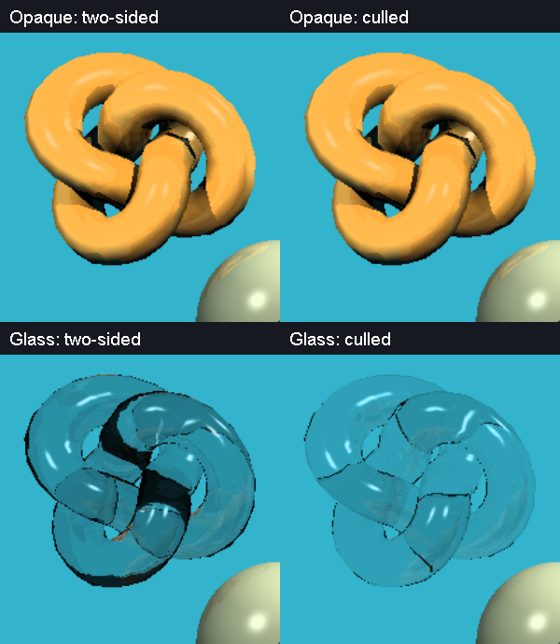
Part II, Figure C.
4. Optional, if you wrote the BVH. Median against SAH in the sweep: build time, nodes per ray, triangle tests per ray, render time. In this builder the SAH tree visits more nodes than the median one but tests fewer triangles. Explain that from EQ-10.05 and the costs C_{T}, C_{I} in bvh.cpp, and say which one wins on your machine and by how much.
Ans The render times and tests/ray are in Question 1; the remaining measurements are below (M/S = median/SAH).
Triangles | Build ms (M / S) | Nodes/ray (M / S)
1,024 | 0.3 / 1.7 | 5.4 / 8.3
2,048 | 0.7 / 3.6 | 6.1 / 8.7
4,096 | 1.7 / 7.3 | 6.0 / 8.6
16,384 | 7.1 / 30.8 | 6.6 / 8.4
65,536 | 30.4 / 130.6 | 7.1 / 8.8
262,144 | 129.5 / 515.4 | 7.7 / 9.5
With C_T = 1 and C_I = 1.5, SAH trades traversal for fewer triangle tests. Its deeper tree visits more nodes, and local cost estimates do not include all real CPU costs. Median wins five of six sizes; at 16k it takes 3.0 versus 3.8 ms (21.1% less time, 1.27× faster). SAH’s 0.1 ms lead at 64k is small relative to run variation. Nodes count popped traversal nodes, not every child-box test.

Part III: A Path Tracer

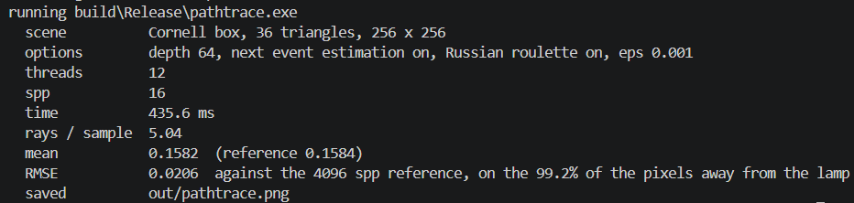

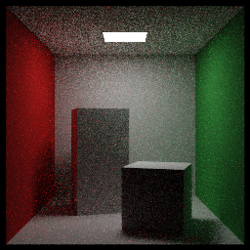

Write-up 3:
Prediction
Recorded before the convergence sweeps and the no-NEE comparison. The implementation’s default 16-spp validation run has already been performed. Drafted with Codex assistance.
Question 1: I predict an RMSE-versus-spp log–log slope near −0.5. Four times as many samples should roughly halve the noise; making the 16-spp image ten times less noisy should require about 1,600 spp and about 100 times its rendering time (roughly 50 s from the preliminary 0.50 s run). At high spp, the finite 4,096-spp reference will cause some departure from ideal scaling. Seed 1 may change the details.
Question 2: I predict disabling next-event estimation at 16 spp will increase RMSE by roughly five times while reducing time per sample because it avoids shadow rays. Matching NEE at 16 spp would then need roughly 400 spp without NEE. The ceiling lamp subtends only a small fraction of the cosine-weighted hemisphere from the floor, so random bounce rays usually miss it. These are predictions, not measurements.
1. --sweep: the table and a log-log plot of RMSE against spp. Is the slope −½? Look at the column RMSE×√spp: why does it creep up at 256 samples? (What is the reference made of? Run --sweep --seed 1 too: does it creep the same way?) How many samples per pixel would make the image 10× less noisy than at 16, and how long would that take on your machine? Compare with the chapter's “4× samples = 2× less noise”.
Ans Slopes are −0.488 (seed 0) and −0.503 (seed 1), close to −½. The reference also contains 4,096-spp noise, so RMSE includes its error and seed-dependent correlation. Seed 0’s scaled error rises to 0.0868, whereas seed 1’s falls to 0.0793; the rise is not universal. For independent estimates, RMSE sqrt(N) includes a factor sqrt(1 + N/4096). Ten times less noise needs 100 times the samples: 1,600 spp, estimated at 45.6 s from the seed-0 16-spp timing. This agrees with “4× samples = 2× less noise” and our predicted slope.
spp | Time ms (seed 0 / 1) | RMSE (seed 0 / 1) | RMSE√spp (seed 0 / 1)
1 | 28.8 / 45.3 | 0.0805 / 0.0809 | 0.0805 / 0.0809
4 | 112.7 / 130.4 | 0.0407 / 0.0406 | 0.0814 / 0.0813
16 | 456.2 / 423.6 | 0.0206 / 0.0204 | 0.0824 / 0.0817
64 | 1736.6 / 1671.4 | 0.0104 / 0.0102 | 0.0831 / 0.0814
256 | 6753.9 / 6767.5 | 0.0054 / 0.0050 | 0.0868 / 0.0793
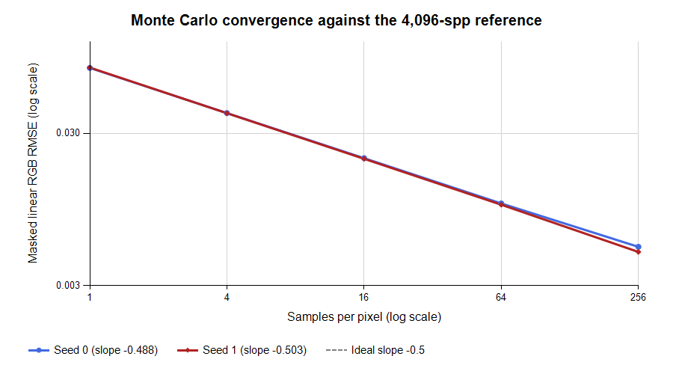
Part III, Figure A.

2. --no-nee at 16 samples per pixel: RMSE and time against the default, and the pictures. How many samples does the no-NEE renderer need to match NEE at 16? Explain the gap from the size of the lamp: roughly what fraction of cosine-weighted directions from the middle of the floor hit it?
Ans Disabling NEE is faster per sample but much noisier. The 16-spp errors predict about 16(0.2168/0.0206)² = 1,772 spp without NEE. At 1,800 spp, the measured error slightly beats NEE at 16, but takes 36.1 s. This is far more than the predicted 400 spp. The lamp’s geometric hit probability is approximately A/(πh²) = 13650/(π·554²) ≈ 1.4% before occlusion, so most random bounce directions miss it.
Renderer | spp | Time (s) | RMSE
NEE | 16 | 0.427 | 0.02060
No NEE | 16 | 0.283 | 0.21680
No NEE | 1800 | 36.063 | 0.02031
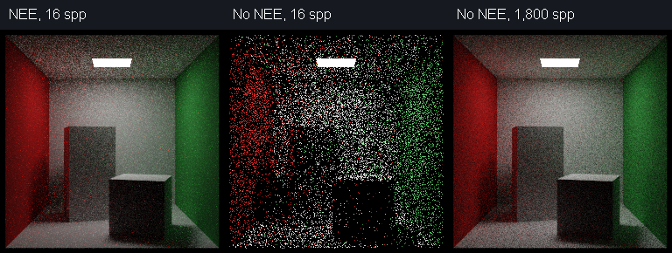
Part III, Figure B

3. Russian roulette: --no-rr against the default at 64 samples: mean, RMSE, time, rays per sample. Is it unbiased? It adds noise: is it worth it? Compare the efficiency 1/(RMSE² × time) of both. Then read the chapter's Part 1 code (Lab 10, Part 1: CPU Path Tracer). It does not compile as printed: what is missing from Hit? Can return hit.emissive ? vec3(12.f) : vec3(0) after the roulette ever return 12? It computes q from the albedo of the current hit, not from the throughput that §10.3.4 and review question 19 describe, and plays from the first bounce: which of these make the image wrong, and which only make it noisier or slower? Measure at least one by changing your code.
Ans Roulette preserves expected light because survivors are divided by their survival probability. The nearly equal means support this. Default RR adds noise but improves efficiency by about 31% over no RR. Starting at bounce 0 preserves the mean but increases noise and gives slightly worse efficiency than starting at bounce 3.

64-spp method | Mean | RMSE | Time (s) | Rays/sample | Efficiency*
RR: bounce 3 | 0.15838689 | 0.01039 | 1.859 | 5.04 | 4982
No RR | 0.15837134 | 0.00825 | 3.861 | 10.61 | 3803
RR: bounce 0 | 0.15845528 | 0.01460 | 1.006 | 3.08 | 4662
*Efficiency = 1/(RMSE² × time in seconds); larger is better. Reference mean = 0.15839350.
Chapter 10, PDF p. 22: Hit lacks vec3 pos, although the code uses hit.pos. The later roulette ternary cannot return 12 because emissive hits already returned earlier; it is redundant, not an emission loss. Albedo-based q and earlier roulette change variance and cost but remain unbiased with the correct survival compensation. The early-roulette row measures the latter change.

4. --depth 1, 2, 3, 5, 10 at 64 samples: the mean of each against the reference. How much light does each extra bounce add, and how much does a hard cut at depth 10 (the chapter's if (depth > 10)) lose here? Why does Russian roulette with --depth 64 not lose it, though most paths stop long before 64?
Ans Extra bounces recover indirect light: the ceiling is black at depth 1 and gains bounced illumination later. The reference mean is 0.15839350. Δ below is the increase since the preceding listed limit, so gaps cover several bounces.
Depth | Mean | Δ since previous listed limit
1 | 0.12362281 | —
2 | 0.14143991 | +0.01781710
3 | 0.15011469 | +0.00867478
5 | 0.15615701 | +0.00604232
10 | 0.15828843 | +0.00213142
64 | 0.15838689 | +0.00009846
Our depth-10 cap loses 0.00009846 mean luminance (0.062%) relative to the paired depth-64 run. The chapter’s depth > 10, starting at zero, permits 11 hits; that test loses 0.033%. Roulette’s survival weighting retains the expected contribution of long paths even though most terminate early. The finite depth-64 safeguard can still truncate light, but its remaining contribution is negligible here.
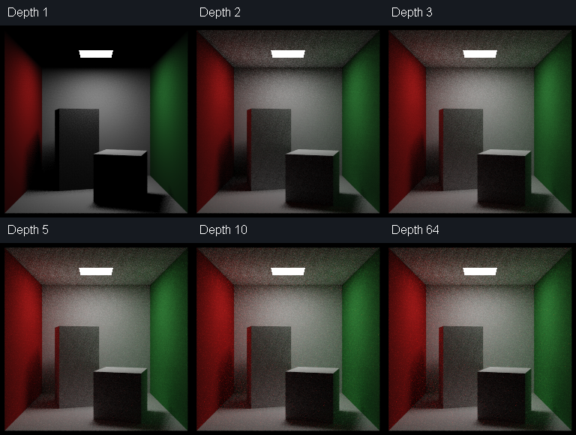
Part III, Figure C.
5. The two traps of TASK 3b and 3d. Put one of them back in your code: report the mean with and without it, show the picture, and explain why it changes the mean, using Equation 12.
Ans I restored the self-shadowing trap by changing “point − origin” to “point − hit.p” when forming the light-sample direction and distance, while keeping the shadow ray’s offset origin. At 64 spp, mean luminance falls from 0.15838689 to 0.13867754 (12.4%). The ray can hit the lamp before its incorrect endpoint, so Equation 12’s visibility V becomes zero for an actually visible sample. This incorrectly removes direct illumination.
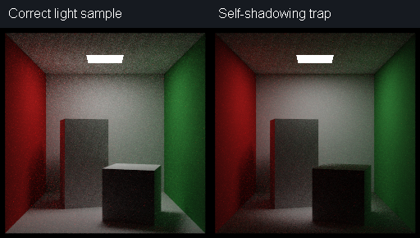
Part III, Figure D.

AI prompt log

PROMPT 1:
Prompt: “Please read the instruction in instruction.pdf and explain the details.”
Model: OpenAI Codex (GPT-6.1).
Idea: I want AI to summarize me all the details that I should know before doing.
Verification: While I was doing lab, I also read the instruction and verified by myself.

PROMPT 2:
Prompt: “Please implement the Task 1.”
Model: OpenAI Codex (GPT-6.1).
Idea: I know about the Math behind and I want to save time, so I order AI to do it for me.
Verification: Read generated code and verified it by myself.
PROMPT 3:
Prompt: “Please more details on part II”
Model: OpenAI Codex (GPT-6.1).
Idea: I am confused about Part II so I asked AI to explain it to me.
Verification: I read the response and it sounds reasonable.

PROMPT 4:
Prompt: “Please create result table with graphs required in Write-up 2 problem 1”
Model: OpenAI Codex (GPT-6.1).
Idea: This is tiresome procedure so I made it do for me.
Verification: Make it explain how it did and the reason behind it. Then I judged based on the rationality.

PROMPT 5:
Prompt: “Please create result table with graphs required in Write-up 3 problem 1, 2, 3 and 4”
Model: OpenAI Codex (GPT-6.1).
Idea: This is tiresome procedure so I made it do for me.
Verification: Make it explain how it did and the reason behind it. Then I judged based on the rationality.

