Automatic Plant Disease Detection Using Computer Vision: Comparing CNN Baselines and a Soft-Voting Ensemble on PlantVillage
‹Team Name›
‹Member 1 — zID›, ‹Member 2 — zID›, ‹Member 3 — zID›, ‹Member 4 — zID›
School of Computer Science and Engineering, UNSW — COMP9444 25T1, Project 090

Abstract—Plant diseases are a persistent threat to crop yield and food security, yet manual diagnosis is slow and subjective. We study automatic leaf-disease recognition on the PlantVillage dataset (54,305 colour images, 14 crops, 38 crop/condition classes). Three convolutional baselines are trained under a single, identical pipeline—a compact CNN from scratch and two ImageNet-pretrained backbones, ResNet-18 and MobileNet-V2—and combined into a soft-voting ensemble as our proposed model. Every baseline exceeds 98.9% test accuracy (ResNet-18 best at 99.68%), and the ensemble improves further to 99.84% accuracy and 99.76 macro-F1, misclassifying only 13 of 8,145 test images. Errors concentrate on genuinely look-alike pairs (e.g. corn Cercospora/Gray leaf spot vs. Northern Leaf Blight) and, for the ensemble, never cross the healthy/diseased boundary. We additionally provide an unsupervised, image-feature severity estimate of the diseased leaf-area fraction, since PlantVillage carries no severity labels. The full pipeline is modular, config-driven and reproducible.
Index Terms—plant disease detection, convolutional neural networks, transfer learning, ensemble, PlantVillage, image classification, precision agriculture.
I. Introduction
Plant diseases significantly reduce agricultural productivity and threaten global food security. Early and accurate identification is critical for timely intervention, but expert visual inspection does not scale to large farms and is subjective and error-prone. Computer vision offers an attractive alternative: a model that maps a leaf photograph to a disease label can support rapid, low-cost screening in the field.
This project targets the PlantVillage benchmark and casts the task as fine-grained image classification over 38 crop/condition classes (26 diseases plus healthy leaves across 14 species). Our aim is threefold. First, we build a CNN classifier that separates healthy from diseased leaves and names the specific condition. Second, following the course requirement to benchmark against multiple methods, we compare three baselines under one controlled pipeline and combine them into a soft-voting ensemble as our proposed model, isolating the effect of architecture, pretraining and model combination. Third, because timely intervention depends not only on which disease is present but on how advanced it is, we add a severity estimate derived from image features.
Our contributions are: (i) a like-for-like comparison of three CNN baselines—a from-scratch CNN, ResNet-18 and MobileNet-V2—under an identical data split, augmentation and optimiser; (ii) a soft-voting ensemble of the three that is our best model at 99.84% test accuracy; (iii) an unsupervised lesion-area severity estimator that needs no additional labels; and (iv) a reproducible, config-driven codebase in which data, models, training, evaluation and severity are independent modules.
II. Related Work
Deep learning is now the dominant approach to plant-disease recognition. Mohanty et al. [2] trained AlexNet and GoogLeNet on PlantVillage and reported up to 99.35% accuracy on a held-out split, establishing the dataset as a standard benchmark. Ferentinos [3] extended this to a larger collection of 87,848 images spanning 58 classes, with VGG reaching 99.5% under laboratory conditions.
Both works also highlight the central limitation of PlantVillage: images are captured on uniform backgrounds, so accuracy drops sharply on independent field photographs. Arsenovic et al. [4] address this generalisation gap with heavier augmentation and GAN-synthesised training data, arguing that controlled-condition accuracy overstates field performance. More recently, Natarajan et al. [5] pair deep architectures with explainable-AI visualisations to make predictions interpretable to agronomists. Our study is complementary: rather than proposing a new architecture, we quantify how much pretraining and capacity matter on the canonical benchmark, combine the baselines into an ensemble, and attach a lightweight severity read-out that prior classification-only pipelines omit.
III. Methods
A. Classification models
We compare three models spanning two families. The custom CNN is a four-block network; each block is a 3×3 convolution, batch normalisation, ReLU and 2×2 max-pooling, with channel widths 32–64–128–256, followed by global average pooling, dropout (0.4) and a linear classifier. It is trained entirely from scratch and serves as the reference baseline. ResNet-18 [6] and MobileNet-V2 [7] are ImageNet-pretrained backbones whose final layer is replaced by a 38-way classifier; the pretrained weights are the only pre-existing component, while the classifier head and the training pipeline are our own.
The three were chosen deliberately: the custom CNN measures what a small purpose-built model achieves without external data; ResNet-18 is a strong residual backbone of moderate size; and MobileNet-V2 is a lightweight, inverted-residual network representative of models deployable on edge and mobile hardware, which is the realistic setting for in-field diagnosis.
B. Training
All models share one pipeline. Images are resized to 128×128 and normalised with ImageNet statistics. Training augmentation applies random resized crops, horizontal flips, ±20° rotations and colour jitter. We optimise with AdamW (learning rate 1×10⁻³, weight decay 1×10⁻⁴) under a cosine-annealed schedule, using cross-entropy with 0.1 label smoothing, for up to 30 epochs with early stopping (patience 7) on validation accuracy. The identical procedure for every model makes the comparison fair.
C. Proposed model: soft-voting ensemble
Our proposed model combines the three trained baselines by soft voting: for each image we take a weighted average of the softmax probability vectors of the custom CNN, ResNet-18 and MobileNet-V2 — with weights tuned on the validation split — and take the arg-max. Averaging calibrated probabilities lets confident, complementary models outvote isolated mistakes, and because the three networks differ in capacity and inductive bias their errors are only partly correlated. The ensemble adds no training cost—it reuses the three checkpoints at inference—yet, as Section V shows, it is our most accurate model.
D. Severity estimation
PlantVillage provides no severity annotations, so severity is estimated from image features and reported only for leaves predicted as diseased. Working in HSV space, the leaf is segmented from the background by Otsu thresholding on saturation; lesion pixels are the leaf pixels whose hue falls outside the healthy-green band (35–85°). The lesion-area fraction is then mapped to ordinal levels—healthy, mild, moderate, severe—by fixed cut-offs (0.05, 0.20, 0.50). The estimate is transparent and label-free, at the cost of sensitivity to lighting and to non-green healthy tissue.
IV. Experiments
Dataset. We use the colour subset of PlantVillage: 54,305 images across 38 classes. Class sizes are imbalanced, ranging from a few hundred to several thousand images per class, so we report macro-averaged precision, recall and F1 alongside accuracy.
Protocol. The data is split 70/15/15 into train/validation/test with a fixed random seed, producing an identical 8,145-image test set for all three models. Checkpoints are selected on validation accuracy; all reported numbers are on the held-out test split. Models were trained on a single NVIDIA GPU. Every hyper-parameter is read from a YAML config, so each run is reproducible from a single command. The ensemble adds no training: it reuses the three checkpoints and is evaluated on the identical test split by a validation-tuned weighted average of their softmax outputs.
Metrics. Beyond overall accuracy we examine macro-averaged metrics (robust to class imbalance), the total number of misclassified test images, and the confusion structure, which reveals whether errors are benign (visually similar diseases of the same crop) or safety-critical (healthy predicted as diseased or vice-versa).
V. Results
TABLE I
Test-set performance on the shared 8,145-image split (%).
Model | Acc. | Prec. | Rec. | F1 | Err.
Custom CNN | 99.15 | 99.01 | 98.82 | 98.91 | 69
ResNet-18 | 99.68 | 99.58 | 99.48 | 99.51 | 26
MobileNet-V2 | 98.98 | 98.67 | 98.76 | 98.70 | 83
Ensemble (ours) | 99.84 | 99.75 | 99.78 | 99.76 | 13
Table I and Fig. 1 summarise test performance. All three baselines exceed 98.9% accuracy, confirming that PlantVillage is highly separable under controlled conditions. Pretrained ResNet-18 is the strongest single model at 99.68% accuracy and 99.51 macro-F1, misclassifying only 26 of 8,145 images. The from-scratch custom CNN is remarkably close at 99.15%, trailing ResNet-18 by roughly half a point while using no external data, and it edges out MobileNet-V2 (98.98%). MobileNet-V2 triggered early stopping after 11 epochs, which partly explains its slightly lower ceiling. Combining all three by a validation-tuned weighted soft vote—our proposed ensemble (weights 0.20 / 0.50 / 0.30 for the custom CNN, ResNet-18 and MobileNet-V2)—raises accuracy to 99.84% and cuts the error count to 13, the best result overall (Table I, bottom row).
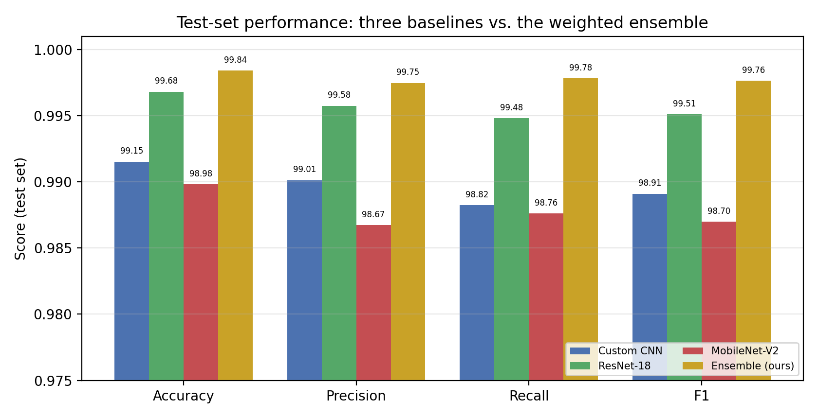
Fig. 1. Accuracy and macro precision/recall/F1 for the three baselines and the ensemble.
Fig. 2 shows validation accuracy over training. Both pretrained backbones reach above 98% within the first few epochs, whereas the custom CNN climbs more gradually before converging—the expected benefit of ImageNet initialisation.
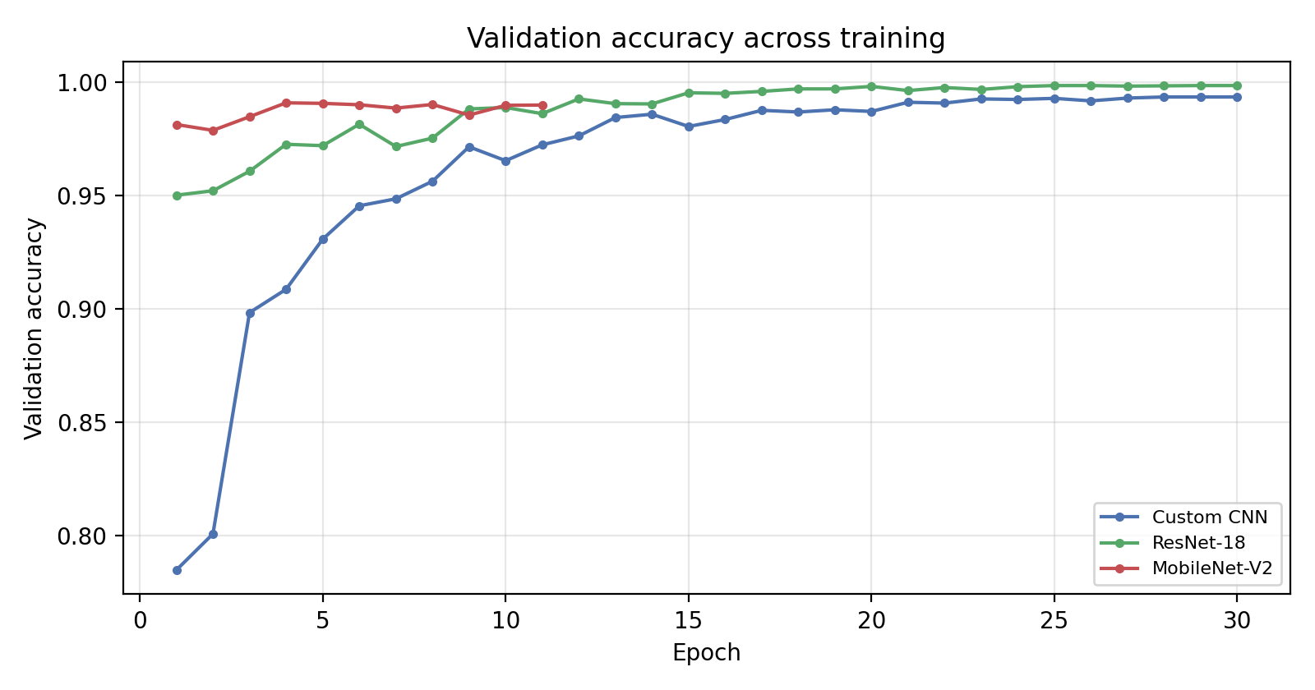
Fig. 2. Validation accuracy across epochs (the three trained baselines).
Error analysis. The errors are overwhelmingly benign. For ResNet-18, 12 of 26 mistakes confuse corn Cercospora/Gray leaf spot with Northern Leaf Blight—a pairing that is difficult even for agronomists—and the remainder are within-crop tomato look-alikes such as Early vs. Late blight. Crucially, no ResNet-18 error crosses the healthy/diseased boundary, so the model never declares a diseased leaf healthy. The weaker models show the same dominant confusions in larger numbers (69 and 83 total errors), indicating a shared, data-intrinsic difficulty rather than model-specific failure. The ensemble reduces the total to just 13 errors—again dominated by the same corn and tomato look-alikes, and likewise with no healthy/diseased crossing—confirming that model combination trims the borderline mistakes without introducing new failure modes.
Severity. Because no ground-truth severity exists, we assess the estimator qualitatively: the reported lesion-area fraction rises with the visible extent of symptoms and is near zero for healthy leaves, giving an interpretable ordinal grade to accompany each diseased prediction.
VI. Conclusion
We presented a controlled comparison of three CNN baselines for plant-disease recognition on PlantVillage, together with a label-free severity estimate. A validation-tuned soft-voting ensemble of the three baselines gave the best result (99.84% test accuracy, 13/8,145 errors); among individual models, pretrained ResNet-18 led at 99.68%, a compact from-scratch CNN came within half a point, and the mobile-friendly MobileNet-V2 remained above 98.9%—useful evidence that accurate, deployable models are attainable on this benchmark. The main strengths are high accuracy, an error profile that never confuses healthy with diseased for the ensemble, and a reproducible, modular codebase.
The chief limitation is shared with the dataset: PlantVillage images are captured on uniform backgrounds, so these numbers overstate performance on cluttered field photographs, and the severity estimate is unvalidated against expert grades. Future work includes evaluation on in-field imagery, domain adaptation and stronger augmentation to close the laboratory-to-field gap, a segmentation-based severity model trained on annotated lesions, and explainable-AI overlays (e.g. Grad-CAM) to build practitioner trust.
References
[1] D. P. Hughes and M. Salathé, “An open access repository of images on plant health,” arXiv:1511.08060, 2015.
[2] S. P. Mohanty, D. P. Hughes, and M. Salathé, “Using deep learning for image-based plant disease detection,” Frontiers in Plant Science, vol. 7, 1419, 2016.
[3] K. P. Ferentinos, “Deep learning models for plant disease detection and diagnosis,” Computers and Electronics in Agriculture, vol. 145, pp. 311–318, 2018.
[4] M. Arsenovic, M. Karanovic, S. Sladojevic, A. Anderla, and D. Stefanovic, “Solving current limitations of deep learning based approaches for plant disease detection,” Symmetry, vol. 11, no. 7, 939, 2019.
[5] S. Natarajan, P. Chakrabarti, and M. Margala, “Robust diagnosis and meta visualizations of plant diseases through deep neural architecture with explainable AI,” Scientific Reports, vol. 14, 13695, 2024.
[6] K. He, X. Zhang, S. Ren, and J. Sun, “Deep residual learning for image recognition,” in Proc. IEEE CVPR, 2016, pp. 770–778.
[7] M. Sandler, A. Howard, M. Zhu, A. Zhmoginov, and L.-C. Chen, “MobileNetV2: Inverted residuals and linear bottlenecks,” in Proc. IEEE CVPR, 2018, pp. 4510–4520.

