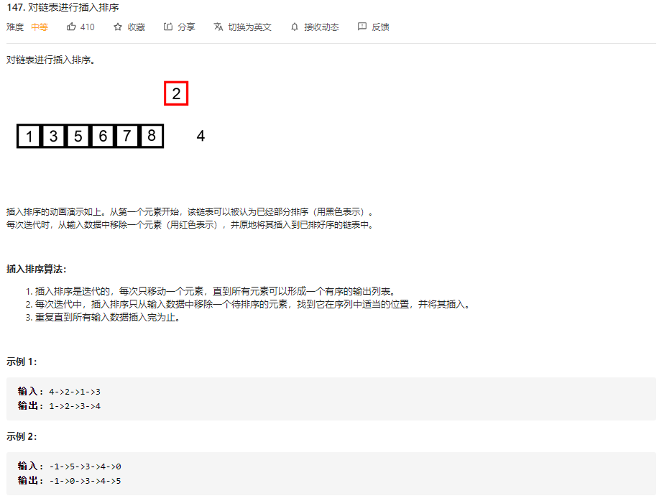

代码：

struct ListNode\* insertionSortList(struct ListNode\* head){

    if(head == NULL || head->next == NULL)

    {

        return head;

    }

    //1.循环的初始条件

    struct ListNode\* sortHead = head;

    struct ListNode\* cur = sortHead->next;

    sortHead->next = NULL;

    while(cur) //2.终止条件

    {

        //3.迭代条件

        struct ListNode\* next = cur->next;

        //将cur结点插入到前面的有序区间

        struct ListNode\* p = NULL , \*c = sortHead;

        while(c)

        {

            if(cur->val < c->val)

            {

                break;

            }

            else

            {

                p = c;

                c = c->next;

            }

        }

        if(p == NULL)

        {

            cur->next = c;

            sortHead = cur;

        }

        else

        {

            p->next = cur;

            cur->next = c;

        }

        cur = next;

    }

    return sortHead;

}