* + As a admin, login to the system
  + Add one Fundamental and Advance courses
  + Open Database in Workbench

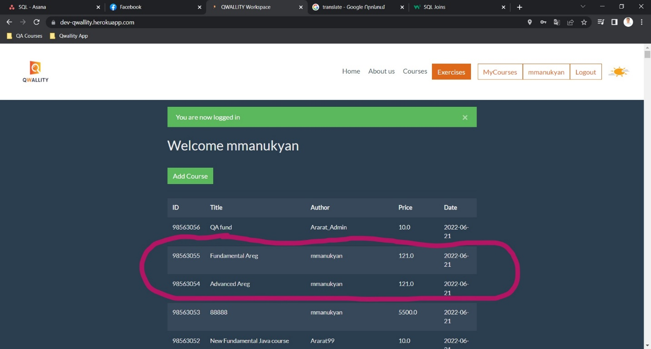

* + Write the following queries
    - which will get added both courses names, created date, course type value and Price

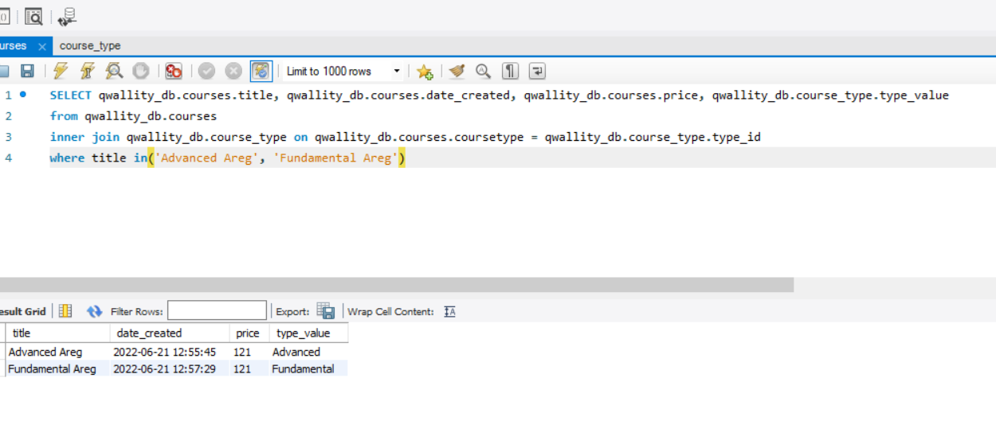

* + - which will update created Fundamental course name to “**Updated title**”

