Introduction To Computing Project
Group Name
MUHAMMAD IQBAL ( L1F24BSCS0174 )
ARSLAN BABAR ( L1F24BSCS0202 )
CODE
#include<iostream>
using namespace std;
int main()
{
cout << "\n GAME : TIK TAK TOE \n" << endl;
char border[9] = { '1','2','3','4','5','6','7','8','9' };
int choice;
char player = 'X';
bool gameover = false;

cout << " Player[X]\n" << endl;
cout << " Player[0]\n" << endl;

while (!gameover)
{
cout << "Player " << player << "'s turn \n" << endl;

cout << "\t\t ""|"" ""|"" " << endl;
cout << "\t\t " << border[0] << " ""| " << border[1] << " ""| " << border[2] << " " << endl;
cout << "\t\t ""|"" ""|"" " << endl;
cout << "\t\t-------""-""-------""-""-------" << endl;
cout << "\t\t ""|"" ""|"" " << endl;
cout << "\t\t " << border[3] << " ""| " << border[4] << " ""| " << border[5] << " " << endl;
cout << "\t\t ""|"" ""|"" " << endl;
cout << "\t\t-------""-""-------""-""-------" << endl;
cout << "\t\t ""|"" ""|"" " << endl;
cout << "\t\t " << border[6] << " ""| " << border[7] << " ""| " << border[8] << " " << endl;
cout << "\t\t ""|"" ""|"" " << endl;

cout << "Enter a number (1-9) to place " << player << ": ";
cin >> choice;

if (choice < 1 || choice > 9 || border[choice - 1] == 'X' || border[choice - 1] == 'O')
{
cout << "Invalid Move. Try Again \n";
continue;
}
border[choice - 1] = player;
if
( (border[0] == border[1] && border[1] == border[2]) ||
(border[3] == border[4] && border[4] == border[5]) ||
(border[6] == border[7] && border[7] == border[8]) ||
(border[0] == border[3] && border[3] == border[6]) ||
(border[1] == border[4] && border[4] == border[7]) ||
(border[2] == border[5] && border[5] == border[8]) ||
(border[0] == border[4] && border[4] == border[8]) ||
(border[2] == border[4] && border[4] == border[6]) )
{
cout << "Player " << player << " Wins ";
gameover = true;
}
bool draw = true;
for (int i = 0; i < 9; i++)
{
if (border[i] != 'X' && border[i] != 'O')
{
draw = false;
break;

}
}
if (draw)
{
cout << "It is a draw ! \n";
gameover = true;
}
if (player == 'X') {
player = 'O';
}
else {
player = 'X';
}

}
cout << "\n\t Final Board \n";

cout << "\t\t ""|"" ""|"" " << endl;
cout << "\t\t "<<border[0]<< " ""| " <<border[1]<< " ""| " <<border[2]<< " " << endl;
cout << "\t\t ""|"" ""|"" " << endl;
cout << "\t\t-------""-""-------""-""-------" << endl;
cout << "\t\t ""|"" ""|"" " << endl;
cout << "\t\t " << border[3] << " ""| " << border[4] << " ""| " << border[5] << " " << endl;
cout << "\t\t ""|"" ""|"" " << endl;
cout << "\t\t-------""-""-------""-""-------" << endl;
cout << "\t\t ""|"" ""|"" " << endl;
cout << "\t\t " << border[6] << " ""| " << border[7] << " ""| " << border[8] << " " << endl;
cout << "\t\t ""|"" ""|"" " << endl;

system("pause");
return 0;

}

OUTPUT
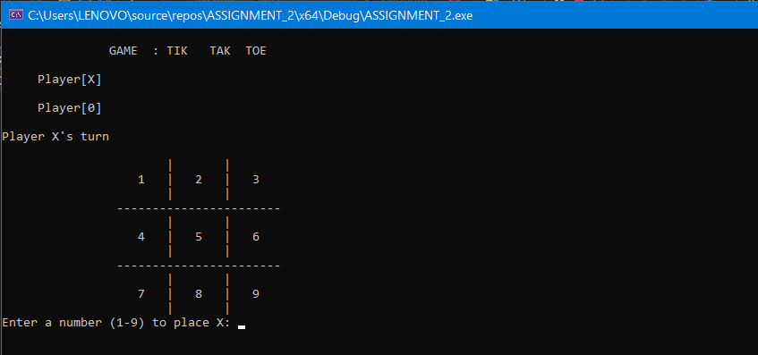
After Enter 5 By player X
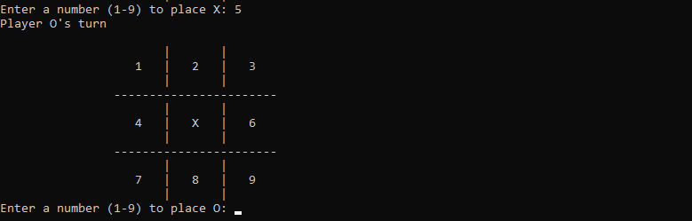
After Enter 3 By player O
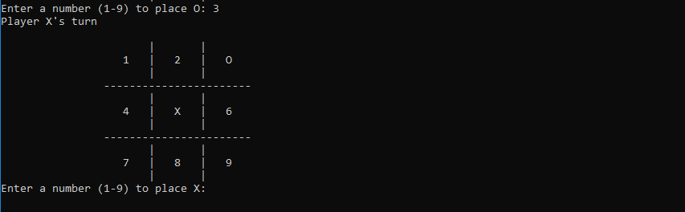
After Enter 1 By player X
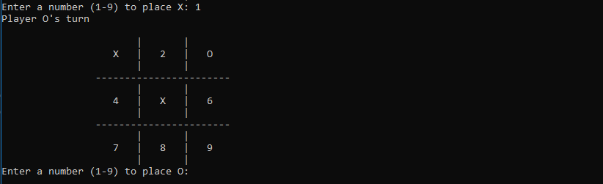
After Enter 8 By player O
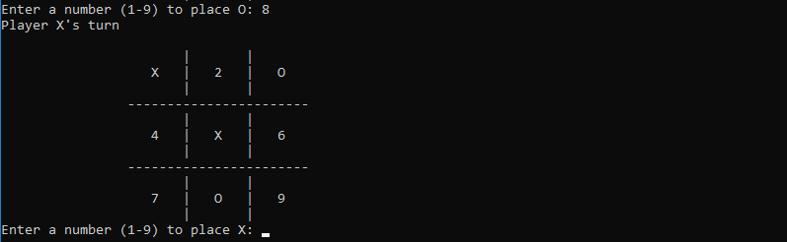

After Enter 4 By player X
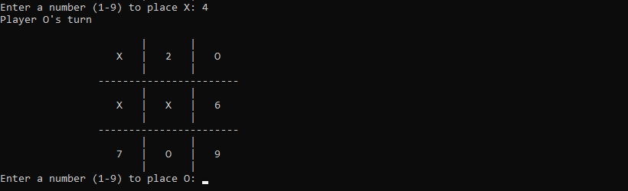
After Enter 6 By player O
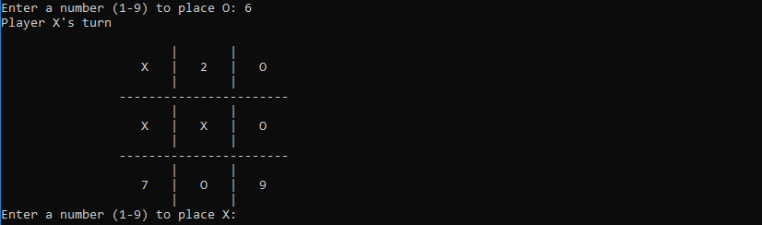
After Enter 2 By player X
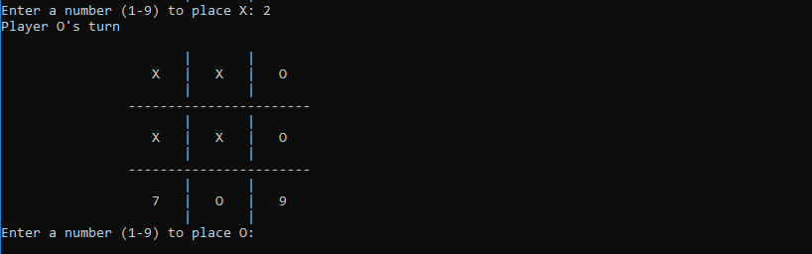
After Enter 9 By player O
