***PAAREES PERFUMES***

***CALVIN KLIEN***

***FOR MEN***

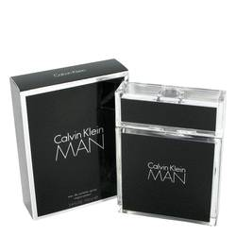

# 

***CALVIN KLIEN MEN***

## *Description:*

Calvin Klein Man by Calvin Klein Cologne. Legendary designer Calvin Klein's signature sense of clean, modern minimalism is on full display in the scent design of Calvin Klein Man. Released in 2007, this intoxicating men's fragrance combines spicy aromatic notes to create a crisp, masculine scent with both warmth and depth. Notes of rosemary, sandalwood, amber and nutmeg mingle to create an appealing fragrance that is dimensional but not overwhelming, making it an ideal daily wear option for the confident modern man.