***PAAREES PERFUMES***

***CALVIN KLIEN***

***FOR MEN***

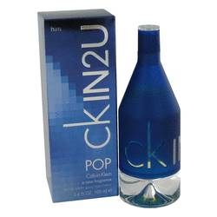

# 

***CK IN 2U POP***

## *Description:*

Ck In 2U Pop by Calvin Klein Cologne. Sporty men revel in the bold, robust notes of Ck In 2U Pop, a verdantly fresh fragrance for men that was released by the design house of Calvin Klein in 2008. This woody yet watery fragrance opens with a zesty zing of mint, cucumber and lemon on the top in a blend that drifts into a manly heart of cardamom, violet and exotic neroli before its bold finish of patchouli and vetiver at its tempting base. It provides a scent that sticks to your skin, keeping you smelling great all day lo