***PAAREES PERFUMES***

***CALVIN KLIEN***

***FOR MEN***

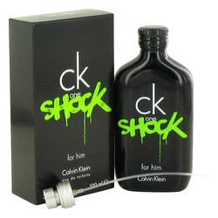

# 

***CK ONE SHOCK***

## *Description:*

Ck One Shock by Calvin Klein Cologne. A continuation of the fragrance sensation started with Ck One and part of a paired launch with a female version, Ck One Shock for men boasts a bold, dynamic character. The exhilarating Oriental spicy composition, a 1994 release from Calvin Klein, fuses lively and unconventional elements. Clementine citrus and fresh cucumber are accented by sharp black pepper and savory black basil. A caffeinated jolt of an energy drink accord intensifies the exciting potion from a classic American label.