***PAAREES PERFUMES***

***CALVIN KLIEN***

***FOR MEN***

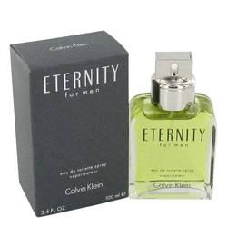

# 

***ELERNITY***

## *Description:*

Eternity by Calvin Klein Cologne. If you are tired of some of the overpowering men's scents out there, try the fresh, tangy tones in Eternity, one of the classic fragrances for men in the strong Calvin Klein line. A mainstay at men's counters since it first came out in 1990, Eternity features a cool combination of lavender, coriander, lemon, bergamot and mandarin orange. This is not a singles' bar fragrance, although those you walk by are definitely going to give you a second glance.