***PAAREES PERFUMES***

***CALVIN KLIEN***

***FOR MEN***

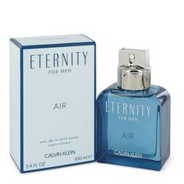

# 

***ELERNITY AIR***

## *Description:*

Elernity Air by Calvin Klein Cologne. The Contradictionline from Calvin Klein was elevated in 2010 when the company introduced Calvin Klein Contradiction for men. This fresh, cool scent features citrus notes blended with lotus, lavender and cucumber, with selected green notes mingled in for added rejuvenation. Just a splash of Contradiction in the morning lasts all day. Choose this fragrance when you want to exude confidence as well as show those around you that you love the finer things in life.