***PAAREES PERFUMES***

***CALVIN KLIEN***

***FOR MEN***

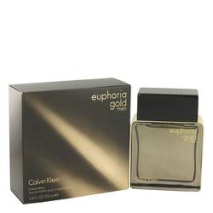

# 

***EUPHORIA GOLD***

## *Description:*

Euphoria Gold by Calvin Klein Cologne. Sugar and spice and many things nice make up this intriguing men's fragrance blend from Calvin Klein. Created in 2014, Euphoria Gold features the warm and cozy scents of amber and vanilla offset by the peppery spice of basil. The sensuous heat of cinnamon mixes with the sweetness of golden honey to round out this complex blend. Splash on this fragrance before your next evening out to make an unforgettable impression on every person you meet.