***PAAREES PERFUMES***

***CALVIN KLIEN***

***FOR MEN***

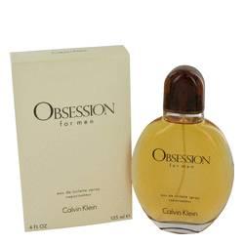

# 

***OBSESSION***

## *Description:*

Obsession by Calvin Klein Cologne. Make a stylish statement by using one of the most recognizable scents in the world. Created by Bob Slattery and launched by Calvin Klein in 1986, Obsession for men is a ground-breaking fragrance that stands tall over all others. The timeless best-selling scent features a blend of sweet amber alongside traditionally masculine notes of lavender, spice and wood. Open the signature Calvin Klein Obsession bottle and dab on the fragrance any time you need to make a powerful impression.