***PAAREES PERFUMES***

***CALVIN KLIEN***

***FOR UNISEX***

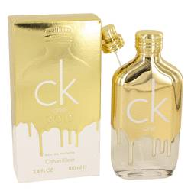

# 

***CK ONE GOLD***

## *Description:*

Ck One Gold by Calvin Klein Cologne. The original Ck fragrance was launched by Calvin Klein in 1994, and marked the beginning of the company’s golden age. In homage to this successful scent, the company launched Ck One Gold in 2016, a fragrance which seeks to embrace the original scent while upgrading it to more modern standards. The top notes of this fragrance include sage, fig and bergamot. The middle notes consist of neroli, violet and jasmine, adding a floral sweetness that everyone can appreciate. The base notes are made up of hints of guaiac wood, patchouli and vetiver for a bit of smoothness, woodiness and spice.