***PAAREES PERFUMES***

***CALVIN KLIEN***

***FOR UNISEX***

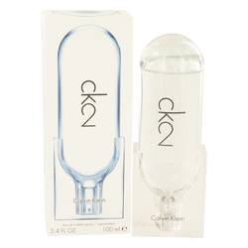

# 

***CK 2***

## *Description:*

Ck 2 by Calvin Klein Perfume. A new take on designer Calvin Klein’s initial successful fragrance, Ck, Ck2 is an updated take on the company’s most popular fragrance to date, and seeks to make it a perfect match for the modern perfume aficionado’s wardrobe. The top notes include pear, violet leaf, mandarin orange and hot wasabi, making it a unique creation right off the bat. The core of the fragrance is made of a combination of rose, orris root, pebbles, hedione and peony, while the base notes consist of white musk, vetiver, sandalwood and incense.