***PAAREES PERFUMES***

***CALVIN KLIEN***

***FOR UNISEX***

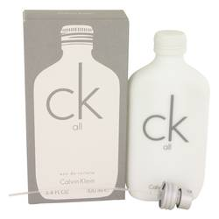

# 

***CK ALL***

## *Description:*

Ck All by Calvin Klein Perfume. Though the bottle is modest and unrevealing, the Ck All is an intriguing and intoxicating fragrance that draws you in to its unique and lovely notes. The crisp notes of mandarin orange, bergamot and grapefruit blossom make up the top. Following this citrus opening is a powdery floral blend of freesia, lily, jasmine and fresh rhubarb. The base notes of vetiver, musk and amber round out the fragrance with warmth and earthiness. Whether you’re a man or woman, this is the perfect perfume to spritz on when you want to draw out your charm and mystique.