***PAAREES PERFUMES***

***CALVIN KLIEN***

***FOR UNISEX***

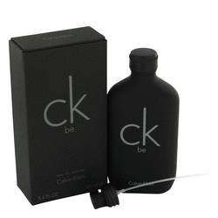

# 

***CK BE***

## *Description:*

Ck Be by Calvin Klein Cologne. Ck Be is a fragrance for men created by Calvin Klein in 1996. Its classic notes of aromatic lavender, green notes, fresh mint, mandarin orange and intense juniper offer a refreshing, oriental scent that is recommended for the office and daytime casual wear. The unique notes couple well with hints of magnolia, woodsy musk, sandalwood and fresh peach. This long-lasting scent always stays true despite rigorous work-outs and hours of wear. Try it for a classic, outdoorsy fragrance experience.