***PAAREES PERFUMES***

***CALVIN KLIEN***

***FOR UNISEX***

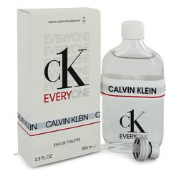

# 

***CK EVERYONE***

## *Description:*

Ck Everyone by Calvin Klein Perfume. Released in 2020, Ck Everyone is a unisex fragrance with citrus, spicy and woody accords. Succulent orange and invigorating ginger create a lively introduction that awakens the senses. The heart consists of a single note: blue tea, an herbal note with earthy and woody tones. Blue tea is brewed from dried flowers of the butterfly pea, a South Asian plant in the legume family. Cedarwood closes the fragrance with its characteristically crisp, clean and bright woody aroma..