***PAAREES PERFUMES***

***CALVIN KLIEN***

***FOR UNISEX***

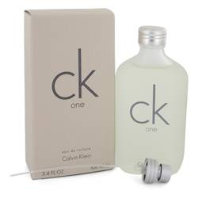

# 

***CK ONE***

## *Description:*

Ck One by Calvin Klein Cologne. Featuring a unique citrus-laced scent that is both refreshing and provocative, ck one by Calvin Klein is a versatile unisex perfume that possesses a distinct and carefully chosen series of notes and scents, such as Mandarin oranges, papaya and pineapple, for a robust, soothing sensation. Created in 1994 for men or women, ck one features undertones of fresh green notes and hints of bergamot, which helps to give it a timeless and highly desirable aromatic appeal..