***PAAREES PERFUMES***

***CALVIN KLIEN***

***FOR UNISEX***

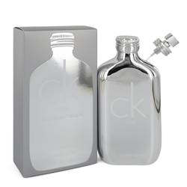

# 

***CK ONE PLATINUM***

## *Description:*

Ck One Platinum by Calvin Klein Perfume. Ck One Platinum is brimming with sprit perfect for the modern woman. The bold composition is comprised of refreshing aldehydes, spicy cardamom and crisp granny smith apple. Middle notes are pink pepper, cinnamon and lavender. Base notes are vetiver, amber and cashmere wood. The dynamic opening transitions to a subdued heart laced with natural sweetness and floral goodness. It’s a dynamic affair that has both warm and cold elements to give you an edge no matter the occasion. The luminous creation has impressive silage that is a testament to its quality. It’s appropriate for both daytime and nighttime use.