***PAAREES PERFUMES***

***CALVIN KLIEN***

***FOR UNISEX***

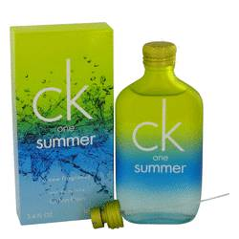

# 

***CK ONE SUMMER***

## *Description:*

Ck One Summer by Calvin Klein Cologne. Reminiscent of summer vacations and warm, unspoiled beaches, Ck One Summer creates a soft aromatic scent for men that lingers in the air without overwhelming those around you. Introduced in 2004, this fragrance combines the classic notes of tangy citrus and earthy greens with fruity, fresh and musky accords. Whether you're planning a trip with your family or spending leisure time with friends, this scent will show everyone that you're confident in who you are.