***PAAREES PERFUMES***

***CALVIN KLIEN***

***FOR WOMEN***

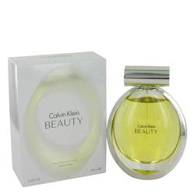

# 

***BEAUTY***

## *Description:*

Beauty by Calvin Klein Perfume. Introduced in 2010, Beauty from Calvin Klein is the perfect fragrance for the professional woman that celebrates her success as much as her inner and physical beauty. Designed by perfume master Sophia Labbe, notes of ambrette, cedar, jasmine and lily blend elegantly for a floral fragrance unmatched in class and perfect as a signature scent. Try this scent today, and instantly turn heads, from early morning office rigors to an evening out with that special someone.